

**Mentor Appointment Scheduling Application**

**Software Design Document**

– Ho Chi Minh, May 2022 –

**Table of Contents**

I. Overview **3**

1. Code Packages/Namespaces 3

1.1 Back-end Code Packages 3

2. Database Schema 5

II. Code Designs **6**

1. <Feature/Function Name1> 6

a. Class Diagram 6

b. Class Specifications 6

XYZ Class 7

ABC Class 7

c. Sequence Diagram(s) 7

d. Database queries 7

2. <Feature/Function Name2> 7

III. Database Tables **8**

1. Majors 8

2. Subjects 8

3. MasUsers 8

4. MentorSubjects 9

5. Slots 9

6. Appointments 9

7. Questions 10

8. Ratings 10

9. AppointmentSubjects 10

# I. Overview

## 1. Code Packages/Namespaces

### 1.1 Back-end Code Packages

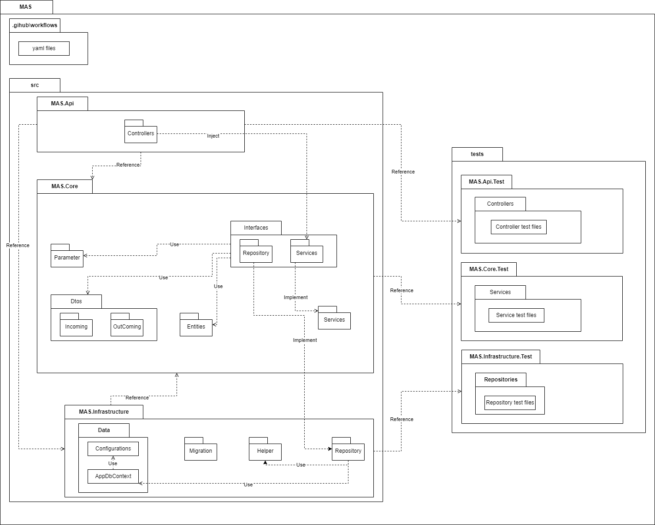

***Package descriptions & package class naming conventions***

| **No** | **Package** | **Description** |
| --- | --- | --- |
| 01 | .github\workflows | Contain config files (YAML files) used to work with GitHub Actions for CI/CD source code. |
| 02 | src | Contains the main source code of project API, include MAS.Api, MAS.Core and MAS.Infrastructure. |
| 03 | MAS.API | Contains the source code of the .NET 5 API, it is a Web API project. It has two main packages: Helpers and Controllers. |
| 04 | Helpers | Contains config files for the API such as service injection (declare the dependency injection into Dependency Inject Container of Asp.Net Core), config for swagger UI to easy testing API on Web browser, auto Seed Data file use to seed data to Database if it does not exist, constant file for the constant value of API. |
| 05 | Controllers | Contains controller files responsible for handling HTTP requests and returning responses with values. |
| 06 | MAS.Core | Contains source code of the Core Business of API, It is a Classlib project, including some main packages such as Parameters, Interfaces (contains Repository interfaces and Service interfaces), Data Transfer Object (Dtos), and Services (Implement level). |
| 07 | Entities | Contains all model classes for mapping with database tables. |
| 08 | Parameters | Contains all Parameters class files, it is used for query routes in API. |
| 09 | Exceptions | Contains files used for logging in Product Environment (Deploy in Azure). |
| 10 | Dtos | Contains Data transfer object classes used for data binding input object (Incoming package) and response mapping output object (Outcoming package). |
| 11 | Interfaces | Contains Interface classes of Repositories (which are working with Entity Framework Core and Database SQL Server to get data), and Services (which will be used by the API, they are same to the Repository Interfaces but they call and use the Repository Interfaces). |
| 12 | Services | Contains the Implement classes of the Interfaces/Services, It calls the Repository, catches the error from the input parameters from users, then passes these input parameters through the repository (Dependency Injection). |
| 13 | MAS.Infrastructure | Contains main files used for Entity Framework Core Object Relational Mapping with Database and the Repository (Implementation from the Repository Interfaces in Core layer). |
| 14 | Data | This package contains the AppDbContext class, where all entities or model classes use mapping with the table in the Database. |
| 15 | Entities | Contains all model classes for mapping with database tables. |
| 16 | Migrations | Contains migrations file, history design, and modified database. |
| 17 | Helpers | Contains files that help populate new model objects. |
| 18 | Repository | Contains files implementation of the Repository Interface in the Core layer. |
| 19 | tests | Contain test projects and test files. |

## 2. Database Schema

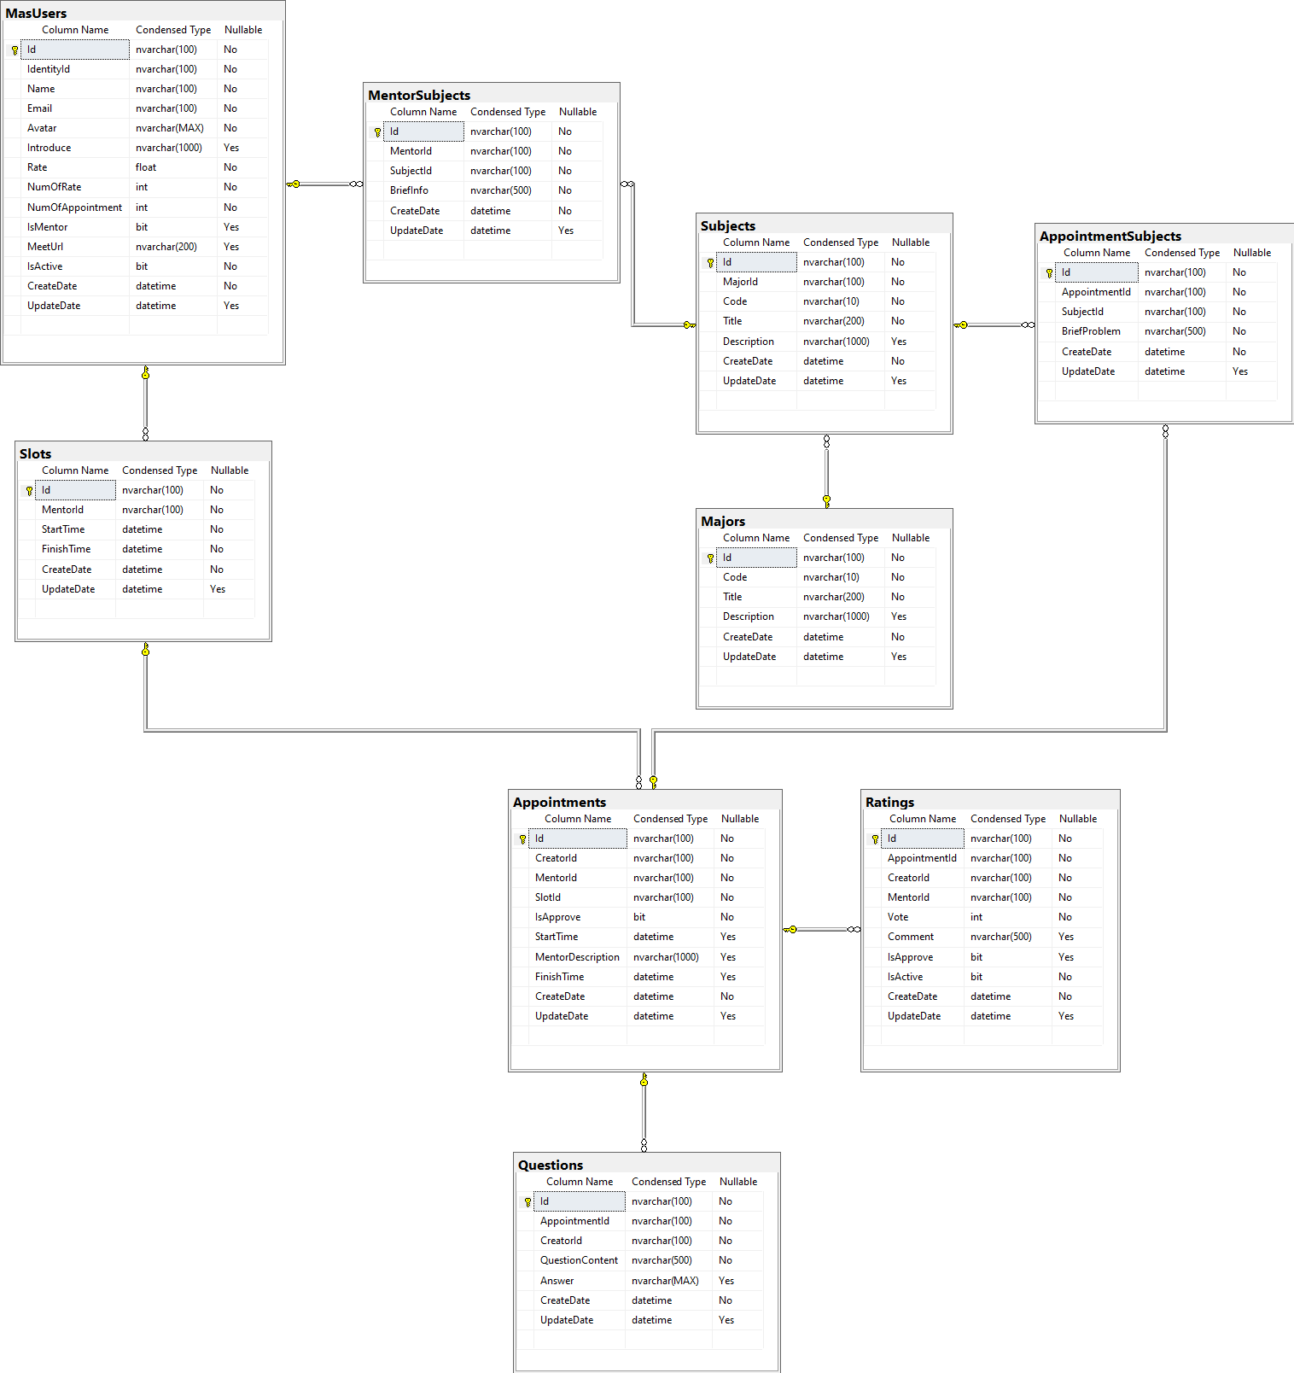

***Table descriptions & package class naming conventions are as below***

| **No** | **Table** | **Description** |
| --- | --- | --- |
| 01 | MasUsers | Contain User (include Mentor and Student, distinguish by IsMentor) information  - Primary keys: Id |
| 02 | MentorSubjects | Contain Subjects of Mentors  - Primary keys: Id  - Foreign keys: MentorId, SubjectId |
| 03 | Subjects | Contain Subject information  - Primary keys: Id  - Foreign keys: MajorId |
| 04 | Majors | Contain Major information  - Primary keys: Id |
| 05 | Slots | Contain Available slot information of Mentors  - Primary keys: Id  - Foreign keys: MentorId |
| 06 | Appointments | Contain Appointment information  - Primary keys: Id  - Foreign keys: SlotId |
| 07 | AppointmentSubjects | Contain Subjects of the Appointment focus  - Primary keys: Id  - Foreign keys: AppointmentId, SubjectId |
| 08 | Questions | Contain Questions of Appointment  - Primary keys: Id  - Foreign keys: AppointmentId |
| 09 | Ratings | Contain Rating information of Appointment  - Primary keys: Id  - Foreign keys: AppointmentId |

# II. Code Designs

## 1. <Feature/Function Name1>

*[Provide the detailed design for the function <Feature/Function Name1>. It include Class Diagram, Class Specifications, and Sequence Diagram(s)]*

### a. Class Diagram

*[This part presents the class diagram for the relevant feature]*

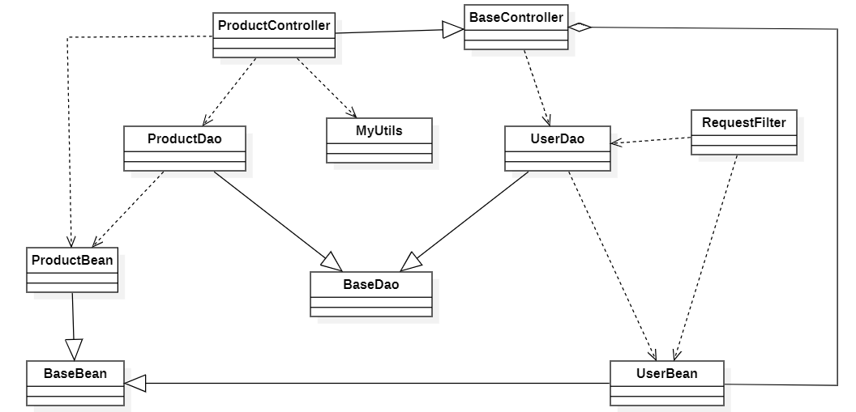

### b. Class Specifications

*[Provide the description for each class and the methods in each class, following the table format as below]*

#### XYZ Class

*[Provide the detailed description for the class methods]*

| **No** | **Method** | **Description** |
| --- | --- | --- |
| *01* | *<method name>* | *<Description of the method, including the inputs, outputs & internal method processing>* |
|  |  |  |

#### ABC Class

***Class Methods***

*[Provide the detailed description for the class methods]*

| **No** | **Method** | **Description** |
| --- | --- | --- |
| *01* | *<method name>* | *<Description of the method, including the inputs, outputs & internal method processing>* |
|  |  |  |

### c. Sequence Diagram(s)

*[Provide the sequence diagram(s) for the feature, see the sample below]*

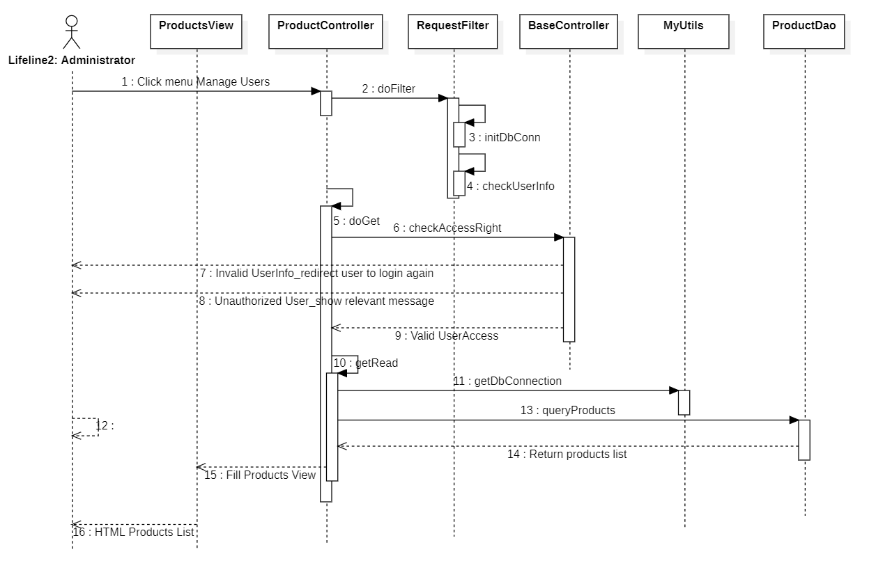

### d. Database queries

*[Provide the detailed SQL (select, insert, update...) which are used in implementing the function/screen]*

## 2. <Feature/Function Name2>

…

# III. Database Tables

## 1. Majors

Contains Major data from FPT University.

| **Field name** | **Type** | **Size** | **Unique** | **Allow Null** | **PK/FK** | **Notes** |
| --- | --- | --- | --- | --- | --- | --- |
| Id | nvarchar | 100 | Yes | No | PK |  |
| Code | nvarchar | 10 | No | No |  |  |
| Title | nvarchar | 200 | No | No |  |  |
| Description | nvarchar | 1000 | No | Yes |  |  |
| CreatedDate | datetime |  | No | No |  |  |
| UpdateDate | datetime |  | No | Yes |  |  |
| IsActive | bit |  | No | No |  | This data is activated or not. |

## 2. Subjects

Contain Subjects data in Major.

| **Field name** | **Type** | **Size** | **Unique** | **Allow Null** | **PK/FK** | **Notes** |
| --- | --- | --- | --- | --- | --- | --- |
| Id | nvarchar | 100 | Yes | No | PK |  |
| MajorId | nvarchar | 100 | Yes | No | FK |  |
| Code | nvarchar | 10 | No | No |  |  |
| Title | nvarchar | 200 | No | No |  |  |
| Description | nvarchar | 1000 | No | Yes |  |  |
| CreatedDate | datetime |  | No | No |  |  |
| UpdateDate | datetime |  | No | Yes |  |  |
| IsActive | bit |  | No | No |  | This data is activated or not. |

## 3. MasUsers

Contain MAS Users data, including Student data and Mentor data, distinguish by IsMentor attribute

| **Field name** | **Type** | **Size** | **Unique** | **Allow Null** | **PK/FK** | **Notes** |
| --- | --- | --- | --- | --- | --- | --- |
| Id | nvarchar | 100 | Yes | No | PK |  |
| IdentityId | nvarchar | 100 | Yes | No |  | tbl.AspNetUsers primary key. |
| Name | nvarchar | 100 | No | No |  |  |
| Email | nvarchar | 100 | Yes | No |  |  |
| Avatar | nvarchar | MAX | Yes | No |  |  |
| Introduce | nvarchar | 1000 | No | Yes |  |  |
| Rate | float |  | No | No |  |  |
| NumOfRate | int |  | No | No |  |  |
| NumOfAppointment | int |  | No | No |  |  |
| IsMentor | bit |  | No | Yes |  |  |
| MeetUrl | nvarchar | 200 | No | Yes |  |  |
| CreatedDate | datetime |  | No | No |  |  |
| UpdateDate | datetime |  | No | Yes |  |  |
| IsActive | bit |  | No | No |  | This data is activated or not. |

## 4. MentorSubjects

Contain Subjects data of Mentor.

| **Field name** | **Type** | **Size** | **Unique** | **Allow Null** | **PK/FK** | **Notes** |
| --- | --- | --- | --- | --- | --- | --- |
| Id | nvarchar | 100 | Yes | No | PK |  |
| MentorId | nvarchar | 100 | Yes | No | FK |  |
| SubjectId | nvarchar | 10 | No | No | FK |  |
| BriefInfo | nvarchar | 500 | No | No |  |  |
| CreatedDate | datetime |  | No | No |  |  |
| UpdateDate | datetime |  | No | Yes |  |  |
| IsActive | bit |  | No | No |  | This data is activated or not. |

## 

## 5. Slots

Contain Subjects data in Major.

| **Field name** | **Type** | **Size** | **Unique** | **Allow Null** | **PK/FK** | **Notes** |
| --- | --- | --- | --- | --- | --- | --- |
| Id | nvarchar | 100 | Yes | No | PK |  |
| MentorId | nvarchar | 100 | Yes | No | FK |  |
| StartTime | datetime |  | No | No |  |  |
| FinishTime | datetime |  | No | No |  |  |
| CreatedDate | datetime |  | No | No |  |  |
| UpdateDate | datetime |  | No | Yes |  |  |
| IsActive | bit |  | No | No |  | This data is activated or not. |

## 

## 6. Appointments

Contain Appointment Data registered by Student to Mentor based on available slot of Mentor.

| **Field name** | **Type** | **Size** | **Unique** | **Allow Null** | **PK/FK** | **Notes** |
| --- | --- | --- | --- | --- | --- | --- |
| Id | nvarchar | 100 | Yes | No | PK |  |
| CreatorId | nvarchar | 100 | Yes | No |  |  |
| MentorId | nvarchar | 100 | Yes | No |  |  |
| SlotId | nvarchar | 100 | Yes | No | FK |  |
| IsApproved | bit |  | No | Yes |  |  |
| StartTime | datetime |  | No | Yes |  |  |
| MentorDescription | nvarchar | 1000 | No | Yes |  |  |
| FinishTime | datetime |  | No | No |  |  |
| CreatedDate | datetime |  | No | No |  |  |
| UpdateDate | datetime |  | No | Yes |  |  |
| IsActive | bit |  | No | No |  | This data is activated or not. |

## 

## 7. Questions

Contain Question data in Appointment.

| **Field name** | **Type** | **Size** | **Unique** | **Allow Null** | **PK/FK** | **Notes** |
| --- | --- | --- | --- | --- | --- | --- |
| Id | nvarchar | 100 | Yes | No | PK |  |
| AppointmentId | nvarchar | 100 | Yes | No | FK |  |
| CreatorId | nvarchar | 100 | Yes | No |  |  |
| QuestionContent | nvarchar | 500 | No | No |  |  |
| Answer | nvarchar | MAX | No | Yes |  |  |
| CreatedDate | datetime |  | No | No |  |  |
| UpdateDate | datetime |  | No | Yes |  |  |
| IsActive | bit |  | No | No |  | This data is activated or not. |

## 

## 8. Ratings

Contain Rating data on Appointment.

| **Field name** | **Type** | **Size** | **Unique** | **Allow Null** | **PK/FK** | **Notes** |
| --- | --- | --- | --- | --- | --- | --- |
| Id | nvarchar | 100 | Yes | No | PK |  |
| AppointmentId | nvarchar | 100 | Yes | No | FK |  |
| CreatorId | nvarchar | 100 | Yes | No |  |  |
| MentorId | nvarchar | 100 | Yes | No |  |  |
| Vote | int |  | No | No |  |  |
| Comment | nvarchar | 500 | No | Yes |  |  |
| IsApprove | bit |  | No | Yes |  |  |
| CreatedDate | datetime |  | No | No |  |  |
| UpdateDate | datetime |  | No | Yes |  |  |
| IsActive | bit |  | No | No |  | This data is activated or not. |

## 

## 9. AppointmentSubjects

Contain Appointment detail, including the Subjects of this Appointment, a brief problem summary.

| **Field name** | **Type** | **Size** | **Unique** | **Allow Null** | **PK/FK** | **Notes** |
| --- | --- | --- | --- | --- | --- | --- |
| Id | nvarchar | 100 | Yes | No | PK |  |
| AppointmentId | nvarchar | 100 | Yes | No | FK |  |
| SubjectId | nvarchar | 100 | Yes | No | FK |  |
| BriefProblem | nvarchar | 500 | Yes | No |  |  |
| CreatedDate | datetime |  | No | No |  |  |
| UpdateDate | datetime |  | No | Yes |  |  |
| IsActive | bit |  | No | No |  | This data is activated or not. |

## 