

**Mentor Appointment Scheduling Application**

**Software Requirement Specification**

– Ho Chi Minh, May 2022 –

**Table of Contents**

I. Overview **4**

1. Introduction 4

2. System Functions 5

a. Screen Flow 5

b. Screen Details 6

c. User Authorization 7

d. Non-Screen Functions 9

II. Functional Requirements **10**

1. Login 10

a. Login 10

2. Manage majors. 10

a. View all major 10

b. Create an new major 11

c. Update a major 12

d. Delete a major 12

3. Manage subjects. 13

a. View all subject 13

b. Create an new subject 14

c. Update a subject 15

d. Delete a subject 15

4. Manage accounts. 16

a. View all accounts 16

b. Disable an account 16

5. Manage register requests. 17

a. View all requests 17

b. View register requests detail 17

c. Accept register requests 17

d. Decline register requests 17

1. Login 18

a. Login 18

b. Logout 18

2. Register 18

3. Forgot password 18

4. View own profile 19

5. View and Search mentor 19

6. View mentor details 20

7. View slot details 21

8. Create appointment 21

9. Send appointment 22

10. View send appointment list 23

11. View appointment details 23

12. View appointment request list 24

13. View appointment request details 25

14. Accept appointment request 25

15. Deny appointment request 26

16. Add question 27

17. View question 27

18. Answer question 28

# I. Overview

## 1. Introduction

The Mentor Appointment Scheduling Application - MAS Application is a software system that helps the student who has problems with studying or career paths can make an appointment online with a mentor to ask for and retrieve advice from the mentor. This system is expected to help students improve their study quality and clarity in their career paths.

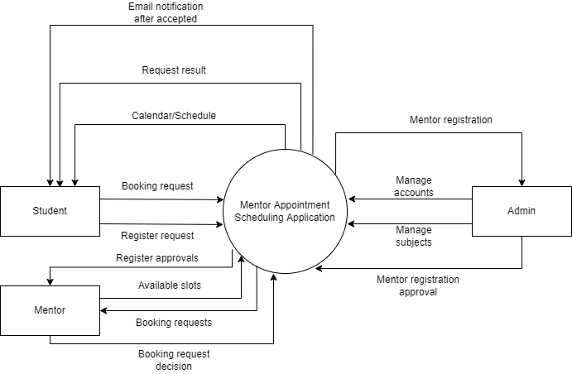

## 2. System Functions

#### a. Screen Flow

* User MAS web application screen flow:

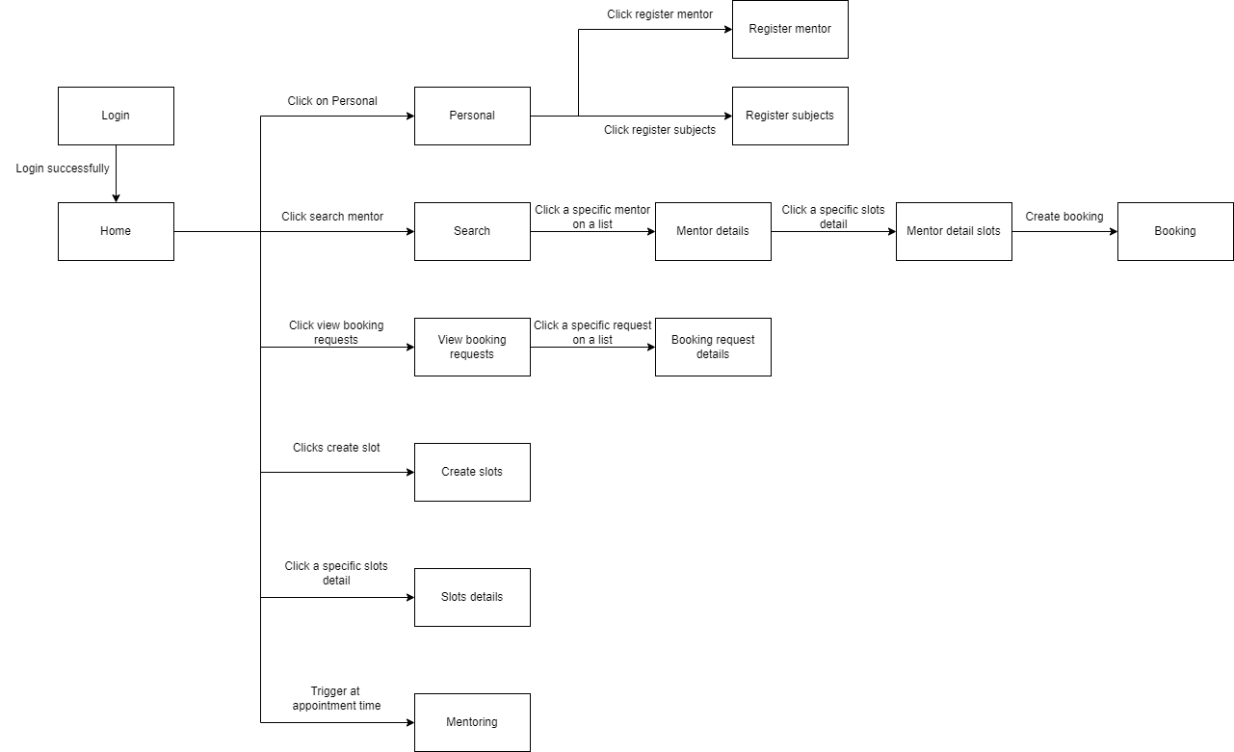

* Admin MAS web application screen flow: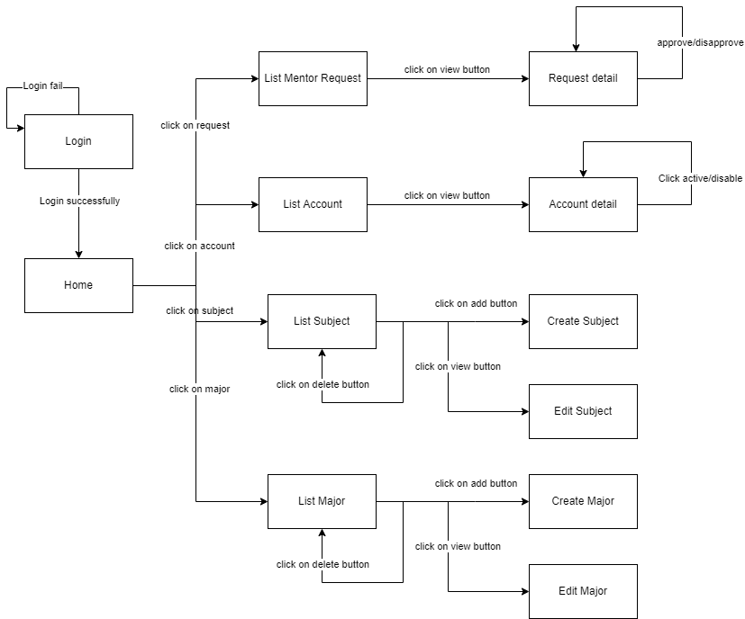

#### b. Screen Details

* User MAS web application screen details:

| **#** | **Feature** | **Screen** | **Description** |
| --- | --- | --- | --- |
| 1 | Login with Google | Login with Google | User login into MAS web application with Google account |
| 2 | View Schedule | Home | View schedule of the user of the current week to the next 3 weeks. |
| 3 | View Profile | Personal | View own student or mentor profile |
| 4 | Search Mentor | Home | Search mentor by name or by subject |
| 5 | View Mentor profile and available slot | Mentor details | View mentor available slots and mentor detail profile |
| 6 | View slot in detail | Mentor slot details | View details available slot. |
| 7 | Booking | Booking | Create a booking request and send it to mentor |
| 8 | View Booking Request | View booking requests | View booking request to available slots |
| 9 | Accept request | View booking requests | Accept a request to available slots |
| 10 | Deny request | View booking requests | Deny a request to available slots |
| 11 | Create available slot | Create available slot page | Create an new available slots |
| 12 | Update available slot | View an available slot details | Update an available slots |
| 13 | Remove available slot | Home | Remove an available slot |
| 14 | Register mentor | Register mentor | User send a mentor registration to admin |
| 15 | Register subjects | Register subjects | User after become a mentor can register to add more subjects |
| 16 | Mentoring | Mentor | User mentor other users |

* Admin MAS web application screen details:

| **#** | **Feature** | **Screen** | **Description** |
| --- | --- | --- | --- |
| 1 | Login with system account | Login | User login into MAS web application with system account |
| 2 | View statistic | Home | View statistics of the system |
| 3 | View all request | Request | View all user requests to become mentor |
| 4 | View request detail | Request | View request details |
| 5 | View all account | Account | View all account of user in system |
| 6 | View account detail | Account detail | View details of specific account |
| 7 | View all major | Major | View all subjects exist in system |
| 8 | Create new major | Create Major | Create new major into system |
| 9 | Edit major | Edit Major | View and edit specific major |
| 10 | View all subject | Subject | View all major exist in system |
| 11 | Create new subject | Create Subject | Create new major into system |
| 12 | Edit subject | Edit Subject | View and edit specific major |

#### c. User Authorization

| **Feature** | **Screen** | **Unauthenticated User** | **User** | **Admin** |
| --- | --- | --- | --- | --- |
| 1. Login with Google | Login |  | X | X |
| 2. View schedule | Home | X |  | X |
| 3. View profile | Personal | X |  | X |
| 3.1. Edit profile | Personal | X |  | X |
| 3.2. Disable subjects | Personal | X |  | X |
| 4. Register mentor | Register mentor | X |  | X |
| 5. Register subjects | Register subject | X |  | X |
| 6. Search mentor | Search | X |  | X |
| 6.1. View list mentor | Search | X |  | X |
| 7. View mentor slots | Mentor details | X |  | X |
| 8. View mentor slot details | Mentor details | X |  | X |
| 9. Booking | Booking | X |  | X |
| 10. View booking requests | View Booking requests | X |  | X |
| 11. View booking requests details | Booking request details | X |  | X |
| 12. Accept booking request | Booking request details | X |  | X |
| 13. Deny booking request | Booking request details | X |  | X |
| 14. Create a new available slot | Create slots | X |  | X |
| 15.1 View an available slots | Slots details | X |  | X |
| 15.2. Update an available slots | Slots details | X |  | X |
| 16. Delete an available slots | Slots details | X |  | X |
| 17. View question | Mentor | X |  | X |
| 18. Answer question | Mentor | X |  | X |
| 19. Login with system account | Login | X | X |  |
| 20. View statistic | Home | X | X |  |
| 21.1 View all request | Request | X | X |  |
| 21.2. View request detail | Request | X | X |  |
| 21.3. Approve/decline request | Request | X | X |  |
| 22.1 View all account | Account | X | X |  |
| 22.2 Active/disable account | Account | X | X |  |
| 23.1 View account detail | Account detail | X | X |  |
| 23.2 Active/disable account | Account detail | X | X |  |
| 24.1 View all subject | Subject | X | X |  |
| 24.2 Delete subject | Subject | X | X |  |
| 25 Create new subject | Create Subject | X | X |  |
| 26.1 Edit subject | Edit Subject | X | X |  |
| 26.2 Delete subject | Edit Subject | X | X |  |
| 27 View all major | Major | X | X |  |
| 28 Add Major | Create Major | X | X |  |
| 29.1 Delete Major | Edit Major | X | X |  |
| 29.2 Edit Major | Edit Major | X | X |  |
| 30 Rating and comment | History Detail | X |  | X |
| 31 View send appointment | Appointment details | x |  | x |
|  |  |  |  |  |
|  |  |  |  |  |

In which:

* Unauthenticated User: User has not logged into MAS web application
* User: User has logged into MAS web application by FPT Google account
* Admin: User has logged into Admin web application as Admin role

#### d. Non-Screen Functions

| **#** | **Feature** | **Description** |
| --- | --- | --- |
| 1 | Send email to user | Send email to user after booking request is accepted |
|  |  |  |

# II. Functional Requirements

1. Admin web application

## 1. Login

### a. Login

**● Function trigger:** Unauthenticated User request login into system by clicks on “Login” button

**● Function description:** Unauthenticated User login to system to verify role, give them

access to more features in the system

**● Screen layout:**

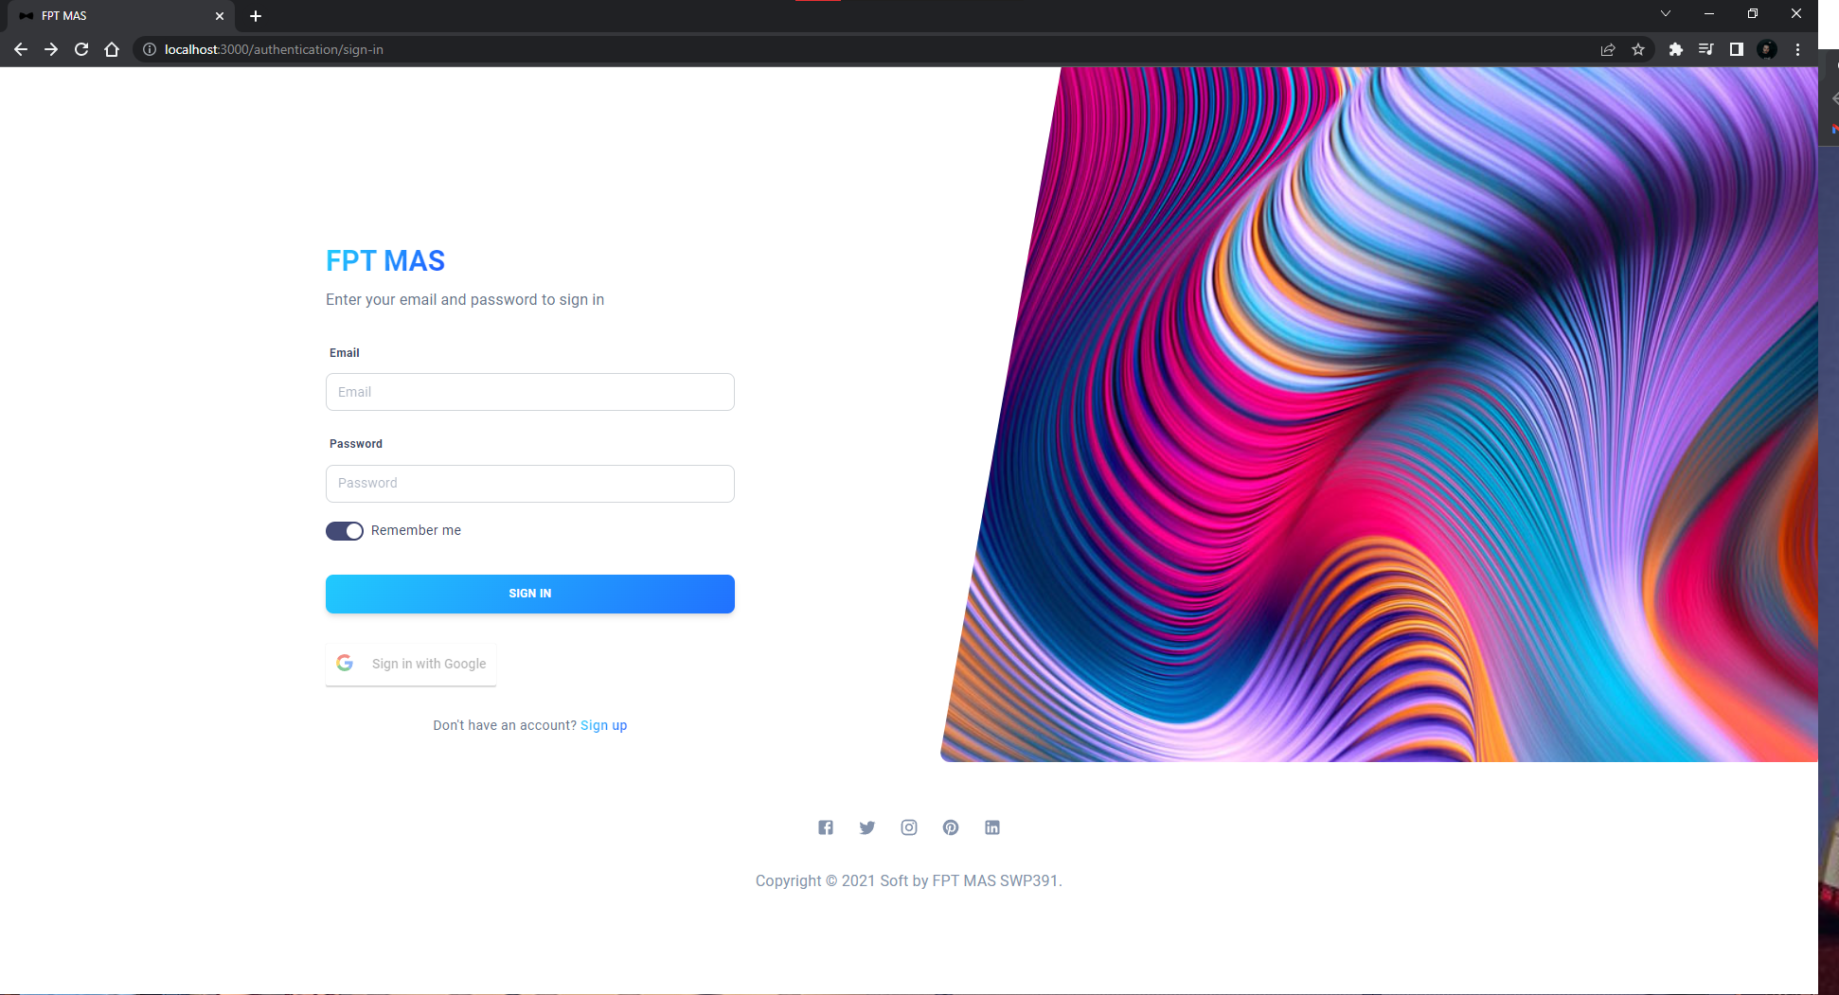

**● Function details:**

* User enters 2 fields:
* Username: Email format
* Password: include at least a number, an uppercase letter and a special character
* User clicks “Dang Nhap” button”
* System generates a token and user account will keep the token to enter the web admin application

## 

## 2. Manage majors.

### a. View all major

**● Function trigger:** Admin clicks “Major” on the left menu bar.

**● Function description:** Admin request view all major.

**● Screen layout:**

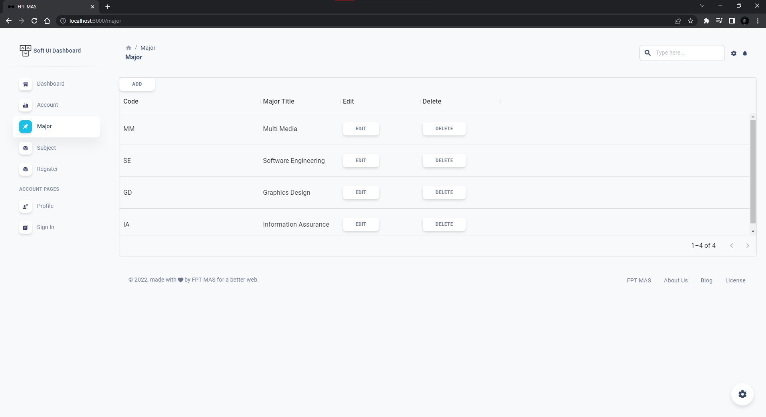

**● Function details:**

* System displays majors

### b. Create an new major

**● Function trigger:** Admin clicks “Create” on the Create major dialog.

**● Function description:** Admin request create a new major for the application

**● Screen layout:**

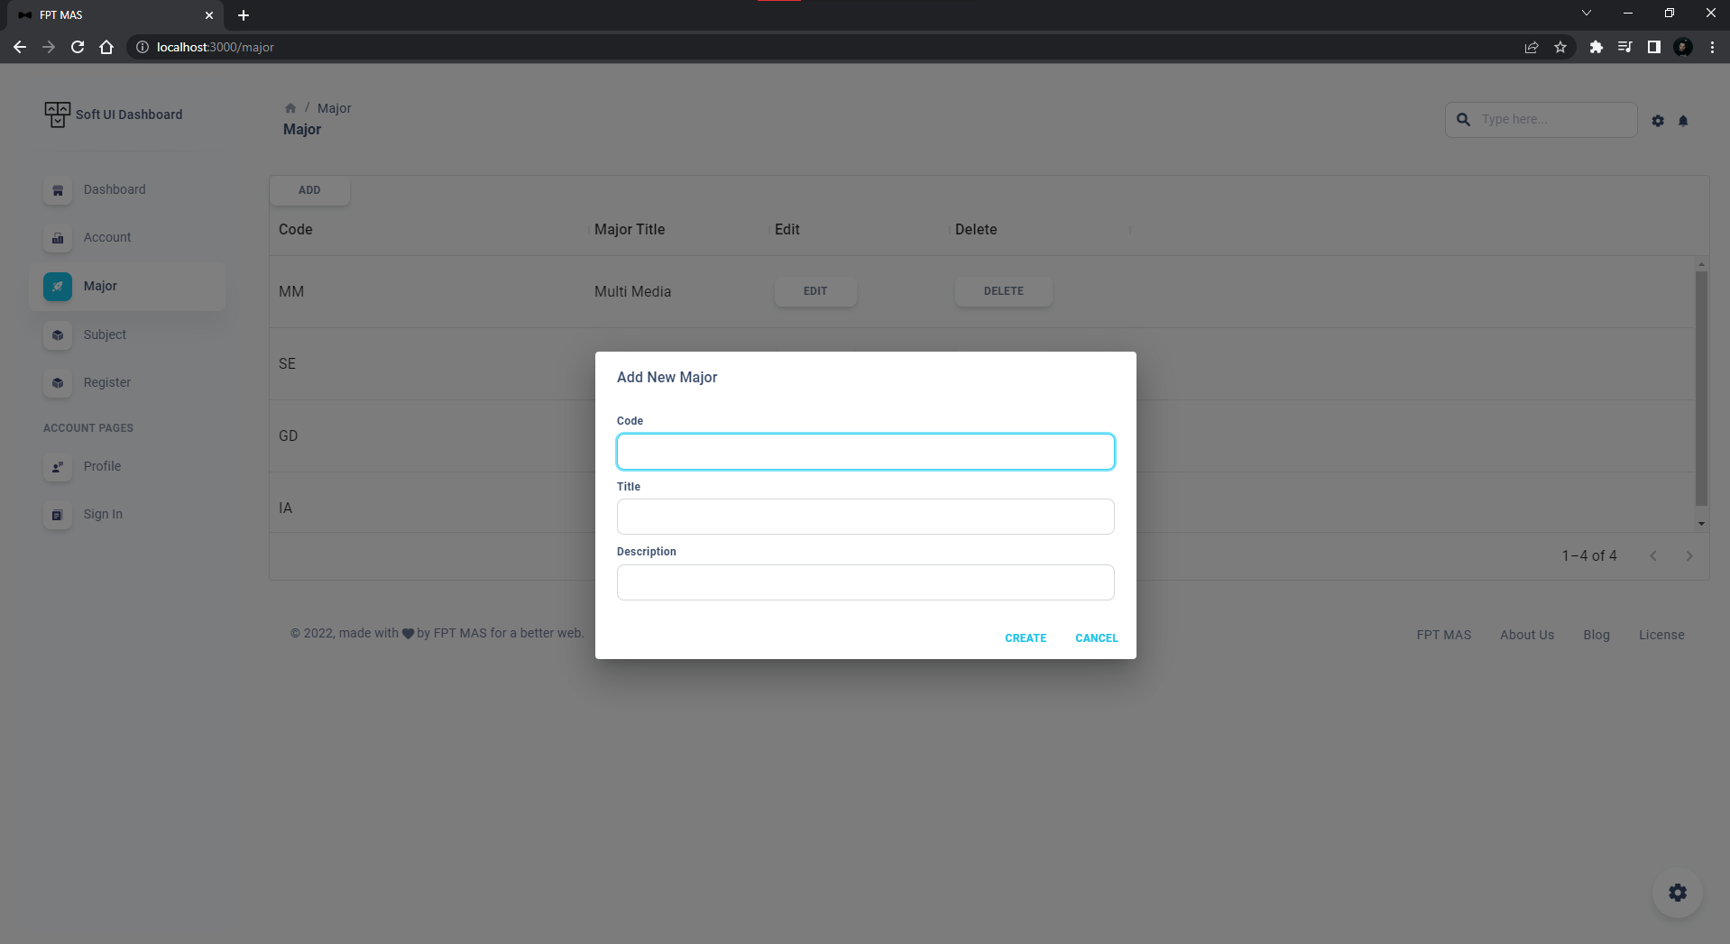

**● Function details:**

* User clicks plus icon on the Major screen
* Systems pops up a create new major dialog
* User enters below fields:
* Major title: the length from 5 to 10
* Major description: the length from 10 to 100
* User clicks “Create” button
* Systems saves the new major and close the pops up

### c. Update a major

**● Function trigger:** Admin clicks “Update” on the major detail dialog.

**● Function description:** Admin requests update major for the application

**● Screen layout:**

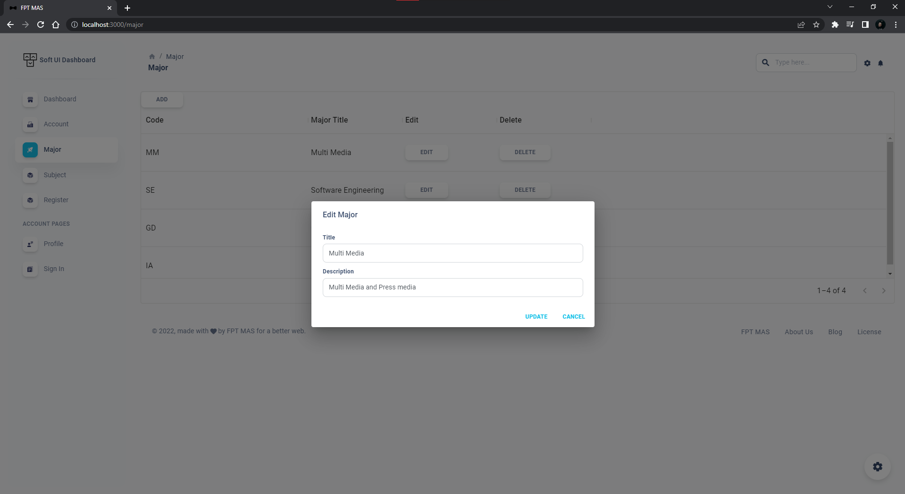

**● Function details:**

* User clicks on a specific update button on a major table.
* Systems pops up a major details dialog
* User updates below fields:
* Major title: the length from 5 to 10
* Major description: the length from 10 to 100
* User clicks “Update”
* Systems saves the new update major and close the pops up.

### d. Delete a major

**● Function trigger:** Admin clicks “Dong y” on the confirm delete dialog

**● Function description:** Admin requests delete a major for the application

**● Screen layout:**

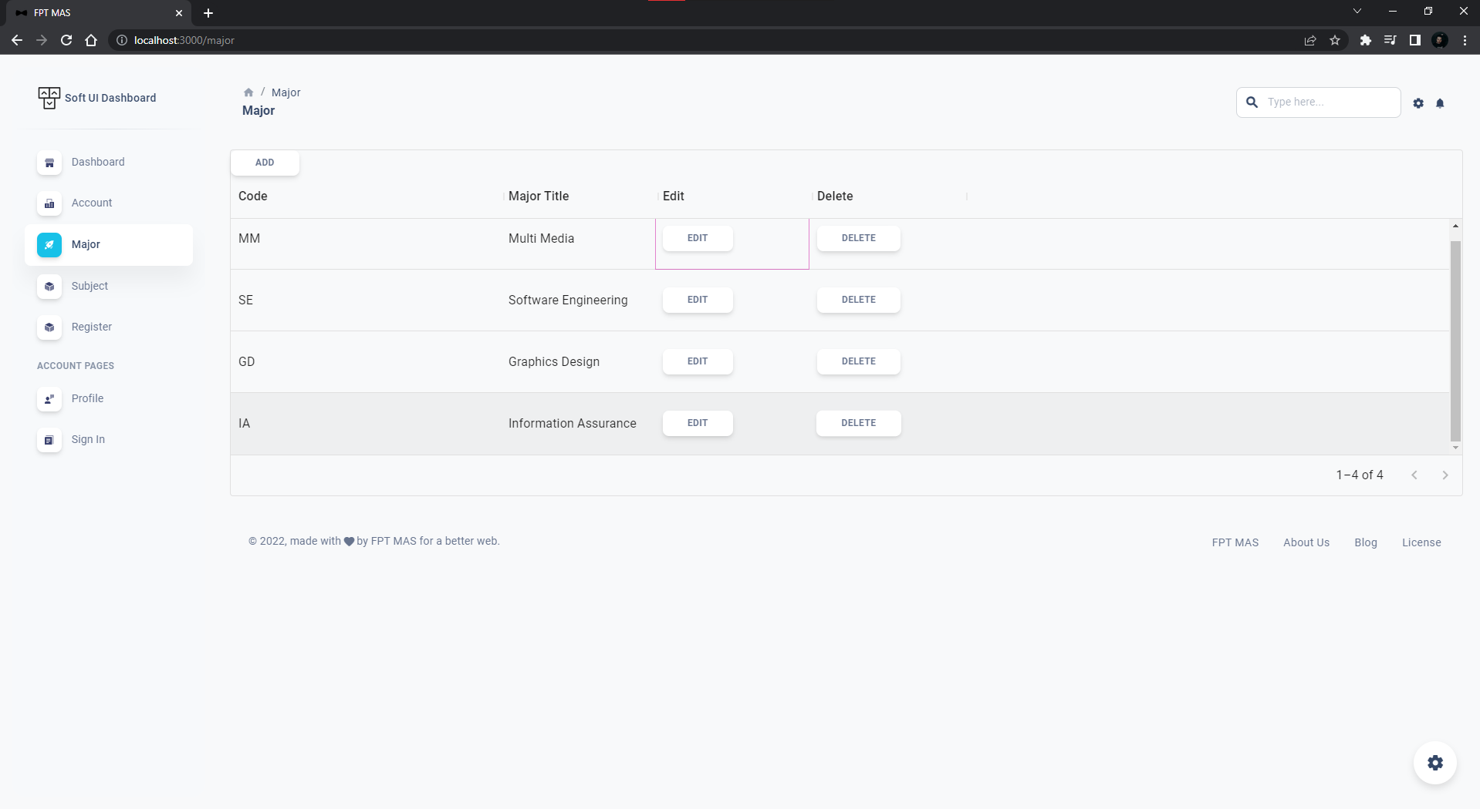

**● Function details:**

* User clicks on a specific delete button on a major table
* Systems pops up a confirm delete dialog
* User clicks “Delete” to delete a major or clicks “Cancel” to not to delete.
* Systems changes the major status isActive to “false”.
* Systems reloads the major table.

## 3. Manage subjects.

### a. View all subject

**● Function trigger:** Admin clicks “Subjects” on the left menu bar.

**● Function description:** Admin request view all Subjects.

**● Screen layout:**

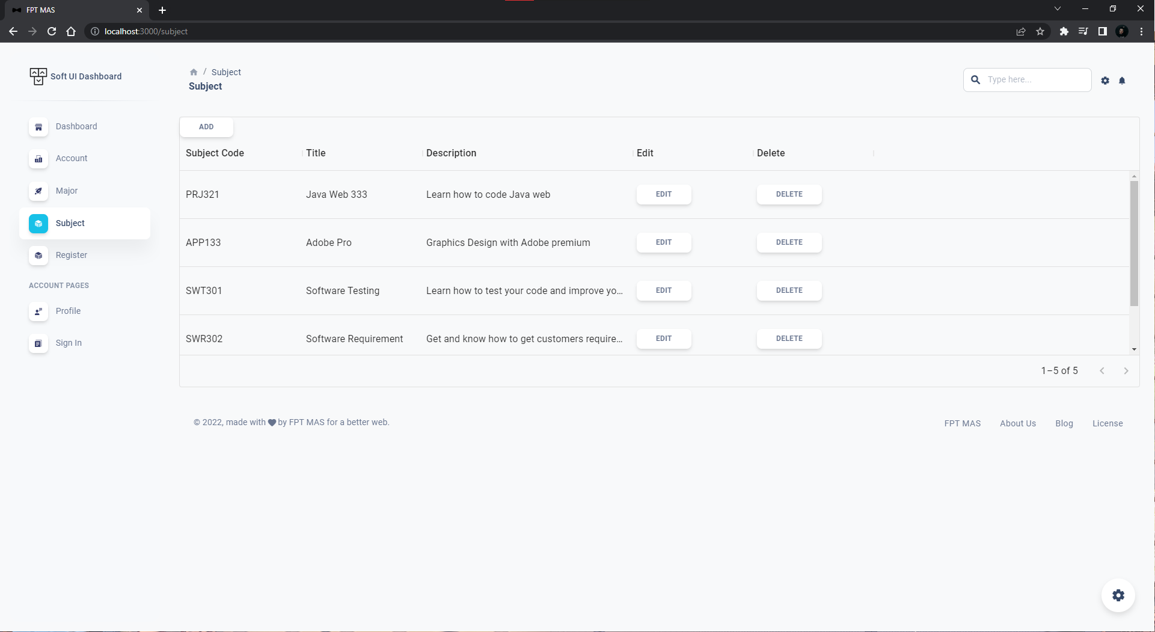

**● Function details:**

* System displays subjects

### b. Create an new subject

**● Function trigger:** Admin clicks “Create” on the Create subject dialog.

**● Function description:** Admin request create a new subject for the application

**● Screen layout:**

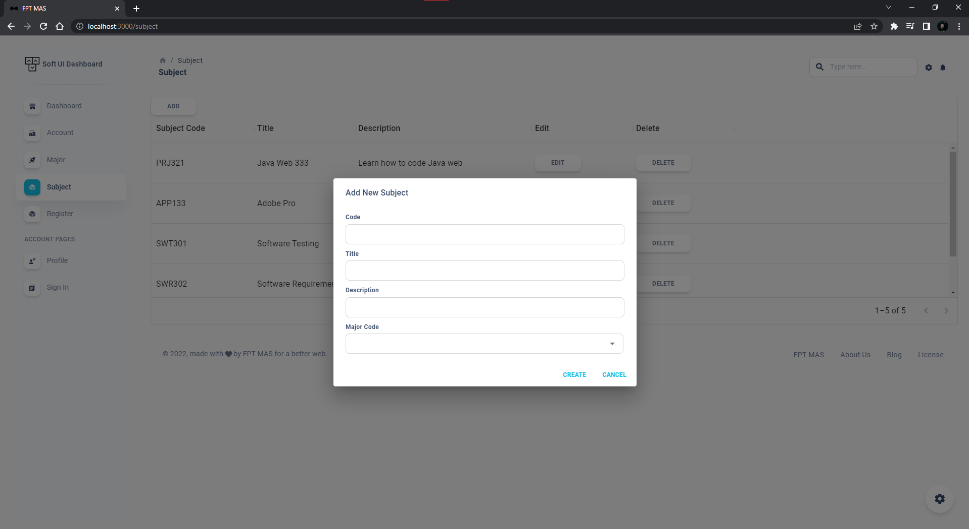

**● Function details:**

* User clicks plus icon on the subject screen
* Systems pops up a create new subject dialog
* User enters below fields:
* Subject title: the length from 5 to 10
* Subject description: the length from 10 to 100
* Subject major: not null.
* User clicks “Tao moi”
* Systems saves the new subject and close the pops up

### c. Update a subject

**● Function trigger:** Admin clicks “Update” on the subject detail dialog.

**● Function description:** Admin requests update subject for the application

**● Screen layout:**

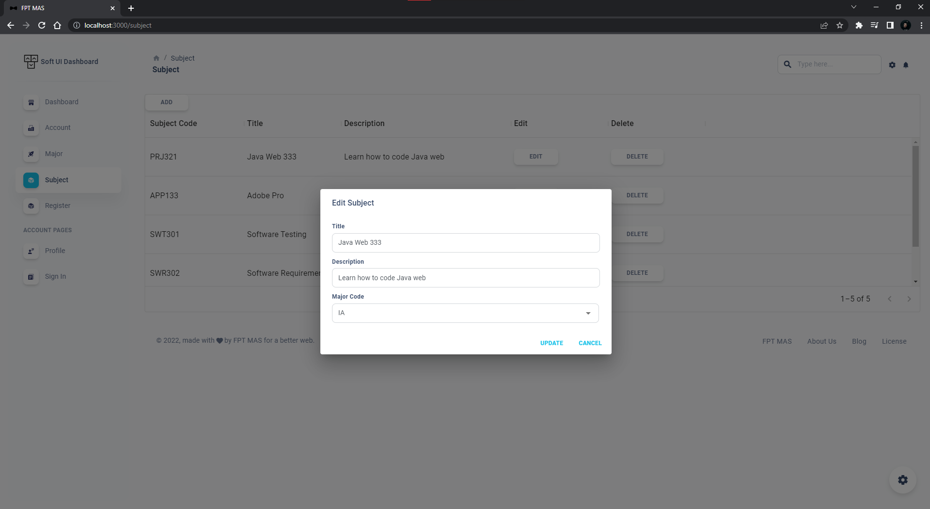

**● Function details:**

* User clicks on a specific update button on a subject table.
* Systems pops up a subject details dialog
* User updates below fields:
* Subject title: the length from 5 to 10
* Subject description: the length from 10 to 100
* Subject major: not null
* User clicks “Update”
* Systems saves the new update subject and closes the pops up.

### d. Delete a subject

**● Function trigger:** Admin clicks “Delete” on the confirm delete dialog

**● Function description:** Admin requests delete a subject for the application

**● Screen layout:**

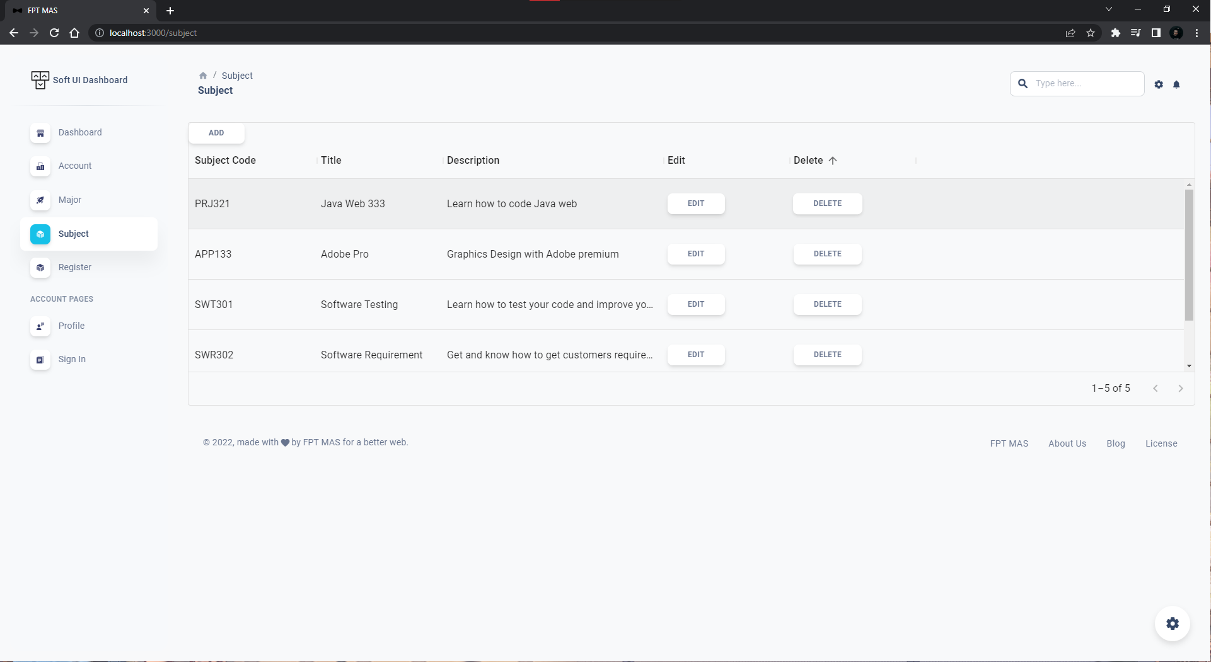

**● Function details:**

* User clicks on a specific delete button on a subject table
* Systems pops up a confirm delete dialog
* User clicks “Delete” to delete a subject or clicks “Cancel” to not to delete.
* Systems changes the subject status isActive to “false”.
* Systems reloads the subject table.

## 4. Manage accounts.

### a. View all accounts

**● Function trigger:** Admin clicks “Account” on the left menu bar.

**● Function description:** Admin request view all Account.

**● Screen layout:**

**● Function details:**

* System displays Accounts

### b. Disable an account

**● Function trigger:** Admin clicks on a specific disable button on the account table.

**● Function description:** Admin request to disable an account

**● Screen layout:**

**● Function details:**

* User clicks on a specific disable button on the account table
* System pops up a disable confirm dialog
* User clicks “Disable” to disable an account or clicks “Cancel” to not to disable an account
* Systems saves the isActive status of the disable account to false.

## 5. Manage register requests.

### a. View all requests

**● Function trigger:** Admin clicks “Register” on the left menu bar.

**● Function description:** Admin request view all register requests.

**● Screen layout:**

**● Function details:**

* System displays all register requests

### b. View register requests detail

**● Function trigger:** Admin clicks on a specific request on the register request table.

**● Function description:** Admin request to view register request details

**● Screen layout:**

**● Function details:**

* User clicks on a specific requests on register request table
* System pops up a request detail dialog

### c. Accept register requests

**● Function trigger:** Admin clicks Accept button

**● Function description:** Admin request to accept register request.

**● Screen layout:**

**● Function details:**

* User clicks on a specific requests on register request table
* System pops up a request detail dialog
* User clicks Accept button
* System saves the register request owner isMentor status to “True”
* System saves the register request status to “Accepted”

### d. Decline register requests

**● Function trigger:** Admin clicks Decline button

**● Function description:** Admin request to decline register request.

**● Screen layout:**

**● Function details:**

* User clicks on a specific requests on register request table
* System pops up a request detail dialog
* User clicks Decline button
* System saves the register request status to Decline

2. User web application

## 1. Login

### a. Login

**● Function trigger:** Unauthenticated User request login into system by clicks on “Login” button

**● Function description:** Unauthenticated User login to system to verify role, give them

access to more features in the system

**● Screen layout:**

**● Function details:**

* User enters 2 fields:
* Username: Email format
* Password: include at least a number, an uppercase letter and a special character
* User clicks “Dang Nhap” button”
* System generates a token and user account will keep the token to enter the user web application

### b. Logout

**● Function trigger:** User request to logout the user web application

**● Function description:** User logouts the system

**● Screen layout:**

**● Function details:**

* User clicks “Logout” button on the menu bar
* Systems removes the token from local storage and redirects to the login screen.

## 2. Register

**● Function trigger:** Unauthenticated User clicks “Register” button on Register screen

**● Function description:** Unauthenticated User request to register a new account to MAS user web application

**● Screen layout:**

**● Function details:**

* User enters below fields:
* Username: Email format
* Password: include at least a number, an uppercase letter and a special character
* Confirm password: exactly the same as password
* User clicks “Register” button”
* System saves a new account to database and redirect to login screen

## 3. Forgot password

**● Function trigger:** Unauthenticated User clicks “Change password” button on Change password screen

**● Function description:** Unauthenticated User request to change account password

**● Screen layout:**

**● Function details:**

* User enters below fields:
* Username: Email format
* Password: include at least a number, an uppercase letter and a special character
* Confirm password: exactly the same as password
* User clicks “Register” button”
* System saves a new account to database and redirect to login screen

## 4. View own profile

**● Function trigger:** User clicks “Profile” on menu bar

**● Function description:** User requests to view own profile

**● Screen layout:**

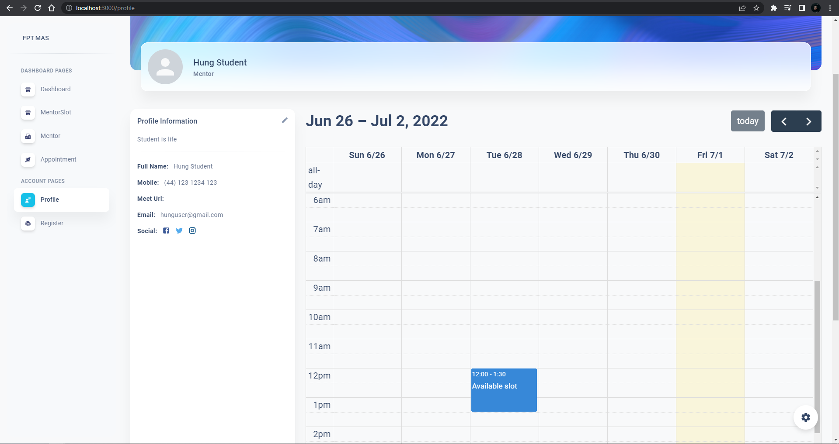

**● Function details:**

* System displays user profile details with calendar belows value:
* name
* meet url
* email
* Slots

## 5. View and Search mentor

**● Function trigger:** User clicks “mentor” on menu bar

**● Function description:** User requests to search mentor

**● Screen layout:**

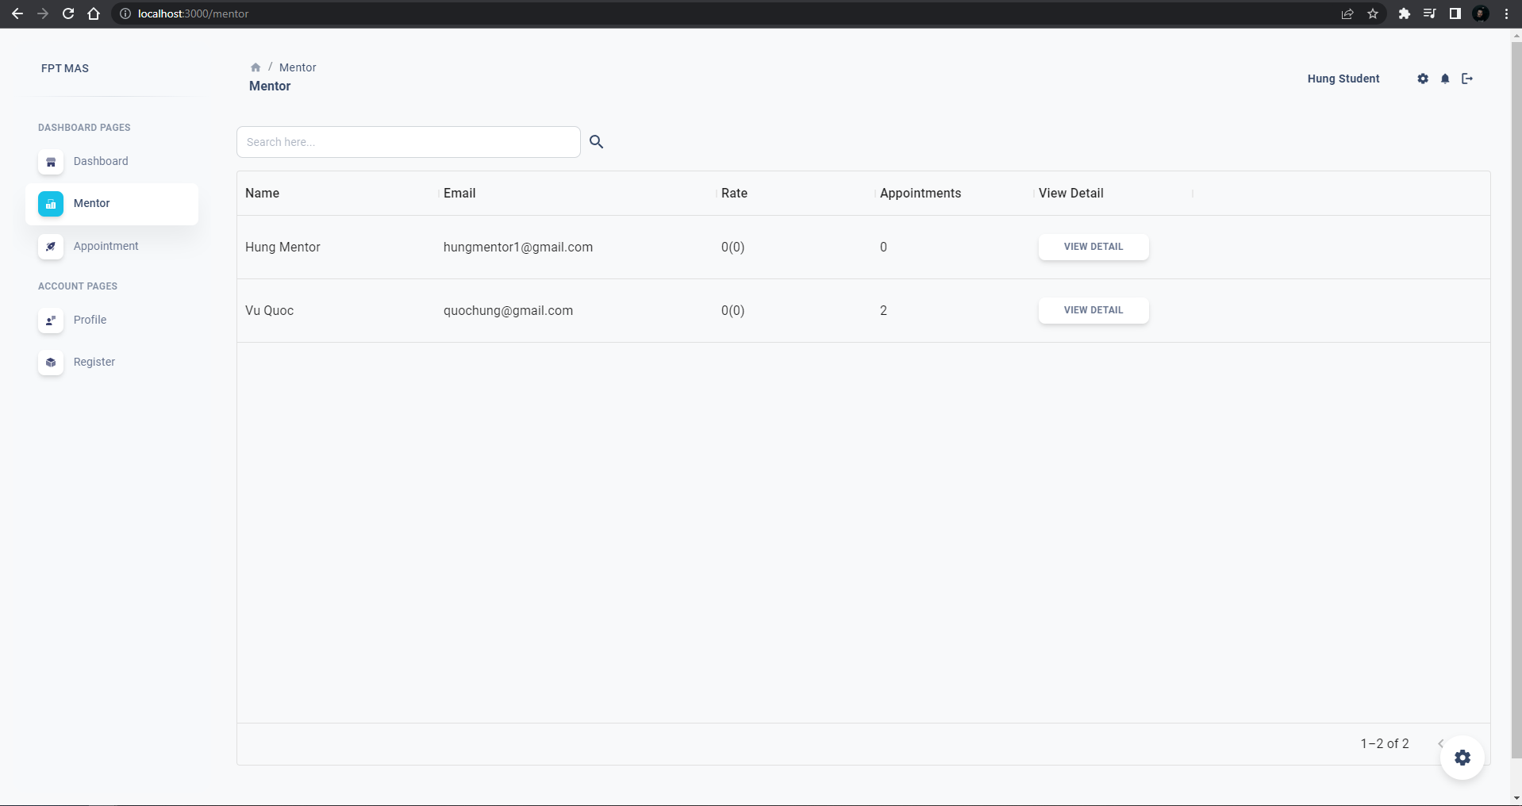

**● Function details:**

* User enters mentor name and press the search icon
* System displays mentor list

## 6. View mentor details

**● Function trigger:** User clicks a view detail on a specific mentor

**● Function description:** User requests to view detail

**● Screen layout:**

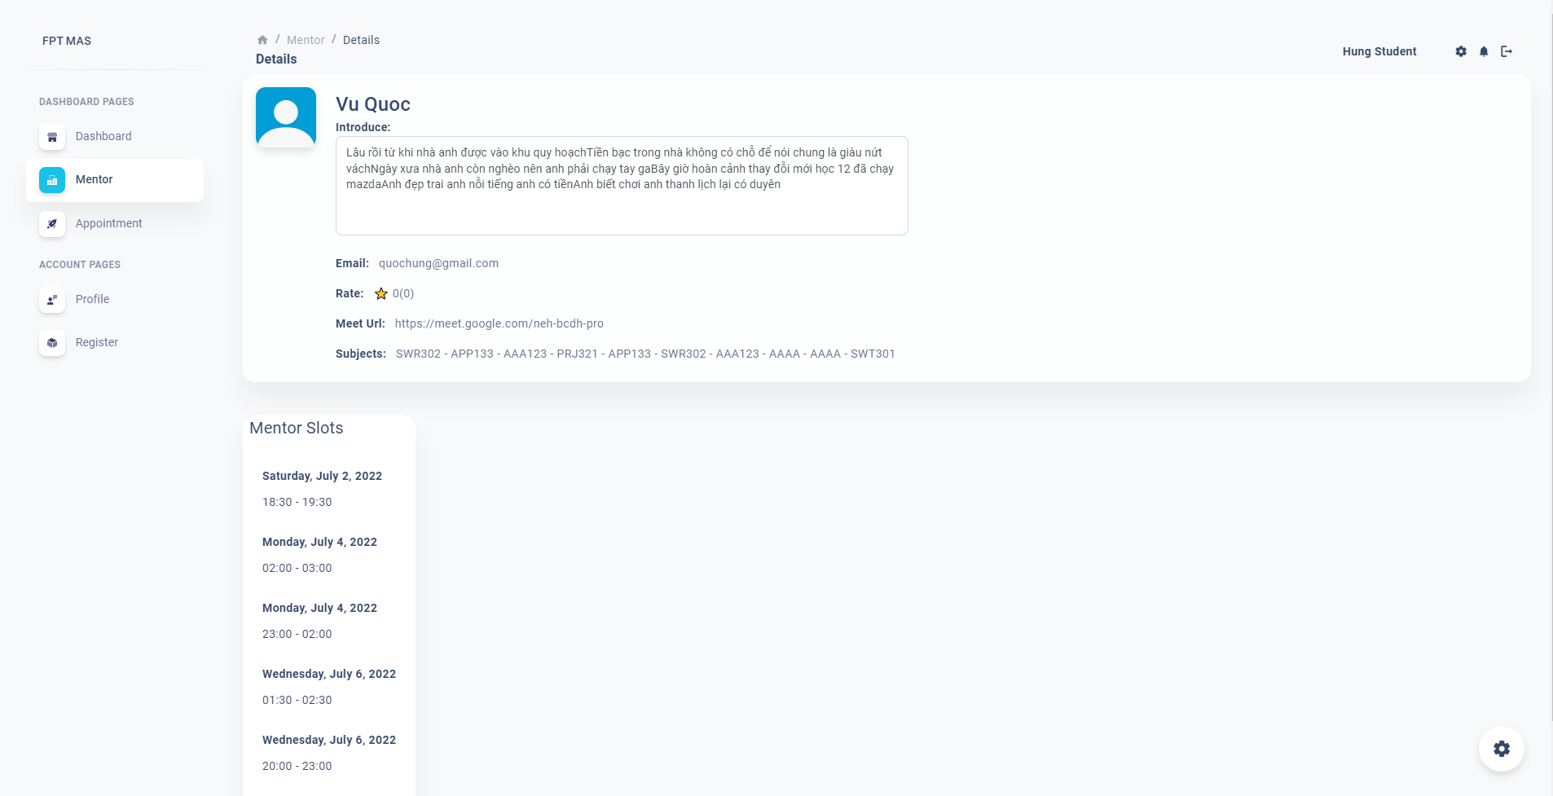

**● Function details:**

* System displays below fields:
* Name
* Introduce
* Rating
* Meet url
* Mentor Subjects
* Slots

## 7. View slot details

**● Function trigger:** User clicks a specific mentor slot

**● Function description:** User requests to view slot detail

**● Screen layout:**

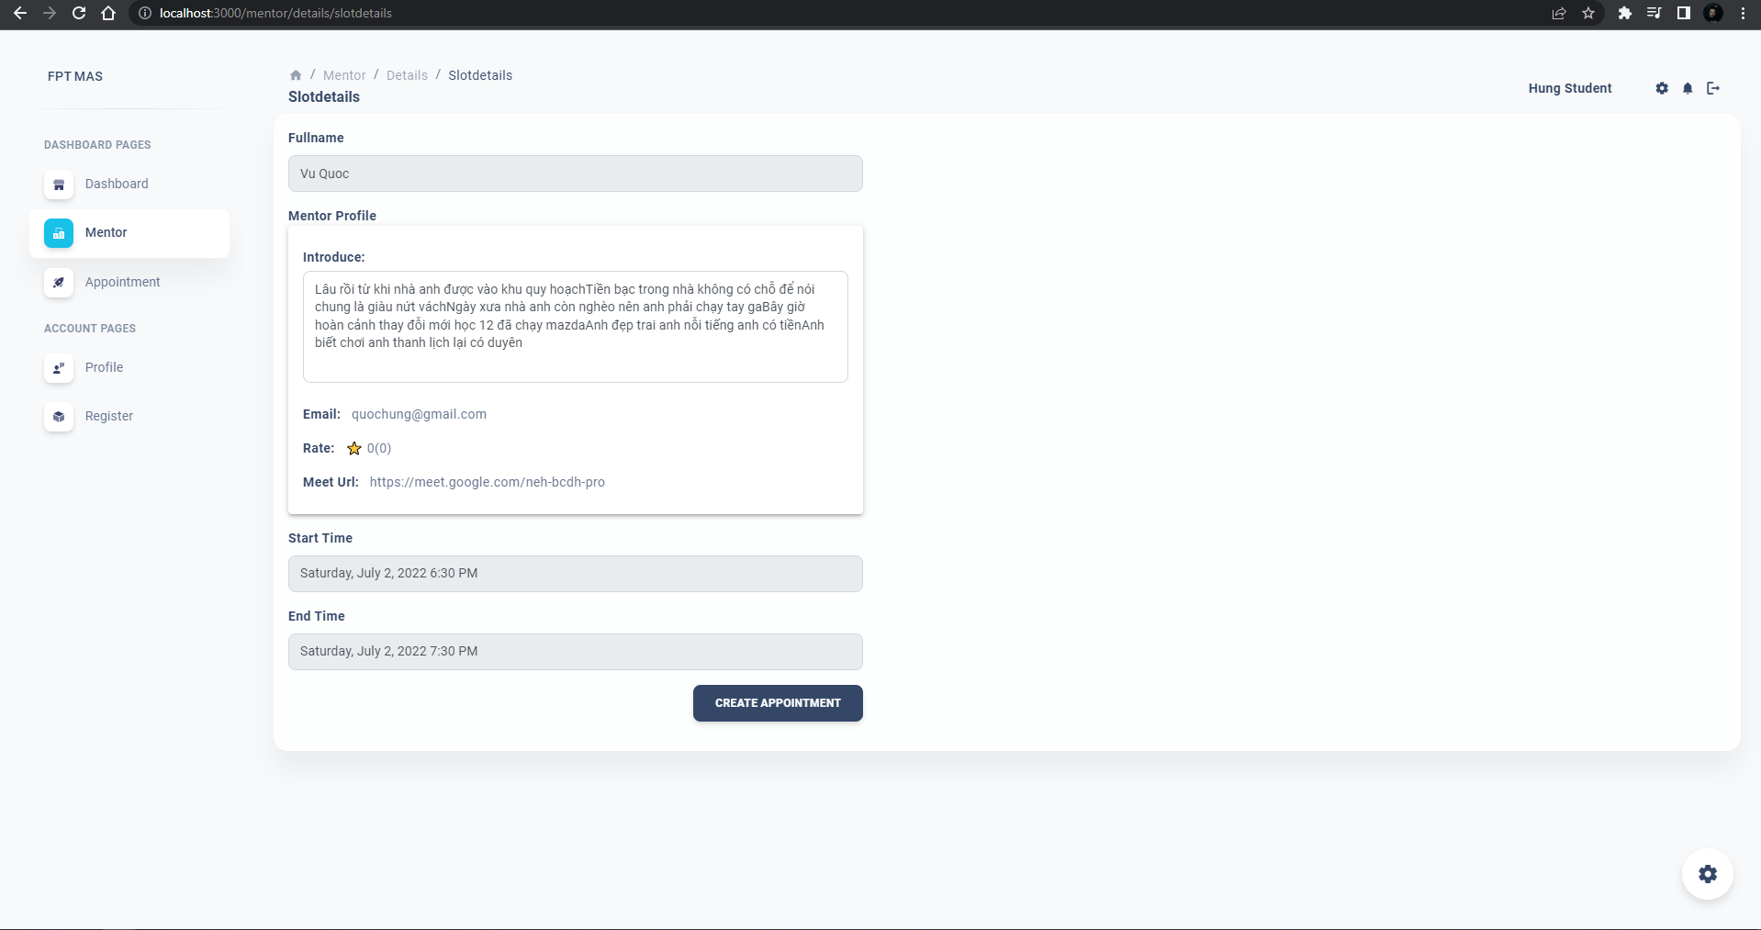

**● Function details:**

* System displays below fields:
* Mentor name
* Introduce
* Rating
* Meet url
* Start time
* End time

## 8. Create appointment

**● Function trigger:** User clicks a create appointment button

**● Function description:** User requests to create appointment

**● Screen layout:**

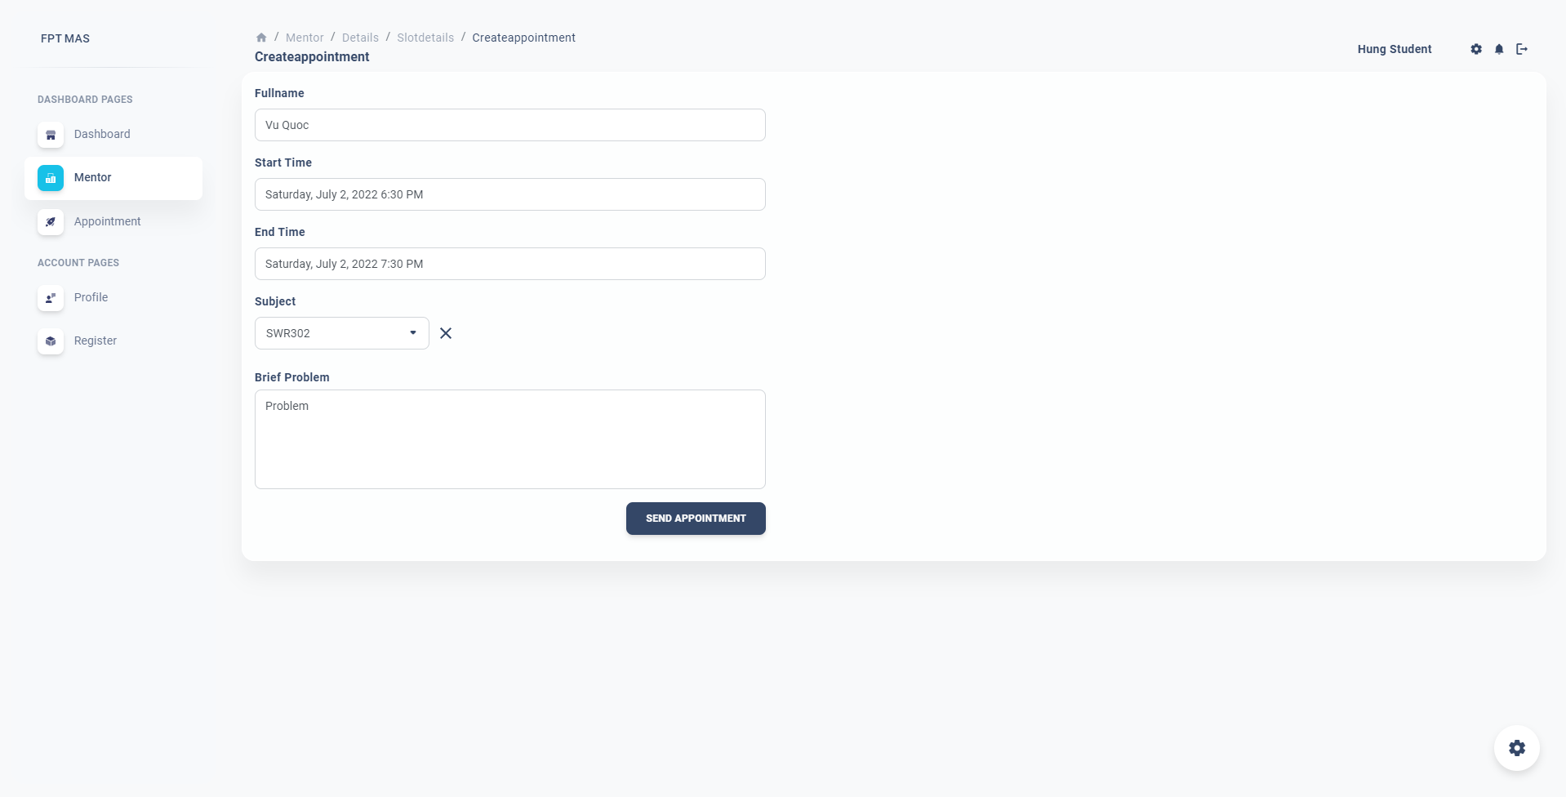

**● Function details:**

* System displays below fields:
* Mentor name
* Start time
* End time
* User enters below fields:
* Subject to mentor
* Brief problem

## 9. Send appointment

**● Function trigger:** User clicks a send appointment button

**● Function description:** User requests to send appointment

**● Screen layout:**



**● Function details:**

* System saves appointment status is “Not approved yet”
* System redirects to Appointment screen

## 10. View send appointment list

**● Function trigger:** User clicks appointment on menu bar

**● Function description:** User requests to view send appointment

**● Screen layout:**

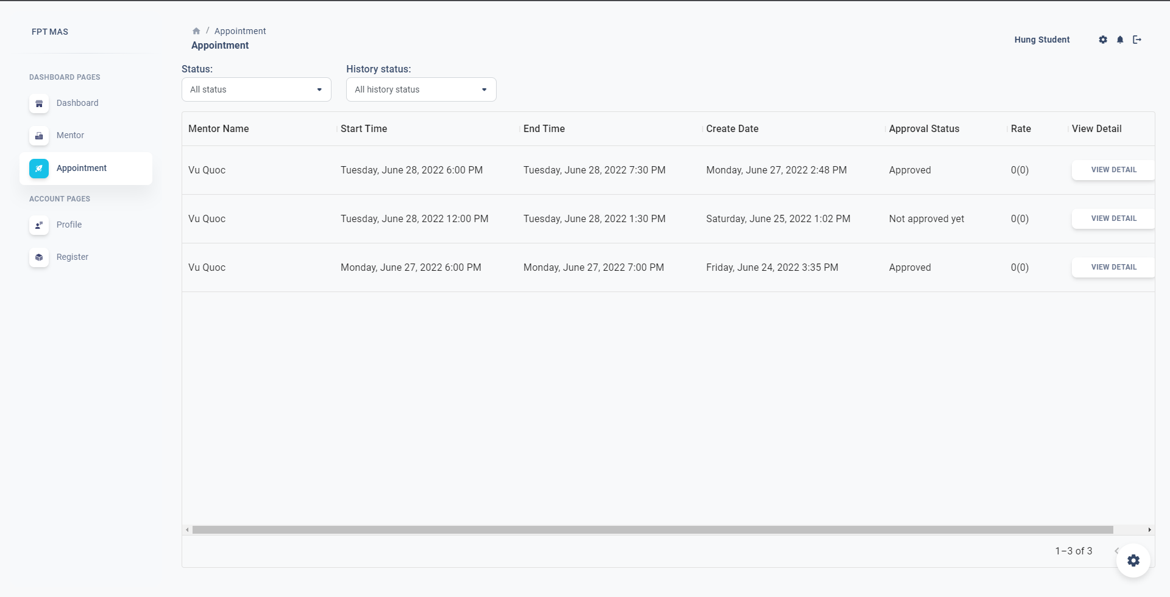

**● Function details:**

* System displays appointment list with status filter and status history filter

## 11. View appointment details

**● Function trigger:** User clicks on a specific appointment

**● Function description:** User requests to view send appointment details

**● Screen layout:**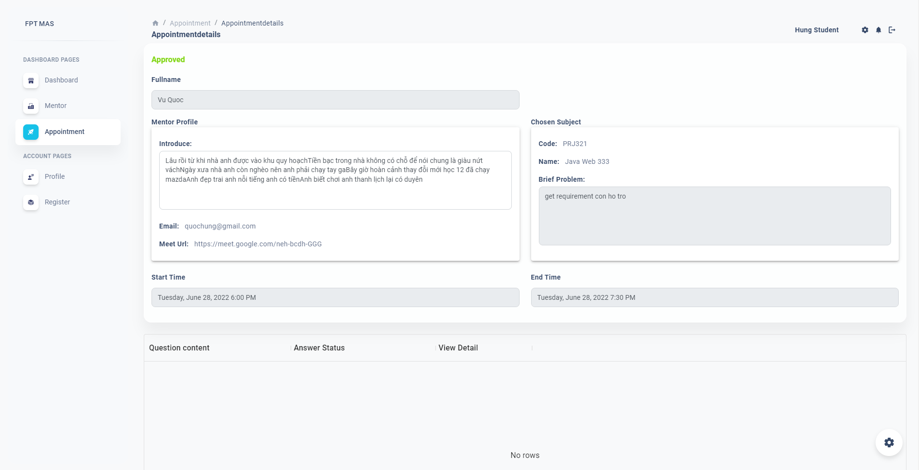

**● Function details:**

* System displays appointment details information

## 12. View appointment request list

**● Function trigger:** User(mentor) clicks request on menu bar

**● Function description:** User requests to view appointment requests

**● Screen layout:**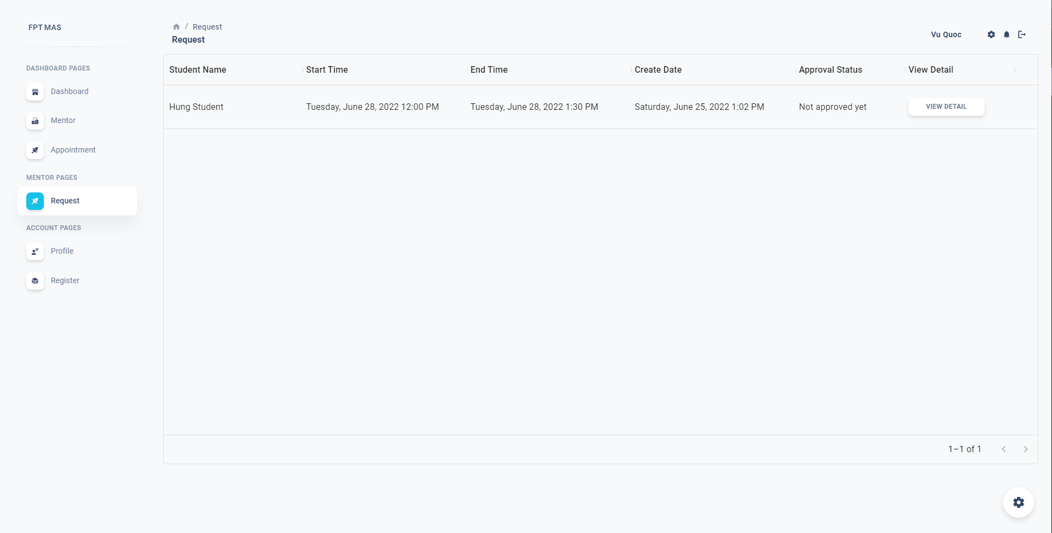

**● Function details:**

* System displays received appointment request

## 13. View appointment request details

**● Function trigger:** User(mentor) clicks a specific details on list

**● Function description:** User requests to view appointment requests details

**● Screen layout:**

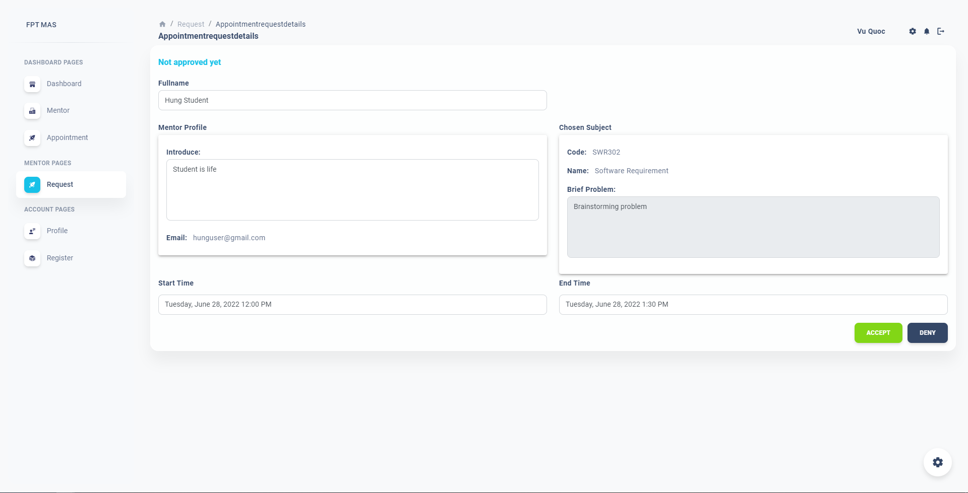

**● Function details:**

* System displays received appointment request details

## 14. Accept appointment request

**● Function trigger:** User(mentor) clicks Accept button

**● Function description:** User requests to accept appointment requests

**● Screen layout:**



**● Function details:**

* System displays received appointment request details
* User clicks accept button
* System saves appointment status to Approved
* System redirects to dashboard

## 15. Deny appointment request

**● Function trigger:** User(mentor) clicks Deny button

**● Function description:** User requests to deny appointment requests

**● Screen layout:**



**● Function details:**

* System displays received appointment request details
* User clicks deny button
* System saves appointment status to Denied
* System redirects to dashboard

## 16. Add question

**● Function trigger:** User clicks Create button

**● Function description:** User requests to create a new question

**● Screen layout:**

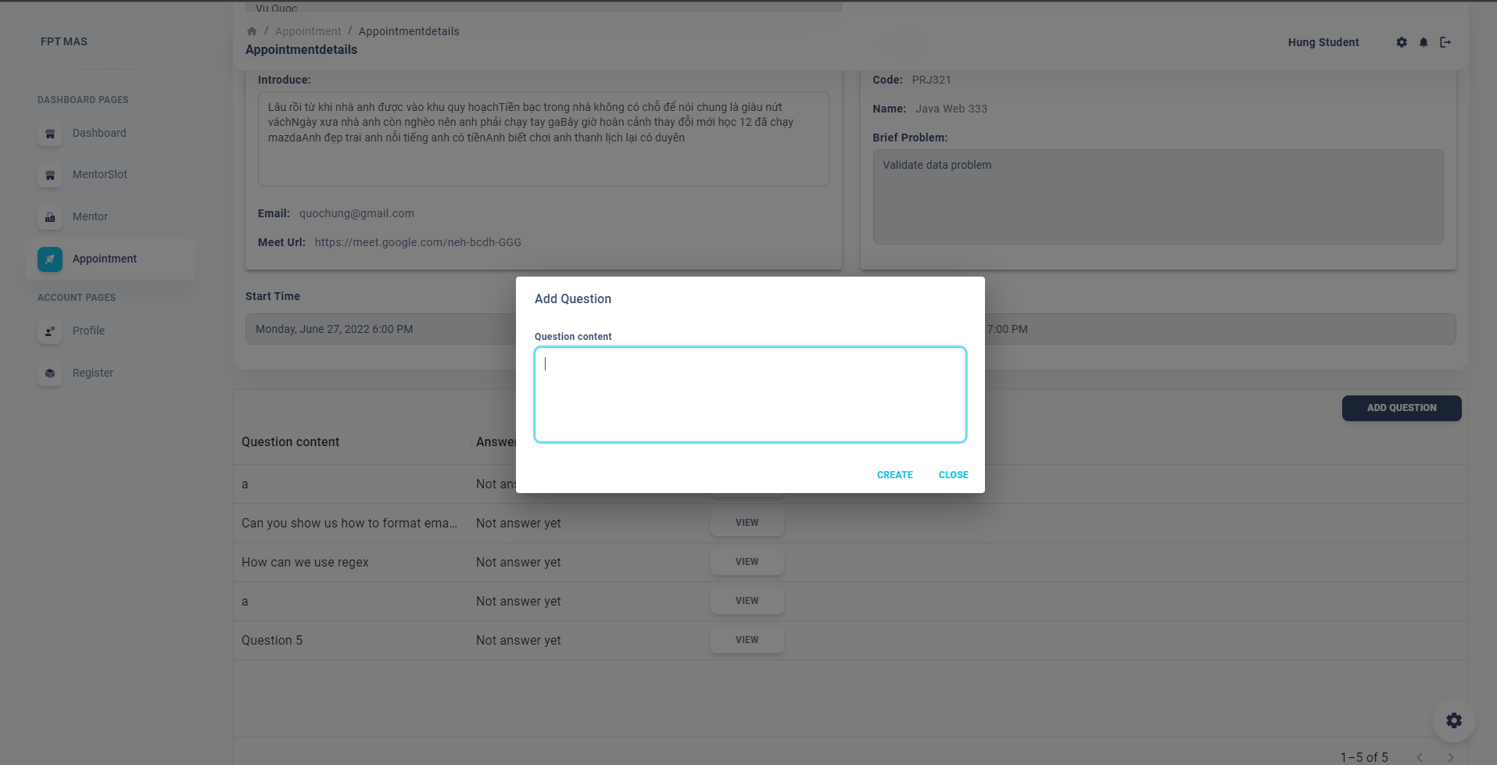

**● Function details:**

* User enters question content
* User clicks Create button
* System saves question with status not answer yet

## 17. View question

**● Function trigger:** User clicks View button

**● Function description:** User requests to view question details

**● Screen layout:**

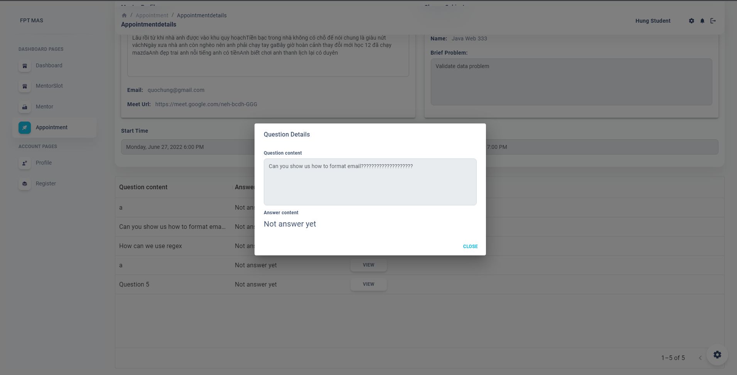

**● Function details:**

* System display question details.

## 18. Answer question

**● Function trigger:** Mentor(user) clicks Save button

**● Function description:** User requests to answer question

**● Screen layout:**

**● Function details:**

* System display question details.
* User enter answer content
* User clicks Save button
* System saves question with answer and change status to answered