

**CLINIC MANAGEMENT SYSTEMS**

**Software Design Document**

– Hanoi, March 2022 –

**Table of Contents**

I. Overview 3

1. Code Packages/Namespaces 3

II. Code Designs 4

1. User Management 4

a. Class Diagram 4

b. Class Specifications 4

UserController 4

UserServiceImpl 4

UserDAOImpl 5

c. Sequence Diagram(s) 5

d. Database queries 7

2. Health news management 8

a. Class Diagram 8

b. Class Specifications 8

HealthNewController 8

HealthNewServiceImpl 8

HealthNewDAOImpl 9

c. Sequence Diagram(s) 9

3. Appointment management 11

a. Class Diagram 11

b. Class Specifications 11

MedicalScheduleController 11

MedicalScheduleServiceImpl 11

MedicalScheduleDAOImpl 12

c. Sequece Diagram(s) 13

III. Database Design 14

1. Database Schema 14

2. Table Description 15

# I. Overview

## 1. Code Packages/Namespaces

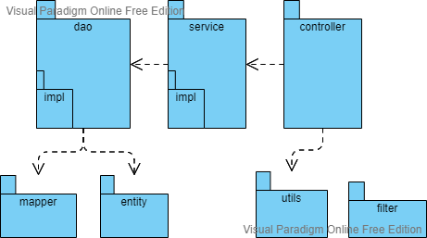

***Package descriptions & package class naming conventions***

|  |  |  |
| --- | --- | --- |
| **No** | **Package** | **Description** |
| *1* | *Controller* | *Handle request from client* |
| *2* | *service* | *Contain business logic* |
| *3* | *dao* | *Data access object* |
| *4* | *entity* | *model of entity* |
| *5* | *mapper* | *mapping entity’ attribute with field columns in database* |
| *6* | *utils* | *has utilities function* |
| *7* | *filter* | *web filter* |

# II. Code Designs

## 1. User Management

### a. Class Diagram

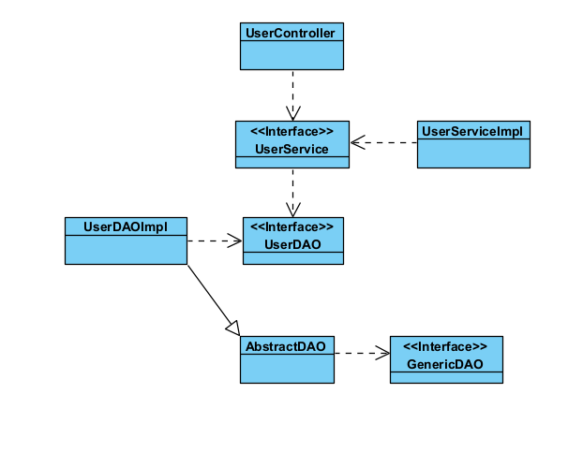

### b. Class Specifications

#### UserController

|  |  |  |
| --- | --- | --- |
| **No** | **Method** | **Description** |
| 1 | doGet() | handle request from client with method GET |
| 2 | doPost | handle request from client with method POST |

#### UserServiceImpl

|  |  |  |
| --- | --- | --- |
| **No** | **Method** | **Description** |
| 1 | signIn(userName, password) | Sign in to the system |
| 2 | changePassword(userId, oldPassword, newPassword) | Update user password |
| 3 | updateInfo(userApp) | Update user information |
| 4 | signUp(userApp) | Create new account to the system |
| 5 | getUserInfoFromRequest | Return user information from request |
| 6 | findById(); | Get user information by id |
| 7 | getUserMember(type) | Get user by role |

#### UserDAOImpl

|  |  |  |
| --- | --- | --- |
| **No** | **Method** | **Description** |
| 1 | findByNameAndPassword(userName, password) | Get user information by username and password |
| 2 | FindByUserName | Get user information by username |
| 3 | save(userApp) | Insert new user to database |
| 4 | update(userApp) | Update user information |
| 5 | findById(id) | Get user by id |
| 6 | findByRoleId(roleID) | Get user by role id |
| 7 | save(roleApp) | Insert new role to database |
| 8 | changePassword(id, password) | Update user password |
| 9 | getAllUserMember() | Get all user |
| 10 | findUserByRoleName(role) | Get all user by role name |

### c. Sequence Diagram(s)

Register:

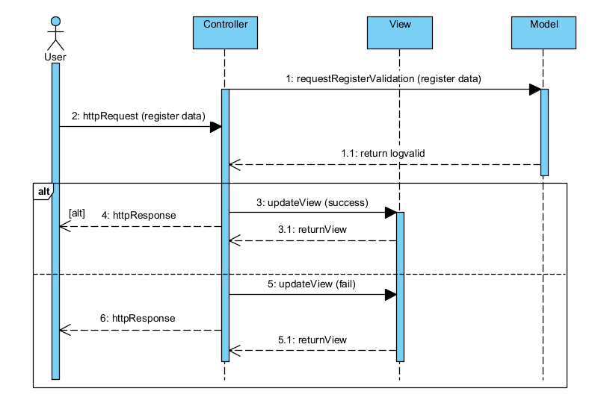

User profile:

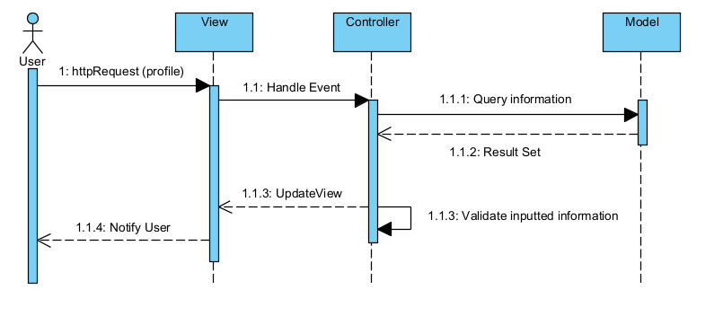

User list:

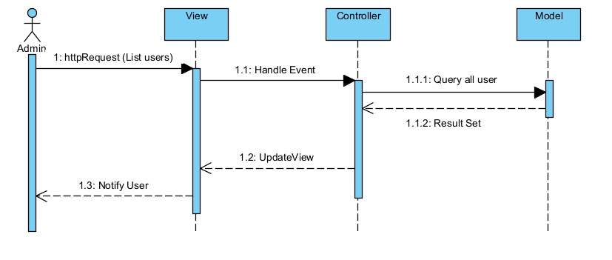

Filter user:

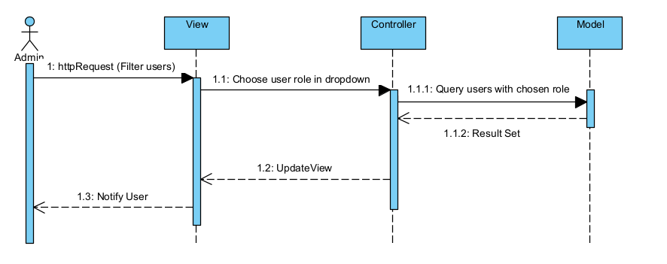

### d. Database queries

* *Find by username and password:* SELECT * FROM user u join role r ON u.role_id=r.id WHERE username =? AND password =?
* *Find by username:* SELECT * FROM user WHERE username =?
* *Save user:* INSERT INTO user (role_id, first_name, last_name, card_id, gender, dob, phone_number, avatar, email, username, password, status, created_stamp) VALUES (?, ?, ?, ?, ?, ?, ?, ?, ?, ?, ?, ?, ?)
* *Update user:* UPDATE user SET first_name=?, last_name=?, card_id=?, gender=?, dob=?, phone_number=?, email=?, avatar=?, modified_stamp=? WHERE id =?
* *Find by id:* SELECT * FROM user WHERE id= ?
* *Find by role id:* SELECT * FROM role WHERE id = ?
* *Find by role name:* SELECT * FROM role WHERE name = ?
* *Save role:* INSERT INTO role (name) VALUES (?)
* *Change password:* UPDATE user SET password = ? WHERE id =?
* *Get all user:* SELECT * FROM user u JOIN role r ON u.role_id=r.id and r.name != 'ADMIN'
* *Find user by role:* SELECT * FROM user u JOIN role r ON u.role_id=r.id and r.name = ?

## 2. Health news management

### a. Class Diagram

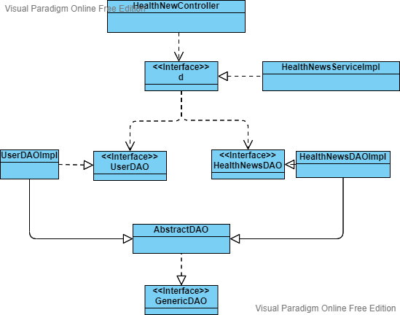

### b. Class Specifications

#### HealthNewController

|  |  |  |
| --- | --- | --- |
| **No** | **Method** | **Description** |
| 1 | doGet() | handle request from client with method GET |
| 2 | doPost | handle request from client with method POST |

#### HealthNewServiceImpl

|  |  |  |
| --- | --- | --- |
| **No** | **Method** | **Description** |
| 1 | save(HealthNews healthNews); | add new record |
| 2 | update(HealthNews healthNews); | update record |
| 3 | findById(Long id); | get record by id |
| 4 | delete(Long id); | delete record by id |
| 5 | buildData(HttpServletRequest request) | create an instance of HealthNew |
| 6 | findAll(); | get all record |
| 7 | findByCreatedId(Long createdId); | get data of user who create the new has {id} |
| 8 | findAll(Pageable pageable); | pagination |
| 9 | getTotalItem(); | get total record |

#### HealthNewDAOImpl

|  |  |  |
| --- | --- | --- |
| **No** | **Method** | **Description** |
| 1 | save(HealthNews healthNews); | add new record |
| 2 | update(HealthNews healthNews); | update record |
| 3 | findById(Long id); | get record by id |
| 4 | delete(Long id); | delete record by id |
| 5 | buildData(HttpServletRequest request) | create an instance of HealthNew |
| 6 | findAll(); | get all record |
| 7 | findAll(Pageable pageable); | pagination |
| 8 | getTotalItem(); | get total record |

### c. Sequence Diagram(s)

1. Add/ Update new Health news

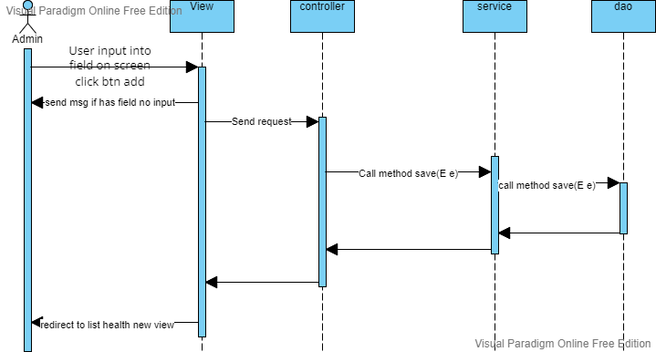

1. Delete Health news

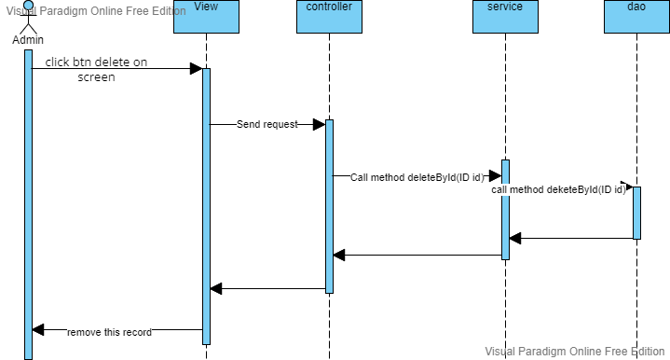

1. Get list health news

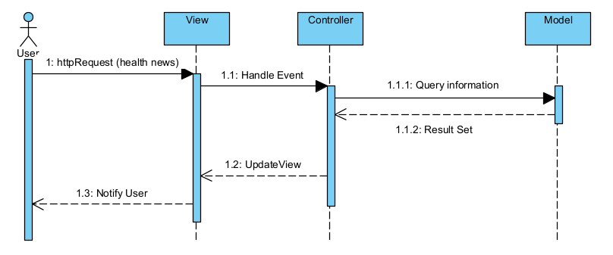

### **d. Database queries**

 "INSERT INTO health_news (created_id, title, thumbnail, short_description, content, created_stamp) VALUES (?, ?, ?, ?, ?, ?)"

"UPDATE health_news SET title=?, thumbnail = ?, short_description = ?, content= ?,modified_stamp=? WHERE id =?"

"SELECT * FROM health_news WHERE id= ?"

"DELETE FROM health_news WHERE id = ?";

"SELECT * FROM health_news";

"SELECT * FROM health_news WHERE created_id= ?";

SELECT * FROM health_news");

SELECT count(*) FROM health_news";

## 3. Appointment management

### a. Class Diagram

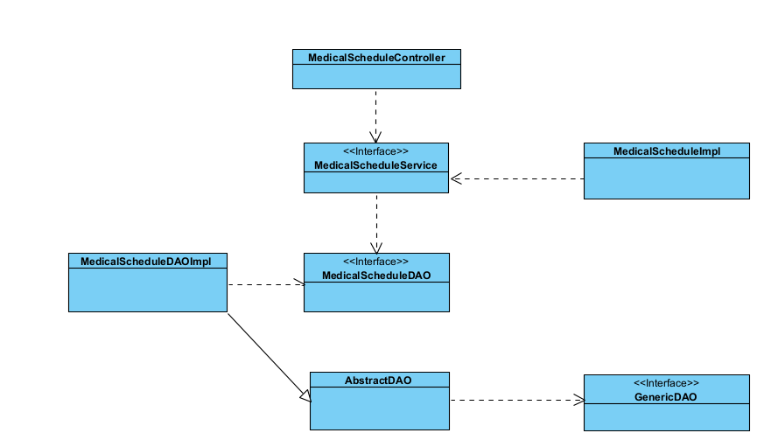

### b. Class Specifications

#### MedicalScheduleController

|  |  |  |
| --- | --- | --- |
| **No** | **Method** | **Description** |
| 1 | doGet() | handle request from client with method GET |
| 2 | doPost() | handle request from client with method POST |

#### MedicalScheduleServiceImpl

|  |  |  |
| --- | --- | --- |
| **No** | **Method** | **Description** |
| 1 | save(MedicalSchedule medicalSchedule); | add new record |
| 2 | update(MedicalSchedule medicalSchedule); | update record |
| 3 | findById(Long id); | get record by id |
| 4 | delete(Long id); | delete record by id |
| 5 | buildData(HttpServletRequest request) | create an instance of MedicalSchedule |
| 6 | findAll(); | get all record |
| 7 | findByCreatedId(Long createdId); | get data of user who create the new has {id} |
| 8 | updateStatus(); | update status of appointment |

#### MedicalScheduleDAOImpl

|  |  |  |
| --- | --- | --- |
| **No** | **Method** | **Description** |
| 1 | save(MedicalSchedule medicalSchedule); | add new record |
| 2 | update(MedicalSchedule medicalSchedule); | update record |
| 3 | findById(Long id); | get record by id |
| 4 | delete(Long id); | delete record by id |
| 5 | findAll(); | get all record |
| 6 | findByCreatedId(Long createdId); | get data of user who create the new has {id} |
| 7 | updateStatus(); | update status of appointment |

### c. Sequece Diagram(s)

1.Add/ Update Apointment:

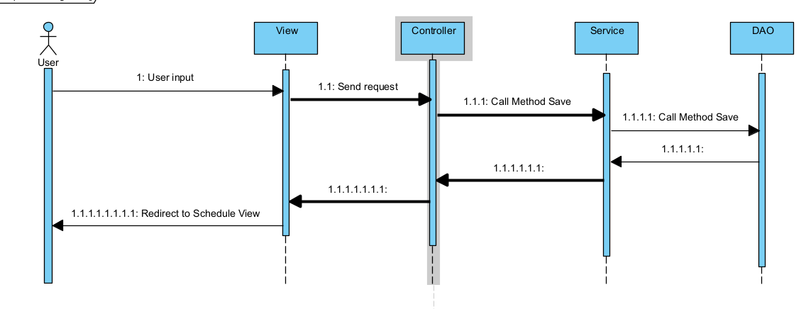

2.Delete Apointment:



### d. Database queries

* Create new schedule:INSERT INTO medical_schedule (created_id, description, schedule, type, status, created_stamp) " +"VALUES (?, ?, ?, ?, ?, ?)
* Update a schedule :UPDATE medical_schedule SET description=?, schedule=?, type=?, modified_stamp=? WHERE id =?
* Find schedule by id:SELECT * FROM medical_schedule WHERE id= ?
* Delete schedule:DELETE FROM medical_schedule WHERE id = ?
* Find schedule by createdId:SELECT * FROM medical_schedule WHERE created_id= ?
* Find all schedule:SELECT * FROM medical_schedule
* Update Status of schedule:UPDATE medical_schedule SET status = ? WHERE id = ?

# III. Database Design

## 1. Database Schema

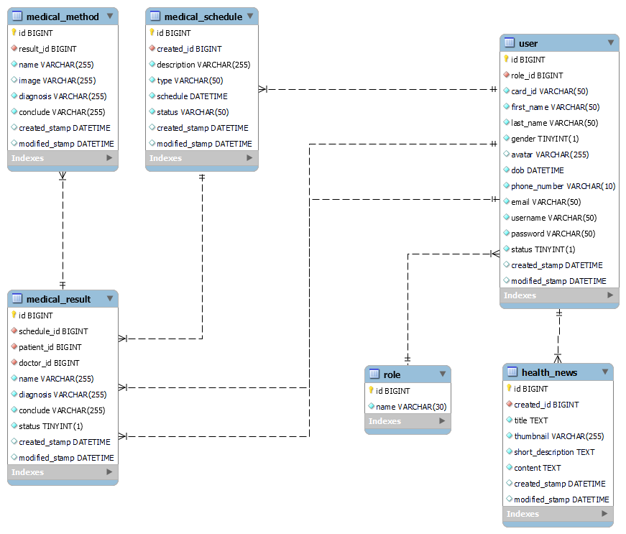

## 2. Table Description

|  |  |  |
| --- | --- | --- |
| **No** | **Table** | **Description** |
| 01 | User | Store information about all of user include admin, doctor, receptionist, patient  CREATE TABLE IF NOT EXISTS `user` (  `id` BIGINT NOT NULL PRIMARY KEY AUTO_INCREMENT,  `role_id` BIGINT NOT NULL,  `card_id` VARCHAR(50) NOT NULL,  `first_name` NVARCHAR(50) NOT NULL,  `last_name` NVARCHAR(50) NOT NULL,  `gender` BOOLEAN NOT NULL,  `avatar` NVARCHAR(255) NULL,  `dob` DATETIME NOT NULL,  `phone_number` VARCHAR(10) NOT NULL,  `email` VARCHAR(50) NOT NULL,  `username` VARCHAR(50) NOT NULL,  `password` VARCHAR(50) NOT NULL,  `status` BOOLEAN NOT NULL,  `created_stamp` DATETIME,  `modified_stamp` DATETIME  ); |
| 02 | Role | CREATE TABLE IF NOT EXISTS `role` (  `id` BIGINT NOT NULL PRIMARY KEY AUTO_INCREMENT,  `name` VARCHAR (30) NOT NULL  ); |
|  | Medical_schedule | CREATE TABLE IF NOT EXISTS `medical_schedule` (  `id` BIGINT NOT NULL PRIMARY KEY AUTO_INCREMENT,  `created_id` BIGINT NOT NULL,  `description` NVARCHAR(255) NOT NULL,  `type` VARCHAR(50) NOT NULL,  `schedule` DATETIME NOT NULL,  `status` VARCHAR(50) NOT NULL,  `created_stamp` DATETIME,  `modified_stamp` DATETIME  ); |
|  | Medical_result | CREATE TABLE IF NOT EXISTS `medical_result` (  `id` BIGINT NOT NULL PRIMARY KEY AUTO_INCREMENT,  `schedule_id` BIGINT NOT NULL,  `patient_id` BIGINT NOT NULL,  `doctor_id` BIGINT NOT NULL,  `name` NVARCHAR(255) NOT NULL,  `diagnosis` NVARCHAR(255) NOT NULL,  `conclude` NVARCHAR(255) NOT NULL,  `status` BOOLEAN NOT NULL,  `created_stamp` DATETIME,  `modified_stamp` DATETIME  ); |
|  | Medical_method | CREATE TABLE IF NOT EXISTS `medical_method` (  `id` BIGINT NOT NULL PRIMARY KEY AUTO_INCREMENT,  `result_id` BIGINT NOT NULL,  `name` NVARCHAR(255) NOT NULL,  `image` NVARCHAR(255) NULL,  `diagnosis` NVARCHAR(255) NOT NULL,  `conclude` NVARCHAR(255) NOT NULL,  `created_stamp` DATETIME,  `modified_stamp` DATETIME  ); |
|  | health_news | CREATE TABLE IF NOT EXISTS `health_news` (  `id` BIGINT NOT NULL PRIMARY KEY AUTO_INCREMENT,  `created_id` BIGINT NOT NULL,  `title` TEXT NOT NULL,  `thumbnail` NVARCHAR(255) NOT NULL,  `short_description` TEXT NOT NULL,  `content` TEXT NOT NULL,  `created_stamp` DATETIME,  `modified_stamp` DATETIME  ); |