

**CLINIC MANAGEMENT SYSTEMS**

**Software Requirement Specification**

– Hanoi, March 2022 –

**Table of Contents**

I. Overview 4

1. Introduction 4

2. System Functions 5

a. Screen Flow 5

b. Screen Details 7

c. User Authorization 7

d. Non-Screen Functions 8

II. Functional Requirements 9

1. Login 9

1.1 Screen Design 9

Table 3.1.1: Screen Definition 9

1.2 Use Case Specification 9

2. Register 10

2.2 Use Case Specification 11

3.1 Screen Design 11

3.2 Use Case Specification 12

4. User Profile 13

4.2 Use Case Specification 13

5. Home Page (health news) 14

5.2 Use Case Specification 14

6. List health news 14

6.2 Use Case Specification 15

7. List appointment: 16

7.1 Screen Design 16

7.2 Use Case Specification 16

8. Filter appointments: 17

8.1 Screen Design 17

8.2 Use Case Specification 17

9. Create new Health news 17

Table 3.1.1: Screen Definition 17

2.2 Use Case Specification 18

screen 18

10. Delete Health news 18

2.2 Use Case Specification 18

screen 19

11. Detail health news 19

2.2 Use Case Specification 19

screen 20

12. List all health news 21

screen 21

13. List all health news 21

14. List users 22

9.1. Screen Design 22

9.2 Use Case Specification 23

15. Filter users 23

10.2 Use Case Specification 24

16. Change appointment status 25

11.2 Use Case Specification 26

17. Change appointment status 27

12.1 Screen Design 27

12.2 Use Case Specification 27

# I. Overview

## 1. Introduction

This project is aimed at developing an online healthcare website for a hospital which supports for the customers tracking their own health and booking reservation for examination schedules. In addition, the medical centres manage their services supporting customers.

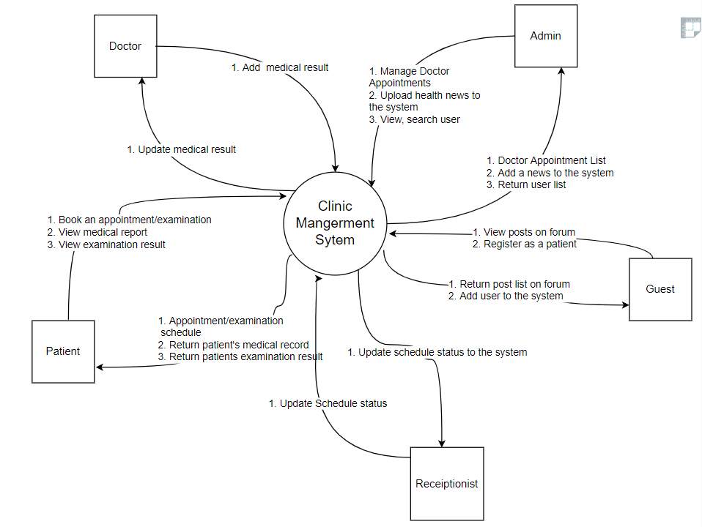

## 2. System Functions

### a. Screen Flow

* **Patient:**

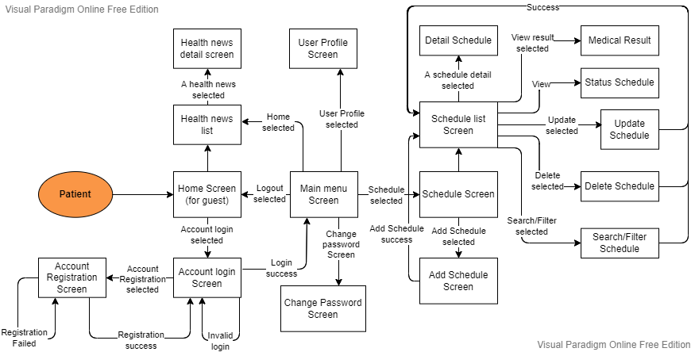

* **Doctor:**

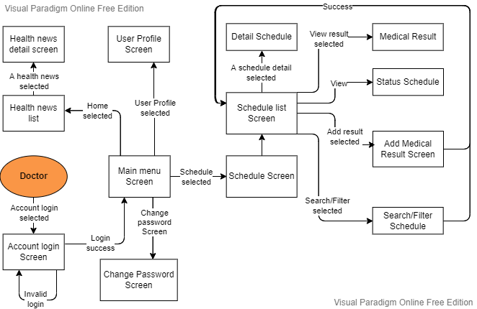

* **Reception:**

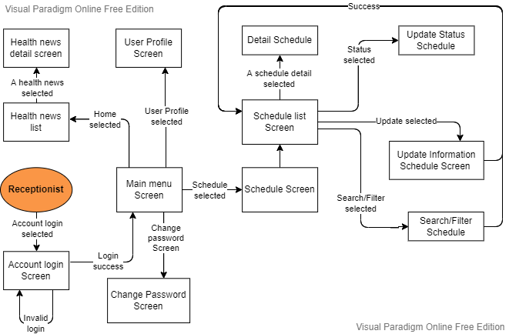

* **Admin:**

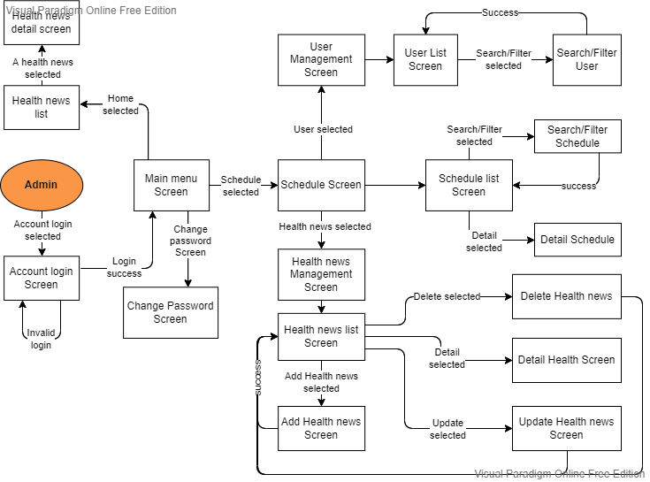

### b. Screen Details

|  |  |  |  |
| --- | --- | --- | --- |
| **#** | **Feature** | **Screen** | **Description** |
| 1 | Register | Register | Register an account to access the system |
| 2 | Login/logout | Login | Login/logout |
| 3 | Profile manage | Profile | Users manage and edit their own profiles |
| 4 | Create appointment | List Appointment | Users will create an appointment on the system. Appointment can be Health Care or Test Covid |
| 5 | Appointment process | List Appointment | Receptionist will consider the appointment and then update , approve or reject appointment |
| 6 | Add result | add result | Doctor add result for each appointment, include result of method |
| 7 | Home Page | Home | Display list news, information about medical |
| 8 | Manage appointment | List appointment | * patient : display all of appointment of each patient * Doctor: display all appointment has approve by receptionist * Receptionist : display all appointment |
| 9 | Manage health new | List health news | admin manage health news |

### c. User Authorization

|  |  |  |  |  |  |
| --- | --- | --- | --- | --- | --- |
| **Screen** | **Admin** | **Patient** | **Guest** | **Doctor** | **Receiptionis** |
| Home page | X | X | X | X | X |
| Register | X |  |  |  |  |
| Login | X | X | X | X | X |
| Change password | X | X | X | X | X |
| View Profile | X | X | X | X | X |
| Book an appointment |  | X |  |  |  |
| Cancel an appointment |  | X |  |  | X |
| Update appointment |  |  |  |  | X |
| Search patient | X |  |  |  |  |
| Medical examination |  |  |  | X |  |
| Book Covid test |  | X |  |  |  |
| View medical report book |  | X |  | X |  |
| Book Vaccination |  | X |  |  |  |
| View patient list | X |  |  |  |  |
| Upload news to system homepage | X |  |  |  |  |
| View list health news | X |  |  |  |  |
| Delete health news | X |  |  |  |  |
| Update health news | X |  |  |  |  |
| View list user | X |  |  |  |  |
| Update medical record |  |  |  | X |  |
| Upload covid test result |  |  |  | X |  |

### d. Non-Screen Functions

|  |  |  |  |
| --- | --- | --- | --- |
| **#** | **Feature** | **System Function** | **Description** |
| 1 | Authentication | Security | To verify who are you? |
| 2 | Authorization | Security | To verify what is your role ? |

# II. User Requirements

## 1. Actors

|  |  |
| --- | --- |
| **#** | **Actor** |
| 1 | Guest |
| 2 | Patient |
| 3 | Receptionist |
| 4 | Doctor |
| 5 | Admin |

## 2. Use Cases

### 2.1 Diagram(s)

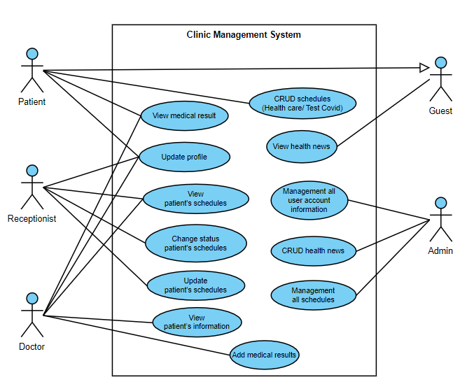

### 2.2 Descriptions

|  |  |  |
| --- | --- | --- |
| # | Actor | Description |
| 1 | *Guest* | 1. View health news |
| 2 | *Patient* | 1. View health news  2. Add/Update/Delete/Search schedule (Health care/ Test Covid)  3. View result medical record  4. Update profile/ Change password |
| 3 | *Receptionist* | 1. Change status patient's schedules (Health care/ Test Covid)  2. Update patient's schedules (Health care/ Test Covid)  3. View patient’s information  3. View/Search/Filter schedules  4. Update profile/ Change password |
| 4 | *Doctor* | 1. Add medical results (Health care/ Test Covid)  2. View patient ‘s medical results  3. View patient’s information  4. View/Search/Filter schedules  5. Update profile/ Change password |
| 5 | *Admin* | 1. View/Search/Filter all user account information  2. Add/Update/Delete health news  3. View/Search/Filter all schedules information |

# III. Functional Requirements

## 1. Login

### 1.1 Screen Design

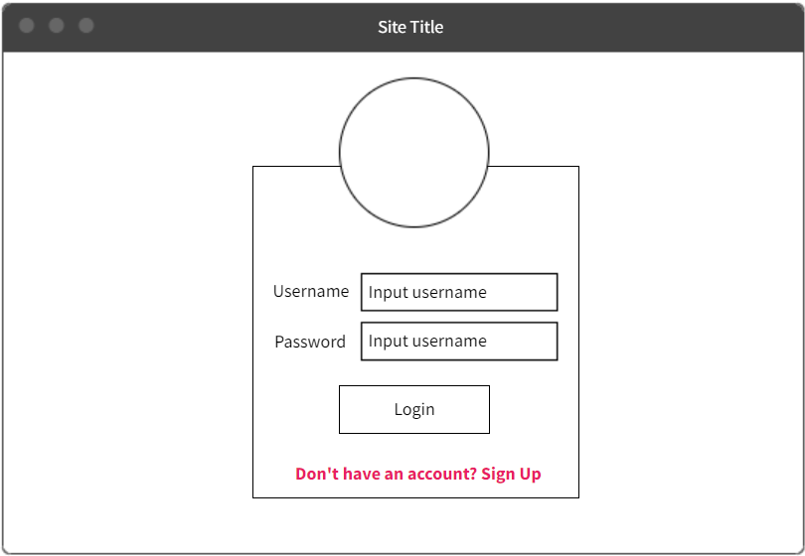

Figure 3.1.1: Screen Design of Login

### 1.2 Screen Definition

|  |  |  |  |  |  |
| --- | --- | --- | --- | --- | --- |
| # | Field Name | Type | Mandatory | Max Length | Description |
| 1 | Username | Text | Yes | N/A |  |
| 2 | Password | Text | Yes | N/A | Display "*" instead of clear character |
| 3 | Login | Button | Yes | N/A | If the username and the password are true go to homepage |

### 1.3 Use Case Specification

|  |  |
| --- | --- |
| Use Case ID | UC01 |
| Use Name | Login |
| Actor | Patient, Doctor, Receptionist, Admin |
| Description | The function allows a user to be able to login in the software when he/she has registered an account and his/her account is still active. |
| Precondition | User is in website Clinic Management System |
| Trigger | User clicks on Login button on the navigation bar of website |
| Post-Condition |  |

|  |  |  |  |  |
| --- | --- | --- | --- | --- |
| Main flows | | | | |
| *Step* | *Actor* | | *Action* | |
| *1* | User | | User clicks on Login button on the navigation bar of website | |
| *2* | CMS | | Display Login screen with the following fields:  - Username  - Password  - Login button | |
| *3* | User | | Enter username & password into Username & Password fields on the Login screen, then click on the Login button. | |
| *4* |  | | Validate the entered username & password and then display Home screen | |
| Alternative flows | | | | |
| AT2 | | At step 4 in the main flows, if failed to validate username & password | | |
| Sub step | | Actor | | Action |
| 4.1 | | MSW | | Display Login page with the message "Username or password incorrect" |

## 2. Register

### 2.1. Screen Design

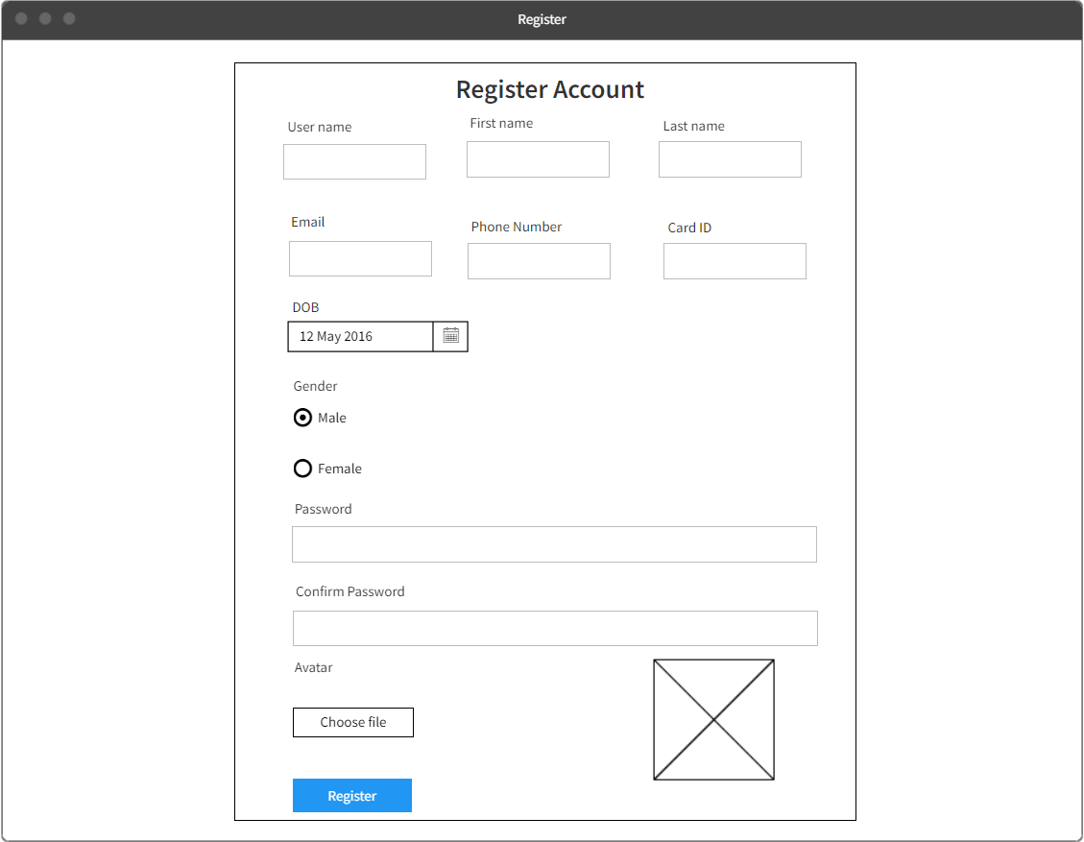

### 2.1 Use Case Specification

|  |  |  |  |  |
| --- | --- | --- | --- | --- |
| Use Case ID | | | UC3 | |
| Use Name | | | Register Account | |
| Actor | | | Patient | |
| Description | | | The function allows patient register new account | |
| Precondition | | | User is in register page | |
| Trigger | | | User enter their information and click on register button | |
| Post-Condition | | |  | |
| Main flows | | | | |
| *Step* | *Actor* | | *Action* | |
| *1* | Patient | | User go to register page, enter their information and click on register button | |
| *2* | CMS | | Validate and add new account with entered information to the system | |
| Alternative flows | | | | |
| AT1 | | At step 2 in the main flows, if there is an internal error, confirmation password is  incorrect or user name existed | | |
| Sub step | | Actor | | Action |
| 2.1 | | MSW | | Display error "This account already existed" |
| 2.1 | | MSW | | Display error "Confirmation password incorrect" |
| 2.1 | | MSW | | Display error “Wrong format” |

## 3. Change password

### 3.1 Screen Design

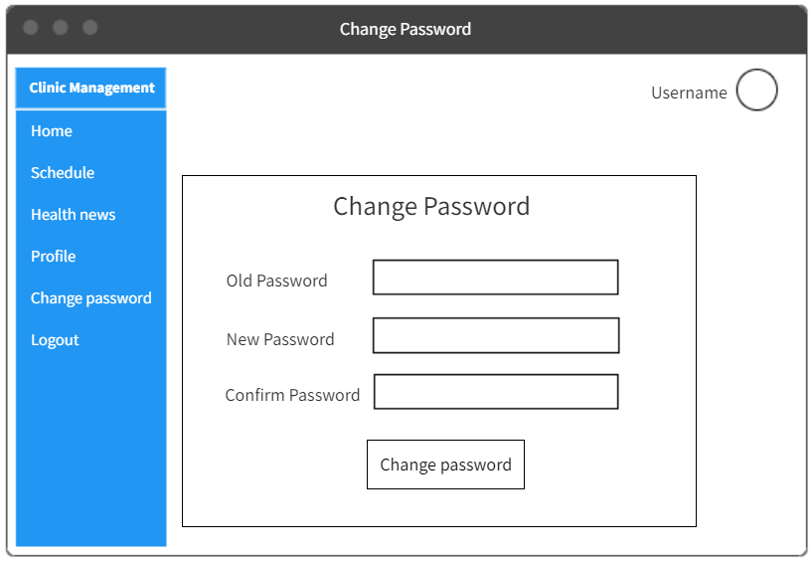

### 3.2 Screen Definition

|  |  |  |  |  |  |
| --- | --- | --- | --- | --- | --- |
| # | Field Name | Type | Mandatory | Max Length | Description |
| 1 | Old password | Text | Yes | 100 |  |
| 2 | New password | Text | Yes | 100 |  |
| 3 | Confirm password | Text | Yes | 100 |  |

### 3.3 Use Case Specification

|  |  |  |  |  |
| --- | --- | --- | --- | --- |
| Use Case ID | | | UC3 | |
| Use Name | | | Change password | |
| Actor | | | All user | |
| Description | | | The function allows User Update password | |
| Precondition | | | User is in website CMS/ Change password page | |
| Trigger | | | User enter new password information and click Change Password button | |
| Post-Condition | | |  | |
| Main flows | | | | |
| *Step* | *Actor* | | *Action* | |
| *1* | All | | User clicks on the Change Password button after enter old password, new password, confirm password | |
| *2* | CMS | | Update user information in the database and show message “Change password success” | |
| Alternative flows | | | | |
| AT1 | | At step 2 in the main flows, if there is an internal error or old password incorrect/ confirm password incorrect | | |
| Sub step | | Actor | | Action |
| 2.1 | | MSW | | Display error "Old password incorrect"/ “Confirm password incorrect” |

## 4. User Profile

4.1. *Screen Design*

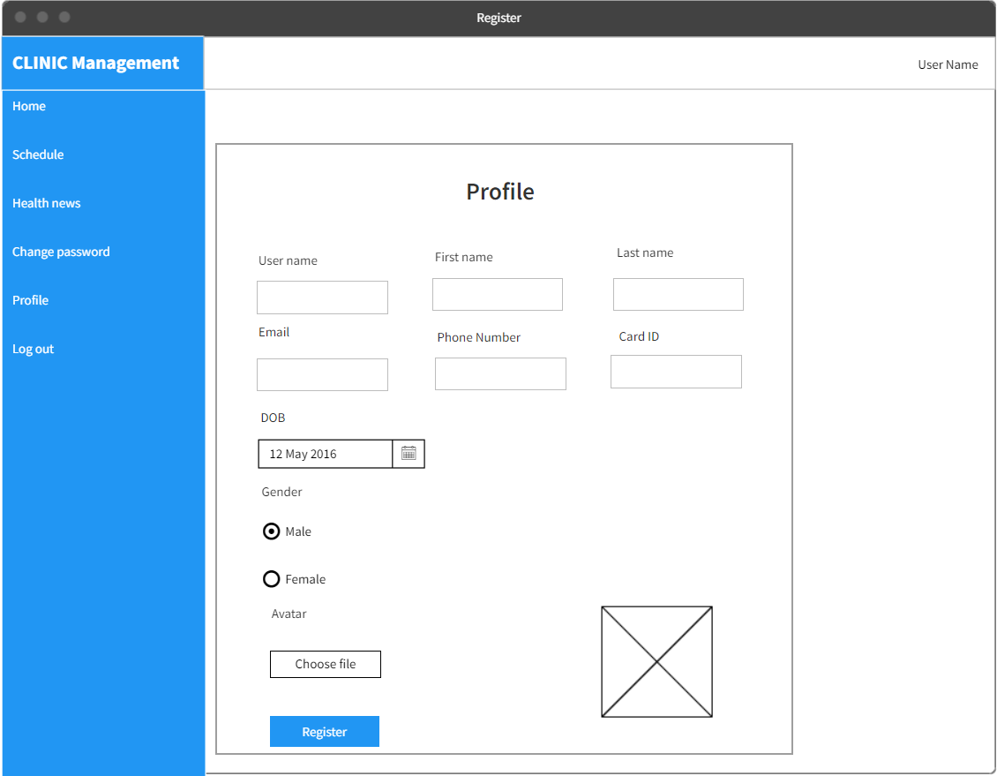

### 4.2 Use Case Specification

|  |  |  |  |  |
| --- | --- | --- | --- | --- |
| Use Case ID | | | UC3 | |
| Use Name | | | User Profile | |
| Actor | | | All role | |
| Description | | | The function allows user to view and update their account | |
| Precondition | | | User logged in and is in profile page | |
| Trigger | | | User enter their information and click on Update button | |
| Post-Condition | | |  | |
| Main flows | | | | |
| *Step* | *Actor* | | *Action* | |
| *1* | Patient | | User go to profile page, enter their information and click on Update button | |
| *2* | CMS | | The system shows user’s information, validate and update their account with entered information to the system | |
| Alternative flows | | | | |
| AT1 | | At step 2 in the main flows, if there is an internal error | | |
| Sub step | | Actor | | Action |
| 2.1 | | MSW | | Display error “Wrong format” |

## 5. Home Page (health news)

5.1. *Screen Design*

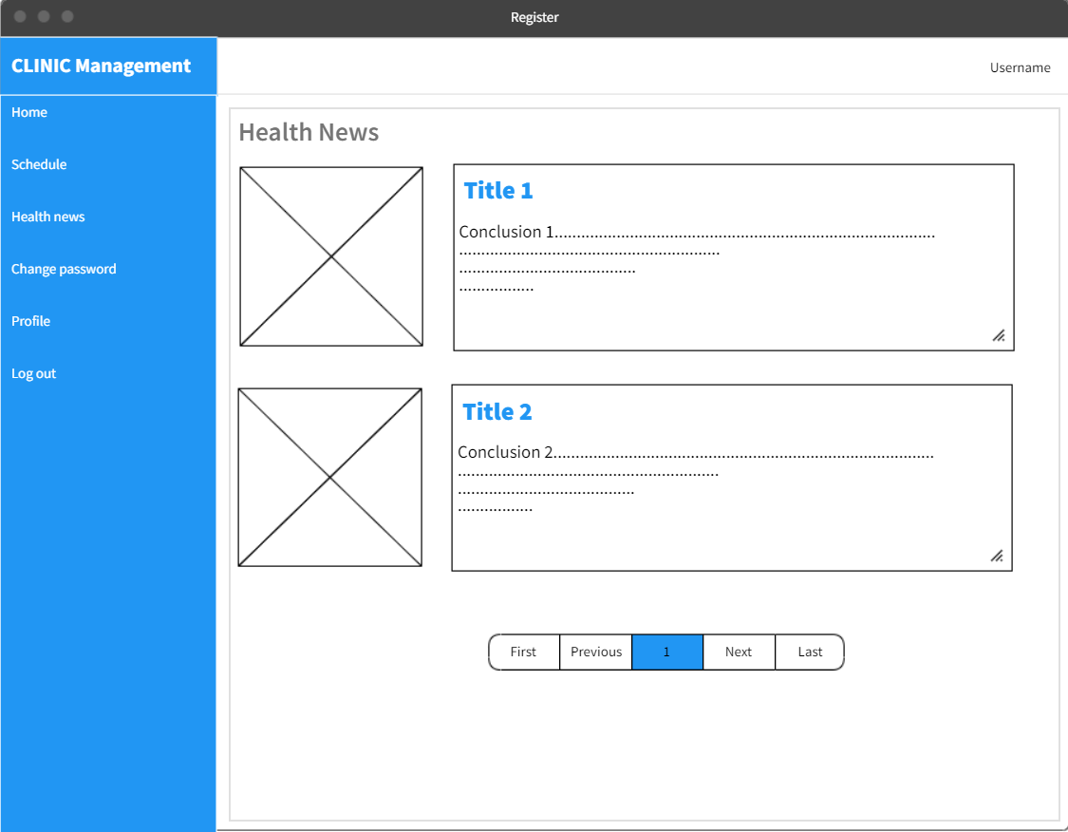

### 5.2 Use Case Specification

|  |  |  |  |  |
| --- | --- | --- | --- | --- |
| Use Case ID | | | UC3 | |
| Use Name | | | Health news | |
| Actor | | | All role | |
| Description | | | The function allows user to see all health news | |
| Precondition | | | User is in home page | |
| Trigger | | | User go to home page | |
| Post-Condition | | |  | |
| Main flows | | | | |
| *Step* | *Actor* | | *Action* | |
| *1* | User | | User go to home page | |
| *2* | CMS | | The system displays health news page on default | |
| Alternative flows | | | | |
| AT1 | | None | | |
| Sub step | | Actor | | Action |
| 2.1 | | MSW | | None |

## 6. List health news

### 6.1. Screen Design

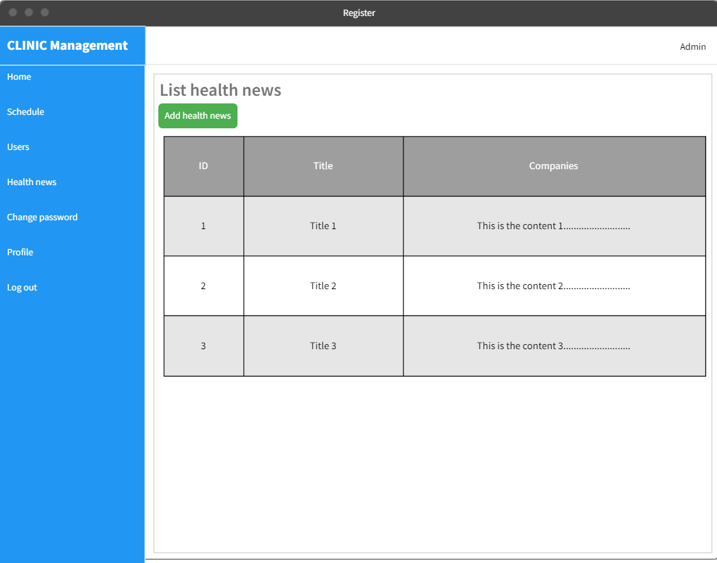

### 6.2 Use Case Specification

|  |  |  |  |  |
| --- | --- | --- | --- | --- |
| Use Case ID | | | UC3 | |
| Use Name | | | List health news | |
| Actor | | | Admin | |
| Description | | | The function allows admin to see list health news | |
| Precondition | | | User logged in as an admin and in health news page | |
| Trigger | | | User go to health news page | |
| Post-Condition | | |  | |
| Main flows | | | | |
| *Step* | *Actor* | | *Action* | |
| *1* | Admin | | User go to home page | |
| *2* | CMS | | The system lists all health news on the page | |
| Alternative flows | | | | |
| AT1 | | None | | |
| Sub step | | Actor | | Action |
| 2.1 | | MSW | | None |

## 7. List appointment:

### 7.1 Screen Design

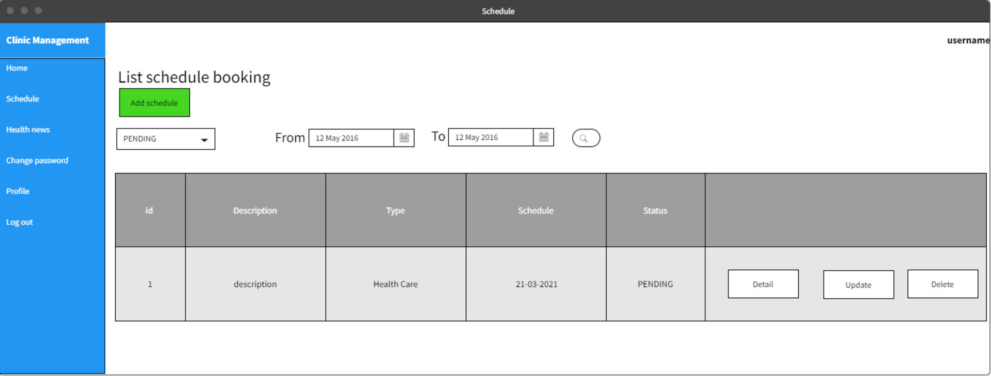

Figure 3.1.1: Screen Design of List Appointment

### 7.2 Use Case Specification

|  |  |
| --- | --- |
| Use Case ID | UC01 |
| Use Case Name | List appointment |
| Actor | Patient, Doctor, Receptionist, Admin |
| Description | The function show list of all appointments. |
| Precondition | User is in website Clinic Management System |
| Trigger | User go to schedule page |
| Post-Condition |  |

|  |  |  |  |  |
| --- | --- | --- | --- | --- |
| Main flows | | | | |
| *Step* | *Actor* | | *Action* | |
| *1* | All | | Go to schedule page | |
| *2* | CMS | | The system lists all schedules on the page | |
| Alternative flows | | | | |
| AT2 | | None | | |
| Sub step | | Actor | | Action |
| 4.1 | | MSW | | None |

## 8. Filter appointments:

### 8.1 Screen Design



Figure 3.1.1: Screen Design of List Appointment

### 8.2 Use Case Specification

|  |  |
| --- | --- |
| Use Case ID | UC01 |
| Use Case Name | Filter appointments |
| Actor | Patient, Doctor, Receptionist, Admin |
| Description | The function show list of all appointments. |
| Precondition | User is in website Clinic Management System |
| Trigger | User fill somes information about status,from date,to date and system will filter by these conditions. |
| Post-Condition |  |

|  |  |  |  |  |
| --- | --- | --- | --- | --- |
| Main flows | | | | |
| *Step* | *Actor* | | *Action* | |
| *1* | All | | Go to schedule page | |
| *2* | CMS | | The system filter all schedule on the page | |
| Alternative flows | | | | |
| AT2 | | None | | |
| Sub step | | Actor | | Action |
| 4.1 | | MSW | | None |

## 9. Create new Health news

### 9.1 Screen Definition

|  |  |  |  |  |  |
| --- | --- | --- | --- | --- | --- |
| # | Field Name | Type | Mandatory | Max Length | Description |
| 1 | Title | Text | Yes | N/A |  |
| 2 | Thumbnail | Image | Yes | N/A |  |
| 3 | Short description | Text | Yes | N/A |  |
| 4 | Content | CKEditor | Yes |  |  |
| 5 | Add | Button |  |  |  |

### 9.2 Use Case Specification

|  |  |  |  |  |
| --- | --- | --- | --- | --- |
| Use Case ID | | | UC3 | |
| Use Case Name | | | Create Health news | |
| Actor | | | Admin | |
| Description | | | The function allows admin to create a article about medical, health, .. | |
| Precondition | | | User logged in as role admin | |
| Trigger | | | User go to add health news page(***/news/add***) | |
| Post-Condition | | | cre | |
| Main flows | | | | |
| *Step* | *Actor* | | *Action* | |
| *1* | Admin | | User go to list health news, then click btn “add health news” | |
| *2* | CMS | | The system display the screen that allow user enter information about news | |
| *3* | Admin | | Enter Title, thumbnail, short description, content | |
| *4* | CMS | | Back to list health new page for admin | |
| Alternative flows | | | | |
| AT1 | | Admin missing one of the fields | | |
| Sub step | | Actor | | Action |
| 4.1 | |  | | Display message require admin must enter all of field |

### 9.3 Screen design

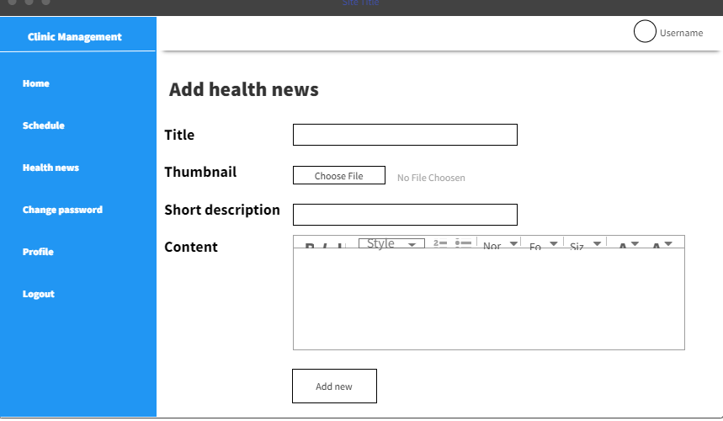

## 10. Delete Health news

### 10.1 Use Case Specification

|  |  |  |  |  |
| --- | --- | --- | --- | --- |
| Use Case ID | | | UC3 | |
| Use Case Name | | | Delete Health news | |
| Actor | | | Admin | |
| Description | | | The function allows admin to create a article about medical, health, .. | |
| Precondition | | | User logged in as role admin | |
| Trigger | | | select button delete on row that you want to delete | |
| Post-Condition | | | health new delete success | |
| Main flows | | | | |
| *Step* | *Actor* | | *Action* | |
| *1* | Admin | | User go to list health news, then click btn “add health news” | |
| *2* | CMS | | The system display the screen that allow user enter information about news | |
| *3* | Admin | | Enter Title, thumbnail, short description, content | |
| *4* | CMS | | Back to list health new page for admin | |
| Alternative flows | | | | |
| AT1 | | Admin missing one of the fields | | |
| Sub step | | Actor | | Action |
| 4.1 | |  | | Display message require admin must enter all of field |

### 10.2 Screen design

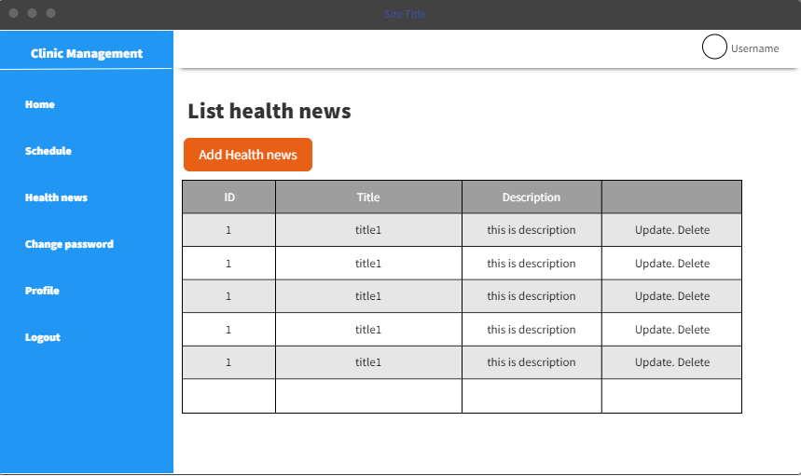

## 11. Detail health news

### 11.1 Use Case Specification

|  |  |  |  |  |
| --- | --- | --- | --- | --- |
| Use Case ID | | | UC3 | |
| Use Case Name | | | Delete Health news | |
| Actor | | | Admin | |
| Description | | | The function allows admin to create a article about medical, health, .. | |
| Precondition | | | User logged in as role admin | |
| Trigger | | | select button delete on row that you want to delete | |
| Post-Condition | | | health new delete success | |
| Main flows | | | | |
| *Step* | *Actor* | | *Action* | |
| *1* | Admin | | User go to list health news, then click btn “add health news” | |
| *2* | CMS | | The system display the screen that allow user enter information about news | |
| *3* | Admin | | Enter Title, thumbnail, short description, content | |
| *4* | CMS | | Back to list health new page for admin | |
| Alternative flows | | | | |
| AT1 | | Admin missing one of the fields | | |
| Sub step | | Actor | | Action |
| 4.1 | |  | | Display message require admin must enter all of field |

### 11.2 Screen design

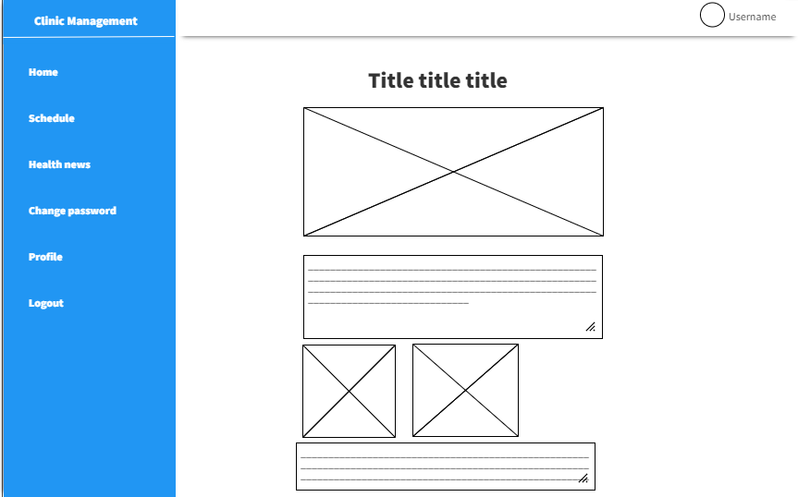

## 12. List all health news

### 12.1 Screen design



## 13. List all health news

### 13.1 Screen design



### 13.2 Use Case Specification

|  |  |  |  |  |
| --- | --- | --- | --- | --- |
| Use Case ID | | | UC3 | |
| Use Case Name | | | Delete Health news | |
| Actor | | | Admin | |
| Description | | | The function allows admin to create a article about medical, health, .. | |
| Precondition | | | User logged in as role admin | |
| Trigger | | | select button delete on row that you want to delete | |
| Post-Condition | | | health new delete success | |
| Main flows | | | | |
| *Step* | *Actor* | | *Action* | |
| *1* | Admin | | User go to list health news, then click btn “add health news” | |
| *2* | CMS | | The system display the screen that allow user enter information about news | |
| *3* | Admin | | Enter Title, thumbnail, short description, content | |
| *4* | CMS | | Back to list health new page for admin | |
| Alternative flows | | | | |
| AT1 | | Admin missing one of the fields | | |
| Sub step | | Actor | | Action |
| 4.1 | |  | | Display message require admin must enter all of field |

## 14. List users

### 14.1. Screen Design

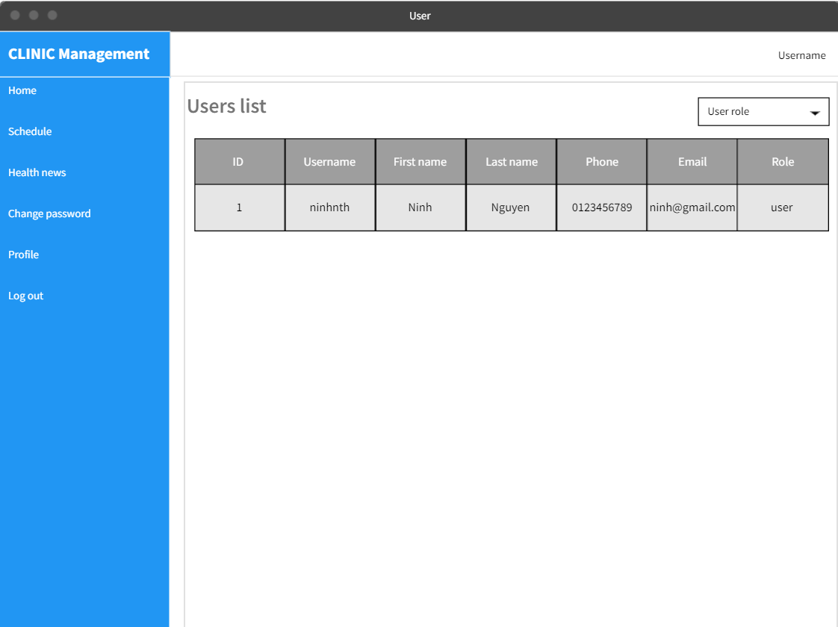

### 14.2 Use Case Specification

|  |  |  |  |  |
| --- | --- | --- | --- | --- |
| Use Case ID | | | UC9 | |
| Use Name | | | List all users | |
| Actor | | | Admin | |
| Description | | | The function allows admin to see list users | |
| Precondition | | | User logged in as an admin and in Users page | |
| Trigger | | | User go to Users page | |
| Post-Condition | | |  | |
| Main flows | | | | |
| *Step* | *Actor* | | *Action* | |
| *1* | Admin | | User go to users page | |
| *2* | CMS | | The system lists all user on the page | |
| Alternative flows | | | | |
| AT1 | | None | | |
| Sub step | | Actor | | Action |
| 2.1 | | MSW | | None |

## 15. Filter users

### 15.1. Screen Design

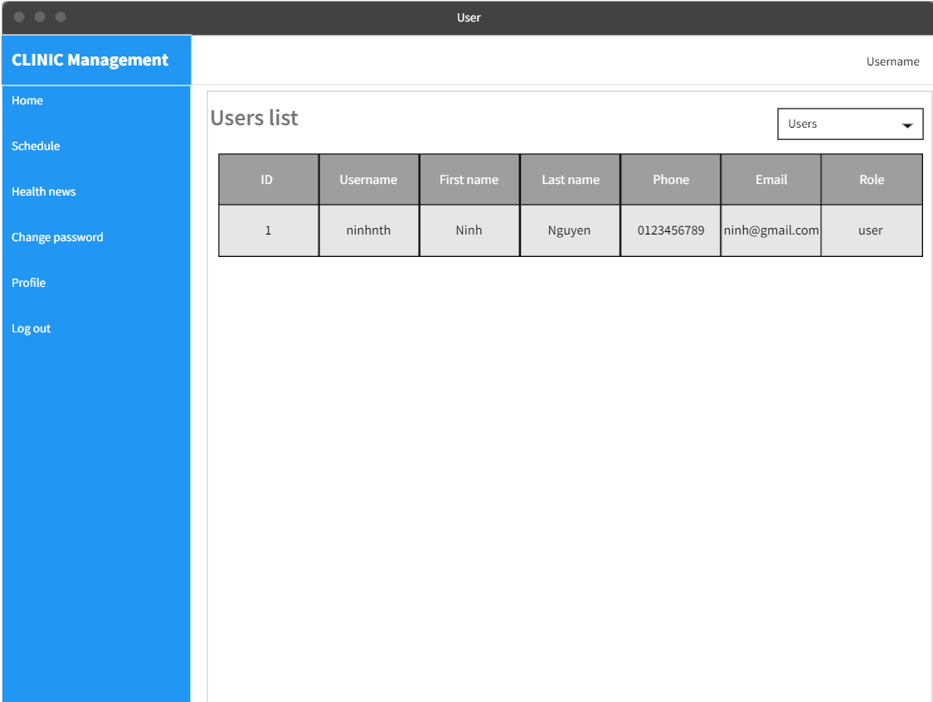

### 15.2 Use Case Specification

|  |  |  |  |  |
| --- | --- | --- | --- | --- |
| Use Case ID | | | UC9 | |
| Use Name | | | Filter users list by role | |
| Actor | | | Admin | |
| Description | | | The function allows admin to filter list users by role | |
| Precondition | | | User logged in as an admin and in Users page | |
| Trigger | | | User go to Users page | |
| Post-Condition | | |  | |
| Main flows | | | | |
| *Step* | *Actor* | | *Action* | |
| *1* | Admin | | User go to users page, choose a role in filter dropdown | |
| *2* | CMS | | The system lists all user with chosen role on the page | |
| Alternative flows | | | | |
| AT1 | | None | | |
| Sub step | | Actor | | Action |
| 2.1 | | MSW | | None |

## 16. Change appointment status

### 16.1Screen Design

Login as Receptionist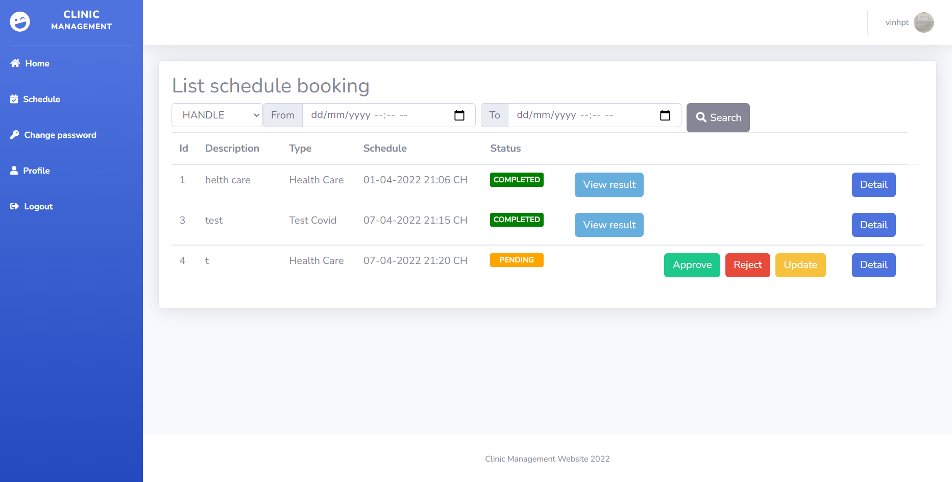

Login as Patient

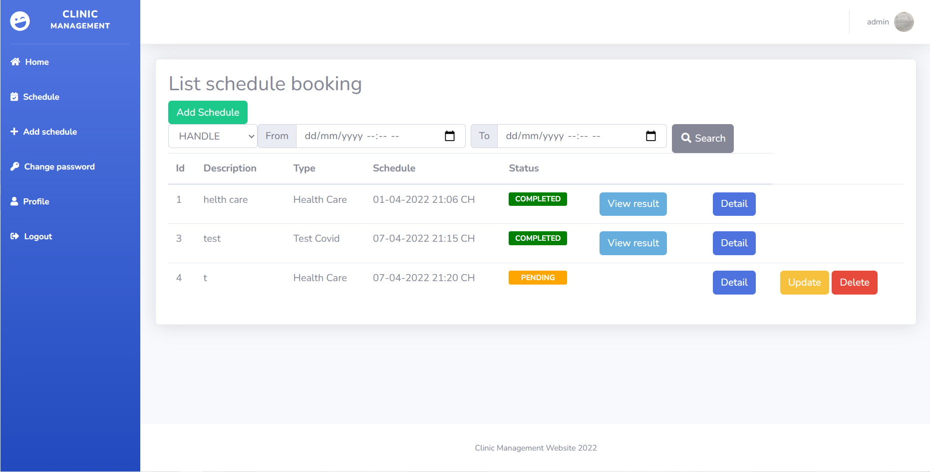

Login as Doctor

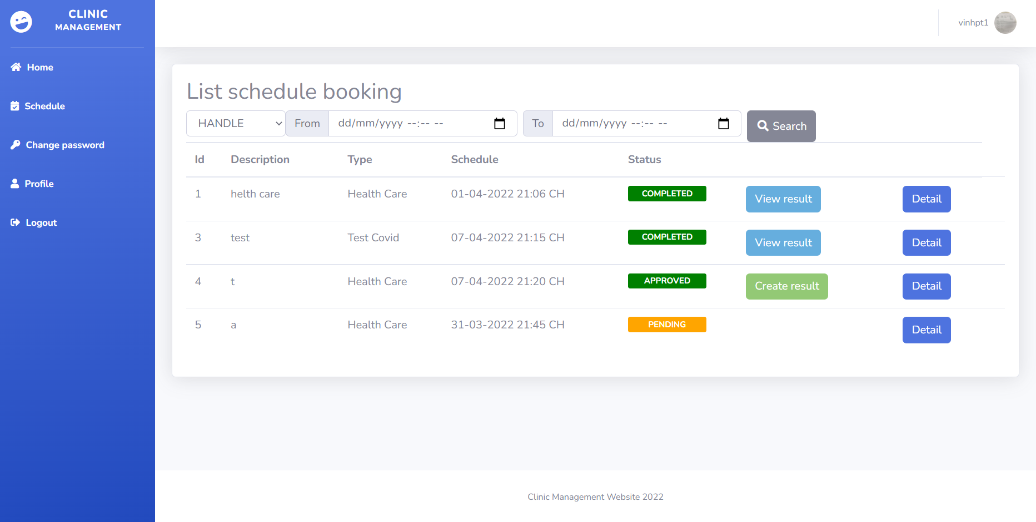

### 16.2 Use Case Specification

|  |  |  |  |  |
| --- | --- | --- | --- | --- |
| Use Case ID | | | UC11 | |
| Use Name | | | Change Appointment Status | |
| Actor | | | Admin | |
| Description | | | The function allows receptionist to update status | |
| Precondition | | | User logged in as an Patient create appointment, User login as Receptionist to update Status to approve and reject,User login as Doctor to add result and change status to complete | |
| Trigger | | | User go to Appointment List | |
| Post-Condition | | |  | |
| Receptionist flows | | | | |
| *Step* | *Actor* | | *Action* | |
| *1* | Receptionist | | User go to Schedult page, choose a date in filter dropdown and status | |
| *2* | CMS | | The system lists all appointment with chosen date and status on the page | |
| *3* | Receptionist | | Update status by click Approve to change status to approve, and click Reject to change status to rejected | |
| Doctor flows | | | | |
| *Step* | *Actor* | | *Action* | |
| *1* | Doctor | | User go to Schedult page, choose a date in filter dropdown and status | |
| *2* | CMS | | The system lists all appointment with chosen date and status on the page | |
| Alternative flows | | | | |
| AT1 | | None | | |
| Sub step | | Actor | | Action |
| 2.1 | | MSW | | None |

## 17. Change appointment status

### 17.1 Screen Design

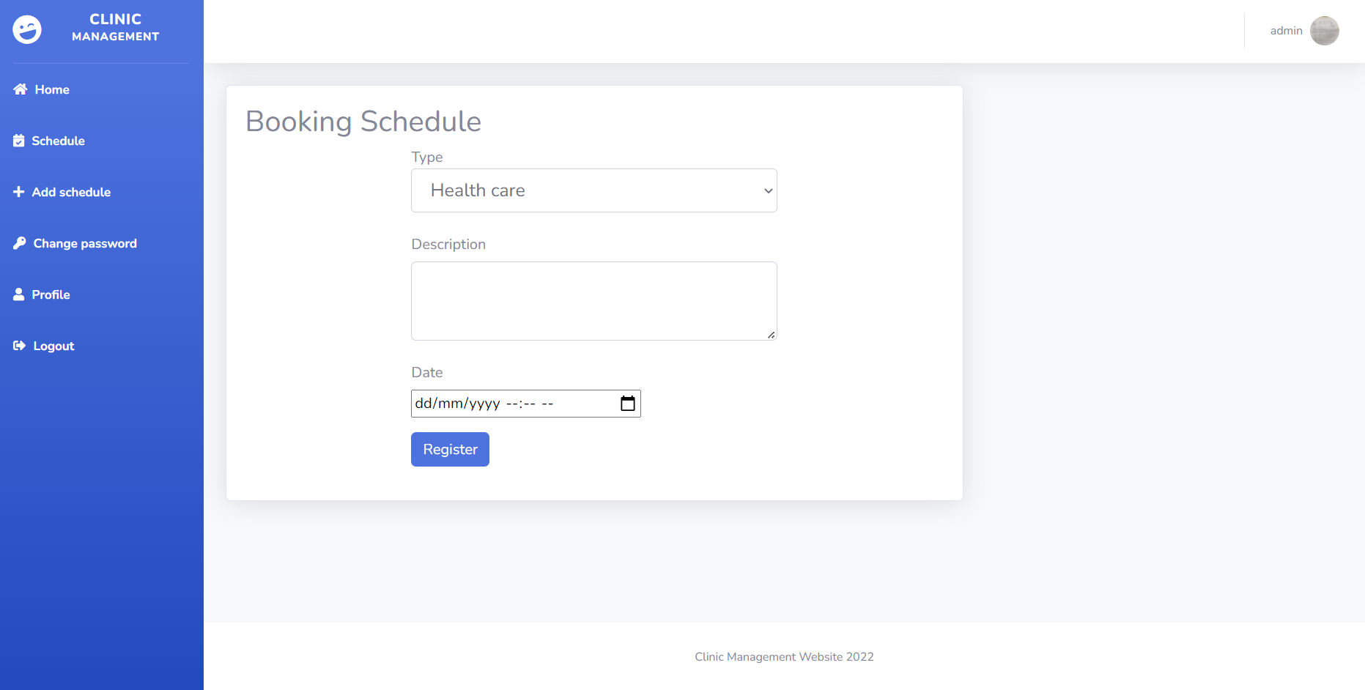

### 17.2 Use Case Specification

|  |  |  |  |  |
| --- | --- | --- | --- | --- |
| Use Case ID | | | UC9 | |
| Use Name | | | Add appointment | |
| Actor | | | Patient | |
| Description | | | The function allows patient to book an appointment | |
| Precondition | | | User login as an patient and go to add schedule page and add schedule | |
| Trigger | | | User go to add schedule and book an appointment | |
| Post-Condition | | |  | |
| Main flows | | | | |
| *Step* | *Actor* | | *Action* | |
| *1* | Patient | | User go to add schedule page, choose type of service they want and write description if they need and pick a date for appointment | |
| *2* | CMS | | The system will receive the appointment and change status of the schedule to pending and the schedule will process by Receptionist. And return to schedule page | |
| Alternative flows | | | | |
| AT1 | | None | | |
| Sub step | | Actor | | Action |
| 2.1 | | MSW | | None |

### 