
GYMMASTER
Software Design Specification
Gym Management System
Version 1.1
Hanoi, July 2026

RECORD OF CHANGES
Version | Date | A/M/D | In charge | Change Description
1.0 | 22/07/2026 | A | GymMaster Team | Created the filled SDS baseline from the current project architecture, endpoint inventory, database design and RDS/SRS; diagram areas are intentionally reserved for later insertion.
1.1 | 22/07/2026 | M | GymMaster Team | Aligned class names, sequence flows and SQL equivalents with the current source/schema; added automatic TOC/caption fields and finalized ownership for all 28 diagrams.

* A - Added; M - Modified; D - Deleted.

TABLE OF CONTENTS
RECORD OF CHANGES 2
TABLE OF CONTENTS 2
I. Overview 4
1. Purpose and Design Scope 4
2. System Architecture 5
3. Code Packages 6
3.1 Frontend Package Diagram 6
3.2 Backend Package Diagram 7
4. Database Design 8
4.1 Database Schema 8
4.2 Table Descriptions 8
II. Code Designs 9
1. Authentication and Session Management 10
a. Class Diagram 10
b. Class Specifications 10
c. Sequence Diagram(s) 11
d. Database Queries 12
2. Password Recovery and Account Profile 13
a. Class Diagram 13
b. Class Specifications 13
c. Sequence Diagram(s) 14
d. Database Queries 14
3. User, Member and Trainer Management 16
a. Class Diagram 16
b. Class Specifications 16
c. Sequence Diagram(s) 17
d. Database Queries 18
4. Membership Packages and Membership Lifecycle 19
a. Class Diagram 19
b. Class Specifications 19
c. Sequence Diagram(s) 20
d. Database Queries 20
5. Payment and VNPay Integration 22
a. Class Diagram 22
b. Class Specifications 22
c. Sequence Diagram(s) 23
d. Database Queries 23
6. Member Check-in 25
a. Class Diagram 25
b. Class Specifications 25
c. Sequence Diagram(s) 26
d. Database Queries 27
7. PT Assignment 28
a. Class Diagram 28
b. Class Specifications 28
c. Sequence Diagram(s) 29
d. Database Queries 30
8. Workout Plans and Trainer Notes 31
a. Class Diagram 31
b. Class Specifications 31
c. Sequence Diagram(s) 32
d. Database Queries 33
9. Progress Tracking and Member 360 34
a. Class Diagram 34
b. Class Specifications 34
c. Sequence Diagram(s) 35
d. Database Queries 35
10. Nutrition Targets, Food Catalog and Meal Journal 36
a. Class Diagram 36
b. Class Specifications 36
c. Sequence Diagram(s) 37
d. Database Queries 37
11. Gemini Food Image Recognition 39
a. Class Diagram 39
b. Class Specifications 39
c. Sequence Diagram(s) 40
d. Database Queries 41
12. Admin Dashboard and Audit Logs 42
a. Class Diagram 42
b. Class Specifications 42
c. Sequence Diagram(s) 43
d. Database Queries 43
III. Team Work Allocation and Review 45
1. Diagram Completion Index 45
2. Final SDS Review Criteria 46

This document uses automatic TOC and SEQ fields. After inserting the final diagrams, press Ctrl+A and F9 in Microsoft Word, then verify pagination before exporting to PDF.

I. Overview

1. Purpose and Design Scope
This Software Design Specification defines the implementation structure of GymMaster. It is derived from the current frontend/backend repository, the completed GymMaster RDS/SRS and the project endpoint inventory. The document focuses on code packages, persistent data, class responsibilities, interaction sequences and database queries. All diagram locations are intentionally left blank so the team can draw and insert the final images.
- System type: single-branch responsive web/PWA for gym operations and member progress tracking.
- Frontend: Next.js 16, React 19, TypeScript, App Router, TanStack Query, Zustand, React Hook Form and Zod.
- Backend: ASP.NET Core .NET 10 Web API with feature-based controllers/services/DTOs.
- Persistence: SQL Server through Entity Framework Core 10.
- Security: JWT role-based authorization, BCrypt password hashing and rotating refresh tokens.
- Integrations: VNPay sandbox, Gemini 2.5 Flash, Cloudinary and SMTP.
- Deployment target: Google Cloud Run and Cloud SQL with HTTPS and environment-based secrets.

2. System Architecture
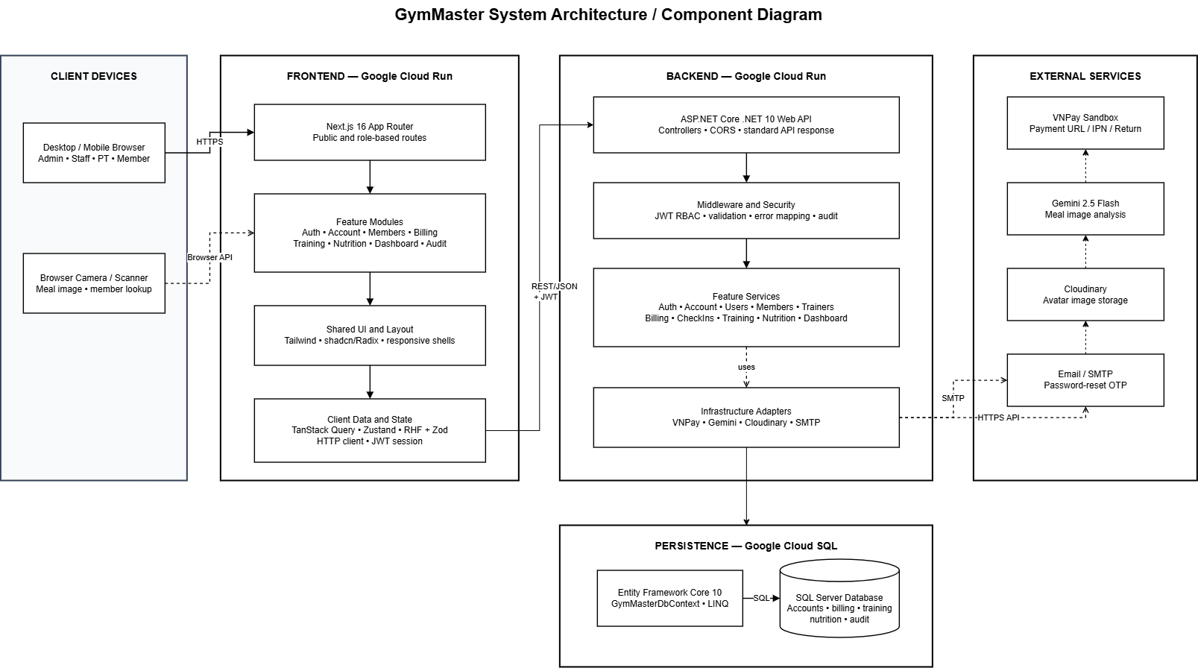
Figure 1. GymMaster System Architecture / Component Diagram
Component | Technology / Location | Responsibility
Browser/PWA Client | Desktop and mobile browser | Renders role workspaces, captures form input, camera images and navigation.
Frontend Application | Next.js 16 / React 19 / TypeScript | Routes, components, form validation, API calls, query caching and session state.
Backend API | ASP.NET Core .NET 10 | Authentication, authorization, business rules, validation, audit and integration orchestration.
Persistence Layer | EF Core 10 / SQL Server | Stores users, memberships, payments, check-ins, training, nutrition and audit data.
External Services | VNPay, Gemini, Cloudinary, SMTP | Online payment, food-image analysis, image storage and reset-email delivery.

3. Code Packages

3.1 Frontend Package Diagram
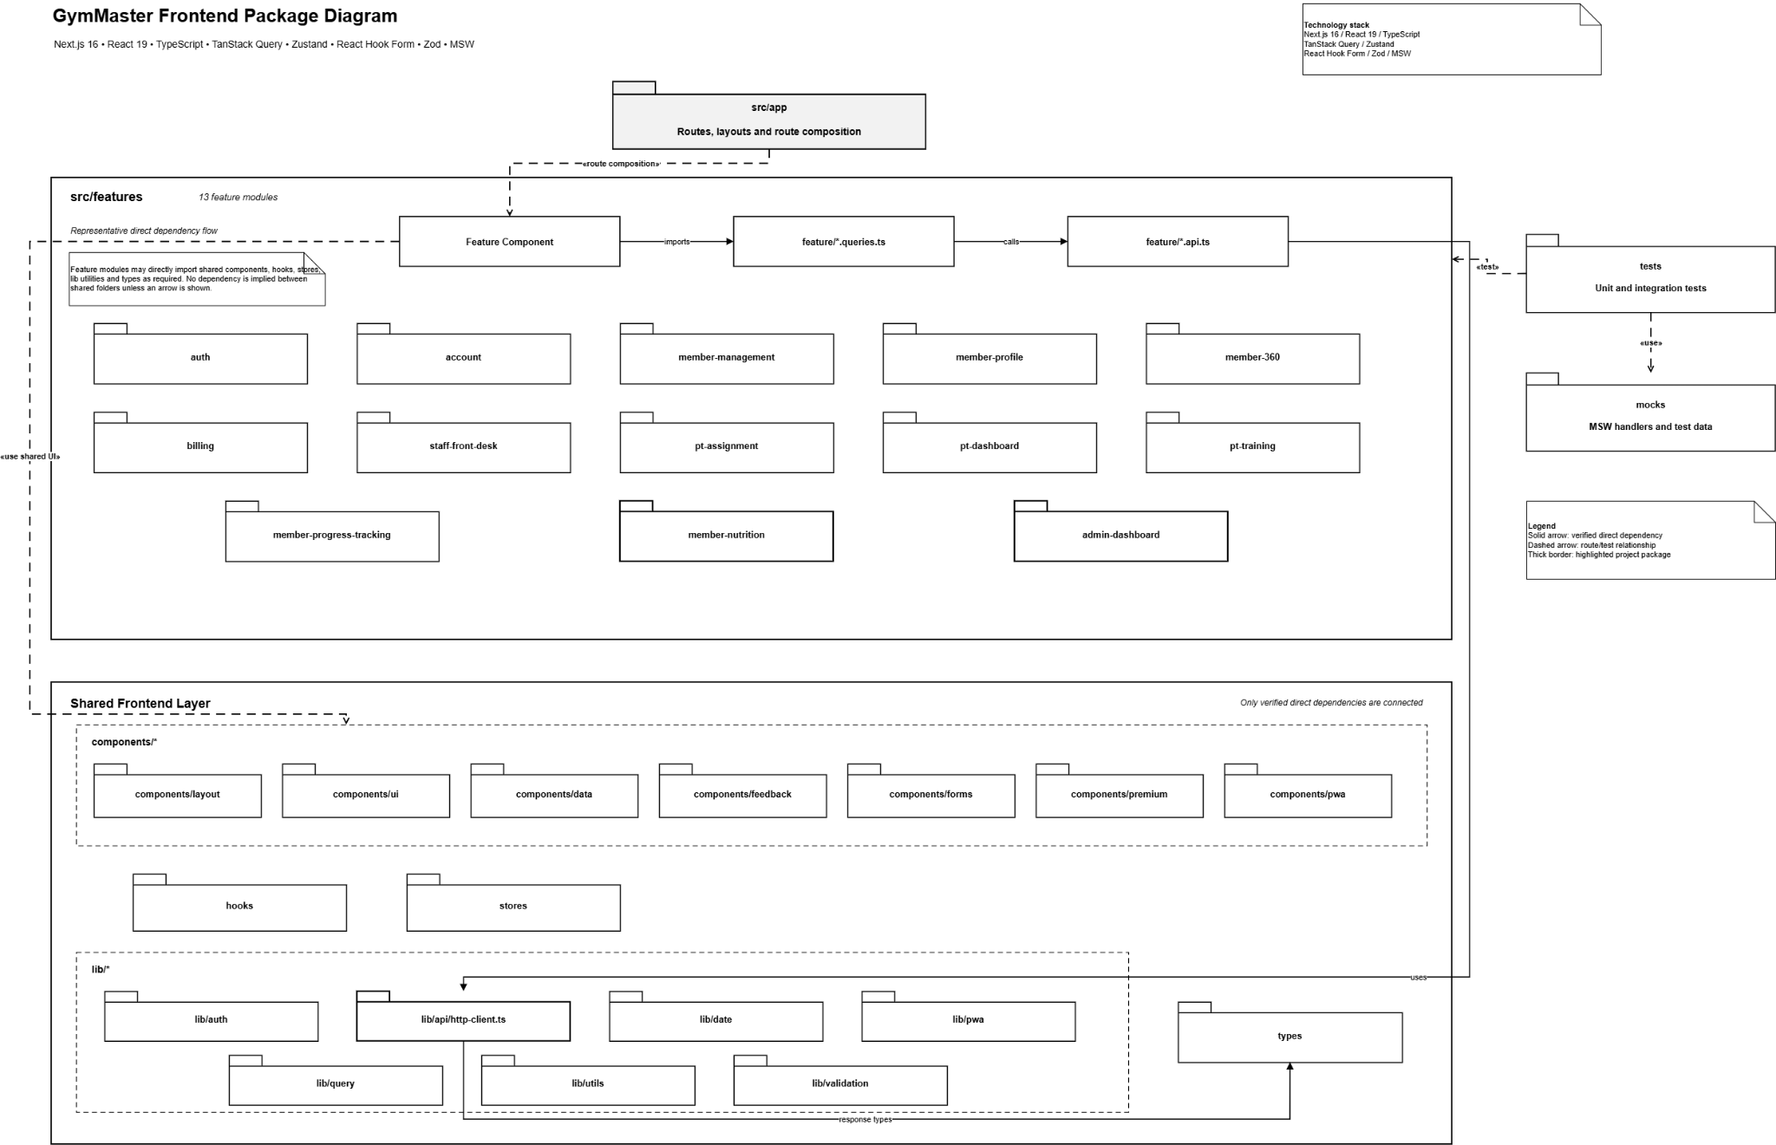
Figure 2. Frontend Package Diagram
No. | Package | Description
01 | src/app | Next.js App Router pages grouped by auth, admin, staff, PT and member routes.
02 | features/auth | Login, signup, forgot/reset/change password, session and role redirect.
03 | features/account | Own account, profile and avatar management.
04 | features/member-management | Admin/Staff user, member and trainer management workspaces.
05 | features/member-360 | Aggregated Member 360 cards, timeline and quick actions.
06 | features/billing | Packages, memberships, payments and VNPay client integration.
07 | features/staff-front-desk | Member search, sell/renew package, manual payment and check-in terminal.
08 | features/pt-assignment | Admin candidate search and PT assignment workspace.
09 | features/pt-dashboard | PT dashboard, assigned members and today check-ins.
10 | features/pt-training | Workout plan and trainer note UI and contracts.
11 | features/member-progress-tracking | Progress form, history table, charts and PT/member views.
12 | features/member-nutrition | Meal journal, food search, AI scan and calorie summary.
13 | features/admin-dashboard | Operational metrics/charts and audit log table.
14 | lib/api and lib/query | Central HTTP client, API normalization, query client and invalidation helpers.
15 | stores | Zustand stores for session, sidebar and PT active-member context.
16 | mocks and tests | MSW handlers, Vitest component tests and Playwright E2E/PWA flows.

3.2 Backend Package Diagram
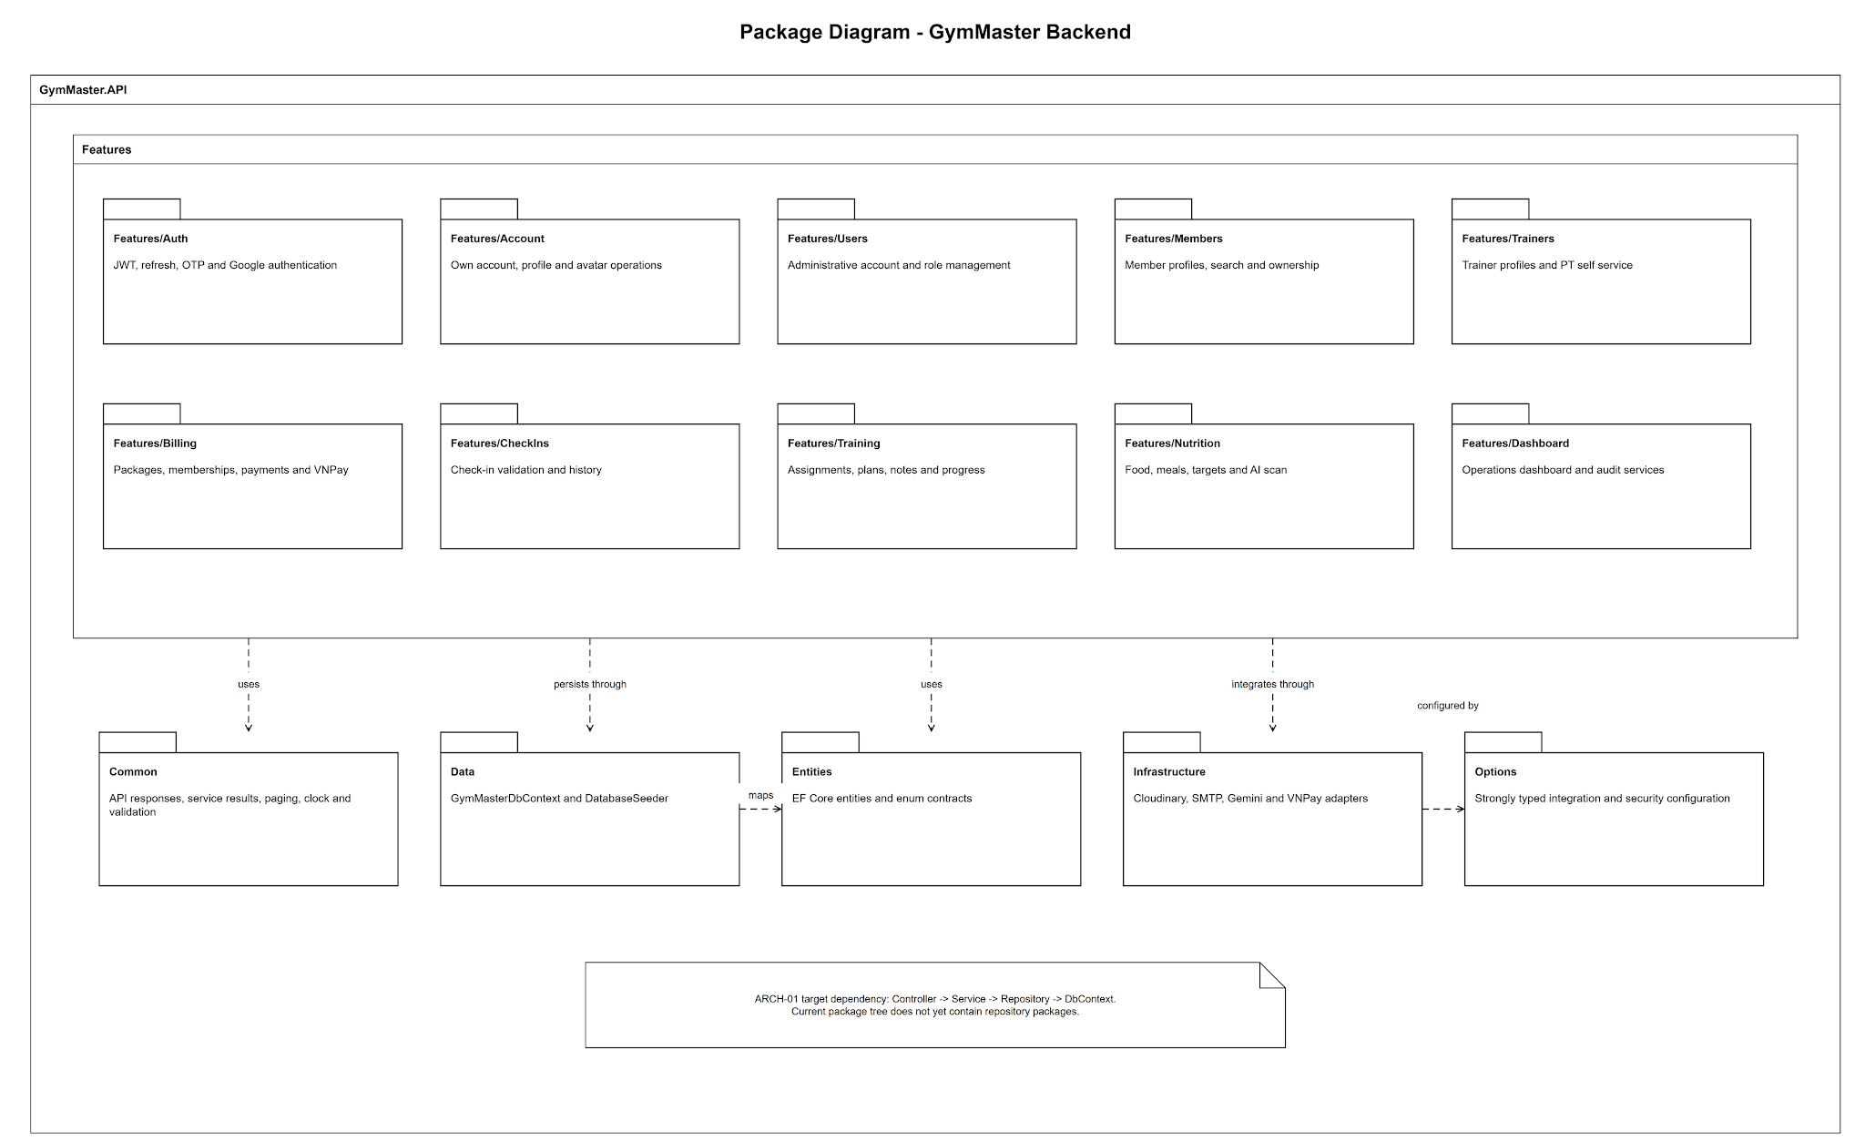
Figure 3. Backend Package Diagram
No. | Package | Description
01 | Common | ApiControllerBase, ApiResponse, ServiceResult, PagedResult, AppClock and shared validation.
02 | Data | GymMasterDbContext, database configuration and seeding.
03 | Entities | EF Core entities and enum contracts.
04 | Features/Auth | JWT, refresh token, OTP and Google authentication.
05 | Features/Account | Self-service account, personal profile and avatar operations.
06 | Features/Users | Admin user-account management and role/status rules.
07 | Features/Members | Member creation, search, ownership and soft-delete.
08 | Features/Trainers | Trainer profile creation, listing and update.
09 | Features/Billing | Packages, memberships, manual payments, lifecycle and VNPay.
10 | Features/CheckIns | Check-in validation, limits and histories.
11 | Features/Training | PT assignments, workouts, notes, progress and Member 360.
12 | Features/Nutrition | Food catalog, meal journal, targets, summaries and image recognition.
13 | Features/Dashboard | Dashboard aggregation and audit query/write services.
14 | Infrastructure | Cloudinary, SMTP, Gemini and VNPay adapters.
15 | Options | Strongly typed JWT, CheckIn, Cloudinary, Email, Gemini, Google and VNPay options.

4. Database Design

4.1 Database Schema
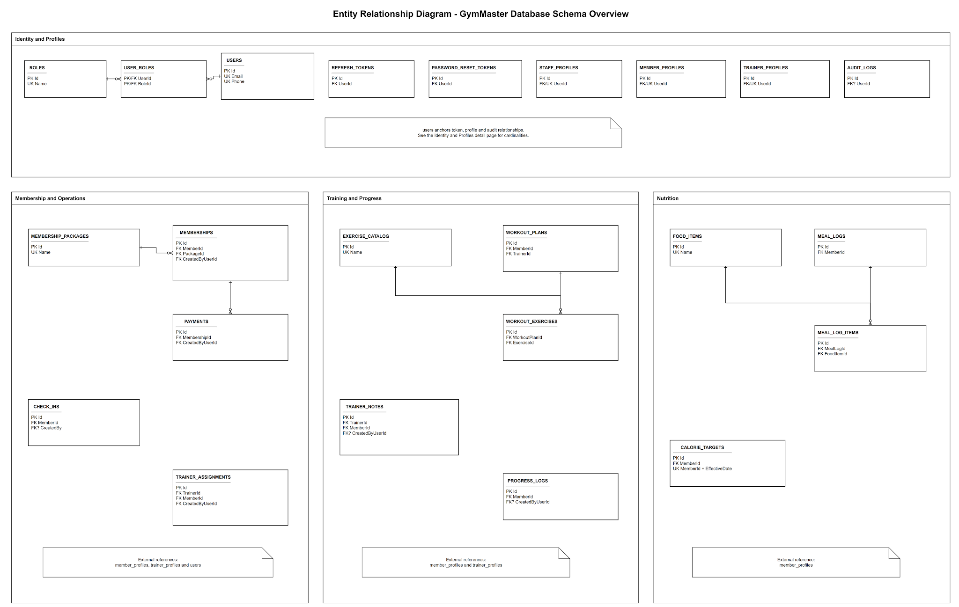
Figure 4. GymMaster Database Schema / ERD

4.2 Table Descriptions
No. | Table | Description
01 | users | Core account and authentication state; unique email and optional phone; password hash, role/status, lock counters and timestamps.
02 | roles | Role master data for Admin, Staff, PT and Member.
03 | user_roles | Many-to-many user-role mapping.
04 | refresh_tokens | Hashed rotating refresh tokens with expiry and revocation state.
05 | password_reset_tokens | Hashed OTP records with expiry, usage and attempt counters.
06 | member_profiles | Member personal information, join date and soft-delete state.
07 | staff_profiles | Admin/Staff personal profile data.
08 | trainer_profiles | PT specialty, bio, experience and personal data.
09 | membership_packages | Package template, duration, price, active state and PT support flag.
10 | memberships | Member package lifecycle with PendingPayment, Active, Expired and Cancelled states.
11 | payments | Manual/VNPay transaction records and status.
12 | check_ins | UTC member arrival timestamps and creator information.
13 | trainer_assignments | PT-member assignment history and active interval.
14 | exercise_catalog | Reusable exercise definitions.
15 | workout_plans | Workout plan header linked to member and trainer.
16 | workout_exercises | Ordered exercises and set/rep/weight/rest details.
17 | trainer_notes | Dated PT notes for assigned members.
18 | progress_logs | Daily weight/body-fat/body-measurement records.
19 | food_items | Food catalog, serving, calorie/macros, source and active state.
20 | meal_logs | Meal header by member/date/type.
21 | meal_log_items | Food quantity and nutrition snapshot per meal.
22 | calorie_targets | Effective-date calorie and macro targets.
23 | audit_logs | Append-only audit trail for important mutations.

II. Code Designs
The following sections group related screens and endpoints into design features. Each feature contains a reserved class-diagram area, completed class specifications, a reserved sequence-diagram area with confirmed textual flow, and SQL equivalents for the main Entity Framework operations.

1. Authentication and Session Management
Implements login, Google login, registration, current-session lookup, access-token refresh and logout for Admin, Staff, PT and Member roles.
Design item | Specification
Actors | Guest; Admin; Staff; PT; Member; Google identity provider
Related screens/routes | /login, /signup and protected route guards
Primary API endpoints | POST /api/v1/auth/login; POST /google; POST /register; POST /refresh; POST /logout; GET /me
Persistent tables | users, roles, user_roles, refresh_tokens

a. Class Diagram
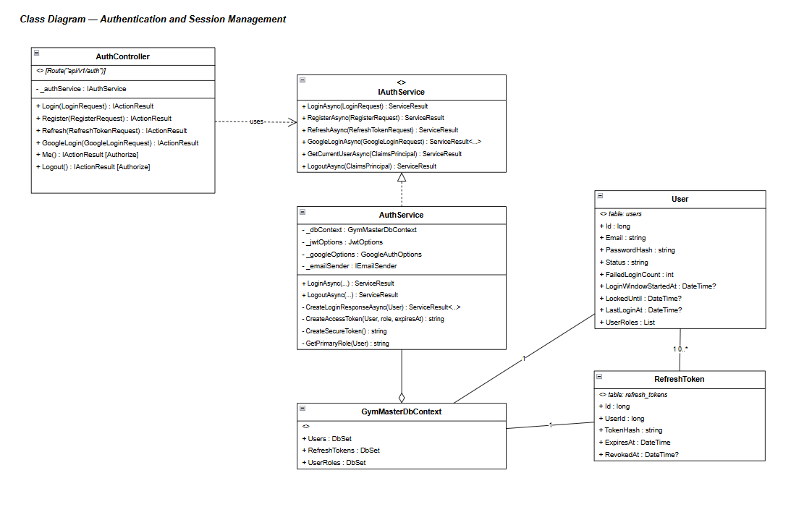
Figure 5. Class Diagram — Authentication and Session Management

b. Class Specifications
AuthController Class
Description: Exposes public and authenticated HTTP endpoints for login, registration, refresh, current-user lookup and logout.
No. | Method | Input / Output | Internal processing
01 | Login(LoginRequest) | Input: email, password. Output: access token, refresh token, role, redirectPath. | Validate request, call AuthService, map ServiceResult to standard API response.
02 | Register(RegisterRequest) | Input: full name, email, phone, password. Output: authenticated Member session. | Validate unique identity and delegate account creation and token issuance.
03 | Refresh(RefreshTokenRequest) | Input: refresh token. Output: rotated access/refresh tokens. | Delegate hash lookup, revocation and token rotation.
04 | Logout() | Input: authenticated user claim. Output: HTTP 204. | Revoke active refresh tokens for the current user.

AuthService Class
Description: Contains authentication, password recovery/change, JWT issuance, refresh-token rotation, role resolution and login-attempt handling.
No. | Method | Input / Output | Internal processing
01 | LoginAsync(LoginRequest) | Input: credentials. Output: AuthLoginResponse or error. | Load user/role, enforce status/lock rules, verify BCrypt, update counters and create the session.
02 | RegisterAsync(RegisterRequest) | Input: registration data. Output: AuthLoginResponse. | Check email/phone uniqueness, hash password, create User + Member role and issue tokens in one transaction.
03 | RefreshAsync(RefreshTokenRequest) | Input: raw refresh token. Output: AuthLoginResponse. | Find a valid token, verify BCrypt hash, revoke it and issue the replacement session.

AuthService Class — Private Token Helpers
Description: Private AuthService helpers create signed JWT access tokens and cryptographically random refresh-token material; there is no separate JwtTokenService class.
No. | Method | Input / Output | Internal processing
01 | CreateAccessToken(User, role, expiresAt) | Input: user, role and expiry. Output: signed JWT. | Private AuthService helper adds identity/role claims and signs with HMAC-SHA256.
02 | CreateSecureToken() | Input: none. Output: random raw token. | Private static AuthService helper generates cryptographically secure random token material; BCrypt hash is persisted.

useAuthSessionStore (Frontend Zustand Store)
Description: Frontend Zustand store in features/auth/session/auth-session.ts that persists the current session, refreshes tokens and logs out the caller.
No. | Method | Input / Output | Internal processing
01 | setSession(AuthSession) | Input: API session payload. Output: updated client state. | Store access/session data and expose authenticated role.
02 | logout() | Input: current access token. Output: anonymous state. | Call the logout API when possible, clear the persisted session and allow protected guards to redirect.

c. Sequence Diagram(s)
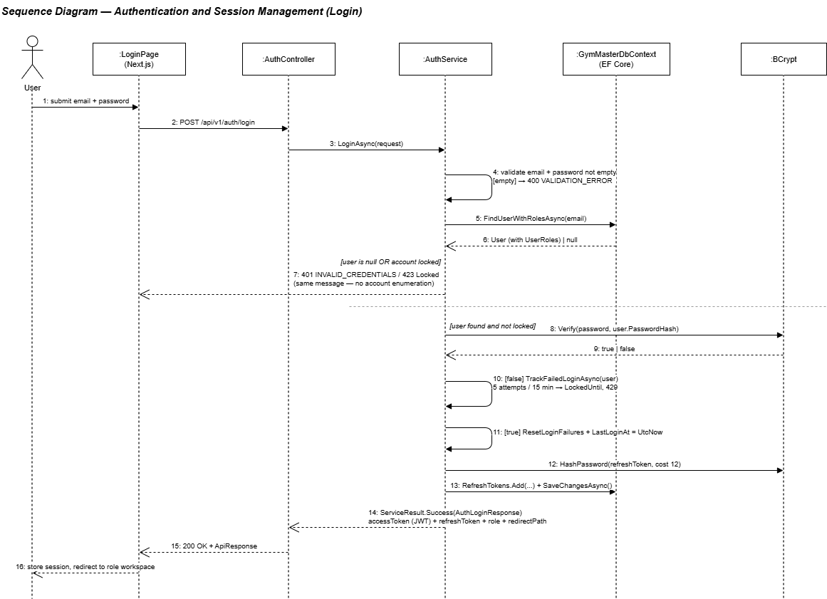
Figure 6. Sequence Diagram — Authentication and Session Management
Confirmed sequence flow used to draw the diagram:
- User enters credentials in the Login screen; frontend validates required fields and email format.
- Frontend posts the request to /api/v1/auth/login through the central HTTP client.
- AuthController delegates to AuthService.
- AuthService loads the active user and assigned role, checks lock counters and verifies the BCrypt password hash.
- On success, AuthService resets failed counters and invokes its private CreateAccessToken/CreateSecureToken helpers.
- The refresh-token hash is stored; the raw refresh token is returned only to the client.
- Backend returns the standard response with role and redirectPath.
- Frontend stores the session and navigates to the role dashboard.
- Alternative: invalid credentials increase failed attempts; locked accounts return ACCOUNT_LOCKED or TOO_MANY_ATTEMPTS.

d. Database Queries
Q-AUTH-01 — Find active user and role
Purpose: Authenticate by email and resolve the single operational role. Input: @Email Output: User and role data
SELECT u.Id, u.Email, u.PasswordHash, u.Status, u.FailedLoginCount, u.LockedUntil, r.Name AS RoleName
FROM users u
JOIN user_roles ur ON ur.UserId = u.Id
JOIN roles r ON r.Id = ur.RoleId
WHERE u.Email = @Email AND u.IsDeleted = 0;

Q-AUTH-02 — Store refresh token
Purpose: Persist the secure hash and lifecycle of a newly issued refresh token. Input: @UserId, @TokenHash, @ExpiresAt Output: Inserted refresh_tokens row
INSERT INTO refresh_tokens (UserId, TokenHash, ExpiresAt, CreatedAt)
VALUES (@UserId, @TokenHash, @ExpiresAt, SYSUTCDATETIME());

Q-AUTH-03 — Rotate refresh token
Purpose: Revoke the old token before inserting the replacement. Input: @TokenId, @NewTokenHash, @ExpiresAt Output: Old token revoked and new token inserted
BEGIN TRANSACTION;
UPDATE refresh_tokens SET RevokedAt = SYSUTCDATETIME()
WHERE Id = @TokenId AND RevokedAt IS NULL;
INSERT INTO refresh_tokens (UserId, TokenHash, ExpiresAt, CreatedAt)
SELECT UserId, @NewTokenHash, @ExpiresAt, SYSUTCDATETIME()
FROM refresh_tokens WHERE Id = @TokenId;
COMMIT;

2. Password Recovery and Account Profile
Covers forgot/reset/change password, own-account updates, role-specific personal profile and Cloudinary avatar replacement.
Design item | Specification
Actors | Guest; Admin; Staff; PT; Member; SMTP; Cloudinary
Related screens/routes | /forgot-password, /reset-password, /change-password, /admin|staff|pt|member/profile, /member/profile/edit
Primary API endpoints | POST /auth/forgot-password; POST /auth/reset-password; POST /auth/change-password; GET/PUT /users/me/profile; PUT /users/me; POST /users/me/avatar
Persistent tables | users, password_reset_tokens, member_profiles, staff_profiles, trainer_profiles

a. Class Diagram
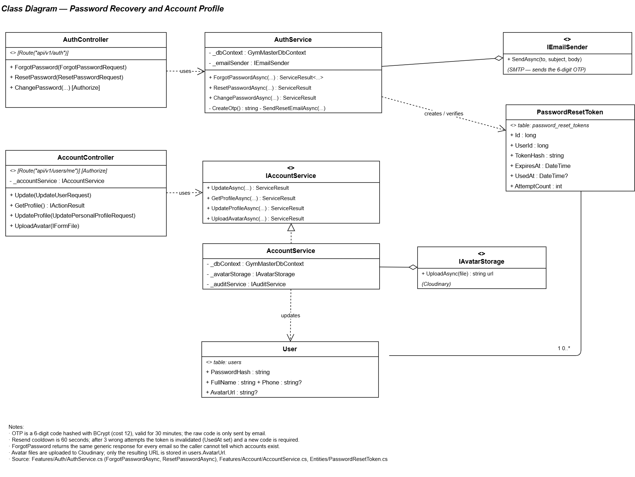

Figure 7. Class Diagram — Password Recovery and Account Profile

b. Class Specifications
AuthService Class — Password Operations
Description: AuthService implements ForgotPasswordAsync, ResetPasswordAsync and ChangePasswordAsync, including OTP lifecycle and refresh-token revocation.
No. | Method | Input / Output | Internal processing
01 | ForgotPasswordAsync(ForgotPasswordRequest) | Input: email. Output: accepted response. | Return a non-enumerating response, enforce resend cooldown, hash the six-digit OTP and send through SMTP.
02 | ResetPasswordAsync(ResetPasswordRequest) | Input: email, OTP, new password. Output: success/error. | Validate unexpired/unused OTP and attempts, replace password hash, mark token used and revoke sessions.
03 | ChangePasswordAsync(userId, ChangePasswordRequest) | Input: current and new password. Output: success/error. | Verify the current password, replace its hash and revoke active refresh tokens.

AccountController Class
Description: Exposes own-account, personal profile and avatar operations to all authenticated roles.
No. | Method | Input / Output | Internal processing
01 | GetMyProfile() | Input: JWT userId/role. Output: role-specific profile DTO. | Resolve profile table by role and return account plus personal information.
02 | UpdateMe(UpdateAccountRequest) | Input: full name, phone. Output: updated account. | Validate uniqueness and update common user fields.
03 | UpdateMyProfile(UpdateProfileRequest) | Input: role-specific personal fields. Output: updated profile. | Apply PersonValidation and update member/staff/trainer profile.
04 | UploadAvatar(IFormFile file) | Input: image file. Output: image URL. | Validate size/type, upload to Cloudinary and update user AvatarUrl.

CloudinaryAvatarStorage Class
Description: IAvatarStorage implementation that validates Cloudinary configuration, uploads a 256×256 face-cropped image and returns the HTTPS URL.
No. | Method | Input / Output | Internal processing
01 | UploadAsync(userId, stream, contentType) | Input: user id and validated image stream. Output: secure URL. | Upload to gymmaster/avatars with overwrite and a 256×256 face-crop transformation.

c. Sequence Diagram(s)
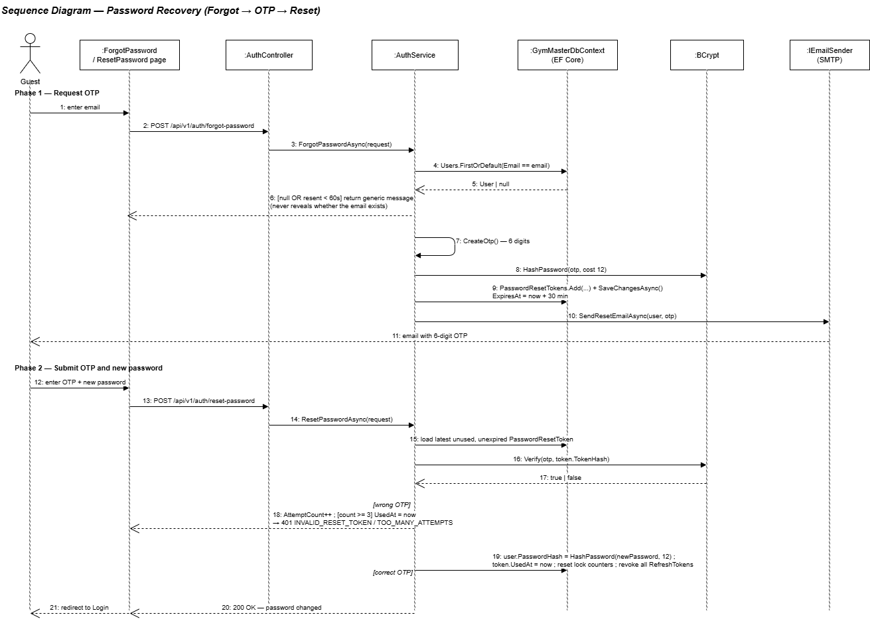
Figure 8. Sequence Diagram — Password Recovery and Account Profile
Confirmed sequence flow used to draw the diagram:
- Guest submits email on Forgot Password.
- AuthService enforces cooldown and creates a BCrypt-hashed OTP record with 30-minute expiry.
- SMTP adapter sends the OTP; the API returns a non-enumerating accepted response.
- Guest submits email, OTP and new password on Reset Password.
- AuthService validates expiry, UsedAt and attempt count; invalid attempts increment AttemptCount.
- On success, the user password is re-hashed, the token is marked used and active refresh tokens are revoked.
- For profile update, authenticated user submits fields; AccountController resolves role profile and applies validation.
- For avatar upload, backend validates the image, uploads to Cloudinary and stores the returned URL.

d. Database Queries
Q-ACC-01 — Insert password-reset OTP
Purpose: Store a hashed reset OTP with expiry and attempt tracking. Input: @UserId, @OtpHash, @ExpiresAt Output: Inserted token row
INSERT INTO password_reset_tokens (UserId, TokenHash, ExpiresAt, AttemptCount, CreatedAt)
VALUES (@UserId, @OtpHash, @ExpiresAt, 0, SYSUTCDATETIME());

Q-ACC-02 — Reset password and revoke sessions
Purpose: Complete password reset atomically. Input: @UserId, @PasswordHash, @TokenId Output: Updated user and token/session state
BEGIN TRANSACTION;
UPDATE users SET PasswordHash = @PasswordHash, UpdatedAt = SYSUTCDATETIME() WHERE Id = @UserId;
UPDATE password_reset_tokens SET UsedAt = SYSUTCDATETIME() WHERE Id = @TokenId;
UPDATE refresh_tokens SET RevokedAt = SYSUTCDATETIME() WHERE UserId = @UserId AND RevokedAt IS NULL;
COMMIT;

Q-ACC-03 — Update avatar URL
Purpose: Persist the Cloudinary URL for the authenticated user. Input: @UserId, @AvatarUrl Output: Updated user row
UPDATE users SET AvatarUrl = @AvatarUrl, UpdatedAt = SYSUTCDATETIME() WHERE Id = @UserId;

3. User, Member and Trainer Management
Provides Admin account administration and Admin/Staff member management, including soft deletion, while trainer profiles are managed by Admin and viewed by PT.
Design item | Specification
Actors | Admin; Staff; Member self; PT self
Related screens/routes | /admin/users, /admin/staff, /admin/members, /admin/members/[id], /admin/trainers, /staff/members, /staff/members/[id], /pt/members, /pt/members/[id]
Primary API endpoints | Users: GET/POST/PUT/DELETE/PATCH /api/v1/users; Members: GET/POST/PUT/DELETE /api/v1/members; Trainers: GET/POST/PUT /api/v1/trainers
Persistent tables | users, roles, user_roles, member_profiles, staff_profiles, trainer_profiles, audit_logs

a. Class Diagram
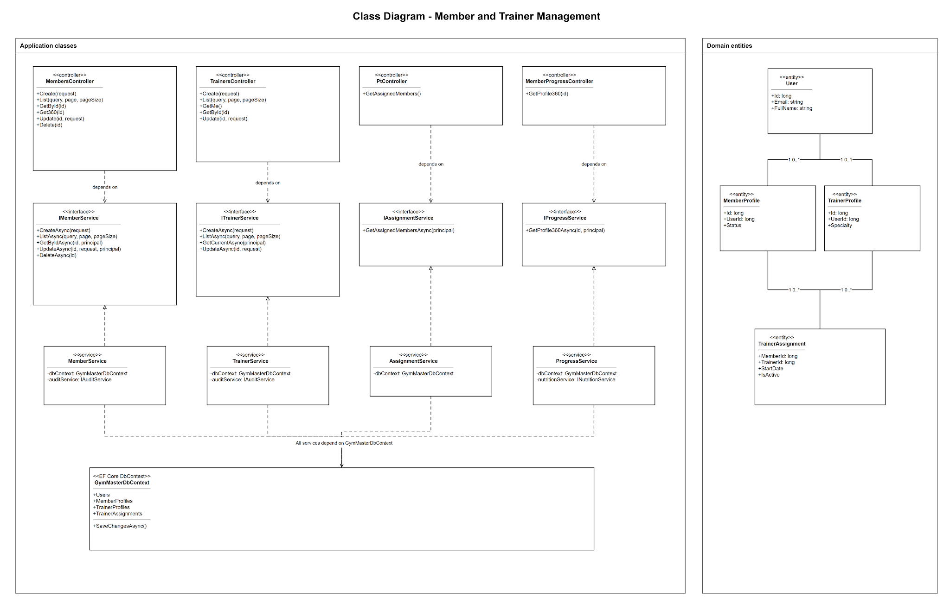
Figure 9. Class Diagram — User, Member and Trainer Management

b. Class Specifications
UsersController Class
Description: Admin-only endpoints for account CRUD, status changes and administrative password reset.
No. | Method | Input / Output | Internal processing
01 | GetUsers(UserQuery) | Input: page, search, role/status filters. Output: paged users. | Build filtered query, join roles and map account summaries.
02 | CreateUser(CreateUserRequest) | Input: account and role. Output: created user. | Validate immutable role, unique identity and create matching profile where required.
03 | UpdateStatus(id, StatusRequest) | Input: user id and new status. Output: updated status. | Apply lock/activate rules and write audit log.
04 | DeleteUser(id) | Input: user id. Output: HTTP 204. | Soft-delete user/profile and preserve historical foreign keys.

MemberService Class
Description: Member profile creation, search, ownership authorization, update and soft deletion.
No. | Method | Input / Output | Internal processing
01 | SearchAsync(MemberQuery) | Input: search/filter/page. Output: paged member summaries. | Filter active member profiles and include current membership summary.
02 | GetByIdAsync(memberId, caller) | Input: member id and caller scope. Output: member details. | Enforce self/role/assignment scope before loading account and profile.
03 | CreateAsync(CreateMemberRequest) | Input: account and member profile. Output: created member. | Create User, Member role and MemberProfile in one transaction.
04 | UpdateAsync(memberId, request) | Input: editable profile fields. Output: updated member. | Validate caller scope, unique fields and update user/profile.

TrainerService Class
Description: Creates and maintains trainer profiles and exposes the current PT profile.
No. | Method | Input / Output | Internal processing
01 | GetAllAsync(TrainerQuery) | Input: search/page. Output: paged trainers. | Query active PT accounts and trainer profile data.
02 | CreateAsync(CreateTrainerRequest) | Input: account, specialty and bio. Output: created trainer. | Create User, PT role and TrainerProfile atomically.
03 | UpdateAsync(trainerId, request) | Input: trainer profile fields. Output: updated trainer. | Validate account/profile and persist specialty, bio and experience.

c. Sequence Diagram(s)
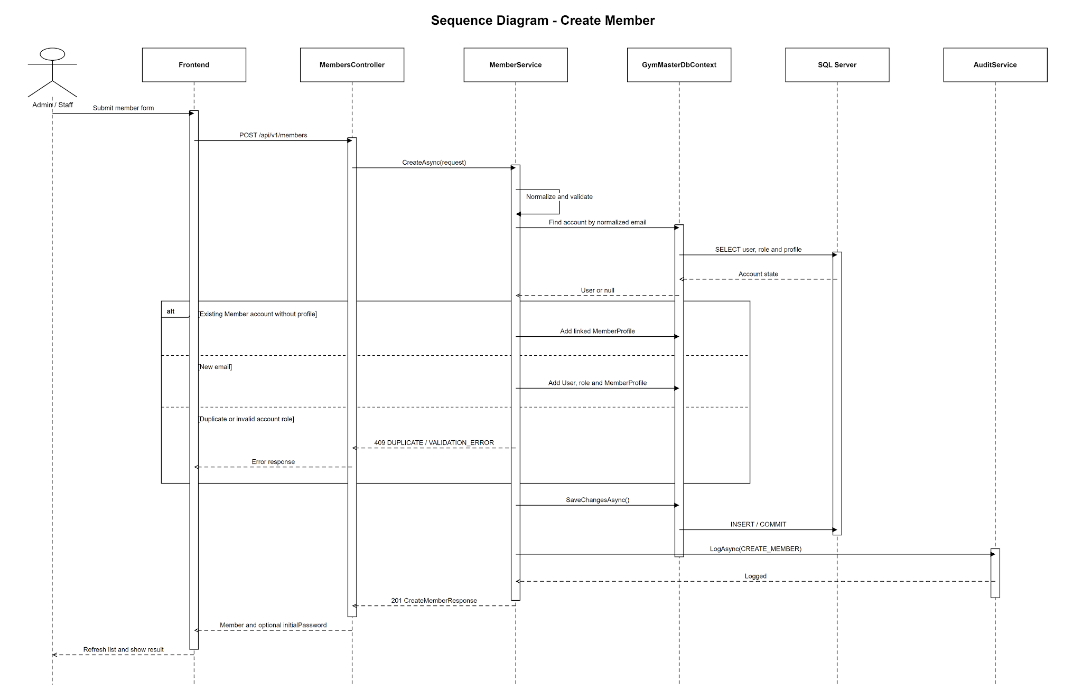
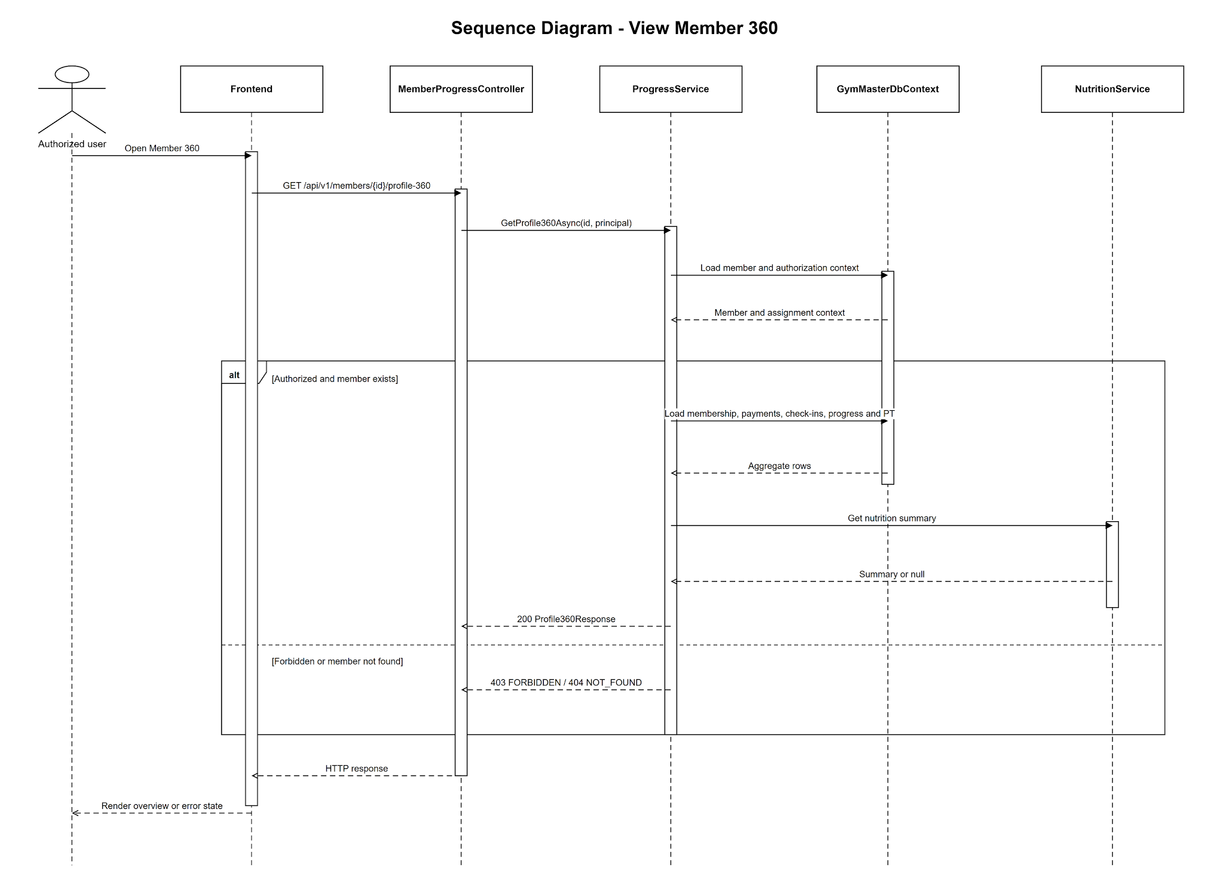
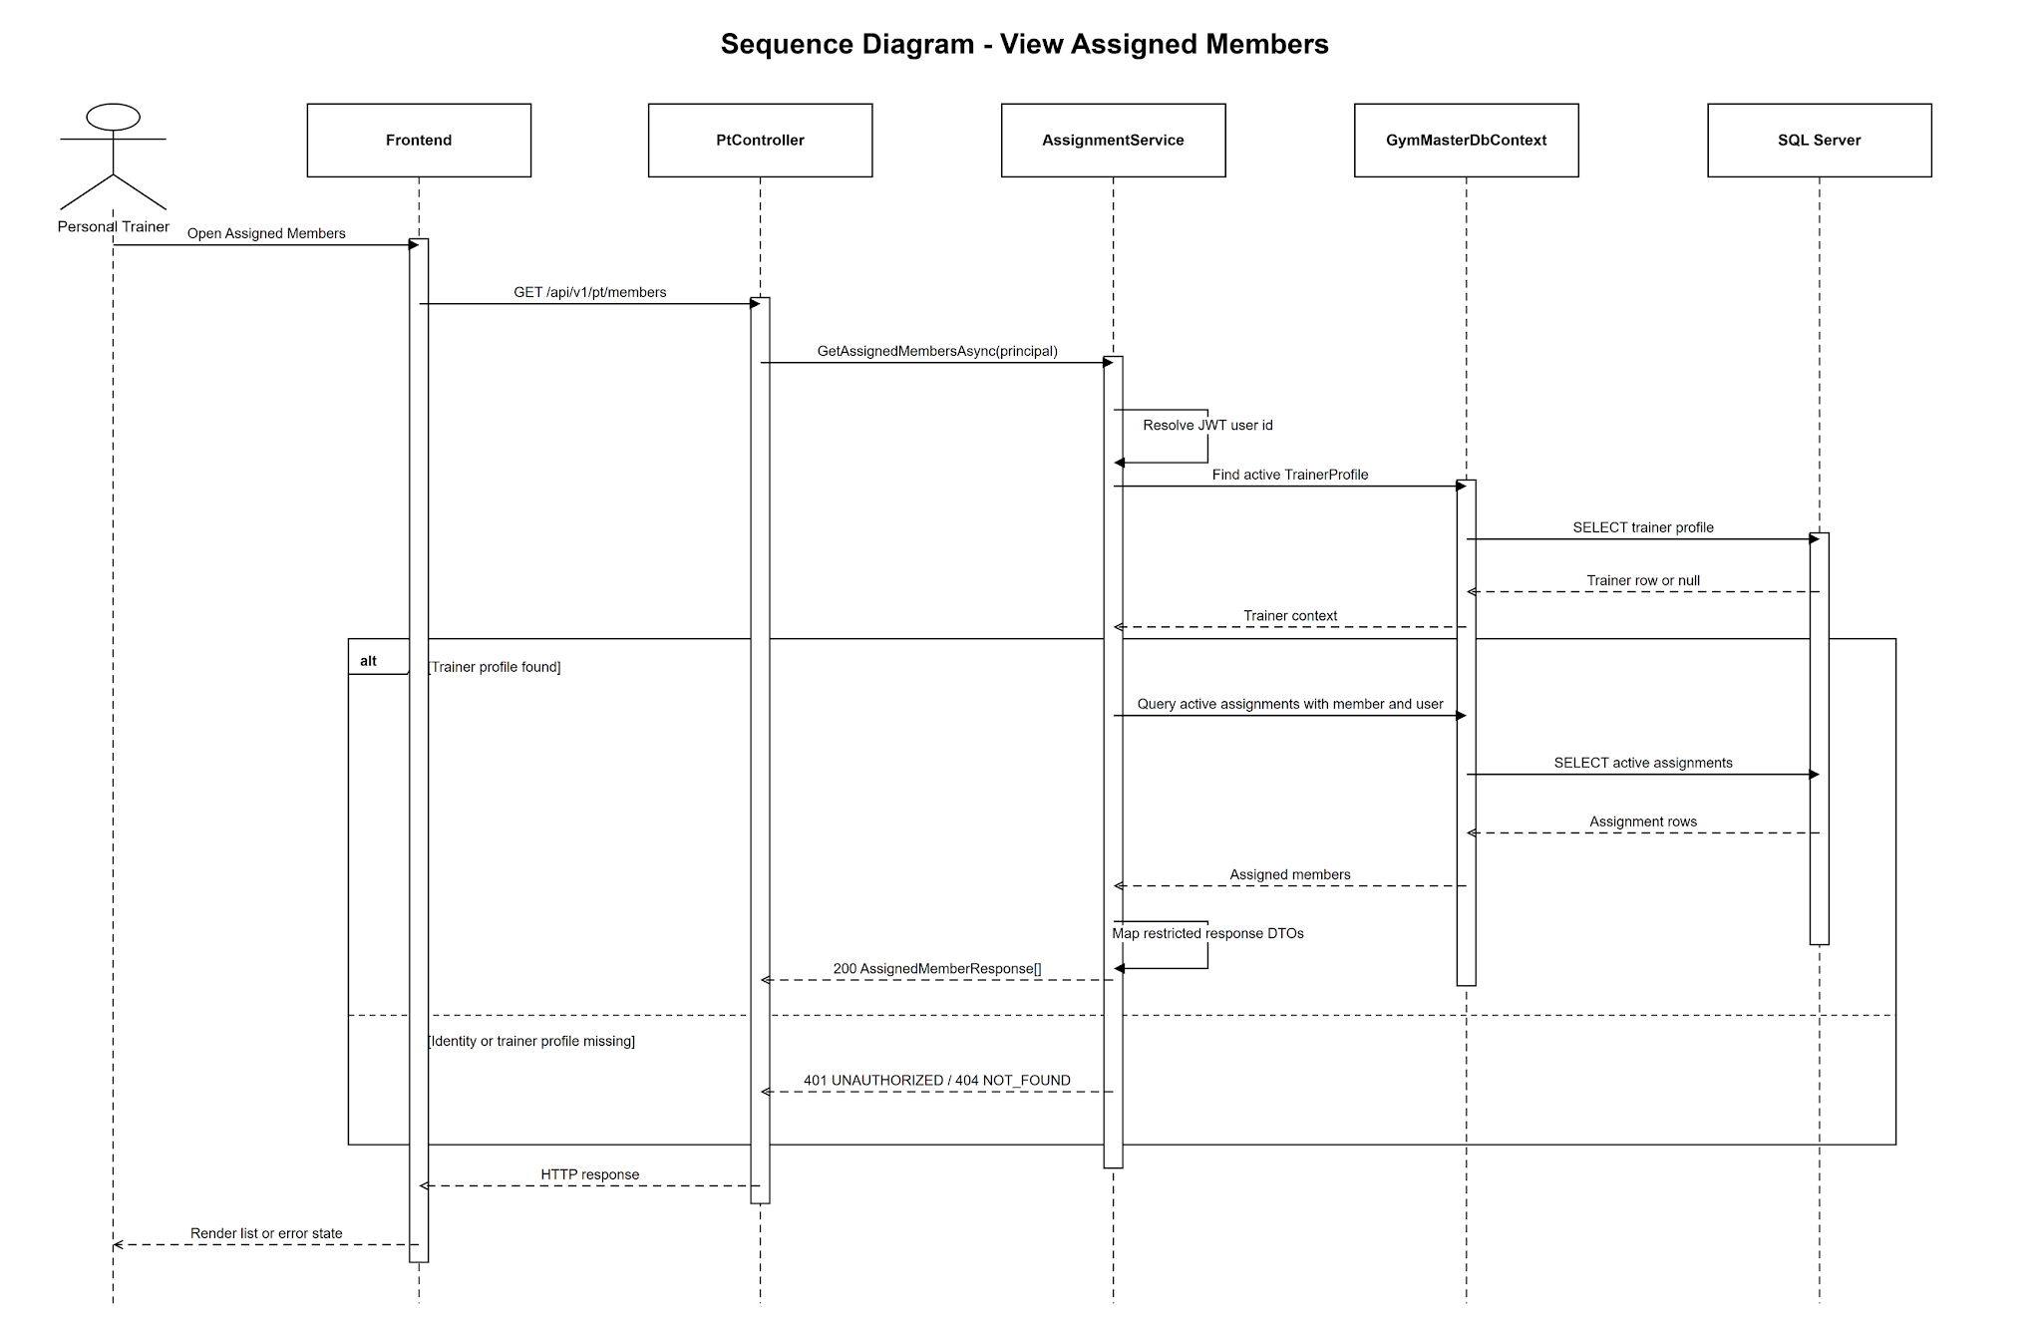
Figure 10. Sequence Diagram — User, Member and Trainer Management
Confirmed sequence flow used to draw the diagram:
- Admin or Staff opens a management workspace and the frontend sends paginated search filters.
- Controller validates role policy and delegates to the corresponding service.
- Service builds a read-only query joining users, roles and role-specific profile table.
- For create, service validates email/phone and role, hashes the initial password and begins a transaction.
- User, role mapping and matching profile are inserted; audit metadata is written.
- For update, service enforces self or management scope and updates only allowed fields.
- For delete, Admin soft-deletes the account/profile; historical payments, check-ins and training data remain intact.
- Frontend invalidates the relevant query cache and refreshes the workspace.

d. Database Queries
Q-MGT-01 — Search members
Purpose: Return active members with account fields and current membership information. Input: @Search, @Skip, @Take Output: Paged member summaries
SELECT m.Id AS MemberId, u.FullName, u.Email, u.Phone, m.JoinedAt, ms.Status AS MembershipStatus, mp.Name AS PackageName
FROM member_profiles m
JOIN users u ON u.Id = m.UserId
LEFT JOIN memberships ms ON ms.MemberId = m.Id AND ms.Status = 1 -- MembershipStatus.Active
LEFT JOIN membership_packages mp ON mp.Id = ms.PackageId
WHERE m.IsDeleted = 0 AND u.IsDeleted = 0
AND (@Search IS NULL OR u.FullName LIKE '%' + @Search + '%' OR u.Email LIKE '%' + @Search + '%')
ORDER BY u.FullName OFFSET @Skip ROWS FETCH NEXT @Take ROWS ONLY;

Q-MGT-02 — Create member account and profile
Purpose: Create the vertical slice atomically. Input: User/profile data and MemberRoleId Output: Created MemberId
BEGIN TRANSACTION;
INSERT INTO users (FullName, Email, Phone, PasswordHash, Status, CreatedAt, UpdatedAt)
VALUES (@FullName,@Email,@Phone,@PasswordHash,N'active',SYSUTCDATETIME(),SYSUTCDATETIME());
DECLARE @UserId BIGINT = SCOPE_IDENTITY();
INSERT INTO user_roles (UserId, RoleId) VALUES (@UserId, @MemberRoleId);
INSERT INTO member_profiles (UserId, JoinedAt, CreatedAt, UpdatedAt)
VALUES (@UserId, SYSUTCDATETIME(), SYSUTCDATETIME(), SYSUTCDATETIME());
COMMIT;

Q-MGT-03 — Soft-delete user/profile
Purpose: Remove an account from active operations without breaking history. Input: @UserId Output: Soft-deleted rows
BEGIN TRANSACTION;
UPDATE users SET IsDeleted = 1, UpdatedAt = SYSUTCDATETIME() WHERE Id = @UserId;
UPDATE member_profiles SET IsDeleted = 1, UpdatedAt = SYSUTCDATETIME() WHERE UserId = @UserId;
UPDATE staff_profiles SET IsDeleted = 1, UpdatedAt = SYSUTCDATETIME() WHERE UserId = @UserId;
UPDATE trainer_profiles SET IsDeleted = 1, UpdatedAt = SYSUTCDATETIME() WHERE UserId = @UserId;
COMMIT;

4. Membership Packages and Membership Lifecycle
Manages package templates, package sales, member renewal requests, renewals, cancellation and automatic/lazy lifecycle synchronization.
Design item | Specification
Actors | Admin; Staff; Member
Related screens/routes | /admin/packages, /admin/memberships, /staff/sell-package, /staff/renew-package, /member/membership
Primary API endpoints | GET/POST/PUT /api/v1/packages; GET /api/v1/memberships; GET /members/{id}/memberships; POST /memberships/sell; /renew; /renewal-request; /cancel
Persistent tables | membership_packages, memberships, users/member_profiles, audit_logs

a. Class Diagram
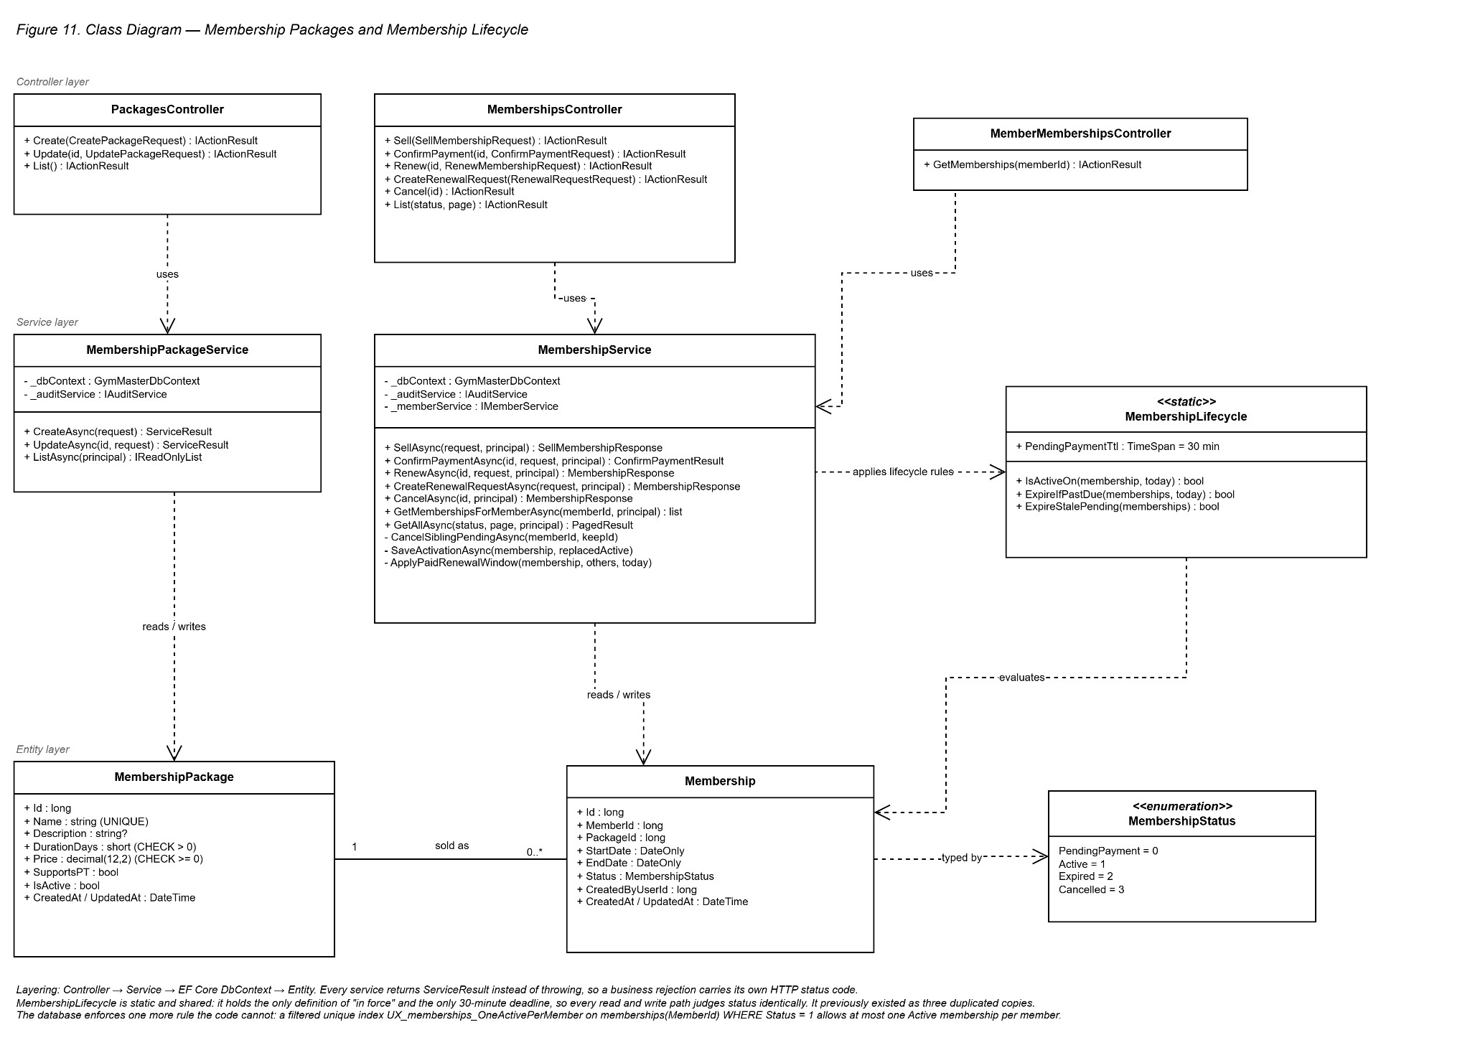
Figure 11. Class Diagram — Membership Packages and Membership Lifecycle

b. Class Specifications
PackagesController Class
Description: Lists available packages and provides Admin create/update endpoints.
No. | Method | Input / Output | Internal processing
01 | Create(CreatePackageRequest, CancellationToken) | Input: name, durationDays, price, description, supportsPT. Output: 201 with the created package. | Admin only. Delegates to MembershipPackageService.CreateAsync.
02 | Update(long id, UpdatePackageRequest, CancellationToken) | Input: package id and the fields to change. Output: 200 with the updated package. | Admin only. Partial update - a null field means leave unchanged, so historical memberships keep their own snapshot.
03 | List(CancellationToken) | Input: the caller identity carried by the token. Output: 200 with the package list. | Any authenticated role; the service decides how much to reveal.

MembershipService Class
Description: Implements sale, renewal, member request, cancellation and lifecycle synchronization.
No. | Method | Input / Output | Internal processing
01 | SellAsync(SellMembershipRequest, ClaimsPrincipal, CancellationToken) | Input: memberId, packageId, optional startDate. Output: a PendingPayment membership. | Six guards run in order: unknown caller 403, member not found 404, package not found 404, package inactive 422, start date in the past 422, member already Active 409. If a pending order already exists it is returned instead of creating a duplicate. EndDate = StartDate + DurationDays.
02 | ConfirmPaymentAsync(long id, ConfirmPaymentRequest, ClaimsPrincipal, CancellationToken) | Input: amount and method. Output: the membership, the payment and the resulting status. | Rejects a cancelled order with 409, an already paid one with 409 DUPLICATE_PAYMENT, and an invalid method or an amount below the package price with 422. On success it chains the renewal window, cancels sibling pending orders, saves through a two-step transaction and writes CONFIRM_PAYMENT.
03 | RenewAsync(long id, RenewMembershipRequest, ClaimsPrincipal, CancellationToken) | Input: packageId and method. Output: the renewed membership. | Only Cancelled is blocked with 422; Active, Expired and even PendingPayment can be renewed. EndDate = max(today, current EndDate) + DurationDays, so remaining days are never lost. A package whose SupportsPT differs is rejected with 422 PACKAGE_PT_MISMATCH. A Paid payment is recorded at once.
04 | CreateRenewalRequestAsync(RenewalRequestRequest, ClaimsPrincipal, CancellationToken) | Input: packageId. Output: a PendingPayment order. | Resolves the member profile from the token rather than from the request, reuses an existing pending order and applies the same PT type guard. The order stays pending until Staff or VNPay confirms it.
05 | CancelAsync(long id, ClaimsPrincipal, CancellationToken) | Input: membership id. Output: the cancelled membership. | Only PendingPayment or Active may be cancelled, otherwise 422 CANNOT_CANCEL - an Expired membership cannot be cancelled. A Member may cancel only their own, otherwise 403. Writes CANCEL_MEMBERSHIP together with the previous status.
06 | GetMembershipsForMemberAsync(long memberId, ClaimsPrincipal, CancellationToken) | Input: member id. Output: the membership list, newest first. | Checks ownership, then synchronises the lifecycle of the rows it just read and persists any change before returning.
07 | GetAllAsync(string status, int page, ClaimsPrincipal, CancellationToken) | Input: status filter and page. Output: a paged list of memberships. | Rejects an unknown status with 422, synchronises stale rows first, then returns page size 20 sorted newest first.

MembershipsController Class
No. | Method | Input / Output | Internal processing
01 | Sell(SellMembershipRequest, CancellationToken) | Input: memberId, packageId, optional startDate. Output: 201 with a PendingPayment membership. | Admin and Staff only.
02 | ConfirmPayment(long id, ConfirmPaymentRequest, CancellationToken) | Input: amount and method. Output: 201 with the membership and the payment. | Admin and Staff only. This is the manual payment endpoint - it belongs to this controller, not to PaymentsController.
03 | Renew(long id, RenewMembershipRequest, CancellationToken) | Input: packageId and method. Output: 200 with the renewed membership. | Admin and Staff only.
04 | CreateRenewalRequest(RenewalRequestRequest, CancellationToken) | Input: packageId. Output: 201 with a pending order. | Member only. Per ADR-05 a member may request a renewal but never activate it.
05 | Cancel(long id, CancellationToken) | Input: membership id. Output: 200 with the cancelled membership. | A Member may cancel only their own membership; Staff and Admin may cancel any.
06 | List(string status, int page, CancellationToken) | Input: status filter and page number. Output: 200 with a paged list. | Admin and Staff only. Page size is fixed at 20.
MemberMembershipsController Class
No. | Method | Input / Output | Internal processing
01 | GetMemberships(long memberId, CancellationToken) | Input: member id. Output: 200 with the membership list, newest first. | Admin and Staff may read any member; a Member may read only their own record, otherwise 403.
MembershipLifecycle Class (static, shared by every service)
No. | Method | Input / Output | Internal processing
01 | IsActiveOn(Membership, DateOnly today) : bool | Input: a membership and the current Vietnam date. Output: true when the membership is in force. | The single definition of in force: Status is Active and EndDate is not earlier than today.
02 | ExpireIfPastDue(IEnumerable<Membership>, DateOnly today) : bool | Input: the rows the caller has just read. Output: true when at least one row changed. | Turns Active rows past their EndDate into Expired. The caller decides whether to save, so the rule never runs on rows nobody asked for.
03 | ExpireStalePending(IEnumerable<Membership>) : bool | Input: the rows the caller has just read. Output: true when at least one row changed. | Turns PendingPayment rows older than PendingPaymentTtl, which is 30 minutes, into Cancelled.

c. Sequence Diagram(s)
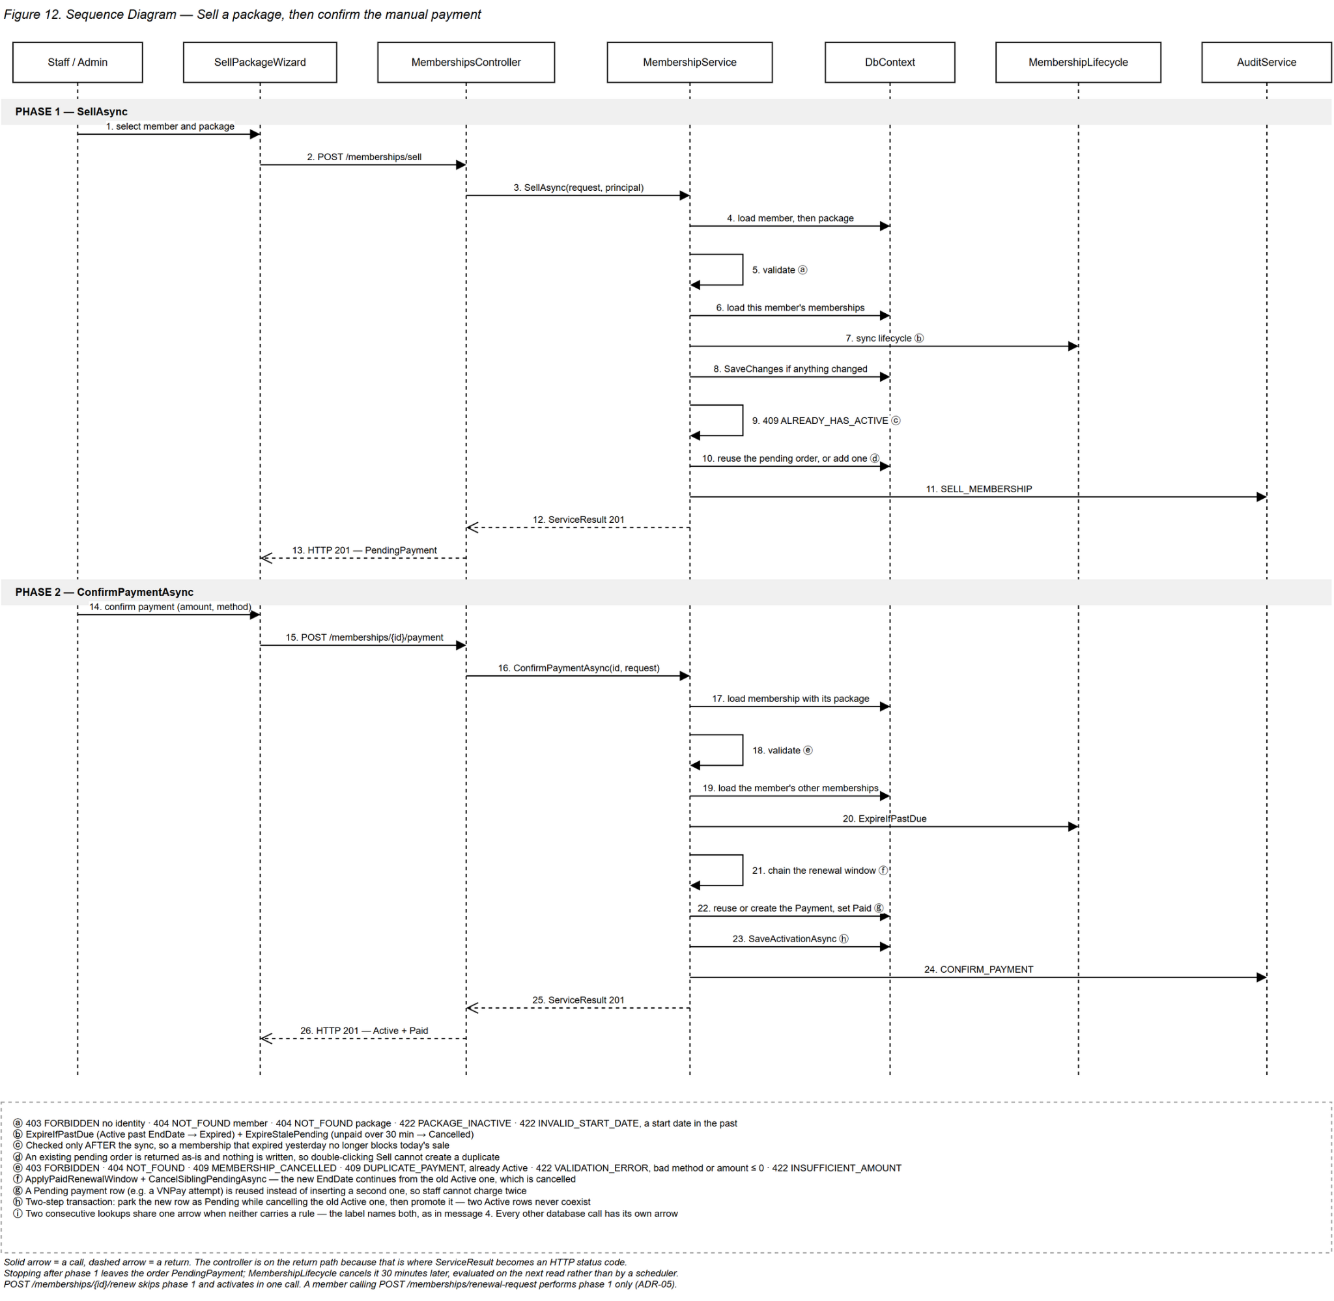
Figure 12. Sequence Diagram — Membership Packages and Membership Lifecycle
Confirmed sequence flow used to draw the diagram:
- Admin/Staff selects a member and package in the sell wizard.
- Frontend loads package data and submits the sale request.
- MembershipService validates active member, active package and requested start date.
- Service calculates EndDate from DurationDays and creates a PendingPayment membership.
- If manual payment is confirmed in the same flow, payment processing activates the membership; otherwise it remains pending.
- When data is queried, lifecycle synchronization cancels stale pending rows and expires past Active rows.
- For renewal, new coverage begins after the current EndDate when it is still active.
- All important mutations append audit metadata and return the refreshed membership DTO.

d. Database Queries
Q-MEM-01 — List package templates
Purpose: Return available package definitions. Input: @IncludeInactive Output: Package list
SELECT Id, Name, DurationDays, Price, SupportsPT, IsActive
FROM membership_packages
WHERE @IncludeInactive = 1 OR IsActive = 1
ORDER BY Price, DurationDays;

Q-MEM-02 — Create pending membership
Purpose: Store a sale or renewal request before payment. Input: @MemberId, @PackageId, @StartDate, @EndDate, @CreatedBy Output: PendingPayment membership
INSERT INTO memberships (MemberId, PackageId, StartDate, EndDate, Status, CreatedByUserId, CreatedAt)
VALUES (@MemberId,@PackageId,@StartDate,@EndDate,0,@CreatedBy,SYSUTCDATETIME()); -- MembershipStatus.PendingPayment

Q-MEM-03 — Lifecycle synchronisation applied at read time
Purpose: Cancel stale pending memberships and expire completed active memberships. Input: @NowUtc, @PendingCutoff Output: Updated statuses
-- EF Core issues these updates only for the rows loaded by the current read,
-- not as a table-wide sweep, and no scheduler ever calls them.
UPDATE memberships SET Status = 3, UpdatedAt = @NowUtc
WHERE Id IN (@LoadedIds) AND Status = 0 AND CreatedAt < @PendingCutoff; -- Pending -> Cancelled after 30 minutes
UPDATE memberships SET Status = 2, UpdatedAt = @NowUtc
WHERE Id IN (@LoadedIds) AND Status = 1 AND EndDate < CAST(@NowUtc AS date); -- Active -> Expired

5. Payment and VNPay Integration
Records manual payments, returns payment history/summary and completes signed VNPay sandbox flows with callback verification and idempotency.
Design item | Specification
Actors | Admin; Staff; Member; VNPay Gateway
Related screens/routes | /admin/payments, /staff/payments, /member/membership, /member/membership/vnpay-return
Primary API endpoints | GET /api/v1/payments; GET /payments/summary; POST /memberships/{id}/payment; POST /payments/vnpay/create-url; GET /payments/vnpay/ipn; GET /payments/vnpay/return
Persistent tables | memberships, payments, audit_logs

a. Class Diagram
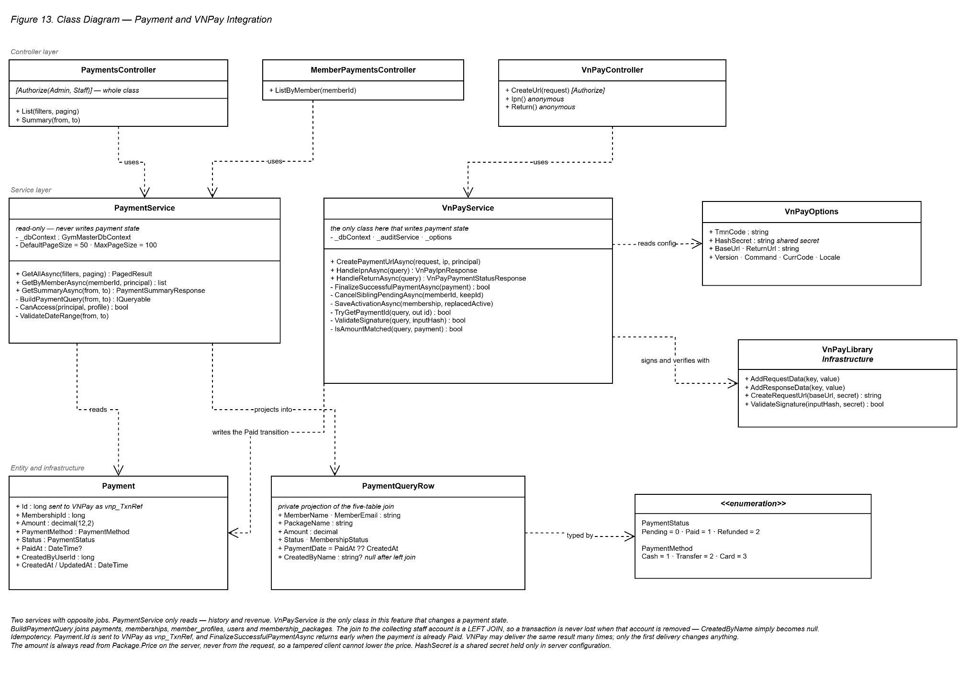
Figure 13. Class Diagram — Payment and VNPay Integration

b. Class Specifications
PaymentsController Class
Description: Exposes payment listing, summary, manual payment and VNPay endpoints.
No. | Method | Input / Output | Internal processing
01 | List(DateOnly from, DateOnly to, string status, long memberId, int page, int pageSize, CancellationToken) | Input: date, status and member filters plus paging. Output: 200 with a paged payment history. | The whole controller is restricted to Admin and Staff. Delegates to PaymentService.GetAllAsync.
02 | Summary(DateOnly from, DateOnly to, CancellationToken) | Input: a date range. Output: 200 with the revenue summary. | Delegates to PaymentService.GetSummaryAsync.

VnPayService Class
Description: Builds and verifies VNPay parameter sets using HMAC-SHA512.
No. | Method | Input / Output | Internal processing
01 | CreatePaymentUrlAsync(CreateVnPayPaymentRequest, string ipAddress, ClaimsPrincipal, CancellationToken) | Input: the pending membership and the caller. Output: the payment id and a signed URL. | Six guards including 500 VNPAY_NOT_CONFIGURED when the secret is missing. The amount is read from Package.Price on the server and never from the request. Reuses or creates a Pending Transfer payment and uses its id as vnp_TxnRef, then signs the sorted parameters with HMAC-SHA512.
02 | HandleIpnAsync(IReadOnlyDictionary<string,string> query, CancellationToken) | Input: the VNPay IPN parameters. Output: a VNPay acknowledgement. | Five checks returning VNPay own codes: 97 bad signature, 01 transaction not found, 04 wrong amount, 02 already confirmed, 00 success. Idempotent, so a repeated delivery is recorded only once.
03 | HandleReturnAsync(IReadOnlyDictionary<string,string> query, CancellationToken) | Input: the VNPay return parameters. Output: the payment and membership status. | Performs the same signature and amount checks but answers with HTTP codes because a browser is reading it. Finalises only as a fallback when the IPN has not arrived, sharing the same idempotent path so no double activation is possible.

MemberPaymentsController Class
No. | Method | Input / Output | Internal processing
01 | ListByMember(long memberId, CancellationToken) | Input: member id. Output: 200 with that member payment list. | Admin and Staff may read any member; a Member may read only their own, otherwise 403.
VnPayController Class
No. | Method | Input / Output | Internal processing
01 | CreateUrl(CreateVnPayPaymentRequest, CancellationToken) | Input: membershipId and returnUrl. Output: 200 with the signed payment URL. | Requires authentication and passes the caller IP address to the signing routine.
02 | Ipn(CancellationToken) | Input: the VNPay query string. Output: a VNPay acknowledgement code. | Anonymous by design - VNPay carries no bearer token, so the HMAC signature is the only proof of origin. This server to server call is the authoritative result.
03 | Return(CancellationToken) | Input: the VNPay query string. Output: 200 with the payment status. | Anonymous as well. This is the browser redirect, used for display and as a safe fallback when the IPN has not arrived.
PaymentService Class
No. | Method | Input / Output | Internal processing
01 | GetAllAsync(from, to, status, memberId, page, pageSize, CancellationToken) | Input: filters and paging. Output: PagedResult<PaymentHistoryResponse>. | Rejects from later than to, and an unknown status, with 422. Normalises paging - page at least 1, pageSize capped at 100 with a default of 50. Joins five tables and excludes soft-deleted members. Sorted newest first, then by id.
02 | GetByMemberAsync(long memberId, ClaimsPrincipal, CancellationToken) | Input: member id. Output: that member payment list. | Returns 404 when the member does not exist and 403 when a Member asks for somebody else. Ownership compares the user id in the token with MemberProfile.UserId, not with memberId.
03 | GetSummaryAsync(from, to, CancellationToken) | Input: a date range. Output: PaymentSummaryResponse. | Counts only Paid rows as revenue, so pending money is never reported as income. Groups by payment method and by Vietnam calendar day using PaymentDate plus seven hours, so a late evening payment lands on the correct day.

c. Sequence Diagram(s)
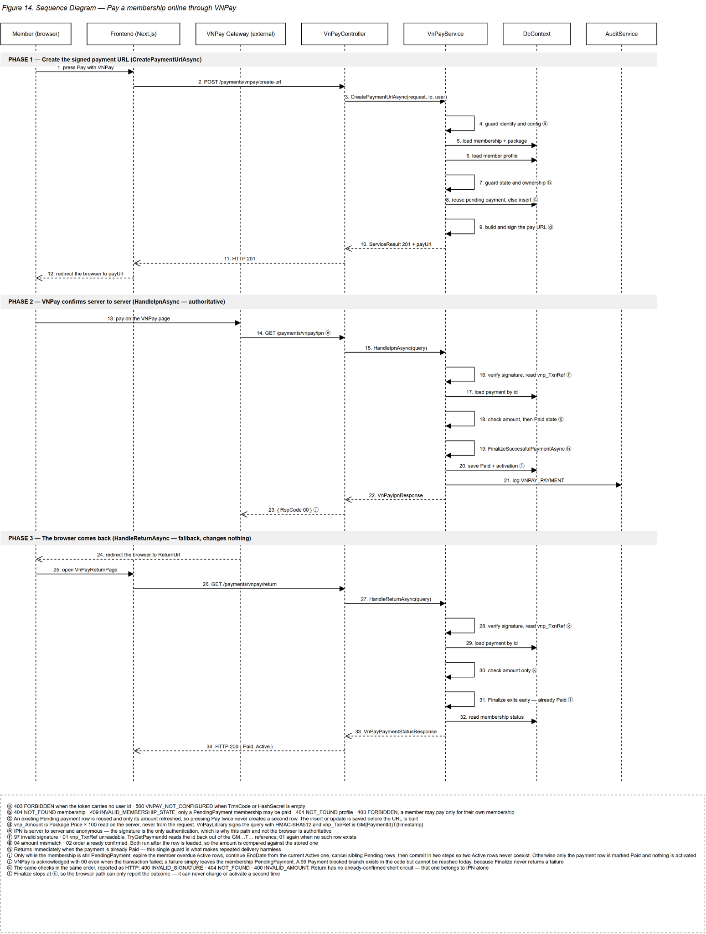
Figure 14. Sequence Diagram — Payment and VNPay Integration
Confirmed sequence flow used to draw the diagram:
- Member opens the pending membership and requests VNPay payment.
- Backend verifies membership ownership/status and creates a signed URL using server secrets.
- Frontend redirects the browser to VNPay.
- VNPay returns the user to the return endpoint and may also call the IPN endpoint.
- VNPayService verifies HMAC signature, membership reference, amount and success code.
- Inside a transaction, the service checks for an existing paid transaction to ensure idempotency.
- If not finalized, it inserts the payment and changes membership status to Active.
- Backend returns verified result; the frontend displays success, failure or already-processed state.

d. Database Queries
Q-PAY-01 — Confirm manual payment
Purpose: Insert paid transaction and activate membership atomically. Input: @MembershipId, @Amount, @CreatedBy Output: Payment and active membership
BEGIN TRANSACTION;
INSERT INTO payments (MembershipId, Amount, PaymentMethod, Status, PaidAt, CreatedByUserId, CreatedAt)
VALUES (@MembershipId,@Amount,@PaymentMethod,1,SYSUTCDATETIME(),@CreatedBy,SYSUTCDATETIME()); -- PaymentStatus.Paid
UPDATE memberships SET Status = 1, UpdatedAt = SYSUTCDATETIME()
WHERE Id = @MembershipId AND Status = 0; -- PendingPayment -> Active
COMMIT;

Q-PAY-02 — Idempotent VNPay finalization
Purpose: Finalize the Pending payment idempotently using Payment.Id from vnp_TxnRef. Input: @PaymentId, @MembershipId Output: One Paid transition at most
BEGIN TRANSACTION;
UPDATE payments SET Status = 1, PaidAt = SYSUTCDATETIME(), UpdatedAt = SYSUTCDATETIME()
WHERE Id = @PaymentId AND MembershipId = @MembershipId AND Status = 0;
IF @@ROWCOUNT = 1
UPDATE memberships SET Status = 1, UpdatedAt = SYSUTCDATETIME()
WHERE Id = @MembershipId AND Status = 0;
COMMIT; -- vnp_TxnRef is Payment.Id; repeated callbacks update zero rows

Q-PAY-03 — Payment summary
Purpose: Aggregate total paid amount and status counts for a date range. Input: @From, @To Output: Revenue and transaction metrics
SELECT SUM(CASE WHEN Status = 1 THEN Amount ELSE 0 END) AS Revenue,
COUNT(*) AS TotalTransactions,
SUM(CASE WHEN Status = 1 THEN 1 ELSE 0 END) AS PaidCount
FROM payments
WHERE CreatedAt >= @From AND CreatedAt < @To; -- PaymentStatus.Paid = 1

6. Member Check-in
Supports Member self check-in, front-desk check-in, PT check-in of assigned members and role-scoped history using Vietnam calendar-day rules.
Design item | Specification
Actors | Member; Staff; Admin; PT
Related screens/routes | /staff/check-in, /pt/check-in and role dashboards/history views
Primary API endpoints | POST /api/v1/checkins; GET /api/v1/checkins; GET /api/v1/members/{id}/checkins; POST /api/v1/pt/members/{memberId}/checkins; GET /api/v1/pt/checkins/today
Persistent tables | check_ins, member_profiles, memberships, trainer_assignments

a. Class Diagram
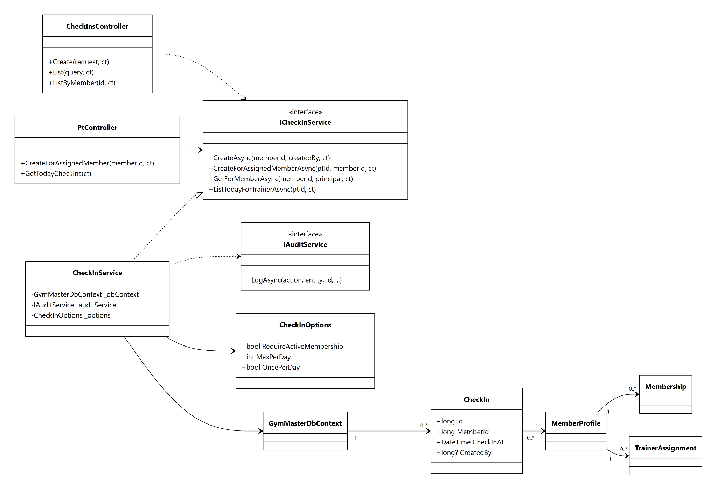
Figure 15. Class Diagram — Member Check-in

b. Class Specifications
CheckInsController Class
Description: Provides self/front-desk check-in and role-scoped history.
No. | Method | Input / Output | Internal processing
01 | CheckIn(CheckInRequest) | Input: optional member id and JWT caller. Output: check-in record. | Resolve member by role, validate daily limits/membership configuration and insert UTC timestamp.
02 | GetCheckIns(CheckInQuery) | Input: date/member/page filters. Output: paged check-ins. | Admin/Staff query with local-day boundaries.
03 | GetMemberHistory(memberId) | Input: member id and caller. Output: history list. | Enforce self/assignment/management scope and order newest first.

CheckInService Class
Description: Centralizes Vietnam-day boundaries, membership enforcement and configurable daily limits.
No. | Method | Input / Output | Internal processing
01 | CreateAsync(memberId, createdBy) | Input: member and creator. Output: CheckInDto. | Convert Vietnam day to UTC range, count existing rows, enforce limit and insert.
02 | CreateForAssignedMemberAsync(ptId, memberId) | Input: PT and member. Output: CheckInDto. | Verify active assignment before calling common create logic.

c. Sequence Diagram(s)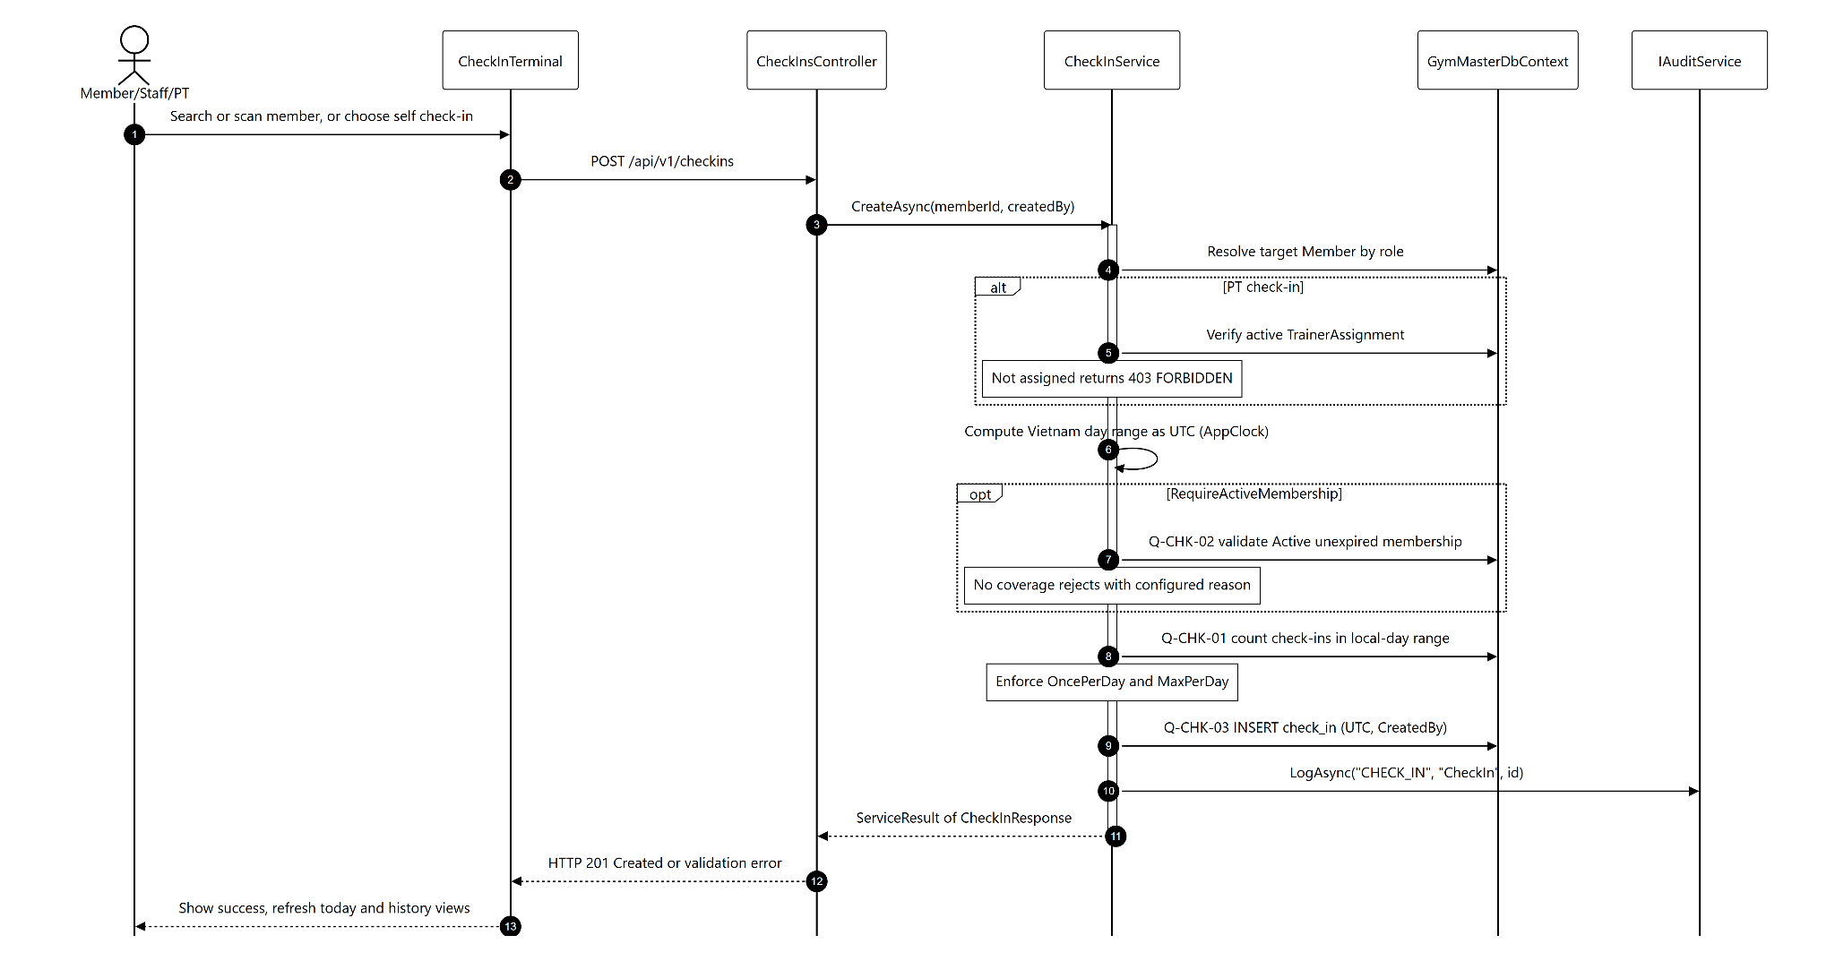Figure 16. Sequence Diagram — Member Check-in
Confirmed sequence flow used to draw the diagram:
- Actor searches/scans a member or chooses self check-in.
- Frontend posts a member identifier or uses caller identity.
- Backend resolves the target Member and verifies role/ownership/active PT assignment.
- CheckInService calculates the current Vietnam calendar-day boundaries as UTC timestamps.
- Service optionally validates Active membership based on CheckIn configuration.
- Service counts existing check-ins in the local-day range and enforces OncePerDay/MaxPerDay rules.
- A new UTC check-in row is inserted with CreatedBy when applicable.
- Frontend shows success and refreshes today/history views; validation failures show the configured reason.

d. Database Queries
Q-CHK-01 — Count check-ins for Vietnam day
Purpose: Apply the configurable daily limit using UTC storage. Input: @MemberId, @DayStartUtc, @DayEndUtc Output: Daily count
SELECT COUNT(*)
FROM check_ins
WHERE MemberId = @MemberId AND CheckInAt >= @DayStartUtc AND CheckInAt < @DayEndUtc;

Q-CHK-02 — Validate active membership
Purpose: Confirm that the member has active unexpired coverage when enforcement is enabled. Input: @MemberId, @Today Output: Boolean/existing membership
SELECT TOP 1 Id FROM memberships
WHERE MemberId = @MemberId AND Status = 1
AND StartDate <= @Today AND EndDate >= @Today
ORDER BY EndDate DESC; -- MembershipStatus.Active = 1

Q-CHK-03 — Insert check-in
Purpose: Store the arrival time in UTC. Input: @MemberId, @CreatedBy Output: Created check-in
INSERT INTO check_ins (MemberId, CheckInAt, CreatedBy)
VALUES (@MemberId, SYSUTCDATETIME(), @CreatedBy);

7. PT Assignment
Allows Admin to search eligible members/trainers, assign or reassign one active PT and lets PT list currently assigned members.
Design item | Specification
Actors | Admin; PT
Related screens/routes | /admin/assignments, /pt/members, /pt/members/[id]
Primary API endpoints | GET /api/v1/assignments/candidates/members; GET /candidates/trainers; POST /api/v1/assignments; GET /api/v1/pt/members
Persistent tables | trainer_assignments, trainer_profiles, member_profiles, memberships, membership_packages, audit_logs

a. Class Diagram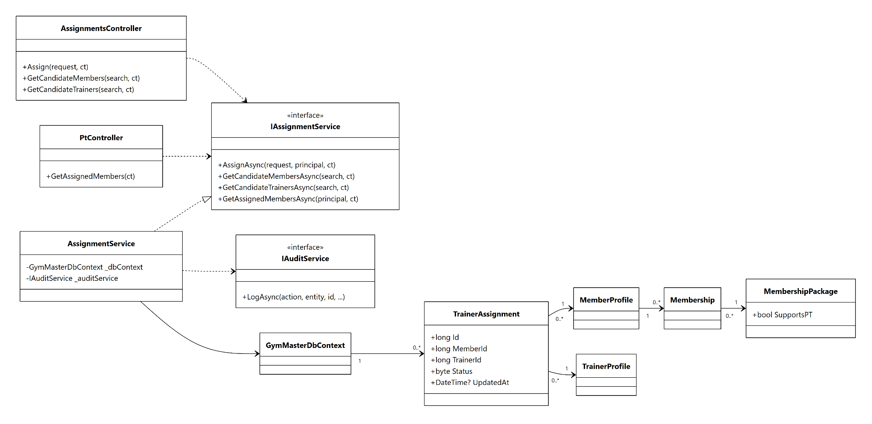Figure 17. Class Diagram — PT Assignment

b. Class Specifications
AssignmentsController Class
Description: Exposes candidate lookup and Admin assignment creation.
No. | Method | Input / Output | Internal processing
01 | GetMemberCandidates(search) | Input: search. Output: eligible members. | Return members with active unexpired packages whose package SupportsPT.
02 | GetTrainerCandidates(search) | Input: search. Output: trainers and assigned count/capacity. | Return active PT profiles and current assignment workload.
03 | Assign(AssignmentRequest) | Input: member id and trainer id. Output: active assignment. | End previous assignment and create one new active assignment transactionally.

AssignmentService Class
Description: Creates/replaces PT assignments and lists eligible members, trainers and currently assigned members. Feature services enforce their own self/management/active-assignment access checks.
No. | Method | Input / Output | Internal processing
01 | AssignAsync(AssignTrainerRequest) | Input: member, trainer and Admin principal. Output: TrainerAssignmentResponse. | Validate PT-enabled active membership, end the prior active assignment and create the replacement.

c. Sequence Diagram(s)
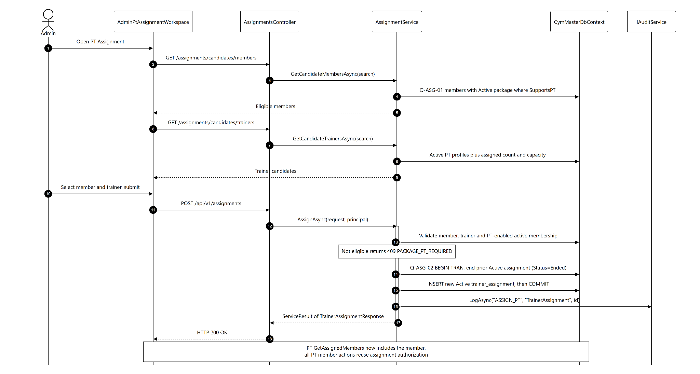
Figure 18. Sequence Diagram — PT Assignment
Confirmed sequence flow used to draw the diagram:
- Admin opens PT Assignment; frontend loads member and trainer candidate lists.
- Member candidates require an Active unexpired membership whose package SupportsPT is true.
- Trainer candidates include current assigned count for workload awareness.
- Admin selects a member and trainer and submits the assignment.
- Service validates both profiles and eligibility.
- Any previous active assignment for the member is ended using the current time.
- A new Active trainer_assignment row is created and an audit log is appended.
- PT assigned-member query immediately includes the member; all PT member actions reuse assignment authorization.

d. Database Queries
Q-ASG-01 — Eligible member candidates
Purpose: Return members whose active package supports PT. Input: @Today, @Search Output: Eligible members
SELECT DISTINCT m.Id, u.FullName, mp.Name AS PackageName
FROM member_profiles m
JOIN users u ON u.Id = m.UserId
JOIN memberships ms ON ms.MemberId = m.Id
JOIN membership_packages mp ON mp.Id = ms.PackageId
WHERE ms.Status = 1 AND ms.EndDate >= @Today AND mp.SupportsPT = 1
AND (@Search IS NULL OR u.FullName LIKE '%' + @Search + '%');

Q-ASG-02 — Reassign PT
Purpose: Guarantee at most one active assignment for a member. Input: @MemberId, @TrainerId, @CreatedBy Output: New assignment
BEGIN TRANSACTION;
UPDATE trainer_assignments SET Status = 2, EndDate = @Today, UpdatedAt = SYSUTCDATETIME()
WHERE MemberId = @MemberId AND Status = 1;
INSERT INTO trainer_assignments (MemberId, TrainerId, StartDate, Status, CreatedByUserId, CreatedAt)
VALUES (@MemberId,@TrainerId,@Today,1,@CreatedBy,SYSUTCDATETIME());
COMMIT; -- AssignmentStatuses: Active=1, Ended=2

8. Workout Plans and Trainer Notes
PT creates and maintains structured workout plans and dated notes for actively assigned members; Member and Admin have authorized read access.
Design item | Specification
Actors | PT; Member; Admin
Related screens/routes | /pt/members/[id]/workout, /pt/members/[id]/notes, /member/workout, /member/notes
Primary API endpoints | GET/POST /api/v1/members/{id}/workout-plans; PUT/DELETE /api/v1/workout-plans/{id}; GET/POST /api/v1/members/{id}/notes; PUT/DELETE /api/v1/trainer-notes/{id}; GET /api/v1/exercises
Persistent tables | trainer_assignments, exercise_catalog, workout_plans, workout_exercises, trainer_notes

a. Class Diagram
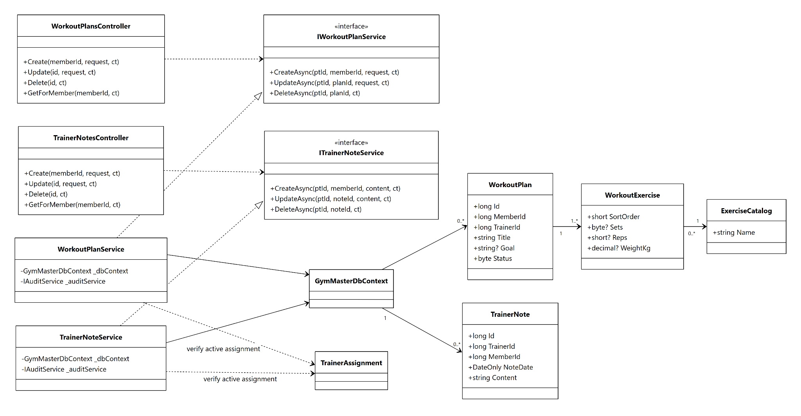
Figure 19. Class Diagram — Workout Plans and Trainer Notes

b. Class Specifications
WorkoutPlanService Class
Description: Validates PT ownership and maintains workout plan headers and ordered exercises.
No. | Method | Input / Output | Internal processing
01 | CreateAsync(ptId, memberId, request) | Input: title, goal and exercises. Output: created plan. | Require active assignment, title and at least one exercise; insert plan and items transactionally.
02 | UpdateAsync(ptId, planId, request) | Input: plan id and full plan payload. Output: updated plan. | Verify owning trainer, update header and replace ordered exercise items.
03 | DeleteAsync(ptId, planId) | Input: plan id. Output: HTTP 204. | Verify ownership and delete plan with cascading items.

TrainerNoteService Class
Description: Maintains dated text notes with trainer ownership rules.
No. | Method | Input / Output | Internal processing
01 | CreateAsync(ptId, memberId, content) | Input: member and content. Output: created note. | Verify active assignment, non-empty content and insert author/member/date.
02 | UpdateAsync(ptId, noteId, content) | Input: note id and content. Output: updated note. | Allow only the creating trainer to edit.
03 | DeleteAsync(ptId, noteId) | Input: note id. Output: HTTP 204. | Allow only the creating trainer to delete.

c. Sequence Diagram(s)
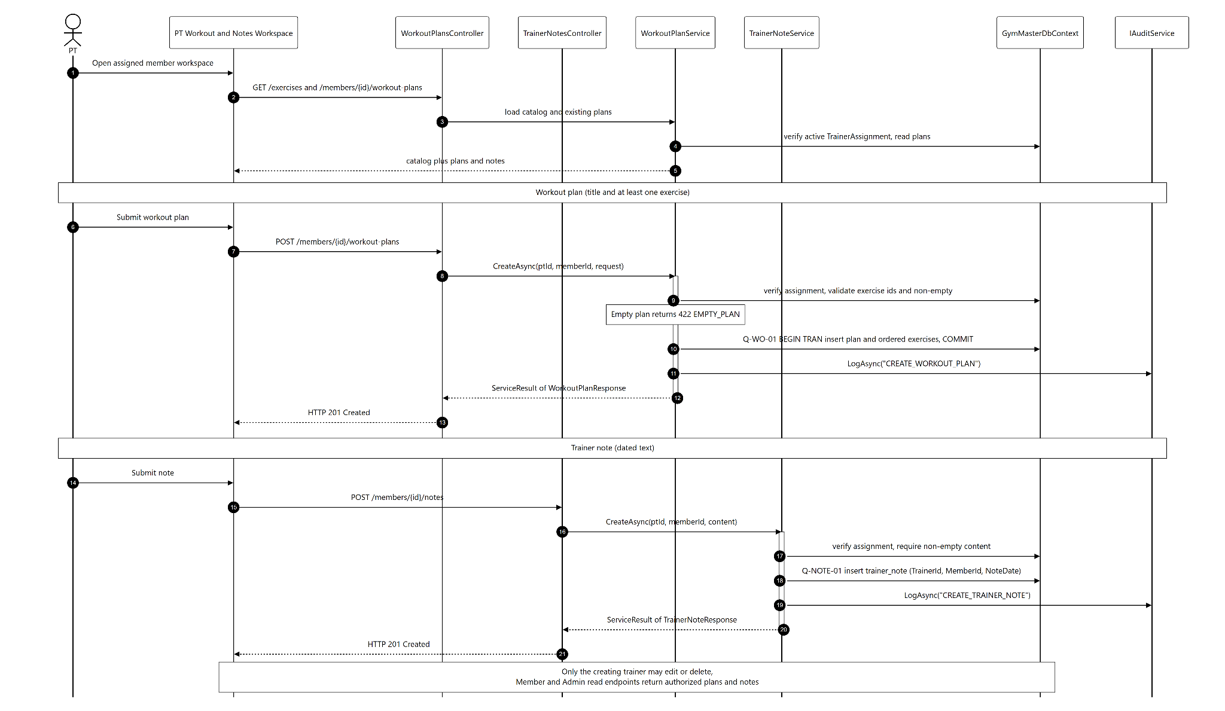
Figure 20. Sequence Diagram — Workout Plans and Trainer Notes
Confirmed sequence flow used to draw the diagram:
- PT opens the assigned member workspace; backend verifies active trainer assignment.
- Frontend loads exercise catalog and existing plans/notes.
- PT submits a workout plan with title and at least one exercise.
- Service validates exercise ids and plan ownership and starts a transaction.
- Workout plan header and ordered workout_exercises rows are stored.
- For update, existing child items are replaced by the submitted ordered set.
- For notes, service stores content, NoteDate, TrainerId and MemberId; only the same trainer may edit/delete.
- Member/Admin read endpoints return authorized plans/notes without mutation controls.

d. Database Queries
Q-WO-01 — Insert workout plan and exercises
Purpose: Persist a complete workout plan atomically. Input: Plan header and exercise list Output: Created plan
BEGIN TRANSACTION;
INSERT INTO workout_plans (MemberId, TrainerId, Title, Goal, StartDate, Status, CreatedAt)
VALUES (@MemberId,@TrainerId,@Title,@Goal,@StartDate,1,SYSUTCDATETIME());
DECLARE @PlanId BIGINT = SCOPE_IDENTITY();
-- Repeat for each ordered exercise
INSERT INTO workout_exercises (WorkoutPlanId, ExerciseId, SortOrder, Sets, Reps, WeightKg, RestSeconds, Note)
VALUES (@PlanId,@ExerciseId,@SortOrder,@Sets,@Reps,@WeightKg,@RestSeconds,@Note);
COMMIT;

Q-NOTE-01 — Create trainer note
Purpose: Store a dated note for an assigned member. Input: @TrainerId, @MemberId, @Content Output: Created note
INSERT INTO trainer_notes (TrainerId, MemberId, Content, NoteDate, CreatedAt)
VALUES (@TrainerId,@MemberId,@Content,CAST(SYSUTCDATETIME() AS date),SYSUTCDATETIME());

Q-WO-02 — Read member workout plans
Purpose: Return plan headers and ordered exercises. Input: @MemberId Output: Plans and items
SELECT wp.Id, wp.Title, wp.Goal, wp.StartDate, wp.Status, we.SortOrder, ec.Name AS ExerciseName,
we.Sets, we.Reps, we.WeightKg, we.RestSeconds, we.Note
FROM workout_plans wp
LEFT JOIN workout_exercises we ON we.WorkoutPlanId = wp.Id
LEFT JOIN exercise_catalog ec ON ec.Id = we.ExerciseId
WHERE wp.MemberId = @MemberId
ORDER BY wp.CreatedAt DESC, we.SortOrder;

9. Progress Tracking and Member 360
Stores one progress measurement per member/day and produces a consolidated Member 360 read model for authorized roles.
Design item | Specification
Actors | Member self; PT assigned; Staff; Admin
Related screens/routes | /member/progress, /pt/members/[id]/progress, /admin/members/[id], /staff/members/[id], /pt/members/[id]
Primary API endpoints | GET/POST /api/v1/members/{id}/progress; GET /api/v1/members/{id}/profile-360; GET /api/v1/members/{id}/360; GET /api/v1/members/me/profile-360
Persistent tables | progress_logs plus member, membership, payment, check-in, assignment, nutrition and training tables

a. Class Diagram

Figure 21. Class Diagram — Progress Tracking and Member 360

b. Class Specifications
ProgressService Class
Description: Validates body measurements and upserts one record per member and Vietnam date.
No. | Method | Input / Output | Internal processing
01 | RecordAsync(memberId, request, principal) | Input: measuredAt and body values. Output: ProgressResponse. | Authorize, validate values and update/insert the single record in the measured calendar-day range.
02 | GetTimelineAsync(memberId, principal) | Input: member and caller scope. Output: progress timeline. | Authorize and return records ordered by MeasuredAt.

ProgressService Class — Member 360
Description: ProgressService.GetProfile360Async builds the authorized 360 read model; there is no separate Member360Service class.
No. | Method | Input / Output | Internal processing
01 | GetProfile360Async(memberId, principal) | Input: member id and caller scope. Output: Profile360Response. | Synchronize lifecycle; load profile, membership/payment, PT, check-ins, progress and nutrition summary.

c. Sequence Diagram(s)
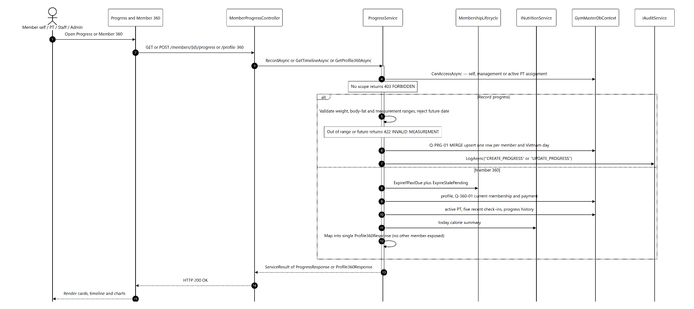
Figure 22. Sequence Diagram — Progress Tracking and Member 360
Confirmed sequence flow used to draw the diagram:
- Authorized actor opens Progress or Member 360.
- Backend enforces self, management or active PT-assignment scope.
- For progress submission, service validates weight/body-fat/measurement ranges and rejects future dates.
- Existing row for the same member/day is updated; otherwise a new row is inserted.
- For Member 360, service first synchronizes membership lifecycle.
- Service executes read-only queries for profile, current membership/payment, active PT, five recent check-ins, progress history and today nutrition summary.
- The data is mapped into a single response DTO without exposing another member.
- Frontend renders cards, timeline and charts.

d. Database Queries
Q-PRG-01 — Upsert daily progress
Purpose: Keep one progress record per member/day. Input: @MemberId, @MeasuredAt, day range and measurement values Output: Inserted or updated progress row
MERGE progress_logs AS target
USING (SELECT @MemberId AS MemberId, @MeasuredAt AS MeasuredAt) AS src
ON target.MemberId = src.MemberId
AND target.MeasuredAt >= @DayStart AND target.MeasuredAt < @DayEnd
WHEN MATCHED THEN UPDATE SET MeasuredAt=@MeasuredAt, WeightKg=@WeightKg, BodyFatPercent=@BodyFat, ChestCm=@ChestCm, WaistCm=@WaistCm, HipCm=@HipCm, Note=@Note
WHEN NOT MATCHED THEN INSERT (MemberId,MeasuredAt,WeightKg,BodyFatPercent,ChestCm,WaistCm,HipCm,Note,CreatedByUserId,CreatedAt)
VALUES (@MemberId,@MeasuredAt,@WeightKg,@BodyFat,@ChestCm,@WaistCm,@HipCm,@Note,@CreatedBy,SYSUTCDATETIME());

Q-360-01 — Current membership for Member 360
Purpose: Select Active membership or latest PendingPayment when no active row exists. Input: @MemberId, @Today Output: Current membership summary
SELECT TOP 1 ms.Id, ms.Status, ms.StartDate, ms.EndDate, mp.Name, mp.SupportsPT, p.Status AS PaymentStatus
FROM memberships ms
JOIN membership_packages mp ON mp.Id = ms.PackageId
LEFT JOIN payments p ON p.MembershipId = ms.Id AND p.Status = 1
WHERE ms.MemberId = @MemberId AND ms.Status IN (1,0)
ORDER BY CASE WHEN ms.Status = 1 THEN 0 ELSE 1 END, ms.CreatedAt DESC;

10. Nutrition Targets, Food Catalog and Meal Journal
Maintains effective calorie/macro targets, food items, daily meal logs and calculated calorie/macro summaries with role and ownership controls.
Design item | Specification
Actors | Member self; PT assigned; Staff; Admin
Related screens/routes | /member/nutrition/meal-journal, /member/nutrition/summary and nutrition cards in Member 360
Primary API endpoints | GET/POST /api/v1/food-items; GET/POST /api/v1/meal-logs; GET/POST /api/v1/members/{id}/calorie-target; GET /calorie-summary; GET /calorie-history
Persistent tables | food_items, meal_logs, meal_log_items, calorie_targets, member_profiles, trainer_assignments

a. Class Diagram
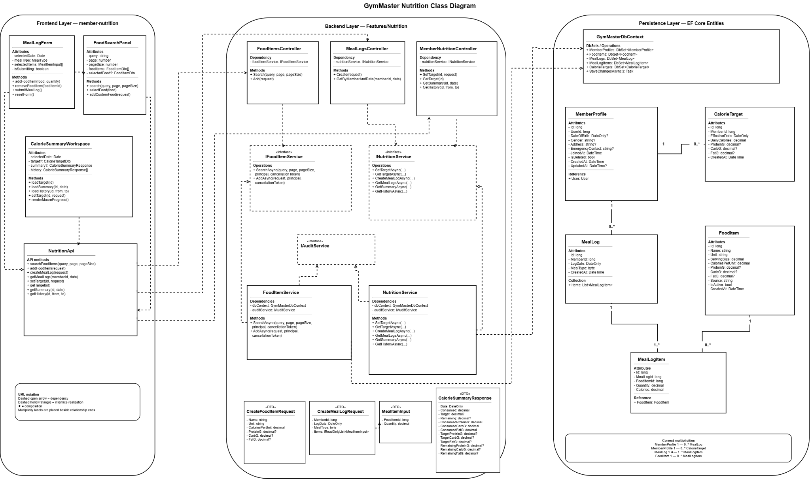
Figure 23. Class Diagram — Nutrition Targets, Food Catalog and Meal Journal

b. Class Specifications
FoodItemsController, MealLogsController and MemberNutritionController
Description: The three implemented controllers expose food catalog, meal journal, calorie target, summary and history endpoints.
No. | Method | Input / Output | Internal processing
01 | GetFoodItems(FoodQuery) | Input: search/page. Output: food catalog. | Return active food items matching name/source.
02 | CreateFoodItem(CreateFoodItemRequest) | Input: food nutrition data. Output: created/reused food. | Validate serving/calories/macros and prevent duplicate normalized names where applicable.
03 | CreateMealLog(CreateMealLogRequest) | Input: date, meal type and food items. Output: meal log. | Resolve member scope and insert meal header/items with nutrition snapshots.
04 | SetCalorieTarget(memberId, request) | Input: effective date and calorie/macros. Output: target. | Authorize and upsert unique MemberId + EffectiveDate target.
05 | GetCalorieSummary(memberId, date) | Input: member and date. Output: target, consumed, remaining and macros. | Select nearest effective target and aggregate all meal items for the day.

NutritionService Class
Description: Stores calorie targets and meals, then calculates calories from meal snapshots and macros from joined FoodItem values.
No. | Method | Input / Output | Internal processing
01 | GetSummaryAsync(memberId, date, principal) | Input: member/date/scope. Output: CalorieSummaryResponse. | Load the effective target; sum calories and FoodItem-derived macros; calculate remaining values.
02 | GetHistoryAsync(memberId, from, to, principal) | Input: date range and caller scope. Output: daily summaries. | Authorize, calculate each requested day and return chronological results.

c. Sequence Diagram(s)
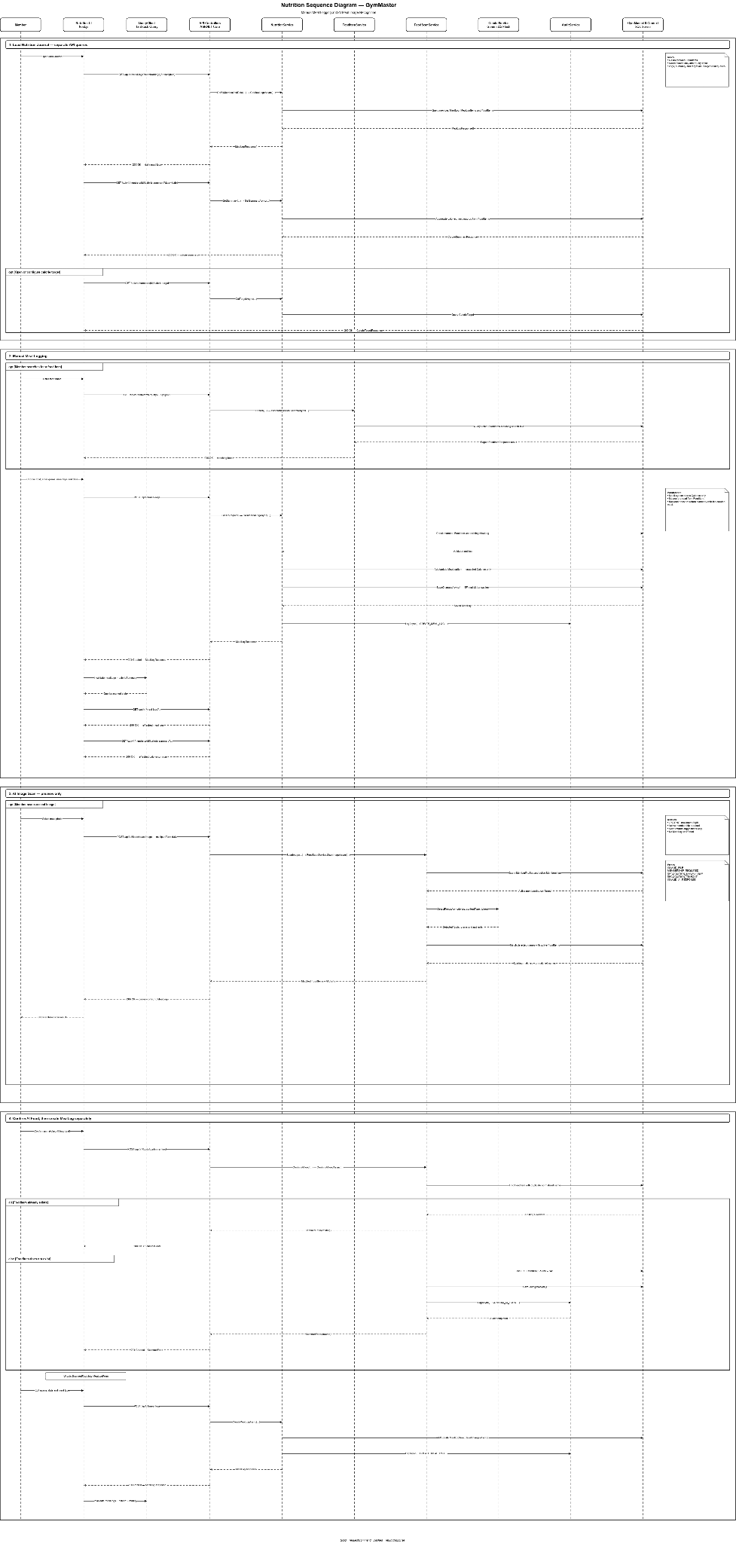
Figure 24. Sequence Diagram — Nutrition Targets, Food Catalog and Meal Journal
Confirmed sequence flow used to draw the diagram:
- Member opens Meal Journal; frontend loads food catalog, existing daily meals and current target.
- Member searches a food or creates a custom food item with serving and macro values.
- Member selects meal type, date, food and quantity and submits the meal.
- MealLogsController delegates to NutritionService, which resolves access scope and validates all item quantities.
- Service creates a meal_logs header and child meal_log_items with quantity and calorie snapshots; macro totals are derived from FoodItem values.
- For summary, service selects the nearest calorie_target whose EffectiveDate is not later than the requested date.
- All meal items for that day are aggregated and compared with the target.
- Frontend refreshes the journal, consumed/remaining cards and history chart.

d. Database Queries
Q-NUT-01 — Effective calorie target
Purpose: Select the nearest target effective on or before the requested date. Input: @MemberId, @Date Output: Calorie and macro target
SELECT TOP 1 DailyCalories, ProteinG, CarbG, FatG, EffectiveDate
FROM calorie_targets
WHERE MemberId = @MemberId AND EffectiveDate <= @Date
ORDER BY EffectiveDate DESC;

Q-NUT-02 — Create meal log and items
Purpose: Persist a meal with quantity and calorie snapshots. Input: Meal header and item list Output: Created meal log
BEGIN TRANSACTION;
INSERT INTO meal_logs (MemberId, LogDate, MealType, CreatedAt)
VALUES (@MemberId,@LogDate,@MealType,SYSUTCDATETIME());
DECLARE @MealLogId BIGINT = SCOPE_IDENTITY();
INSERT INTO meal_log_items (MealLogId, FoodItemId, Quantity, Calories)
VALUES (@MealLogId,@FoodItemId,@Quantity,@Calories);
COMMIT; -- MealType is tinyint: Breakfast=1, Lunch=2, Dinner=3, Snack=4

Q-NUT-03 — Daily calorie/macro aggregation
Purpose: Calculate consumed calories and macros for a member/day. Input: @MemberId, @Date Output: Consumed totals
SELECT COALESCE(SUM(i.Calories),0) AS Calories,
COALESCE(SUM(COALESCE(f.ProteinG,0) * i.Quantity),0) AS ProteinG,
COALESCE(SUM(COALESCE(f.CarbG,0) * i.Quantity),0) AS CarbG,
COALESCE(SUM(COALESCE(f.FatG,0) * i.Quantity),0) AS FatG
FROM meal_logs l
JOIN meal_log_items i ON i.MealLogId = l.Id
JOIN food_items f ON f.Id = i.FoodItemId
WHERE l.MemberId = @MemberId AND l.LogDate = @Date;

11. Gemini Food Image Recognition
Uses Gemini 2.5 Flash to analyze a meal image, returns editable food drafts, and confirms the selected result into the food catalog without automatically creating a meal log.
Design item | Specification
Actors | Member with active membership; Gemini AI Service
Related screens/routes | /member/nutrition/meal-journal — AI image assistance panel
Primary API endpoints | POST /api/v1/foods/scan-image; POST /api/v1/foods/confirm-ai-food
Persistent tables | membership/member validation, food_items; meal tables only after user separately adds the confirmed food to a meal

a. Class Diagram
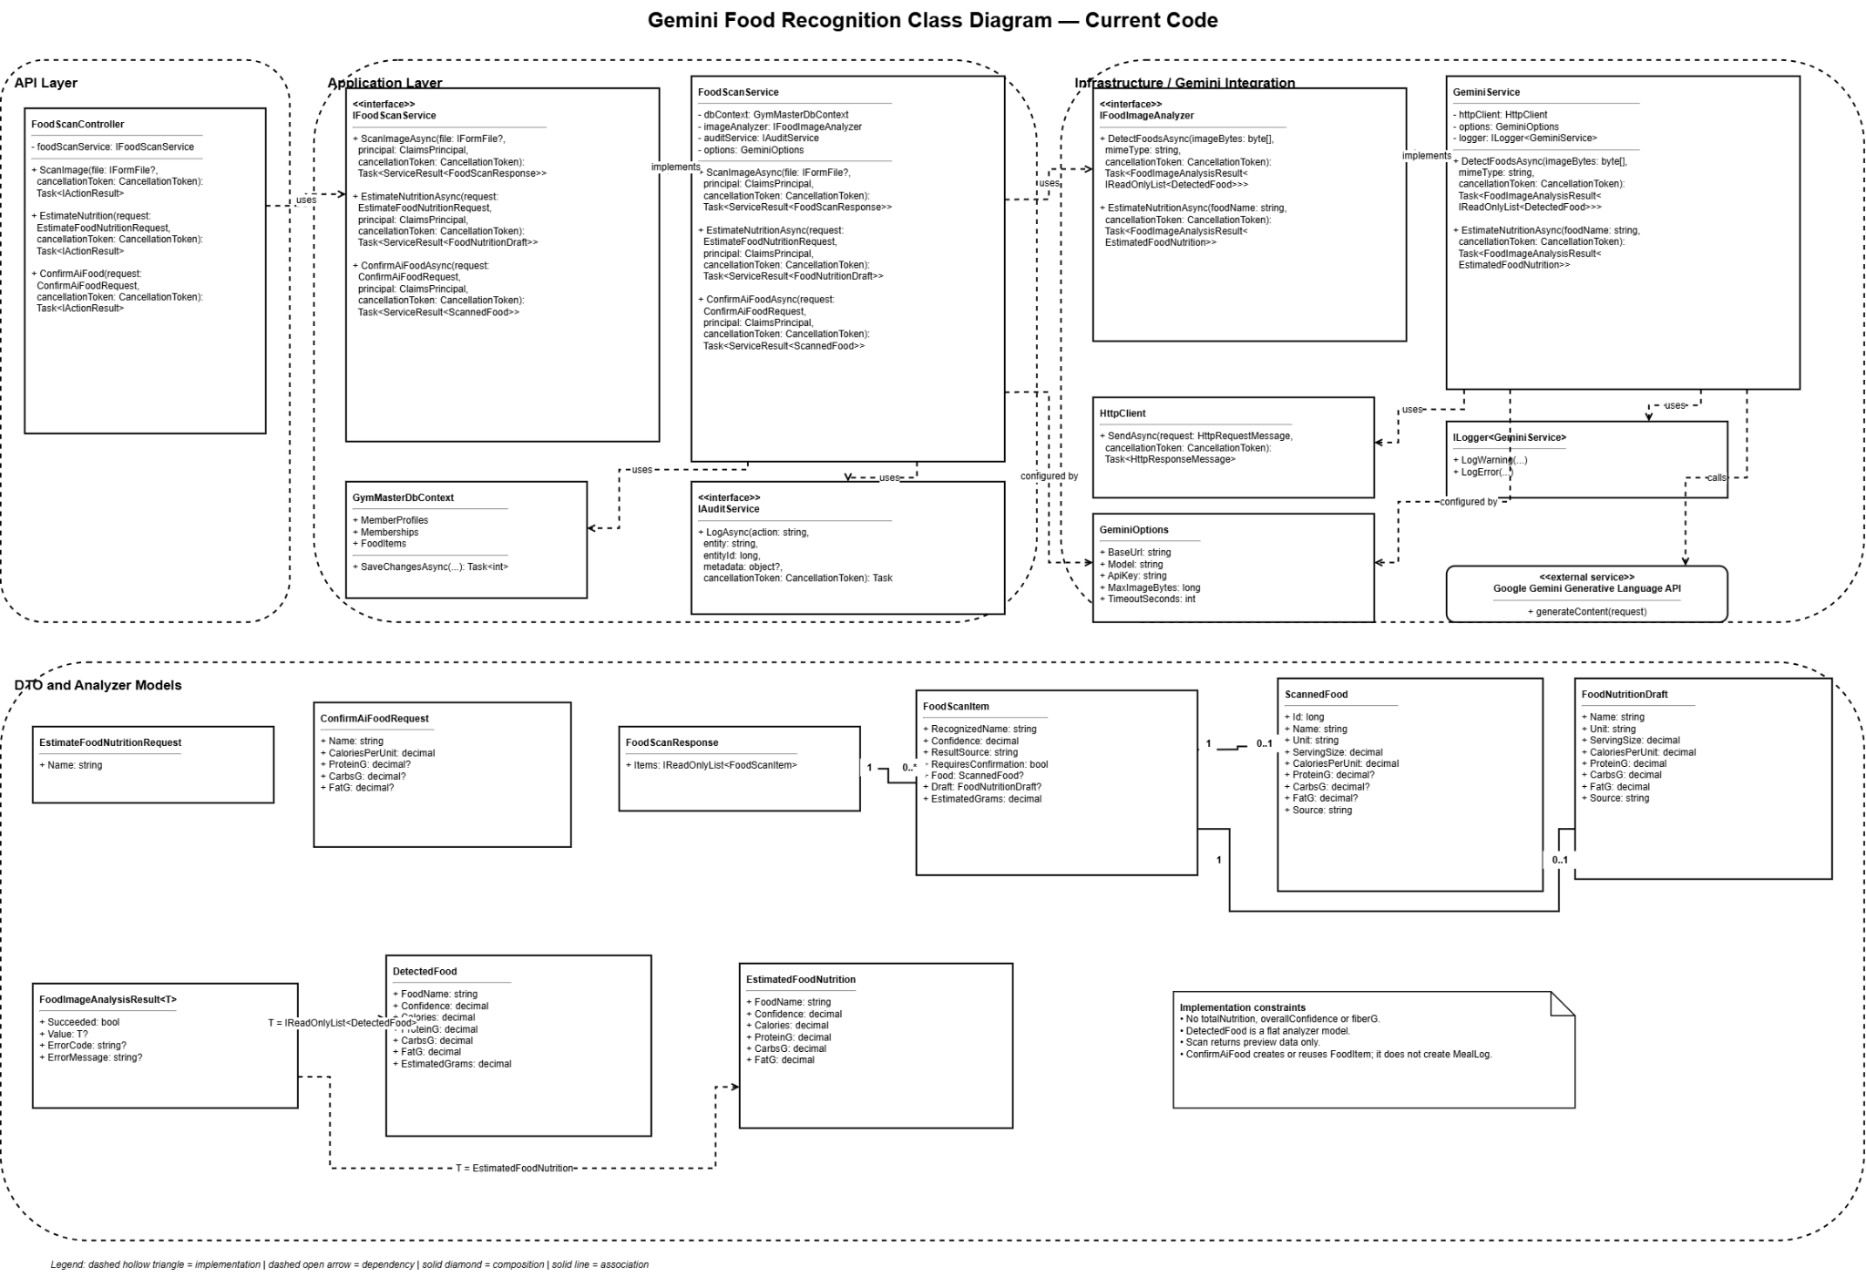
Figure 25. Class Diagram — Gemini Food Image Recognition

b. Class Specifications
FoodScanController Class
Description: Member-only endpoints for scan-image, estimate-nutrition and confirm-ai-food under /api/v1/foods.
No. | Method | Input / Output | Internal processing
01 | ScanImage(IFormFile image) | Input: food image. Output: editable AI food drafts. | Validate role/membership and file, then call FoodScanService.ScanImageAsync.
02 | ConfirmAiFood(ConfirmAiFoodRequest) | Input: corrected food draft. Output: existing/new FoodItem. | Validate values and call FoodScanService.ConfirmAiFoodAsync.
03 | EstimateNutrition(EstimateFoodNutritionRequest) | Input: food name. Output: nutrition estimate. | Call FoodScanService.EstimateNutritionAsync without persisting data.

GeminiService Class
Description: IFoodImageAnalyzer implementation that invokes Gemini 2.5 Flash, validates structured output and returns detected-food estimates.
No. | Method | Input / Output | Internal processing
01 | DetectFoodsAsync(byte[], contentType, token) | Input: image bytes/type. Output: detected-food list. | Call gemini-2.5-flash with JSON schema; strip/parse/validate the structured response.

c. Sequence Diagram(s)
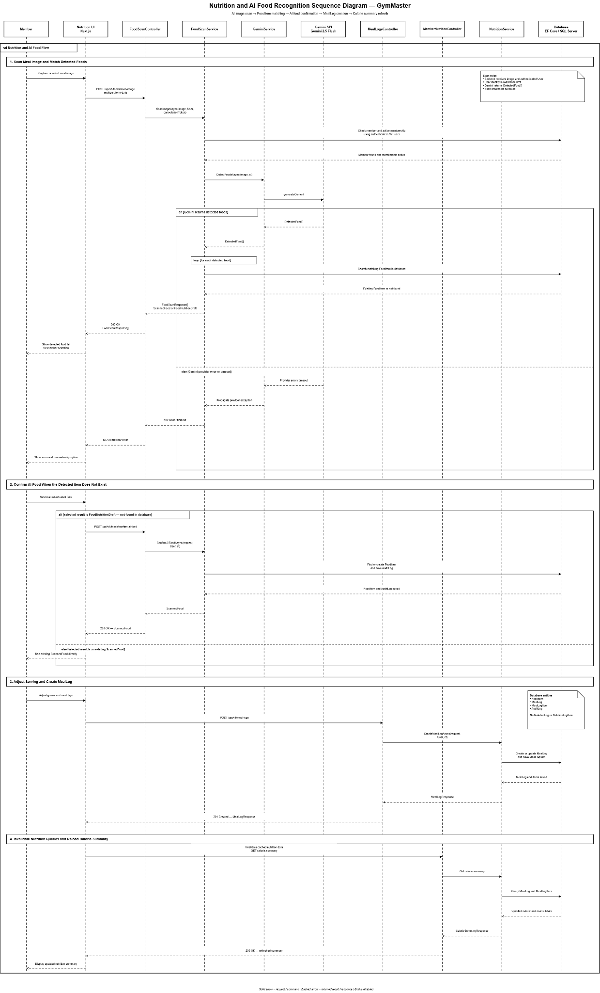
Figure 26. Sequence Diagram — Gemini Food Image Recognition
Confirmed sequence flow used to draw the diagram:
- Member selects or captures a food image in Meal Journal.
- Frontend validates file type/size and posts multipart form data to /foods/scan-image.
- Backend confirms the caller has an active membership and validates the image.
- GeminiService sends the image with a strict structured-output prompt and timeout token.
- Gemini response is normalized, code fences are removed and JSON is parsed into food drafts.
- Invalid, empty or timed-out responses return a safe external-service error without persisting data.
- Frontend lets the Member correct name, serving, calories and macros.
- Member confirms a draft; backend finds an equivalent catalog item or inserts a new AI-sourced food item.
- The confirmed item becomes available for normal meal-log creation.

d. Database Queries
Q-AI-01 — Verify active membership
Purpose: Restrict AI scan to an active member subscription. Input: @MemberId, @Today Output: Active membership exists
SELECT TOP 1 1 FROM memberships
WHERE MemberId = @MemberId AND Status = 1
AND StartDate <= @Today AND EndDate >= @Today; -- MembershipStatus.Active = 1

Q-AI-02 — Find or create confirmed food
Purpose: Reuse an equivalent food item or persist the corrected AI result. Input: Food name and nutrition values Output: FoodItem
SELECT TOP 1 * FROM food_items
WHERE IsActive = 1 AND Name COLLATE Latin1_General_100_CI_AI = @Name;
IF @@ROWCOUNT = 0
INSERT INTO food_items (Name, Unit, ServingSize, CaloriesPerUnit, ProteinG, CarbG, FatG, Source, IsActive, CreatedAt)
VALUES (@Name,N'g',100,@CaloriesPerUnit,@ProteinG,@CarbsG,@FatG,N'AI',1,SYSUTCDATETIME());

12. Admin Dashboard and Audit Logs
Aggregates operational metrics for Admin and provides paged, filterable, append-only audit history of important mutating actions.
Design item | Specification
Actors | Admin
Related screens/routes | /admin/dashboard, /admin/audit-logs; summary cards on role dashboards use related feature APIs
Primary API endpoints | GET /api/v1/dashboard/summary; GET /api/v1/audit-logs
Persistent tables | payments, memberships, membership_packages, check_ins, member_profiles, trainer_assignments, audit_logs, users

a. Class Diagram
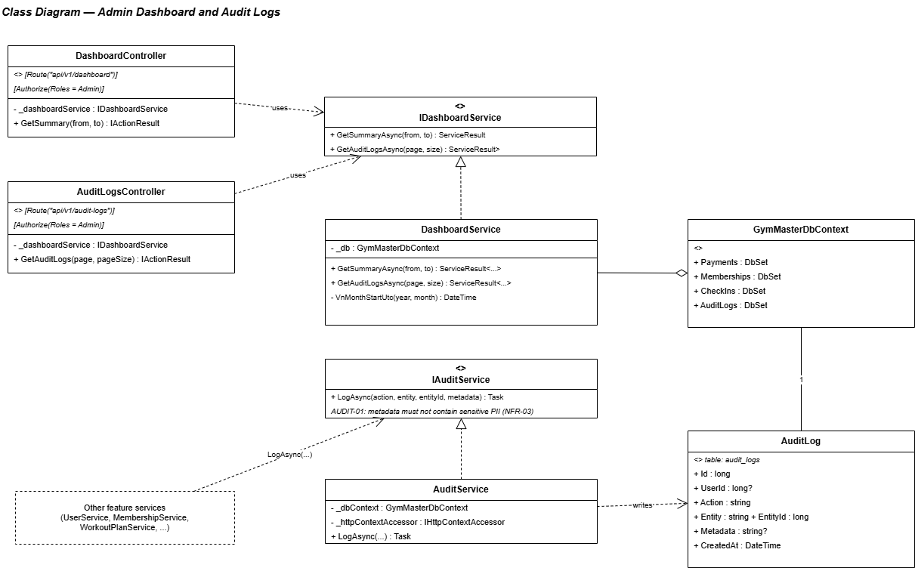
Figure 27. Class Diagram — Admin Dashboard and Audit Logs

b. Class Specifications
DashboardController Class
Description: Admin endpoint for date-range operational summary and chart data.
No. | Method | Input / Output | Internal processing
01 | GetSummary(DashboardQuery) | Input: from/to and grouping options. Output: dashboard DTO. | Validate range, call aggregation service and return revenue, membership, check-in and facility-load metrics.

DashboardService Class
Description: Executes optimized read-only aggregates and maps them to dashboard cards/charts.
No. | Method | Input / Output | Internal processing
01 | GetSummaryAsync(from, to) | Input: UTC date range. Output: DashboardSummaryDto. | Run revenue, membership, new-member, check-in and peak-hour aggregates; combine into one response.

AuditService and DashboardService — Audit Operations
Description: AuditService.LogAsync appends records; DashboardService.GetAuditLogsAsync performs Admin filtering and paging. There is no AuditLogService class.
No. | Method | Input / Output | Internal processing
01 | AuditService.LogAsync(action, entity, entityId, metadata) | Input: audit context. Output: Task. | Resolve actor from HttpContext, serialize safe metadata and append an AuditLog.
02 | DashboardService.GetAuditLogsAsync(filters, page) | Input: user/action/date/search/page. Output: PagedResult. | Filter AuditLogs, page newest first and resolve non-deleted user display names.

c. Sequence Diagram(s)
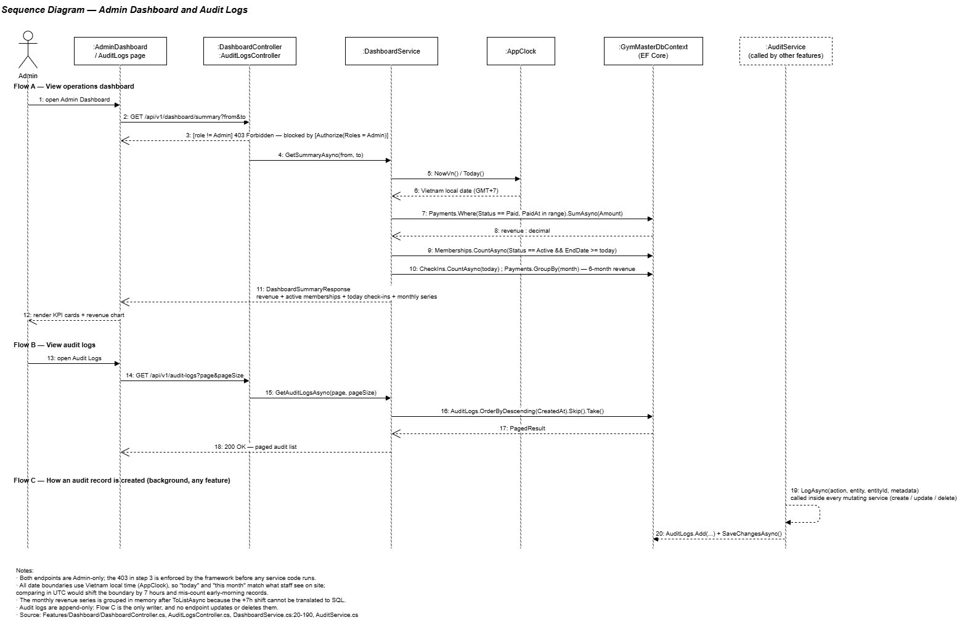
Figure 28. Sequence Diagram — Admin Dashboard and Audit Logs
Confirmed sequence flow used to draw the diagram:
- Admin opens Dashboard and selects a date range.
- Frontend requests /api/v1/dashboard/summary.
- DashboardController validates that the caller is Admin and that the date range is valid.
- DashboardService executes independent read-only aggregates for payments, memberships, members and check-ins.
- Peak-hour and facility-load values use Vietnam-local hour/day grouping while data remains UTC.
- Service combines the aggregate results into card and chart DTOs and returns them.
- For audit logs, Admin applies user/action/date/search filters.
- DashboardService.GetAuditLogsAsync returns paged append-only records newest first with user display name and safe metadata.

d. Database Queries
Q-DASH-01 — Revenue by day
Purpose: Build the dashboard revenue series. Input: @FromUtc, @ToUtc Output: Daily paid revenue
SELECT CAST(PaidAt AT TIME ZONE 'UTC' AT TIME ZONE 'SE Asia Standard Time' AS date) AS RevenueDate,
SUM(Amount) AS Revenue
FROM payments
WHERE Status = 1 AND PaidAt >= @FromUtc AND PaidAt < @ToUtc
GROUP BY CAST(PaidAt AT TIME ZONE 'UTC' AT TIME ZONE 'SE Asia Standard Time' AS date)
ORDER BY RevenueDate; -- PaymentStatus.Paid = 1

Q-DASH-02 — Membership status counts
Purpose: Count memberships by current lifecycle status. Input: @FromUtc, @ToUtc Output: Status counts
SELECT Status, COUNT(*) AS Total
FROM memberships
WHERE CreatedAt >= @FromUtc AND CreatedAt < @ToUtc
GROUP BY Status;

Q-DASH-03 — Peak check-in hour
Purpose: Identify the busiest Vietnam-local hour. Input: @FromUtc, @ToUtc Output: Hourly check-in counts
SELECT DATEPART(HOUR, CheckInAt AT TIME ZONE 'UTC' AT TIME ZONE 'SE Asia Standard Time') AS LocalHour, COUNT(*) AS CheckInCount
FROM check_ins
WHERE CheckInAt >= @FromUtc AND CheckInAt < @ToUtc
GROUP BY DATEPART(HOUR, CheckInAt AT TIME ZONE 'UTC' AT TIME ZONE 'SE Asia Standard Time')
ORDER BY CheckInCount DESC;

Q-AUD-01 — Search audit logs
Purpose: Return paged Admin audit results newest first. Input: @UserId, @Action, @From, @To, @Search, @Skip, @Take Output: Paged audit records
SELECT a.Id, a.UserId, u.FullName, a.Action, a.Entity, a.EntityId, a.Metadata, a.CreatedAt
FROM audit_logs a
LEFT JOIN users u ON u.Id = a.UserId
WHERE (@UserId IS NULL OR a.UserId = @UserId)
AND (@Action IS NULL OR a.Action = @Action)
AND (@From IS NULL OR a.CreatedAt >= @From)
AND (@To IS NULL OR a.CreatedAt <= @To)
AND (@Search IS NULL OR a.Action LIKE '%' + @Search + '%' OR a.Entity LIKE '%' + @Search + '%')
ORDER BY a.CreatedAt DESC OFFSET @Skip ROWS FETCH NEXT @Take ROWS ONLY;

III. Team Work Allocation and Review
The official allocation below assigns all 28 missing diagrams with explicit ownership at the two shared boundaries. Each owner must validate names and lifelines against this corrected SDS before inserting images.
Group | Member | Assigned scope | Class | Sequence | Total
N1 | Như | Authentication; Password/Profile; Admin Dashboard/Audit | 3 | 3 | 6
N2 | Quang Anh | Backend Package; ERD; User/Member/Trainer; Progress/Member 360 class | 4 | 1 | 5
N3 | Lộc | Membership lifecycle; Payment/VNPay | 2 | 2 | 4
N4 | Đam | Check-in; PT Assignment; Workout/Notes; Progress/Member 360 sequence | 3 | 4 | 7
N5 | Minh | System Architecture; Frontend Package; Nutrition; Gemini | 4 | 2 | 6

1. Diagram Completion Index
No. | Diagram | Official owner | Status
1 | System Architecture / Component Diagram | N5 — Minh | Not inserted
2 | Frontend Package Diagram | N5 — Minh | Not inserted
3 | Backend Package Diagram | N2 — Quang Anh | Not inserted
4 | Database Schema / ERD | N2 — Quang Anh | Not inserted
5 | Class — Authentication and Session | N1 — Như | Not inserted
6 | Sequence — Authentication and Session | N1 — Như | Not inserted
7 | Class — Password Recovery and Profile | N1 — Như | Not inserted
8 | Sequence — Password Recovery and Profile | N1 — Như | Not inserted
9 | Class — User/Member/Trainer Management | N2 — Quang Anh | Not inserted
10 | Sequence — User/Member/Trainer Management | N2 — Quang Anh | Not inserted
11 | Class — Membership Packages/Lifecycle | N3 — Lộc | Not inserted
12 | Sequence — Membership Packages/Lifecycle | N3 — Lộc | Not inserted
13 | Class — Payment and VnPay | N3 — Lộc | Not inserted
14 | Sequence — Payment and VnPay | N3 — Lộc | Not inserted
15 | Class — Member Check-in | N4 — Đam | Not inserted
16 | Sequence — Member Check-in | N4 — Đam | Not inserted
17 | Class — PT Assignment | N4 — Đam | Not inserted
18 | Sequence — PT Assignment | N4 — Đam | Not inserted
19 | Class — Workout Plans/Trainer Notes | N4 — Đam | Not inserted
20 | Sequence — Workout Plans/Trainer Notes | N4 — Đam | Not inserted
21 | Class — Progress Tracking/Member 360 | N2 — Quang Anh | Not inserted
22 | Sequence — Progress Tracking/Member 360 | N4 — Đam | Not inserted
23 | Class — Nutrition/Meal Journal | N5 — Minh | Not inserted
24 | Sequence — Nutrition/Meal Journal | N5 — Minh | Not inserted
25 | Class — Gemini Food Recognition | N5 — Minh | Not inserted
26 | Sequence — Gemini Food Recognition | N5 — Minh | Not inserted
27 | Class — Admin Dashboard/Audit | N1 — Như | Not inserted
28 | Sequence — Admin Dashboard/Audit | N1 — Như | Not inserted

2. Final SDS Review Criteria
- The package descriptions match the current folder/namespace structure.
- The ERD matches the SQL schema and EF Core entities.
- Every class/method name is reviewed against the final source before submission.
- Every sequence diagram follows the numbered flow written in this SDS and includes error branches.
- Every SQL statement uses the final table/column names and is equivalent to the implemented LINQ/EF query.
- All automatic figure captions and the table of contents are updated after images are inserted.
- No diagram line overlaps text, frames or other connections; branch axes are spaced widely.
- Word fields, figure numbering and page numbers are updated with Ctrl+A, F9 before exporting to PDF.

