Course Project Report
  - Subject: SWD392
Da Nang, April 2025
Table of Contents

Course Project Report
Subject: SWD392
Project: AutoWash Pro — Smart Car Wash Management System
— Da Nang, April 2025 —

Record of Changes
Date | A*, M, D | In charge | Change Description
2025-04-02 | A | Team | Initialize report structure, add Overview & Requirement Specification
2025-04-08 | A | Team | Add Context, Use Case and Activity diagrams
2025-04-14 | A | Team | Add Analysis models (Interaction, State, Timing)
2025-04-20 | A | Team | Add Design specification (Component, Package, Class, Object)
2025-04-25 | M | Team | Add Implementation mapping and Alternative Architecture (SOA, Service Discovery)
* A - Added · M - Modified · D - Deleted

I. Overview

I.1 Project Information
- Project name: AutoWash Pro — Smart Car Wash Management System
- Project code: SU26SWP01
- Group name: SWD392-G1
- Software type: Web Application (Admin Web Console) + Mobile/Web App (Customer) with cloud back-end services
AutoWash Pro is a smart car-wash management platform that digitalizes the whole service cycle: customers book a wash online, are recognized automatically at the gate by a License Plate Recognition (LPR) camera, the wash is executed and paid for, and the system rewards customers through an integrated Loyalty (membership tier) program that drives repeat business.

I.2 Project Team
Full Name | Role | Email | Mobile
Nguyen Trung Kien | Lecturer | kiennt@fe.edu.vn | 0912656836
Phạm Nhật Tân | Leader | ntan0409@gmail.com
Phạm Vạn Phúc | Member
Dao Thi Phuong | Member
Vu Thi Thuy | Member

II. Requirement Specification

II.1 Problem description
Traditional car-wash stations rely on manual queues, paper/phone bookings and cash payments. This creates long waiting times, no-shows, lost walk-in revenue, no reliable customer history, and no systematic way to retain loyal customers.
AutoWash Pro is a new software system that replaces these manual processes with an end-to-end digital workflow. Customers register their vehicles, book a wash for a specific branch, service package and time slot, and receive automatic confirmation. When the vehicle arrives, an LPR camera identifies the plate and matches it to the booking for touchless check-in. After the wash, the customer pays through an integrated Payment Gateway; the Loyalty Engine then awards points, evaluates tier upgrades, and issues promotions/vouchers for the next visit.
The Context Diagram in section II.3 presents the system boundary: the external entities (Customer, Staff/Operator, LPR Camera System, Payment Gateway and Notification Service) and the data flows that cross the boundary into and out of the AutoWash Pro system.

II.2 Major Features
- FE-01: Register and manage customer accounts and vehicles (one plate is bound to exactly one account to prevent points fraud).
- FE-02: Book, view, modify and cancel a wash by branch, service package and time slot with temporary slot hold.
- FE-03: Touchless check-in via License Plate Recognition (LPR), with manual fallback for staff.
- FE-04: Execute the wash service workflow and produce an electronic invoice/receipt.
- FE-05: Online payment through an integrated payment gateway, with optional points redemption.
- FE-06: Loyalty program — earn points per transaction, automatic tier evaluation (Member / Silver / Gold / Platinum) and point expiry.
- FE-07: Promotions & rewards — tier-based discounts, vouchers and targeted promotions.
- FE-08: Notifications (SMS / Email / Push) for confirmation, payment, points and tier changes.
- FE-09: Admin management — configure tier & point rules, manage services, promotions, rewards, bookings, and view analytics & reports.

II.3 Context Diagram
The Context Diagram (DFD Level 0) shows AutoWash Pro as a single “black box” (process 0) surrounded by external entities. Following the modelling rule, each arrow represents exactly one data flow — solid arrows are inputs into the system, dashed arrows are outputs from the system.
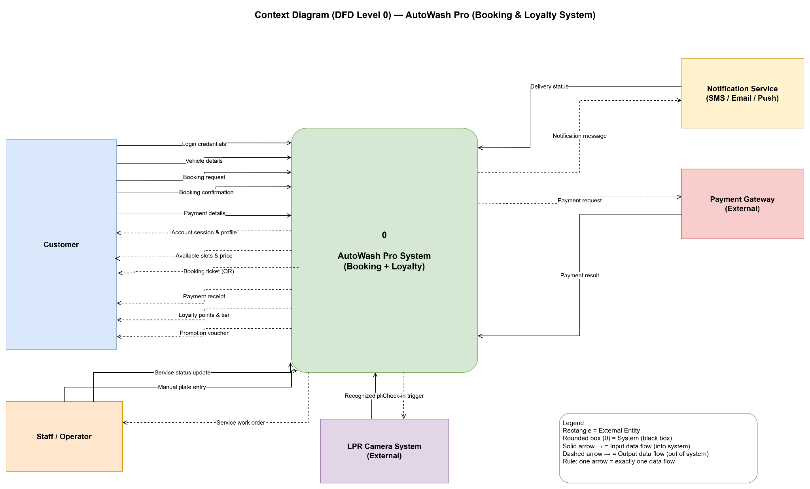
Context Diagram (DFD Level 0) — AutoWash Pro
External Entity | Inputs to system | Outputs from system
Customer | Login credentials, Vehicle details, Booking request, Booking confirmation, Payment details | Account session & profile, Available slots & price, Booking ticket (QR), Payment receipt, Loyalty points & tier, Promotion voucher
Staff / Operator | Manual plate entry, Service status update | Service work order
LPR Camera System | Recognized plate data | Check-in trigger
Payment Gateway | Payment result | Payment request
Notification Service | Delivery status | Notification message

II.4 Nonfunctional requirements
# | Feature | System Function | Description
NF-01 | Performance | LPR matching / Booking | LPR recognition response < 2s; create-booking response < 1s under normal load.
NF-02 | Security | Payment & Auth | Payment data encrypted; PCI-DSS aligned; passwords stored hashed; JWT session with idle timeout.
NF-03 | Reliability | Payment & Loyalty | Payment and loyalty-point updates are atomic (transactional) to guarantee consistency.
NF-04 | Availability | LPR Check-in | Manual check-in fallback when LPR fails or confidence is low; target uptime 99.5%.
NF-05 | Auditability | Loyalty / Tier | Every change of points and tier is logged for traceability.
NF-06 | Scalability | Whole system | Supports multiple branches and many concurrent time slots; able to scale horizontally.
NF-07 | Maintainability | Whole system | Layered architecture with clear separation of concerns for easy maintenance.

II.5 Functional requirements

II.5.1 Actors
# | Actor | Description
1 | Customer | End user who registers, manages vehicles, books washes, pays, earns/redeems points and receives promotions.
2 | Admin | Configures tier & point rules, manages services/promotions/rewards/bookings, and views analytics & reports.
3 | Staff / Operator | On-site personnel who perform manual check-in, run the wash service and update service status.
4 | LPR Camera | External device that captures and recognizes the license plate to trigger check-in.
5 | Payment Gateway | External service that processes payment transactions.
6 | SMS / Email Gateway (Notification Service) | External service that delivers confirmations and notifications.
7 | Scheduler (Time) | Time-based trigger that runs the monthly loyalty review (point expiry, tier evaluation).

II.5.2 Use Cases
A use case describes a sequence of interactions between the system and an external actor that delivers a valuable outcome. Use-case names are written as a verb + object.
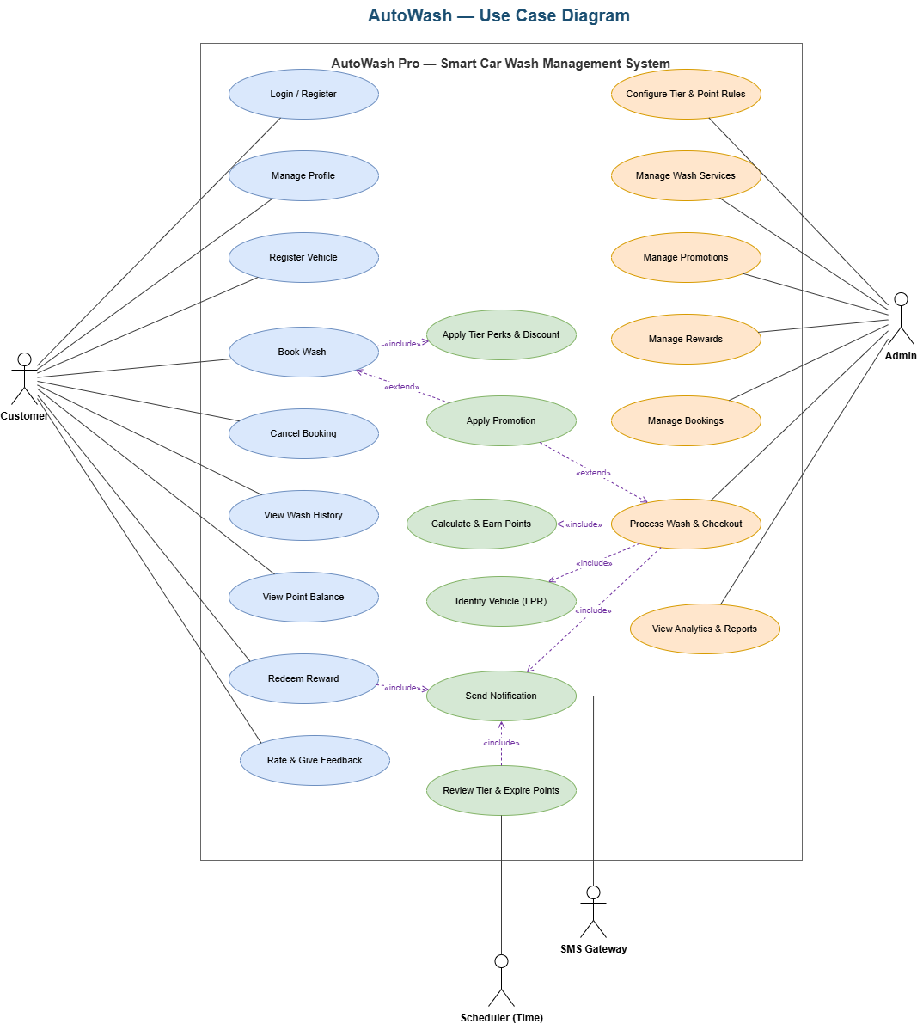
Use Case Overview

II.5.2.1 Diagram(s)
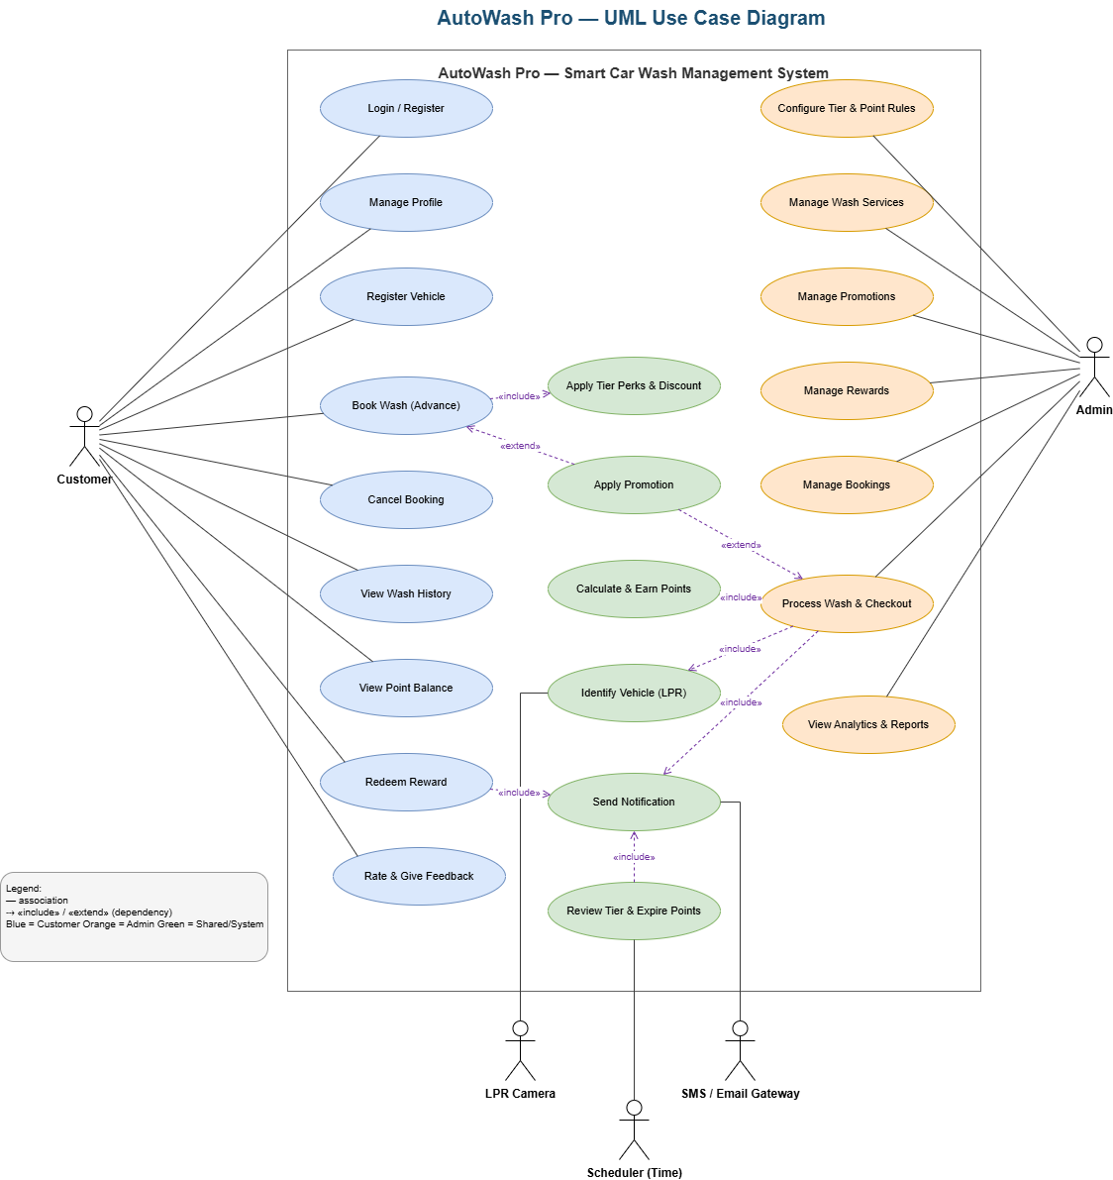
AutoWash Pro — UML Use Case Diagram

II.5.2.2 Use case descriptions
ID | Use Case | Actors | Use Case Description
UC-01 | Login / Register | Customer, Admin | Authenticate or create an account to access the system.
UC-02 | Register Vehicle | Customer | Link one or more vehicles (plate, type) to the account.
UC-03 | Book Wash (Advance) | Customer | Create a booking for a branch, service package and slot; «include» Apply Tier Perks & Discount; «extend» Apply Promotion.
UC-04 | Cancel Booking | Customer | Cancel a confirmed booking within the allowed window.
UC-05 | Identify Vehicle (LPR) | LPR Camera, Customer | Recognize the plate and match it to a confirmed booking for check-in.
UC-06 | Process Wash & Checkout | Staff, Customer | Execute the wash and proceed to payment; «include» Calculate & Earn Points; «include» Send Notification.
UC-07 | Make Payment | Customer, Payment Gateway | Pay the final invoice, optionally redeeming points.
UC-08 | Calculate & Earn Points | Loyalty Engine | Award loyalty points after a successful payment.
UC-09 | Review Tier & Expire Points | Scheduler, Loyalty Engine | Periodically evaluate tier and expire old points.
UC-10 | Redeem Reward | Customer | Redeem points/vouchers for a discount.
UC-11 | View Wash History / Point Balance | Customer | View past services and current point balance.
UC-12 | Manage Services / Promotions / Rewards / Bookings | Admin | Administer master data and operations.
UC-13 | Configure Tier & Point Rules | Admin | Configure tier thresholds and the point-earning rules.
UC-14 | View Analytics & Reports | Admin | View operational and business reports.
Detailed description — UC-03 Book Wash (Advance)
Field | Content
UC ID and Name | UC-03 Book Wash (Advance)
Created By | SWD392-G1
Primary Actor | Customer
Secondary Actors | Loyalty Engine, Notification Service
Trigger | Customer chooses to book a wash.
Description | The customer selects a vehicle, branch, service package and time slot; the system applies tier perks and any valid promotion, then confirms the booking and holds the slot.
Preconditions | PRE-1: Customer is authenticated. PRE-2: At least one vehicle is registered. PRE-3: A free slot exists.
Postconditions | POST-1: A booking is created in CONFIRMED state with a final price. POST-2: The slot is locked and a confirmation is sent.
Normal Flow | 3.0: (1) Customer selects vehicle/branch/package/slot. (2) System shows free slots and a tentative price. (3) System creates a PENDING booking and holds the slot. (4) System checks loyalty tier and applies perks/discount. (5) Customer confirms. (6) System sets status CONFIRMED, generates a QR/booking code and sends a confirmation notification.
Alternative Flows | 3.1: (At step 4) A valid promotion exists → system applies the promotion before computing the final price.
Exceptions | 3.0.E1: Slot already held by another user → ask the customer to re-select. 3.0.E2: Hold timer expires before confirmation → booking auto-EXPIRED and slot released.
Priority | High — Must Have
Frequency of Use | Very high (core daily transaction).
Business Rules | BR-01, BR-03, BR-04
Other Information | If notification delivery fails, the booking is still confirmed; delivery is retried asynchronously.
Assumptions | The branch calendar and service catalogue are configured.
b. Business Rules
ID | Business Rule | Business Rule Description
BR-01 | Unique plate | One license plate belongs to exactly one account (prevents points fraud).
BR-02 | Earn after payment | Loyalty points are credited only after a successful payment.
BR-03 | Tier discount base | Tier discount applies to the base price before any surcharges.
BR-04 | Slot hold | A slot is held temporarily and auto-released if not confirmed in time.
BR-05 | LPR threshold | LPR auto-matches only when confidence ≥ threshold; otherwise manual entry.
BR-06 | Refund revokes points | Refund/cancellation revokes the corresponding earned points.
BR-07 | Tier change | Up/down-grade is based on point thresholds and takes effect for later bookings.

II.5.3 Activity diagram
The activity diagram below shows the main end-to-end flow with swimlanes (Customer, System, LPR Camera, Admin/Staff, Payment Gateway), including the LPR match decision (with manual check-in fallback), the payment retry loop, and the loyalty point/tier evaluation at the end of the cycle.
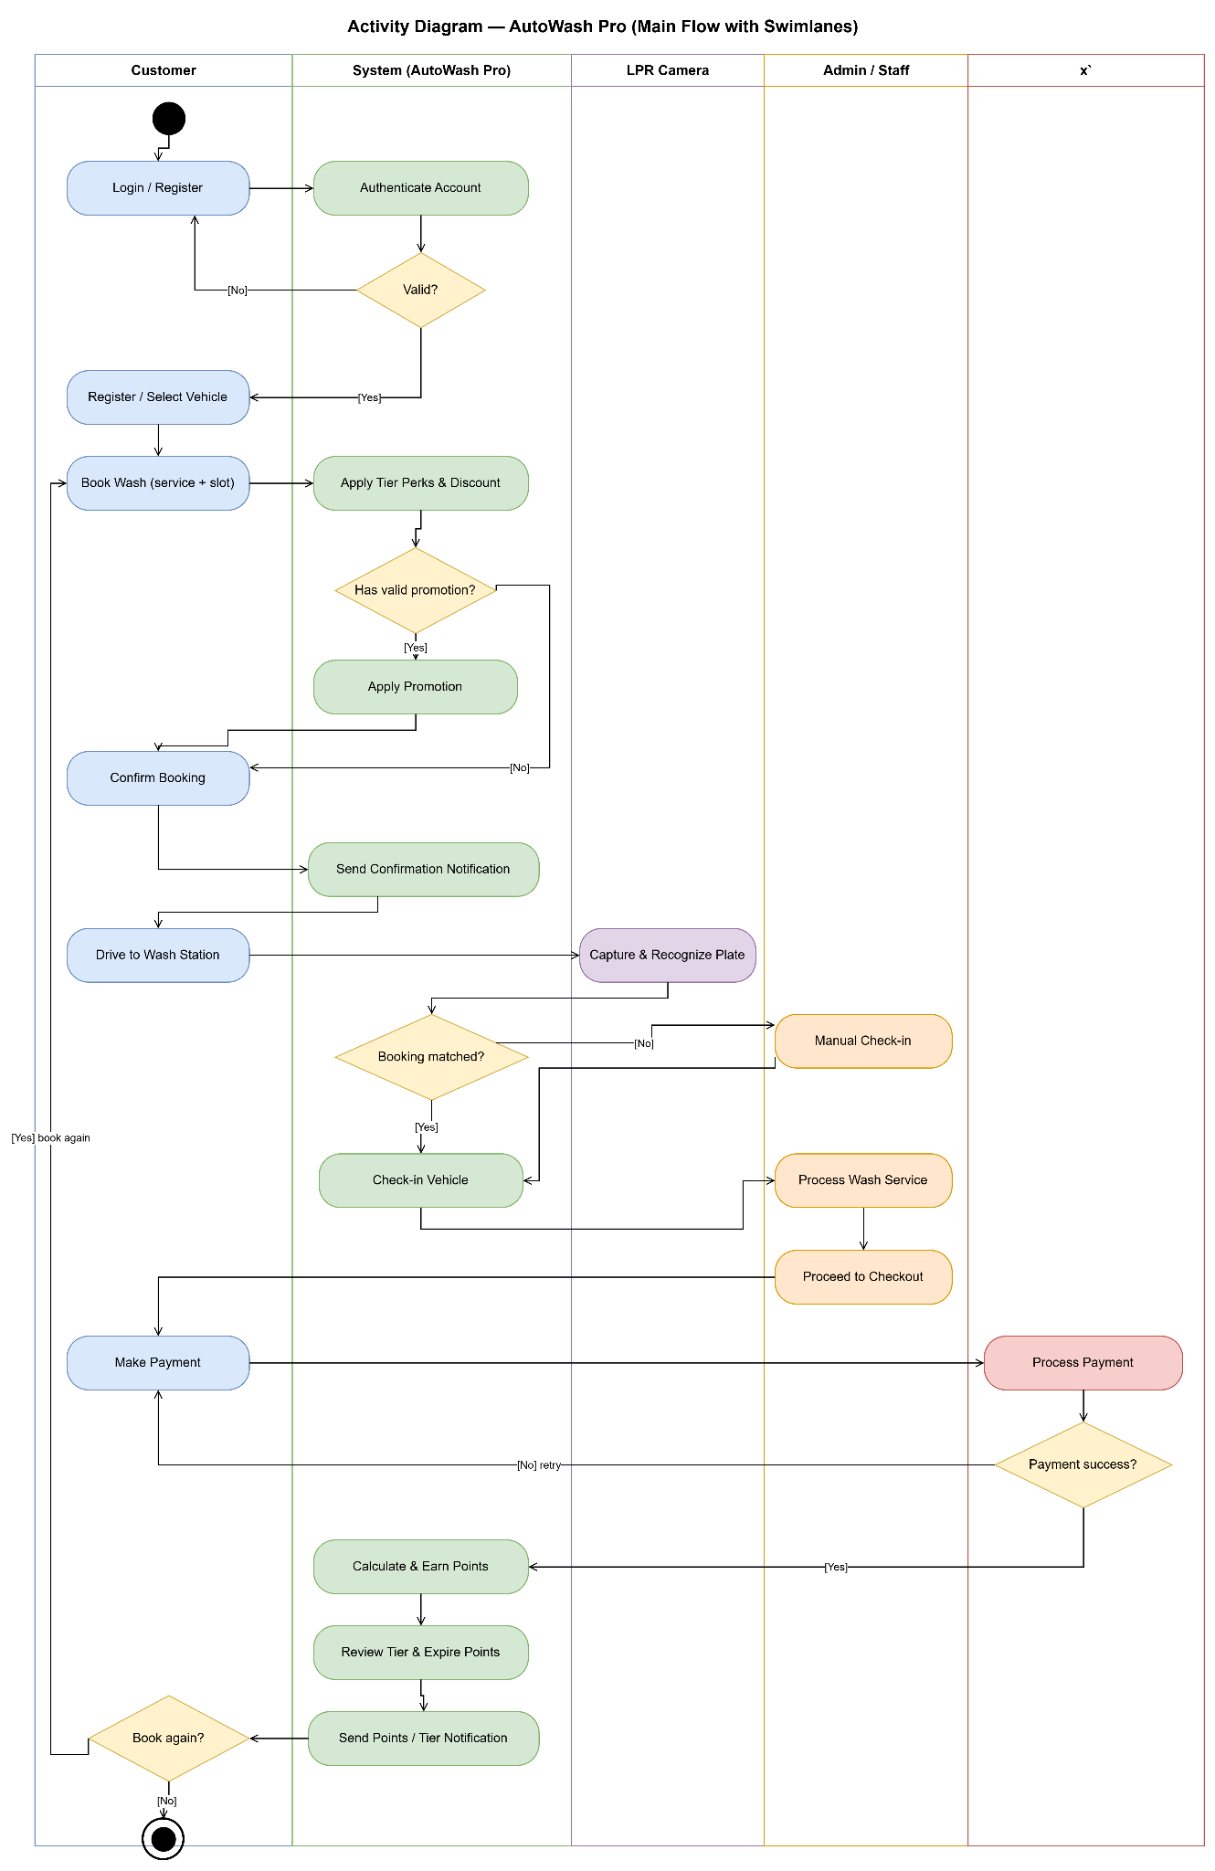
Activity Diagram — AutoWash Pro (Main Flow with Swimlanes)

II.6 Entity Relationship Diagram
The conceptual ERD below shows the core domain entities and their relationships in the AutoWash Pro booking & loyalty domain.
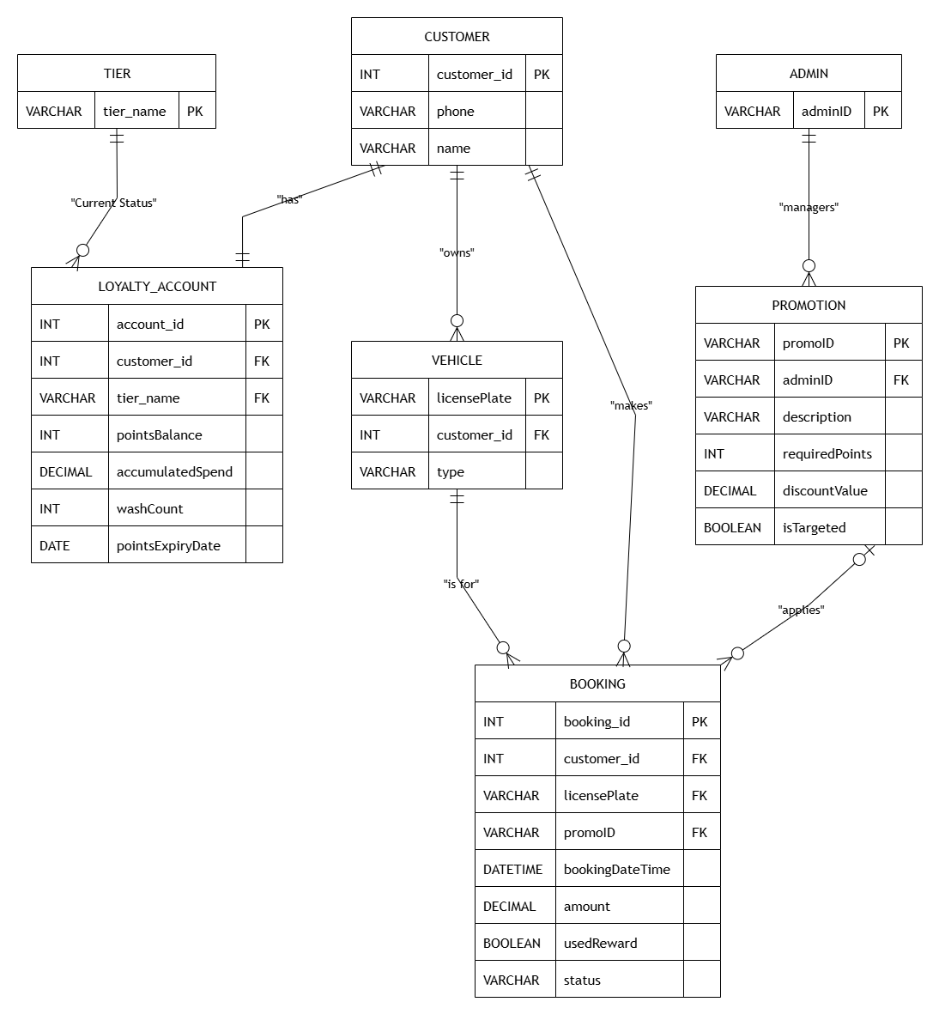
Conceptual Diagram (ERD) — AutoWash Pro
No | Entity | Key attributes
01 | Customer | customerID, name, email, phone, passwordHash
02 | Vehicle | vehicleID, licensePlate, brand, model, color
03 | Booking | bookingID, scheduledTime, createdAt, status, queuePriority
04 | ServicePackage | packageID, packageName, basePrice, durationMinutes
05 | Service | serviceID, serviceName, description, price
06 | WashSession | sessionID, startTime, endTime, detectedPlate, status
07 | Invoice | invoiceID, subtotal, discountApplied, finalAmount, paymentStatus
08 | Redemption | redemptionID, type, pointsUsed, discountValue
09 | LoyaltyProfile | loyaltyID, pointsBalance, pointsExpiry, tierStatus, totalVisits, totalSpend
10 | TierRule | ruleID, tier, minSpend, minVisits, bookingWindowDays, pointRateMultiplier, queuePriority
11 | Promotion | promoID, name, minTier, startDate, endDate, discountPercent, targetSegment

III. Analysis models

III.1 Interaction diagrams
Interaction diagrams illustrate how objects collaborate in a particular scenario by exchanging messages over time. Two views are used: a Sequence Diagram (time-ordering of messages) and a Communication Diagram (structure/relationships between objects).
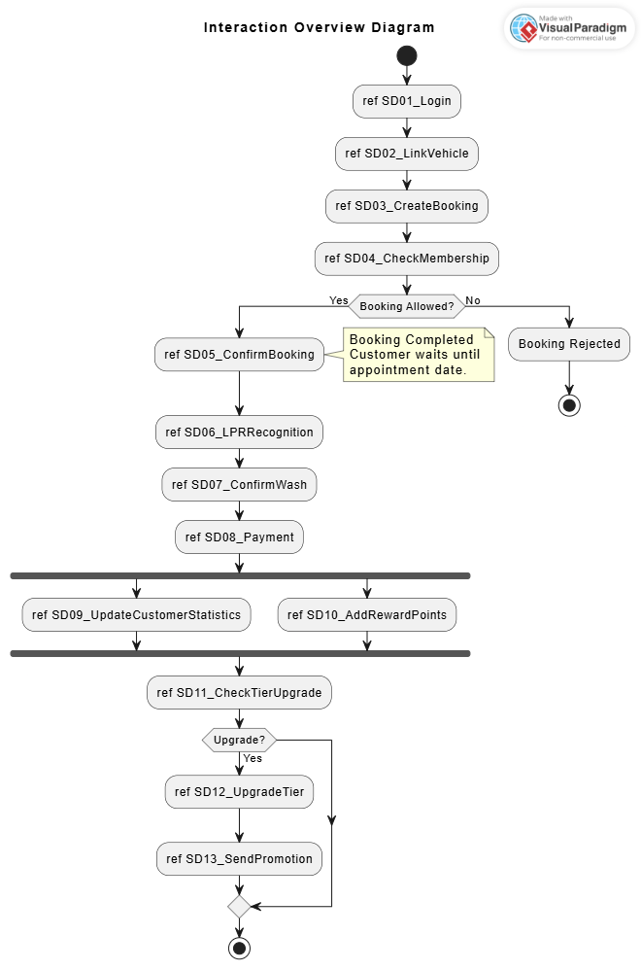
Interaction Diagram Overview

III.1.1 Sequence Diagram
Scenario — Book Wash with tier & promotion:
- customer → BookingController : requestBooking(vehicle, date)
- BookingController → LoyaltyEngine : getTierAndPoints(customerID)
- LoyaltyEngine → BookingController : return(Tier, Points, BookingWindow)
- BookingController → BookingController : validatePriority(date, BookingWindow)
- BookingController → PromotionRules : fetchAvailablePerks(Tier)
- PromotionRules → BookingController : return(perksList)
- customer → BookingController : confirmBooking(redeemPoints)
- BookingController → LoyaltyEngine : deductPoints(redeemPoints)
- BookingController → Book : create(vehicle, date, rewardDetails)
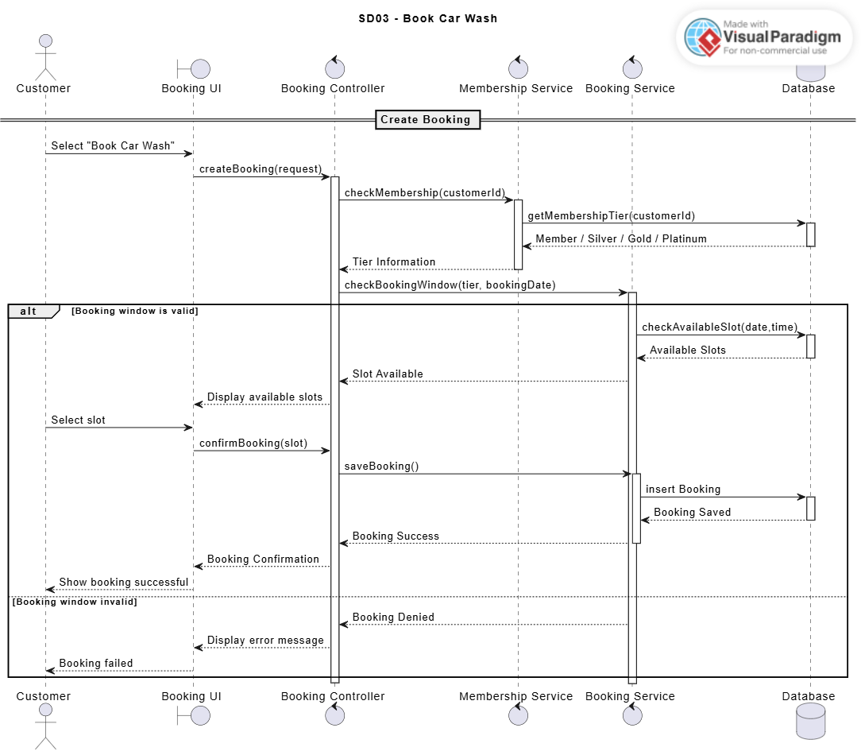
Sequence Diagram — Book Wash
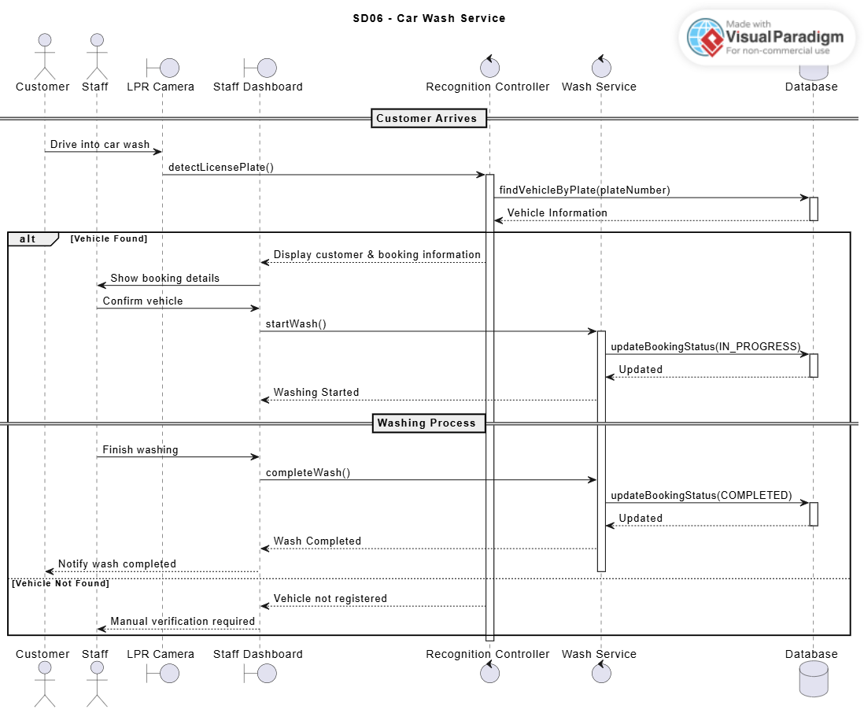
Sequence Diagram — LPR Check-in
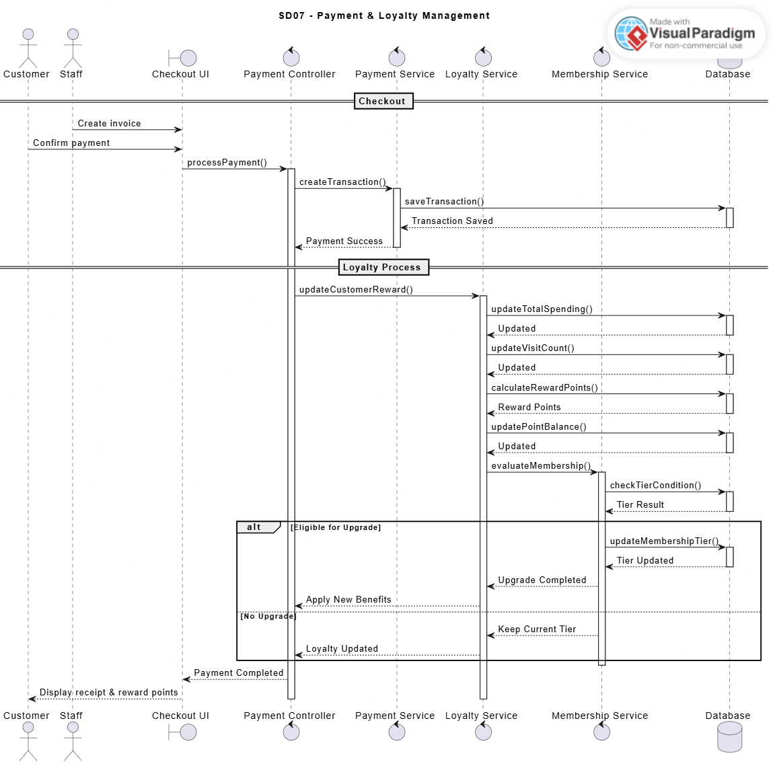
Sequence Diagram — Payment & Loyalty
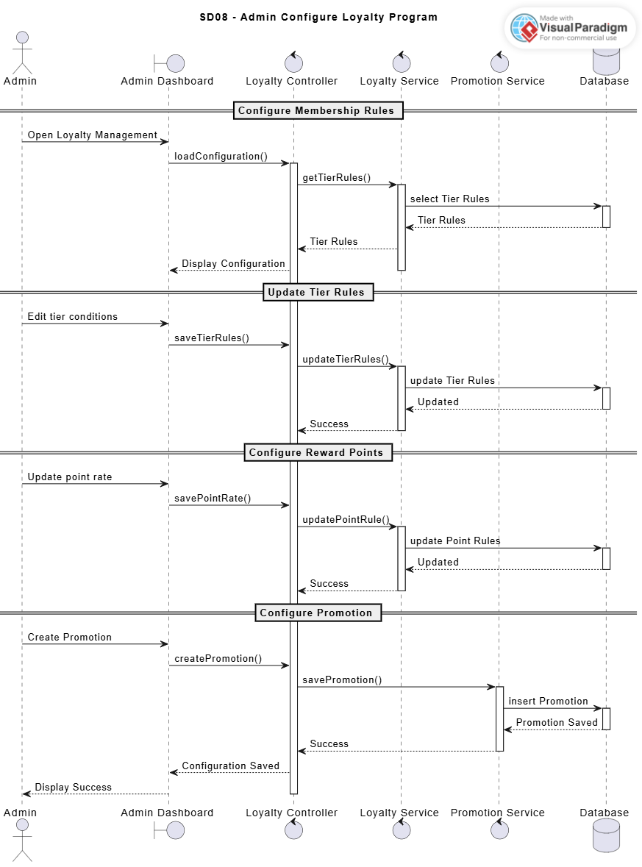
Sequence Diagram — Tier Review

III.1.2 Communication Diagram
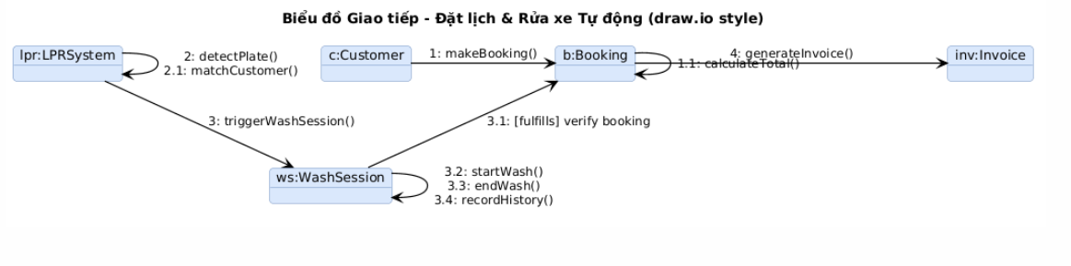
Communication Diagram — Booking & Wash flow
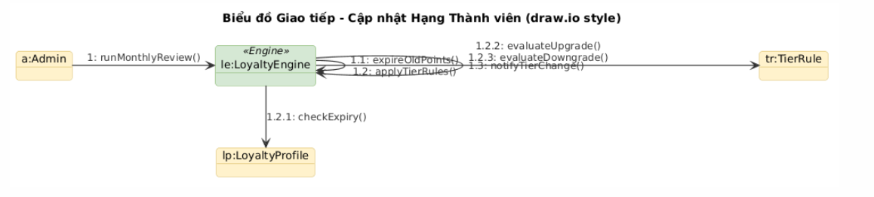
Communication Diagram — Membership tier update

III.2 State diagram
H.2.a) State Diagram — Booking: the booking lifecycle moves PENDING → CONFIRMED → IN_PROGRESS → WAITING_PAYMENT → COMPLETED, with CANCELLED reachable from PENDING/CONFIRMED (timeout/no-show, customer cancel, or system error).
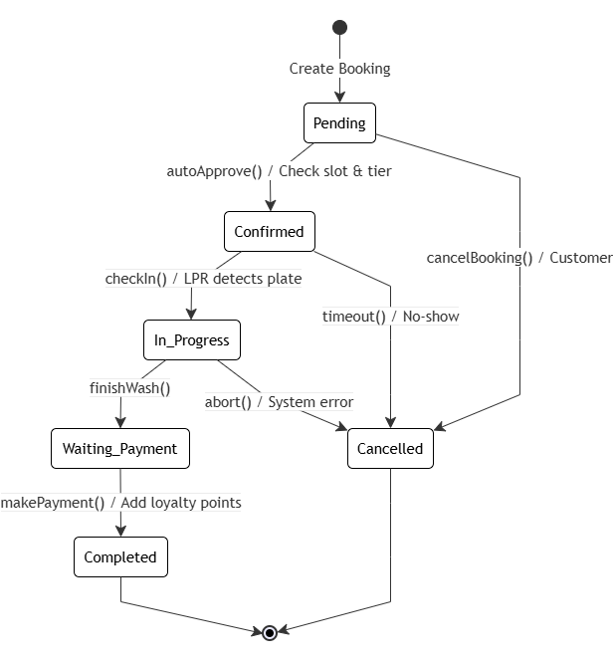
State Diagram — Booking
H.2.b) State Diagram — Customer Tier: the membership state transitions between Member, Silver, Gold and Platinum, driven by monthlyReview() guarded by point thresholds (upgradeTier() / downgradeTier()), and ends with deleteAccount().
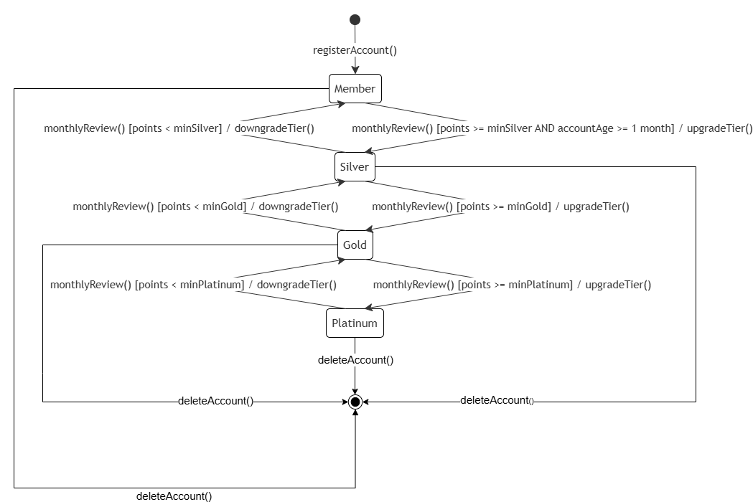
State Diagram — Customer Tier

IV. Design specification

IV.1 Integrated Communication Diagrams
The integrated communication diagram consolidates the main collaboration around BookingController, coordinating customer, LoyaltyEngine, PromotionRules and Book to complete a booking with tier perks and point redemption.
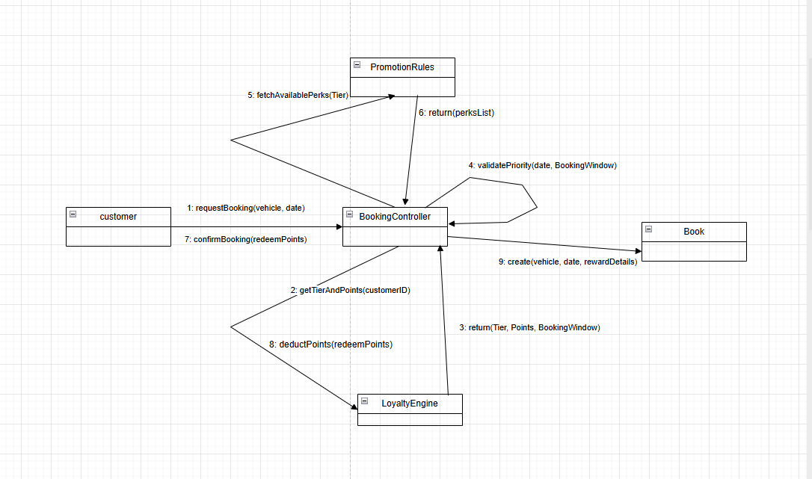
Integrated Communication Diagram

IV.2 System High-Level Design
AutoWash Pro adopts a Layered Architecture with five layers:
- Presentation Layer — Customer UI, Staff UI, Admin UI.
- Application / Service Layer — Auth, Vehicle, Booking, Wash Service, LPR, Payment, Loyalty, Promotion, Notification, Feedback, Reporting modules.
- Domain Layer — domain models (Customer, Vehicle, Booking, WashService, Payment, Tier, LoyaltyTransaction, Promotion, Reward, Feedback).
- Data Access Layer — repositories / ORM.
- Infrastructure / External Integration Layer — LPR camera, payment gateway, SMS/Email, scheduler.
The layering enforces a one-way dependency (top depends on bottom), which supports maintainability, testability and replaceability of each layer.
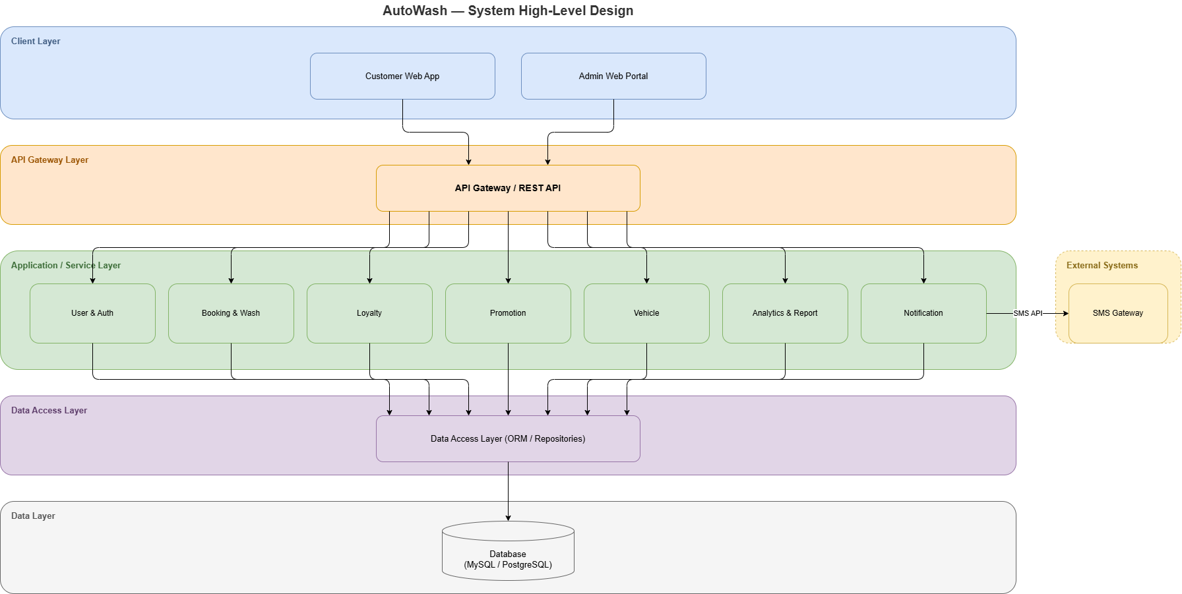
System High-Level Design

IV.3 Component and Package Diagram

IV.3.1 Component Diagram
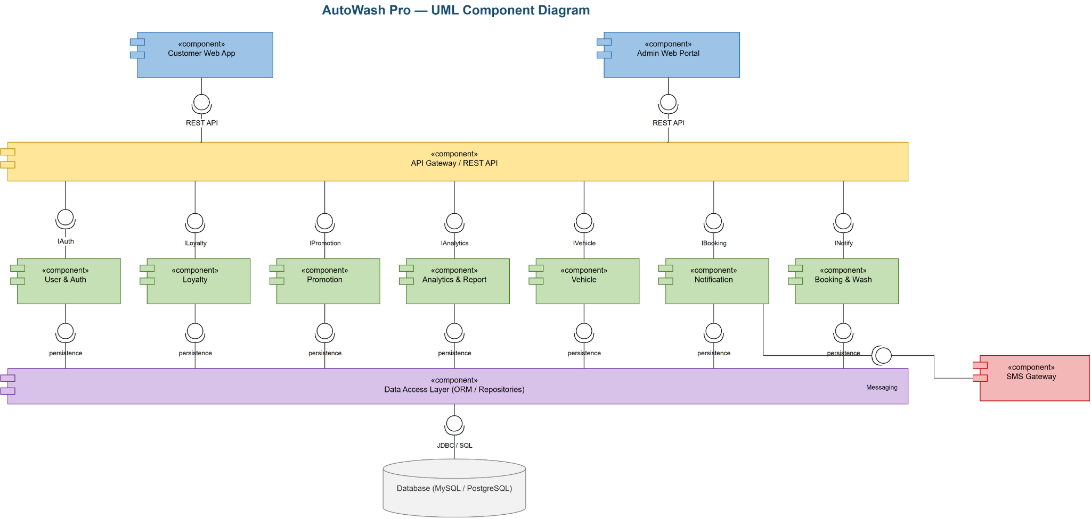
AutoWash Pro — UML Component Diagram
Front-end components (Customer Web App, Admin Web Portal) consume the API Gateway / REST API, which exposes provided/required interfaces (IAuth, ILoyalty, IPromotion, IAnalytics, IVehicle, IBooking, INotify) to the back-end service components. Service components persist through the Data Access Layer to the database; Booking&Wash integrates with the LPR Camera Service and Notification integrates with the SMS/Email Gateway.

IV.3.2 Package Diagram
The package diagram below shows the five layers and the dependencies between packages («use», «access», «import», «trigger»).
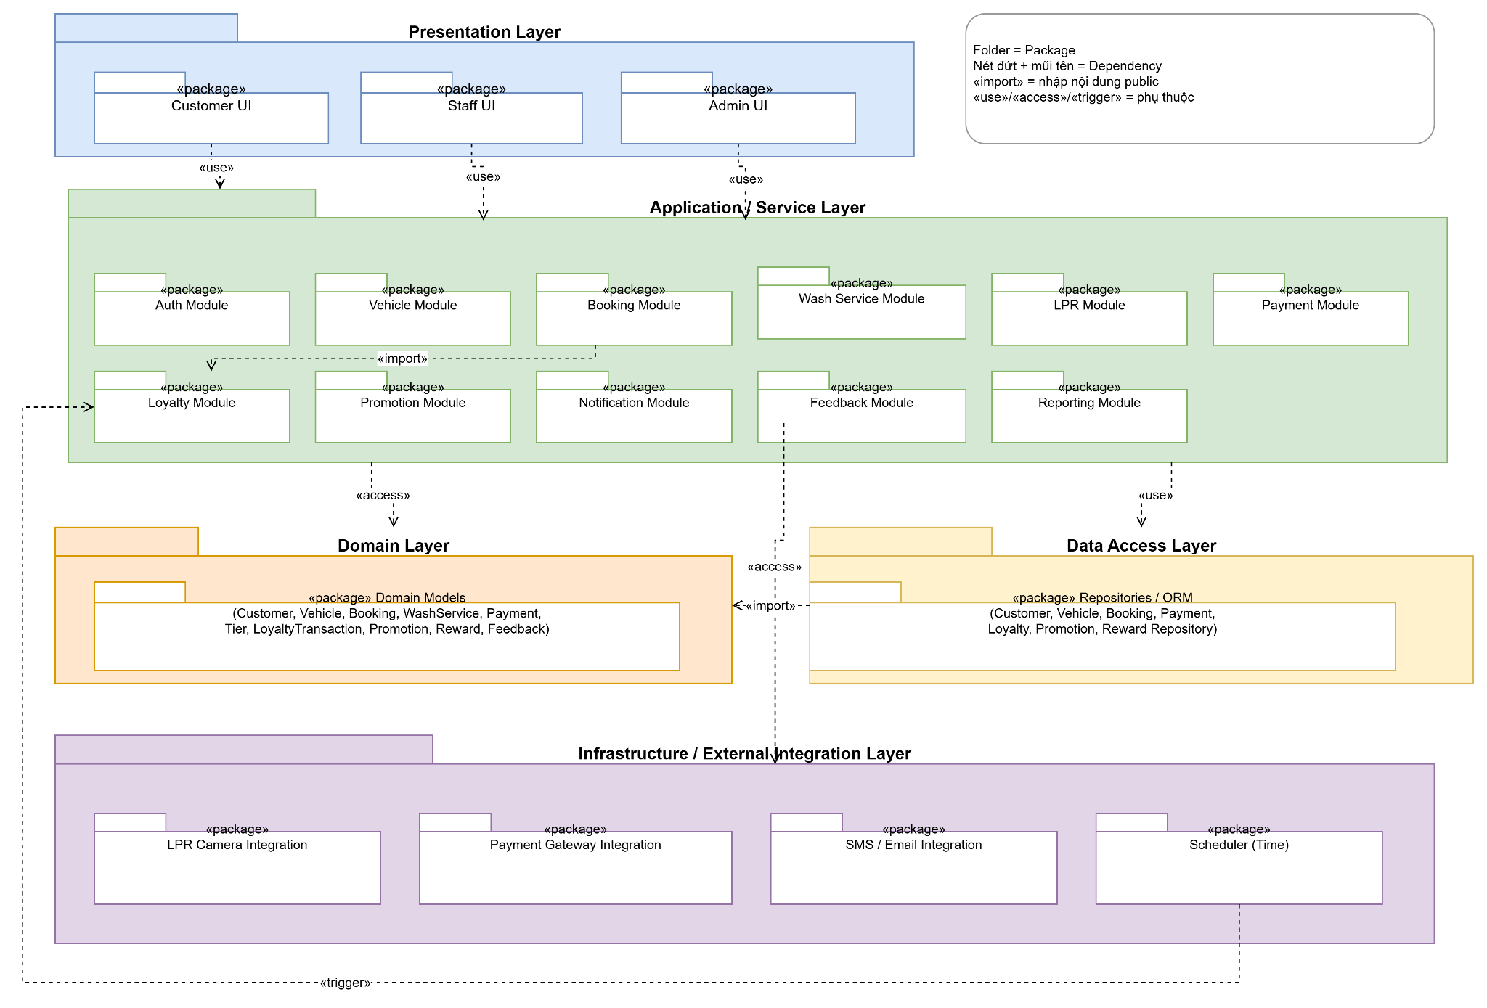
Package Diagram — AutoWash Pro
Package descriptions
No | Package | Description
01 | Customer/Staff/Admin UI | Presentation packages that render screens and call application services.
02 | Auth Module | Authentication, session/JWT issuance, account lockout.
03 | Vehicle Module | Vehicle registration and plate normalization/uniqueness.
04 | Booking Module | Slot management, booking lifecycle, price calculation; imports Loyalty.
05 | Wash Service Module | Wash session execution and history.
06 | LPR Module | Plate recognition processing and booking match.
07 | Payment Module | Invoice and payment processing with the gateway.
08 | Loyalty Module | Point earning/redemption, tier evaluation and expiry.
09 | Promotion Module | Promotion eligibility and voucher generation.
10 | Notification Module | Sending confirmations and notifications.
11 | Feedback / Reporting Module | Customer feedback and analytics/reporting.
12 | Domain Models | Core entity classes shared across services.
13 | Repositories / ORM | Data persistence mapping to the database.
14 | Infrastructure Integrations | LPR camera, payment gateway, SMS/Email, scheduler adapters.

IV.3.3 Composite Structure diagram
The composite structure diagram shows the internal ports/parts wiring: pCustomer/pStaff route to authService and bookingManager; lprSystem (fed by pCamera) feeds the booking manager; bookingManager checks the tier via loyaltyManager, which adds points after payment through billingService.
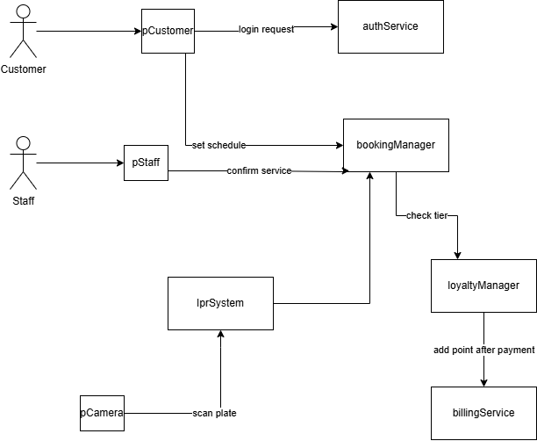
Composite Structure Diagram

IV.4 Class diagram
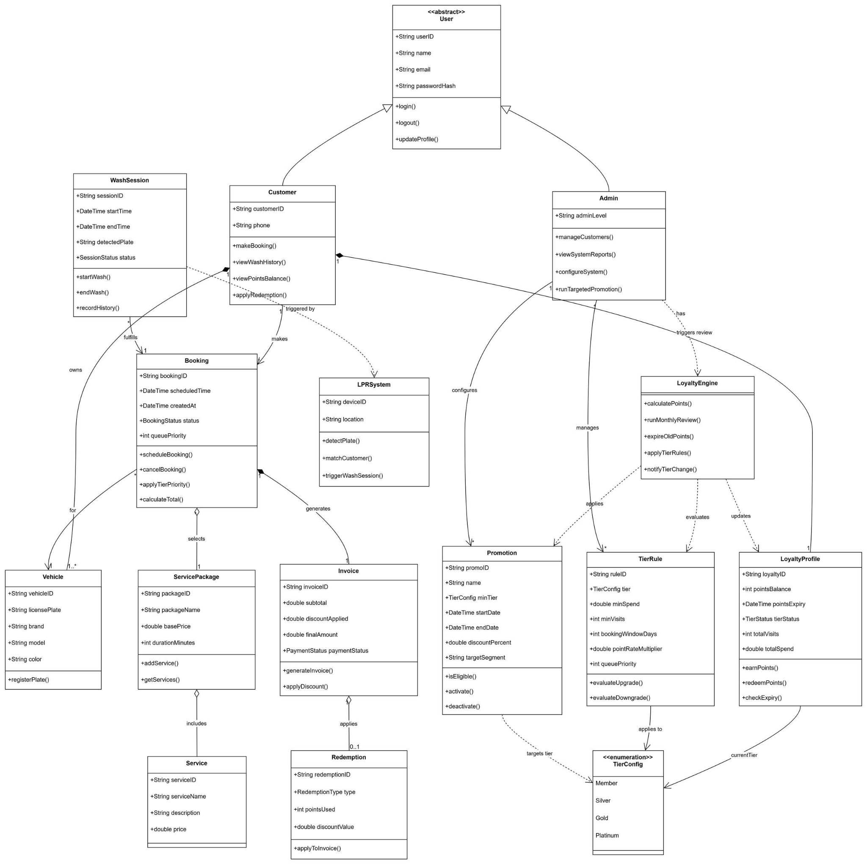
AutoWash Pro — Class Diagram
The abstract User is specialized by Customer and Admin. Customer owns Vehicles and makes Bookings; a Booking selects a ServicePackage (which includes Services), generates an Invoice (which may apply a Redemption), and is fulfilled by a WashSession triggered by the LPRSystem. The LoyaltyEngine applies TierRules, evaluates the TierConfig enumeration (Member/Silver/Gold/Platinum) and updates the LoyaltyProfile; Admin configures Promotions and tier/point rules.

IV.5 Object diagram
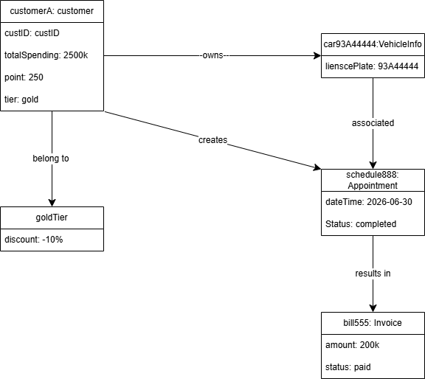
Object Diagram — a concrete snapshot
The object diagram shows a runtime snapshot: customer customerA (tier = gold, point = 250) owns vehicle car93A44444, creates appointment schedule888 (status completed) which results in invoice bill555 (amount 200k, status paid), and belongs to goldTier (discount −10%).

IV.6 Database Design

IV.6.1 Conceptual Diagram
Entities and relationships at business level: Customer–Vehicle (1..), Customer–Booking (1..), Booking–ServicePackage (..1), Booking–Invoice (1..1), Customer–LoyaltyProfile (1..1), LoyaltyProfile–TierConfig (..1).
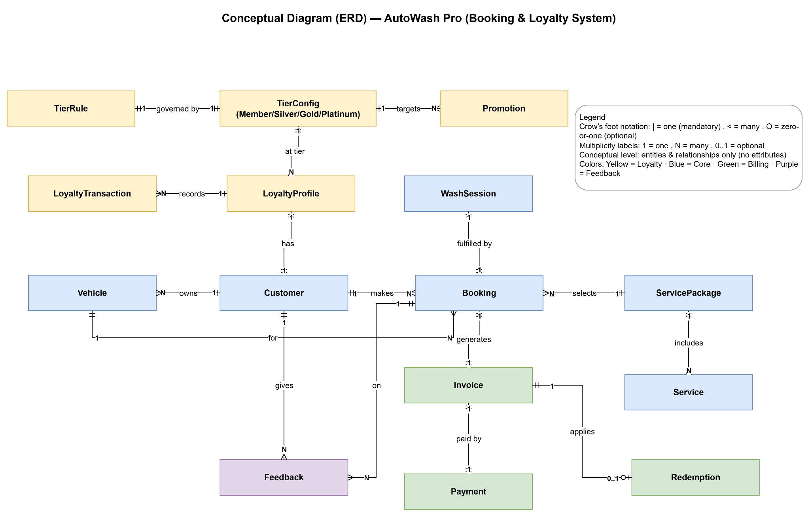
Conceptual Database Diagram

IV.6.2 Logical Diagram
Relational tables with primary/foreign keys following PostgreSQL naming conventions (e.g. customer, vehicle, booking, service_package, invoice, loyalty_profile, tier_rule, promotion).
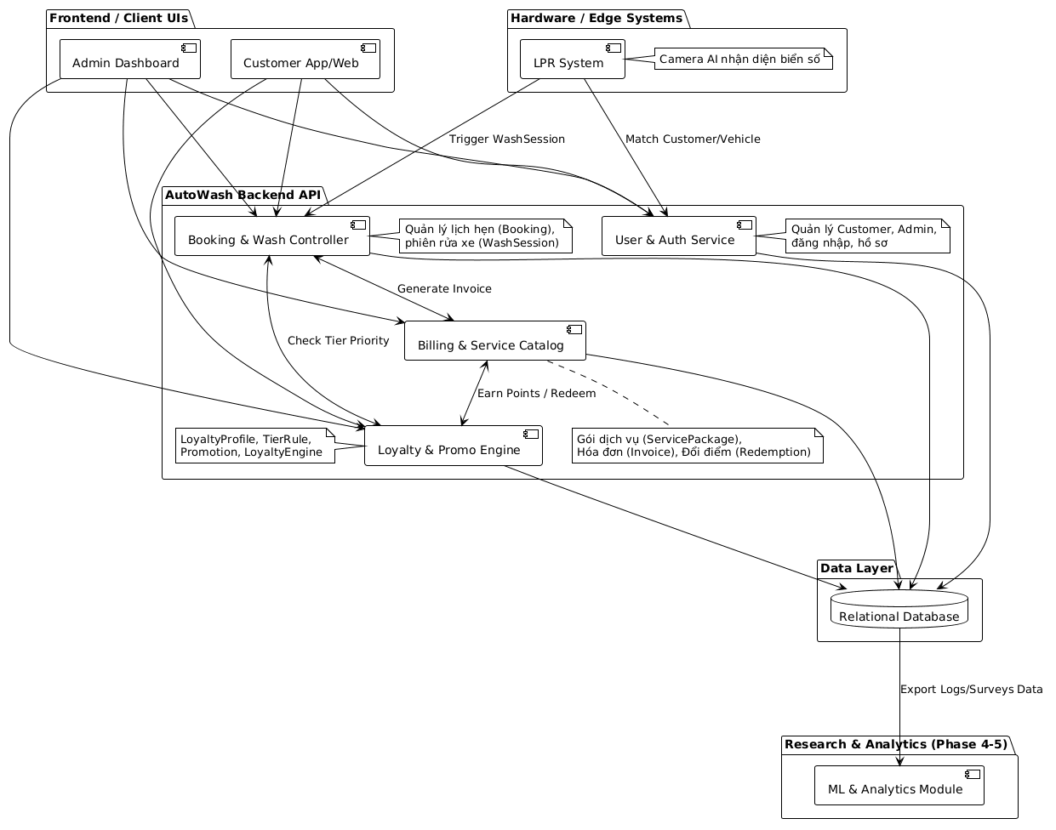
Logical Database Diagram

IV.6.3 Physical Diagram
Concrete column data types, indexes (e.g. unique index on vehicle.license_plate), and constraints for the target DBMS (PostgreSQL).
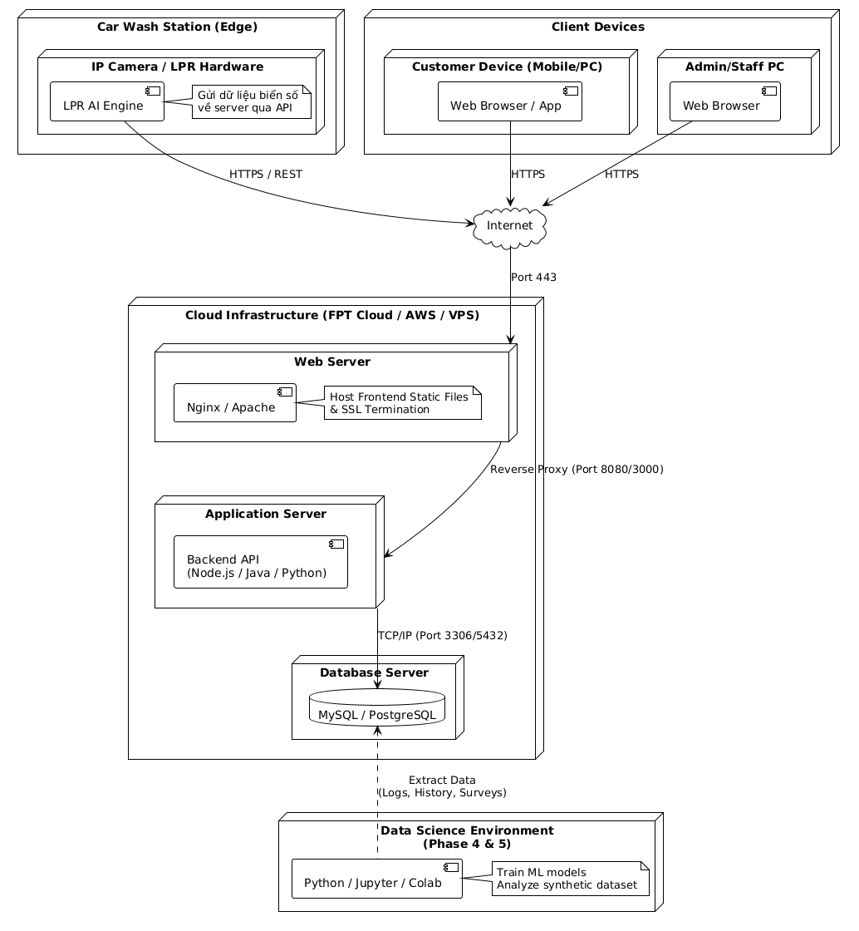
Physical Database Diagram

IV.6.4 Database design
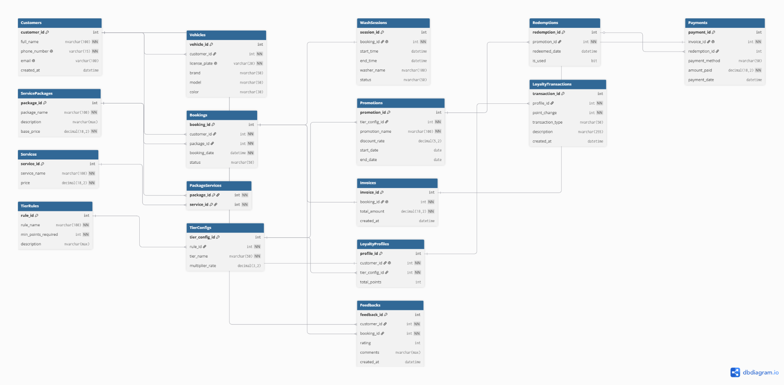
Database Design — Table relationships

V. Implementation

V.1 Map architecture to the structure of the project
1. Overview of the Chosen Architecture — The project uses a Layered Architecture (Presentation → Application/Service → Domain → Data Access → Infrastructure). It was selected to satisfy the non-functional requirements of maintainability (NF-07), reliability (NF-03) and scalability (NF-06): each layer can evolve and be tested independently, and external integrations are isolated behind the infrastructure layer.
2. Mapping to Project Structure — a representative project structure:
autowash-pro/
├─ presentation/ # Customer UI, Staff UI, Admin UI (Presentation Layer)
├─ application/ # service modules (Application/Service Layer)
│ ├─ auth/ vehicle/ booking/ wash/ lpr/ payment/
│ ├─ loyalty/ promotion/ notification/ feedback/ reporting/
├─ domain/ # entity models (Domain Layer)
├─ dataaccess/ # repositories / ORM (Data Access Layer)
└─ infrastructure/ # lpr-camera, payment-gateway, sms-email, scheduler (Infra Layer)
Each architectural layer maps one-to-one to a top-level module; each service in the component diagram (e.g. Booking, Loyalty, Payment) maps to a package under application/.

V.2 Map Class Diagram and Interaction Diagram to Code
The booking scenario (sequence/communication diagrams) maps to a BookingController that depends on LoyaltyEngine and PromotionRules. Design patterns used:
- Strategy — tier discount / point-rate calculation in TierRule (evaluateUpgrade(), pointRateMultiplier).
- Repository — data access through ORM repositories (Data Access Layer).
- Observer / Publisher-Subscriber — notifyTierChange() and notification delivery.
- State — Booking.status and tier state transitions (state diagrams).

VI. Applying Alternative Architecture Patterns

VI.1 Applying the Service-Oriented Architecture (SOA)
1. Problem Identification — In the current layered monolith, reusability (NF-05) and independent scalability (NF-06) are limited because all modules share one runtime; scaling the LPR/booking load forces scaling everything.
2. SOA-Based Solution — Reorganize the application into independent, separately deployable services: Booking Service, Loyalty Engine, LPR Processing Service, Notification Service, Payment Service, fronted by an API Gateway. Services communicate over REST/messaging and own their data access, so they can be reused and scaled independently.
3. Supporting Diagrams
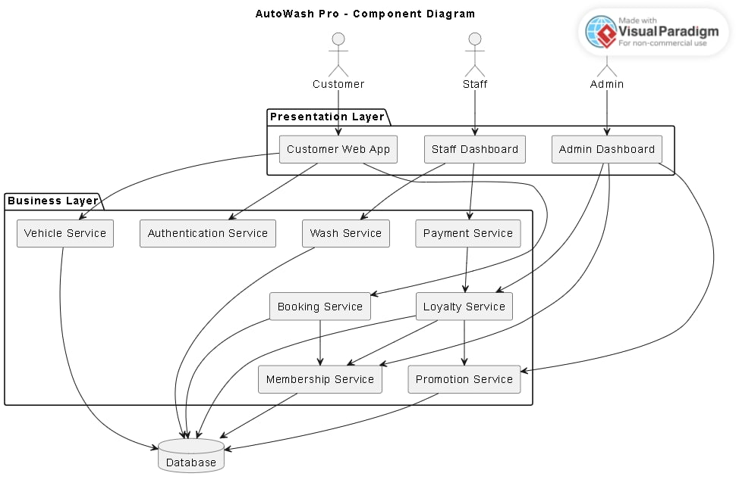
SOA Component Diagram
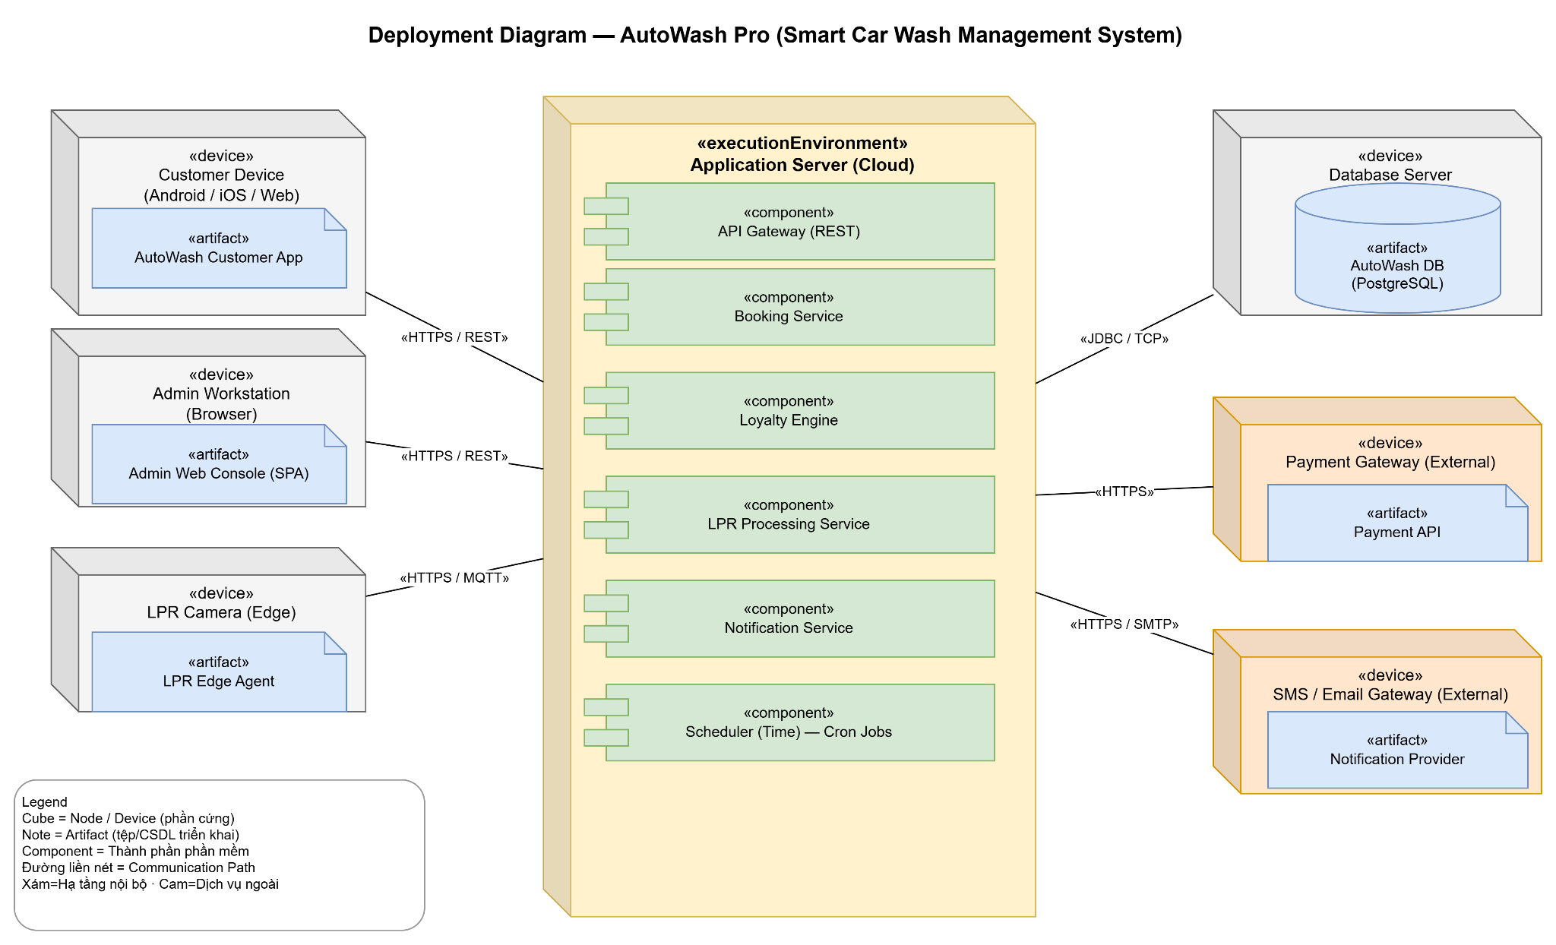
Deployment Diagram — AutoWash Pro
The deployment view shows the cloud Application Server hosting the API Gateway and service components, connecting to a PostgreSQL Database Server and to external Payment and SMS/Email gateways; edge devices (Customer Device, Admin Workstation, LPR Camera) connect over HTTPS/REST/MQTT.

VI.2 Applying Service Discovery Pattern in the service-oriented architecture
1. Problem & Requirement — As branches and service instances grow (NF-06 Scalability), hard-coding service endpoints becomes unmanageable; the system needs dynamic registration and discovery of service instances.
2. Service Discovery-Based Solution — Introduce a Service Discovery component: each service registers itself with a registry on startup and the API Gateway/clients resolve instances dynamically (client- or server-side discovery), enabling horizontal scaling and resilient routing. Candidate technologies: Consul, Netflix Eureka, or Kubernetes DNS.
3. Supporting Diagrams — an updated deployment/component view would add a Discovery Service (Registry) node, multiple instances per service registering with it, and the API Gateway querying the registry to route requests.

