SmartEquip – Equipment Rental Marketplace
Software Design Specification

Da Nang, November 2026

Record of changeS
Date | A*  M, D | In charge | Change Description
02/11/2026 | A | Group 1 | Completed source-based SDS design, diagrams, class specifications and database operations.
*A - Added M - Modified D - Deleted

Table of Contents
I. Overview 4
1. Code Packages 4
2. Database Design 4
a. Database Schema 4
b. Table Description 4
II. Code Designs 5
1. <Feature/Function Name1> 5
a. Class Diagram 5
b. Class Specifications 5
c. Sequence Diagram(s) 5
d. Database queries 6
2. <Feature/Function Name2> 6

I. Overview

1. Code Packages
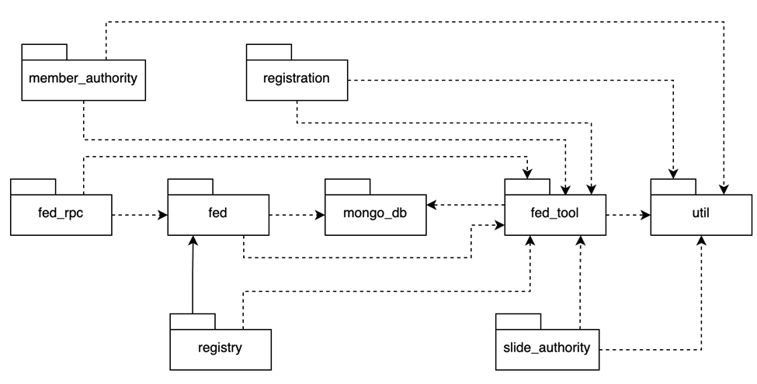

Package descriptions
No | Package | Description
01 | fe/src/pages | React/TypeScript UI screens for auth, marketplace, owner, moderator and admin.
02 | fe/src/components | Reusable frontend interface components.
03 | fe/src/App.tsx | Application entry and frontend route composition.
04 | be/src/routes | Express endpoints: auth, marketplace, owner, owner registration, moderator and admin.
05 | be/src/controllers | HTTP request handlers and business operations for each route module.
06 | be/src/models | 14 Mongoose model definitions and ObjectId references.
07 | be/src/middleware | Authentication, authorization and request processing middleware.
08 | be/src/services | Supporting integrations and shared service logic, where present.

2. Database Design

a. Database Schema
Database schema of SmartEquip. Blue headers and field markers follow the reference format. Arrows indicate Mongoose ObjectId references, not SQL foreign keys. The overview is intentionally simplified; detailed diagrams show additional fields.
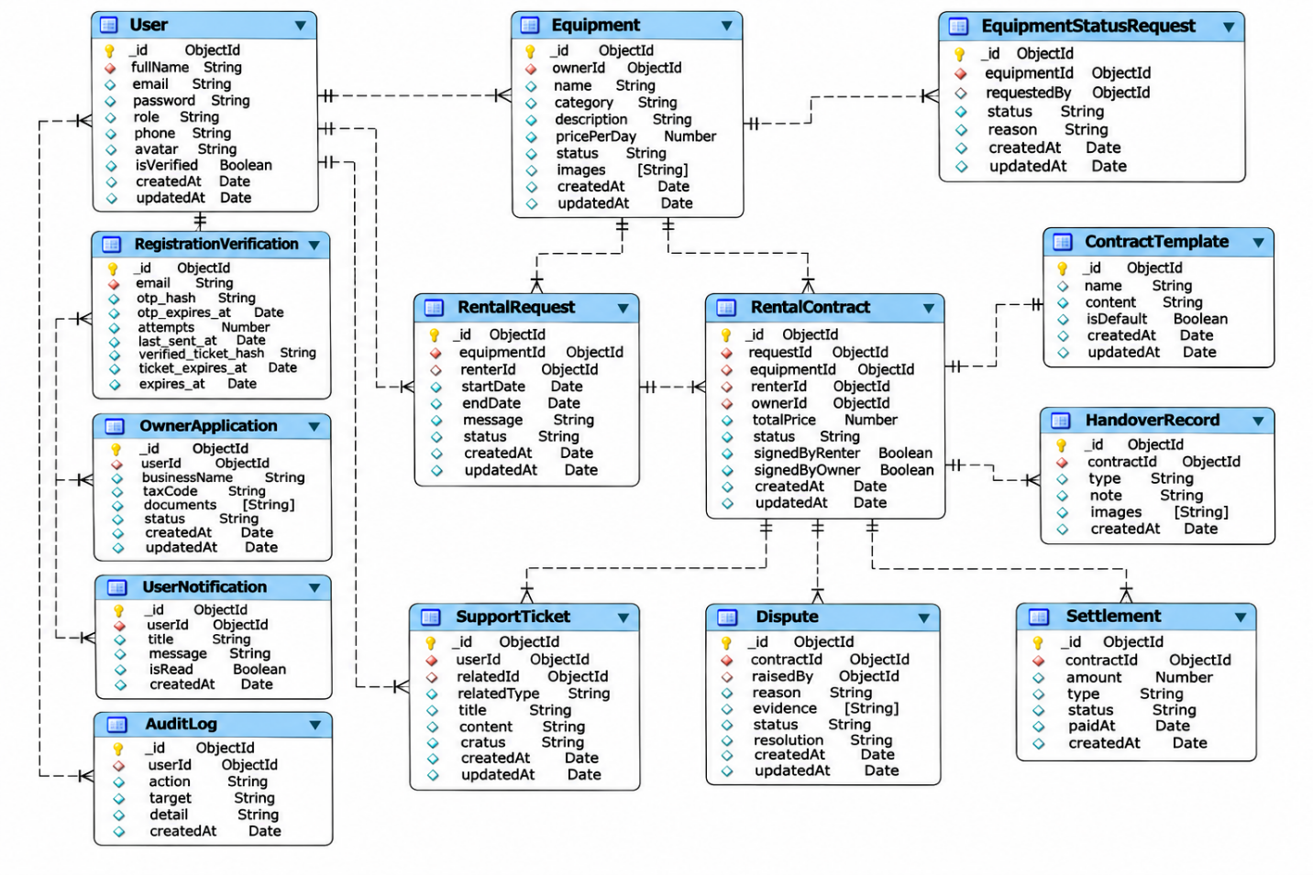
Figure I.2-1. Overall database schema – all 14 Mongoose models and their declared references.

b. Table Description
No | Table | Description
01 | AuditLog | Administrative audit trail.
02 | ContractTemplate | Versioned contract templates.
03 | Dispute | Contract-related disputes and resolution.
04 | Equipment | Rental equipment listings and owner data.
05 | EquipmentStatusRequest | Equipment status change review request.
06 | HandoverRecord | Handover / return evidence and review.
07 | OwnerApplication | Owner role application and approval.
08 | RegistrationVerification | Email OTP registration verification.
09 | RentalContract | Rental agreement and approval lifecycle.
10 | RentalRequest | Rental request dates, fees and workflow status.
11 | Settlement | Financial settlement associated with rentals.
12 | SupportTicket | Support cases and responses.
13 | User | User accounts, credentials, role and profile.
14 | UserNotification | Notifications to platform users.

II. Code Designs

1. Authentication, Registration and User Profile
This section documents the implemented authentication, registration and user profile module. Primary backend controller: be/src/controllers/authController.js; related Mongoose models: User, RegistrationVerification, UserNotification. The diagrams depict logical source-code modules, not Java classes.

a. Class Diagram
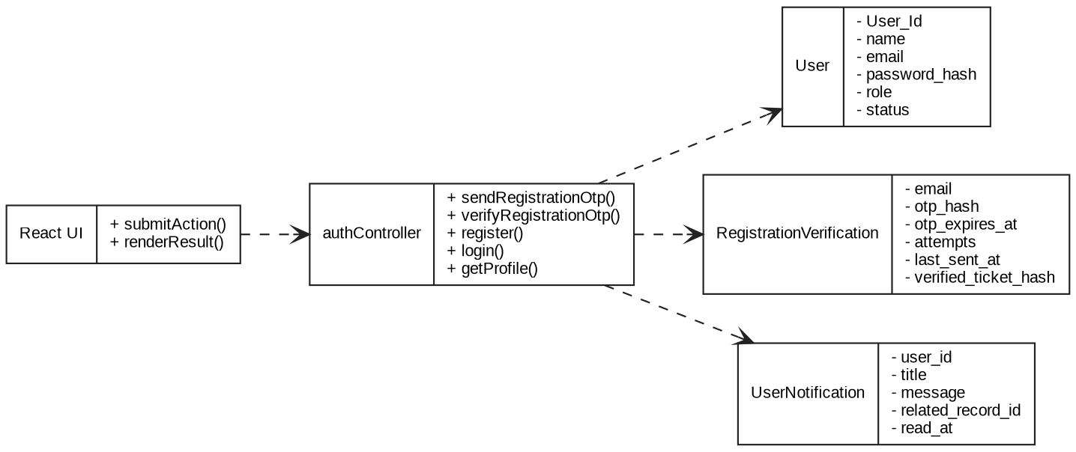
Figure II.1a – Class Diagram: Authentication, Registration and User Profile.

b. Class Specifications
authController – Controller methods found in source code
No | Method / Module | Description
01 | sendRegistrationOtp | Implemented handler in authController.js; processes request/response and accesses related models as needed.
02 | verifyRegistrationOtp | Implemented handler in authController.js; processes request/response and accesses related models as needed.
03 | register | Implemented handler in authController.js; processes request/response and accesses related models as needed.
04 | login | Implemented handler in authController.js; processes request/response and accesses related models as needed.
05 | logout | Implemented handler in authController.js; processes request/response and accesses related models as needed.
06 | changePassword | Implemented handler in authController.js; processes request/response and accesses related models as needed.
07 | forgotPassword | Implemented handler in authController.js; processes request/response and accesses related models as needed.
08 | resetPassword | Implemented handler in authController.js; processes request/response and accesses related models as needed.
09 | googleLogin | Implemented handler in authController.js; processes request/response and accesses related models as needed.
10 | getProfile | Implemented handler in authController.js; processes request/response and accesses related models as needed.
11 | updateProfile | Implemented handler in authController.js; processes request/response and accesses related models as needed.
12 | listNotifications | Implemented handler in authController.js; processes request/response and accesses related models as needed.
13 | markNotificationRead | Implemented handler in authController.js; processes request/response and accesses related models as needed.
Mongoose model specifications
No | Method / Module | Description
01 | User | User accounts, credentials, role and profile. Declared in be/src/models/User.js.
02 | RegistrationVerification | Email OTP registration verification. Declared in be/src/models/RegistrationVerification.js.
03 | UserNotification | Notifications to platform users. Declared in be/src/models/UserNotification.js.

c. Sequence Diagram(s)
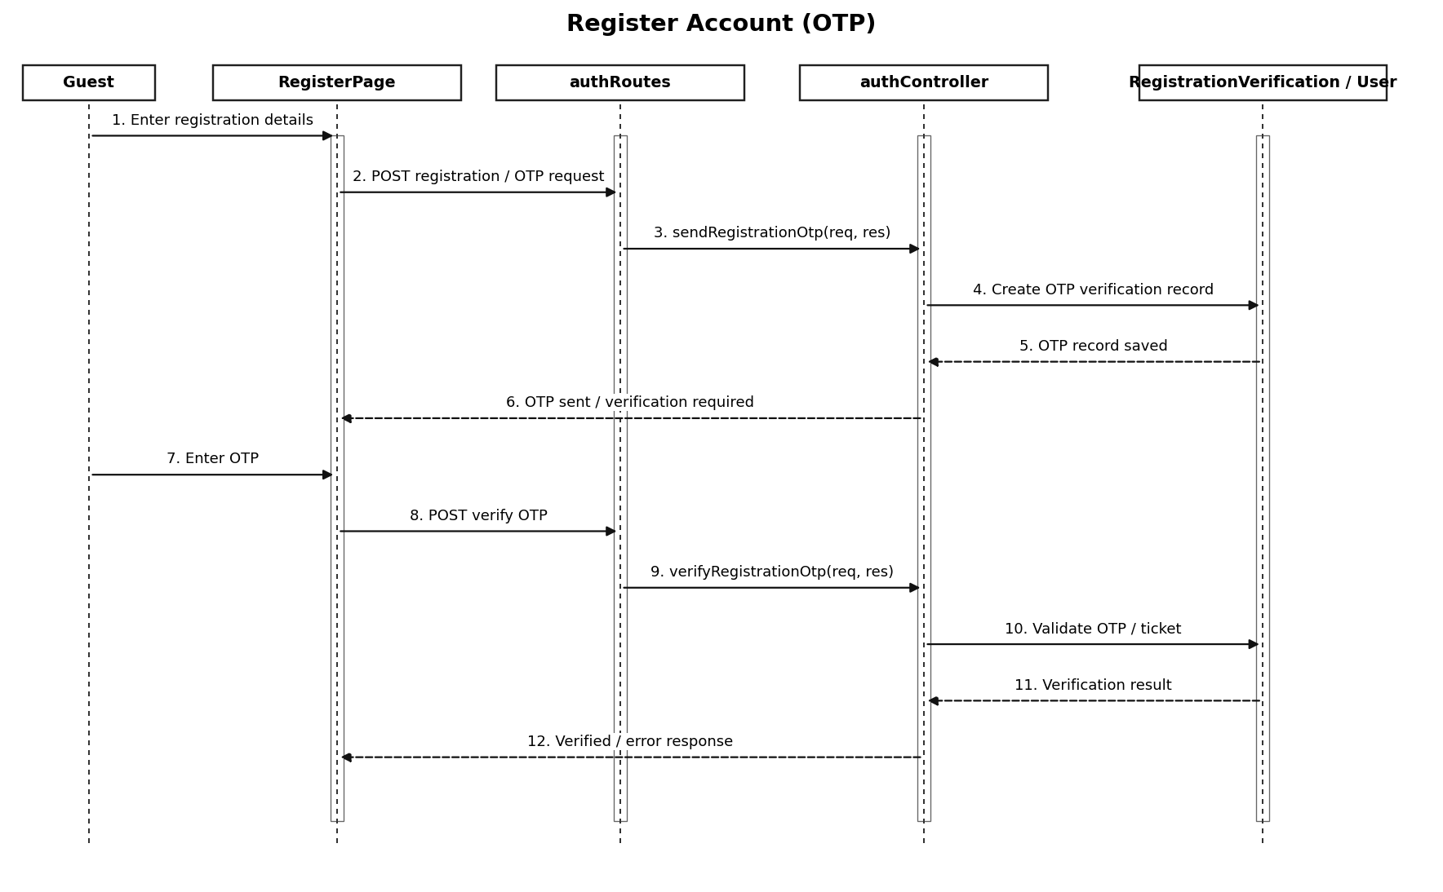
Figure II.1c – Register Account (OTP) (Sequence Diagram).
Interaction description: Guest/Renter/Owner -> React account page -> authRoutes -> authController -> User / RegistrationVerification -> response.

d. Database Queries
MongoDB/Mongoose operation patterns (representative; exact predicates and update guards are defined in the controller source):
No | Method / Module | Description
01 | User.find(filter) | Read matching User documents; write operations are role- and endpoint-dependent.
02 | RegistrationVerification.find(filter) | Read matching RegistrationVerification documents; write operations are role- and endpoint-dependent.
03 | UserNotification.find(filter) | Read matching UserNotification documents; write operations are role- and endpoint-dependent.

2. Public Equipment Marketplace and Rental Requests
This section documents the implemented public equipment marketplace and rental requests module. Primary backend controller: be/src/controllers/marketplaceController.js; related Mongoose models: Equipment, RentalRequest, User. The diagrams depict logical source-code modules, not Java classes.

a. Class Diagram
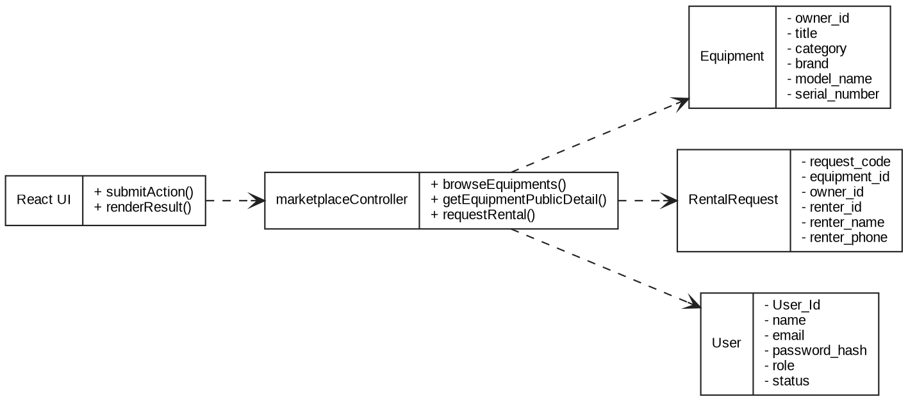
Figure II.2a – Class Diagram: Public Equipment Marketplace and Rental Requests.

b. Class Specifications
marketplaceController – Controller methods found in source code
No | Method / Module | Description
01 | browseEquipments | Implemented handler in marketplaceController.js; processes request/response and accesses related models as needed.
02 | getEquipmentPublicDetail | Implemented handler in marketplaceController.js; processes request/response and accesses related models as needed.
03 | requestRental | Implemented handler in marketplaceController.js; processes request/response and accesses related models as needed.
Mongoose model specifications
No | Method / Module | Description
01 | Equipment | Rental equipment listings and owner data. Declared in be/src/models/Equipment.js.
02 | RentalRequest | Rental request dates, fees and workflow status. Declared in be/src/models/RentalRequest.js.
03 | User | User accounts, credentials, role and profile. Declared in be/src/models/User.js.

c. Sequence Diagram(s)
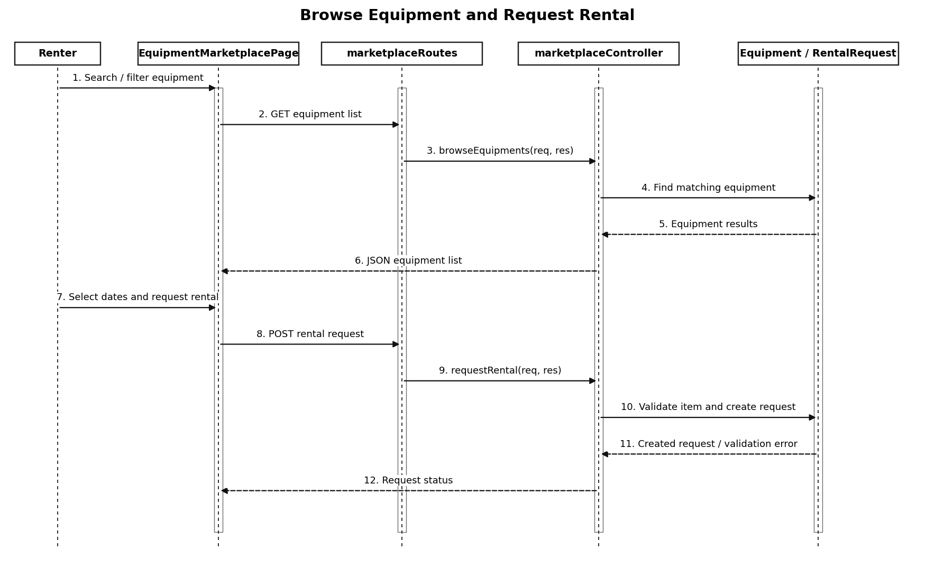
Figure II.2c – Browse Equipment and Request Rental (Sequence Diagram).
Interaction description: Guest/Renter -> EquipmentMarketplacePage / EquipmentDetailPage -> marketplaceRoutes -> marketplaceController -> Equipment / RentalRequest.

d. Database Queries
MongoDB/Mongoose operation patterns (representative; exact predicates and update guards are defined in the controller source):
No | Method / Module | Description
01 | Equipment.find(filter) | Read matching Equipment documents; write operations are role- and endpoint-dependent.
02 | RentalRequest.find(filter) | Read matching RentalRequest documents; write operations are role- and endpoint-dependent.
03 | User.find(filter) | Read matching User documents; write operations are role- and endpoint-dependent.

3. Owner Registration and Application Review
This section documents the implemented owner registration and application review module. Primary backend controller: be/src/controllers/ownerRegistrationController.js; related Mongoose models: OwnerApplication, User. The diagrams depict logical source-code modules, not Java classes.

a. Class Diagram
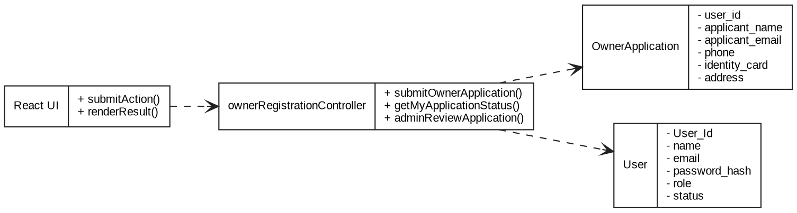
Figure II.3a – Class Diagram: Owner Registration and Application Review.

b. Class Specifications
ownerRegistrationController – Controller methods found in source code
No | Method / Module | Description
01 | submitOwnerApplication | Implemented handler in ownerRegistrationController.js; processes request/response and accesses related models as needed.
02 | getMyApplicationStatus | Implemented handler in ownerRegistrationController.js; processes request/response and accesses related models as needed.
03 | adminListApplications | Implemented handler in ownerRegistrationController.js; processes request/response and accesses related models as needed.
04 | adminReviewApplication | Implemented handler in ownerRegistrationController.js; processes request/response and accesses related models as needed.
Mongoose model specifications
No | Method / Module | Description
01 | OwnerApplication | Owner role application and approval. Declared in be/src/models/OwnerApplication.js.
02 | User | User accounts, credentials, role and profile. Declared in be/src/models/User.js.

c. Sequence Diagram(s)
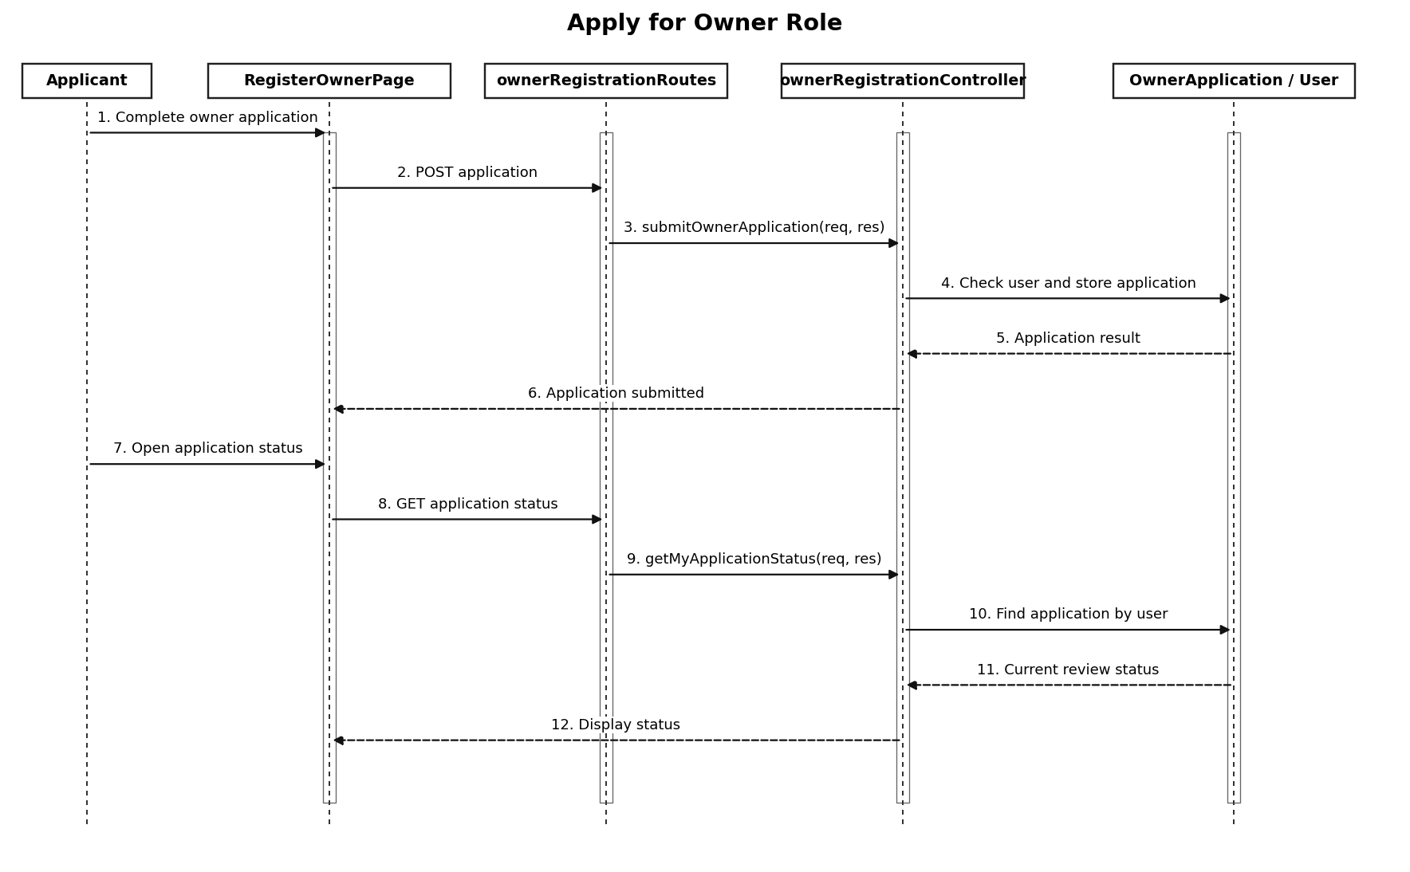
Figure II.3c – Apply for Owner Role (Sequence Diagram).
Interaction description: Applicant -> RegisterOwnerPage -> ownerRegistrationRoutes -> ownerRegistrationController -> OwnerApplication; administrator reviews application.

d. Database Queries
MongoDB/Mongoose operation patterns (representative; exact predicates and update guards are defined in the controller source):
No | Method / Module | Description
01 | OwnerApplication.find(filter) | Read matching OwnerApplication documents; write operations are role- and endpoint-dependent.
02 | User.find(filter) | Read matching User documents; write operations are role- and endpoint-dependent.

4. Owner Equipment Listings and Availability
This section documents the implemented owner equipment listings and availability module. Primary backend controller: be/src/controllers/ownerController.js; related Mongoose models: Equipment, EquipmentStatusRequest, User. The diagrams depict logical source-code modules, not Java classes.

a. Class Diagram
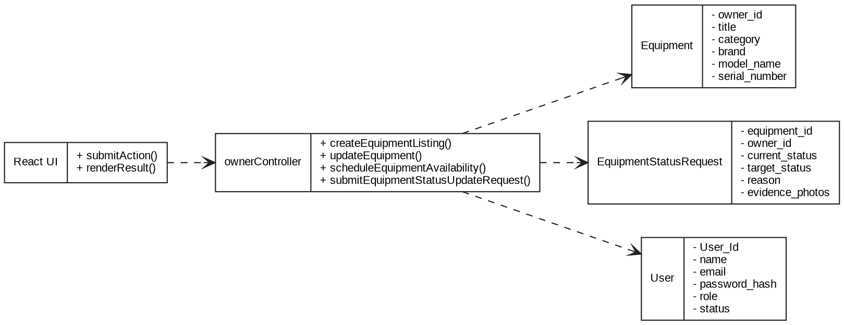
Figure II.4a – Class Diagram: Owner Equipment Listings and Availability.

b. Class Specifications
ownerController – Controller methods found in source code
No | Method / Module | Description
01 | getOwnerEquipments | Implemented handler in ownerController.js; processes request/response and accesses related models as needed.
02 | getEquipmentDetail | Implemented handler in ownerController.js; processes request/response and accesses related models as needed.
03 | createEquipmentListing | Implemented handler in ownerController.js; processes request/response and accesses related models as needed.
04 | updateEquipment | Implemented handler in ownerController.js; processes request/response and accesses related models as needed.
05 | toggleEquipmentVisibility | Implemented handler in ownerController.js; processes request/response and accesses related models as needed.
06 | scheduleEquipmentAvailability | Implemented handler in ownerController.js; processes request/response and accesses related models as needed.
07 | submitEquipmentStatusUpdateRequest | Implemented handler in ownerController.js; processes request/response and accesses related models as needed.
Mongoose model specifications
No | Method / Module | Description
01 | Equipment | Rental equipment listings and owner data. Declared in be/src/models/Equipment.js.
02 | EquipmentStatusRequest | Equipment status change review request. Declared in be/src/models/EquipmentStatusRequest.js.
03 | User | User accounts, credentials, role and profile. Declared in be/src/models/User.js.

c. Sequence Diagram(s)
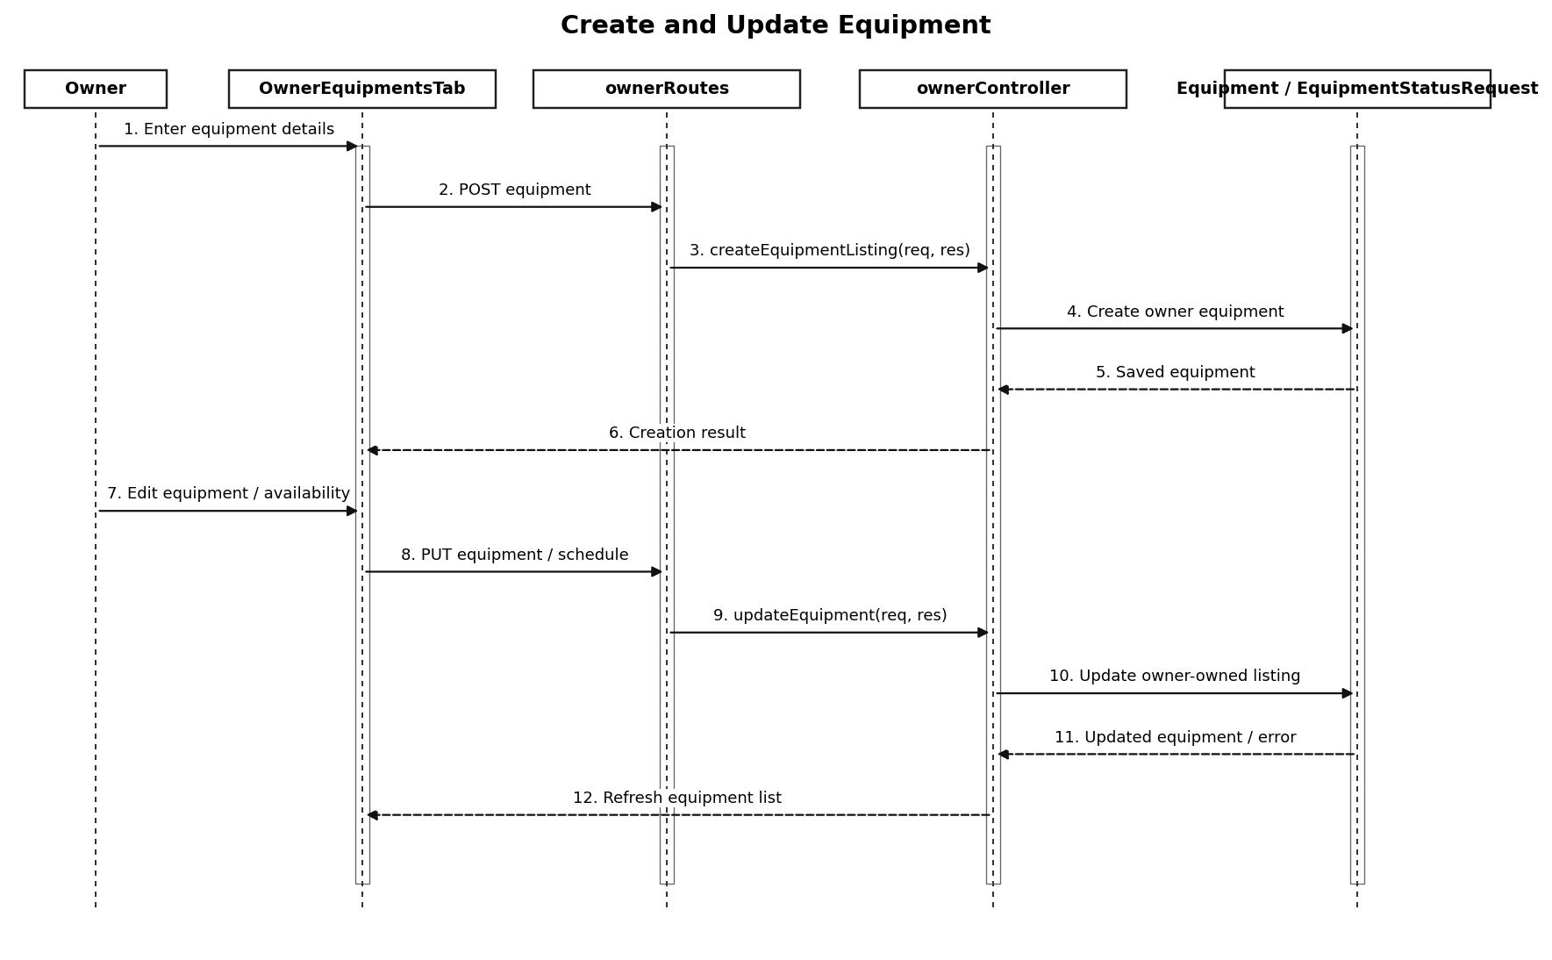
Figure II.4c – Create and Update Equipment (Sequence Diagram).
Interaction description: Owner -> OwnerEquipmentsTab -> ownerRoutes -> ownerController -> Equipment / EquipmentStatusRequest.

d. Database Queries
MongoDB/Mongoose operation patterns (representative; exact predicates and update guards are defined in the controller source):
No | Method / Module | Description
01 | Equipment.find(filter) | Read matching Equipment documents; write operations are role- and endpoint-dependent.
02 | EquipmentStatusRequest.find(filter) | Read matching EquipmentStatusRequest documents; write operations are role- and endpoint-dependent.
03 | User.find(filter) | Read matching User documents; write operations are role- and endpoint-dependent.

5. Owner Rental Requests and Contracts
This section documents the implemented owner rental requests and contracts module. Primary backend controller: be/src/controllers/ownerController.js; related Mongoose models: RentalRequest, RentalContract, ContractTemplate, Equipment. The diagrams depict logical source-code modules, not Java classes.

a. Class Diagram
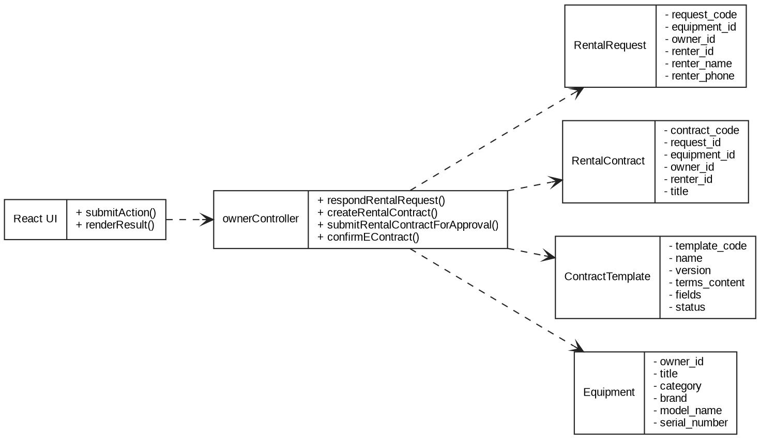
Figure II.5a – Class Diagram: Owner Rental Requests and Contracts.

b. Class Specifications
ownerController – Controller methods found in source code
No | Method / Module | Description
01 | submitEquipmentStatusUpdateRequest | Implemented handler in ownerController.js; processes request/response and accesses related models as needed.
02 | getRentalRequests | Implemented handler in ownerController.js; processes request/response and accesses related models as needed.
03 | respondRentalRequest | Implemented handler in ownerController.js; processes request/response and accesses related models as needed.
04 | getContracts | Implemented handler in ownerController.js; processes request/response and accesses related models as needed.
05 | getPublishedContractTemplates | Implemented handler in ownerController.js; processes request/response and accesses related models as needed.
06 | getContractDetail | Implemented handler in ownerController.js; processes request/response and accesses related models as needed.
07 | createRentalContract | Implemented handler in ownerController.js; processes request/response and accesses related models as needed.
08 | updateDraftContract | Implemented handler in ownerController.js; processes request/response and accesses related models as needed.
09 | submitRentalContractForApproval | Implemented handler in ownerController.js; processes request/response and accesses related models as needed.
10 | confirmEContract | Implemented handler in ownerController.js; processes request/response and accesses related models as needed.
11 | getContractHandoverRecords | Implemented handler in ownerController.js; processes request/response and accesses related models as needed.
12 | getSettlementByContract | Implemented handler in ownerController.js; processes request/response and accesses related models as needed.
Mongoose model specifications
No | Method / Module | Description
01 | RentalRequest | Rental request dates, fees and workflow status. Declared in be/src/models/RentalRequest.js.
02 | RentalContract | Rental agreement and approval lifecycle. Declared in be/src/models/RentalContract.js.
03 | ContractTemplate | Versioned contract templates. Declared in be/src/models/ContractTemplate.js.
04 | Equipment | Rental equipment listings and owner data. Declared in be/src/models/Equipment.js.

c. Sequence Diagram(s)
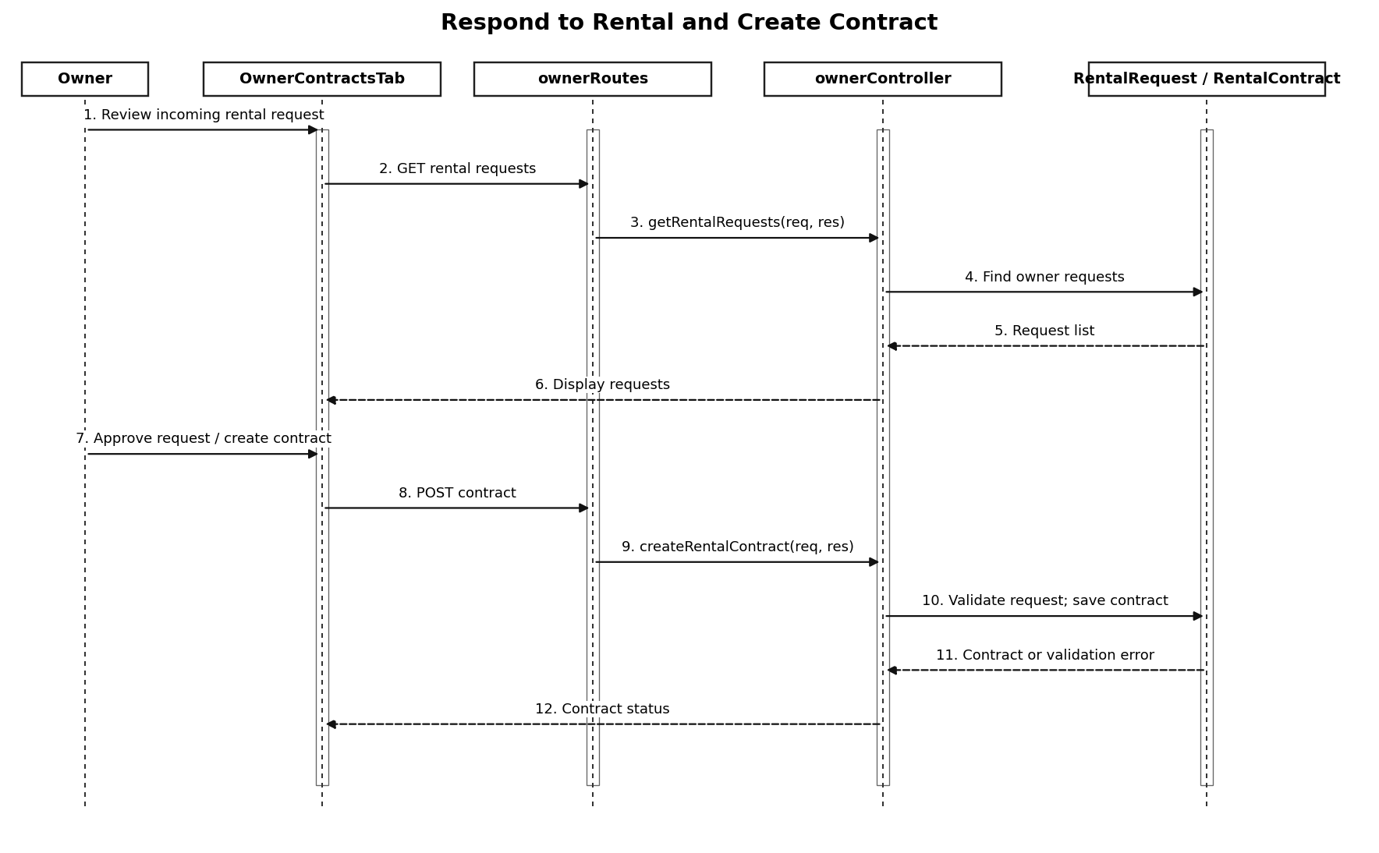
Figure II.5c – Respond to Rental and Create Contract (Sequence Diagram).
Interaction description: Owner -> OwnerRequestsTab / OwnerContractsTab -> ownerRoutes -> ownerController -> RentalRequest / RentalContract / ContractTemplate.

d. Database Queries
MongoDB/Mongoose operation patterns (representative; exact predicates and update guards are defined in the controller source):
No | Method / Module | Description
01 | RentalRequest.find(filter) | Read matching RentalRequest documents; write operations are role- and endpoint-dependent.
02 | RentalContract.find(filter) | Read matching RentalContract documents; write operations are role- and endpoint-dependent.
03 | ContractTemplate.find(filter) | Read matching ContractTemplate documents; write operations are role- and endpoint-dependent.
04 | Equipment.find(filter) | Read matching Equipment documents; write operations are role- and endpoint-dependent.

6. Owner Handover, Settlement, Disputes and Support
This section documents the implemented owner handover, settlement, disputes and support module. Primary backend controller: be/src/controllers/ownerController.js; related Mongoose models: HandoverRecord, Settlement, Dispute, SupportTicket, RentalContract. The diagrams depict logical source-code modules, not Java classes.

a. Class Diagram
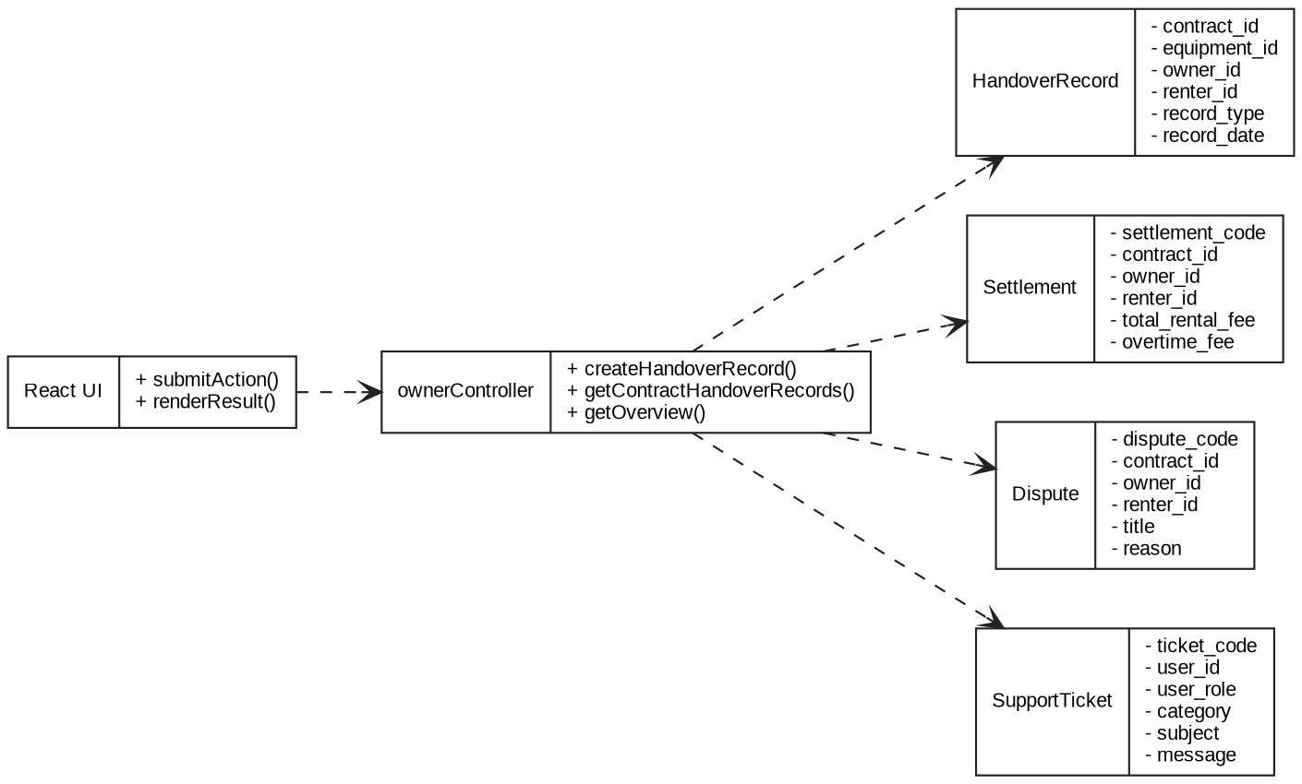
Figure II.6a – Class Diagram: Owner Handover, Settlement, Disputes and Support.

b. Class Specifications
ownerController – Controller methods found in source code
No | Method / Module | Description
01 | getOverview | Implemented handler in ownerController.js; processes request/response and accesses related models as needed.
02 | getContractHandoverRecords | Implemented handler in ownerController.js; processes request/response and accesses related models as needed.
03 | updateHandoverRecordAfterReview | Implemented handler in ownerController.js; processes request/response and accesses related models as needed.
04 | createHandoverRecord | Implemented handler in ownerController.js; processes request/response and accesses related models as needed.
05 | getSettlements | Implemented handler in ownerController.js; processes request/response and accesses related models as needed.
06 | getSettlementByContract | Implemented handler in ownerController.js; processes request/response and accesses related models as needed.
07 | confirmSettlementPayout | Implemented handler in ownerController.js; processes request/response and accesses related models as needed.
08 | submitRentalDispute | Implemented handler in ownerController.js; processes request/response and accesses related models as needed.
09 | getOwnerDisputes | Implemented handler in ownerController.js; processes request/response and accesses related models as needed.
10 | submitSupportTicket | Implemented handler in ownerController.js; processes request/response and accesses related models as needed.
11 | getOwnerSupportTickets | Implemented handler in ownerController.js; processes request/response and accesses related models as needed.
12 | replySupportTicket | Implemented handler in ownerController.js; processes request/response and accesses related models as needed.
Mongoose model specifications
No | Method / Module | Description
01 | HandoverRecord | Handover / return evidence and review. Declared in be/src/models/HandoverRecord.js.
02 | Settlement | Financial settlement associated with rentals. Declared in be/src/models/Settlement.js.
03 | Dispute | Contract-related disputes and resolution. Declared in be/src/models/Dispute.js.
04 | SupportTicket | Support cases and responses. Declared in be/src/models/SupportTicket.js.
05 | RentalContract | Rental agreement and approval lifecycle. Declared in be/src/models/RentalContract.js.

c. Sequence Diagram(s)
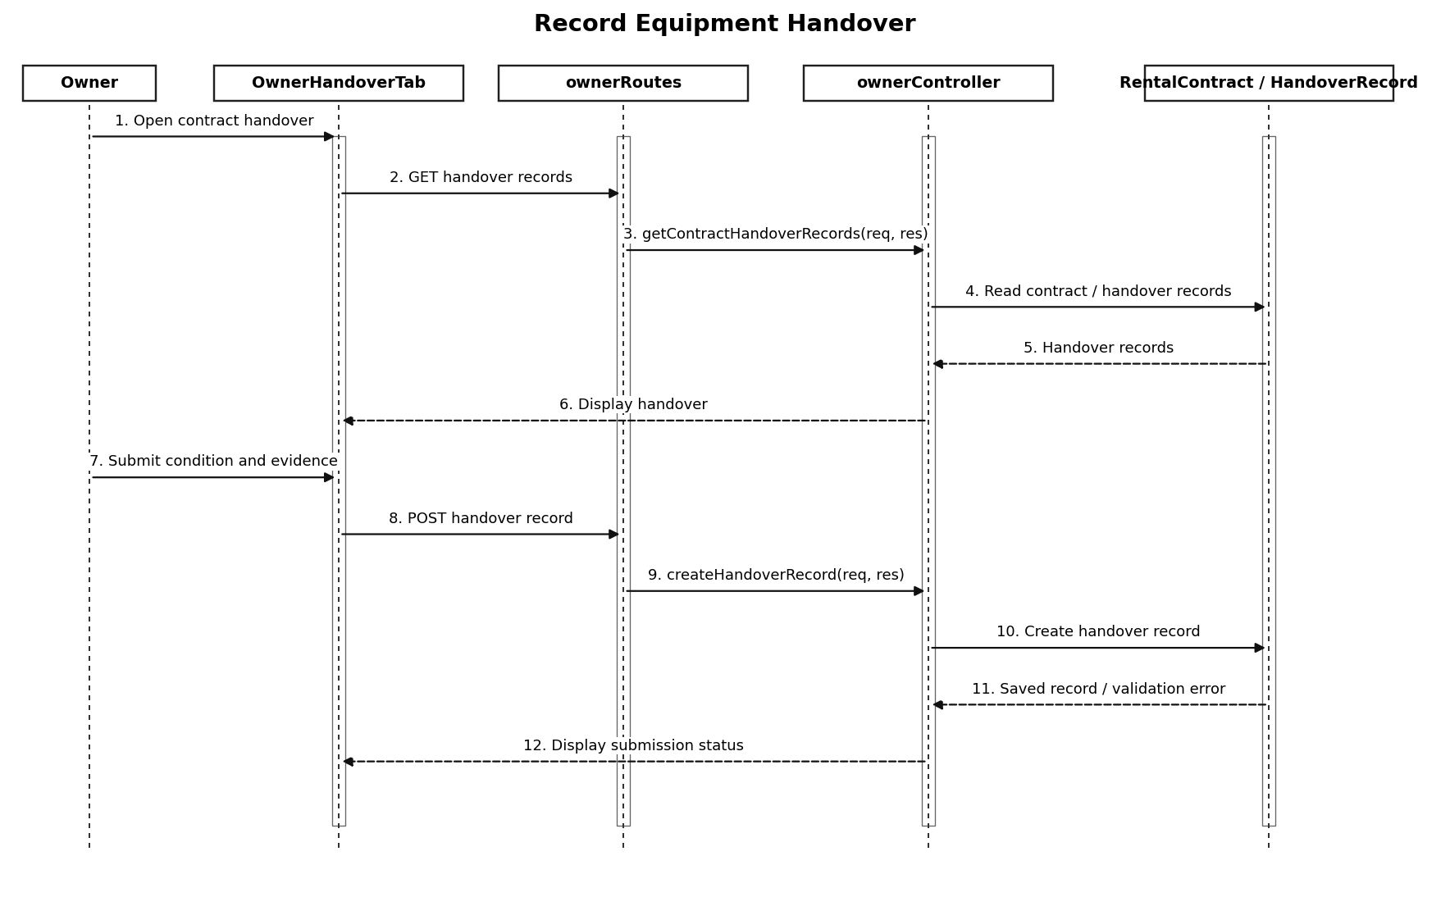
Figure II.6c – Record Equipment Handover (Sequence Diagram).
Interaction description: Owner -> OwnerHandoverTab / OwnerSettlementTab / OwnerDisputesTab / OwnerSupportTab -> ownerRoutes -> ownerController -> MongoDB.

d. Database Queries
MongoDB/Mongoose operation patterns (representative; exact predicates and update guards are defined in the controller source):
No | Method / Module | Description
01 | HandoverRecord.find(filter) | Read matching HandoverRecord documents; write operations are role- and endpoint-dependent.
02 | Settlement.find(filter) | Read matching Settlement documents; write operations are role- and endpoint-dependent.
03 | Dispute.find(filter) | Read matching Dispute documents; write operations are role- and endpoint-dependent.
04 | SupportTicket.find(filter) | Read matching SupportTicket documents; write operations are role- and endpoint-dependent.
05 | RentalContract.find(filter) | Read matching RentalContract documents; write operations are role- and endpoint-dependent.

7. Rental Moderator Review and Contract Templates
This section documents the implemented rental moderator review and contract templates module. Primary backend controller: be/src/controllers/moderatorController.js; related Mongoose models: RentalContract, Equipment, HandoverRecord, EquipmentStatusRequest, ContractTemplate, SupportTicket. The diagrams depict logical source-code modules, not Java classes.

a. Class Diagram
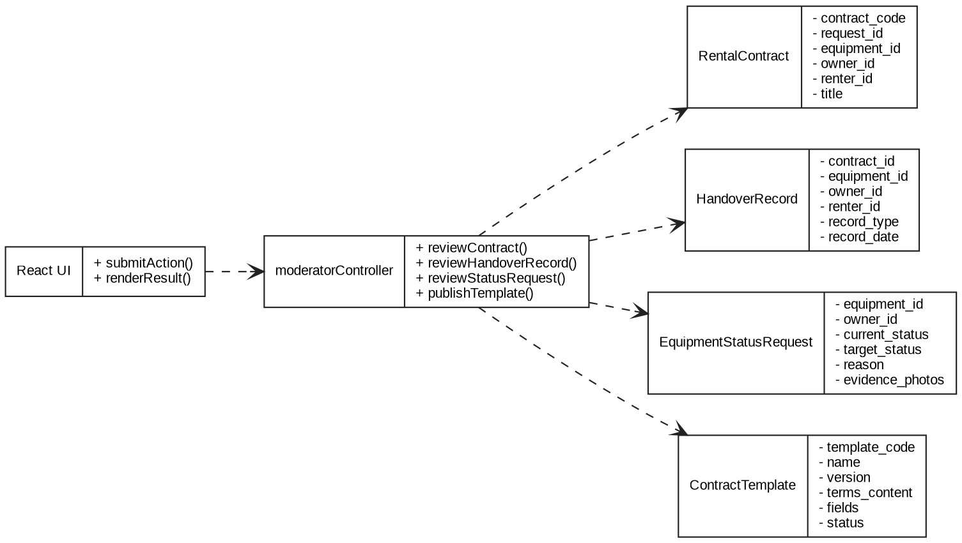
Figure II.7a – Class Diagram: Rental Moderator Review and Contract Templates.

b. Class Specifications
moderatorController – Controller methods found in source code
No | Method / Module | Description
01 | notifyUsers | Implemented handler in moderatorController.js; processes request/response and accesses related models as needed.
02 | listContracts | Implemented handler in moderatorController.js; processes request/response and accesses related models as needed.
03 | reviewContract | Implemented handler in moderatorController.js; processes request/response and accesses related models as needed.
04 | listEquipments | Implemented handler in moderatorController.js; processes request/response and accesses related models as needed.
05 | listHandoverRecords | Implemented handler in moderatorController.js; processes request/response and accesses related models as needed.
06 | reviewHandoverRecord | Implemented handler in moderatorController.js; processes request/response and accesses related models as needed.
07 | listStatusRequests | Implemented handler in moderatorController.js; processes request/response and accesses related models as needed.
08 | reviewStatusRequest | Implemented handler in moderatorController.js; processes request/response and accesses related models as needed.
09 | listTemplates | Implemented handler in moderatorController.js; processes request/response and accesses related models as needed.
10 | createTemplate | Implemented handler in moderatorController.js; processes request/response and accesses related models as needed.
11 | createTemplateVersion | Implemented handler in moderatorController.js; processes request/response and accesses related models as needed.
12 | publishTemplate | Implemented handler in moderatorController.js; processes request/response and accesses related models as needed.
13 | retireTemplate | Implemented handler in moderatorController.js; processes request/response and accesses related models as needed.
14 | listPublishedTemplates | Implemented handler in moderatorController.js; processes request/response and accesses related models as needed.
15 | submitSupportTicket | Implemented handler in moderatorController.js; processes request/response and accesses related models as needed.
Mongoose model specifications
No | Method / Module | Description
01 | RentalContract | Rental agreement and approval lifecycle. Declared in be/src/models/RentalContract.js.
02 | Equipment | Rental equipment listings and owner data. Declared in be/src/models/Equipment.js.
03 | HandoverRecord | Handover / return evidence and review. Declared in be/src/models/HandoverRecord.js.
04 | EquipmentStatusRequest | Equipment status change review request. Declared in be/src/models/EquipmentStatusRequest.js.
05 | ContractTemplate | Versioned contract templates. Declared in be/src/models/ContractTemplate.js.
06 | SupportTicket | Support cases and responses. Declared in be/src/models/SupportTicket.js.

c. Sequence Diagram(s)
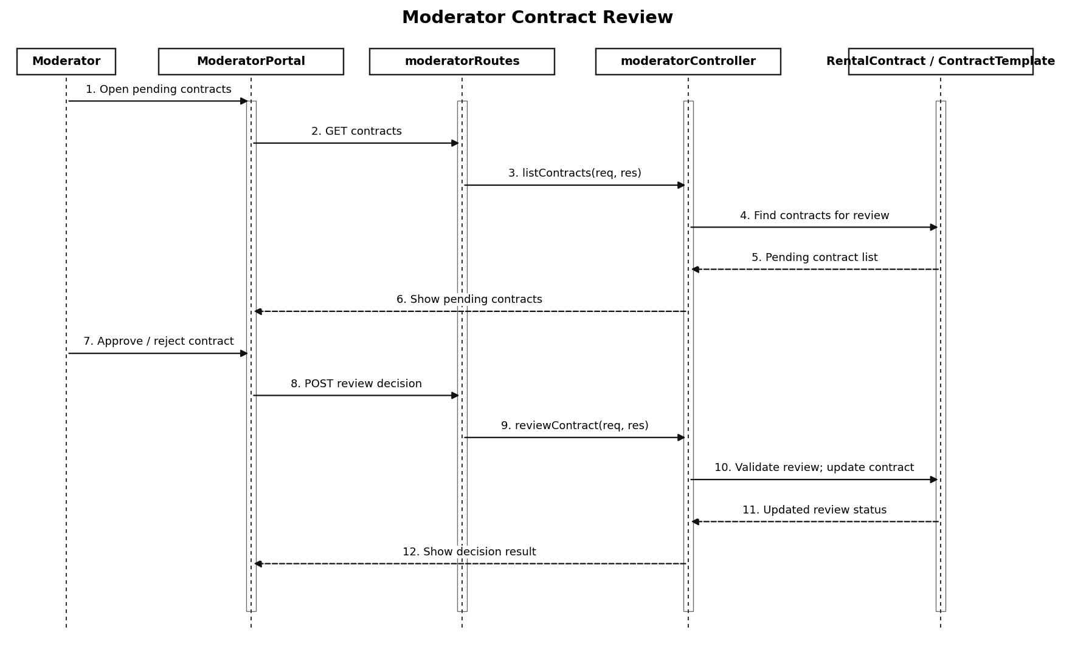
Figure II.7c – Moderator Contract Review (Sequence Diagram).
Interaction description: Moderator -> ModeratorPortal -> moderatorRoutes -> moderatorController -> review records / contract templates -> MongoDB.

d. Database Queries
MongoDB/Mongoose operation patterns (representative; exact predicates and update guards are defined in the controller source):
No | Method / Module | Description
01 | RentalContract.find(filter) | Read matching RentalContract documents; write operations are role- and endpoint-dependent.
02 | Equipment.find(filter) | Read matching Equipment documents; write operations are role- and endpoint-dependent.
03 | HandoverRecord.find(filter) | Read matching HandoverRecord documents; write operations are role- and endpoint-dependent.
04 | EquipmentStatusRequest.find(filter) | Read matching EquipmentStatusRequest documents; write operations are role- and endpoint-dependent.
05 | ContractTemplate.find(filter) | Read matching ContractTemplate documents; write operations are role- and endpoint-dependent.
06 | SupportTicket.find(filter) | Read matching SupportTicket documents; write operations are role- and endpoint-dependent.

8. System Administration and Platform Oversight
This section documents the implemented system administration and platform oversight module. Primary backend controller: be/src/controllers/adminController.js; related Mongoose models: User, AuditLog, SupportTicket, Equipment, Dispute, OwnerApplication. The diagrams depict logical source-code modules, not Java classes.

a. Class Diagram
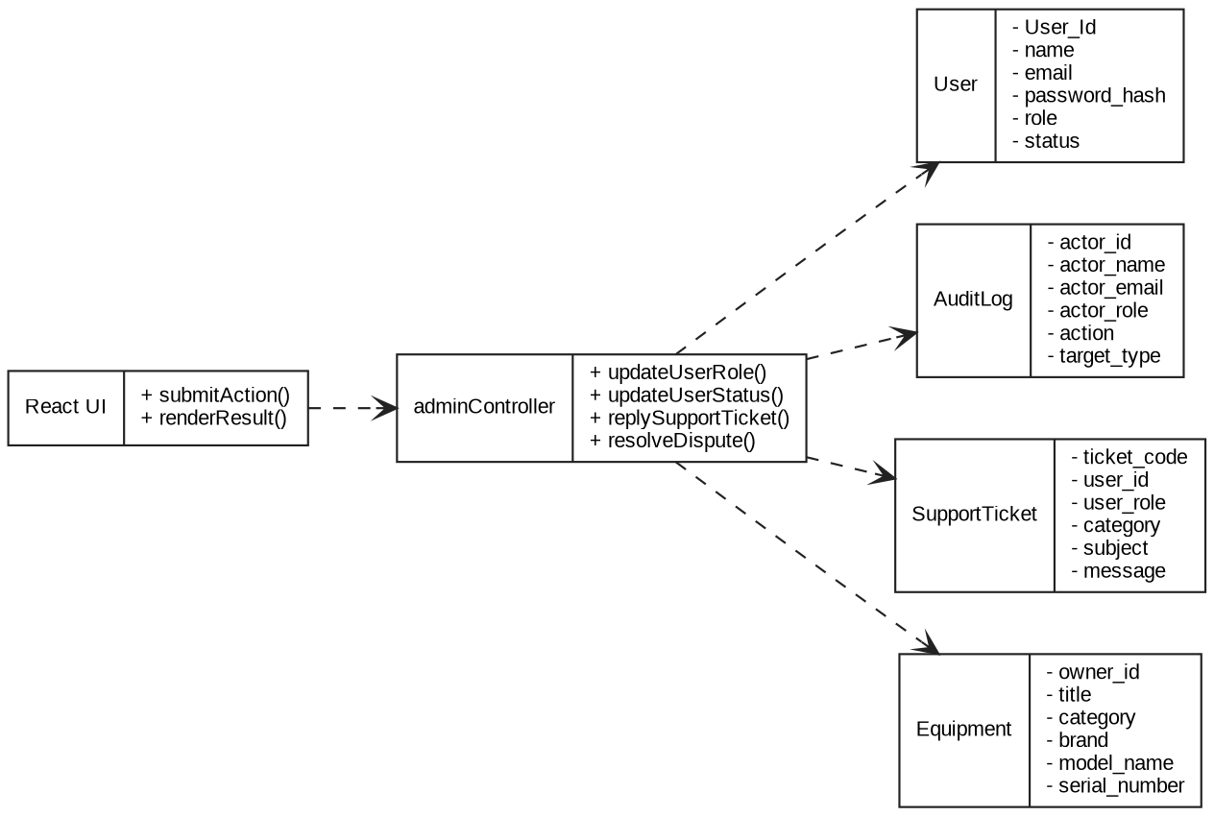
Figure II.8a – Class Diagram: System Administration and Platform Oversight.

b. Class Specifications
adminController – Controller methods found in source code
No | Method / Module | Description
01 | getOverview | Implemented handler in adminController.js; processes request/response and accesses related models as needed.
02 | updateUserRole | Implemented handler in adminController.js; processes request/response and accesses related models as needed.
03 | updateUserStatus | Implemented handler in adminController.js; processes request/response and accesses related models as needed.
04 | listSupportTickets | Implemented handler in adminController.js; processes request/response and accesses related models as needed.
05 | replySupportTicket | Implemented handler in adminController.js; processes request/response and accesses related models as needed.
06 | updateSupportTicketStatus | Implemented handler in adminController.js; processes request/response and accesses related models as needed.
07 | listEquipments | Implemented handler in adminController.js; processes request/response and accesses related models as needed.
08 | reviewEquipmentApproval | Implemented handler in adminController.js; processes request/response and accesses related models as needed.
09 | updateEquipmentVisibility | Implemented handler in adminController.js; processes request/response and accesses related models as needed.
10 | listDisputes | Implemented handler in adminController.js; processes request/response and accesses related models as needed.
11 | getDisputeDetail | Implemented handler in adminController.js; processes request/response and accesses related models as needed.
12 | resolveDispute | Implemented handler in adminController.js; processes request/response and accesses related models as needed.
13 | listKycSubmissions | Implemented handler in adminController.js; processes request/response and accesses related models as needed.
14 | reviewKycSubmission | Implemented handler in adminController.js; processes request/response and accesses related models as needed.
15 | listAuditLogs | Implemented handler in adminController.js; processes request/response and accesses related models as needed.
Mongoose model specifications
No | Method / Module | Description
01 | User | User accounts, credentials, role and profile. Declared in be/src/models/User.js.
02 | AuditLog | Administrative audit trail. Declared in be/src/models/AuditLog.js.
03 | SupportTicket | Support cases and responses. Declared in be/src/models/SupportTicket.js.
04 | Equipment | Rental equipment listings and owner data. Declared in be/src/models/Equipment.js.
05 | Dispute | Contract-related disputes and resolution. Declared in be/src/models/Dispute.js.
06 | OwnerApplication | Owner role application and approval. Declared in be/src/models/OwnerApplication.js.

c. Sequence Diagram(s)
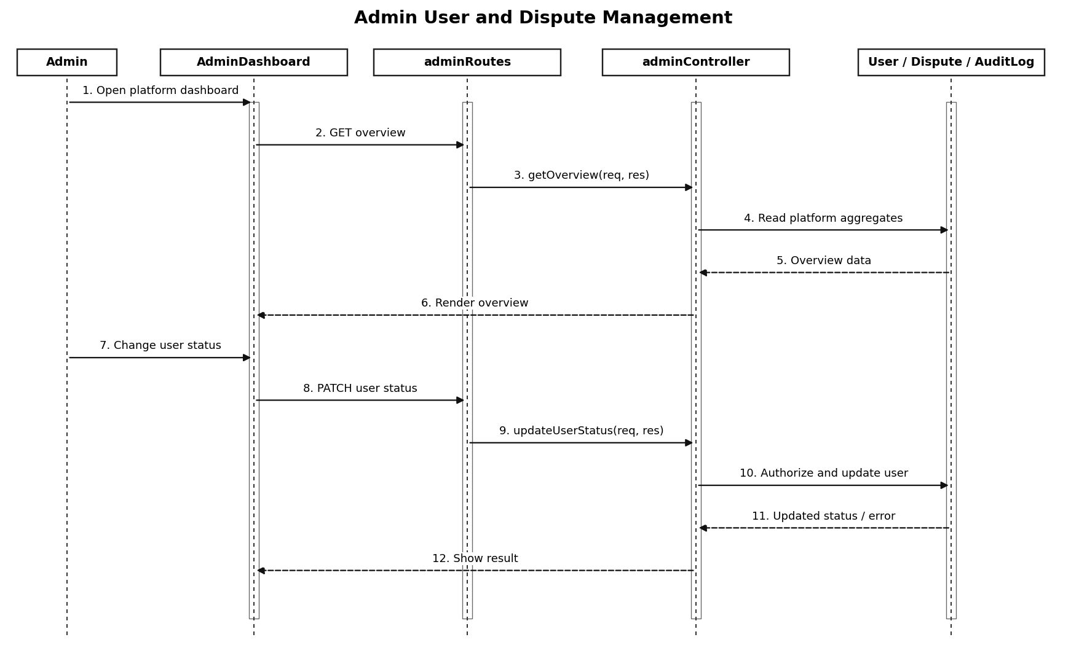
Figure II.8c – Admin User and Dispute Management (Sequence Diagram).
Interaction description: Admin -> AdminDashboard -> adminRoutes -> adminController -> users, support, equipment, disputes, owner applications and audit logs.

d. Database Queries
MongoDB/Mongoose operation patterns (representative; exact predicates and update guards are defined in the controller source):
No | Method / Module | Description
01 | User.find(filter) | Read matching User documents; write operations are role- and endpoint-dependent.
02 | AuditLog.find(filter) | Read matching AuditLog documents; write operations are role- and endpoint-dependent.
03 | SupportTicket.find(filter) | Read matching SupportTicket documents; write operations are role- and endpoint-dependent.
04 | Equipment.find(filter) | Read matching Equipment documents; write operations are role- and endpoint-dependent.
05 | Dispute.find(filter) | Read matching Dispute documents; write operations are role- and endpoint-dependent.
06 | OwnerApplication.find(filter) | Read matching OwnerApplication documents; write operations are role- and endpoint-dependent.

8.1–8.7 Detailed Design for Seven System Admin Functions
Each function below follows the school template: a. Class Diagram; b. Class Specifications; c. Sequence Diagram(s); d. Database Queries. Flows are aligned to README_WORKFLOW_SYSTEM_ADMIN_7UC.pdf and checked against the supplied SmartEquip source code. Diagram labels represent implemented interactions; source-level limitations are explicitly noted.

8.1 Admin Login (UC_A01)
Function / endpoint(s): POST /api/auth/login

a. Class Diagram
Figure II.8.1a – Admin Login (Class Diagram).

b. Class Specifications
Component / Class | Responsibility / Operations
LoginPage | Frontend component responsible for initiating and displaying the function.
authController.login / authService.loginUser | Backend request handler(s); validates request and orchestrates persistence.
Admin route middleware | authenticate and authorize("systemadmin", "Systemadmin") for /api/admin endpoints.
User | Mongoose persistence model used by this function.
authService.loginUser | Validates login credentials and account status, and issues the authentication result.

c. Sequence Diagram(s)
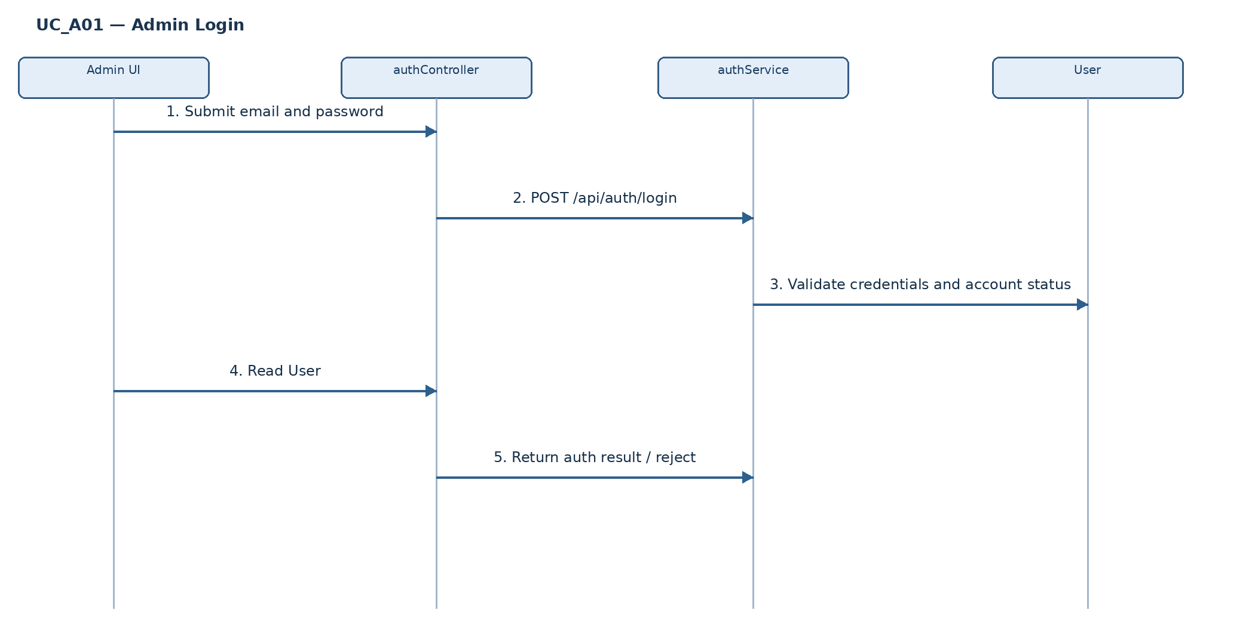
Figure II.8.1c – Admin Login (Sequence Diagram / ordered interactions).
Alternative and exception flows: Invalid credentials or blocked/inactive account: login rejected; A non-admin authenticated user cannot enter System Admin routes.

d. Database Queries
No. | Mongoose query / database operation
1 | User.findOne({ email: normalizedEmail })
2 | User password verification and status validation (authService.loginUser)
3 | JWT issued after successful authentication
Source mapping: authController.login / authService.loginUser.

8.2 View System Dashboard (UC_A02)
Function / endpoint(s): GET /api/admin/overview

a. Class Diagram
Figure II.8.2a – View System Dashboard (Class Diagram).

b. Class Specifications
Component / Class | Responsibility / Operations
AdminDashboard / adminApi | Frontend component responsible for initiating and displaying the function.
adminController.getOverview | Backend request handler(s); validates request and orchestrates persistence.
Admin route middleware | authenticate and authorize("systemadmin", "Systemadmin") for /api/admin endpoints.
User | Mongoose persistence model used by this function.
Equipment | Mongoose persistence model used by this function.
Dispute | Mongoose persistence model used by this function.
SupportTicket | Mongoose persistence model used by this function.

c. Sequence Diagram(s)
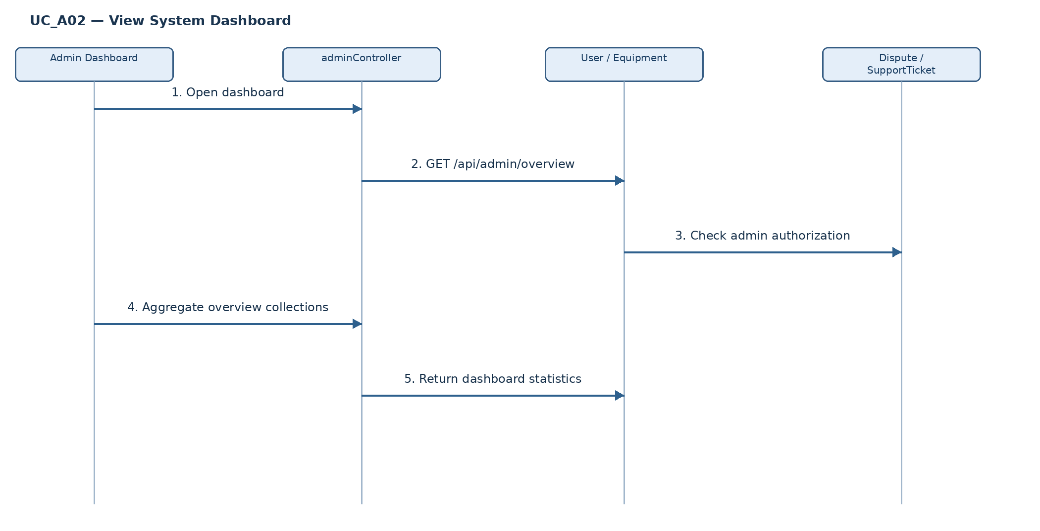
Figure II.8.2c – View System Dashboard (Sequence Diagram / ordered interactions).
Alternative and exception flows: Unauthorized request is rejected by middleware; API failure displays error state.

d. Database Queries
No. | Mongoose query / database operation
1 | User.countDocuments() and User.countDocuments({status:"active"})
2 | User.countDocuments({role:{$regex:/^systemadmin$/i}})
3 | Equipment.countDocuments({approval_status:"pending"})
4 | Dispute.countDocuments({status:{$in:["pending_review","investigating"]}})
5 | User.countDocuments({kycStatus:"pending"})
6 | SupportTicket.countDocuments({status:"open"})
7 | User.find({}, safeProjection).sort({createdAt:-1}).lean()
Source mapping: adminController.getOverview.

8.3 View and Search User Accounts (UC_A03)
Function / endpoint(s): GET /api/admin/overview (initial data only)

a. Class Diagram
Figure II.8.3a – View and Search User Accounts (Class Diagram).

b. Class Specifications
Component / Class | Responsibility / Operations
AdminUserTable | Frontend component responsible for initiating and displaying the function.
adminController.getOverview | Backend request handler(s); validates request and orchestrates persistence.
Admin route middleware | authenticate and authorize("systemadmin", "Systemadmin") for /api/admin endpoints.
User | Mongoose persistence model used by this function.

c. Sequence Diagram(s)
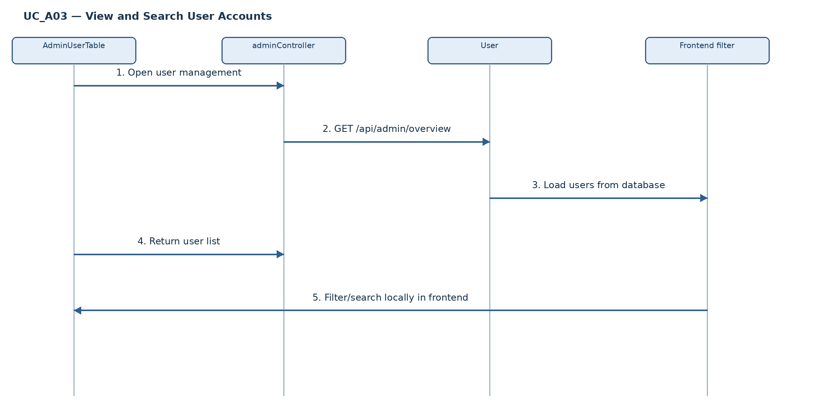
Figure II.8.3c – View and Search User Accounts (Sequence Diagram / ordered interactions).
Alternative and exception flows: No matches: display empty result; Search/filter changes do not call a new backend search endpoint.

d. Database Queries
No. | Mongoose query / database operation
1 | User.find({}, {password_hash:0,password_reset_token_hash:0,google_id:0}).sort({createdAt:-1}).lean()
2 | Keyword and role filtering occur in React, not MongoDB
Source mapping: adminController.getOverview.

8.4 Suspend or Reactivate User Account (UC_A04)
Function / endpoint(s): PATCH /api/admin/users/:userId/status

a. Class Diagram
Figure II.8.4a – Suspend or Reactivate User Account (Class Diagram).

b. Class Specifications
Component / Class | Responsibility / Operations
AdminUserTable / AdminDashboard | Frontend component responsible for initiating and displaying the function.
adminController.updateUserStatus | Backend request handler(s); validates request and orchestrates persistence.
Admin route middleware | authenticate and authorize("systemadmin", "Systemadmin") for /api/admin endpoints.
User | Mongoose persistence model used by this function.
AuditLog | Mongoose persistence model used by this function.
auditLogger / AuditLog | Records the administrator action in the audit trail.

c. Sequence Diagram(s)
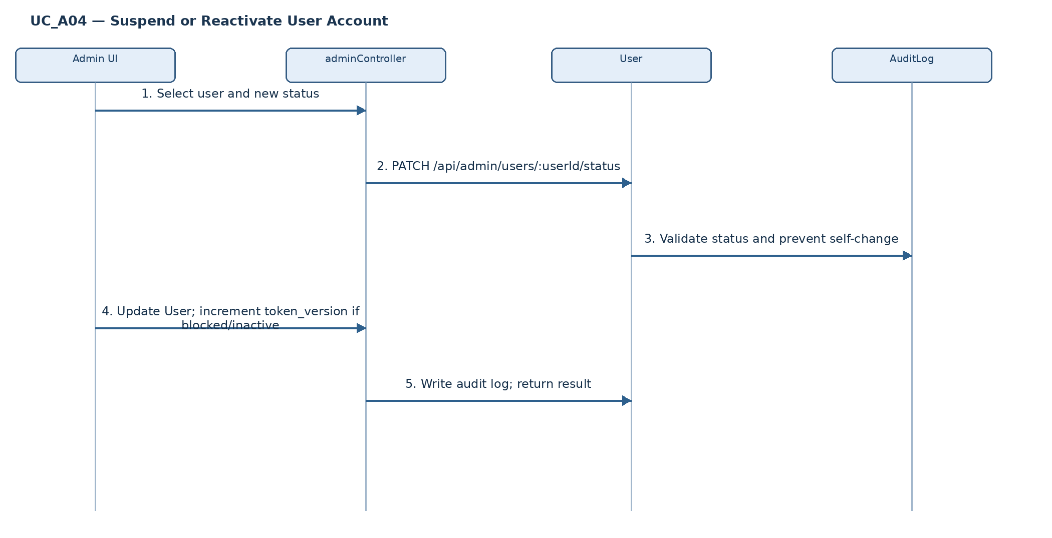
Figure II.8.4c – Suspend or Reactivate User Account (Sequence Diagram / ordered interactions).
Alternative and exception flows: Invalid status: HTTP 400; Unknown user: HTTP 404; Self-targeted change: HTTP 400; Switching to active does not increment token_version.

d. Database Queries
No. | Mongoose query / database operation
1 | User.findById(userId)
2 | user.status = status; if(status!=="active") user.token_version++
3 | user.save()
4 | recordAuditLog({action:"USER_STATUS_UPDATED", targetType:"User", ...})
Source mapping: adminController.updateUserStatus.

8.5 Assign or Revoke User Roles (UC_A05)
Function / endpoint(s): PATCH /api/admin/users/:userId/role

a. Class Diagram
Figure II.8.5a – Assign or Revoke User Roles (Class Diagram).

b. Class Specifications
Component / Class | Responsibility / Operations
AdminUserTable / AdminDashboard | Frontend component responsible for initiating and displaying the function.
adminController.updateUserRole | Backend request handler(s); validates request and orchestrates persistence.
Admin route middleware | authenticate and authorize("systemadmin", "Systemadmin") for /api/admin endpoints.
User | Mongoose persistence model used by this function.
AuditLog | Mongoose persistence model used by this function.
auditLogger / AuditLog | Records the administrator action in the audit trail.

c. Sequence Diagram(s)
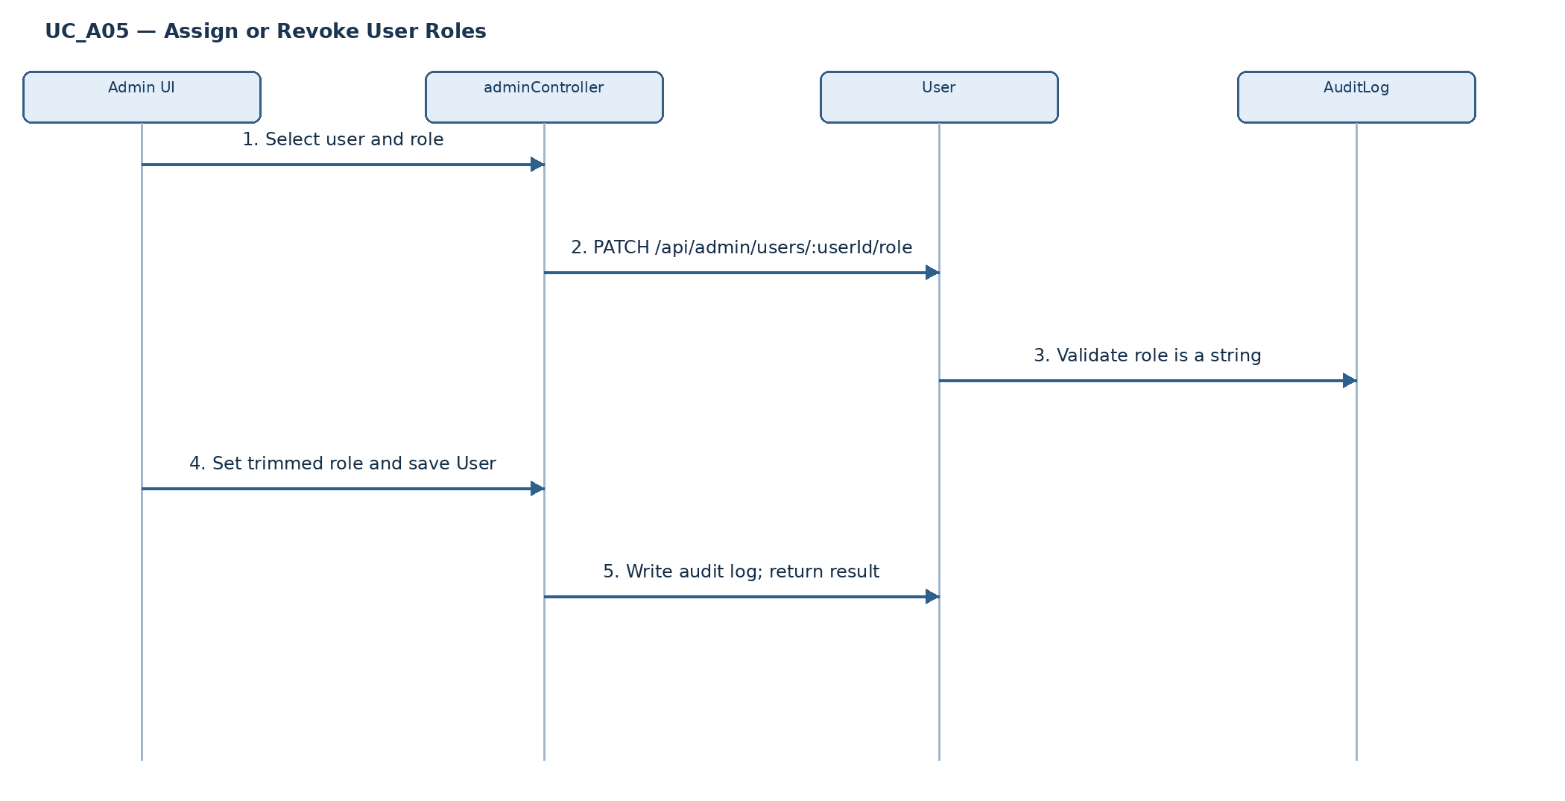
Figure II.8.5c – Assign or Revoke User Roles (Sequence Diagram / ordered interactions).
Alternative and exception flows: Invalid/missing role: HTTP 400; Unknown user: HTTP 404; Controller does not enforce a fixed role allowlist or prohibit self-role changes.

d. Database Queries
No. | Mongoose query / database operation
1 | User.findById(userId)
2 | user.role = role.trim(); user.save()
3 | recordAuditLog({action:"USER_ROLE_UPDATED", targetType:"User", ...})
Source mapping: adminController.updateUserRole.

8.6 Approve or Reject Owner Registration (UC_A07)
Function / endpoint(s): GET /api/admin/owner-applications; PATCH /api/admin/owner-applications/:id/review

a. Class Diagram
Figure II.8.6a – Approve or Reject Owner Registration (Class Diagram).

b. Class Specifications
Component / Class | Responsibility / Operations
AdminOwnerApplications | Frontend component responsible for initiating and displaying the function.
ownerRegistrationController.adminListApplications / adminReviewApplication | Backend request handler(s); validates request and orchestrates persistence.
Admin route middleware | authenticate and authorize("systemadmin", "Systemadmin") for /api/admin endpoints.
OwnerApplication | Mongoose persistence model used by this function.
User | Mongoose persistence model used by this function.

c. Sequence Diagram(s)
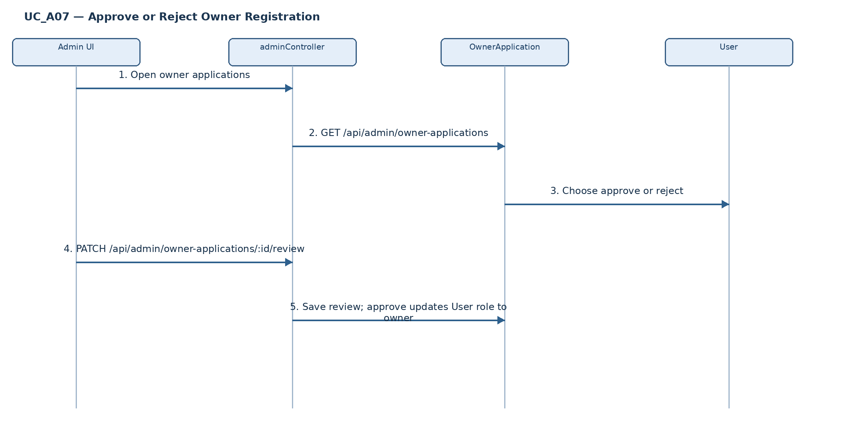
Figure II.8.6c – Approve or Reject Owner Registration (Sequence Diagram / ordered interactions).
Alternative and exception flows: Invalid action or missing application is rejected; Controller does not enforce pending-only review; Rejection note is not mandatory in current backend.

d. Database Queries
No. | Mongoose query / database operation
1 | OwnerApplication.find(...) for listing
2 | OwnerApplication.findById(id)
3 | application.status / admin_note / reviewed_by / reviewed_at; application.save()
4 | User.findById(application.user_id); user.role="owner"; user.save() on approval
Source mapping: ownerRegistrationController.adminListApplications / adminReviewApplication.

8.7 Respond to Support Ticket (UC_A17)
Function / endpoint(s): GET /api/admin/support-tickets; POST /api/admin/support-tickets/:id/reply

a. Class Diagram
Figure II.8.7a – Respond to Support Ticket (Class Diagram).

b. Class Specifications
Component / Class | Responsibility / Operations
AdminSupportTickets | Frontend component responsible for initiating and displaying the function.
adminController.listSupportTickets / replySupportTicket | Backend request handler(s); validates request and orchestrates persistence.
Admin route middleware | authenticate and authorize("systemadmin", "Systemadmin") for /api/admin endpoints.
SupportTicket | Mongoose persistence model used by this function.
UserNotification | Mongoose persistence model used by this function.
AuditLog | Mongoose persistence model used by this function.
auditLogger / AuditLog | Records the administrator action in the audit trail.
Socket.IO | Emits ticket:replied after persistence (best-effort).

c. Sequence Diagram(s)
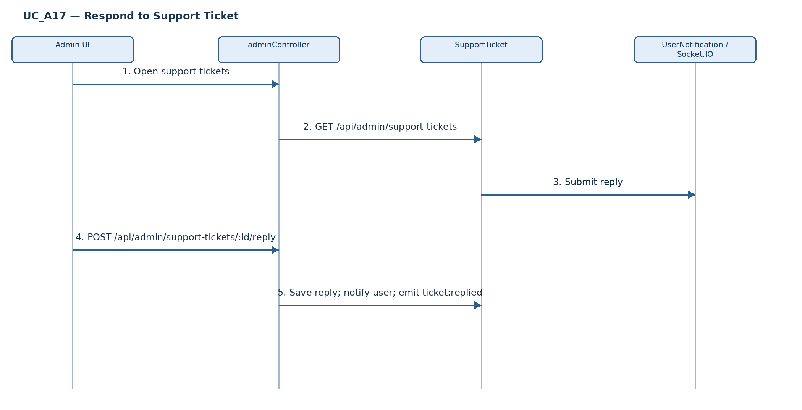
Figure II.8.7c – Respond to Support Ticket (Sequence Diagram / ordered interactions).
Alternative and exception flows: Empty reply: HTTP 400; unknown ticket: HTTP 404; Notification/Socket.IO errors are caught separately; Valid nextStatus: open, in_progress, resolved, closed.

d. Database Queries
No. | Mongoose query / database operation
1 | SupportTicket.findById(id)
2 | ticket.replies.push({...}); ticket.save()
3 | UserNotification.create({...}) (best-effort)
4 | recordAuditLog({action:"SUPPORT_TICKET_REPLIED", ...})
5 | SupportTicket.findById(id).populate(...).lean()
Source mapping: adminController.listSupportTickets / replySupportTicket.

