3. Existing Systems

3.1 Mobile application
This software can be downloaded on Google Play and App Store . The mobile app is used by the customers of the motel bokerage. If an user is a new user, he/she can register an account through the app and login. From the app:
• User can check the following parameters: Price,Utilities, type of rooms,gender, ...
• Users also receive comment and notifications when owner need to find customer
• Update location user through the app.

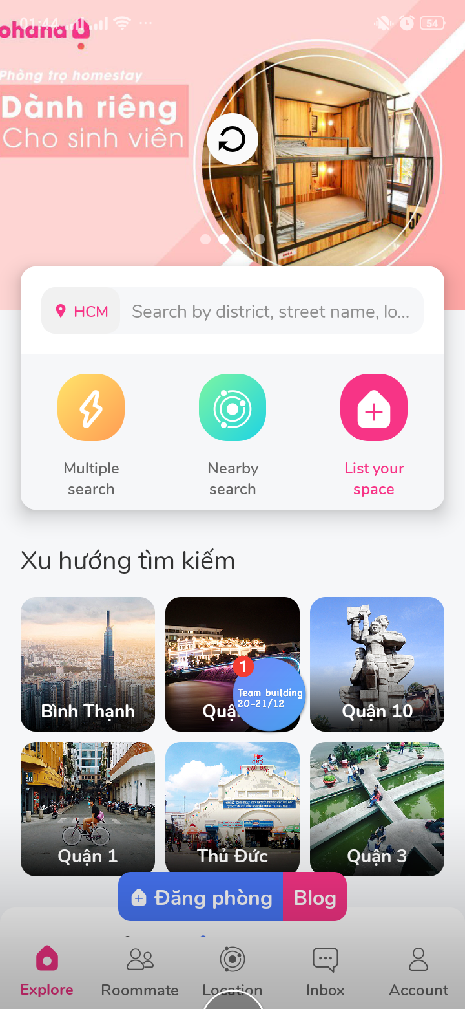
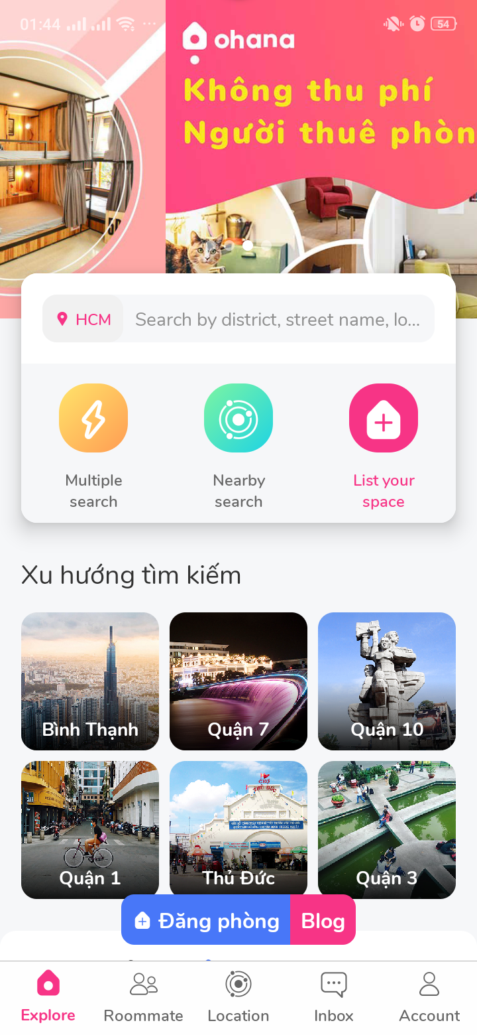
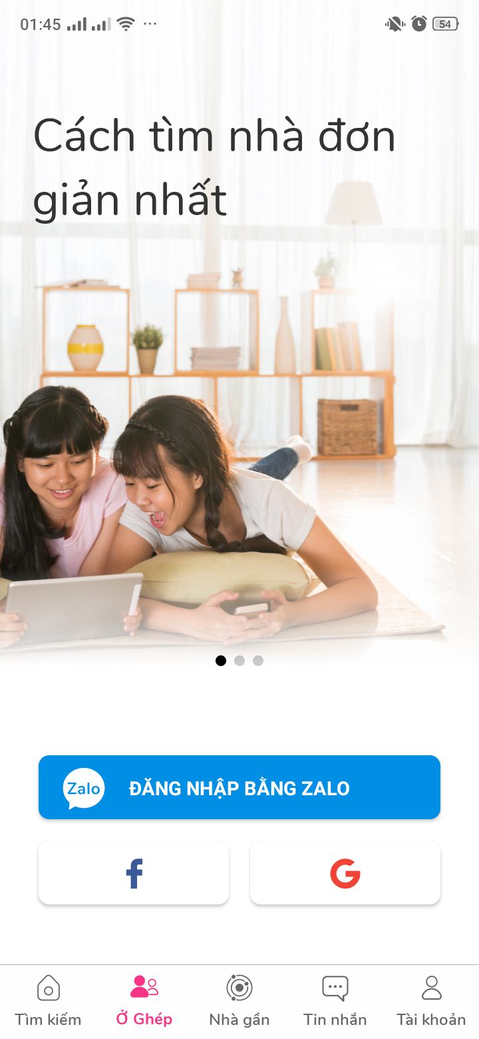

Advantages | Disadvantages
GUI is user-friendly, suppost language: VietNamese. | Need internet to take notification
Freeware, public on Google Play and Appstore
Handy, simple, easy to use anytime, anywhere

3.2 Web application
This software is published publicly on the Internet and it is freeware. It covers bussiness aspects that a motel bokerage would face in a real life situation, such as creating, reading, updating and deleting motel and order cylinder informations, etc... This software supports only remote access and all data stored on a server. The server uses Database-as-a-Service (DaaS), which brings many benefits such as Security, High Availability, less configuration. That’s a good option and example for us to consider using DaaS.
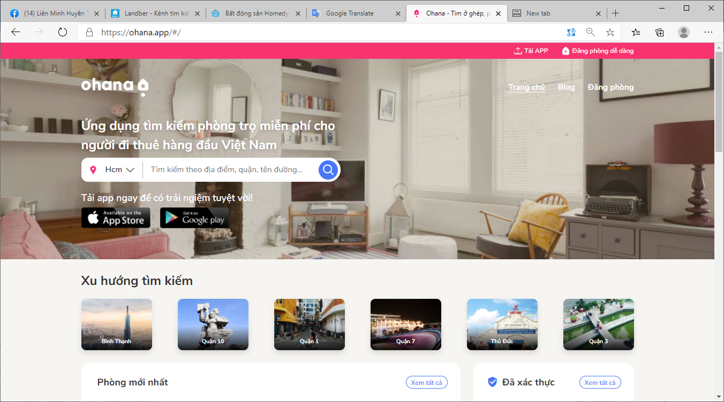

Advantages | Disadvantages
GUI is user-friendly, support language: Vietnamese | Only support remote access (Web), no support for offline use (Desktop apps)
There is always an employee flow the website 24/7 | Only support via hotline, not via facebook, zalo, etc…
As long as the internet is available, it can be accessed at all times. | Low security, easy to attack by hackers

3.3 Backend system
Backend system is made base on Spring Boot. Spring Boot is a project developed by JAV (java language) in Spring framework ecosystem. It helps our programmers to simplify the process of programming an application with Spring, focusing only on developing business for the application.

3.4 Embedded system
Backend system is made base on Arduino. Arduino is an open-source electronics platform based on easy-to-use hardware and software. It’s simple and accessible user experience, bring many benefits such as high Availability, less configuration. That’s a good option and example for us to consider using Adruino.

