Task 2: Test log
Description of test | Test data to be used (if required) | Test data type | Expected outcome | Actual outcome | Comments and intended actions
First test to check if registering a user | Hb1  tester  harris  butt  31/01/2007 | Normal | Data should be inputted into the database and the system redirects to login page | Error thrown | Will look into why error has been thrown and fix error  see 1. for error
Test to see is registering a user can complete | Hb1  tester  harris  butt  31/01/2007 | Normal | Data should be inputted into the database and the system redirects to login page | Data is inputted into database with correct hashing and redirects to log in page | Log in page doesn’t exist yet but it redirects to the correct url and password in the database is hashed see 2.
Test to see if system allows 2 of the same username | Hb1  tester  harris  butt  31/01/2007 | Normal | Should not add the user to the database and displays a message | User is not inputted into the database and a message is displayed | Works as it should do see 3.
Test to see if log in is working | Hb1  tester | Normal | Given that password and username are correct should be redirected to index page with a message | User that has logged on has been redirected to index and given a message | Works as intended see 4.
Test to see if logout works | N/A | N/A | Should end the users session and display a message | Ends the session and displays a message | Works as intended see 5.
Test to see if I can make a booking | 123 Random Street | Normal | Should process the booking and display a message | Throws an error | An error is thrown and nothing gets committed to the database see 6.
Test to see if I can make a booking | 123 Random Street | Normal | Should process the booking and display a message | Throws an error | An error is thrown and nothing gets committed to the database see 7.
Test to see if I can make a booking | 123 Random Street | Normal | Should process the booking and display a message | Throws an error | An error is thrown and nothing gets committed to the database see 8.
Test to see if I can make a booking | 123 Random Street | Normal | Should process the booking and display a message | I can create a booking that gets committed to the database | Works as intended see 9.

1.
2.
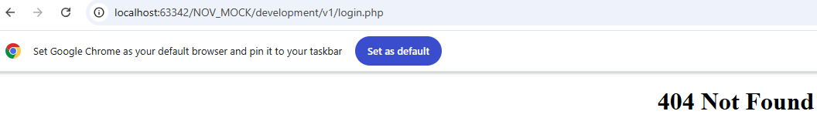

3.

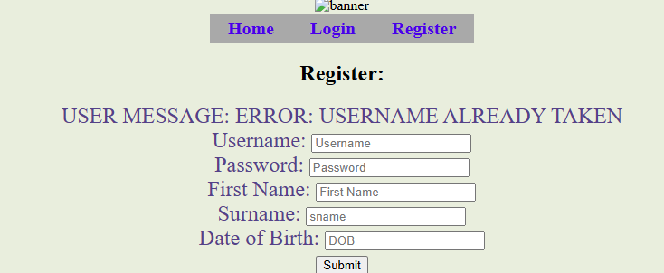

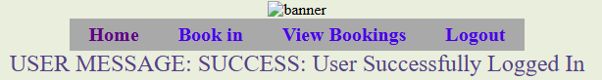
4.

5.

6.
7.
8.
9.

10.

