My audience is adults that are in the age range 18-30 this audience has grown up with the internet and now that the world it become more digital online account are starting to appear more and more now so it is important to maintain password security otherwise our data and information can be stolen very easily.

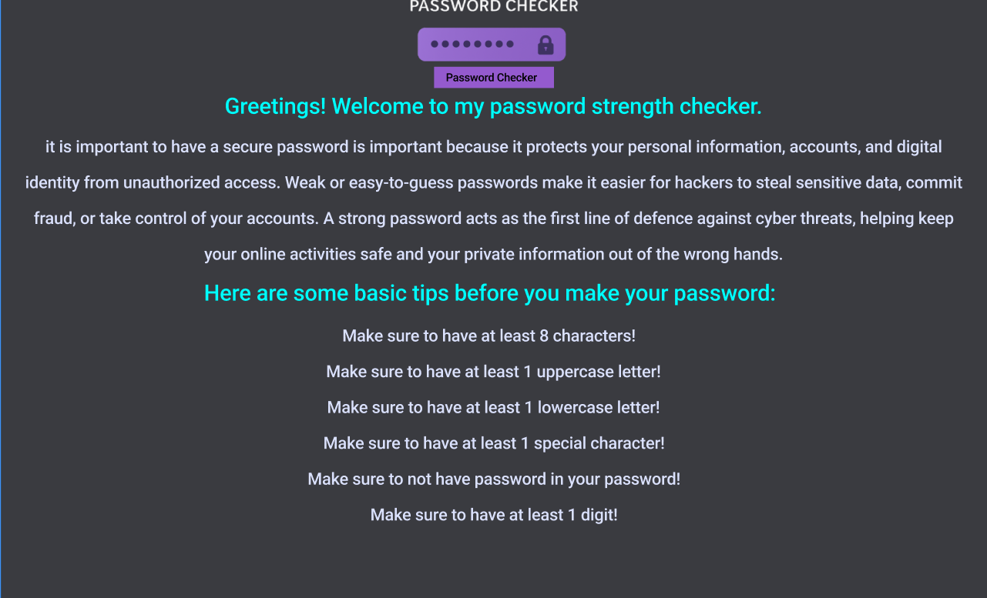
Home page:
This is my home page. I have chosen this colour scheme as it gives the website a clean professional look due to the contrasting colours that help catch the users eyes by using brightly coloured text to entice the user to read all the information. I have made the icons and text larger so that they are easy to see and read in case the user may be visually impaired to make is easier for the user to navigate. I have made use of generative ai to generate the content for this page to help users gain insight on why password security is important but if it was to make this for a real company I would take the time to research and gain better information to create content for the home page.
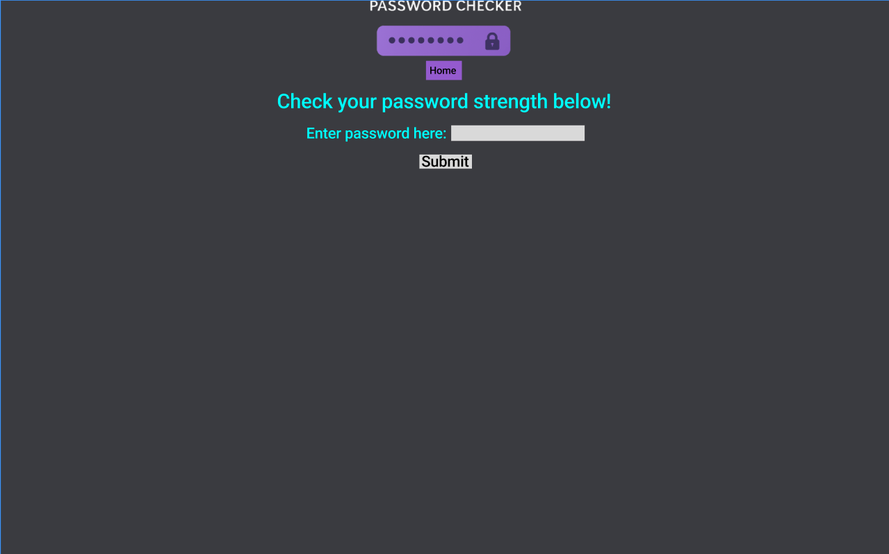
Page 1:
This is the first page. I have chosen this colour scheme to give this page a clean and professional look. I have used contrasting bright colours paired with enlarged text to help visually impaired users navigate the website with ease.

