Task 2: Test log
Description of test | Test data to be used (if required) | Data type | Expected outcome | Actual outcome | Comments and intended actions
Test to see if I can view bookings | N/A | N/A | Should display the booking | Booking is displayed but details are wrong | I have identified a logic error where they type of appointment has not been inputted into the database but the address instead see 1.
Test to see if logic error with booking is fixed | 123 Random Street | Normal | Should have a type rather than inputting the address into type | Throws an error | Throws an error see 2.
Test to see if booking logic error is fixed | 123 Random Street | Normal | It should have a type now and not 2 addresses | Works as intended | Works as intended but warning are being shown see 3.
Test to see if warnings are gone | N/A | Normal | Warnings should no longer show up | Works as intended | Works as intended
Test to see if updated register and booking works | Hb1  tester  harris  butt  31/01/2007  123 Random Street | Normal | Should register the use with the address and be able to view bookings without the address | Works as intended | Works as intended
Test to see if I can cancel a booking | N/A | N/A | Should display a message confirming that appointment is cancelled | Works as intended | Works as intended
Test to see if I can alter a booking | N/A | N/A | Should alter the booking and display a message | Throws an error | Throws error because I had forgot to add the type column into my update statment
Test to see if I can alter a booking | N/A | N/A | Should alter the booking and display a message | Works as intended | Works as intended

1.
2.
3.
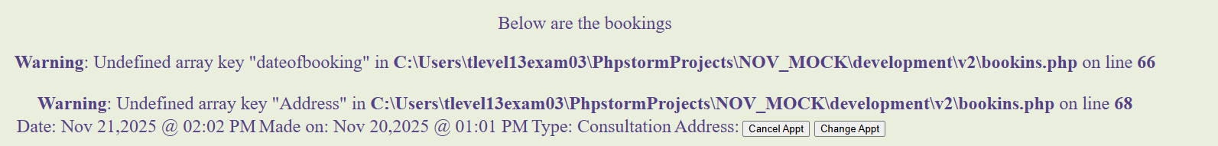
4.
5.

