## Stocks and Stock Changes

### Introduction

It has been emphasized in the description and discussion of all variables of the FBS system that there is no alternative to systematic measurement. But given the special importance of stocks for food security in general and for price stability in particular, there is no alternative to accurately measured stocks, at least in the long run. Several initiatives are underway to improve measured stocks estimates, including efforts under the Agricultural Market Information System (AMIS) and the Global Strategy to Improve Rural and Agricultural Statistics (GS). Under the auspices of the GS, a 10-year integrated survey programme, known as AGRIS (Agricultural Integrated Survey) has been developed, which not only lays the foundations for the creation of an efficient, overall agricultural statistical system, but also offers explicit options to estimate levels of stocks for different agricultural commodities. Given the fact that AGRIS estimates can provide stocks in conjunction with several other variables of the FBS (production, feed, seed, etc.), it promises to provide particularly relevant estimates for stocks. Countries are therefore encouraged to make all efforts to measure stocks, at least for their most important food staples, either in the context of a specialized survey or preferably in the context of an integrated survey system such as AGRIS.

The low level of measurement at country level is directly reflected in the availability of stocks data for FAO. In fact, the return rates for stock estimates are so low that stock estimates are currently not included in any of the FAOSTAT domains. There is not a separate domain that brings such estimates into one place (e.g. analogous to production or trade), nor is there a systematic inclusion of stocks in any other data domain. The only domain where stocks surface are the commodity balances, and the food balance sheets are a subset of these balances. Even there, no levels of stocks but only year-to-year changes in stocks are available.

The main reason for low coverage lies in the fact that such data are seldom collected and where they are, data are not always available. However, as stocks, or at least stock changes, are an integral part of every supply-demand balance, estimates for stock changes have been included in the FBS system. In many instances, stock changes function as a balancing item.

Using stocks as a balancing item, however, implies (as for any other element that is used as a balancing item) that all measurement errors are relegated to stocks (or the chosen balancing item). This also means that stock changes no longer only capture changes in stocks, but also function as a catchall for all measurement errors and would better be referred to as stock changes and residual uses. This is an undesirable outcome for any element of the balance but given the importance of stock for e.g. price volatility analysis, it would seriously diminish its value as a statistical indicator. Moreover, stock changes would “inherit” errors from previous years, resulting in steadily increasing distortions over time.

### Imputation/Estimation

The need to move away from a residual approach poses the challenge of identifying an alternative method to generate an estimate or rather an expected value and a distribution. If empirical stock estimates are available (the US for instance undertakes a bi-annual survey of its cereal stocks) these would enter the balance as an observed value, ideally even with a measured distribution. Clearly, this is the first best solution and should be encouraged for a maximum number of countries and commodities.

If no information is available about stock changes, a distribution would need to be assumed. However, even assuming a distribution such as a uniform distribution (shown below in Figure 1) is problematic: we are assuming that a stock change near the assumed minimum value is just as likely as a stock change close to 0; however, a stock change just outside of the boundaries has zero probability. Moreover, uniform distributions can be problematic in the balancing stage, as such elements essentially become residuals. Thus, it is very important to construct some distribution for stocks, even if it is very wide to indicate that there is much variability in the estimate.

The strategy here, however, is to harness additional and readily available information inherent in stock holding practice and economics. Such prior information is available e.g. from knowledge about the costs of stock accumulation and reduction over time. This prior information can be harnessed to move away from a uniform distribution in which every stock level would have the same probability between a maximum (max) and a minimum (min) to an approach that makes different levels of stocks more likely than others, still within the limits of (max) and (min).

The prior information about the economics and dynamics of storage can be used to derive both an expected value and a distribution.

1. Expected value. The expected value for the mean stock change should be zero in the long run; empirical information fully confirms this *a priori* expectation, and Figure 10 captures this for wheat stocks in the US. The reasons for the long-run mean reversion to zero are obvious. Any long-run positive deviation from zero would amount to accumulation of stocks, which would rise the longer such positive shifts prevail and the higher the positive values are. Conversely, successive negative deviations would amount to a permanent drawdown of stocks and thus be tantamount to an eventual stock-out, or imply unlikely (very costly) high initial levels of stocks. The reasons for a non-zero short-term stock change lie in the ability of smoothing fluctuations of consumption. The desire to keep consumption stable means that stocks will function as a short term buffer to smooth surpluses and deficits, i.e. demand for stocks is, at least at high levels of stocks, very price elastic while consumption is not.

#### Distribution

The above implies that positive and negative stock changes are likely to be symmetrically distributed around the zero mean. The analysis for US wheat and maize suggests that the empirical distribution could be approximated by a normal distribution with a zero mean (see Figure 10 as well as Figure 12 and Figure 13, Shapiro-Wilk metrics highly significant). Thus, we have already made improvements beyond assuming a uniform distribution for stock changes.

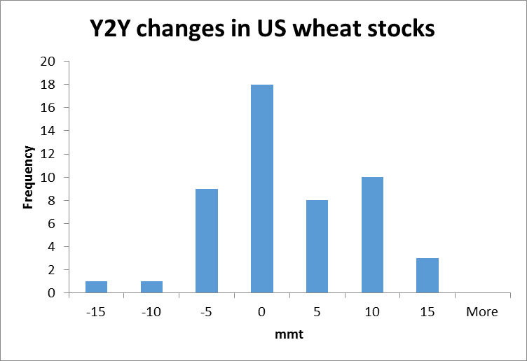

Figure 10: Distribution of year-to-year changes in US wheat stocks

#### Estimating stock changes in t

The analysis presented so far suggests that stock changes are likely to be normally distributed around a zero mean. However, we do not believe stock changes to be independent over time: the stock changes in previous years will likely influence the stock change in the current year. Thus, the expected value for the stock change in the current year may not have an expected value of zero, but rather some amount which depends on previous stock changes.

There is information that can be harnessed to gauge both the likely direction and even the likely amount of stock changes in t. In fact, a positive stock change in t becomes increasingly likely the longer the preceding period of stock drawdowns and the higher the amounts of drawdowns, i.e. the cumulative drawdown over time. If cereal stocks are being drawn down for say 15 years in a row, the likelihood for a drawdown in the successive year(s) becomes increasingly small[1].

Conversely, if a country accumulates stocks for many years in a row, the cumulative amount of stocks would become so high that storage capacity dwindles, losses loom, and the costs of holding stocks become prohibitively high. This means that the probability for a positive change in time t increases the longer the history and larger the cumulative amounts of negative changes in the past and vice-versa.

Thus, we need to construct a model for stock changes that is informed by our knowledge of historical changes. One such model would be

${ΔS}_{t}=β\left(\sum_{i=1}^{k}{{ΔS}_{t-i}}\right)+ε_{t}$ (Equation 9)

In other words, we assume that the stock changes at time t depend on the sum of the previous k stock changes. We add an error term to indicate that the change in stock at time t is not exactly equal to this value; rather, the distribution of the stock change at time t is adjusted given the knowledge of previous stock changes and still has variability. We could alternatively express this as

${ΔS}_{t}∼N\left(β\sum_{i=1}^{k}{{ΔS}_{t-i}},σ^{2}\right)$ (Equation 10)

This provides a further improvement on the distribution of stock changes. We can assume a normal distribution and we can also adjust the mean based on the previous stock changes. This has the effect of reducing the spread of the distribution as we now know more about what the stock change at time t should be.

Returning to US cereals data, we can examine if our hypothesis holds true. Figure 11 shows the relationship between the sum of previous stock changes over 15 years and the current stock change. We see that there is generally a negative trend, thus validating our original hypothesis. The trends may not be extremely strong or significant, but they allow us to infer a distribution for the stock change given previous cumulative changes. For example, if we know that over the previous 15 years the net stock change for "Barley and products" was 2,500 (i.e. the value on the horizontal axis in the first panel of Figure 5) then we can say that the next stock change should be normally distributed with a mean of -400 (the value of the blue line at that value) and a variability which allows values between -1200 to 400 (the gray region at that value).

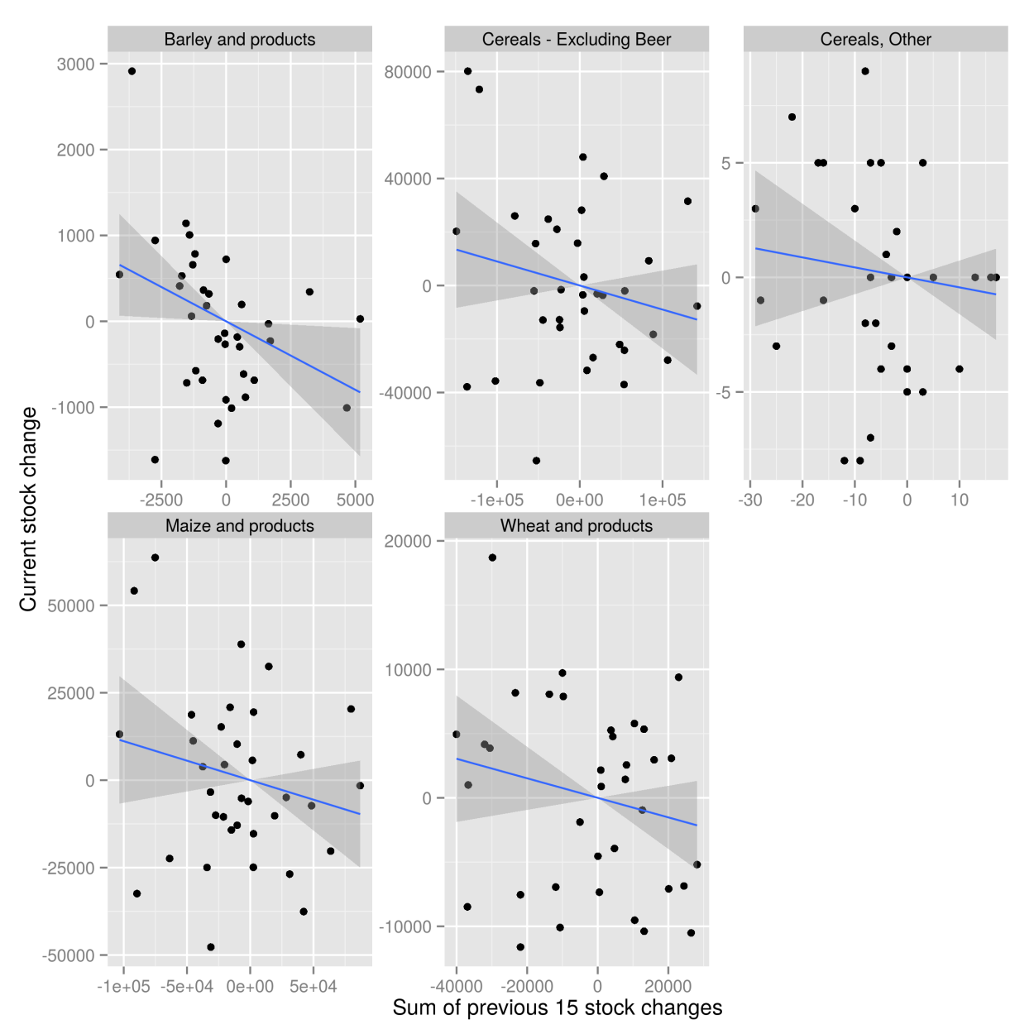

Figure 11: Stock changes in t in relation to the cumulative stock changes in the past 15 years.

**Testing for normality in the distribution of stock changes**

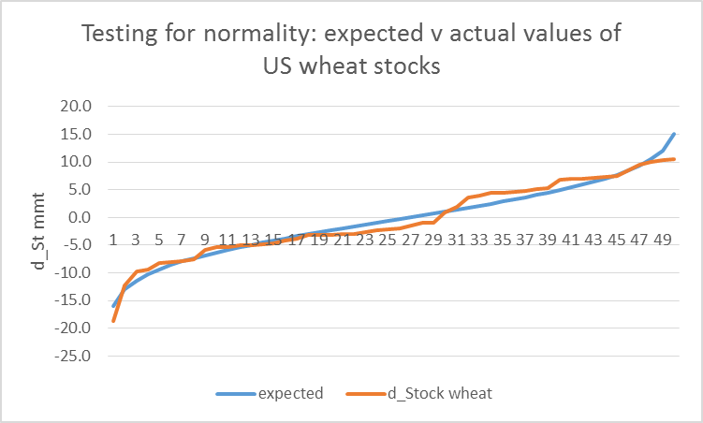

Figure 12: Testing for normality, wheat stocks

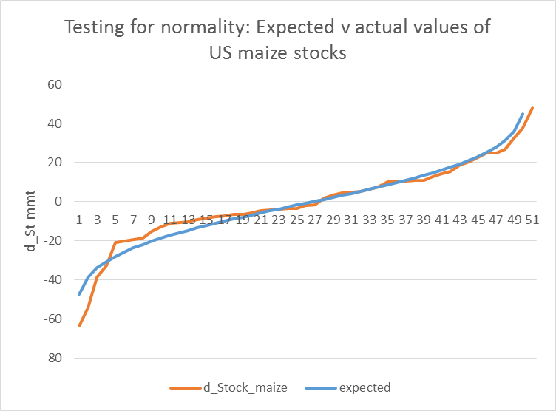

Figure 13: Testing for normality, maize stocks

1. Such a development may lead to (near) stock-out and would be accompanied by a price spike (at least at the global level).