## Feed use

There are only a few feed surveys available to FAO that are representative at country level and cover both feed production by farmers and feed compounders. Even in the US commodity balances, feed serves as the balancing item and is, accordingly, called “Feed and residual use”. When feed demand is measured, feed surveys often are limited to industrial feed sectors and are based on data only from commercial feed companies. Germany, Spain and China, for instance, obtain their feed estimates through a survey of feed companies. The usefulness of such data is rather limited in an FBS context. Only very few countries, e.g. Hungary and the Netherlands, have surveys that also include farm production of feedstuffs.

This lack of actual measurement appears even more surprising in view of the fact that feed use is a key source of utilization in the food balance sheet (FBS) and of rising importance. Growing consumption of meat, milk, and other livestock products and ever more intensive production systems have resulted in rapidly rising demand for feed products, notably compound and concentrate feeds (CC feeds). Indirect but rather compelling evidence stems from the rapidly rising production of commodities, which are exclusively or at least mainly destined for feed use, notably oil meals and certain coarse grains.

Moreover, shifts to higher consumption levels of livestock products and to more intensive feeding systems have not been limited to developed countries. Available evidence, including from the production of livestock products, suggests that the same trends now prevail in developing countries, and particularly so in many emerging economies (Brazil, China).

The absence of measured estimates and, at the same time, the rapidly growing importance of feed use means that any methodology to impute/estimate feed use deserves particular attention. Above all, it must capture intensifying livestock production systems and the rising overall importance, volume and diversity of livestock products. In addition, short term shocks such as epidemic outbreaks of diseases or other mortality-inducing events must be captured in feed use estimates. It should also capture the rapid technical progress in rearing animals in intensive livestock systems and, as part of the progress, the growing feeding efficiency with which feedstuffs are used in modern livestock systems. These trends may not always drive feed use in the same direction. For instance, information available from extension services and modern livestock operations suggest an offsetting effect of growing feed intensity, i.e. ever higher shares of CC feeds in total feed rations on the one hand and steady progress in using feedstuffs more efficiently on the other, i.e. requiring less CC feeds to produce a given amount of livestock products. The dynamics of these changes should be reflected in an FBS imputation system.

## A brief review of the previous methodology

Before conceiving any new methodology, it is useful to review and appraise the existing approach typically used to estimate feed demand, whether it adequately represents the current and prospective characteristics of feed use and livestock systems. This review can help in deciding (i) whether the old system can be used with minor changes; (ii) whether parts of the old system can be salvaged; or (iii) whether an entirely new system needs to be developed.

The basic approach currently used in the FBS system is easily stated. Feed use is simply calculated as a share of feed availability;

${Fe}_{i,j}=\left(P_{i,j}+I_{i,j}-X_{ij}\right)* r_{i,j}$ (Equation 11)

i.e. the feed use of feedstuff (j) in a country (i) is determined as a ratio (r) of the availability of the feedstuff in this country. The share is specific to a given country and product, (largely) stable over time, and not specific to the different elements of availability, i.e. not distinguishing between production and trade.

From an ex-post perspective, the rationale behind the choice of this approach is difficult to understand. On the face of it, it may have been motivated by the need to capture the dynamics of feed use in a non-intensive feeding system, whereby feed use rises where and when supplies are ample, and shrinks where and when feedstuffs are in short supply.

Being supply-oriented in nature, the approach could reflect reality insofar as CC feed use rises in a non-intensive system after bumper crops and contracts, often sharply, after crop failures. Possibly being reflective of livestock production systems several decades ago (when the method was conceived), the method is, however, hardly representative of modern feeding systems, and seemingly fails to capture the level of feed use even in the least developed countries. It was therefore decided to radically change the imputation approach from a simple, supply-driven method to a more complex yet tractable approach that correctly respects the demand-driven nature of feed demand in most countries.

### The new feed use estimation procedure

This section will provide an introduction to the new feed use methodology. Being a radical departure from the previous approach, we pay considerable attention at least to its main elements, noting that a still more detailed description is available from the specialized documentation of the new approach to feed estimation.

The new feed use estimation process can be divided into three steps or stages. To begin, a stepwise and demand-oriented approach to determining CC feed use is implemented. Total feed requirements Ri,t in a given country i and year t are calculated as a function of the herd size N and the species, country and time specific requirement index, rs,i,t (where the s index runs over all commodities).

#### Determining total feed requirements Ri

The requirement indices are further expressed in terms of an animal unit and incorporate maintenance needs M and output requirements, such as for meat, milk or wool P, as well as the overall efficiency E (over the entire herd[1]) that is characteristic of a given feeding system.

(Equation 12)

where

(Equation 13)

and S is the total number of all commodities. The requirements are calculated for metabolizable energy (MJ ME) and tonnes of crude protein (t CP) via the requirements index, which is constructed dualistically. They are inclusive of all feedstuffs, not only CC feeds. In a second step, the shares of actual CC feed in total requirements are determined.

#### Determining actual use of CC feed

The first step was used to calculate total requirements based on the needs of a herd, its needs for maintenance and output, for all types of animals within a herd and across species. These needs can and indeed are being covered by both CC feeds, and other feedstuffs such as roughages or products from pastures, or even table scraps. To determine the share of CC feeds, it is necessary to multiply the requirements Ri with an intensification factor Ii. The intensification factor is a simple ratio that determines how much of the total requirements will be covered by CC feeds and how much by other feedstuffs.

This can be expressed as follows:

${CC}_{Feed}=R_{i}*I_{i}$ (Equation 14)

Again, all calculations distinguish between metabolizable energy (MJ ME) and quantities of crude protein (t CP).

The intensity factors Ii vary across feeding systems and animal species Ai. Across animal species, the main dividing line is between ruminants and monogasters (pigs and poultry). For monogasters kept in modern feeding systems, the intensity factors have been rising steadily over past decades and have reached values close to unity in essentially all developed countries. This is particularly the case for poultry where values have reached high levels in all countries. Only organic agriculture leaves actual ratios for poultry below unity. For pigs, intensification factors can still be well below unity where backyard production and non-intensive family farms account for a large share of output. This is still the case for very large production systems such as pig production in China; but even there intensification factors have been rising steadily and rising rates now feature prominently in most developing countries, too. The actual data for the intensification rates have been gleaned from the FAO GLEAM database (2005, 2010), namely representative of feeding baskets in countries, and have been extrapolated to capture the most recent situations.

For ruminants, the spectrum of intensification rates varies much more widely than for monogasters, even in mature feeding systems. In all feeding systems, intensification rates of unity or close to unity cannot be found in practice and are unlikely to occur in the future. The physiological needs of ruminants for a certain minimum amount of crude fibre imply that even the most intensive feeding systems (e.g. milk production in Israel or meat production in US feeder lots) will have intensification rates of less than unity. On the other end of the spectrum, there are systems where roughages remain the economically most efficient source (abundant pasture in New Zealand) or opportunity costs of CC are too high for feed use (milk production in India). In these systems, the intensification rates Ii would seem only marginally above zero.

#### Determining the requirements of fed/farmed fish

The methodology presented thus far has not taken into account the feeding of fish, as required in aquaculture. In fact, most available feed statistics do not take this part into account. Given the increasing importance of farmed fish as a source of protein for human consumption, it is expected that the industry absorbs rather significant amounts of agricultural as well as marine outputs. In absolute terms, the most important users of fish feeds are in Eastern and South Eastern Asia, most importantly in China. As a share of total feed, aquaculture is particularly important in small island states such as Iceland and the Faroe Islands where fed fish are often the main consumer of feedstuffs. Given their absolute and relative importance, a complete and correct assessment of feed use requires including feeds fed to farmed fish into the estimation process.

The estimation of energy and crude protein needs for aquaculture are derived in analogy to those for livestock. To arrive at a precise assessment, species-specific feed efficiency ratios (FCR) are directly applied to aquaculture production data (tonnes of fish and crustaceans) and converted into energy and crude protein equivalents, which yields the total nutrient requirements of the produced amounts of fish.

Also fish are farmed at different intensity levels. On the one hand, salmon and carnivore trout must entirely be fed with feeds from outside the ponds, while other species, e.g. carp, may retrieve nutrients from microorganisms, aquatic plants, fellow fish and aquatic wastes that are available in their surrounding waters, depending on the production system. Hence, an intensity factor is applied to the overall biological requirements in order to circumscribe the actual aqua-feed demand.

Both the parameters of FCR and feeding intensity are retrieved and extrapolated from survey data published by the FAO Fisheries Department. Eventually, the aquaculture requirements are added to those of livestock to arrive at the total feed energy and crude protein use for every year and country.

### Determining use of individual feedstuffs

Thus far, the new approach has only produced total feed requirements and total feed use of CC feeds in terms of metabolizable energy and crude protein. No distinction has yet been made to identify which of the various feedstuffs contribute to cover CC feeds. The next step required to produce this information in the FBS is to break the CC feeds of energy and protein down into individual feedstuffs at the commodity level.

The most common approach used for such an allocation in practice is to set-up a linear programming system (LP) that determines the most price-efficient combination of feedstuffs, which meets the constraints of total requirements and the nutrient composition of individual feedstuffs. Theoretically, such an approach may be very appealing, but it lacks practical relevance for the FBS system. For one thing, it requires the exact knowledge and constant updating of prices for feedstuffs. Collecting this information is a tall order in developed countries and infeasible or impossible in developing ones. For another, it would render an economically optimal, but not a necessarily empirically likely solution, simply because actual use of CC feeds is determined in practice by many factors beyond relative price quotations, as supply-chain constraints and opportunity costs need also to be considered.

An alternative solution is to break the total requirements down by availability shares. This means allocating feedstuffs in accordance to overall availability, i.e. feedstuffs available in abundance are used more than those in scarcity[2]. Within the allocation of CC feeds to individual components, again a two-stage process is employed. In a first step, all those CC feeds that can only (or at least in their vast majority) be used as feeds are allocated first. In essence, these are oil meals (OM) and oilcakes (OC) as well as all brans not used for human consumption (not as breakfast cereals). Also by-products from biofuel production, most notably dried distillers grains (DDGS) are assumed to be exclusively fed to animals. Their energy and protein content is deducted from the estimated overall feed use.

Cereals, tubers, pulses etc. = CCF - (OM+OC+brans)

In a second step, all other feeds from commodities (cereals, tubers, pulses etc.) from inside and outside the FBSs, are allocated as a simple proportion of their availabilities.

As requirements are expressed in energy and protein units, two factors, one for the proportion of energy availability and one for that of protein are constructed:

 (Equation 15)

The proportion of feed availability (a) of feedstuff (f) in country (i) and year (t) for the respective nutritive conversion factor (n), which is either energy units or protein units per unit of feedstuff, is determined by its available nutritive quantity (q * n) divided by the total nutritive value provided by all available feedstuffs.

These factors can now be applied to the requirements and converted into quantities (tonnes). Given the different composition of feedstuffs in terms of crude protein and energy content, two slightly different allocations of feedstuffs are obtained, i.e. energy rich feedstuffs will be more important contributors to overall energy availability than protein rich feedstuffs and vice versa.

The final quantities of feedstuffs must have the property that they meet both the energy and protein requirements. Hence, it is possible that from the two allocations (i) one allocation meets both requirements, (ii) no allocation meets both requirements, (iii) both allocations meet both requirements.

In the case of (i), the allocation which meets both requirements is preferred. In the case of (ii), upper and lower bounds for each feedstuff can be established since each allocation meets its individual demand. In other words, if the protein based allocation meets the protein demand, and the energy based allocation meets energy demand, the maximum values of those two for each feedstuff must at least satisfy if not exceed both requirements. Similarly, the sum of the minimum values of each feedstuff will not satisfy any of the two requirements and thus, an optimal solution satisfying both demands lies in between. In order to avoid the allocation of excessive feed, the final quantity for each feedstuff is obtained by optimizing the allocation linearly such that both requirements are satisfied, using the least amount of additional feedstuffs in accordance with their respective nutritive values. This means that preference is given to energy and protein rich feedstuffs after the minimum quantities have been allocated. For case (iii) the same procedure as for (ii) is applied, but naturally in the opposite way, i.e. quantities are subtracted in order to arrive at the minimum solution that meets both requirements. For instance, the final allocation of wheat for feed use is determined as a share of total availability is retrieved as

(Equation 16)

where c is the respective conversion factor from either protein or energy into wheat quantities and depends on the derivation of a.

### Results and consistency checks

Figure 12 depicts global energy and protein feed demands respectively from 1992, grouped in the World Bank income level classification. The shift towards pig and poultry production, especially in emerging economies becomes apparent as the protein demand of these countries exceeds the levels in high income countries at an earlier stage than the energy demand. This reflects the fact that monogasters require relatively more protein than ruminants.

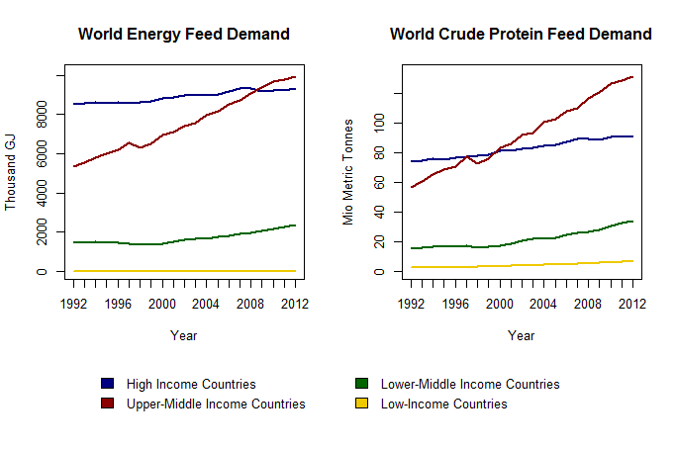

Figure 14: Results of the feed estimates at the global level



Figure 15: Results of the feed estimates at the global levelFigure 16: Results of the feed estimates at the global level

The validation of feed estimates is a challenging task, not least in view of the fact that reliable feed statistics are seldom available. The first stage of results, namely the feed requirements expressed in crude protein and metabolizable energy, are being compared to reported feed figures. As some countries officially report on feed in the annual FAO questionnaire, these have been taken as the starting point for comparisons with the results of the new method. Figure 17 depicts the results of this comparison.

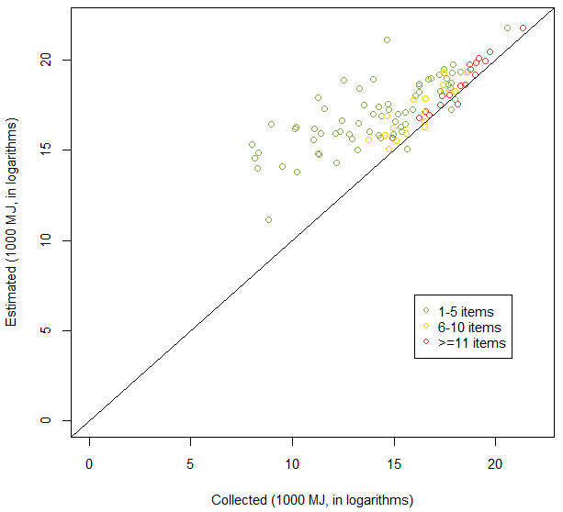

Figure 17: Estimated vs collected value for metabolizable energy

In Figure 17 each dot represents a pair of estimated feed demand and collected feed use in logarithms, and the straight line represents the scenarios in which collected energy feed fully coincides with estimated energy feed in a given country. It is worth noting, that most countries report only sporadically on individual feeds, which means that the whole range of feedstuffs is seldom covered. As the information on feed use is not complete, feed reported should not exceed estimated feed. Graphically this implies that the dots should never fall below the diagonal line, for which only five cases can be spotted. (Saudi Arabia, Cyprus, Kazakhstan, Azerbaijan and Egypt). This may be due to either over-reporting of feed or underestimation of demand.

The difference between reported feed and estimated feed can represent the feeds that have not been reported. From Figure 17 it is apparent that, the more extensive countries report on feed, the closer the estimate to the collected aggregate. Assuming that countries that have a higher item coverage in reporting feed are also more confident about their real feed usage levels, this provides strong evidence that the estimated requirements are, indeed, not far from reality. Indeed the correlation coefficients between collected feed use and estimated demand increase steadily when the item coverage threshold is raised. Starting with 0.93 for an item coverage of greater than six, for which 36 observations are available, 0.99 for an item coverage of 20+[3]. In addition to that, the discrepancy of absolute feed required and feed used in these cases has shrunk to 13%, encouraging the methodology for estimating feed demand.

The next step is to check how the final feed estimates, after allocating particular feedstuffs, compare to other prominent data sources. In Figure 18, global cereal feed data from the USDA, and FAOSTAT (the old estimates derived under the old methodology) from 1992 to 2011 are depicted. Besides the newly modelled feed, all other data sources use entirely supply-driven estimates, except for FAOSTAT figures that are officially reported by countries. However, reported figures are not modified by the new feed estimation procedure. The interpretation of this graph is that the new estimation procedure produces overall estimates that are relatively consistent with alternative methods but based on more firm theoretical grounds.

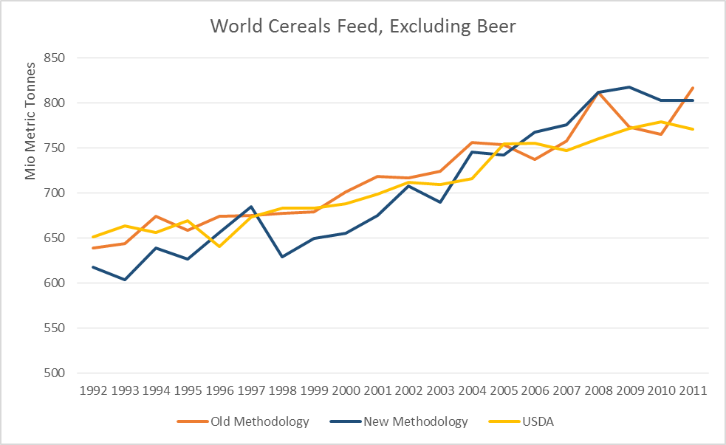

Figure 18: World cereal feeds, comparing results at the global level

### A review of the empirical results

Overall, the new methodology suggests a slightly steeper increase of cereal feed than other data sources/estimates, which has several explanations. From the demand side, the sharp increase of herd sizes and animal production over the past decades certainly can lead to higher feed use than supply oriented allocations suggest. In addition, the growing intensification of animal husbandry has favoured the use of energy-rich grains, in particular maize. Combined with the shift towards pork and poultry, these factors support the faster increase of grains produced in the new methodology (Figure 18). What is more, feed use in aquaculture, which was not taken into account in the old methodology, has exhibited extraordinary growth, and also supports the faster increase produced by the new methodology. Perhaps most importantly, it shows that the results of the two approaches are much more different than Figure 18 suggests. Had aquaculture been taken into account in the old approach, the existing FAOSTAT estimates would have been higher by the equivalent of 47.3 million tonnes of aqua-feed equivalents[4] in 2012, while in 1992 only 5.9 million extra tonnes of aqua-feed equivalents are not considered.

Secondly, the new methodology suggests more variation of feed use over time. It seems to be counterintuitive that cereal feed use is actually steady over time. Feed is at least the second biggest factor of disappearance for most cereals. Since food use tends to be stable if commodity availability varies, feed is expected to absorb parts of variation as determined by availability.

Thirdly, while the global use estimates may not be entirely dissimilar, even after accounting for aqua-feed and feedstuffs for camels, horses, etc. there are considerable differences across countries, which cancel out in the global aggregate

#### Consistency and Quality checks of feed allocations

Overall, while the new method is more data and knowledge intensive, it nevertheless allows consistency checks of feed allocation vs. the amount of nutrients that are required to produce the animal products reported by a country.

*Negative protein balance*

Arguably, one of the most reliable estimates of feed requirements in FBS comes from outside the FBS system; these are the estimates for the availability of oil meals and cakes. For one thing, oil meal and cakes are destined exclusively for feeding purposes[5] and for another, oil meals and cakes are by-products of oilseeds crushing. This means that they are industry products, and both production and imports of such variables are more reliable than estimates of primary products, not to mention use data. A similar rationale can be put forward for brans. What is more, both feedstuffs are protein-rich commodities and often the main ingredients to cover protein needs in a feed ration. The high confidence that can be put into these estimates is not only the basis for identifying them in the feed allocation process separately (1st step), but also offers possibilities to undertake consistency checks.

The main approach to consistency checks is to juxtapose the availability of these feedstuffs with the needs of protein to cover protein requirements, or rather total use of protein. The most obvious case of an inconsistency is when the available protein from oil cakes and meals as well as brans exceeds the calculated needs/total use of protein (requirement times intensification rate). Figure 4 shows all 5256 data points, each representing the logarithm of the amount of protein required and the amount of protein available from oilmeals, oilcakes and brans in a given country and year. In 526 cases the protein availability exceeds demand, which represents about 10% of all data. In Figure 19, this is apparent as the dots below the 45-degree line.

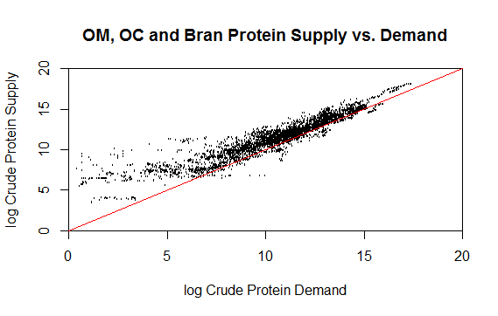

Figure 19: Oilcakes, oil meals and brans supply vs. demand

Such an imbalance can be due to two principal reasons. First, the intensification rate is too low and thus underestimates the actual needs. Second, either the number of animals or the feeding efficiency ratios are too low, which again would understate the actual needs. Such negative protein balances seem to be unlikely to occur, simply because they would suggest a gross underestimation of needs[6]. But in practice they have occurred in many instances after systematically triangulating protein needs with availability. The results have been reviewed on a case by case basis (country by country, year by year) and resulted in many adjustments of animal numbers and livestock productivity, in line with the newly obtained information from consistency checks. Where these are based on official estimates, the inconsistencies are being brought to the attention of the data suppliers. A separate document has been compiled providing a complete overview of the results.

*Insufficient availability*

Just as there are negative balances, in some countries, at least in some years, vastly positive balances have occurred. While such large positive balances can occur without violating the feed approach in principle, they can absorb so many cereals and pulses that they would render unreasonably low results for food and other uses.

### Country cases for Argentina and Myanmar

In the following section, the feed estimation process for Argentina and Myanmar for the year of 2011 shall serve as a practical example. Both countries host the complete range of considered species and aquaculture and are therefore useful examples to examine the new approach. Both countries also represent the animal husbandry trends (from ruminants to monogastrics) as well as recent changes in feed utilization (mostly maize in Argentina and predominantly rice in Myanmar) which are characteristic of their respective regions and income class.

The starting point, as outlined earlier, is the animal numbers of each species. The biological requirements measure is expressed in terms of an animal unit index (AUI), one for energy needs and one for protein needs, and are measured using standard regression equations provided by state of the art animal science analysis. In particular, the National Research Council’s publications on animal nutritive requirements of the National Academy of science of the United States of America have been used to estimate the requirements of each species in a given country and year.

The result of this process is set in relation to the standard requirements of the base unit, which is that of a mature 500kg cow that produces 3500kg milk and calves every 13 months. Such a cow is expected to metabolize 35600 MJ of energy and 319 kg of crude protein per year. Within the species, a distinction between dairy and beef cattle is made as well. Hence, applying the indices to the animal numbers will require the multiplication with the base unit requirements in order to obtain whole country requirements. Next, only the demand generated through intensive feeding systems, and not through roughage and waste feeds will be filtered out by applying the intensification rate (IR). Thus, in Table 1, the calculation goes as:

Table 1: Feed use requirements calculations for Argentina

|  |  |  |  |  |  |  |
| --- | --- | --- | --- | --- | --- | --- |
| Animal | Number | AUE | AUP | IR | Energy Demand (000 MJ) | Protein (metric tonnes) |
| Cattle | 46000000 | 0.6414 | 0.3818 | 0.0757 | 79460350.42 | 423876 |
| Sheep | 14731000 | 0.0404 | 0.0352 | 0.0062 | 131010.3619 | 1021.628 |
| Goats | 4280000 | 0.0320 | 0.0278 | 0.0062 | 30138.76003 | 235.0242 |
| Pigs | 2350000 | 0.2012 | 0.1141 | 0.8145 | 13710611.58 | 69645.52 |
| Chickens | 1.00E+08 | 0.0210 | 0.0466 | 0.9386 | 70300170.37 | 1394261 |
| Ducks | 2550000 | 0.0230 | 0.0551 | 0.9386 | 1957614.199 | 42074.84 |
| Geese | 165000 | 0.0256 | 0.0636 | 0.9386 | 141020.3539 | 3141.334 |
| Turkeys | 3050000 | 0.0518 | 0.0480 | 0.9386 | 5278047.506 | 43872.91 |
| Aqua |  |  |  |  | 22155.82694 | 580.3475 |
|  | | **Demand** | | | **171031119.4** | **1978709** |
| **OC, OM &Brans** | | | **65268351** | **1699681** |
| **Cereal Feed Demand** | | | **105762768.4** | **279028.1** |

Table 2: Feed use requirements calculations for Myanmar

|  |  |  |  |  |  |  |
| --- | --- | --- | --- | --- | --- | --- |
| Animal | Number | AUE | AUP | IR | Energy Demand (000 MJ) | Protein (metric tonnes) |
| Cattle | 14088043 | 0.4011 | 0.2609 | 0.0729 | 14668012.33 | 85479.11 |
| Sheep | 854383 | 0.0387 | 0.0338 | 0.1116 | 131647.2227 | 1026.595 |
| Goats | 3851919 | 0.0435 | 0.0379 | 0.1112 | 667026.0403 | 5201.518 |
| Pigs | 10497493 | 0.1811 | 0.1071 | 0.6822 | 46193124.93 | 244859.6 |
| Chickens | 176839000 | 0.0111 | 0.0224 | 0.8702 | 60900789.88 | 1100012 |
| Ducks | 15507000 | 0.0135 | 0.0270 | 0.8702 | 6468232.347 | 116336.4 |
| Geese | 1966000 | 0.0181 | 0.0403 | 0.8702 | 1106240.864 | 21984.46 |
| Turkeys | 3000 | 0.0348 | 0.0282 | 0.8702 | 3233.141735 | 23.53616 |
| Aqua |  |  |  |  | 10784477.33 | 220610 |
|  | | | **Demand** | | **140922784.1** | **1795533** |
| **OC, OM &Brans** | | **44981407.66** | **661432.3** |
| **Cereal Feed Demand** | | **95941376.43** | **1134101** |

Energy = Numbers * AUE * IR * 35600 and Protein = Numbers * IR * 0.319

Summing up all requirements of livestock as well as poultry species and adding those from aquaculture yields the aggregate CC Feed Demand. Subtracting the amounts of energy and protein available in OC, OM and Brans finally gives the remaining demand that has to be covered by cereals, pulses, tubers etc.

Having established demand, now the supply side is added to the picture. Availability shares are constructed focusing on the remaining feed items, mostly cereals, pulses, tubers, but also meat meals and milk. For each commodity and its corresponding nutrient supply, an availability share is constructed yielding two independent allocations. In the case of Argentina, the energy based feed allocation meets both demands, while in Myanmar it is the protein-based feed allocation that satisfies the dual demand structure.

Given now the decision on the allocation, the remaining requirements (Table 3 and Table 4) are allocated and finally converted from nutritive values into tonnes of feed through dividing by the respective content per unit of feed. In the case of energy, this is expressed as MJ per kg, while for protein it is in percent of feed.

Table 3: Feed Availability shares and nutrient conversion factors for Argentina

|  |  |  |  |  |
| --- | --- | --- | --- | --- |
|  | Energy based | Protein based | Energy cont.[7] | Feed (tonnes) |
| Canary Seed | 0.0007 | 0.0007 | 12.50 | 5804.3 |
| Meat Meal | 0.0002 | 0.0002 | 12.20 | 1669.0 |
| Cassava | 0.0070 | 0.0018 | 13.00 | 57121.1 |
| Wheat | 0.0160 | 0.0183 | 13.80 | 122742.0 |
| Molasses | 0.0284 | 0.0177 | 11.10 | 270989.5 |
| Beet P. Dry | 0.0000 | 0.0000 | 12.90 | 81.1 |
| Wheat Gluten | 0.0001 | 0.0003 | 15.50 | 697.4 |
| Barley | 0.0661 | 0.0698 | 14.00 | 498978.9 |
| Carobs | 0.0000 | 0.0000 | 12.20 | 0.0 |
| Maize | 0.4082 | 0.3755 | 14.30 | 3018928.8 |
| Germ Maize | 0.0013 | 0.0018 | 14.40 | 9792.2 |
| Fr Pulp Feed | 0.0307 | 0.0114 | 14.20 | 228598.6 |
| Cocoa Husks | 0.0000 | 0.0000 | 14.80 | 335.8 |
| Rye | 0.0030 | 0.0028 | 13.60 | 23196.1 |
| Oats | 0.0265 | 0.0261 | 14.00 | 200555.9 |
| Millet | 0.0000 | 0.0000 | 14.30 | 221.4 |
| Sorghum | 0.1627 | 0.1539 | 14.30 | 1203029.0 |
| Skim Milk Cows | 0.0237 | 0.0304 | 12.20 | 205424.9 |
| Whey, Fresh | 0.2253 | 0.2892 | 12.20 | 1953215.1 |

Table 4: Feed Availability shares and nutrient conversion factors for Myanmar

|  |  |  |  |  |
| --- | --- | --- | --- | --- |
|  | Energy based | Protein based | Protein cont.[8] | Feed (tonnes) |
| Roots Tub Ns | 0.0000 | 0.0000 | 0.054 | 11.3 |
| Wheat | 0.0039 | 0.0042 | 0.126 | 38184.4 |
| Bagasse | 0.0035 | 0.0005 | 0.018 | 32950.9 |
| Beans, Dry | 0.1330 | 0.2753 | 0.248 | 1259100.7 |
| Chick-Peas | 0.0150 | 0.0263 | 0.221 | 134780.7 |
| Bran Pulses | 0.0057 | 0.0100 | 0.215 | 52948.4 |
| Rice, Paddy | 0.4713 | 0.3461 | 0.083 | 4728434.3 |
| Rice, Broken | 0.2376 | 0.2138 | 0.104 | 2331410.7 |
| Maize | 0.0819 | 0.0707 | 0.105 | 763818.2 |
| Oats | 0.0000 | 0.0000 | 0.110 | 1.9 |
| Millet | 0.0106 | 0.0109 | 0.125 | 99089.1 |
| Sorghum | 0.0095 | 0.0085 | 0.108 | 88961.9 |
| Dry Whey | 0.0004 | 0.0004 | 0.125 | 4059.4 |
| Whey, Fresh | 0.0275 | 0.0332 | 0.125 | 301116.2 |

Hence, the last columns provide an estimate of how much of each commodity is used as feed and can be implemented in the balance. Figure 5: Argentina use of CC feed, old v new methodology depicts aggregate cereals of this procedure for the whole time period from 1992 to 2012, comparing it to the previous estimate in place, and the amount of OC, OM and brans supply. In general, an increase of oilcake supply will, ceteris paribus, lead to a decrease of cereal feed, at an elasticity which is defined by respective conversion factors. Graphically, this would lead to an asymmetric reflexion of the cereal feed line and the OC, OM and bran line. Obviously, if levels of demand change, the lines will behave accordingly as to cover the additional or decreased feed required.

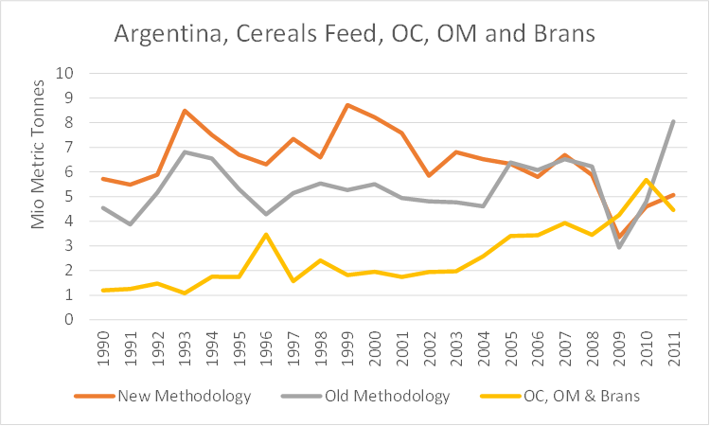

Figure 5: Argentina use of CC feed, old v new methodology

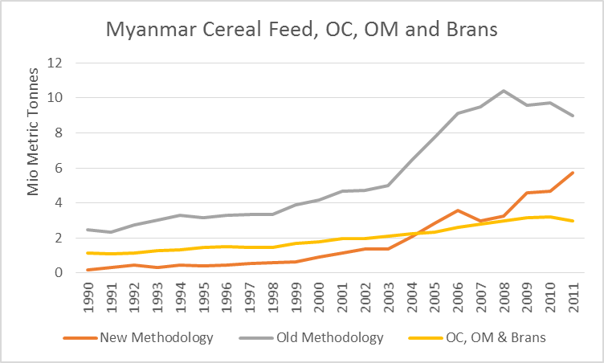

Figure 6: Myanmar use of CC feed, old v new methodology

In the case of Argentina (Figure 5), the new estimations lead to an overall higher level of cereal feed estimation, while the trends are somewhat similar, being very much in sync from 2005 on. Generally, this is linked to herd sizes and feeding intensity. Here, both suggest a higher use of cereal feed. The divergence from 1998 is due to an increase of cattle stock by more than 3%, combined with decreased imports of oil cakes, and an overall steadily inclining productivity and numbers of animals in other species. The 2009 change is due to a decreased availability of cereals, which may have its source in the cereal price spikes from 2006 on, and is also in accordance with previously supply oriented estimates. Indeed, oilcake exports show a reduction by a considerable percentage. In particular soybean meal exports decreased by about 16% from 2007 to 2009. In addition, other feed items show higher levels of usage in order to compensate for the lower cereal use.

The estimates for Myanmar suggest a similar trend until 2006 like the old feed figures. However, productivity of ruminants started to decline sharply, for instance in cattle by 15%. After 2006, the number of pigs and poultry rose in tandem with productivity, while the number of ruminants was rather stagnant. This would support the idea of a shift from ruminants to monogastric species also taking place in Asia. Monogasters are reared in a more intensive manner than ruminants, which after all would not support the decreasing levels of feed use.

As both cases exhibit, as long as only the supply side is affected by any change, both estimation methods go hand in hand. However, as soon as there is some dynamism within the livestock and poultry sector, or even when human consumption preference shifts occur, the new methodology will capture these effects in contrast to the old, bringing new information on feed use to the table.

1. E.g. in the case of pigs, the requirements are those of all “types” of pigs along the production chain, i.e. from piglets to hogs to sows, etc. Likewise, the feeding efficiency refers to the arc-efficiency across all types. This indicator lies necessarily above the better known feeding efficiency ratios which refer to rearing hogs only, i.e. growing them from 30kg to slaughter-weight of e.g. about 100kg. Lower feeding ratios signify higher efficiency, as fewer kg of feedstuff are needed to produce 1 kg of livestock output, in this example pig meat.
2. This procedure retains the basic idea of the previous approach used in determining feed use. The decisive difference to the previous approach is that the availability shares are applied after requirements are determined and intensification is respected.
3. Even if the underlying threshold is only cases
4. Aquafeed, similar to compound feed for livestock, is composed of feedstuffs external to fish farms and may include a variety of ingredients, e.g. grains, meat or fish meals and oils. 47.3 million tonnes of aquafeed is equivalent to about 140 million tonnes of maize and 5.9 tonnes of aquafeed corresponds to about 17.3 million tonnes of maize.
5. Some oilcakes are being used as biofuels (e.g. cakes of olives), but they are generally negligible in terms of quantities and would not be considered feedstuffs under normal circumstances.
6. A negative balance would not only not leave room for any other CC feed but suggest that availability from OM/OC already exceeds the requirements inherent in the needs calculations.
7. In MJ per kg
8. As a share of feed