Food Balance Sheets

## Wheat

For this example, we'll first consider the commodity tree for wheat. We start off with an empty table:

|  |  |  |  |  |  |  |  |  |  |  |  |  |  |
| --- | --- | --- | --- | --- | --- | --- | --- | --- | --- | --- | --- | --- | --- |
| Item | AreaHarv | Yield | Production | Imports | Exports | StockChange | Food | Feed | Waste | Seed | Industrial | Tourist | Residual |
| 0111 | 0 | 0 | 0 | 0 | 0 | 0 | 0 | 0 | 0 | 0 | 0 | 0 | 0 |
| 23110 | 0 | 0 | 0 | 0 | 0 | 0 | 0 | 0 | 0 | 0 | 0 | 0 | 0 |
| 23140.02 | 0 | 0 | 0 | 0 | 0 | 0 | 0 | 0 | 0 | 0 | 0 | 0 | 0 |
| 23140.03 | 0 | 0 | 0 | 0 | 0 | 0 | 0 | 0 | 0 | 0 | 0 | 0 | 0 |
| 23220.01 | 0 | 0 | 0 | 0 | 0 | 0 | 0 | 0 | 0 | 0 | 0 | 0 | 0 |
| 39120.01 | 0 | 0 | 0 | 0 | 0 | 0 | 0 | 0 | 0 | 0 | 0 | 0 | 0 |

### Production

For production data, we first fill in the table with any available official figures.

|  |  |  |  |  |  |  |  |  |  |  |  |  |  |
| --- | --- | --- | --- | --- | --- | --- | --- | --- | --- | --- | --- | --- | --- |
| Item | AreaHarv | Yield | Production | Imports | Exports | StockChange | Food | Feed | Waste | Seed | Industrial | Tourist | Residual |
| 0111 | 0 | 0 | 54418808 | 0 | 0 | 0 | 0 | 0 | 0 | 0 | 0 | 0 | 0 |
| 23110 | 0 | 0 | 18652048 | 0 | 0 | 0 | 0 | 0 | 0 | 0 | 0 | 0 | 0 |
| 23140.02 | 0 | 0 | NA | 0 | 0 | 0 | 0 | 0 | 0 | 0 | 0 | 0 | 0 |
| 23140.03 | 0 | 0 | NA | 0 | 0 | 0 | 0 | 0 | 0 | 0 | 0 | 0 | 0 |
| 23220.01 | 0 | 0 | NA | 0 | 0 | 0 | 0 | 0 | 0 | 0 | 0 | 0 | 0 |
| 39120.01 | 0 | 0 | NA | 0 | 0 | 0 | 0 | 0 | 0 | 0 | 0 | 0 | 0 |

Next, we run the production imputation module. Production is only imputed for primary products, and so in this case no imputation is done (and no changes occur in the table).

### Trade

For the next example, we'll show how the imputation, mirroring and balancing works. In this case, we just take the country totals and insert into this table.

|  |  |  |  |  |  |  |  |  |  |  |  |  |  |
| --- | --- | --- | --- | --- | --- | --- | --- | --- | --- | --- | --- | --- | --- |
| Item | AreaHarv | Yield | Production | Imports | Exports | StockChange | Food | Feed | Waste | Seed | Industrial | Tourist | Residual |
| 0111 | 0 | 0 | 54418808 | 760869 | 8001087 | 0 | 0 | 0 | 0 | 0 | 0 | 0 | 0 |
| 23110 | 0 | 0 | 18652048 | 336723 | 260274 | 0 | 0 | 0 | 0 | 0 | 0 | 0 | 0 |
| 23140.02 | 0 | 0 | NA | 189434 | 360146 | 0 | 0 | 0 | 0 | 0 | 0 | 0 | 0 |
| 23140.03 | 0 | 0 | NA | 305037 | 309519 | 0 | 0 | 0 | 0 | 0 | 0 | 0 | 0 |
| 23220.01 | 0 | 0 | NA | 312229 | 287944 | 0 | 0 | 0 | 0 | 0 | 0 | 0 | 0 |
| 39120.01 | 0 | 0 | NA | 271432 | 1819592 | 0 | 0 | 0 | 0 | 0 | 0 | 0 | 0 |

NOTE (Josh): The trade figures I quote here are based on the US data, but not exactly. We have HS6 trade data, and I can map that to CPC. However, some HS6 codes map to many CPC codes. My understanding is that the historical approach has been to not use split factors and to simply map the quantity straight into one of the CPC codes. For this simple example, I map the HS data to CPC and randomly split it.

### Stock Changes

We now estimate the stock changes. Note that for most products, we assume that countries do not hold stocks. Generally, stocks will only be held for primary level products, and not even all of these products. The numbers below represent the estimated stock changes (by the stock imputation methodology mentioned above) for the example country we're considering.

|  |  |  |  |  |  |  |  |  |  |  |  |  |  |
| --- | --- | --- | --- | --- | --- | --- | --- | --- | --- | --- | --- | --- | --- |
| Item | AreaHarv | Yield | Production | Imports | Exports | StockChange | Food | Feed | Waste | Seed | Industrial | Tourist | Residual |
| 0111 | 0 | 0 | 54418808 | 760869 | 8001087 | NA | 0 | 0 | 0 | 0 | 0 | 0 | 0 |
| 23110 | 0 | 0 | 18652048 | 336723 | 260274 | NA | 0 | 0 | 0 | 0 | 0 | 0 | 0 |
| 23140.02 | 0 | 0 | NA | 189434 | 360146 | NA | 0 | 0 | 0 | 0 | 0 | 0 | 0 |
| 23140.03 | 0 | 0 | NA | 305037 | 309519 | NA | 0 | 0 | 0 | 0 | 0 | 0 | 0 |
| 23220.01 | 0 | 0 | NA | 312229 | 287944 | NA | 0 | 0 | 0 | 0 | 0 | 0 | 0 |
| 39120.01 | 0 | 0 | NA | 271432 | 1819592 | NA | 0 | 0 | 0 | 0 | 0 | 0 | 0 |

### Food

The allocation to food, on the other hand, can potentially be considered at any processing level, although some commodities (such as wheat) are assumed to not be eaten as such. We impute food consumption numbers for the example country and update the FBS table below.

|  |  |  |  |  |  |  |  |  |  |  |  |  |  |
| --- | --- | --- | --- | --- | --- | --- | --- | --- | --- | --- | --- | --- | --- |
| Item | AreaHarv | Yield | Production | Imports | Exports | StockChange | Food | Feed | Waste | Seed | Industrial | Tourist | Residual |
| 0111 | 0 | 0 | 54418808 | 760869 | 8001087 | NA | NA | 0 | 0 | 0 | 0 | 0 | 0 |
| 23110 | 0 | 0 | 18652048 | 336723 | 260274 | NA | 18539484 | 0 | 0 | 0 | 0 | 0 | 0 |
| 23140.02 | 0 | 0 | NA | 189434 | 360146 | NA | 3684 | 0 | 0 | 0 | 0 | 0 | 0 |
| 23140.03 | 0 | 0 | NA | 305037 | 309519 | NA | 98131 | 0 | 0 | 0 | 0 | 0 | 0 |
| 23220.01 | 0 | 0 | NA | 312229 | 287944 | NA | NA | 0 | 0 | 0 | 0 | 0 | 0 |
| 39120.01 | 0 | 0 | NA | 271432 | 1819592 | NA | NA | 0 | 0 | 0 | 0 | 0 | 0 |

### Losses

|  |  |  |  |  |  |  |  |  |  |  |  |  |  |
| --- | --- | --- | --- | --- | --- | --- | --- | --- | --- | --- | --- | --- | --- |
| Item | AreaHarv | Yield | Production | Imports | Exports | StockChange | Food | Feed | Waste | Seed | Industrial | Tourist | Residual |
| 0111 | 0 | 0 | 54418808 | 760869 | 8001087 | NA | NA | 0 | 560306 | 0 | 0 | 0 | 0 |
| 23110 | 0 | 0 | 18652048 | 336723 | 260274 | NA | 18539484 | 0 | NA | 0 | 0 | 0 | 0 |
| 23140.02 | 0 | 0 | NA | 189434 | 360146 | NA | 3684 | 0 | NA | 0 | 0 | 0 | 0 |
| 23140.03 | 0 | 0 | NA | 305037 | 309519 | NA | 98131 | 0 | NA | 0 | 0 | 0 | 0 |
| 23220.01 | 0 | 0 | NA | 312229 | 287944 | NA | NA | 0 | NA | 0 | 0 | 0 | 0 |
| 39120.01 | 0 | 0 | NA | 271432 | 1819592 | NA | NA | 0 | NA | 0 | 0 | 0 | 0 |

### Seed

|  |  |  |  |  |  |  |  |  |  |  |  |  |  |
| --- | --- | --- | --- | --- | --- | --- | --- | --- | --- | --- | --- | --- | --- |
| Item | AreaHarv | Yield | Production | Imports | Exports | StockChange | Food | Feed | Waste | Seed | Industrial | Tourist | Residual |
| 0111 | 0 | 0 | 54418808 | 760869 | 8001087 | NA | NA | 0 | 560306 | 1929614 | 0 | 0 | 0 |
| 23110 | 0 | 0 | 18652048 | 336723 | 260274 | NA | 18539484 | 0 | NA | NA | 0 | 0 | 0 |
| 23140.02 | 0 | 0 | NA | 189434 | 360146 | NA | 3684 | 0 | NA | NA | 0 | 0 | 0 |
| 23140.03 | 0 | 0 | NA | 305037 | 309519 | NA | 98131 | 0 | NA | NA | 0 | 0 | 0 |
| 23220.01 | 0 | 0 | NA | 312229 | 287944 | NA | NA | 0 | NA | NA | 0 | 0 | 0 |
| 39120.01 | 0 | 0 | NA | 271432 | 1819592 | NA | NA | 0 | NA | NA | 0 | 0 | 0 |

### Industrial Utilization

Work in progress...

### Tourist Consumption

Work in progress...

### Residual Other Uses

Work in progress...

### Standardization

Now, suppose we have the following commodity tree:

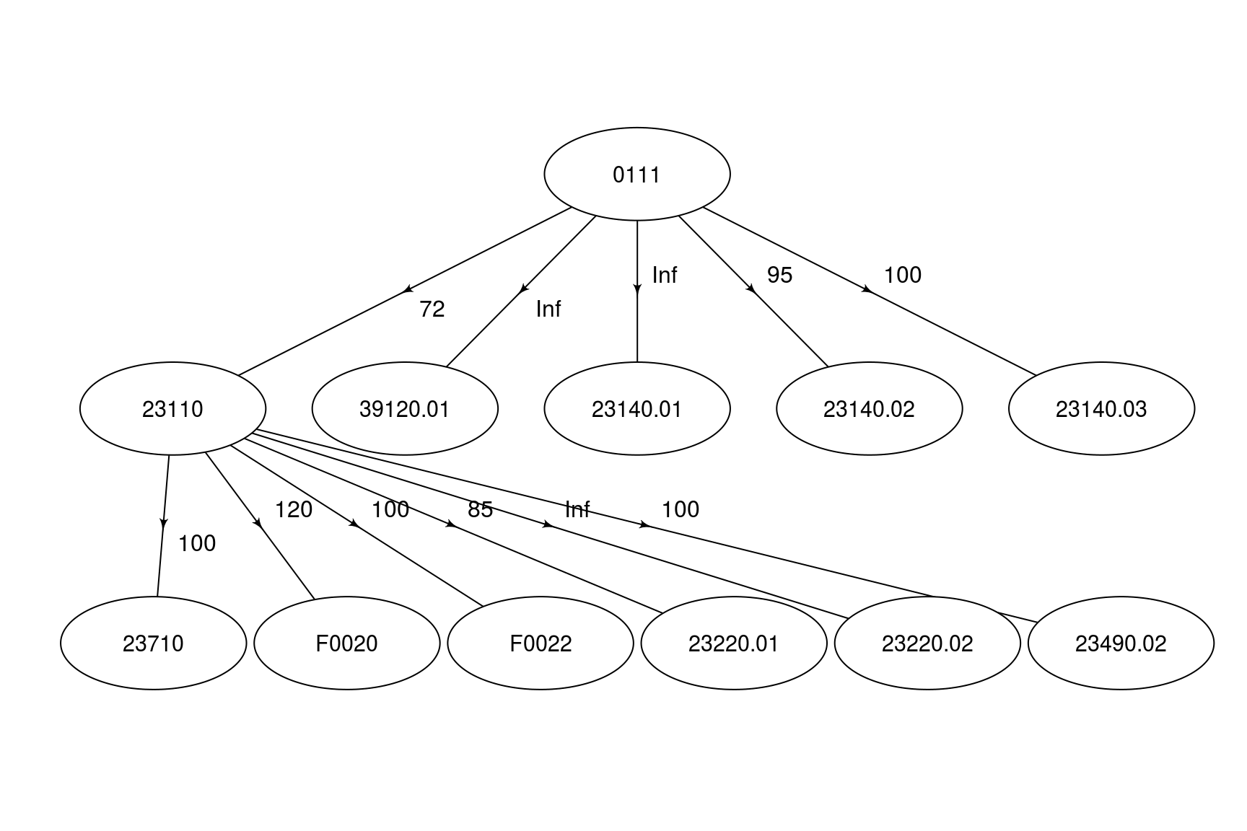

NOTE (Josh): This commodity tree above is derived based on the FCL commodity tree. It will likely need to be updated, but for now I just simply map the FCL elements to their corresponding CPC codes.

NOTE (Josh): At this point, we should also compute calories/proteins/fats.

NOTE (Josh): Need to keep track of the standard deviations as well so that we can balance at the end.

The first step in this process of creating the food balance sheets is to standardize all commodities up or down the commodity tree to the first processing level equivalent. Thus, our table is updated as follows:

|  |  |  |  |  |  |  |  |  |  |  |  |  |  |
| --- | --- | --- | --- | --- | --- | --- | --- | --- | --- | --- | --- | --- | --- |
| Item | AreaHarv | Yield | Production | Imports | Exports | StockChange | Food | Feed | Waste | Seed | Industrial | Tourist | Residual |
| 23110 | 0 | 0 | 90455216 | 1707992 | 11156114 | 0 | 18539484 | 0 | 739298 | 2546039 | 0 | 0 | 0 |
| 23140.01 | 0 | 0 | 0 | 0 | 0 | 0 | 0 | 0 | 0 | 0 | 0 | 0 | 0 |
| 23140.02 | 0 | 0 | 572812 | 197443 | 444366 | 0 | 3684 | 0 | 5898 | 20311 | 0 | 0 | 0 |
| 23140.03 | 0 | 0 | 2176752 | 335471 | 629562 | 0 | 98131 | 0 | 22412 | 77185 | 0 | 0 | 0 |
| 39120.01 | 0 | 0 | 0 | 271432 | 1819592 | 0 | 0 | 0 | 0 | 0 | 0 | 0 | 0 |

To illustrate the calculations occuring in this step, we'll focus on one specific element: the imports for 23140.02. This commodity originally had 189434 kg reported. However, all children commodities must be rolled up into this first level processing element (in this case there are none) and all primary products must be processed down according to the default shares and extraction rates. In this case, the share of 0111 to 23140.02 was 1% and the extraction rate was 95%. Thus, we will take the imports for 0111, i.e. 760869, and multiply it by the share while dividing by the extraction rate. This gives a increase of 8009 kg to the import of element 23140.02, thus the final import value is 197443.

NOTE (Josh): I'm not 100% confident this is the right approach, but it seems to make sense. We need to process wheat into flour so that we can create bran and germ, but we don't know how much to process down (as we haven't yet balanced the wheat). However, we could just simply standardize each element individually down into first level processing, and I think that should work.

### Feed

Feed allocation must be done at this phase in order to ensure that we have reduced the feed demand by the corresponding amounts of feed products (i.e. wheat bran, wheat germ, etc.).

### Balancing

## Cattle Meat

|  |  |  |  |  |  |  |  |  |  |  |  |  |  |
| --- | --- | --- | --- | --- | --- | --- | --- | --- | --- | --- | --- | --- | --- |
| Item | AreaHarv | Yield | Production | Imports | Exports | StockChange | Food | Feed | Waste | Seed | Industrial | Tourist | Residual |
| 21111.01 | 0 | 0 | 11921102 | 3190 | 86950 | 0 | 0 | 0 | 0 | 0 | 0 | 0 | 0 |
| 21111.02 | 0 | 0 | 0 | 122754 | 125163 | 0 | 0 | 0 | 0 | 0 | 0 | 0 | 0 |
| 21182 | 0 | 0 | 0 | NA | NA | 0 | 0 | 0 | 0 | 0 | 0 | 0 | 0 |
| 21185 | 0 | 0 | 0 | NA | NA | 0 | 0 | 0 | 0 | 0 | 0 | 0 | 0 |
| 21512.01 | 0 | 0 | 0 | 90902 | 351680 | 0 | 0 | 0 | 0 | 0 | 0 | 0 | 0 |

### Production

### Trade

### Stock Changes

|  |  |  |  |  |  |  |  |  |  |  |  |  |  |
| --- | --- | --- | --- | --- | --- | --- | --- | --- | --- | --- | --- | --- | --- |
| Item | AreaHarv | Yield | Production | Imports | Exports | StockChange | Food | Feed | Waste | Seed | Industrial | Tourist | Residual |
| 21111.01 | 0 | 0 | 11921102 | 3190 | 86950 | NA | 0 | 0 | 0 | 0 | 0 | 0 | 0 |
| 21111.02 | 0 | 0 | 0 | 122754 | 125163 | NA | 0 | 0 | 0 | 0 | 0 | 0 | 0 |
| 21182 | 0 | 0 | 0 | NA | NA | NA | 0 | 0 | 0 | 0 | 0 | 0 | 0 |
| 21185 | 0 | 0 | 0 | NA | NA | NA | 0 | 0 | 0 | 0 | 0 | 0 | 0 |
| 21512.01 | 0 | 0 | 0 | 90902 | 351680 | NA | 0 | 0 | 0 | 0 | 0 | 0 | 0 |

### Food

|  |  |  |  |  |  |  |  |  |  |  |  |  |  |
| --- | --- | --- | --- | --- | --- | --- | --- | --- | --- | --- | --- | --- | --- |
| Item | AreaHarv | Yield | Production | Imports | Exports | StockChange | Food | Feed | Waste | Seed | Industrial | Tourist | Residual |
| 21111.01 | 0 | 0 | 11921102 | 3190 | 86950 | NA | NA | 0 | 0 | 0 | 0 | 0 | 0 |
| 21111.02 | 0 | 0 | 0 | 122754 | 125163 | NA | 7793721 | 0 | 0 | 0 | 0 | 0 | 0 |
| 21182 | 0 | 0 | 0 | NA | NA | NA | 98 | 0 | 0 | 0 | 0 | 0 | 0 |
| 21185 | 0 | 0 | 0 | NA | NA | NA | 949 | 0 | 0 | 0 | 0 | 0 | 0 |
| 21512.01 | 0 | 0 | 0 | 90902 | 351680 | NA | NA | 0 | 0 | 0 | 0 | 0 | 0 |

### Losses

|  |  |  |  |  |  |  |  |  |  |  |  |  |  |
| --- | --- | --- | --- | --- | --- | --- | --- | --- | --- | --- | --- | --- | --- |
| Item | AreaHarv | Yield | Production | Imports | Exports | StockChange | Food | Feed | Waste | Seed | Industrial | Tourist | Residual |
| 21111.01 | 0 | 0 | 11921102 | 3190 | 86950 | NA | NA | 0 | 22766 | 0 | 0 | 0 | 0 |
| 21111.02 | 0 | 0 | 0 | 122754 | 125163 | NA | 7793721 | 0 | NA | 0 | 0 | 0 | 0 |
| 21182 | 0 | 0 | 0 | NA | NA | NA | 98 | 0 | NA | 0 | 0 | 0 | 0 |
| 21185 | 0 | 0 | 0 | NA | NA | NA | 949 | 0 | NA | 0 | 0 | 0 | 0 |
| 21512.01 | 0 | 0 | 0 | 90902 | 351680 | NA | NA | 0 | NA | 0 | 0 | 0 | 0 |

### Seed

|  |  |  |  |  |  |  |  |  |  |  |  |  |  |
| --- | --- | --- | --- | --- | --- | --- | --- | --- | --- | --- | --- | --- | --- |
| Item | AreaHarv | Yield | Production | Imports | Exports | StockChange | Food | Feed | Waste | Seed | Industrial | Tourist | Residual |
| 21111.01 | 0 | 0 | 11921102 | 3190 | 86950 | NA | NA | 0 | 22766 | NA | 0 | 0 | 0 |
| 21111.02 | 0 | 0 | 0 | 122754 | 125163 | NA | 7793721 | 0 | NA | NA | 0 | 0 | 0 |
| 21182 | 0 | 0 | 0 | NA | NA | NA | 98 | 0 | NA | NA | 0 | 0 | 0 |
| 21185 | 0 | 0 | 0 | NA | NA | NA | 949 | 0 | NA | NA | 0 | 0 | 0 |
| 21512.01 | 0 | 0 | 0 | 90902 | 351680 | NA | NA | 0 | NA | NA | 0 | 0 | 0 |

### Industrial Utilization

Work in progress...

### Tourist Consumption

Work in progress...

### Residual Other Uses

Work in progress...

### Standardization

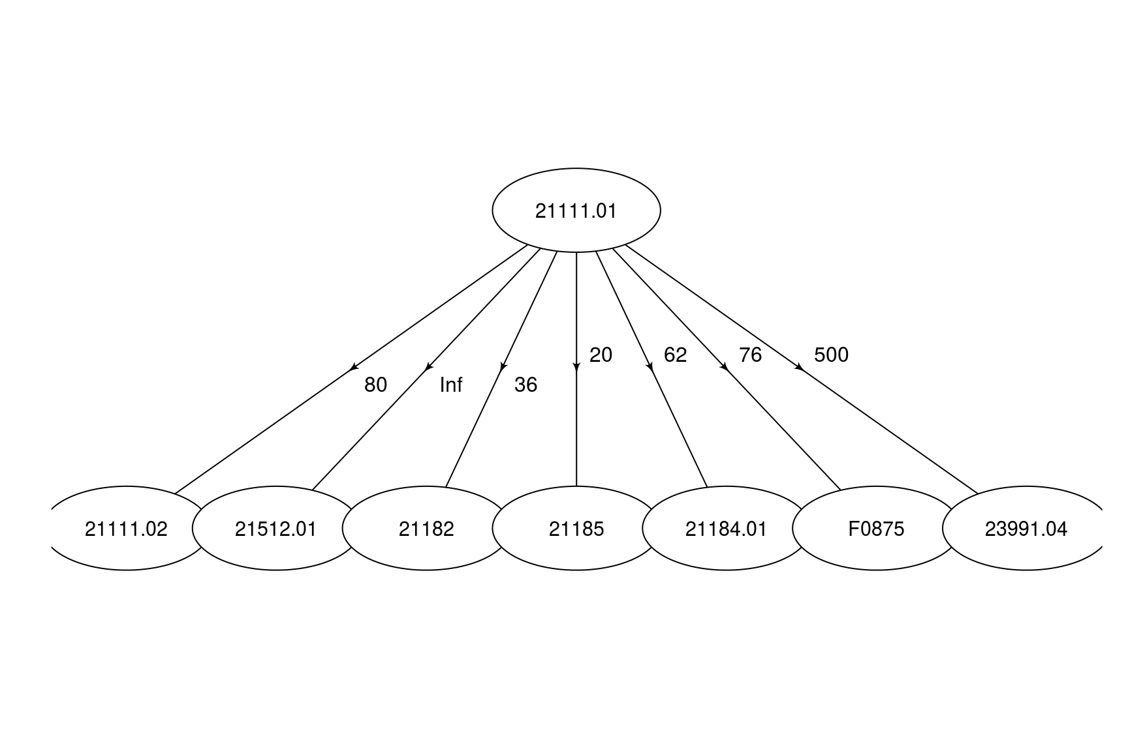

|  |  |  |  |  |  |  |  |  |  |  |  |  |  |
| --- | --- | --- | --- | --- | --- | --- | --- | --- | --- | --- | --- | --- | --- |
| Item | AreaHarv | Yield | Production | Imports | Exports | StockChange | Food | Feed | Waste | Seed | Industrial | Tourist | Residual |
| 02111 | 0 | 0 | 11921102 | 3190 | 86950 | 0 | 0 | 0 | 22766 | 0 | 0 | 0 | 0 |
| 21111.02 | 0 | 0 | 5960551 | 124350 | 168638 | 0 | 7793721 | 0 | 11383 | 0 | 0 | 0 | 0 |
| 21182 | 0 | 0 | 3352810 | 897 | 24455 | 0 | 98 | 0 | 6403 | 0 | 0 | 0 | 0 |
| 21184.01 | 0 | 0 | 1915960 | 513 | 13975 | 0 | 0 | 0 | 3659 | 0 | 0 | 0 | 0 |
| 21185 | 0 | 0 | 5960551 | 1595 | 43475 | 0 | 949 | 0 | 11383 | 0 | 0 | 0 | 0 |
| 21512.01 | 0 | 0 | 0 | 90902 | 351680 | 0 | 0 | 0 | 0 | 0 | 0 | 0 | 0 |
| 23911.04 | 0 | 0 | 0 | 0 | 0 | 0 | 0 | 0 | 0 | 0 | 0 | 0 | 0 |
| F0875 | 0 | 0 | 1577758 | 422 | 11508 | 0 | 0 | 0 | 3013 | 0 | 0 | 0 | 0 |

### Feed

### Balancing

## Palm Oil

|  |  |  |  |  |  |  |  |  |  |  |  |  |  |
| --- | --- | --- | --- | --- | --- | --- | --- | --- | --- | --- | --- | --- | --- |
| Item | AreaHarv | Yield | Production | Imports | Exports | StockChange | Food | Feed | Waste | Seed | Industrial | Tourist | Residual |
| 2165 | 0 | 0 | 0 | NA | NA | 0 | 0 | 0 | 0 | 0 | 0 | 0 | 0 |
| 21691.14 | 0 | 0 | 0 | NA | NA | 0 | 0 | 0 | 0 | 0 | 0 | 0 | 0 |
| 21700.02 | 0 | 0 | 3714000 | NA | NA | 0 | 0 | 0 | 0 | 0 | 0 | 0 | 0 |
| 34120 | 0 | 0 | 0 | NA | NA | 0 | 0 | 0 | 0 | 0 | 0 | 0 | 0 |
| 34550 | 0 | 0 | 0 | NA | NA | 0 | 0 | 0 | 0 | 0 | 0 | 0 | 0 |
| F1243 | 0 | 0 | 260000 | NA | NA | 0 | 0 | 0 | 0 | 0 | 0 | 0 | 0 |
| F1275 | 0 | 0 | 0 | NA | NA | 0 | 0 | 0 | 0 | 0 | 0 | 0 | 0 |

### Production

### Trade

### Stock Changes

|  |  |  |  |  |  |  |  |  |  |  |  |  |  |
| --- | --- | --- | --- | --- | --- | --- | --- | --- | --- | --- | --- | --- | --- |
| Item | AreaHarv | Yield | Production | Imports | Exports | StockChange | Food | Feed | Waste | Seed | Industrial | Tourist | Residual |
| 2165 | 0 | 0 | 0 | NA | NA | NA | 0 | 0 | 0 | 0 | 0 | 0 | 0 |
| 21691.14 | 0 | 0 | 0 | NA | NA | NA | 0 | 0 | 0 | 0 | 0 | 0 | 0 |
| 21700.02 | 0 | 0 | 3714000 | NA | NA | NA | 0 | 0 | 0 | 0 | 0 | 0 | 0 |
| 34120 | 0 | 0 | 0 | NA | NA | NA | 0 | 0 | 0 | 0 | 0 | 0 | 0 |
| 34550 | 0 | 0 | 0 | NA | NA | NA | 0 | 0 | 0 | 0 | 0 | 0 | 0 |
| F1243 | 0 | 0 | 260000 | NA | NA | NA | 0 | 0 | 0 | 0 | 0 | 0 | 0 |
| F1275 | 0 | 0 | 0 | NA | NA | NA | 0 | 0 | 0 | 0 | 0 | 0 | 0 |

### Food

|  |  |  |  |  |  |  |  |  |  |  |  |  |  |
| --- | --- | --- | --- | --- | --- | --- | --- | --- | --- | --- | --- | --- | --- |
| Item | AreaHarv | Yield | Production | Imports | Exports | StockChange | Food | Feed | Waste | Seed | Industrial | Tourist | Residual |
| 2165 | 0 | 0 | 0 | NA | NA | NA | 0 | 0 | 0 | 0 | 0 | 0 | 0 |
| 21691.14 | 0 | 0 | 0 | NA | NA | NA | 15000 | 0 | 0 | 0 | 0 | 0 | 0 |
| 21700.02 | 0 | 0 | 3714000 | NA | NA | NA | 3729905 | 0 | 0 | 0 | 0 | 0 | 0 |
| 34120 | 0 | 0 | 0 | NA | NA | NA | NA | 0 | 0 | 0 | 0 | 0 | 0 |
| 34550 | 0 | 0 | 0 | NA | NA | NA | NA | 0 | 0 | 0 | 0 | 0 | 0 |
| F1243 | 0 | 0 | 260000 | NA | NA | NA | 175439 | 0 | 0 | 0 | 0 | 0 | 0 |
| F1275 | 0 | 0 | 0 | NA | NA | NA | NA | 0 | 0 | 0 | 0 | 0 | 0 |

### Losses

|  |  |  |  |  |  |  |  |  |  |  |  |  |  |
| --- | --- | --- | --- | --- | --- | --- | --- | --- | --- | --- | --- | --- | --- |
| Item | AreaHarv | Yield | Production | Imports | Exports | StockChange | Food | Feed | Waste | Seed | Industrial | Tourist | Residual |
| 2165 | 0 | 0 | 0 | NA | NA | NA | 0 | 0 | NA | 0 | 0 | 0 | 0 |
| 21691.14 | 0 | 0 | 0 | NA | NA | NA | 15000 | 0 | NA | 0 | 0 | 0 | 0 |
| 21700.02 | 0 | 0 | 3714000 | NA | NA | NA | 3729905 | 0 | NA | 0 | 0 | 0 | 0 |
| 34120 | 0 | 0 | 0 | NA | NA | NA | NA | 0 | NA | 0 | 0 | 0 | 0 |
| 34550 | 0 | 0 | 0 | NA | NA | NA | NA | 0 | NA | 0 | 0 | 0 | 0 |
| F1243 | 0 | 0 | 260000 | NA | NA | NA | 175439 | 0 | NA | 0 | 0 | 0 | 0 |
| F1275 | 0 | 0 | 0 | NA | NA | NA | NA | 0 | NA | 0 | 0 | 0 | 0 |

### Seed

|  |  |  |  |  |  |  |  |  |  |  |  |  |  |
| --- | --- | --- | --- | --- | --- | --- | --- | --- | --- | --- | --- | --- | --- |
| Item | AreaHarv | Yield | Production | Imports | Exports | StockChange | Food | Feed | Waste | Seed | Industrial | Tourist | Residual |
| 2165 | 0 | 0 | 0 | NA | NA | NA | 0 | 0 | NA | NA | 0 | 0 | 0 |
| 21691.14 | 0 | 0 | 0 | NA | NA | NA | 15000 | 0 | NA | NA | 0 | 0 | 0 |
| 21700.02 | 0 | 0 | 3714000 | NA | NA | NA | 3729905 | 0 | NA | NA | 0 | 0 | 0 |
| 34120 | 0 | 0 | 0 | NA | NA | NA | NA | 0 | NA | NA | 0 | 0 | 0 |
| 34550 | 0 | 0 | 0 | NA | NA | NA | NA | 0 | NA | NA | 0 | 0 | 0 |
| F1243 | 0 | 0 | 260000 | NA | NA | NA | 175439 | 0 | NA | NA | 0 | 0 | 0 |
| F1275 | 0 | 0 | 0 | NA | NA | NA | NA | 0 | NA | NA | 0 | 0 | 0 |

### Industrial Utilization

Work in progress...

### Tourist Consumption

Work in progress...

### Residual Other Uses

Work in progress...

### Standardization

NOTE (Josh): This commodity tree looks like two separate trees. But, the two parent nodes can actually be processed into many of the same children. I'm not sure what the logic was for historically rolling up some of the children into one of the parents and some of the children into the other parent, but that would presumably need to be reviewed/revised.

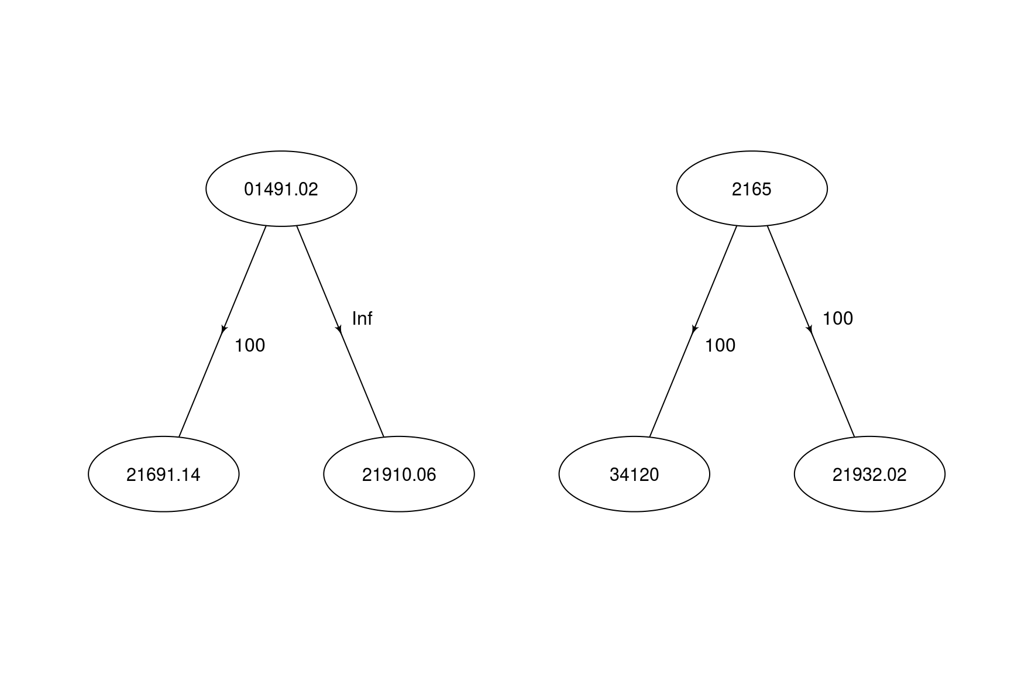

|  |  |  |  |  |  |  |  |  |  |  |  |  |  |
| --- | --- | --- | --- | --- | --- | --- | --- | --- | --- | --- | --- | --- | --- |
| Item | AreaHarv | Yield | Production | Imports | Exports | StockChange | Food | Feed | Waste | Seed | Industrial | Tourist | Residual |
| 01491.01 | 0 | 0 | 0 | 0 | 0 | 0 | 0 | 0 | 0 | 0 | 0 | 0 | 0 |
| 01491.02 | 0 | 0 | 0 | 0 | 0 | 0 | 15000 | 0 | 0 | 0 | 0 | 0 | 0 |
| 21512 | 0 | 0 | 260000 | 0 | 0 | 0 | 175439 | 0 | 0 | 0 | 0 | 0 | 0 |
| 21691.12 | 0 | 0 | 0 | 0 | 0 | 0 | 0 | 0 | 0 | 0 | 0 | 0 | 0 |
| 21691.90 | 0 | 0 | 3094876 | 0 | 0 | 0 | 3108130 | 0 | 0 | 0 | 0 | 0 | 0 |
| 21932.02 | 0 | 0 | 0 | 0 | 0 | 0 | 0 | 0 | 0 | 0 | 0 | 0 | 0 |
| 34120 | 0 | 0 | 0 | 0 | 0 | 0 | 0 | 0 | 0 | 0 | 0 | 0 | 0 |

### Feed

### Balancing