Food losses and waste (FLW)

Definition of FLW in the FBS system
The FAO FBS system covers food availability up to the point of food purchases, typically the retail level. In line with the definition of food availability, food losses cover all losses up to the same level, i.e. up to the retail level (see Figure 21). Postharvest losses (PHL) and losses that occur during storage and transportation as well as processing are therefore included, while losses at the retail level or even the household level are not included in the FBS system. Processing losses are estimated in the standardization process (see section on standardization), whereby a small allowance is made when extraction rates are applied to primary products. Figure 21 below provides an overview of losses across the entire value chain and delineates losses covered in the FBS system from losses outside the FAO food balances.

Data availability
The FAO production questionnaire (see section on production) includes a section for countries to report estimates of waste and losses. While the vast majority of FAO member countries report production and/or productivity data, estimates for losses are notoriously scarce and, where they are made available by countries through the questionnaire, they are unlikely to be based on reliable measurement efforts. Indeed, the Global Strategy to Improve Rural and Agricultural Statistics found that there is not even a readily available and reliable method to measure losses. The next steps are to devise an experimental design that could ultimately be used to measure food losses and waste in an accurate manner. This means that available estimates are not only limited, but the few available may not be fully reliable and comparable across countries.
These concerns become visible in the data on losses and waste reported by countries. They can differ, even as percentage loss rates, i.e. as shares of production and trade, considerably even across similar countries. A cross-country comparison has found such differences both for individual commodities, as well as for overall losses at country level estimate. No doubt, this is not an optimal basis to develop an imputation approach, but in the absence of better information, this is the only available basis to start to develop a new imputation method. The basic elements of the new method are laid out below. Before detailing the new method, a quick review of the previous approach is in order.
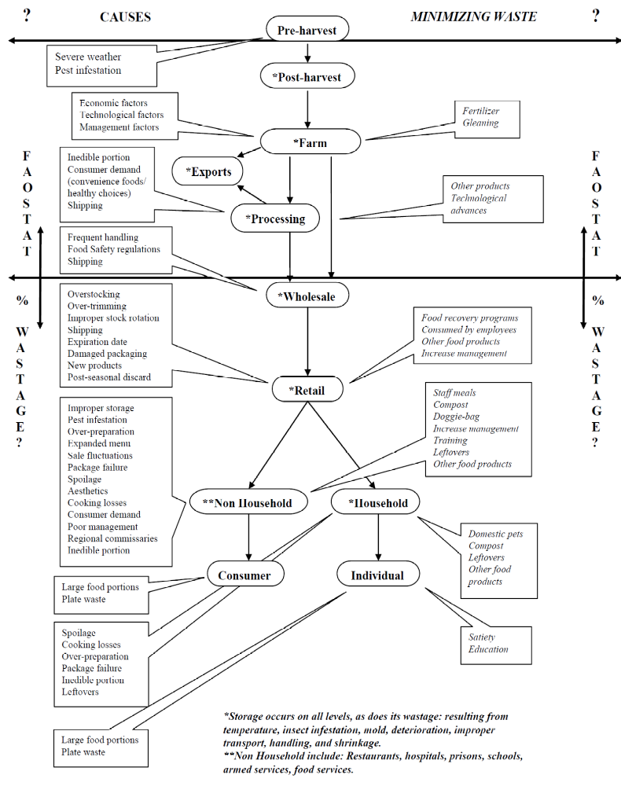
Figure 21: Flow chart of food losses and wastages
Source: Research Report on the Assessment of Intra-household Wastage of Food. FAO, ESS, 2004.

The previous imputation approach
Just like feed use, FLW have been estimated as a simple ratio (share) of availability; this means that the amount of food loss of commodity i in country j (Lo_{i,j}) is:
${Lo}_{i,j}=\left(P_{i,j}+I_{i,j}\right)* r_{i,j}$ (Equation 26)
Again, similarly to the previous approach to estimate feed use, no differentiation is made between trade and domestic production, i.e. a uniform loss rate is applied to all elements of availability.

The new imputation approach
Given the possible shortcomings of the old imputation method and notwithstanding the data and methodological limitations, it was decided to develop a new method to estimate FLW based on those data points that are officially reported. The scarcity of official data made it necessary to pool available data into a panel. It was also deemed necessary to distinguish losses that occur for domestic products from trade products as there are strong a priori reasons to assume that the latter are generally lower. The main reasons for lower trade losses are the fact that PHL do not apply to trade and that traded commodities are likely to be handled and processed in more advanced systems, which are typically less prone to losses.
FBS compilers at country level are encouraged to use all country-specific information to gauge the amount of losses in their home countries. They can probably draw on country and commodity-specific knowledge about their farm production (harvesting machinery, storage facilities, etc.) and food processing system that is not readily available to FAO. As for all variables, FAO appreciates receiving such information, ideally through its production questionnaire.

The model/estimation procedure
In the absence of empirical estimates, countries may want to consider using the FAO method of estimating FLW. To this end, a hierarchical linear model (HLM) was developed with the loss quantity as response. The strength of the approach is its ability to pool together different levels of information for the best inference and optimal prediction.
Modelling is performed in a hierarchical fashion, with country/commodity specific estimates at the lowest hierarchical level followed by commodity specific estimates, food group estimates, and lastly food perishable group estimates. The coefficients in the hierarchy are estimated simultaneously to ensure they are consistent between and within the hierarchy. The specific model employed is the following:

$$\log\left({Loss}_{ijklm}\right)= α_{1}t+α_{2ijkl}\log\left({Production}_{ijklm}+1\right)+A_{ijklm}$$
$$α_{2ijkl}=β_{20}+β_{2ijk}{\left(Country:Commodity\right)}_{ijkl}+B_{ijkl} \\ β_{2ijk}=γ_{20}+γ_{2ij}{\left(Commodity\right)}_{ijk}+C_{ijk} \\ γ_{2ij}=δ_{20}+δ_{2i}{\left(Food Group\right)}_{ij}+D_{ij}$$$δ_{2i}=ζ_{20}+ζ_{21}{\left(Food Perishable Group\right)}_{i}+E_{i}$
(Equation 27a-e)

where the i_{th} index represents the effect of food perishable group, the j_{th} index the effect of food group, the k_{th} index the effect of commodity, the l_{th} index the effect of country/commodity, and the m_{th} index the individual observations. The capital letters represent random errors, and these are all assumed to follow normal distributions with some unknown variance. The Greek letters indicate coefficients to be estimated from the data.
The utility of this model is that if a coefficient is missing due to non-availability of official data for estimation, the algorithm will impute losses based on the next level of hierarchy. This means that if loss estimates are missing for a specific country and commodity, the global loss rate for that commodity is applied. If that is not available, the global loss rate for the food group of that commodity is used, and if that is even still not available, the loss rates for perishable food is used. However, if large quantities of data for a particular commodity within a particular country are available, these data are used for imputation without moving up the hierarchy.
The particular advantage of the model lies in the fact that a single model will suffice, where the common approach usually demands several models to impute when a single model fails. In addition, when separate models were estimated individually, they do not incorporate the hierarchical information present in the data.

Total availability would notionally include stock withdrawals; as no data on stock levels were available in the past, stock withdrawals had been omitted.

