# PP harvester procedure

Step by step procedure to run the Annual producer prices harvester.

1. First of all create a .zip folder with all the Annual questionnaires.
2. Go to the SWS (QA) <https://hqlqasws1.hq.un.fao.org:8443/sws/> and click on the ‘Harvester’ button as on the screenshot below

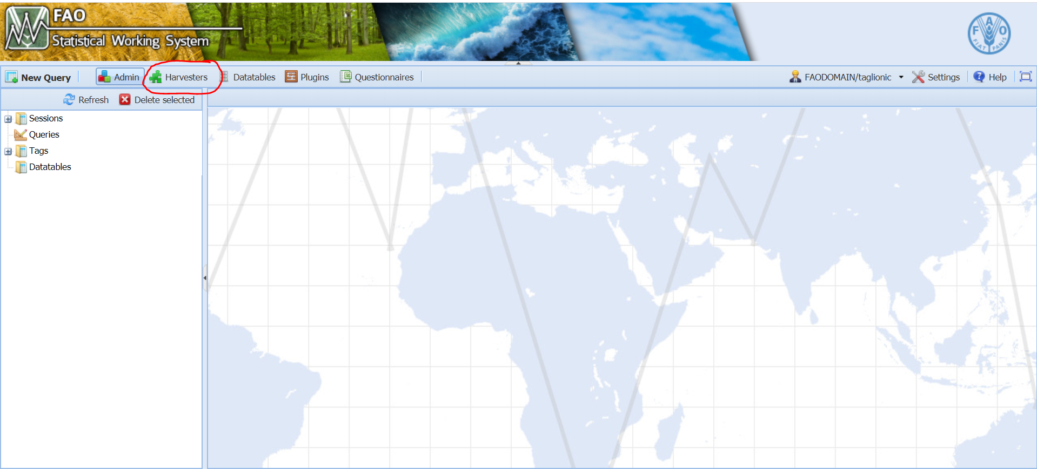

1. Once the new tab is opened select the harvester to run: ‘Producer Prices Annual Questionnaire Harvester’

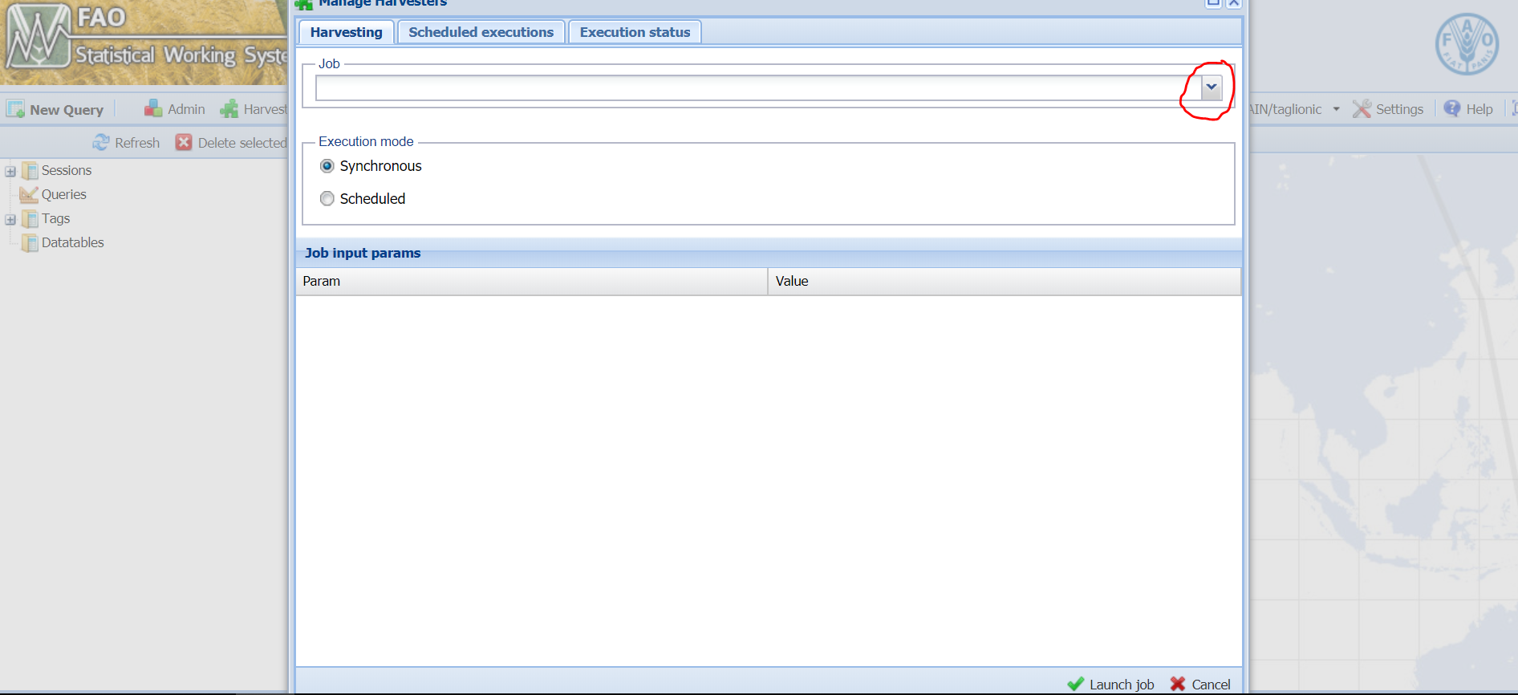

1. Once the harvester has been selected Browse to select the .zip file with the questionnaires

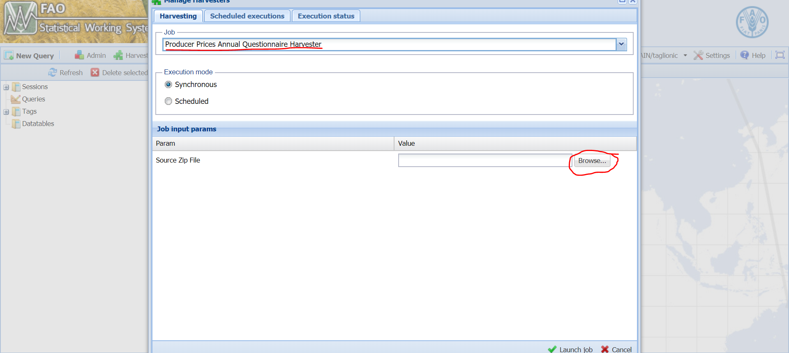

1. Once the file has been selected (PPquestionnaire.zip in the example) click on the ‘Launch job’ button and wait for the confirmation email.

