# Exchange rate source and domain data comparison

### September 21st, 2020

After a first formal analysis of the dataset containing exchange rates in the Statistical Working System (SWS) a second comparison among data contained in the datasets and in the official sources has been performed and is summarized in this document.

The domains identified as containing exchange rates data are:

* Common domain (data outdated and dataset structure to review)
* Fisheries and Fisheries commodities (sharing the same source)
* Macro Statistics (part of the ECO team duties and responsible for publishing the data on FAOSTAT)
* Trade of Crop, livestock and food statistics (CLFS) team

The four domains contains some differences in the way exchange rates are treated and saved.

The issue to highlight and discuss with the teams are the following:

1. The number of decimals reported: the number is different in all the domains and should be aligned
2. The type of rate: UNSD and FAOSTAT publish the exchange rates as ‘Domestic currency per USD’ whereas Fisheries and Trade (CLFS) use what is called the inverse exchange rate ‘USD per domestic currency’ (= 1/‘Domestic currency per USD’) this has to be highlighted as it might impact calculations
3. The type of currency: UNSD and FAOSTAT publish the exchange rates using the Standard Local Currency (SLC) as ‘Domestic currency’, meaning that the exchange rates refers to the current currency even for years when the currency was not in use yet (e.g. Euro/USD exchange rate for year 1970). Fisheries instead uses as ‘Domestic currency’ the Local Currency Unit (LCU), i.e. the currency actually used at the reported year (hence Euro/USD exchange rates start in 1999). The first approach, based on SLC, requires exchange rates data to be saved along with the country variable (as, for example, before 1999 the Euro/USD exchange rates depend on the LCU of each country). The approach based on LCU instead can ignore the country variable as, in its validity period, a unique currency has only one exchange rate value with the USD. [1]

Table Exchange rate format saved in each domain and source

|  |  |  |  |
| --- | --- | --- | --- |
| Source | decimals | Type or rate | Currency |
| IMF | 14 | Domestic currency per USD & inverse | LCU |
| UNSD | 15 | Domestic currency per USD | SLC |
| FAOSTAT | 4 | Domestic currency per USD | SLC |
| Fisheries | 10 | Inverse (USD per domestic currency) | LCU |
| Trade (Clfs team) | 6 | Inverse (USD per domestic currency) | Not applicable (only Euro from 2000) |

The points listed need to be discussed and the content of the Exchange rate dataset in the common domain must be agreed accordingly.

Having a single dataset from where all teams can extract exchange rates will also ensure the consistency of the source used, the number of digits available and, more generally, of the values. Table 2 reports an example of the exchange rate value of the EUR/USD for 2015 (a datum that one would not expect to be problematic). Values in red highlight the inverse exchange rates. As it is shown, differences among the values are not imputable only to different rounding. The final output would indeed benefit of a unique source.

Table Example of EUR/USD extraction rates reported for year 2015. Last available data for all sources.

|  |  |  |  |  |  |  |
| --- | --- | --- | --- | --- | --- | --- |
| **XR year** | **IMF** | **Fisheries** | **Trade (CLFS)** | **FAOSTAT** | **UNSD Xpop**  **(Macro indicators)** | **Data.un.org** |
| **2015** | 0.901296423367096 | 1.1095128906 = 1/0.9012964233670 | 1.109625 | 0.9017  (all countries) | 0.901658961641278 | 0.9013 |

The example in table 2 opens to a larger set of data identified as problematic when comparing the data in the Fisheries domain and in FAOSTAT.

Comparing[2] the data by currency in the Fisheries domain (SWS Production environment) with the latest data published in FAOSTAT the following currency have shown value differences above 0.1 (i.e. not ascribable to rounding issues):

Australian Dollar, Chilean Peso, Cuban Peso, Egyptian Pound, Quetzal, Argentine Peso, Iraqi Dinar, Libyan Dinar, Moldovan Leu, Kyat, Naira, Nuevo Sol, Lao Kip, New Israeli Sheqel, Iceland Króna, Somali Shilling, Hryvnia, Yemeni Rial, CFA Franc BCEAO, Peso Uruguayo, Dong, Congolese Franc, Czechoslovak Koruna, Ouguiya, Dobra, Ruble, Bolivar Fuerte, Yemeni Dinar, Belarusian Ruble.

Sometimes value are completely incomparable, whereas sometimes it looks like a ‘scale’ problem. In the first case the more recent examples are the Iraqi Dinar (IQD, from 1970 until 2006 fisheries data are non-consistent with IMF) and the Kiat (Myanmar, MMK). Scale problems have been spotted for example with the Belarusian Ruble (BYR, FIAS data are 10,000 times smaller than the FAOSTAT published ones).

Below there are screenshot of the EUR/USD example and peculiarities of each domain.

IMF

Exchange rate: domestic currency (LCU) per USD and also USD per LCU, until 14th decimal place

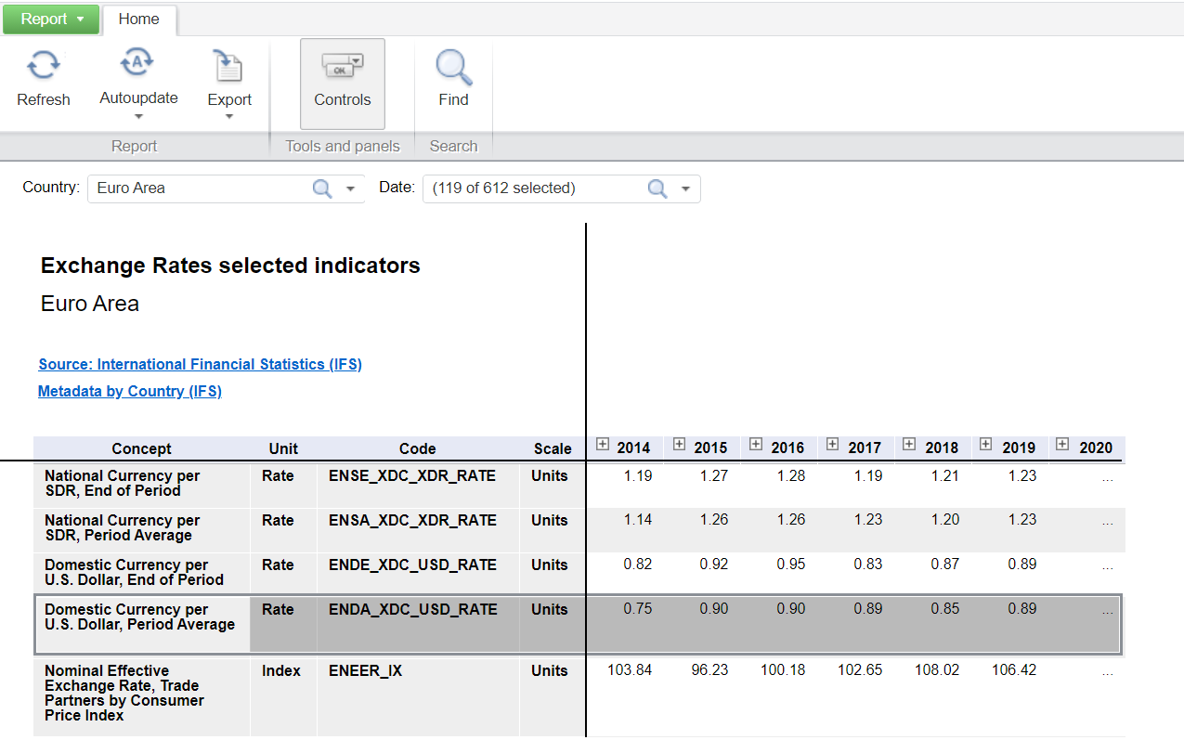

Figure : IMF publishes Domestic currency per USD rates and inverse exchange rates. EUR/USD example of the first type.

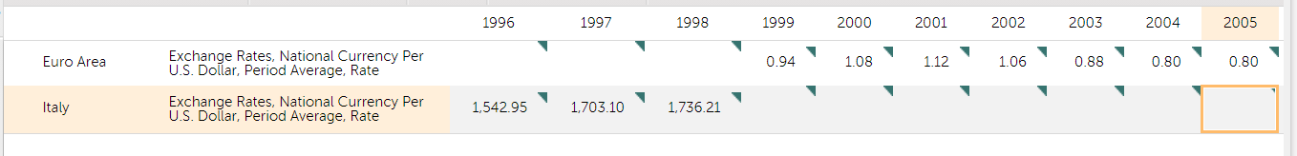

Figure IMF publishes data in domestic currency (LCU). ITL and EUR example.

Fisheries

Exchange rate: USD per domestic currency (LCU), until 10th decimal place

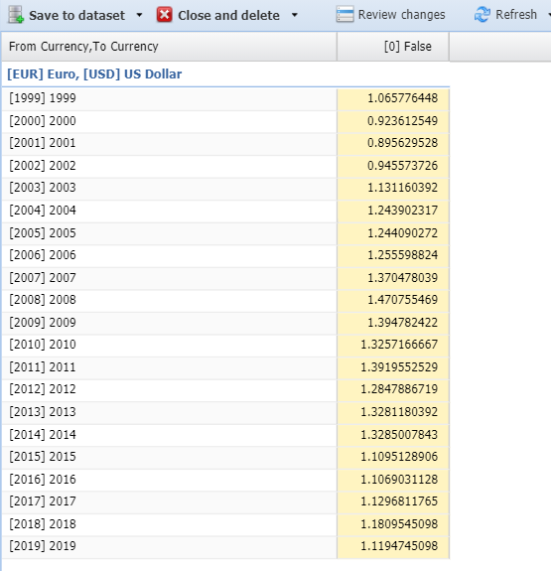

Figure FIAS uses inverse exchange rates USD per Domestic currency referring to LCU. EUR/USD example, EUR series starts from 1999.

Trade (CLFS team)

Exchange rate: USD per domestic currency (EUR only), until 6th decimal place

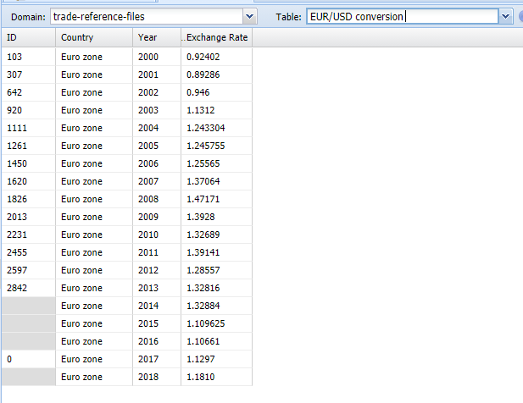

Figure Trade CLFS team uses inverse exchange rates USD per Domestic currency only for Euro starting from 2000.

FAOSTAT (ECO team)

Exchange rate: domestic currency (SLC) per USD, until 4th decimal place

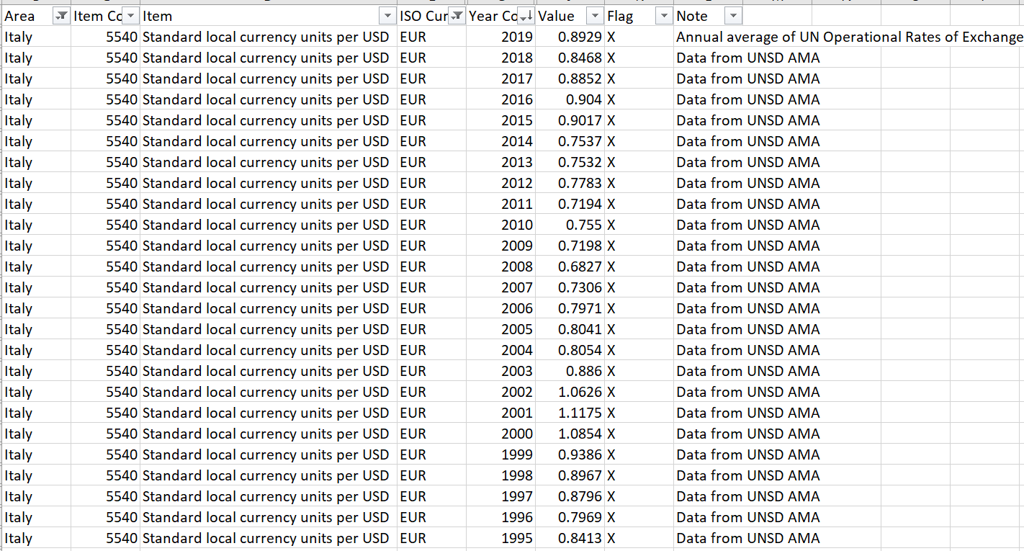

Figure ECO team publishes exchange rates referring to SLC. Example of Italy with EUR/USD exchange rates from 1995 until 2019 (the series actually starts from 1970 as all the others).

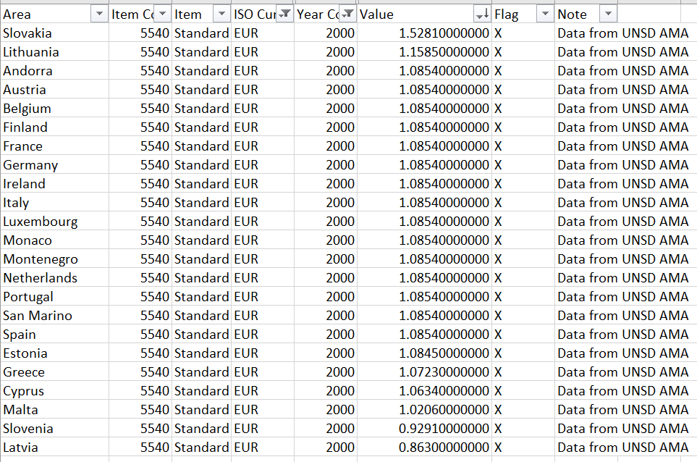

Figure Country specific EUR/USD exchange rates in year 2000. Countries not yet in the Euro Area have different values due to the SLC approach.

UNSD link!

Depending on the method to download data from UNSD the data obtained are different. When using the API (<https://unstats.un.org/unsd/amaapi/api/file/30>) the results is the one published in FAOSTAT and used by the ECO team. When using the link <http://data.un.org/> some data differ. E.g. exchange rate for Slovakia in 2015 from the API downloaded file is 0.90165896, the same rate from the file downloaded from data.un.org is 0.9013.

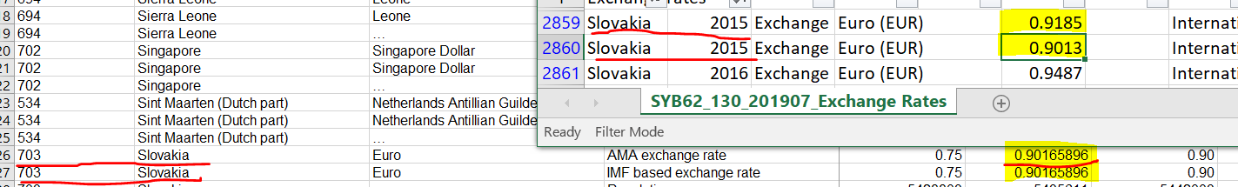

Figure UNSD exchange rates emerging inconsistency

1. Note: This issue seems similar to the one encountered for Population data. In FAOSTAT population data are disseminated according to the historical geopolitical structure, i.e. with breaks in the series as it happens with LCU, whereas UNSD publishes population data according to the current geopolitical structure, i.e. reconstructing time series avoiding breaks as with SLC.
2. The comparison has been made accounting for the fact that FIAS uses inverse rates.