# Exchange rates datasets presentation and update

## 24th November 2021

The Statistical Working System (SWS) hosts in the ‘Common Domain’ the two datasets “Exchange Rates (annual)” and “Exchange Rates (monthly)” containing respectively the annual and the monthly exchange rates for all the available countries.

The annual dataset contains both the exchange rates in Local Currency Unit (LCU), extracted through the IMF API, and the ones in Standard Local Currency (SLC) extracted through the UNSD API.

In each dataset, the dimensions are:

1. the country classified according to the M49 standard (geographicAreaM49 codelist in SWS)
2. the currency with the standard ISO code (from_currency and to_currency codelists)
3. the element of classification, i.e. if the exchange rates refer to LCU or SLC
4. the points in time: year (timePointYears) and monthly (timePointMonths only in the monthly dataset)

In all datasets, the exchange rates refer to the period average of the Domestic currency per US Dollar (from LCU and SLC to USD).

The exchange rates datasets are simple datasets that only need a recurrent update through an *ad-hoc* developed harvester procedure.

If between two updates there has been a currency change in a country this must be reflected in the “Exchange Rates Correspondences” datatable available in the “Common Domain”.

Please note the datatable is an easily modified object and there is no track of the modification so it is strongly recommended to keep back-ups of the different versions.

The datatable in the figure below contains the information about the country and the currency from at least 1970 onwards. If there is a currency change, the end year and end date of the previous currency must be inserted and the new currency must be inserted manually. The operation can be done online or downloading and re-uploading the file with the Import and Export buttons. The advice is to do it online.

Note that the update operation must apply to all countries that adopted the currency.

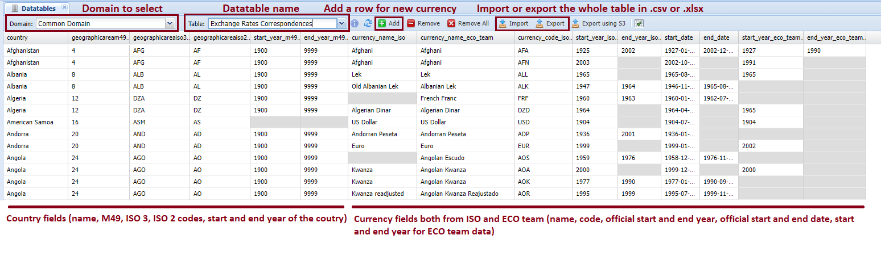

The dataset update procedure is straightforward: an automatized API updates the data using the identified sources from 1970 to the latest available year.

Before the update, it is advisable to create a tag of the dataset so that any change can be traced back.

The pictures below show the procedure that is similar for both annual and monthly datasets.

Select the ‘Harvester’ button on the main page <https://sws.fao.org/>

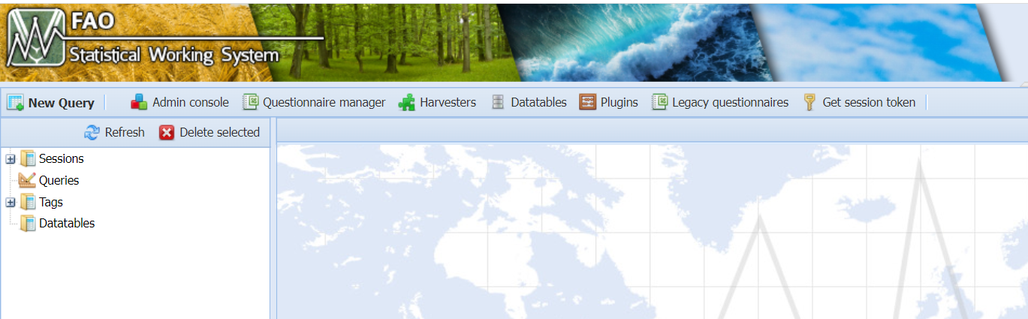

The list of available harvesters appears to the user. Select the desired one “Exchange Rates Harvester (Annual)” or “Exchange Rates Harvester (Monthly)”

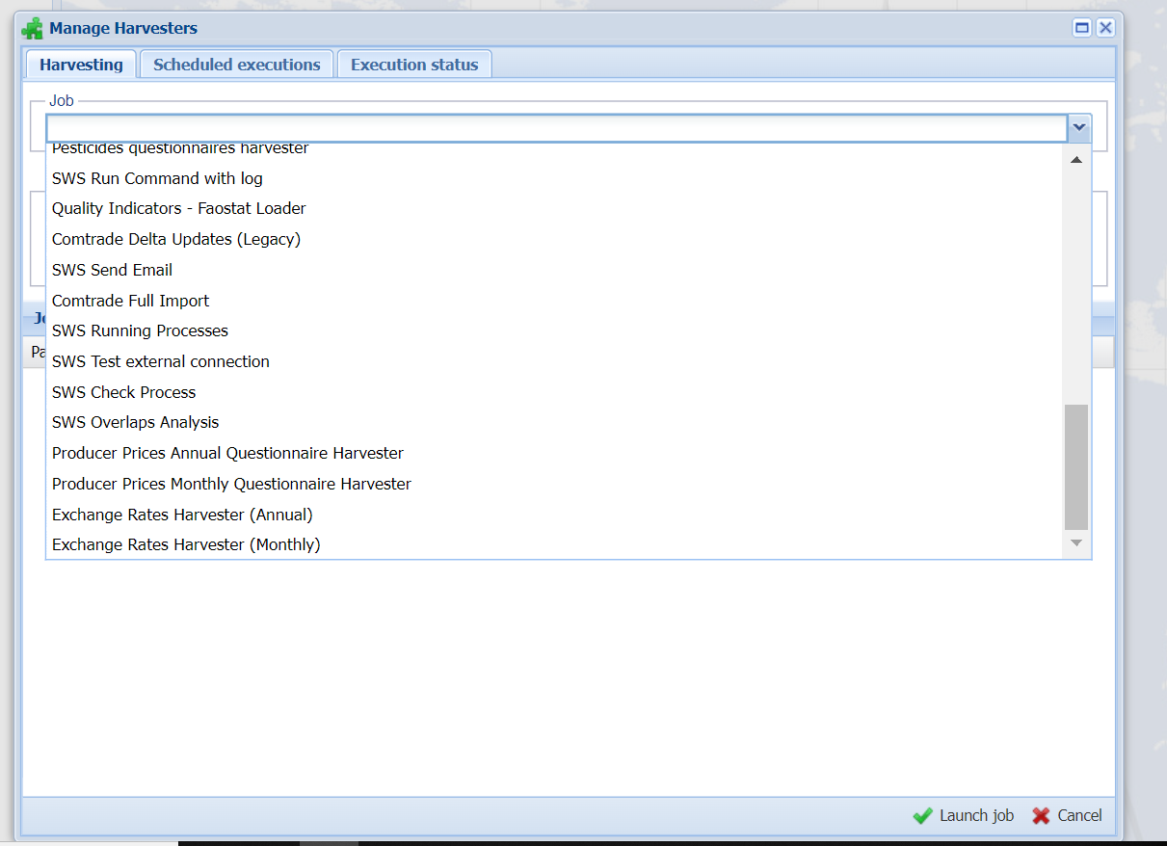

If the annual procedure is selected the desired source must be specified in the “Source” field, i.e. UNSD or IMF then press the button “Launch job” and wait until an email updates about the outcome of the procedure (successful, warnings or errors).

Type IMF or UNSD

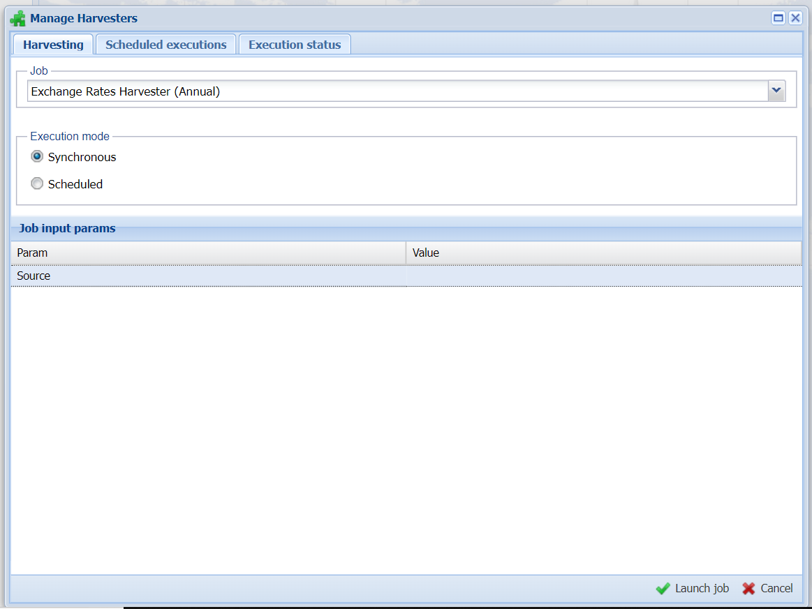

If any error appears, please contact the CSI unit so that they can address the issue.

The monthly harvester has a similar procedure but no source must be inserted as all monthly rates are collected from IMF.

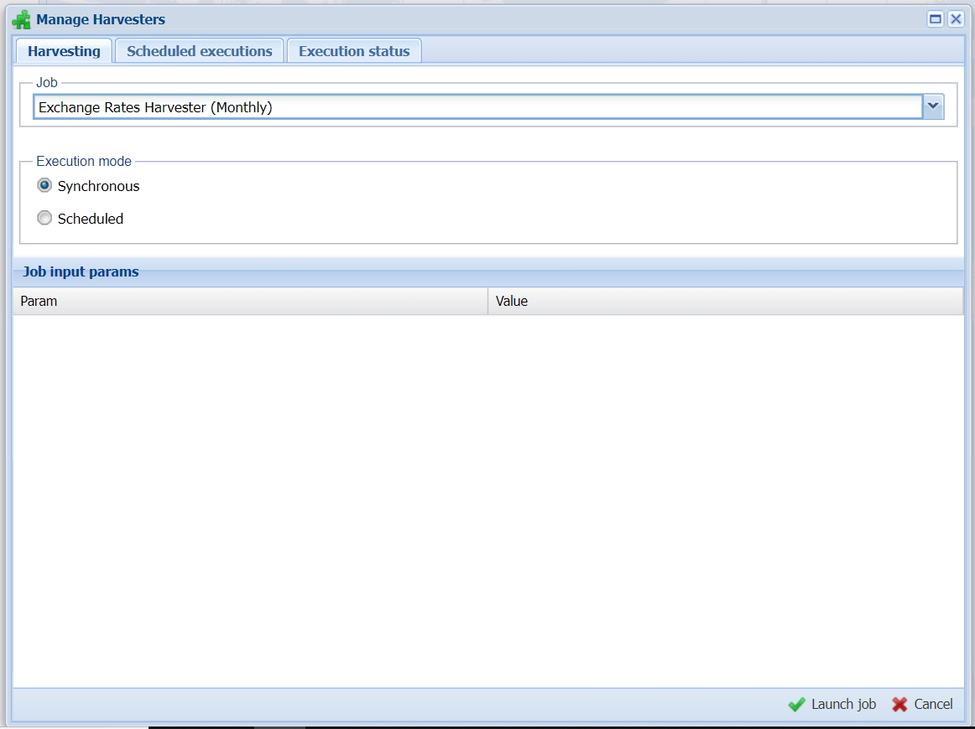

The ECO team is responsible for the

* Update of both the datasets and the datatable
* Information to the stakeholder about the regular updates