Manual for Video Tutorial in Ucounting

1. **which have completed by us**:

* Checking and trying to solve some problem:
* Firstly, we have checked all help modules in all sections of ucounting and then tried to give the right link for every anchor/link.
* We have given help button in some sub module such as:

1.POS(sales)  
        2.Chart of Accounts(setup)  
    3. Sales Tax Authorities(tools)  
    4. Sales Tax Rates(tools)

* But we didn’t find any related link for the following modules:

  1. Recurring Invoice(sales)  
    2.Debit Memos(sales,purchase)  
    3.Projects(sales)  
    4.CRM(sales)  
    5.Debit memos(purchase).  
    6.Transaction Sequence(setup)  
    7.Purchase Tax Authorities(tools)  
    8.Purchase Tax Rates(tools)  
    9.SKU Pricer(tools)

* And the help button of the following sections aren't showing correct page:

   1.RMA and projects are not right link(sales)  
    2.Customer Price Sheets   
    3.purchase price sheets  
    4.Transfer Inventory(inventory)  
    5. Customer Refunds(banking)  
    6.Vendor Refunds(banking)  
    7. Customer Deposits(banking)  
    8.Vendor Deposits(banking)  
    9. Bank Transfer(banking)  
    10.Budgeting(General Ledger)  
    11.Select Print Template(setup)  
    12. Asset Management(setup)

* Dynamically change in any page of ucounting help from backend:
* We tried to make an easier way so that admin can easily change the content of help page of application from backend of ucounting.
* If Admin wants to change any feature of any page then he should to follow the following procedure :
  + - Admin will get a hidden link in help window beside search button when admin click on the ‘Get Url’ button.

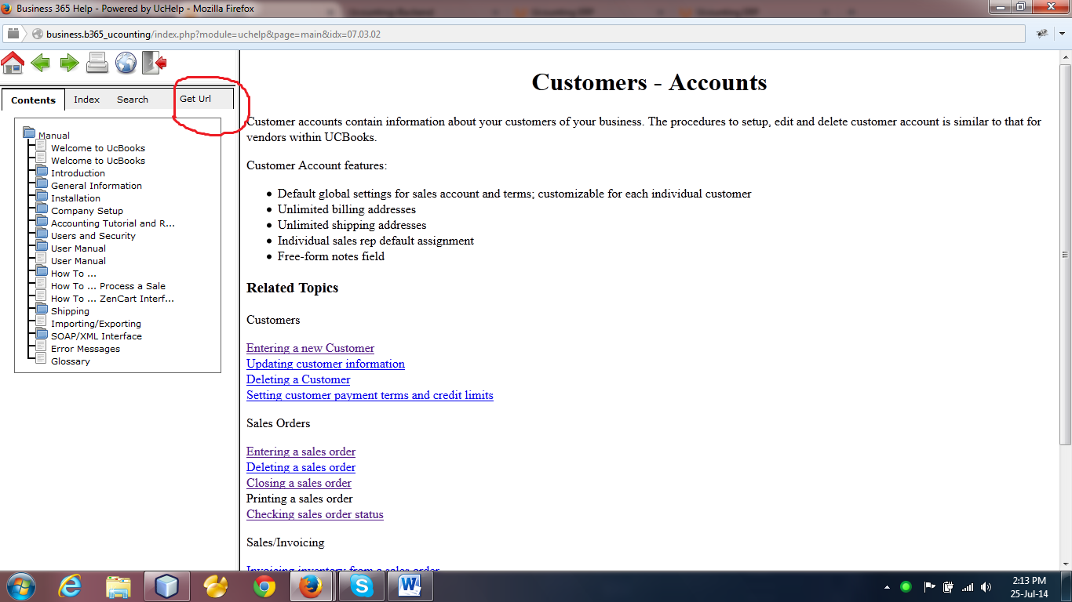

* + - If he click this button then the actual url will be copy in to clipboard and admin will see this in an alert.

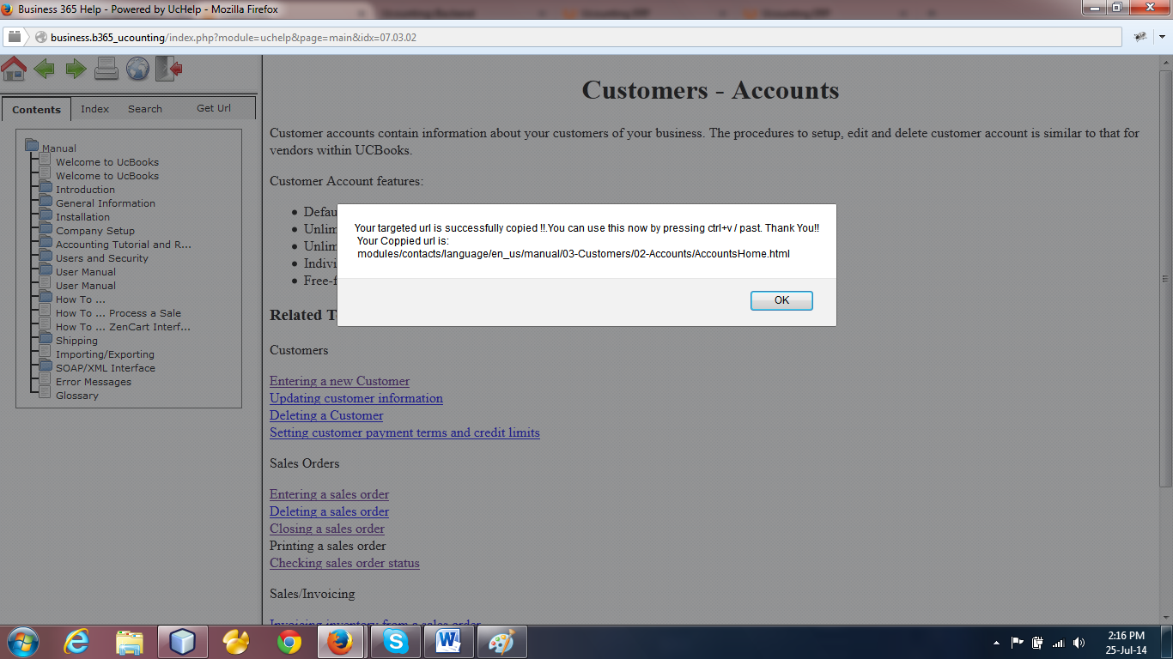

* + - Then admin will go to ucounting backend/help module and paste this url in a search input box.

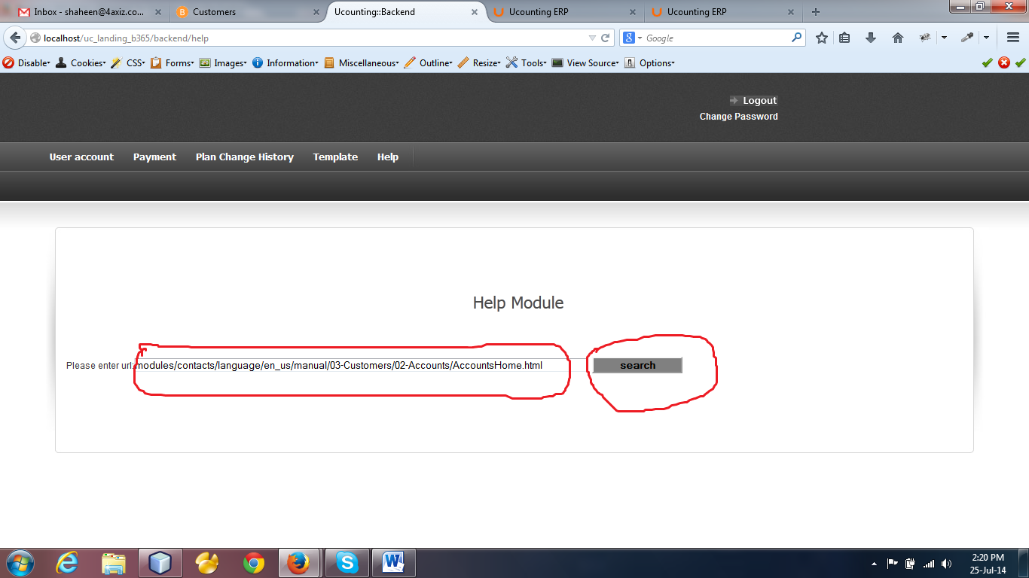

* + - Then admin press the search button and he will get the actual page of help module in an editor.

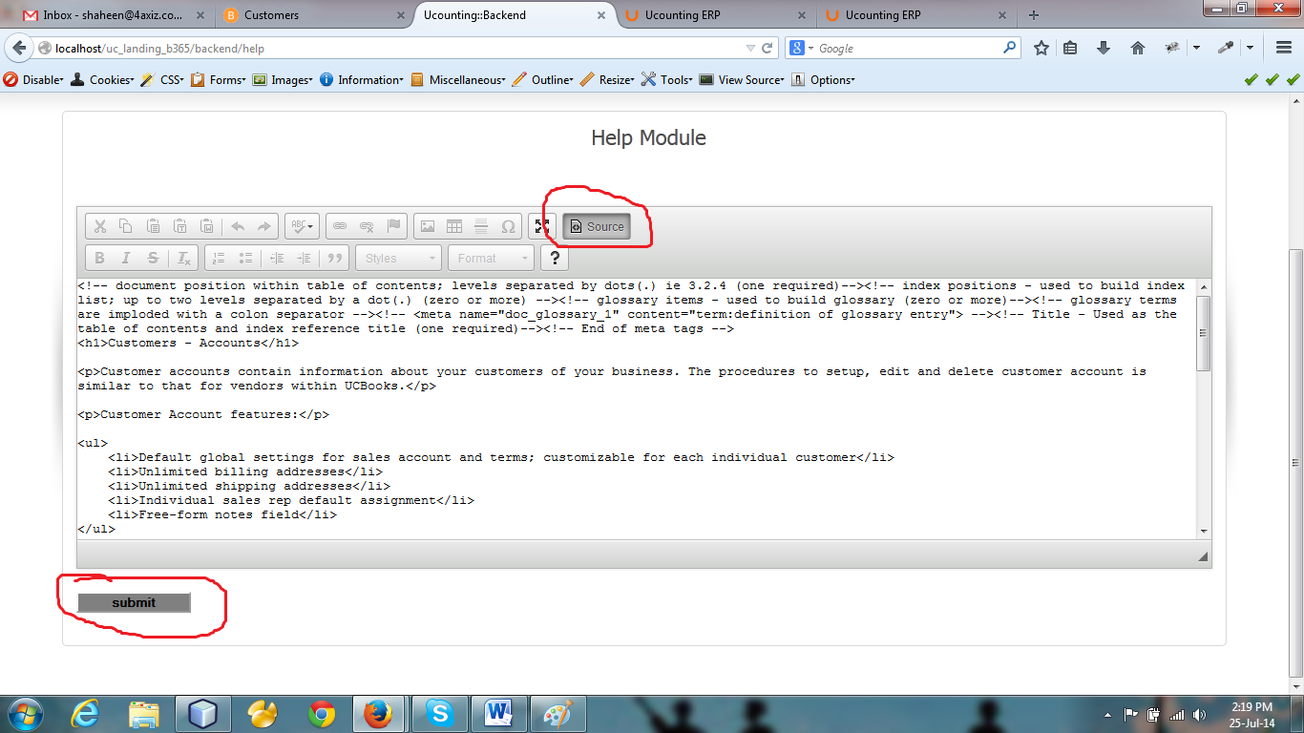

* + - Then he will change/modify of this page content in source code option.
    - After his modification he will press the submit button and this page will be save.
    - Then admin can see this in application page.

1. **Our Limitation:**

* We can’t get the main html inner pages links.

1. **Have to do by us:**

* We can give the actual url of every page in top of the page.
* Then admin can get the actual url from there and he will use this.

------------------------------------ **End** ---------------------------------------