**Practical Exam**

**For**

**PHP Developer**

Revision History

|  |  |  |  |
| --- | --- | --- | --- |
| **Name** | **Date** | **Reason For Changes** | **Version** |
| MAH | 2014-07-03 | Document Creation | 1.1 |

Table of Contents

1. Introduction: 3

2. Overall Description: 3

3. General Information: 3

4. System Features: 4

4.1. Patient List: 4

4.2. Patient Details: 5

5. Technologies that we Prefers: 6

6. Deliverable: 6

# Introduction:

You need to develop a small PHP app related to patient management. The main features of the apps are following :

1. List of patients
2. Details of Patient
3. Edit and Delete functionality.

# Overall Description:

1. Patient general information (Name, Age and Sex) will be shown in a grid/list.
2. There is “Edit”, “Delete” button in each row of the grid/list.
3. Clicking on the “Edit” button will show patient updated details information.
4. User can edit information from details screen.
5. Clicking “Delete” button will delete particular patient record.

# General Information:

1. Application Name: *Patient Info Pad*
2. Development Framework: No Frameworks should be used
3. MVC pattern must be taken into consideration.
4. All UI must be developed using css and jquery UI
5. All validation must be placed on client side according to the requirement of UI.
6. Make the use of JSON while interacting with mysql database.
7. Use of images while making buttons or UI is strictly prohibited.

# System Features:

## Patient List:

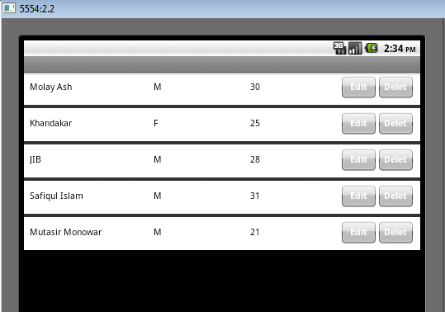

Fig-1: Patient List

Patients general information will be shown in this screen.

* The list contains following information:
* Name Column: Contains Patient Name (Given Name + Middle Name + Family Name)
* Sex: Male=”M” , Female= “F”
* Age: Patient Age
* Edit : Clicking edit button will redirect to “Patient Details” Screen.
* Delete: Clicking Delete button will delete particular patient information.

Please note:

1. This screen contains sample data and all the data are hardcoded. For storing patient information you can use ArrayList, SharedPreference or any collection type.

## Patient Details:

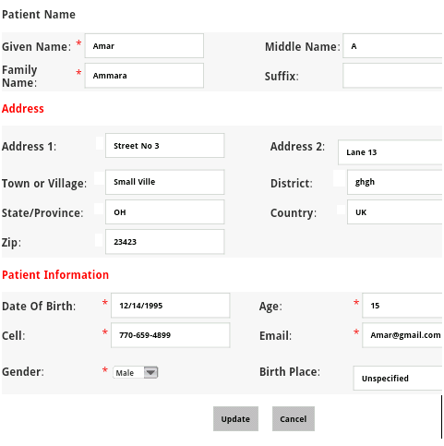

Fig-2: Patient Details

Patient details will be shown in in this screen.

* Given Name: Free entry
* Middle Name: Free Entry
* Family Name: Free Entry
* Suffix: Free Entry
* Address: Free Entry
* Date of Birth: date field. *Format: MM/DD/YYYY*
* Cell: Format: *xxx-xx-xxxx*
* Gender: Drop Down
* Age: Numeric field
* E-mail: *e-mail field validation*
* Birth Place: Free Entry.
* Update: Clicking update button will update particular patient information.
* Cancel: Back to “Patient List” screen

Please note:

1. This screen contains sample data. But the data format are valid.
2. Validation checking: Only applicable as “Required Field Validator”. By default, NO validation sign will be shown. Validation sign will only be shown after clicking “Update” button.
3. If user update any patient information, next time when he/she enter this page, it will show updated information.

# Coding Requirements:

1. PHP with no frameworks
2. Use efficient coding (possibly Hungarian or Pascal notation) and appropriate comments / documentation.
3. Fig-1 and Fig-2 contains sample screen layout or background color. Please try to develop profession screen layout.
4. No need to show any custom message. No splash screen.

# Deliverable:

1. Source Code in .ZIP format. Name of the ZIP file will be “<Your name>_SourceCode”
2. Third party control:
3. If it’s free then please send us the download ink
4. If it’s original version then you need to provide the download link as well as License/Serial number (and why you are using it ?).

Good Luck!!!