Hello Nasir,

Thank you for your update. I thoroughly tested each section for the website and find the following anomalies. Please review and distribute the workload on your staff to fix them accordingly. Please send me you comment in front of each point saying it is done or not. If not done then why it is not done.

Product section:

1. Display Toyota hiace issue is still there. Please fix it.
2. Edit cart timer is starting once the user’s email is blocked while cart preview or verification code popup. Please fix it and make it start only once user click ok on verification code/ cart preview-blocking popup. You did this correctly before and it should not be damaged again.
3. The message displayed once user fail to edit the cart on time is wrong. Please fix it. it should say : Unfortunately, you did not finish editing the cart during the given lead-time…. The rest of the normal messages.
4. While shopping if user visits the home page then it shows zero items in cart. Once he goes back to cart then it shows the number of items in the cart. Please make it display the number of the cart in all the pages as initially programmed. (done)

Contact us section:

1. After blocking his email address in contact us verification code user clicks Ok and the system redirect him to contact us to edit it with a lead time. Once user click submit without changing his email then system display a popup saying that his email is blocked. Once user click ok then system redirect him to contact us form but the timer is frozen. Please make the timer continue the countdown. (done)
2. Backend Block reasons in contact us form is wrong. Please fix it to display the correct blockage reason. (It always shows 3) (done)

Career section:

1. Once user uploads, his resume and click submit system is not displaying the confirmation popup message. Please fix it. (done)
2. The message related to the case when user fail to enter his verification code during the lead-time is wrong. Please fix it. (done)

Promotion section:

1. There is no footer in promotion section (except award). Please fix it. (done)

##### Delete buttons are not working on edit promotion section/ Knowledge Sub Title/ edit : <http://kondar.ca/kondarmia/admin/index/edit_knowledge_subtitle/54> it is redirecting to <http://kondar.ca/kondarmia/admin/index/edit_job_section/32> -- > please fix it.

1. Photo keep deleting every few minutes. Please investigate the matter and fix it accordingly.

Distribution application:

1. Once user is blocked then the blocking popup is not displaying correctly. -- > please fix it.
2. Verification code memorizes the latest event after the user’s email blocked and if we release the email address and user click submit without changing his email the the verification code popup a blinking message --- > Please fix it.
3. Once user successfully submit the distribution form and click Ok on the acknowledgement popup the system is redirecting him to an empty distribution form. Once user click cancel then no effect is taking place. Please fix it.
4. Timer is restarting every time we resend the verification code. Please fix it.
5. I blocked my email and after that I click submit again without changing the clocked email address. I get the following meaningless popup. Please fix it.

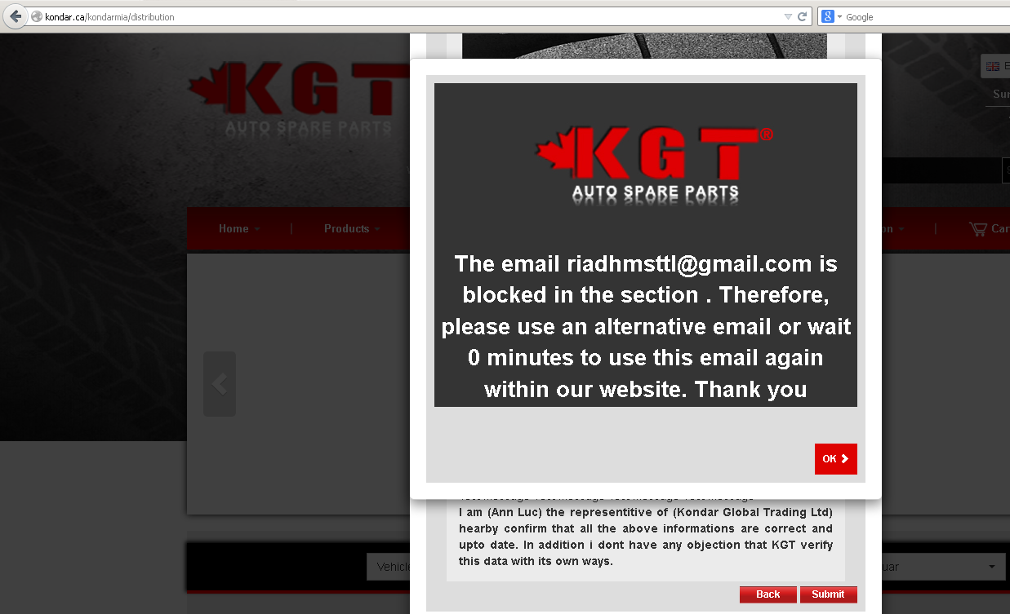

1. I cancelled the distribution application process but the blockage is registered in Distribution Block user list only. It should simultaneously be registered in Blocks list as well as agreed before. In addition, even though the system shows that my email is blocked in distribution section but I am able to use it in other section as if it is not blocked at all --- > please fix it.

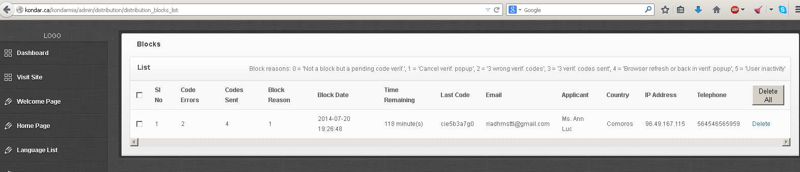

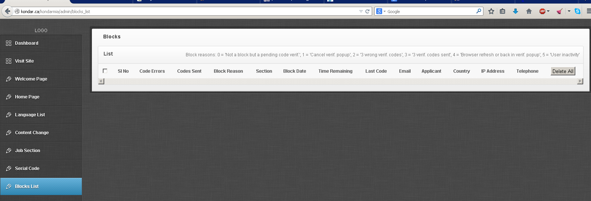

Home page:

1. E-library products are turning very fast. Please make their speed smoother.
2. Get instant quote in footer and client section as well as claim award are not linked as agreed. Please fix it.
3. Products drop down menu vehicle photos are not displaying correctly in home page. They are displaying correctly in product section itself. Please make sure that they are displaying correctly in all the pages.
4. The language drop down menu in the home page is not reading its data from the backend (<http://kondar.ca/kondarmia/admin/index/language> ). It should be similar to the landing page logic. Please fix it.
5. I tried to delete the landing page background photo but it is not deleting it and the landing page keep having the background image even though the backend shows that image as deleted. --- > please fix it.
6. [http://kondar.ca/kondarmia/#](http://kondar.ca/kondarmia/) --- > please explain the sign (#). I don’t understand why it shows in our URL from time to time.

Please call me on Skype if you have any clarification.

Regards

Steve