



**AACS Requirements**

**Team 3**

Document Information

|  |  |
| --- | --- |
| **Issuing authority** | Team 3 |

Revision History

|  |  |  |  |  |
| --- | --- | --- | --- | --- |
| **Version** | **Date** | **Comment** | **Author** | **Approver** |
| 0.1 | 2021-06-11 | Initial Version | Team 3 |  |
|  |  |  |  |  |
|  |  |  |  |  |
|  |  |  |  |  |
|  |  |  |  |  |
|  |  |  |  |  |
|  |  |  |  |  |
|  |  |  |  |  |
|  |  |  |  |  |
|  |  |  |  |  |

**Overview** **4**

**Objectives** **4**

**Scope** **4**

**Related Documents** **4**

**Terms & Acronyms** **5**

**Introduction** **5**

**System Purpose** **6**

**System Objective** **6**

**Target Information** **6**

**System Scope** **6**

**General System Description** **7**

**System Overview** **7**

**Operational Scenarios** **7**

**Functionality Requirements** **8**

**Functional Requirements** **9**

**Quality Attribute** **12**

**Quality Attribute** **12**

# Overview

## Objectives

The requirements specification of AACS developed in this project has the following purposes.

* Requirements are developed based on the analysis results of customer requirements.
* System development scope identification and system context definition
* Creating functional/non-functional requirements of the system

## Scope

In this document, the details of the analysis of the requirements necessary for the development of the AI ​Attendance Check System are detailed.

## Related Documents

Documents related to this document are as follows.

**Table 1 Related Documents**

|  |  |  |  |
| --- | --- | --- | --- |
|  | **Filename** | **Version** | **Remark** |
| 1 | AACS_ThreatAnalysis_RiskAssessment_Result.xlsx | 1.0 |  |
| 2 | AACS_Architecture_Specificaiton.docx | 1.0 |  |
| 3 |  |  |  |

## Terms & Acronyms

**Table 2 Terms & Acronyms**

|  |  |  |  |
| --- | --- | --- | --- |
|  | **Terms & Acronyms** | **Description** | **Remark** |
| 1 | AACS | AI Attendance Check System |  |
| 2 | FRS | Face Recognition System |  |
| 3 | ACS | Attendance Check System |  |

# Introduction

This system was developed at the request of the tartan company that received the order from CMU.

CMU believes that checking student attendance is a waste of time and wants automatic attendance

checks.

## System Purpose

### System Objective

**Table 3 System Objective**

|  |  |
| --- | --- |
| **System name** | **AACS(AI Attendance Check System)** |
| **Purpose of the system** | When installed in the classroom, this system can automatically check the attendance, late, and absence of students. |

### Target Information

**Table 4 Target Information**

|  |  |
| --- | --- |
| **Customer** | **Tartan Company** |
| **End Customer** | **CMU** |

## System Scope

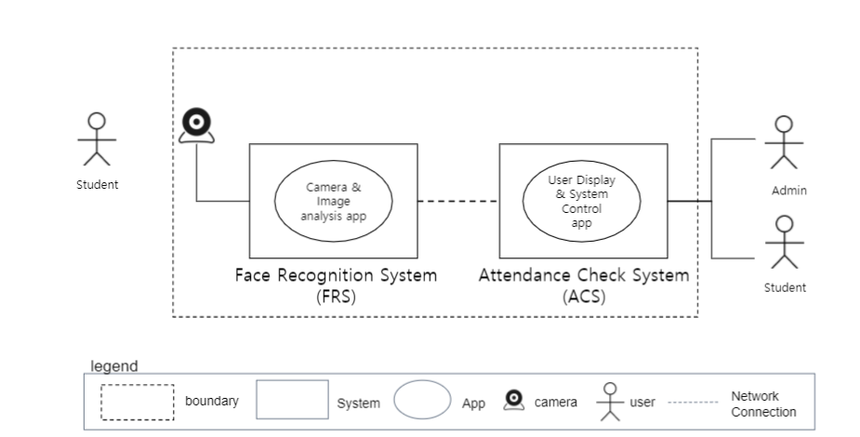

**Figure 1 System Scope**

# General System Description

## System Overview

* The system registers the students' faces through the camera.
* Check the attendance status of registered students according to the set class time. Attendance status is indicated as attendance, tardy, or absence.
* Administrators can check the attendance status of students.
* When a student requests an administrator to check past attendance, it can be viewed as a saved video.
* 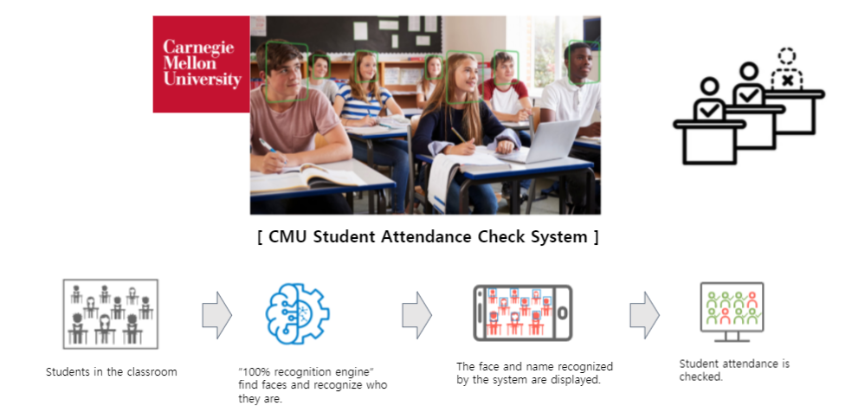

**Figure 2 System Overview**

# Functionality Requirements

**Describes system requirements that satisfy customer requirements.**

**Functional requirements were derived by analyzing customer requirements.**

**In addition, some requirements were derived through threat analysis.**

* ID: Requirement_ID with AACS-REQ-xxx
* category : Categorize and organize requirements. If it is divided into categories, it is thought that it will be helpful to check them by category during future development.
* Contents : Detailed description of requirements
* Priority: Define and describe development priorities. Since our development period is set to 3 weeks, it is necessary to prioritize and apply it across the entire requirements.
* implementation : It is an indication of an implementation application item. Among the total requirements, the requirements reflected in the implementation are indicated.

## Functional Requirements

|  |  |  |  |  |  |  |
| --- | --- | --- | --- | --- | --- | --- |
| ID | category - 1 | category - 2 | contents | priority | type | implementation |
| AACS-REQ-001 | login | create user | This system should be able to create users through membership registration. | Low | common | X |
| AACS-REQ-002 | user password | The system applies a hash function to the user password. SHA256 | High | common | O |
| AACS-REQ-003 | user password | To set a strong password we should provide the notice (message) to select Password with combination of chars, numbers and special chars etc | High | common | O |
| AACS-REQ-004 | captcha authentication | This system makes a captcha appear when the password is wrong 3 times or more. | Low | common | X |
| AACS-REQ-005 | user authentication | This system requires 2-factor authentication for user authentication. | High | common | O |
| AACS-REQ-006 | set permissions | This system should be able to set student/administrator privileges when creating users. | High | common | O |
| AACS-REQ-007 | set mode | This system should be able to set secure mode and real-time mode when logging in. | High | common | O |
| AACS-REQ-008 | login | This system must be able to connect the ACS and FRS systems during the login function. | High | common | O |
| AACS-REQ-009 | pre-defined user | This system creates users with the privileges of students and administrators in advance. | Mid | common | O |
| AACS-REQ-010 | register of student (Learn mode) | add photo | The system should be able to add photos of students. | High | common | O |
| AACS-REQ-011 | delete photo | The system should be able to delete student photos. | High | derived | O |
| AACS-REQ-012 | end register | The system must be able to finish the student registration function. | High | derived | O |
| AACS-REQ-013 | tune photo | This system should provide the ability to adjust the brightness and illuminance of the photo. | Low | common | X |
| AACS-REQ-014 | select class | This system should allow students to set up their own classes. | Low | derived | X |
| AACS-REQ-015 | attendance check  (Run mode, Test run mode) | live attendance | The system should be able to check student attendance in real time. | High | common | O |
| AACS-REQ-016 | past attendance | This system should be able to check the attendance of students through past saved images. | High | common | O |
| AACS-REQ-017 | student list | The system should be able to see a list of students assigned to a class. | High | derived | O |
| AACS-REQ-018 | save student attendance time | The system should be able to store the attendance time of students. | High | derived | O |
| AACS-REQ-019 | check student status | The system should be able to know the attendance, late, and absence status of students. | High | derived | O |
| AACS-REQ-020 | Attendance time setting | The system should be able to set attendance times for students. | High | derived | O |
| AACS-REQ-021 | add class | This system should be able to add a class for attendance check. | Low | derived | X |
| AACS-REQ-022 | Add class manager | This system should be able to set the person responsible for the class. | Low | derived | X |
| AACS-REQ-023 | security | log | The system must support logging for non-repudiation. | High | common | O |
| AACS-REQ-024 | defense | The system should be prepared for keyboard and mouse hooking. | High | common | O |
| AACS-REQ-025 | storing personal information | In this system, the user's personal information and data related to facial recognition must be encrypted and stored. | High | common | O |
| AACS-REQ-026 | secure mdoe | This system requires encryption of data transmission. | High | common | O |
| AACS-REQ-027 | secure code | Secure coding & static analysis -> Fix RATS results | High | common | O |
| AACS-REQ-028 | snooping | The system should not allow intermediaries to snoop or spy on the ongoing video feed. | High | common | O |
|  | **The security requirements are derived through threat analysis as follows.** | | | | |
| AACS-REQ-029 | limited photos | Each student must be able to save up to 5 photos. | High | derived | O |
| AACS-REQ-030 | check capacity | When saving student photos, this system should be able to check the remaining capacity. | High | derived | TBD |
| AACS-REQ-031 | check capacity | When saving a video about attendance, this system should be able to check the remaining capacity. | Midium | derived | TBD |
| AACS-REQ-032 | separate partition | This system should be able to save the video of the attendance in a separate partition. | Midium | common | TBD |
| AACS-REQ-033 | operation | This system should be able to operate the attendance function even if it is not possible to save the video of the attendance. | High | common | TBD |
| AACS-REQ-034 | encryption | Videos of attendance in this system must be encrypted. | High | common | O |
| AACS-REQ-035 | hash | User accounts accessing this system must be hashed. | High | common | O |
| AACS-REQ-036 | hash | Config setting file that manages device information stored in the system should be hashed | High | derived | O |
| AACS-REQ-037 | encryption | Face DB in the system must be encrypted. | High | common | O |
| AACS-REQ-038 | input validation | When logging into the system, the input data should be verified. | High | common | O |
| AACS-REQ-039 | sign | Face DB data stored in the system must be signed by admin. | High | common | O |
| AACS-REQ-040 | encryption | Video DB data stored in the system must be encrypted. | High | common | O |
| AACS-REQ-041 | sign | Video DB data stored in the system must be signed by admin. | High | common | O |
| AACS-REQ-042 | encryption | User DB data stored in the system must be encrypted. | High | common | O |
| AACS-REQ-043 | sign | User DB data stored in the system must be signed by admin. | High | common | O |
| AACS-REQ-044 | heart beat | The system's Comm Manager (ACS) must apply a heart beat. | High | common | TBD |
| AACS-REQ-045 | input validation | Input verification for the Config setting in the system should be done. | High | common | O |
| AACS-REQ-046 | hash | AI Engine data shall be hashed. | High | common | O |
| AACS-REQ-047 | input validation | Input verification for engine data in the system should be done. | High | common | O |
| AACS-REQ-048 | data loading | It is necessary to check the loading completion of the engine data of the system. | High | derived | TBD |
| AACS-REQ-049 | input validation | The Comm Manager (FRS) in the system should verify the input. | High | common | O |
| AACS-REQ-050 | IP filtering | The FRS system must receive only a set IP through IP filtering. | High | common | O |
| AACS-REQ-051 | TLS | TLS version 1.2 and above is needed must be applied for communication between FRS and ACS in the system. | High | common | O |

**legend**

type : common-initial requirements, derived-AACS requirements

implementation : X-won't do, O-will do

# Quality Attribute

**Quality attribute refers to the characteristic attributes of a product. Satisfying quality attributes can satisfy customers' requirements for quality.**

**Quality attributes were derived through customer requirements.**

**In addition, some Quality attributes were derived through threat analysis.**

1. ID: Quality Attribute ID with AACS-QA-xxx
2. Properties : Types of quality attributes
3. Contents : Detailed description of quality attribute

## Quality Attribute

|  |  |  |  |
| --- | --- | --- | --- |
| ID | Properties | Contents | |
| AACS-QA-001 | Performance | The system must deliver video as close to real time as possible,  especially in real-time mode. | |
| AACS-QA-002 | Authentication | The system must use two factor authentication for sign on and  user credentials must be protected. Lost or compromised credentials must be handled in a reasonable way. | |
| AACS-QA-003 | Communication privacy | When in the desired mode the system must ensure that  data sent to a user remains private while in transit. No intermediary should be able to snoop or spy on an ongoing video feed. | |
| AACS-QA-004 | Proof of identity (nonrepudiation) | Users should be confident that the camera  they are using is the one that they believe it is. | |
| AACS-QA-005 | Multi-user privacy: | The system must ensure that multiple video feeds remain  private between the intended users. | |
| AACS-QA-006 | reliability | The system must ensure that video is reliably delivered. The system  should recover from networking errors as soon as possible. The goal is to  maintain a secure, performant connection at all costs. | |
| AACS-QA-007 | Testing | Ensure the developed software is adequately tested. | |
| AACS-QA-008 | Availability | Conduct proper fault/error detection, recovery and reporting. | |
| AACS-QA-009 | Security | Ensure the developed software adheres to the company coding standard and quality standards. | |
| AACS-QA-010 | Security | Key management for system must be secure. | |