Software Requirements Specification

For project:

Booking event

Prepare by:

Nguyễn Anh Huy

Nguyễn Minh Hùng

Nguyễn Trần Việt Quốc

Lý Gia Kiệt

Trần Gia Kiệt

June 4, 2024

# Table of contents

1. **Introduction**

**1.1 Back-ground**

**1.2 Business opportunity**

**1.3 Business Objectives**

**1.4 Vision Statement**

1. **Overall Description**

**2.1 Context diagram**

**2.2 User Classer and Characteristic**

1. **System Feature**

**3.1 Use case**

1. **Data requirements**

**4.1 Logical Data Model**

1. **Swimlane**
2. **Screen Flow**

**6.1 Visitor screen**

**6.2 Event operator screen**

**6.3 Checking staff screen**

**6.4 Admin screen**

# Introduction

## 1.1 Background

FPT students always want to attend events organized by clubs or schools. But they have no place to gather all the events for quick tracking. They have to fill out cumbersome registration forms, transfer money, etc. That is the reason why our group's Event Booking website was born. This place will help you keep track of events that the school will organize in the near future. Where you can register to participate quickly and neatly.

## 1.2 Business opportunity

Developing an event booking app offers a lucrative business opportunity. As we increasingly seek affordable solutions for event planning, the need for reliable booking platforms continues to grow. By providing a centralized application to search, compare, and book events, customers can take advantage of the hobby of event planning on the go. With features like real-time availability and location, an innovative event booking app can deliver a seamless experience, boost customer satisfaction, and drive repeat business.

## 1.3 Business Objectives

Our primary objective is to create a user-friendly and reliable event booking platform that meets the needs of students at FPT University. Specifically, we aim to:

Provide a convenient and efficient way for students to track and register for events

Offer a comprehensive event calendar that allows students to easily find and book events that interest them

Develop a payment system that is secure, efficient, and easy to use

Build a loyal customer base by providing exceptional customer service and ensuring that our platform is always up-to-date and reliable.

## 1.4 Vision Statement

Our vision is to become the leading event booking platform for FPT students, providing a seamless and enjoyable experience for users to discover, register, and participate in events. We aim to revolutionize the way students interact with events by providing a user-friendly and efficient platform that meets their needs and expectations.

# Overall Description

## 2.1 Context diagram

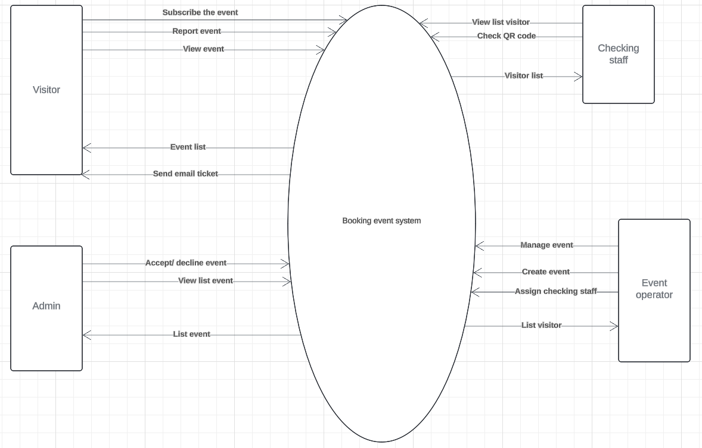

## 2.2 User Classes and Characteristics

* **Visitor:**

A person who wishes to register to participate in events being organized. Attendees will receive tickets after successful registration and payment. In addition to web services, it also supports monitoring uptime and notifying event registrants.

* **Event operator:**

It is the person who creates events and manages them. Here you can see your reporting statistics and event management settings.

* **Checking staff:**

After being assigned by the event operator, they are responsible for supporting that event. You can also scan QR codes to check in visitors.

* **Admin:**

Is the manager of all events that event operators create. Can manage all accounts. Provide an account for the event operator.

# 3. System feature

## 3.1 Use case diagram

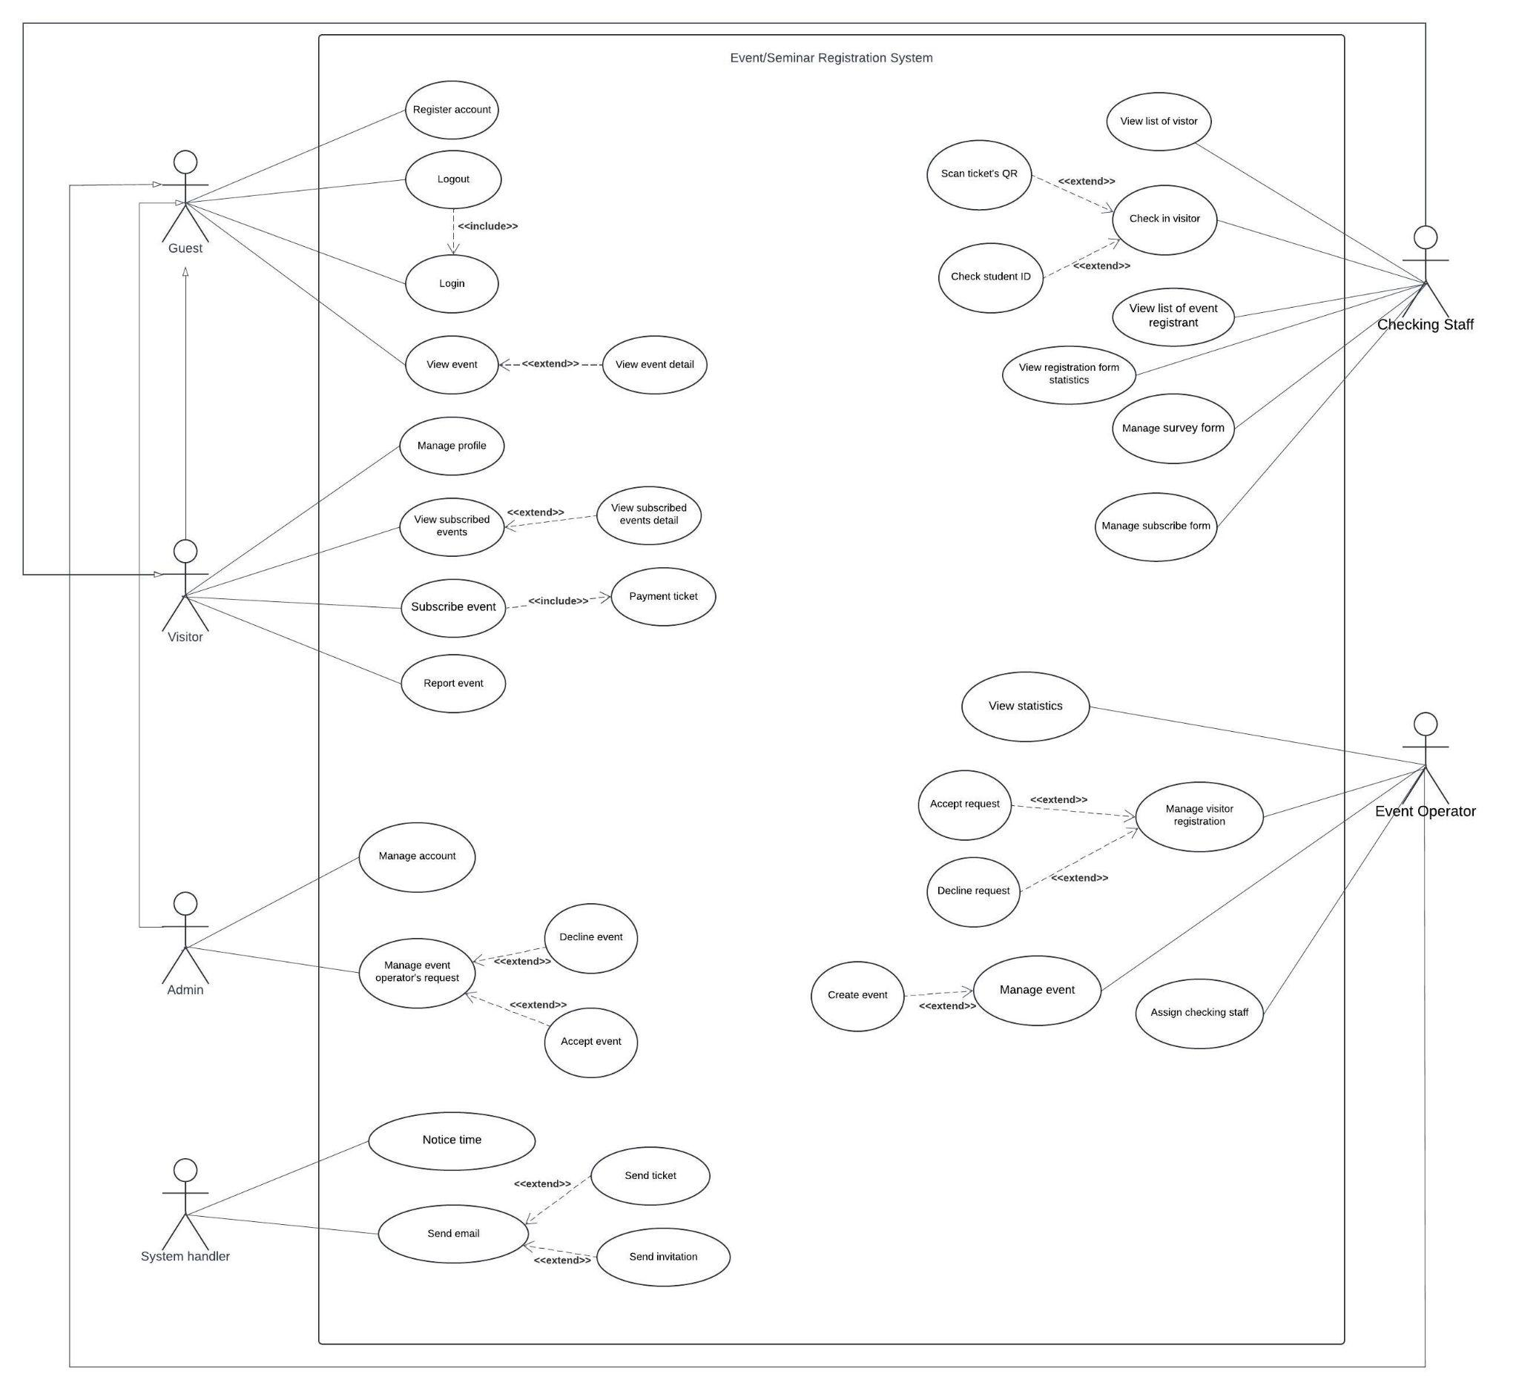

# 4. Data Requirements

## 4.1 Logical Data Model

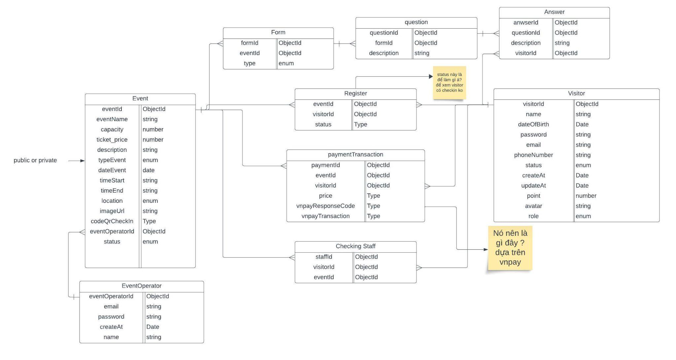

# 5. Swimlane

# 6. Screen flow

## 6.1 Visitor screen

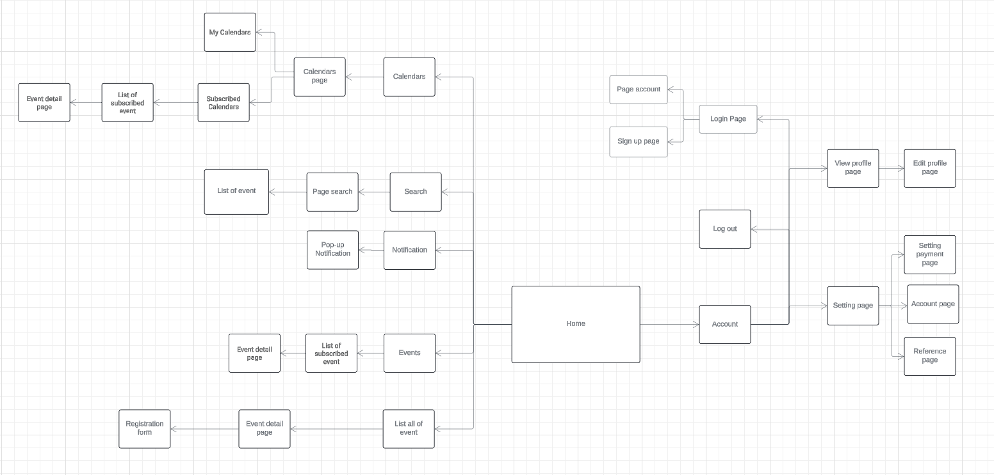

## 6.2 Event operator screen

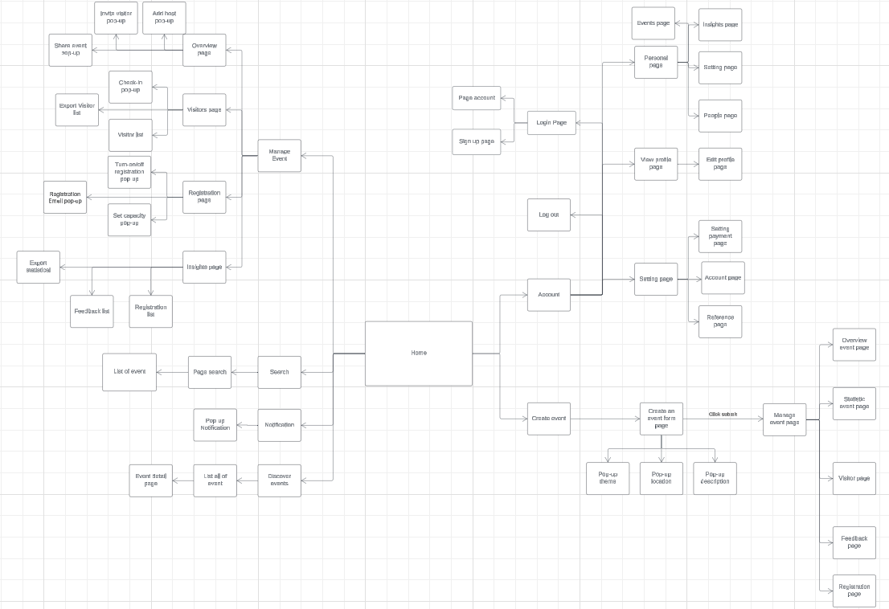

## 6.3 Checking staff

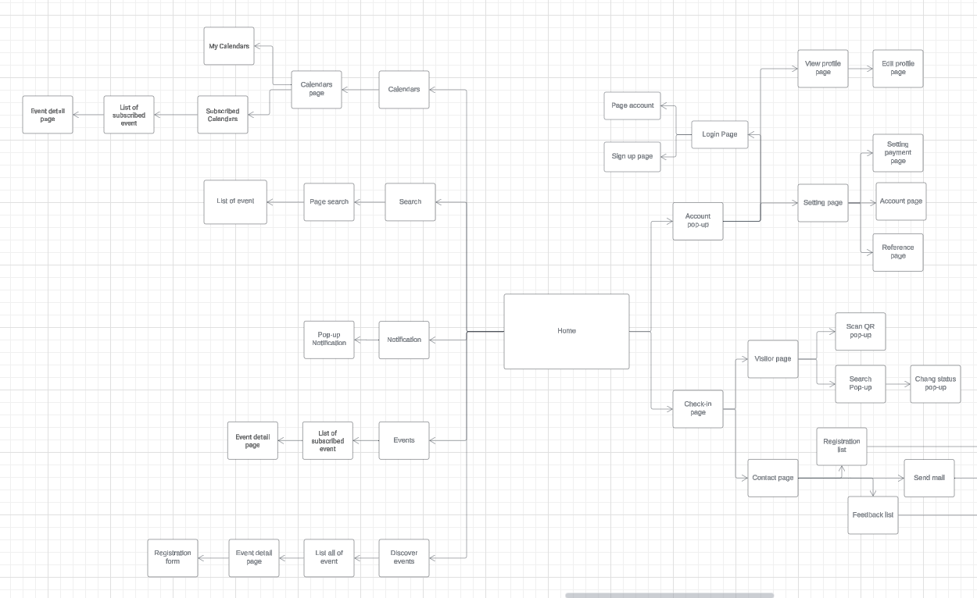

## 6.4 Admin screen