# Sign in: (Hùng + Quốc)

# **1. Login**

**Email Field**

# **T1:** Email - The email must not be blank.

# **T2:** Email - The email must be in a valid format (e.g., user@example.com).

**Password Field**

T4: Password - The password cannot be blank.

T5: Password - The password must be correct.

**Optional**:

Continues with email

email- check có dưới data có account chứa email ko

password - nếu email đúng thì password đúng ko

Sign in with FPT EDU

T6: FPT Email - An email address must end with @fpt.edu.vn

**T7:** FPT Email -The FPT Email address must be valid

# Register event: (Kiệt)

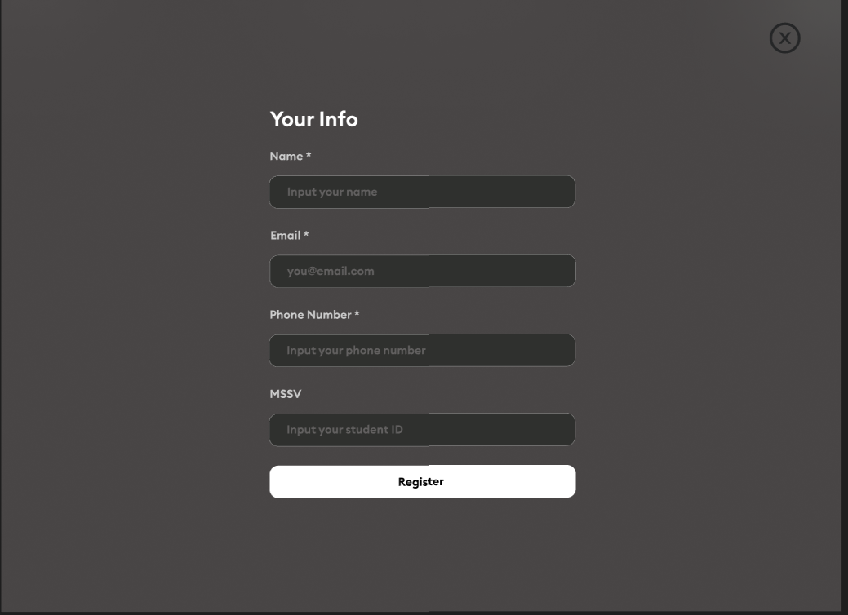

**Name Field**

RE1: Name - Special characters are not allowed.

RE2: Name - Numbers are not allowed.

RE3: Name - The name must not be blank.

RE4: Name - The first character cannot be a space.

**Email Field**

RE5: Email - The email must be in a valid format (e.g., user@example.com).

RE6: Email - The email must not be blank.

**Phone Number Field**

RE7: Phone Number - The phone number must be numeric.

RE8: Phone Number - The phone number must not be blank.

RE9: Phone Number - The phone number must be a maximum of 10 numbers

**Student ID Field**

RE10: MSSV - Special characters are not allowed in the student ID.

RE11: MSSV - The student ID must be in a valid format (e.g., SE123456).

RE12: MSSV - The student ID must not be blank.

RE13: MSSV - The first character of the student ID cannot be a space.

# Create event: (Hùng + Quốc)

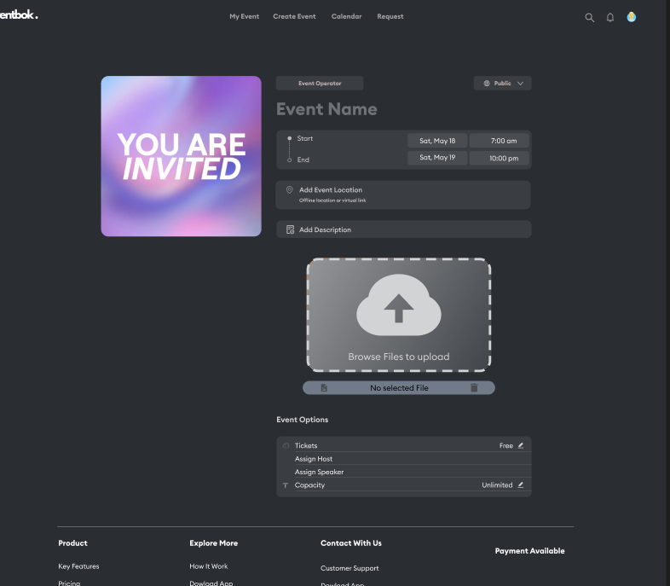

**Event Name**

T1: Name - The event name must not be blank.

T2: Name - The event name cannot contain special characters.

T3: Name - The event name must not exist.

**Time**

T4: Time - Time start should be before time end.

T5: Time - Starting time must be in the future.

capacity 10-100

T6 Capacity- capacity more than 10 people

T7 Capacity- Capacity less than 100 people

description 200-300

T8 description- description needs 200-300 characters