CONTAINERS, DOCKER, OCHESTRATION NOTES

What is software packaging and why is it important?
Software packaging is the process of building an installer that includes all your applications' resources and can be used to distribute them on the end-user devices.
A software package is a collection of system resources that are packed together. These packages enable the end-user to perform some types of tasks when the software package gets installed on their device.
A software package could come in multiple formats – EXE and MSI being the most common ones used by Independent Software Vendors (ISVs) all over the world.
Despite it being one of the most relevant packaging formats, enterprises are reluctant to bring the EXE files within their environment, reason being:
- EXEs are difficult to customize.
- They have no support for silent install/uninstall switches.
- There are remnants left behind after uninstalling.
Most used software packaging formats are
MSI- provides a standard foundation for installing and uninstalling software. It also supports silent install/uninstall switches, and is easy to customize.
App-V- enables each application to run its own virtual container on the client computer. This means that whilst the applications are still able to interact with the client computer, they are isolated from each other – which results in no conflicts between applications! Also, it allows for smooth uninstalls and upgrades of the software package.
MSIX- Same as App-V, MSIX relies on container technology. However, MSIX software packages use a modern app container in order to get access to the Universal Windows Platform (UWP) API and provide end-users with modern and engaging Windows 10 experiences such as live tiles, notifications etc.
Software packaging brings multiple benefits for enterprises, the most important ones being:
- Ensuring a stable, standard environment
- Reducing support costs
- Packaging once and then distribute everywhere

Software packaging as shown below is just a single step of a much more complex process, consisting of the stages shown.
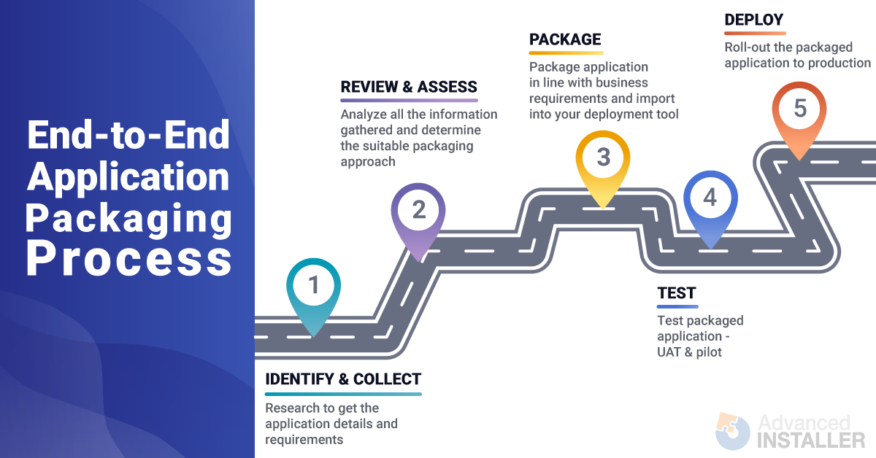

What packaging software should I use?
Depending on your organization's needs and requirements, there are various tools on the market. Some of them are free but they usually have limited functionalities – like Orca which is used only for editing MSI packages. Another limitation is that they sometimes don't have a GUI or have a very basic one like the MSIX Packaging Tool, and others only support certain packaging formats, which is the case of WiX Toolset.
However, paid software like Advanced Installer could help you cut costs by simplifying the way you package/repackage your software products through its easy-to-use GUI which includes powerful and time-saving features.
Compiling Vs Interpreting in programming

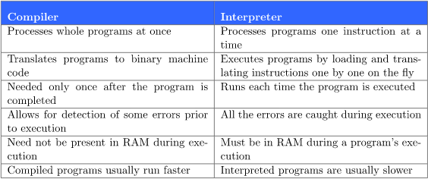
We usually think of programming languages as either compiled or interpreted. Still we can make interpreters for C just as we can create compilers for Python. Furthermore, some languages mix both concepts e.g we first compile Java programs to bytecode, the code of Java Virtual Machine; we interpret the bytecode afterward.
Examples of pure compiled languages are C, C++, Erlang, Haskell, Rust, and Go.
Examples of common interpreted languages are PHP, Ruby, Python, and JavaScript.

Some definitions
JDK (Java Development Kit) - is the full set of software kit and tools that enable us develop java applications.
JVM - Known as the Java Virtual Machine, compiles the java source code into bytecode.
JRE - It’s the Java Runtime Environment. It interprets the bytecode in any machine, since Java offers portability. It is the implementation of JVM and it is specially designed to provide an environment to execute Java programs. I consists of JVM, Java binaries, and other classes for the smooth execution of the program.
=> Bytecode is program code that has been compiled from source code into low-level code designed for a software interpreter. It is the intermediate code compiled and executed by a VM (as opposed to running on a CPU). In other words it is an intermediate code between the source code and machine code.

Microservice architecture style
A microservices architecture consists of a collection of small, autonomous services. Each service is self-contained and should implement a single business capability within a bounded context. A bounded context is a natural division within a business and provides an explicit boundary within which a domain model exists.
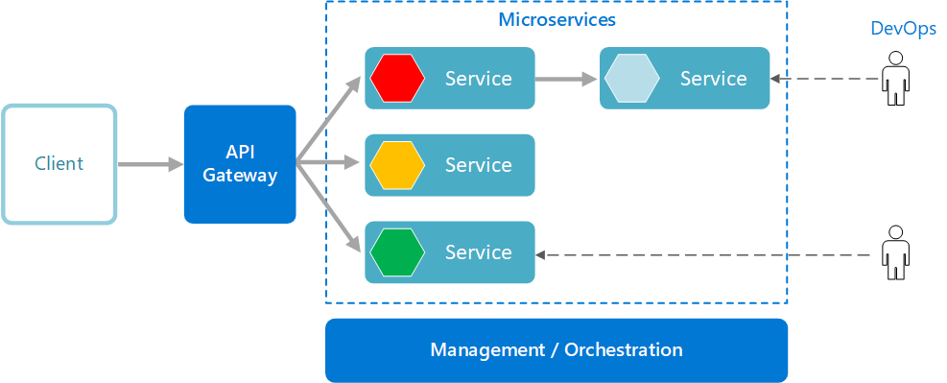

What are microservices?
- Microservices are small, independent, and loosely coupled. A single small team of developers can write and maintain a service.
- Each service is a separate codebase, which can be managed by a small development team.
- Services can be deployed independently. A team can update an existing service without rebuilding and redeploying the entire application.
- Services are responsible for persisting their own data or external state. This differs from the traditional model, where a separate data layer handles data persistence.
- Services communicate with each other by using well-defined APIs. Internal implementation details of each service are hidden from other services.
- Supports polyglot programming. For example, services don't need to share the same technology stack, libraries, or frameworks.
Besides for the services themselves, some other components appear in a typical microservices architecture:
Management/orchestration. This component is responsible for placing services on nodes, identifying failures, rebalancing services across nodes, and so forth. Typically this component is an off-the-shelf technology such as Kubernetes, rather than something custom built.
API Gateway. The API gateway is the entry point for clients. Instead of calling services directly, clients call the API gateway, which forwards the call to the appropriate services on the back end.
Advantages of using an API gateway include:
- It decouples clients from services. Services can be versioned or refactored without needing to update all of the clients.
- Services can use messaging protocols that are not web friendly, such as AMQP.
- The API Gateway can perform other cross-cutting functions such as authentication, logging, SSL termination, and load balancing.
- Out-of-the-box policies, like for throttling, caching, transformation, or validation.

Benefits
- Agility. Because microservices are deployed independently, it's easier to manage bug fixes and feature releases. You can update a service without redeploying the entire application, and roll back an update if something goes wrong. In many traditional applications, if a bug is found in one part of the application, it can block the entire release process. New features may be held up waiting for a bug fix to be integrated, tested, and published.
- Small, focused teams. A microservice should be small enough that a single feature team can build, test, and deploy it. Small team sizes promote greater agility. Large teams tend be less productive, because communication is slower, management overhead goes up, and agility diminishes.
- Small code base. In a monolithic application, there is a tendency over time for code dependencies to become tangled. Adding a new feature requires touching code in a lot of places. By not sharing code or data stores, a microservices architecture minimizes dependencies, and that makes it easier to add new features.
- Mix of technologies. Teams can pick the technology that best fits their service, using a mix of technology stacks as appropriate.
- Fault isolation. If an individual microservice becomes unavailable, it won't disrupt the entire application, as long as any upstream microservices are designed to handle faults correctly (for example, by implementing circuit breaking).
- Scalability. Services can be scaled independently, letting you scale out subsystems that require more resources, without scaling out the entire application. Using an orchestrator such as Kubernetes or Service Fabric, you can pack a higher density of services onto a single host, which allows for more efficient utilization of resources.
- Data isolation. It is much easier to perform schema updates, because only a single microservice is affected. In a monolithic application, schema updates can become very challenging, because different parts of the application may all touch the same data, making any alterations to the schema risky.

Challenges
The benefits of microservices don't come for free. Here are some of the challenges to consider before embarking on a microservices architecture.
- Complexity. A microservices application has more moving parts than the equivalent monolithic application. Each service is simpler, but the entire system as a whole is more complex.
- Development and testing. Writing a small service that relies on other dependent services requires a different approach than a writing a traditional monolithic or layered application. Existing tools are not always designed to work with service dependencies. Refactoring across service boundaries can be difficult. It is also challenging to test service dependencies, especially when the application is evolving quickly.
- Lack of governance. The decentralized approach to building microservices has advantages, but it can also lead to problems. You may end up with so many different languages and frameworks that the application becomes hard to maintain. It may be useful to put some project-wide standards in place, without overly restricting teams' flexibility. This especially applies to cross-cutting functionality such as logging.
- Network congestion and latency. The use of many small, granular services can result in more interservice communication. Also, if the chain of service dependencies gets too long (service A calls B, which calls C...), the additional latency can become a problem. You will need to design APIs carefully. Avoid overly chatty APIs, think about serialization formats, and look for places to use asynchronous communication patterns like queue-based load leveling.
- Data integrity. With each microservice responsible for its own data persistence, data consistency can be a challenge. Embrace eventual consistency where possible.
- Management. To be successful with microservices requires a mature DevOps culture. Correlated logging across services can be challenging. Typically, logging must correlate multiple service calls for a single user operation.
- Versioning. Updates to a service must not break services that depend on it. Multiple services could be updated at any given time, so without careful design, you might have problems with backward or forward compatibility.
- Skill set. Microservices are highly distributed systems. Carefully evaluate whether the team has the skills and experience to be successful.

Best practices
- Model services around the business domain.
- Decentralize everything. Individual teams are responsible for designing and building services. Avoid sharing code or data schemas.
- Data storage should be private to the service that owns the data. Use the best storage for each service and data type.
- Services communicate through well-designed APIs. Avoid leaking implementation details. APIs should model the domain, not the internal implementation of the service.
- Avoid coupling between services. Causes of coupling include shared database schemas and rigid communication protocols.
- Offload cross-cutting concerns, such as authentication and SSL termination, to the gateway.
- Keep domain knowledge out of the gateway. The gateway should handle and route client requests without any knowledge of the business rules or domain logic. Otherwise, the gateway becomes a dependency and can cause coupling between services.
- Services should have loose coupling and high functional cohesion. Functions that are likely to change together should be packaged and deployed together. If they reside in separate services, those services end up being tightly coupled, because a change in one service will require updating the other service. Overly chatty communication between two services may be a symptom of tight coupling and low cohesion.
- Isolate failures. Use resiliency strategies to prevent failures within a service from cascading. See Resiliency patterns and Designing reliable applications.

What is an embedded server?
An embedded server is embedded as part of a deployable application. If talking about Java apps, that would be a JAR. The advantage with this is you don’t need the server pre-installed in the deployment environment.
With SpringBoot, the default embedded server is Tomcat.
Embedded servers are quite scalable, and can host apps that support millions of users.
Why use embedded servers?
- Can be used with apps for deployment in high-workload environments without sacrificing reliability and stability.
- Are quite lightweight.
- Embedded server images don’t generally result in huge archive sizes and helps in building smaller containers.
In a typical microservice architecture there could be hundreds of microservice instances deployed at a given point in time. We’d like to automate development and deployment of microservices to the maximum extent possible.
A good approach would be to take the application, wrap it in a container image, and manage is as needed using something like K8. For this the deployment process needs to be very simple. If you’re using a custom version of Tomcat, or WebLogic to deploy your main app, then you’d need to:
install JavaScript => install web server => deploy application artifact to web server
How can we make it simpler? An interesting approach would be to make the server a part of your application. In that case, there are just two steps:
install the right version of Java => run the application
Thus the concept of an embedded server.

Web server Vs Application Server

Web Server | App Server | Example
A web server‘s primary job is to accept and fulfill requests from clients for static content from a website (HTML pages, JavaScript files, images, style sheets, etc.). The client is typically a browser and the request/response takes the form of a Hypertext Transfer Protocol (HTTP) message. | An application server’s primary job is to provide its clients with access to what is commonly called business logic, which is code that executes at the server side for each request/response pair. The business logic may produce dynamic content as part of its response. Communication between the application server and its clients might take the form of HTTP(S) messages, but this is not a requirement. Application servers can typically manage any type of message transfer, including WebSockets and many other protocols. | 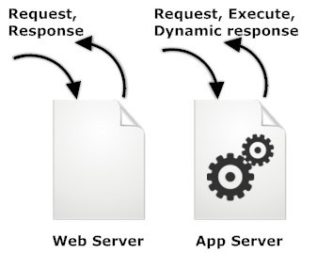

Web servers and application servers both offer a way to provide an embedded system with an Internet presence. The difference lies in the amount of programming required to adapt the server to the system.
Classic web servers simply process HTTP requests and responses; anything else must be developed from scratch. Much of that work amounts to spending time and money "reinventing the wheel" for common functions and infrastructure that aren't supported by a web server.
By contrast, application servers include frameworks that dramatically shorten the development cycle. Choosing an application server means that you don't have to write commonly-used communication and user interface functions or their underlying infrastructure for each system. Programming resources can instead be focused on functionality that is specific to the system.
NGINX
nginx [engine x] is an HTTP and reverse proxy server, a mail proxy server, and a generic TCP/UDP (transmission control protocol/ user datagram protocol) proxy server, originally written by Igor Sysoev. For a long time, it has been running on many heavily loaded Russian sites including Yandex, Mail.Ru, VK, and Rambler. According to Netcraft, nginx served or proxied 21.62% busiest sites in August 2022. Here are some of the success stories: Dropbox, Netflix, Wordpress.com, FastMail.FM. Because Nginx is asynchronous, each request can be executed by the worker concurrently without blocking other requests.
Some common features seen in Nginx include:
- Reverse proxy with caching
- IPv6
- Load balancing
- FastCGI support with caching
- WebSockets
- Handling of static files, index files, and auto-indexing
- TLS/SSL with SNI

TCP is a connection-oriented protocol, whereas UDP is a connectionless protocol. A key difference between TCP and UDP is speed, as TCP is comparatively slower than UDP. Overall, UDP is a much faster, simpler, and efficient protocol, however, retransmission of lost data packets is only possible with TCP.

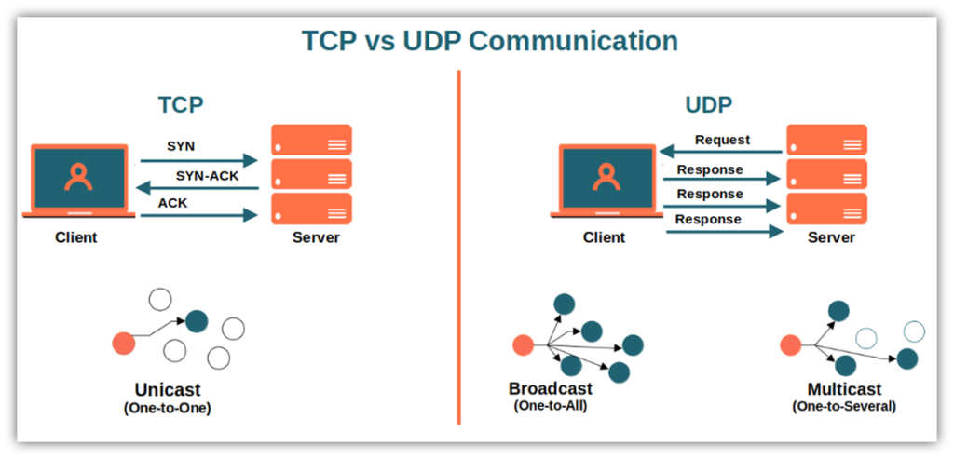
APACHE
The Apache HTTP Server Project is an effort to develop and maintain an open-source HTTP server for modern operating systems including UNIX and Windows. The goal of this project is to provide a secure, efficient and extensible server that provides HTTP services in sync with the current HTTP standards.
The Apache HTTP Server ("httpd") was launched in 1995 and it has been the most popular web server on the Internet since April 1996. It has celebrated its 25th birthday as a project in February 2020.
The Apache HTTP Server is a project of The Apache Software Foundation.

Apache is the most widely used webserver software and runs on 67% of all websites in the world. Developed and maintained by Apache Software Foundation, Apache is open source software and available for free.
It’s fast, reliable, and secure. And Apache can be highly customized to meet the needs of many different environments by using extensions and modules.
Apache is a free and open-source software that allows users to deploy their websites on the internet. It is one of the oldest and most reliable web server software maintained by the Apache Software Foundation, with the first version released in 1995.
APACHE Vs NGINX
Nginx, pronounced Engine-X, is a free, open-source software. Compared to Apache, it is a more recent web server application released in 2004.
Nginx was created to solve the so-called c10k problem, meaning that a web server that uses threads to handle user requests is unable to manage more than 10,000 connections at the same time.
- Since Apache uses the thread-based structure, owners of high-traffic websites may encounter performance problems. Nginx is one of the web servers that address the c10k problem and probably the most successful one.
- Nginx has an event-driven architecture that doesn’t create a new process for each request. Instead, it handles every incoming request in a single thread. This master process manages several worker processes that perform the actual processing of requests. The event-based model of Nginx distributes user requests among worker processes in an efficient way, therefore leading to much better scalability.
- If you need to manage a high-traffic website, Nginx is an excellent choice, as it can do that by using minimal resources. It cannot be a coincidence that it’s used by many high-visibility websites such as Netflix, Hulu, Pinterest, and Airbnb.
- However, for small and medium players, Apache comes with a handful of advantages over Nginx, such as its easy configuration, lots of modules, and a beginner-friendly environment.

VIRTUAL MACHINES VS PHYSICAL SERVERS
key concept- A hypervisor, also known as a virtual machine monitor or VMM, is software that creates and runs virtual machines (VMs) and is installed on top of physical hardware.
key concept- A physical server or a bare-metal server is a single-tenant computer server; designated to a single user, resources and components are not shared between multiple users. It includes mem, processors, network connection, hard drive and an OS.
key concept- A virtual machine is a software computer used as emulation of an actual physical computer. It operates in a multi-tenant environment i.e multiple VMs can run on the same physical hardware. Can have multiple guest OSes and server applications on top of the virtual hardware.

Physical Servers | Virtual Machines
Large upfront costs | Small upfront costs
No need for licensing purchase | VM software licenses
Physical servers and additional equipment take a lot of space | A single physical server can host multiple VMs, thus saving space
Has a short life-cycle | Supports legacy applications
No on-demand scalability | On-demand scalability
Hardware upgrades are difficult to implement and can lead to considerable downtime | Hardware upgrades are easier to implement; the workload can be migrated to a backup site for the repair period to minimize downtime
Difficult to move or copy | Easy to move or copy
Poor capacity optimization | Advanced capacity optimization is enabled by load balancing
Doesn’t require any overhead layer | Some level of overhead is required for running VMs
Perfect for organizations running services and operations which require highly productive computing hardware for their implementation | Perfect for organizations running multiple operations or serving multiple users, which plan to extend their production environment in the future

CONTAINERS, VMs AND DOCKER
Docker is a helpful tool for packing, shipping, and running applications within “containers.”
Containers and VMs are similar in their goals => to isolate an application and its dependencies into a self-contained unit that can run anywhere. Moreover, containers and VMs remove the need for physical hardware, allowing for more efficient use of computing resources, both in terms of energy consumption and cost effectiveness. Main difference between the two is in their architectural approach.

A VM is essentially an emulation of a real computer that executes programs like a real computer. VMs run on top of a physical machine using a “hypervisor”. A hypervisor, in turn, runs on either a host machine or on “bare-metal”.

Unlike a VM which provides hardware virtualization, a container provides operating-system-level virtualization by abstracting the “user space”.
For all intent and purposes, containers look like a VM. For example, they have private space for processing, can execute commands as root, have a private network interface and IP address, allow custom routes and iptable rules, can mount file systems, and etc.
The one big difference between containers and VMs is that containers *share* the host system’s kernel (a kernel is an OSs core part which has complete control over everything in the system; the kernel is responsible for process management, CPU scheduling, file system and IO devices) with other containers.
Containers package up just the user space, and not the kernel or virtual hardware like a VM does. Each container gets its own isolated user space to allow multiple containers to run on a single host machine.
So where does Docker come in? Docker is an open-source project based on Linux containers. It uses Linux Kernel features like namespaces and control groups to create containers on top of an operating system. Why is it important now?
- Ease of use => “build once, run anywhere”
- Speed => create and run a docker container in seconds; lightweight and fast
- Docker hub => “app store for Docker images”
- Modularity and scalability => break out your app’s functionality into individual containers then link them up

Fundamental Docker concepts
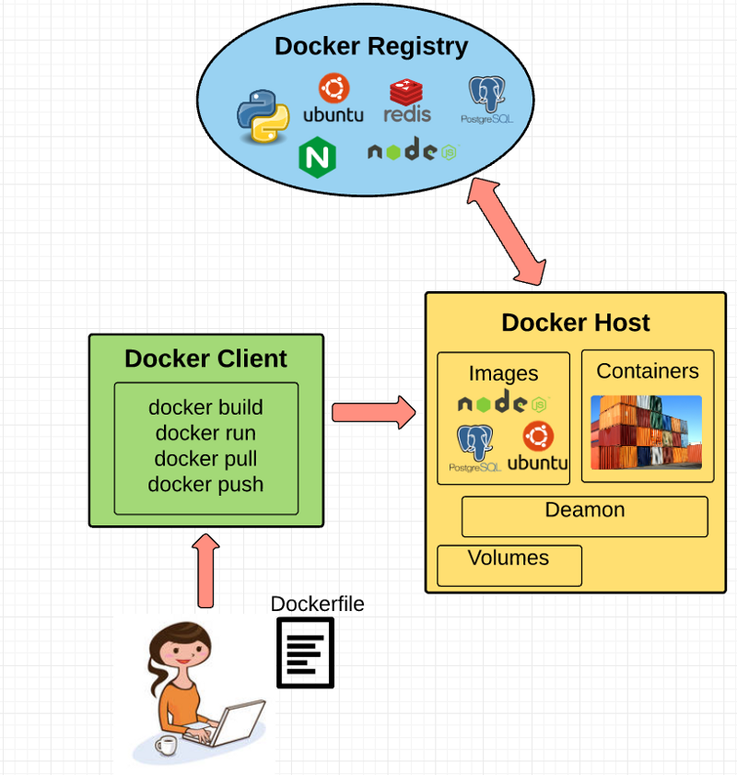
Docker engine: the layer on which Docker runs. It’s a lightweight runtime and tooling that manages containers, images, builds, and more. It runs natively on Linux systems and is made up of:
- A Docker Daemon that runs in the host computer.
- A Docker Client that then communicates with the Docker Daemon to execute commands.
- A REST API for interacting with the Docker Daemon remotely.
Docker client: what you, as the end-user of Docker, communicate with. Think of it as the UI for Docker.
Docker daemon: what actually executes commands sent to the Docker Client — like building, running, and distributing your containers. The Docker Daemon runs on the host machine, but as a user, you never communicate directly with the Daemon.
Dockerfile: where you write the instructions to build a Docker image. These instructions can be:
- RUN apt-get y install some-package: to install a software package
- EXPOSE 8000: to expose a port
- ENV ANT_HOME /usr/local/apache-ant: to pass an environment variable
Once you’ve got your Dockerfile set up, you can use the docker build command to build an image from it.
Docker image: Images are read-only templates that you build from a set of instructions written in your Dockerfile. Images define both what you want your packaged application and its dependencies to look like *and* what processes to run when it’s launched. The Docker image is built using a Dockerfile.
Union file systems: Docker uses Union File Systems to build up an image.
Volumes: are the “data” part of a container, initialized when a container is created. Volumes allow you to persist and share a container’s data.
Docker containers: a container wraps an application’s software into an invisible box with everything the application needs to run. That includes the operating system, application code, runtime, system tools, system libraries, and etc. Docker containers are built off Docker images.
Docker creates a network interface so that the container can talk to the local host, attaches an available IP address to the container, and executes the process that you specified to run your application when defining the image.
Once you’ve successfully created a container, you can then run it in any environment without having to make changes.

NB: The term “container” is really just an abstract concept to describe how a few different features work together to visualize a “container”. These are:
- Namespaces- provide containers with their own view of the underlying Linux system, limiting what the container can see and access. Are of different types e.g. NET, PID, MNT, UTS. Docker uses these namespaces together in order to isolate and begin the creation of a container.
- Control groups or cgroups- a Linux kernel feature that isolates, prioritizes, and accounts for the resource usage (CPU, memory, disk I/O, network, etc.) of a set of processes. In this sense, a cgroup ensures that Docker containers only use the resources they need.
- Isolated union file system- a stackable file system, meaning files and directories of separate file systems (known as branches) can be transparently overlaid to form a single file system, and is the one used to build up the Docker image.

This here is exactly why we need containers!



Hardware Virtualization
Software such as VMWare & Virtual box facilitates hardware virtualization. In simple words, you can run multiple operating systems on a single computer. The software consists of a component called Hypervisor or Virtual Machine Manager. This component manages the life cycle of the individual operating system.
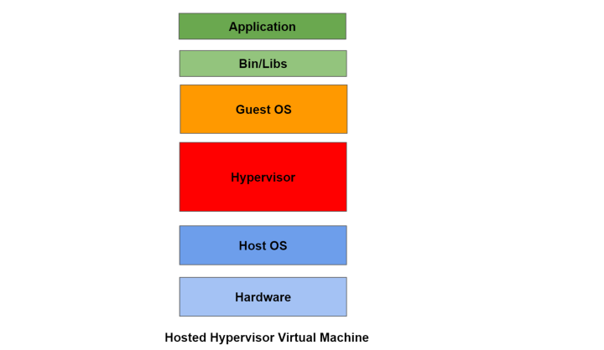

One of the biggest benefits of Virtualization is that you can launch multiple OSs on a single computer. Hypervisor guarantees security and isolation for the guest OSs.
Each VM requires its own operating system. This adds to the storage and memory overhead while running the VM. A lot of system resources are consumed while running a virtual machine. As a result, Virtual Machines are heavyweight & add to the system complexity.

To overcome this, virtualization was introduced at the Operating system level.

Cgroups & Namespaces
In 2006, Google conceptualized “control groups” or “cgroups”. This was a Linux kernel feature that could control resource usage for user processes. Processes could be put together into “namespaces”. The processes could then share the resource limitations defined for a given namespace.
One can create multiple namespaces and allocate resource limitations for each of them. For eg:- We can create two namespaces, one for a real-time application & another for a background job. Depending upon the resource usage, one can then set the limits for the two namespaces.
Further, a concept of namespace isolation was introduced for cgroups. This was similar to the existing process isolation feature. The namespace isolation ensures isolation between processes in the cgroup namespaces.

Containers
The first thing that comes to our mind when we hear Containers is the Docker Container. The Docker container has become an industry standard for containerization. However, LXC (Linux Container) was the first implementation of containerization technology. It leveraged the Linux cgroups and namespace isolation to create light-weight containers. In fact, the initial version of Docker was directly built on top of LXC. Similar to docker, there are other containers such as rocket & containerd.
Containers overcome all the shortcomings of Virtual Machines. Containers don’t require the installation of a separate guest operating system. They directly run and use the host operating system. Containers only need the dependent file system and binaries for their functioning. For eg:- A java app while running inside a container will need Java Runtime Environment (JRE). As a result, containers are lightweight as compared to Virtual Machines.
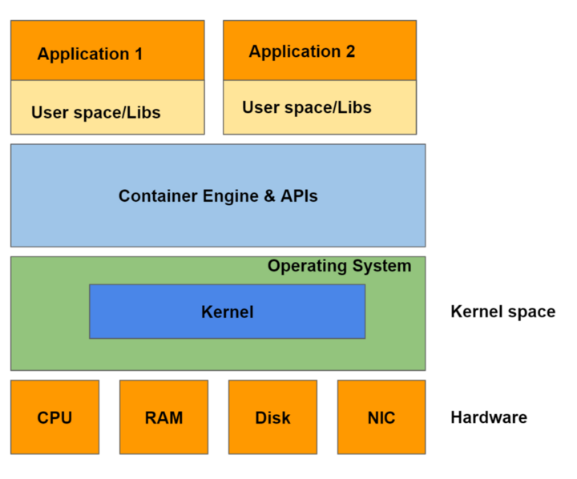

Containers & Microservices
Companies are moving away from monolithic to microservices-based architecture. There are innumerable benefits that microservices offer over traditional monoliths. Microservices segregate the responsibility & allow easy scaling of applications.
Since containers are easily portable, we can package a microservice as a part of a container. We can complete the development of a service on a Ubuntu machine & bundle it as a part of the container. We can deploy this container on a host running any OS. The host OS doesn’t have to be Ubuntu as long as we are using the container with the right base image.
Every container is given a fixed set of resource configurations. It's given a fixed amount of CPU, memory, etc. For scaling the microservices, we need to scale the number of containers. This gives more flexibility to the developers to scale up or scale down their applications.

Container Orchestration
Today, most internet product companies distribute their workloads across many machines on the cloud. Containers have made it easy to scale and deploy microservices. Scalability, Reliability & Operability are three cornerstones of any distributed system.
While deploying & managing microservices in a distributed environment, we may run into the following issues:-
- Failures such as Container crashes
- Scheduling containers to specific machines depending on the configuration
- Upgrading or rolling back the applications
- Scaling up or Scaling down containers across a set of machines
Orchestration engines like Kubernetes solve the above-mentioned problems. It simplifies the deployment, scaling, and management of containers on the cloud.

Kubernetes vs Docker
Of the current crop of container orchestration tools, the most popular is the open-source platform Kubernetes, or K8s, as it is sometimes stylized based on the number of letters between “K” and “s.” Kubernetes was originally developed by Google but is now maintained by the Cloud Native Computing Foundation (CNCF).
The popularity of Kubernetes is such that it is sometimes mistaken as a competitor to Docker. This is not the case, however, since Kubernetes does container orchestration. Docker is just one of the container platforms that is supported on Kubernetes.
Docker has its own integrated container orchestration platform, Docker Swarm, which is designed for simpler and smaller container applications without a need for scale. For more complex applications, Docker recommends Kubernetes.
Kubernetes offers full container support and is built to provide comprehensive container orchestration. For this reason, it is relatively complex compared to Docker Swarm.
Major cloud providers such as Amazon Web Services, Microsoft Azure, Google Cloud Platform, IBM Bluemix, and Red Hat OpenShift offer support for Kubernetes. In fact, most cloud providers now have so-called Kubernetes-as-a-Service products. For example, Amazon Elastic Container Service for Kubernetes, Azure Kubernetes Services, and Google Kubernetes Engine.

Apache Mesos
Apache Mesos is yet another container orchestration market leader that takes somewhat of a more modular and distributed approach to container management. It gives users the flexibility to scale the applications that they can run. It also allows users to run other container management frameworks like Chronos, Mesosphere Marathon, Apache Aurora, etc. It abstracts data center resources to a single pool, automates day-to-day operations by collocating diverse workloads, and manages stateless micro-services and Java.
Key concept- container orchestration—a tool that automates the deployment, management, scaling, networking, and availability of container-based applications.

OpenShift vs. Kubernetes software: A comparative overview
Red Hat's® OpenShift® is an open-source container platform that runs on the Red Hat enterprise Linux operating system and Kubernetes. The product is typically termed a "Platform as a Service" (PaaS) because it combines a host of services within the platform for enterprise businesses. This includes the Kubernetes platform and Docker container images. It also includes additional features that are exclusive to the OpenShift enterprise platform.
Kubernetes is also an open-source container orchestration platform. It enables developers to control, more easily manage and maintain software processing workloads for better deployment and scalability.

Kubernetes architecture: How Kubernetes works
Kubernetes’s architecture makes use of various concepts and abstractions. Some of these are variations on existing, familiar notions, but others are specific to Kubernetes.

Kubernetes clusters
The highest-level Kubernetes abstraction, the cluster, refers to the group of machines running Kubernetes (itself a clustered application) and the containers managed by it. A Kubernetes cluster must have a master, the system that commands and controls all the other Kubernetes machines in the cluster. A highly available Kubernetes cluster replicates the master’s facilities across multiple machines. But only one master at a time runs the job scheduler and controller-manager.

Kubernetes nodes and pods
Each cluster contains Kubernetes nodes. Nodes might be physical machines or VMs. Again, the idea is abstraction: Whatever the app is running on, Kubernetes handles deployment on that substrate. Kubernetes even makes it possible to ensure that certain containers run only on VMs or only on bare metal.
Nodes run pods, the most basic Kubernetes objects that can be created or managed. Each pod represents a single instance of an application or running process in Kubernetes, and consists of one or more containers. Kubernetes starts, stops, and replicates all containers in a pod as a group. Pods keep the user’s attention on the application, rather than on the containers themselves. Details about how Kubernetes needs to be configured, from the state of pods on up, is kept in Etcd, a distributed key-value store.
Pods are created and destroyed on nodes as needed to conform to the desired state specified by the user in the pod definition. Kubernetes provides an abstraction called a controller for dealing with the logistics of how pods are spun up, rolled out, and spun down. Controllers come in a few different flavors depending on the kind of application being managed. For instance, the StatefulSet controller is used to deal with applications that need persistent state. The Deployment controller is used to scale an app up or down, update an app to a new version, or roll back an app to a known-good version if there’s a problem.

Kubernetes services
Because pods live and die as needed, we need a different abstraction for dealing with the application lifecycle. An application is supposed to be a persistent entity, even when the pods running the containers that comprise the application aren’t themselves persistent. To that end, Kubernetes provides an abstraction called a service.
A service in Kubernetes describes how a given group of pods (or other Kubernetes objects) can be accessed via the network. As the Kubernetes documentation puts it, the pods that constitute the back-end of an application might change, but the front-end shouldn’t have to know about that or track it. Services make this possible.
A few more pieces internal to Kubernetes round out the picture. The scheduler parcels out workloads to nodes so that they’re balanced across resources and so that deployments meet the requirements of the application definitions. The controller manager ensures that the state of the system—applications, workloads, etc.—matches the desired state defined in Etcd’s configuration settings.
It is important to keep in mind that none of the low-level mechanisms used by containers, such as Docker itself, are replaced by Kubernetes. Rather, Kubernetes provides a larger set of abstractions for using these mechanisms for the sake of keeping apps running at scale.

Kubernetes policies
Policies in Kubernetes ensure that pods adhere to certain standards of behavior. Policies prevent pods from using excessive CPU, memory, process IDs, or disk space, for example. Such “limit ranges” are expressed in relative terms for CPU (e.g., 50% of a hardware thread) and absolute terms for memory (e.g., 200MB). These limits can be combined with resource quotas to ensure that different teams of Kubernetes users (as opposed to applications generally) have equal access to resources.

Kubernetes Ingress
Kubernetes services are thought of as running within a cluster. But you’ll want to be able to access these services from the outside world. Kubernetes has several components that facilitate this with varying degrees of simplicity and robustness, including NodePort and LoadBalancer, but the component with the most flexibility is Ingress. Ingress is an API that manages external access to a cluster’s services, typically via HTTP.
Ingress does require a bit of configuration to set up properly. Matthew Palmer, who wrote a book on Kubernetes development, steps you through the process on his website.

Kubernetes Dashboard
One Kubernetes component that helps you keep on top of all of these other components is Dashboard, a web-based UI with which you can deploy and troubleshoot apps and manage cluster resources. Dashboard isn’t installed by default, but adding it isn’t too much trouble.

