Year 9 English Curriculum Medium-Term Plan

.

The most important purpose of curriculum planning documents is that they will specify everything that students should learn. What is not specified is far less likely to be taught, let alone assessed appropriately.

Term | Half Term | Year 9 Overview
Autumn | HT1 | Analysing writer’s craft  Theme: Diversity
 | HT2 | Writing to argue and persuade (review and speech)  Theme: Diversity
Spring | HT3 | Poetry from historical period  Theme: Power and Conflict - Comparison
 | HT4 | Writing a report  Theme: Power and Conflict
Summer | HT5 | Theme study: Oppression  Novel Study - Descriptive Writing
 | HT 6 | Theme : Oppression  Novel Study - Theme Study

Term & Year Group | Summer Term 2 - Y9
Links to the National Curriculum/Examination Specification | - Analyse the language, form, and structure used by a writer to create meanings and effects, using relevant subject terminology where appropriate  - Understand increasingly challenging texts through learning new vocabulary  - Use a wide range of vocabulary, and grammar, punctuation, and spelling, accurately  - Analyse and evaluate the themes presented in the novel critically.  - Discuss how themes relate to real-life issues and experiences  - Provide historical and cultural context for the novel, helping students to understand how societal changes and historical events influence the themes and characters in the text.
Overall Aims | What are the overarching aims for students in terms of the key substantive knowledge components, disciplinary knowledge (skills) and understanding they will develop?  - Students will develop a deep understanding of the themes presented in "Of Mice and Men," such as marginalisation, loneliness, friendship, dreams, discrimination, and the American Dream.  - Students will gain insight into the characters' motivations, relationships, and development throughout the novel, including their roles in shaping the overarching themes.  - Students will identify and analyse the author's use of literary techniques, such as symbolism, foreshadowing, and imagery, to convey themes and enhance the reader's understanding.
Prior learning & common misconceptions | What learning has come before this unit that should be drawn upon to secure deeper understanding and make connections?  Year 7: - Autumn 1 and 2: character analysis/ descriptive writing  Year 8 - Autumn 1: theme study. Summer 1 and 2: character analysis and development/ narrative writing short stories (suspense)  Year 9 - (Currently Summer 1 and 2): descriptive and theme study  What are the common misconceptions that hinder progress?  - Assuming that a theme can be reduced to a single word or phrase.  - Missing the presence of sub themes within a novel  - Overlooking the importance of reader interpretation  - Ignoring character development through the themes selected  - Neglecting context and how it can impact the interpretation of a theme
Assessment | How will student progress be assessed through both formative & summative assessments?  Formative: Debate about a theme running through the novel/ Formal letter writing  Summative: How is the writer’s intention portrayed through the development of a specific theme? Students should consider how characters, relationships and plot intertwine.
Language & Reading | What is the provision to:  Talk like a specialist:: Students will analyse how themes are shown in "Of Mice and Men" by looking at what happens and how the author writes. They will discuss how characters and themes are connected in "Of Mice and Men" by looking at why characters act the way they do and what that says about the themes. Students will share their own feelings and thoughts about the themes in "Of Mice and Men" and how they relate to your life.  Read like a specialist: Students will read carefully to find where themes like marginalisation, loneliness or dreams are mentioned and how characters act. They will pay attention to how characters' actions and relationships show the book's main themes and think about how the book's themes relate to your own experiences and feelings.  Write like a specialist: Students will write about the important themes in the book and how they are shown through what happens and what characters say and do. They will write about how characters' actions and relationships help to show the important themes in the book.
Links to SMSC/SRE/British Values | SP1, SP2. SP3, SP4  M1, M2, M3  SO1, SO3  C1, C2, C3, C4, C6

Component
Component
Component
Component

Component
Component
Component

Know how writers can present a viewpoint through fiction writing.

Know how to embed evidence in writing and explain its significance.

Know how analysing the choice of words, sentence structure, and syntax can relate to themes presented

Know how the the central themes or ideas are presented in the novel

Know how to find and cite specific textual evidence to support their interpretation of the theme
Know how to analyse the figurative language devices such as metaphors, similes, personification, and symbolism can help uncover deeper thematic meanings

Know how to develop skills in drawing meaningful conclusions from the novel
Know how to use transitional words and phrases to ensure that writing flows smoothly

Know how writers employ their vocabulary to develop concepts throughout.

Know how to critically analyse the text and its themes, including evaluating the author's choices and considering alternative interpretations

LO1: comment and explain how a theme is presented to the reader
LO2: provide insights into the connections between characters and themes.
LO3: provide a personal response to a common theme.
Know how to evaluate the author's choices, the characters' actions, and the overall message of the novel
Know how to expand vocabulary and understand rhetorical devices (e.g., parallelism, anaphora, irony

Know how the narrative point of view (first-person, third-person, etc.) affects the reader's engagement
Know how understanding the historical, cultural, and social context of the novel is crucial for a deeper exploration of its themes

Know how to compare themes within the novel

Know how sentence structure and punctuation can identify patterns in the author's writing style.
Know how dialogues between characters often reveal their personalities, conflicts, and beliefs, which can be tied to the novel's themes.

This unit build a pupils knowledge up the following Pillars of Progression

Literary in English | Complex Composition | Rhetoric | Linguistics/ Grammar
- Learn how Steinbeck presents the character Crooks to the reader through reading and analysis of Chapter 4 (L1)  - To develop knowledge and understanding of racial segregation in 1930s America. L2)  - Understand the concept of marginalisation and its importance in "Of Mice and Men. (L3+4) | - Develop skills to infer Steinbeck’s intentions behind depicting marginalised characters, focusing on Curley's wife.(lL7)  - To develop knowledge and understanding of Steinbeck’s use of vocabulary and description in Chapter Five. (L8) | - Analyse how Steinbeck portrays marginalisation through the character Crooks.(L5+6)

Week/ Lesson  Key Question? | Key knowledge components & Lesson Outcomes  What do students need to know & what should they be able to do? | Pedagogy & Assessment– How do we teach and assess this at Coal Clough Academy? Strategies to support students knowing more & remembering more  Suggested teaching activities & resources including ‘non-negotiables’ for delivery e.g. minimum of two assessment style questions per week, minimum of one practical per week…
Lesson 1  Key question:  What are your first impressions of Crooks? | What are the key knowledge components students must be taught in this lesson?  - Learn how Steinbeck presents the character Crooks to the reader through reading and analysis of Chapter 4.  What are the learning outcomes for this lesson?.  - I can describe Crooks’s characteristics and his treatment by others. | Key vocabulary for this lesson & how it will be introduced?  - Characterisation  - Prejudice  - PEE (Point, Evidence, Explanation)  Recall activity:  - 3-a-day  Suggested teaching activities, pedagogy and assessment to inform next steps:  - ORACY: Begin with a brief discussion on what students know about Crooks from previous chapters. Ask: "What are your initial impressions of Crooks?"  - Read Chapter 4 of "Of Mice and Men" as a class, focusing on the sections that describe Crooks and his interactions with others.  - As you read, pause to annotate key passages that highlight Crooks's characteristics and how he is treated by others. Encourage students to underline or highlight significant phrases and make notes in the margins.  - Discuss the key characteristics of Crooks. Prompt students with questions such as:  - How does Steinbeck describe Crooks’s physical appearance?  - What can we infer about Crooks’s personality from his dialogue and actions?  - How is Crooks treated by other characters, and what does this reveal about his position on the ranch?  - Provide students with a table to fill out Crooks's characteristics. The table should include columns for direct quotes from the text, the trait or characteristic shown, and what this reveals about Crooks (e.g., his feelings, social status, etc.).  Assessment:  Model a PEE response using a quotation about Crooks. For example:  - Point: Steinbeck presents Crooks as a marginalised character on the ranch.  - Evidence: This is shown when Crooks says, “A guy needs somebody - to be near him. A guy goes nuts if he ain't got nobody.”  - Explanation: This quote reveals Crooks's deep sense of isolation and loneliness, emphasising how the racial prejudice he faces contributes to his marginalisation.  Success Criteria:  - Participation in reading and discussion  - Completion of the characteristics table  - Quality of PEE responses and contributions to pair and class discussions
Addressing gaps  - Ask students to choose another quotation from Chapter 4 and write their own PEE response about Crooks. Provide sentence starters if necessary.  - Summarise the main points discussed in the lesson about Crooks’s character and how Steinbeck presents him. |  | Deepening knowledge  - How does the historical context of racial segregation influence Crooks's experiences on the ranch?  - What societal attitudes towards race and disability are reflected in the treatment of Crooks?

Week/ Lesson  Key Question? | Key knowledge components & Lesson Outcomes  What do students need to know & what should they be able to do? | Pedagogy & Assessment– How do we teach and assess this at Coal Clough Academy? Strategies to support students knowing more & remembering more  Suggested teaching activities & resources including ‘non-negotiables’ for delivery e.g. minimum of two assessment style questions per week, minimum of one practical per week…
Lesson 2  Key question:  Define context and what can you recall for OMAM? | What are the key knowledge components students must be taught in this lesson?  - To develop knowledge and understanding of racial segregation in 1930s America.  What are the learning outcomes for this lesson?.  - I can research the topic well and present clear, accurate information about racism, life for African Americans, Jim Crow laws, Reconstruction, or the Civil Rights Movement.  - I can understand how the 1930s racial segregation relates to Crooks in "Of Mice and Men" during discussions and reflections. | Key vocabulary for this lesson & how it will be introduced?  - Racial Segregation  - Racism  - Jim Crow Laws  - Reconstruction  - Civil Rights Movement  Recall activity:  - 3-a-day  Suggested teaching activities, pedagogy and assessment to inform next steps:  - Show a short video clip or present a few images from the 1930s that illustrate racial segregation to set the context.  - ORACY: Facilitate a class discussion on the connections between the historical context of the 1930s and the character of Crooks in "Of Mice and Men.  Assessment:  Research Task:  - Find out about racism in America of the 1930s. What was life like for African Americans?  - What were the Jim Crow laws?  - What was reconstruction?  - What was the civil rights movement about?  Success Criteria:  - Students research their topic well and present clear, accurate information about racism, life for African Americans, Jim Crow laws, Reconstruction, or the Civil Rights Movement.  - Students show understanding of how the 1930s racial segregation relates to Crooks in "Of Mice and Men" during discussions and reflections.
Addressing gaps  - Provide students with a set of guiding questions for their research:  - What was the general attitude towards African Americans in the 1930s?  - How did Jim Crow laws affect the daily lives of African Americans?  - What were the main goals and outcomes of Reconstruction?  - What was the Civil Rights Movement about, and what were its early beginnings in the 1930s?  - Provide a list of reliable websites, books, and articles for students to use. Ensure they have access to the internet or a library. |  | Deepening knowledge  - How do the Jim Crow laws and the social norms of the 1930s explain the treatment of Crooks in "Of Mice and Men"?  - In what ways does Steinbeck reflect the realities of racial segregation through the character of Crooks?  - Why do you think Steinbeck chose to highlight the character of Crooks in the context of racial segregation?

Week/ Lesson  Key Question? | Key knowledge components & Lesson Outcomes  What do students need to know & what should they be able to do? | Pedagogy & Assessment– How do we teach and assess this at Coal Clough Academy? Strategies to support students knowing more & remembering more  Suggested teaching activities & resources including ‘non-negotiables’ for delivery e.g. minimum of two assessment style questions per week, minimum of one practical per week…dis
Lesson 3+4  Key question:  What is marginalisation? | What are the key knowledge components students must be taught in this lesson?  - Understand the concept of marginalisation and its importance in "Of Mice and Men.  What are the learning outcomes for this lesson?  - I can define the concept of marginalisation and identify marginalised characters in Chapter 3 of "Of Mice and Men" using specific textual evidence. | Key vocabulary for this lesson & how it will be introduced?  - Impression  - Marginalisation  Recall activity: 3-a-day  Suggested teaching activities, pedagogy and assessment to inform next steps:  - Write the key words "Impression" and "Marginalisation" on the board.  - ORACY: Begin by asking students what they think marginalisation means.  - Write their ideas on the board to build a working definition.  - Provide a clear definition: Marginalisation is the process by which certain groups or individuals are pushed to the edge of society, limiting their access to resources and opportunities.  - ORACY: Discuss real-world examples of marginalisation (e.g., racial, economic, gender-based).  - ORACY: Ask students to share any examples they know from current events or history.  - Highlight how marginalisation affects individuals' lives and society as a whole.  - Provide a brief summary of the context of Chapter 3 in "Of Mice and Men."  - Explain that the focus will be on identifying instances of marginalisation in the text.  - ORACY: Read selected excerpts from Chapter 3 that illustrate marginalisation (e.g., scenes involving Crooks, Candy, and Curley’s wife).  - As you read, pause to annotate and highlight key phrases that indicate marginalisation.  - Encourage students to note their initial impressions of the characters and their situations.  - Guided question prompts: How is this character treated by others?/ What language or behaviour indicates their marginalisation?/ What are your initial impressions of this character’s situation?  Assessment:  - Ask students to write a brief reflection on what they learned about marginalisation and its impact on the characters in the text.  - Encourage them to think about their own initial impressions and how the discussion may have influenced their understanding.  Success Criteria:  - Participation in group discussions and class presentations.  - Quality of annotations and initial impressions noted.  - Written reflection at the end of the lesson.
Addressing gaps  - Ensure students clearly understand the definitions of marginalisation and its related terms (e.g., discrimination, exclusion).  - Use real-life examples and visual aids to illustrate these concepts.  - Break down complex passages and discuss them as a class to ensure comprehension.  - Draw explicit connections between the marginalisation of characters and the broader themes of the novel, such as the American Dream and isolation.  - Use graphic organisers like mind maps to visually link characters, themes, and instances of marginalisation. |  | Deepening knowledge  - Have you ever witnessed or experienced marginalisation in your own life? How did it affect your perceptions or actions?  - How might understanding marginalisation in literature help us to address it in real life?

Week/ Lesson  Key Question? | Key knowledge components & Lesson Outcomes  What do students need to know & what should they be able to do? | Pedagogy & Assessment– How do we teach and assess this at Coal Clough Academy? Strategies to support students knowing more & remembering more  Suggested teaching activities & resources including ‘non-negotiables’ for delivery e.g. minimum of two assessment style questions per week, minimum of one practical per week…
Lesson 5+6  Key question: How does Steinbeck explore the theme of marginalisation in the text. | What are the key knowledge components students must be taught in this lesson?  - Analyse how Steinbeck portrays marginalisation through the character Crooks.  What are the learning outcomes for this lesson?  - I can analyse how Steinbeck portrays marginalisation through the character of Crooks  - I can express these ideas through a well-organised and authentic character letter. | Key vocabulary for this lesson & how it will be introduced?  - inference  - annotation  - marginalisation  - racism  Recall activity:3-a-day  Suggested teaching activities, pedagogy and assessment to inform next steps:  - ORACY:Begin with a brief discussion on what students remember about Crooks from previous readings. Ask them to share their initial impressions of his character.  - ORACY: Briefly discuss the historical context of racism in 1930s America, particularly in the rural setting where "Of Mice and Men" is set.  - Highlight examples of systemic racism, segregation, and discrimination prevalent during this time period.  - Select the key passage from Chapter 4 that highlights Crooks' marginalisation. Read the passage aloud to the class.  - Distribute copies of the passage and model how to annotate it, highlighting significant words or phrases that indicate marginalisation.  - Students individually annotate their copies, focusing on language, tone, and context that suggest Crooks' marginalisation.  - ORACY: Guided questions: What language or actions marginalised Crooks?/ How does Crooks' living situation reflect his marginalisation?/ What can we infer about Steinbeck’s intentions in depicting Crooks this way?  - Complete the following question table:  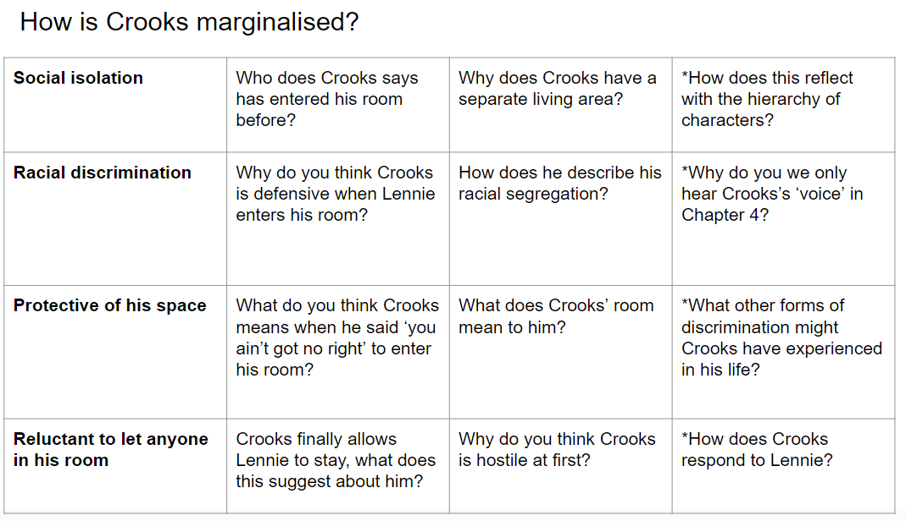  Assessment:  - Read model letter written from the perspective of Crooks.  - Write a letter from the point of view of Crook, reflecting on how you are treated on the ranch. Make references to how others treat you (marginalisation), how you feel and what your hopes are for the future.  Dear Friend,  I hope this letter finds you well. I want to share with you what life is like for me here on the ranch. It's not always easy, and sometimes it feels very lonely.  Being the only black man on the ranch, I am treated differently from the others. The men don't come into my room very often. In fact, they mostly avoid it. The only ones who visit are Slim and the boss. They treat me fairly, but most of the other men ignore me. They see my skin colour first and think less of me because of it. This makes me feel like an outsider, like I don't belong.  Every day, I work hard just like the others, but I don't get to share in their laughter and friendship. When they play cards or talk about their dreams, I am left out. They think I am different because of the colour of my skin. It hurts to be so alone. Sometimes, I wonder if anyone will ever see me for who I really am.  There are days when I feel angry about how I am treated. I have my own room, but it's more of a prison than a sanctuary. It's the only place where I have some control, but it's also where I feel the most isolated. It's hard to keep hope alive when you feel invisible.  Despite all this, I still have dreams for the future. I dream of a world where people are judged by their character, not by the colour of their skin. I hope for a time when I can walk into a room and be greeted with kindness and respect. I want to feel like I belong, like I am part of something bigger.  Sometimes, I imagine leaving the ranch and finding a place where I am accepted. A place where I can be free from prejudice and live in peace. I don't know if that place exists, but it's what keeps me going.  Thank you for listening to my story. Writing this letter has given me a bit of comfort. I hope that one day things will change for the better, not just for me, but for everyone who feels marginalised.  Yours sincerely, Crooks  Success Criteria:  - Show how Crooks is treated unfairly and feels left out.  - Write in a way that sounds like Crooks, reflecting his emotions.  - Clearly express Crooks' feelings about his situation and his hopes for the future.  - Write the letter with a clear beginning, middle, and end, making it easy to follow.
Addressing gaps  - Extend the context activity to a 10-minute mini-lecture on 1930s racism, using visuals and handouts summarising key points.  - Provide a clear explanation and examples of inferences, including a think-aloud strategy to model the inference-making process. |  | Deepening knowledge  - How do Crooks' interactions with other characters highlight his marginalisation?  - What does Crooks’ marginalisation reveal about the society depicted in the novel?  - How does Steinbeck use Crooks to comment on race and power dynamics?

Week/ Lesson  Key Question? | Key knowledge components & Lesson Outcomes  What do students need to know & what should they be able to do? | Pedagogy & Assessment– How do we teach and assess this at Coal Clough Academy? Strategies to support students knowing more & remembering more  Suggested teaching activities & resources including ‘non-negotiables’ for delivery e.g. minimum of two assessment style questions per week, minimum of one practical per week…
Lesson 7  Key question:  What is oppression? | What are the key knowledge components students must be taught this lesson?  - Develop skills to infer Steinbeck’s intentions behind depicting marginalised characters, focusing on Curley's wife.  What are the learning outcomes for this lesson?  - I can identify and highlight key words and phrases  - I can break down a selected quotation  - I can write and share well-supported inferences about why Steinbeck chose to marginalise Curley's wife, using textual evidence. | Key vocabulary for this lesson & how it will be introduced?  - Inferences  - Annotation  - Marginalisation  - Quotation  - Analysis  - Oppression  Recall activity:  - 3-a-day  Suggested teaching activities, pedagogy and assessment to inform next steps:  - Select key passages from "Of Mice and Men" that highlight the marginalisation of Curley's wife. Read the passages aloud to the class.  - Distribute copies of the passages and model how to annotate them, highlighting significant words or phrases that indicate marginalisation.  - Have students individually annotate their copies, focusing on language, tone, and context that suggest why Steinbeck portrays Curley's wife in this manner.  - Students write their inferences about why Steinbeck chose to marginalise Curley's wife, using evidence from their annotations.  - ORACY: What language or actions marginalised Curley's wife?  - ORACY: How does her treatment by other characters reflect societal attitudes towards women?  - ORACY: What can we infer about Steinbeck’s intentions in depicting Curley's wife this way?  - Explain the concept of "exploding the quotation," which involves breaking down a quotation into its key parts and analysing each part in detail to uncover deeper meanings and inferences.  - Provide an example of exploding a quotation, such as "I never get to talk to nobody. I get awful lonely."  Assessment:  - Students select a quotation from the annotated passages and explode it, analysing the language used and making inferences about why Steinbeck depicted Curley's wife this way  Success Criteria:  - Identify and highlight key words and phrases in the passages that show Curley's wife's marginalisation.  - Break down a selected quotation and analyse its parts to make clear inferences about Steinbeck’s intentions.  - Write and share well-supported inferences about why Steinbeck chose to marginalise Curley's wife, using textual evidence.
Addressing gaps  - Provide sentence starters such as "Steinbeck portrays Curley's wife as lonely because..." or "The depiction of Curley's wife suggests that Steinbeck wanted to highlight..."  - Encourage students to use sentence starters like "The use of the word... suggests..." or "This phrase highlights..." |  | Deepening knowledge  - Highlight how understanding Curley's wife's marginalisation adds depth to our interpretation of the novel.

Week/ Lesson  Key Question? | Key knowledge components & Lesson Outcomes  What do students need to know & what should they be able to do? | Pedagogy & Assessment– How do we teach and assess this at Coal Clough Academy? Strategies to support students knowing more & remembering more  Suggested teaching activities & resources including ‘non-negotiables’ for delivery e.g. minimum of two assessment style questions per week, minimum of one practical per week…
Lesson 8  Key question:  Why do writers use the senses in their writing? | What are the key knowledge components students must be taught in this lesson?  - To develop knowledge and understanding of Steinbeck’s use of vocabulary and description in Chapter Five.  What are the learning outcomes for this lesson?.  - I can successfully match challenging vocabulary words with their definitions, demonstrating understanding of the new terms introduced in Chapter Five.  - I can identify and analyse literary techniques in Chapter Five, providing insightful explanations of how these techniques contribute to Steinbeck's descriptive language. | Key vocabulary for this lesson & how it will be introduced?  - Vocabulary  - Description  - Imagery  - Tone  - Mood  Recall activity:  - 3-a-day  Suggested teaching activities, pedagogy and assessment to inform next steps:  - Start with a brief discussion on the importance of descriptive language in literature. Ask: "How can an author's choice of words affect our perception of a story?"  - Provide students with a list of challenging vocabulary words from Chapter Five and their definitions. Have students match each word with its correct definition.  - ORACY: Review the matches as a class and discuss the meanings of the words. Ask students to use each word in a sentence related to the text.  - Read Chapter Five of "Of Mice and Men" aloud to the class, focusing on passages rich in descriptive language.  - Pose the questions to aid understanding: What happens to Lennie's puppy in Chapter 5?/Describe how Lennie reacts to what happens and why this is significant./How does Curley's wife interact with Lennie in the barn?/What does she talk about, and what does this reveal about her character?/ Why does Curley's wife let Lennie touch her hair?/What happens as a result, and why is this moment crucial?/ What is the reaction of the other characters when they discover what has happened in the barn?/ How do they respond to the situation involving Curley's wife and Lennie?/How does Steinbeck use descriptive language to create mood and tension in the barn scene?/ IIdentify specific words or phrases and explain their effect on the reader.  - Literary technique task:  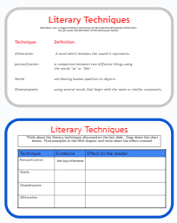  - ORACY: What imagery stands out to you in Chapter Five?/ How does Steinbeck use descriptive language to develop the mood of the scene?/ What can we infer about the characters based on Steinbeck’s descriptions?  Assessment:  - ORACY: Summarise the main points discussed in the lesson about Steinbeck’s use of vocabulary and description.  Success Criteria:  - I can successfully match challenging vocabulary words with their definitions, demonstrating understanding of the new terms introduced in Chapter Five.  - I can identify and analyse literary techniques in Chapter Five, providing insightful explanations of how these techniques contribute to Steinbeck's descriptive language.
Addressing gaps  - As you read, pause to annotate key phrases and vocabulary that create vivid imagery, establish tone, or convey mood. Encourage students to highlight these in their books and write notes in the margins.  - Provide students with guiding questions to help them identify potential gaps in the text. |  | Deepening knowledge  - There are a number of references to nature in the opening paragraphs of Chapter Five.  - How does Steinbeck use natural images to convey character, theme and plot?

Week/ Lesson  Key Question? | Key knowledge components & Lesson Outcomes  What do students need to know & what should they be able to do? | Pedagogy & Assessment– How do we teach and assess this at Coal Clough Academy? Strategies to support students knowing more & remembering more  Suggested teaching activities & resources including ‘non-negotiables’ for delivery e.g. minimum of two assessment style questions per week, minimum of one practical per week…
Lesson  Key question: | What are the key knowledge components students must be taught in this lesson?  What are the learning outcomes for this lesson? | Key vocabulary for this lesson & how it will be introduced?  Recall activity:3-a-day  Suggested teaching activities, pedagogy and assessment to inform next steps:  Assessment:  Success Criteria:
Addressing gaps |  | Deepening knowledge

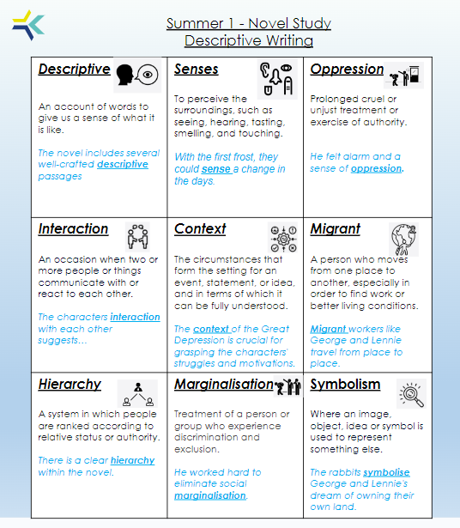
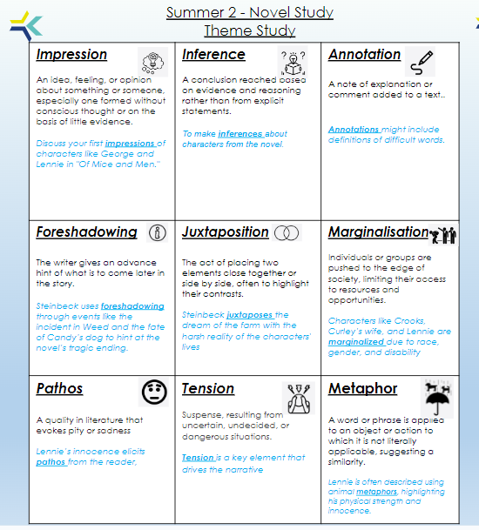

*ASSESSMENT+ SLIDE HERE*

- How is the writer’s intention portrayed through the development of a specific theme?
- How do the characters in the text link to the theme of …..?
- Debate about a theme running through the novel

Progress Pathways for summative assessment of component & composite knowledge:

Assessment Focus | BELOW
What the teacher is looking for in student work? | - Use summarising, predicting, clarifying and questioning to develop a secure understanding of writers’ ideas, viewpoints and themes in texts of differing lengths.  - express opinions about a text, using evidence from the text, giving reasons and explanations. (Point, evidence, explanation)  - explain how a writer’s use of language has been used to create effects and impact on the reader.  - explain how a writer’s use of grammatical features have been used to create effects and impact on the reader.  - understand the different ways in which texts can reflect their social, cultural and historical contexts and/or the literary traditions in which they were written.

Assessment Focus | IMPROVING
What the teacher is looking for in student work? | - use a range of reading strategies to retrieve relevant information and main points from texts, distinguishing between fact, opinion and opinions presented as fact, where appropriate; trace the development of writers’ ideas, viewpoints and themes in different texts.  - make use of appropriate evidence from a text to support inferences and opinions, using more than one piece of evidence if needed.  - recognise and comment on how writers’ choices and techniques create layers of meaning and contribute to the overall effect on readers  - Explore and begin to unpick the range, variety and effect of literary, rhetorical and grammatical features used by writers of literary and non-literary texts.  - understand and explore the concept of literary heritage, and why certain texts of different social, historical and cultural experiences are important within it.

Assessment Focus | EXPECTED
What the teacher is looking for in student work? | - select from a range of strategies the most appropriate ways to locate and retrieve information and ideas from a variety of texts; analyse a range of ideas and respond to differing viewpoints, purposes and themes in a variety of related texts.  - build an interpretation of a whole text, recognising links between ideas, themes or characters and supporting points with precise evidence and explanation  - use a repertoire of reading strategies to analyse and explore different layers of meaning within texts and consider the potential impact of language choices on different readers.  - analyse in depth and detail, in fiction and non-fiction, writers’ use of literary, rhetorical and grammatical features and their effects  - develop an informed understanding of how ideas, experiences and values are portrayed in texts from different cultures, traditions and eras, and how texts are shaped by audiences’ preferences, opinions and experiences.

Assessment Focus | ABOVE
What the teacher is looking for in student work? | Working at GCSE standard:  - summarise and evaluate the main points with accuracy and  - understanding  - understand and respond to explicit meanings and viewpoints.  - Responses to implicit meanings may be inconsistent.  - explain relevant aspects of language and structure  - support their comments and opinions with relevant references to  - texts  - make explicit links between texts and develop points of comparison.

