Samuel Willyams
Stw0454@arastudent.ac.nz
Council Request Classifier
Final Report

Table of Contents
Introduction and Project Objective 3
GitHub link: 3
Scenario and Problem Context 3
Dataset and Data Preparation 4
Dataset 4
Data cleaning 4
Stop words 4
Model Design and Evaluation 6
Baseline 6
Testing improvement 6
Alternate models 6
Lemmatization 6
Final model 7
API Design and Networking Component 8
Confidence rank thresholds 9
API calling example 9
System Integration and Testing 11
Automated Testing 11
Manual Testing 11
Model/Training testing 12
Results and Discussion 12
Ethical Evaluation 13
Data Bias 13
Privacy & The Privacy Act 2020 13
Reliability & Impact of Errors 13
Transparency 13
Te Tiriti o Waitangi and CARE principles 14
Limitations and future improvements 15
Training data 15
Lemmatization and stemming 15
Conclusion 16

Introduction and Project Objective
An AI based classification system has been developed to categorise requests to a local council into one of the four categories specified by the training data. To interact with the classification system, an API has been developed, so requests can be sent as a text string, and a Json response will include the predicted category.
The objective is to be able to categorise requests with little or no human input and do so with enough accuracy and reliability to justify its integration into council systems; reducing response delays and operational overhead.
GitHub link:

Scenario and Problem Context
A local city council receives maintenance requests from its constituents through a unified portal; this means requests need to be classified before they can be directed to the correct department. Adding an automated classification system could decrease the delay in requests being delivered to the appropriate department and decrease costs by reducing human input.
Requests fall into one of 4 categories: road, waste, water and safety. 80 requests were provided for model training, 60 of them were considered valid after duplicate removal.

Dataset and Data Preparation

Dataset
The training data (80 requests) provided contains a request id, request text, category, suburb, priority and date reported. The model uses the request text to decide on a category prediction. Categories such as suburb, or date reported could have been used as predictors, but ethically there is no guarantee that patterns in the training data will continue into the future.

Data cleaning
Training data contains 20 duplicate text values in request texts, where request text, suburb and category are identical, but the ID and date differ, priority may or may not differ. If the duplicate values were left in, they could give additional weight to tokens contained in these requests that could lower the effectiveness of the categorisations of new data, and invalidate the usefulness of testing the model, as the test data could be identical to the model data. For example, request ID 63 and 58 of category water are exact text duplicates “Strong wastewater smell near the channel suggests a pipe issue.”, so all words in the request will be given a higher weighting, this could cause the request “Dog waste bin is full and smell is getting worse.” to be miscategorised as ‘water’ rather than ‘waste’ due to it containing the work smell, that had occurred in the two duplicates.
In training the get_clean_df_arrays() function (/training/data_process_lib.py) loads the training data .csv file, cleans (lowercase and punctuation removed) the text and removes extraneous columns using the clean_training_data() helper function; which also removes exact duplicates using the remove_duplicates() helper function. The get_clean_df_arrays() returns a list of requests and a list of categories. Strictly speaking, removing punctuation and converting to lowercase isn’t necessary as these functions are performed by default within the vectorizer.

Stop words
Function words, known in natural language processing as ‘stop words’, such as “the, as, of, in, when, this, is”, should be removed as these words to not describe the content, but may still influence the categorisation. Table 1 shows the uneven distribution of stop words in the training data, for example the word if appears 6 times in the road category and nowhere else. If ‘if’ was left in, then ‘if’ could be a strong predictor for classification in the road category.
A custom set of function words (/training/custom_stop_words.py) was developed specific to the request classifier, which improved performance over Scikit-learn’s default stop word list. The custom stop word list is passed to the vectorizer during training or testing; the API doesn’t need to remove stop words as the trained model will treat them as unknown words.

Model Design and Evaluation

Baseline
Initial testing was focussed on Logistic Regression and Naïve Bayes, with logistic regression performing best initially, but was outperformed once a domain specific stop word list was introduced. Both models performed poorly when attempting to categorise requests related to roading. Both model’s accuracy was improved by introducing bias weightings to their probability indexes, however their accuracy remained lower than a MLP classifier.

Testing improvement
The original 80% training, 20% testing data split was abandoned in favour of Leave-One-Out-Cross-Validation (LOOCV), which trains the model on all but one sample, used for testing. The testing is then expanded by repeating the training, with the next sample left out and so on. By using all but 1 sample for training, it produces test results closer to the final training, and by using all samples for testing on completion, it produces no error variance, as it’s a census rather than sample. In the initial 80-20 training, random state 42 was used, it reported 67% accuracy which is one of best-case states, compared to random state 10 which reported 50% accuracy.
LOOCV gives the same training set up 55% accuracy. Therefore 80-20 training with random-state 42 over-reported accuracy by 12 percentage points.

Alternate models
A random tree classifier showed initial promise but did not improve with a custom stop word list, like other models did, and performed poorly one new testing examples.
A neural network based MLP classifier showed the best accuracy, especially after a custom stop word list was introduced. While neural networks have the potential to benefit from character n-grams, the training dataset was too small to train such a model, as such only word tokens were used. Neural networks have a reputation for overfitting, but when testing on new data, MLP classifier improved retained improved accuracy.

Lemmatization
Lemmatization, the process of reducing words down to their core meaning was attempted but did not improve categorisation accuracy and slowed both model training and predictions. While lemmatization can theoretically improve accuracy by allowing more comparisons, it also deletes information by removing its original wording.

Final model
The final model uses a MLP classifier using a standard word count vectorizer and a custom stop word list, which achieved 75% accuracy using LOOCV testing and 52% accuracy on large language model (LLM) generated testing data, intended to represent new requests.

API Design and Networking Component
The API uses the FastAPI framework as it’s engine. To run the API server, navigate to the /API folder in a terminal, ensure module requirements are met, and run "py -m uvicorn main:app " or “python -m uvicorn main:app” depending on your python alias.
You can test the server by navigating to localhost:8000/docs or ensure LOCAL_TESTING=True in the main.py file and open Use_predict_api.html file in the main folder. Set local_testing back to false once complete.
The API has 4 endpoints:
- The root endpoint gives the name of the system: “Council Request Classifier”.
- /health gives {“status”: “ok”} if system is running, it will return a 503 error if the API is running but the classifier has failed to load.
- /categories will list the categories the model is able to categorise, currently {“categories”:[”road”,”safety”,”waste”,”water]}
- /predict is the main interaction point when a Json style post request is given in {“request_text”:”request”} style, then a Json response will be given in the following Json format:
{“request_text”:”request”,
“predicted_category”:”category”,
“confidence”:confidence,
“confidence_rank”:”confidence_rank”,
“needs_review”:bool,
“review_reason”:null or “review_reason”
}
For example:
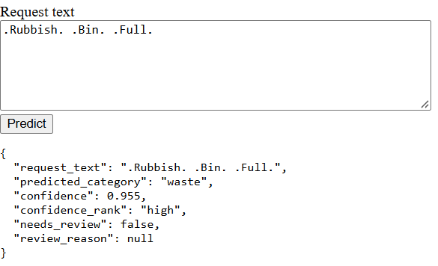

Confidence rank thresholds
- Very_low confidence relates to confidence values below any successful categorisation that occurred during testing. Representing predictions that are very unlikely to be accurate
- Low confidence relates to values between the lowest successful categorisation and the median inaccurate confidence value. Representing values where accurate predictions are possible but are more likely inaccurate.
- Medium confidence relates to values between the median inaccurate value and the highest inaccurate testing result. This represents values where predictions are more likely to be accurate than inaccurate, but inaccurate predictions still occurred during testing.
- High confidence relates to values higher than the highest inaccurate prediction. These predictions could still potentially be wrong, but it never happened during testing, therefore representing the highest confidence rank.
These thresholds should be adjusting with feedback during use and/or user testing. Confidence values can be saved when the prediction is accepted as accurate or flagged as inaccurate by staff. Additionally, the rankings might need to be adjusted by how the wider council system or staff prefer to interpret the results.

API calling example
The Use_predict_api.html code contains an HTML/JavaScript example of the code required to interact with the API, although the IP address will need to be changed if not running locally:
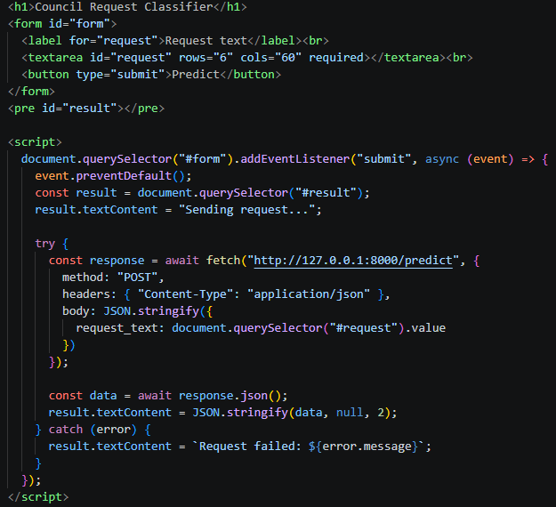

System Integration and Testing
System integration successfully connected the FastAPI backend, the saved joblib model artifacts (model.joblib, vectoriser.joblib), and client interfaces.
Automated Testing
An automated test suite was constructed using the pytest module, comprising 12 comprehensive unit and integration tests (all passing successfully, as verified in test logs). Testing is run from the project folder using the "python -m pytest -q" command. Automated testing code is in /testing/tests.py.
Automated tests cover:
- Health API functionality and error reporting
- Category API functionality and error reporting
- Predict API:
  - Correctly categorises valid request
  - Correctly flags invalid (unknown text) request
  - Correctly reject empty request
  - Returns correct error code when failing
- Confidence ranking subroutine functions correctly

Manual Testing
Testing covered valid inputs, edge cases, and invalid inputs. Testing via Use_predict_api.html confirmed correct classification across diverse scenarios:
Valid cases:
- "Rubbish bin full" → waste (confidence: 0.955, needs_review: false)
- "drain overflowing into creek" → water (confidence: 0.67, needs_review: false)
- "Broken handrail is causing a hazard" → safety (confidence: 0.805, needs_review: false)
- "the buses were all late today" → road (confidence: 0.513, needs_review: false)
Invalid cases: TODO few more
- "hello how are you doing?" → (needs_review: true, review_reason: "no_known_words")
- “” → 422 error (“text must not be blank”)
Edge cases:

Model/Training testing
Gemini was asked to produce more testing data, testing on this data resulted in 52% accuracy compared to LOOCV testing of 75%. This shows that the Gemini testing data had a different shape to the initial training data; and that the model lost accuracy when applied to requests of a different shape. Shape in this context referring to how different words appear across the data set and how they are used; for example, the Gemini data used the slang phrase wheelie bin, and the training data did not.
If council is confident the training data is a representative sample of their requests, then this isn’t a concern, as LOOCV testing results will be accurate but using a smaller sample, and filtering requests, reduces the probability the data remains representative.

Results and Discussion
The iterative development process yielded significant performance improvements. The baseline logistic regression model with default settings achieved 62–63% accuracy. Through systematic experimentation—including removing 20 duplicate records, testing Naive Bayes and Random Forest classifiers, and introducing domain-specific stop-word removal—model performance increased substantially.
The primary breakthrough resulted from replacing default stop-word lists with a custom council-specific stop-word dictionary. Because function words like "if" and "to" were unevenly distributed across categories in the small 80-record dataset, default models overfitted on grammatical markers rather than substantive issue keywords. Removing these artifacts and deploying the MLP Classifier raised LOOCV accuracy to 75%.
Testing against independent LLM-generated test sets yielded an accuracy of 52% for the MLP model. While lower than cross-validation accuracy due to vocabulary divergence, this performance confirms that the model generalizes reasonably well to unseen inputs. The integration of probability thresholds and confidence grading successfully mitigates classification uncertainty by flagging ambiguous predictions for human review.

Ethical Evaluation
Ethical considerations were embedded throughout the project lifecycle:

Data Bias
The starter dataset was extremely small (80 records, 60 valid), leading to imbalances where certain maintenance categories (such as roading) were harder to classify accurately. Additionally, the classifier performed worse when used on new testing data, suggesting its performance is dependent on the training data being representative of requests the classifier will be used on.
The removal of duplicates ensuring testing did not produce false confidence, and the removal of domain-specific stop words, suburbs and dates ensured models did not learn questionable correlations.

Privacy & The Privacy Act 2020
Requests may inadvertently contain personal or sensitive information (names, phone numbers, physical addresses, email addresses). While the starter dataset contained no personal information, operational deployment requires strict data scrubbing and compliance with the Privacy Act 2020. Personal and identifying data should always be removed from training data, this ensures Privacy Act responsibilities such as informed consent, clear and specific purpose, data security and disposal are reduced. Ideally categories such as suburb and date would be removed as these could perceivably used to identify requests when combined with other information.
If personal data such as names or address was included in training, then it is possible to extract this data from the trained model, without direct access to the training data. For example, from a training request: “the people at 123 example street are overfilling their rubbish bins”, entering “123 example street” into the classifier will result in the waste category classification, letting the user know that 123 example street has been involved in rubbish incidents.

Reliability & Impact of Errors
Misclassifying public service requests can result in delayed council responses, citizen frustration, and wasted administrative time. To safeguard against failure, the API incorporates confidence ranking (confidence_rank) and a review routing mechanism (needs_review, review_reason) that flags low-confidence submissions for human staff oversight; and removes predictions when there was no words recognised.

Transparency
The confidence value is not a measure of accuracy, but of how decisively a model has chosen one category over the others. With 4 categories, the lowest possible confidence value for a prediction is 0.25, as confidence values across categories will always add up to 1, so the maximum value can never drop below 1 divided by 4 categories. In practice, the lowest possible confidence can be higher than this due to adjustments made by the model.
Classifier outputs include a confidence rank to assist end user interpretation of the numerical confidence value. These confidence ranks are based off accuracy during testing, allowing the user to interpret results without needing to understand how the model produces confidence values.
If words are recognised, the model’s prediction is deleted as it’s based off mathematical constants rather than request text contents. Without this feature council staff would still receive predictions without knowing it was generated without basis.

Te Tiriti o Waitangi and CARE principles
Consideration was given to Indigenous data sovereignty and the CARE principles (Collective benefit, Authority to control, Responsibility, Ethics). The training dataset lacked examples in Te Reo Māori. Standard text preprocessing (such as punctuation stripping or lowercasing without macron support) risks stripping linguistic meaning from Māori text, potentially disadvantaging speakers who communicate in Te Reo. Future iterations should incorporate Māori language training data, for example, by translating existing training data into Māori using a paid Māori language expert. Additionally, data sovereignty principles dictate that sensitive council data must remain hosted in New Zealand rather than being transferred to overseas cloud services.

Limitations and future improvements
The classifier only achieved 75% accuracy with the training data, and 52% accuracy with new LLM generated data.

Training data
The was very small (60 non-duplicate records). Machine learning benefits from more examples of words and word combinations. Additional I suspect the training data was artificially generated as it is lacks slang, small talk, misspelling and grammatical errors; without being given messy real-world data to train on, to model will perform worse when attempting to categorise real world data.
At the moment, the model includes no Māori language examples, adding the ability to incorporate Māori language would help the council fulfil its Treaty of Waitangi obligations and make the classifier accessible to a wider audience.
Training on a larger, varied and representative data set would be a significant improvement. The stop word list might need to be adjusted once this new data is acquired.

Lemmatization and stemming
Lemmatization or stemming didn’t show any improvements during development; however, the specific reasons were not investigated due to time constraints. It is possible that with adjustments or an alternate similar methodology may achieve improved predictions, even with a small training data set; but there is a potential for wasted effort.

Conclusion
The Council Request Classifier project has successfully demonstrated the design, development, integration, and testing of an end-to-end AI-powered service request classification system. Through rigorous iterative data engineering (eliminating duplicates, developing custom stop words), model experimentation (benchmarking Logistic Regression, Naive Bayes, Random Forest, and MLP classifiers), and robust FastAPI backend development with automated testing (pytest), all project objectives have been achieved.
The final classification model achieved a 75% accuracy in LOOCV testing; but only achieved 52% accuracy when used on freshly generated testing data. Model accuracy can be improved with more training data, but without it, it is perceivable that approximately 50% or less of its predictions will be inaccurate or unclassified, when used on messy real-world requests. This wastes staff time and delaying processing by sending requests to the wrong place; or requires staff to review requests with additional information, namely staff must review the classifier’s prediction and confidence rank, and then review the request text to ensure the prediction matches their own judgement, instead of reviewing only the request text.
Given this, I do not recommend using the classifier to replace existing council systems unless inaccurate predictions are of little or no consequence to the council. One practical implementation would be to limit the classifications to those of a high confidence threshold and send all other requests to the existing business flow; this should result in an overall workload reduction.
The classifier has potential but requires more training data and testing to ensure it performs to a higher level of accuracy.

