Github link
https://github.com/SWillyams/CouncilRequestClassifier

Training and testing.
20 Duplicates were removed from training data. Extensive testing using all available data was performed, the document describing testing in detail is in the same folder: Iteration2Tests.docx. Final training achieved approximately 63% accuracy.
Training and testing was completed using training/ModelTraining.py which uses training/data_process_lib.py, pandas, joblib and scikit-learn. Full requirements in training/requirements.txt.
Requests related to roading were difficult to categorise, see testing summary doc. Training would be improved with more data. Due to small training data size with uneven numbers of useful keywords, inverse document frequency weighing hurts prediction accuracy. Due to small training data size, minimum document frequency should be set at 1. Due to small training data size, n-gram maximum should be set at 1.
Saved trained model in /model/ model.joblib and vectoriser.joblib

API
An quick API was built with fastAPI and is contained in the /API folder with requirements.txt. This is a functional prototype aimed at meeting the API specification, not a final product.
Instructions
Run server with "py -m uvicorn main:app --reload" from API folder.
Open localhost:8000/docs and navigate to /predict
Input text for prediction
Note the code needed for a json type request is currently commented out in favour of an easier to test string input.
Screenshots:
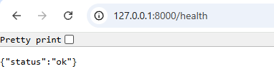
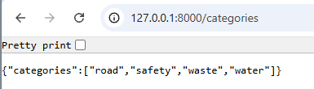
Simple post:
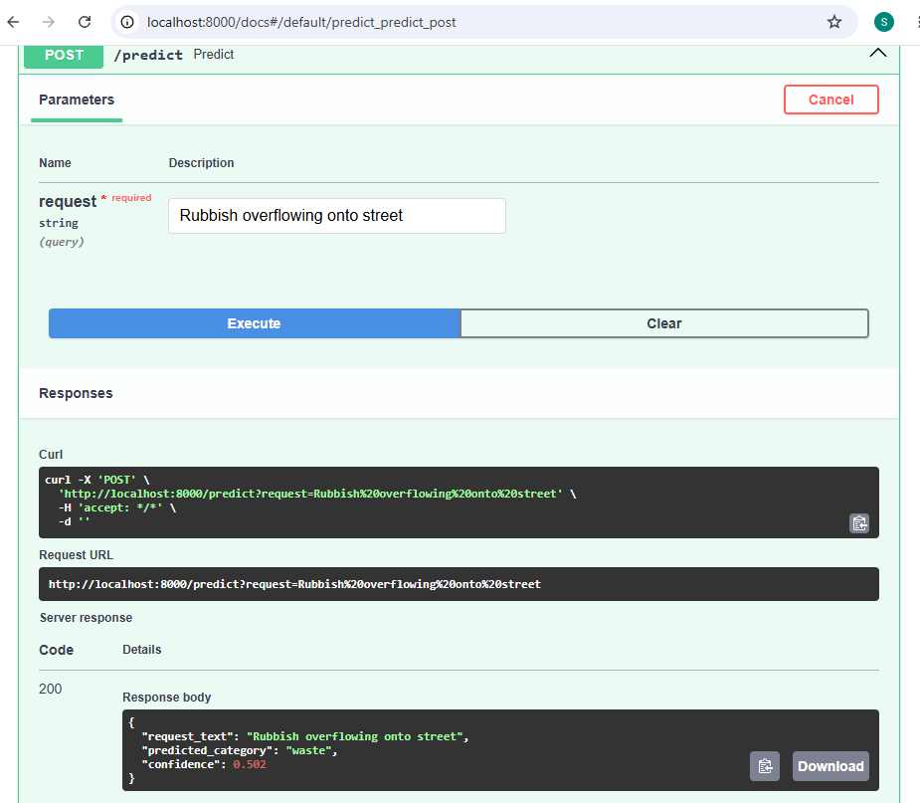
JSON style post: (currently disabled)
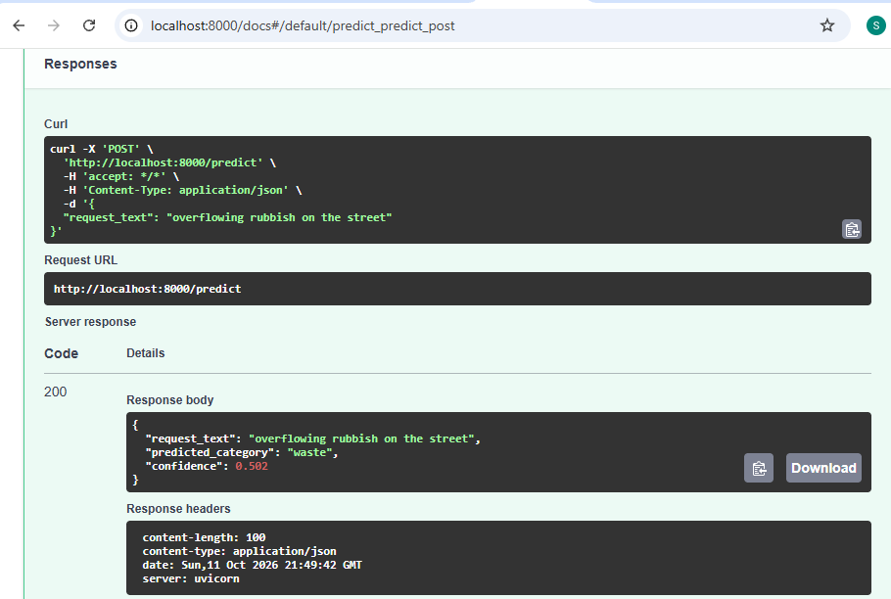

Next iteration:
Model training and testing would be more effective with additional training data. Will look at publicly available data mentioned in the brief.
Although both logistic regression and naïve bayes performed poorly with categorising requests related to roading, they did produce separate results, with logistic regression underestimating roading, and naïve bayes overestimating roading. Using naïve bayes when logistic regression’s confidence is low, or averaging results from both models might improve performance, it is worth investigating.
Using a custom stop word list would probably improve performance, especially if inverse document frequency weighing isn’t used.
Neural network based training is unlikely to improve performance with such a small data set. It might still be useful as a fallback method when prediction confidences are low.
API needs error handling and to handle invalid data. A testing program to interact with the API needs to be built.

Ethics
The training data needs to be checked to ensure it is correct, otherwise the model will carry forward mistakes into the classifier.
Training data doesn’t include any Māori language examples. The classifier may be unable to handle requests with words in Māori correctly, resulting in poor performance for people who use Māori in regular communication. Need to ensure data cleaning doesn’t remove Māori language letters; as the letters impart information on word meaning. Standard cleaning removes these letters, either removing their meaning, or producing jumbled words.
Any street names or areas in the request text, will be included in training. Past history for a street or area may not be an accurate predictor of future categories. For example, if a street had a lot of roading requests when the training data was collected, the model will use the street name as a strong predictor for roading requests into the future. For this reason, the suburb column was not used in the training, even though it may have improved model performance in testing.

