Github link:

Baseline model accuracy
Final model accuracy from last iteration was 62% measured using Leave One Out Cross Validation, this testing methodology for all future testing.
Baseline model used L2 normalisation, no Inverse Document Frequency (IDF), minimum feature appear count of 1, and n-gram maximum of 1.

Fall-back methods
A variety of fall-back methods were investigated. The first followed a simple logic, make predictions with both logistic regression and naïve bayes methods were asked to make predictions, where their predictions differed, the prediction with the highest probability won. This method lowered test accuracy by 2 out of 60 tests. On investigation (see predictwithfallbackconfidences.xlsx), averaging the two models’ probabilities also result in a reduction of accuracy. This is because naïve bayes performs worse, and so incorporating it in any way lowers overall performance.

Low probability thresholds
The predict_proba results have significant overlap between accurate and inaccurate predictions as seen in figure 1. Of the 37 successful categorisation, the lowest had a probability of 0.27, only two incorrect categorisations had lower values. The highest incorrect categorisation had a probability 0.375; 21 out of 37 correct categorisations had lower probabilities. Using the median value of incorrect predictions: 0.310288, 8 out of 37 correct predictions have lower probabilities.
These thresholds mentioned were incorporated into the API, see figure 3.
Weighted classifications
The predict_proba values can be given transformed by model performance during testing. The probability value is reduced by a model’s tendency to overestimate a category, and reduced by its inaccuracy in correctly categorising a specific category.
This weight approach improves logistic regression and 2 model averages to 66.7% accuracy and naïve bayes accuracy to 68% accuracy.
This adds a second layer to the training that makes it highly specific to the shape of training data so might not improve the model on new data; this is different to overfitting which makes a model fit specific instances of the data, thereby reducing performance with new data.

Neural Network classifier
Scikit-Learns neural network text classifier is called MLP classifier. As seen in table 1, the MLP classifier achieved a 65% success rate using TFIDF vectorizer, this is surprising as NN based training is expected to perform poorly with small datasets. Using TFIDF isn’t necessary for a neural network, using a count vectorizer instead produces a consistent 63 - 65% accuracy across most parameters. Note because neural networks introduce randomness, testing results may differ each test run. MLP had a relatively flat success rate across parameter types, this is due to the ability of multilevel logic to establish its own transformations rather than relying on the transformations within TFIDF vectorizer.
Using character tokens rather than word tokens reduced MLP performance, likely as it gives an opportunity for training overfitting.

Random tree classifier
Scikit learn provides a random tree classifier (RandomForestClassifer). This type of classifier builds multiple decision tree classifiers from random features in the training data and uses the majority decision of those trees. An example of a decision tree is “if request contains road, check if it contains curb, if it does categorise as ‘road’.”. Random tree is good at handling small training data sizes, as such it is the best performing classifier as seen in table 4; notably it was the only classifier performing better with a higher minimum word appearance count (df_min). It has a disadvantage of long training and prediction times, especially as training data becomes larger.

Stop words
It should be mentioned, not using stop words does improve all model’s apparent performance. This is because the distribution of function words is not even across categories as seen in table 2; therefore, models can use these as predictors, particularly for the road category, which the models tend to underestimate without access to stop words. I consider the improved performance an example of overfitting, categorising requests based on distribution of stop words is unlikely to prove effective with new data.
A custom list of stop words (custom_stop_words.py) was manually generated from the dictionary of words contained within the training requests (feature_list.csv). Words were considered stop words if they were functional words not providing value in relation to council requests. For example, “night” might not be considered a stop word in a different context, but regarding council requests, the time of day isn’t relevant to the type of request. Conversely, “full” is removed from scikit-learns default stop word list but is highly relevant to the waste category.
Using custom stop words increased base model performance to 70% as seen in table 3. Notably the best performing parameters, now include using IDF.
5 tests of MLP classifier with the new stop word list achieved an average of 75% accuracy.
Random tree’s performance was not increased.
Naïve Bayes classifier’s best performance was 73%

Testing on new data
New testing data was created with CoPilot, but it looked suspiciously like the original training data, so I used Gemini instead.
Improved logistic regression achieved 49%
MLP achieved 52%
Naïve Bayes achieved 50%

Training data size
Small training data size remains a limiting factor in model efficacy.

API
API was finished with all required end points and error feedback; model and confidence thresholds updated to best performing MLP classifier. The /predict end point now includes confidence_rank, needs_review and review_reason; see figure 3. Figure 4 shows 7 additional test cases using Use_predict_api.html testing environment. Health and categories APIs remain functional as in last iteration.
Run details in readme.md.
And automated test suite was also built using pytests module. Run details in readme.md, all tests passed, see figure 5.

Ethics
Ethical considerations from last progress summary remain see it2ethic.docx.
The use of custom stop words or no stop words could be used to artificially inflate apparent model performance in testing without improving model performance on new data.
Low accuracy could mean a lot of miscategorised requests, which would waste time, including time developing this app.

Appendix
Figure 1.
Predict_Proba Values Logistic Regression Classification. 0 On The X-Axis Representing Wrong Categorisation And 1 Representing Correct Categorisation.

Figure 2
Code Supporting Prediction Confidence Feedback
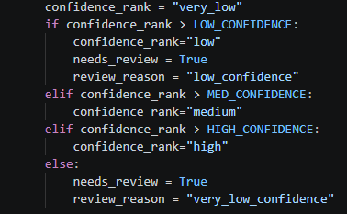

Table 1.
MLP Classifier Success Across Parameters With TFIDF Vectorizer
df_min | ngram_max | norm_model | use_idf | Success %
1 | 1 | l2 | FALSE | 65%
1 | 2 | l1 | FALSE | 63%
1 | 3 | l1 | FALSE | 63%
1 | 1 | l2 | TRUE | 62%
1 | 2 | l2 | FALSE | 62%
1 | 3 | l1 | TRUE | 62%
1 | 1 | l1 | FALSE | 60%
1 | 2 | l1 | TRUE | 60%
1 | 3 | l2 | FALSE | 60%
1 | 2 | l2 | TRUE | 58%
2 | 2 | l1 | FALSE | 58%
1 | 1 | l1 | TRUE | 57%
1 | 3 | l2 | TRUE | 57%
2 | 1 | l1 | FALSE | 57%
2 | 2 | l2 | FALSE | 57%
2 | 3 | l2 | FALSE | 57%
2 | 3 | l2 | TRUE | 57%
2 | 1 | l2 | TRUE | 55%
2 | 2 | l1 | TRUE | 55%
2 | 3 | l1 | FALSE | 55%
2 | 1 | l1 | TRUE | 53%
2 | 1 | l2 | FALSE | 53%
2 | 2 | l2 | TRUE | 53%
2 | 3 | l1 | TRUE | 52%

Table 2.
Number Of Requests Containing Different Function Words By Category
Function word |  | Category
 | road |  | waste | water | safety
If | 6 |  | 0 | 0 | 0
To | 6 |  | 3 | 3 | 6
The | 8 |  | 12 | 10 | 6
For | 2 |  | 4 | 2 | 0
And | 8 |  | 7 | 6 | 6
On | 8 |  | 10 | 8 | 7
When | 1 |  | 0 | 0 | 0
Of | 1 |  | 1 | 0 | 1

Table 3.
Logistic Regression Results With Custom Stop Words
Df min | Ngram max | Use idf | success %
1 | 1 | TRUE | 70%
1 | 2 | TRUE | 68%
1 | 3 | TRUE | 68%
1 | 1 | FALSE | 67%
1 | 2 | FALSE | 67%
1 | 3 | FALSE | 65%
2 | 1 | FALSE | 53%
2 | 2 | FALSE | 53%
2 | 2 | TRUE | 53%
2 | 3 | FALSE | 53%
2 | 3 | TRUE | 53%
2 | 1 | TRUE | 50%
Note: Sub linear TF not shown as it has no effect. L1 model testing not shown as it always lowers success rate compared to L2.

Table 4.
Random Tree Classifier Performance Across Parameters
Df min | Ngram max | Norm model | Use idf | Sublinear tf | Success %
2 | 3 | l2 | FALSE | TRUE | 68.3%
2 | 1 | l2 | TRUE | FALSE | 66.7%
2 | 3 | l2 | TRUE | FALSE | 66.7%
2 | 1 | l1 | FALSE | FALSE | 65.0%
2 | 1 | l1 | FALSE | TRUE | 65.0%
1 | 1 | l1 | FALSE | FALSE | 63.3%
2 | 1 | l1 | TRUE | FALSE | 63.3%
2 | 1 | l1 | TRUE | TRUE | 63.3%
2 | 2 | l1 | TRUE | TRUE | 63.3%
2 | 3 | l1 | FALSE | FALSE | 63.3%
1 | 1 | l1 | FALSE | TRUE | 61.7%
1 | 1 | l2 | FALSE | TRUE | 61.7%
2 | 2 | l1 | FALSE | FALSE | 61.7%
2 | 2 | l1 | FALSE | TRUE | 61.7%
2 | 2 | l2 | TRUE | FALSE | 61.7%
2 | 3 | l1 | FALSE | TRUE | 61.7%
2 | 3 | l1 | TRUE | FALSE | 61.7%
2 | 3 | l1 | TRUE | TRUE | 61.7%
2 | 1 | l2 | TRUE | TRUE | 60.0%
2 | 2 | l1 | TRUE | FALSE | 60.0%
2 | 2 | l2 | FALSE | FALSE | 60.0%
2 | 2 | l2 | FALSE | TRUE | 60.0%
2 | 2 | l2 | TRUE | TRUE | 60.0%
2 | 3 | l2 | TRUE | TRUE | 60.0%
1 | 1 | l2 | FALSE | FALSE | 58.3%
1 | 1 | l1 | TRUE | TRUE | 56.7%
2 | 1 | l2 | FALSE | TRUE | 56.7%
2 | 3 | l2 | FALSE | FALSE | 56.7%
1 | 1 | l1 | TRUE | FALSE | 55.0%
1 | 1 | l2 | TRUE | FALSE | 55.0%
1 | 1 | l2 | TRUE | TRUE | 55.0%
2 | 1 | l2 | FALSE | FALSE | 55.0%
1 | 2 | l1 | FALSE | FALSE | 51.7%
1 | 2 | l1 | TRUE | FALSE | 51.7%
1 | 2 | l2 | TRUE | FALSE | 48.3%
1 | 2 | l1 | FALSE | TRUE | 46.7%
1 | 2 | l2 | FALSE | TRUE | 45.0%
1 | 2 | l1 | TRUE | TRUE | 43.3%
1 | 2 | l2 | FALSE | FALSE | 43.3%
1 | 3 | l1 | FALSE | FALSE | 43.3%
1 | 3 | l1 | FALSE | TRUE | 43.3%
1 | 3 | l1 | TRUE | TRUE | 43.3%
1 | 2 | l2 | TRUE | TRUE | 41.7%
1 | 3 | l2 | TRUE | FALSE | 41.7%
1 | 3 | l2 | FALSE | FALSE | 40.0%
1 | 3 | l2 | FALSE | TRUE | 40.0%
1 | 3 | l2 | TRUE | TRUE | 38.3%
1 | 3 | l1 | TRUE | FALSE | 30.0%

Figure 3.
New /Predict API
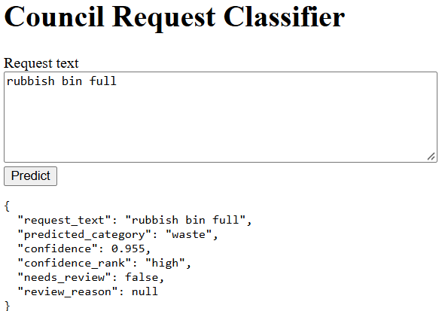

Figure 4.
7 /predict test cases.
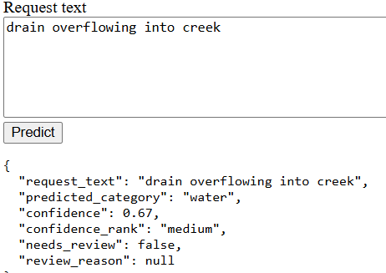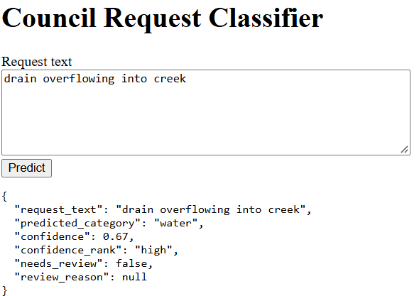
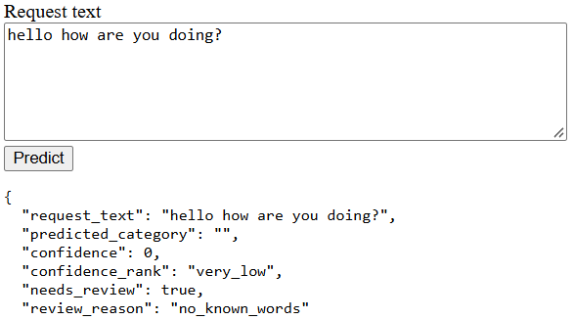
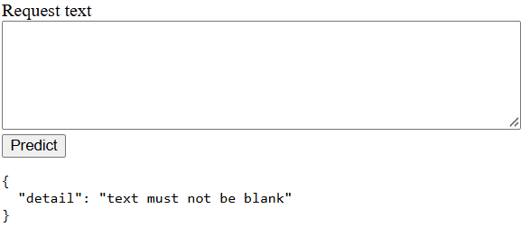
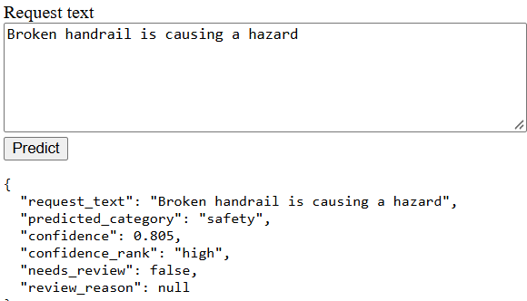
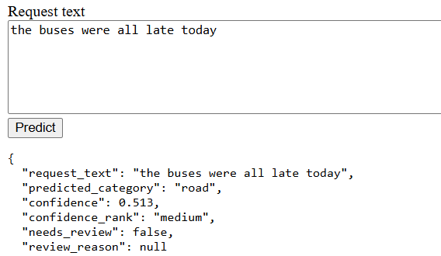
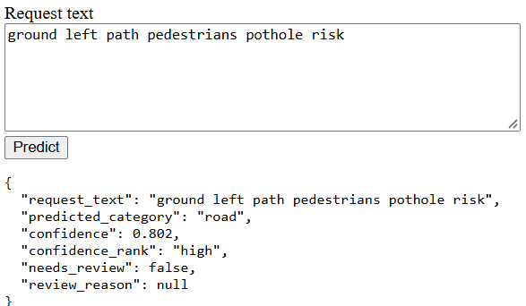
Figure 5.
Automated Test Results

