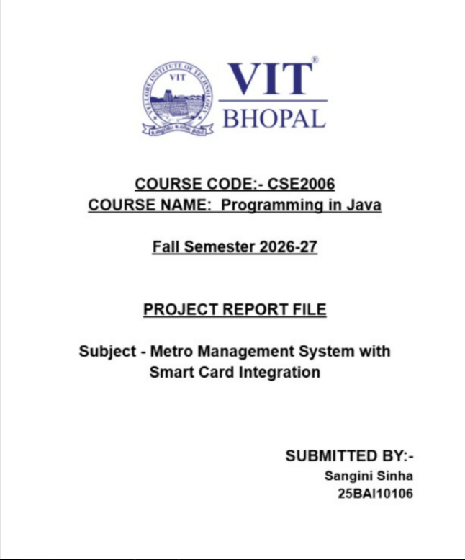

Table of Contents
1. Cover Page
2. Introduction
3. Problem Statement
4. Functional Requirements
5. Non-functional Requirements
6. System Architecture
7. Design Diagrams
7.1 Use Case Diagram
7.2 Workflow Diagram
7.3 Sequence Diagram
7.4 Class/Component Diagram
7.5 ER Diagram
8. Design Decisions & Rationale
9. Implementation Details
10. Screenshots / Results
11. Testing Approach
12. Challenges Faced
13. Learnings & Key Takeaways
14. Future Enhancements
15. References

2. Introduction
The Metro Management System with Smart Card Integration is a command-line based Java application that models a simplified digital metro travel workflow. The system combines Core Java, object-oriented programming, JDBC and MySQL to manage passengers, smart cards, stations, journeys and fare transactions.
A passenger can register or use the supplied demo account, obtain an active smart card, view its balance, recharge the card, select an entry station, complete a journey at an exit station and review journey history. Fare is calculated automatically from the distance between the selected stations.

2.1 Project Objectives
- Provide a simple digital alternative to repeated paper-ticket purchases.
- Demonstrate Java classes, inheritance, abstraction, encapsulation and polymorphism.
- Use JDBC to connect the Java application with a relational MySQL database.
- Automate fare calculation and balance deduction during journey completion.
- Maintain persistent records for passengers, smart cards, journeys and transactions.
- Demonstrate validation and exception handling for invalid user operations.

2.2 Scope
The prototype scope includes passenger registration and login, smart-card issuance, card recharge, station listing, metro entry/exit, distance-based fare calculation and journey history. It is intentionally a terminal application and does not attempt to emulate physical NFC readers, payment gateways, live train tracking or a production-grade authentication service.

3. Problem Statement
Traditional metro ticketing can require passengers to repeatedly purchase tickets, while manual recording of journeys and fares can increase processing time and the possibility of data-entry errors. Daily passengers benefit from a reusable payment mechanism in which a stored balance can be used for multiple journeys.
The project addresses this problem by modelling a smart-card workflow. A card is associated with a passenger; an entry creates an open journey; an exit triggers distance calculation, fare determination, balance validation, fare deduction and transaction logging. The result is a consistent digital record of the trip.

3.1 Proposed Solution
- Register or authenticate a passenger.
- Issue or retrieve an active smart card.
- Recharge the card when additional balance is required.
- Record the passenger's entry station.
- Record the exit station and calculate travel distance.
- Calculate fare using predefined distance slabs.
- Deduct the fare only when the card has sufficient balance.
- Store the completed journey and fare transaction in MySQL.

4. Functional Requirements
ID | Requirement | Description
FR-01 | Passenger Registration | Accept name, phone, optional email and password; validate required fields.
FR-02 | Passenger Login | Authenticate using phone number and password.
FR-03 | Demo Login | Provide a preloaded demo passenger for evaluation.
FR-04 | Smart Card Issuance | Create an active card with a generated card number and initial balance.
FR-05 | View Smart Card | Display card ID, card number, balance and status.
FR-06 | Recharge | Increase card balance and record a RECHARGE transaction.
FR-07 | Station Listing | Display stations with line name and distance from origin.
FR-08 | Start Journey | Validate card/station and create an OPEN journey.
FR-09 | End Journey | Validate exit station, calculate distance/fare, deduct balance and complete journey.
FR-10 | Journey History | Display previous journeys with entry, exit, fare and status.
FR-11 | Fare Information | Display the distance-to-fare slabs used by the application.
FR-12 | Validation/Error Handling | Reject invalid numbers, missing fields, duplicate phone numbers, invalid cards and insufficient balance.

5. Non-functional Requirements
Attribute | Requirement
Usability | Menu-driven CLI with clear prompts and success/error messages.
Reliability | Uses validation, SQL constraints and transactions for critical journey/fare updates.
Maintainability | Business logic is separated into MetroService, fare logic and domain classes.
Performance | The prototype uses direct JDBC queries and simple in-memory lists; suitable for academic/demo scale.
Portability | Designed for Java 17+ and can be launched from command line using run.bat or run.sh.
Data Integrity | Primary keys, foreign keys, unique constraints and transactional updates protect relationships.
Security | Prototype-level only; passwords are stored plainly and production deployment would require hashing.
Scalability | Architecture separates CLI, service logic and database access so components can be replaced or extended.

These requirements describe the prototype as an academic application rather than a production metro platform. In particular, the database connection configuration and password handling would require environment-based secrets and secure hashing in a real deployment.

6. System Architecture
The application follows a lightweight layered architecture. Main.java acts as the presentation layer and collects terminal input. MetroService contains the main business rules and coordinates database operations. Domain classes represent passengers, cards, stations and users. FareCalculator isolates the fare policy, while DatabaseConnection centralizes JDBC connectivity. MySQL stores persistent records.

6.1 Architecture Flow
- Presentation Layer → Main.java: menus, prompts, input collection and user-facing output.
- Business Layer → MetroService.java: registration, login, card, recharge and journey operations.
- Domain Layer → User, Passenger, Admin, SmartCard and Station: object representation.
- Utility/Rule Layer → FareCalculator.java and ValidationException.java.
- Data Access Layer → DatabaseConnection.java and JDBC PreparedStatements.
- Database Layer → MySQL database named metro_system.

6.2 Technology Stack
Technology | Role
Java 17+ | Application language and object-oriented implementation.
Core Java | CLI, collections, exception handling and object model.
JDBC | Database connectivity and parameterized SQL execution.
MySQL 8+ | Persistent relational data storage.
MySQL Connector/J | JDBC driver required to connect Java to MySQL.
Command Line | User interface and project evaluation environment.

7. Design Diagrams
The diagrams below document the system from different perspectives: user interactions, process flow, message sequence, software structure and relational data design.

7.1 Use Case Diagram
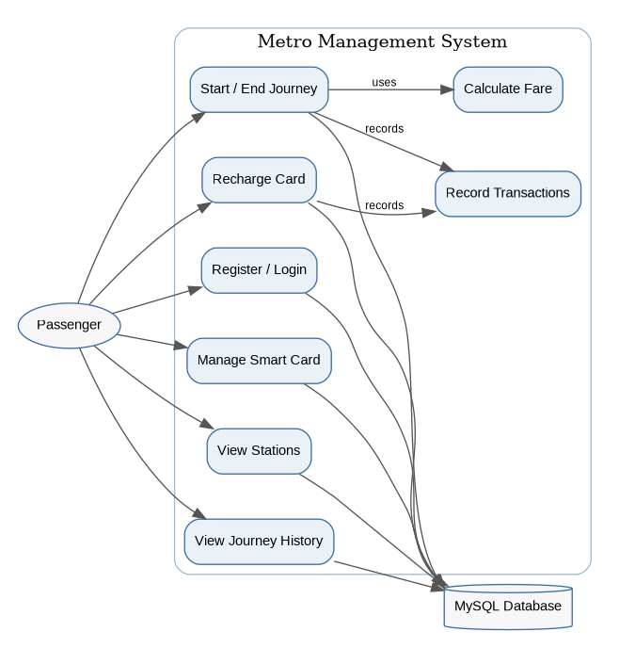
Figure 7.1 — Use case view of the Metro Management System.

7.2 Workflow Diagram
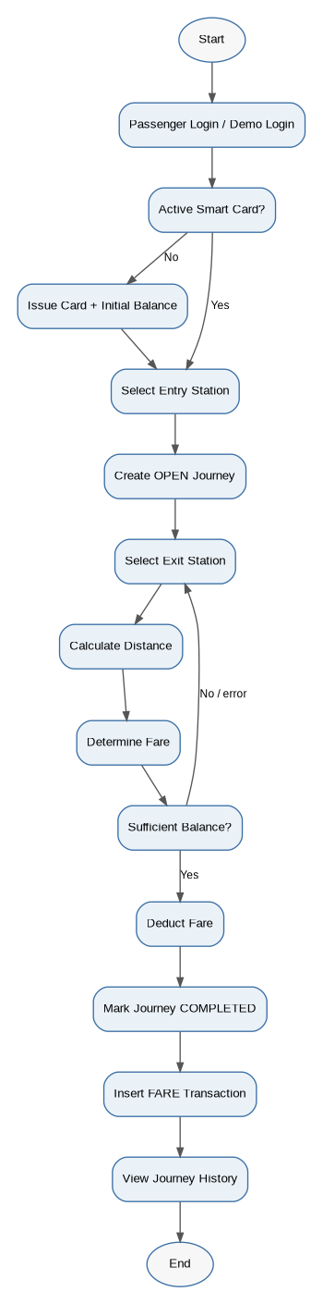
Figure 7.2 — Passenger journey and fare-processing workflow.

7.3 Sequence Diagram
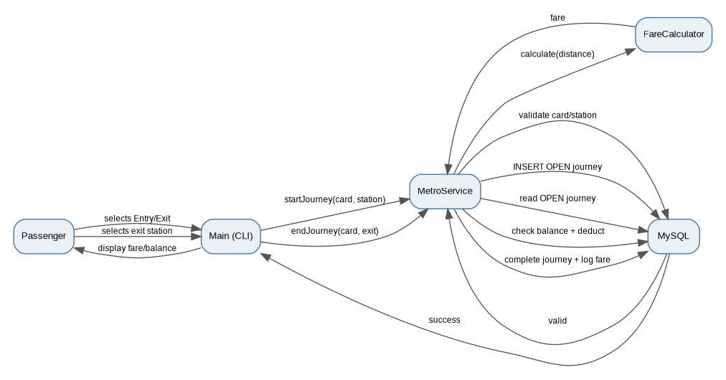
Figure 7.3 — Sequence for starting and completing a journey.

7.4 Class/Component Diagram
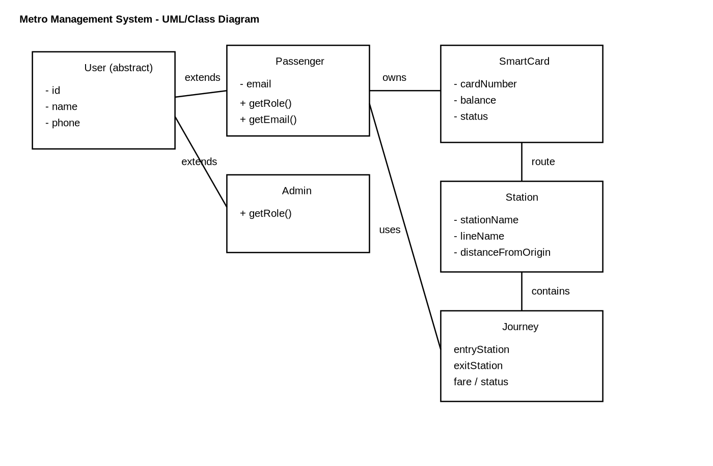
Figure 7.4 — Project class structure / component organization.
The implemented object model uses User as an abstract superclass. Passenger and Admin inherit from User and override getRole(). SmartCard and Station are independent domain classes. MetroService coordinates these objects and the database operations.

7.5 ER Diagram
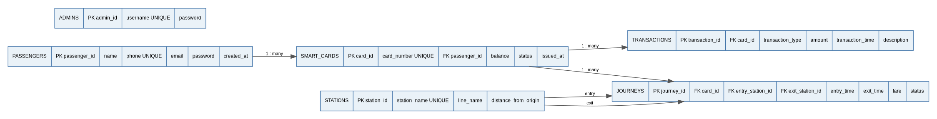
Figure 7.5 — Relational data model used by the MySQL database.

8. Design Decisions & Rationale
Decision | Rationale
CLI instead of GUI | The project is intentionally executable from a terminal, reducing setup complexity and making core Java logic easy to evaluate.
Service layer | MetroService centralizes business rules so Main.java remains focused on interaction and display.
PreparedStatements | Parameterized SQL reduces SQL-injection risk and keeps database calls structured.
Database transactions | Recharge and journey completion use transaction control so related updates can commit together or roll back on failure.
Distance-based fare | Station distance values provide a simple deterministic basis for the academic fare model.
Generated card number | UUID-derived identifiers avoid dependence on manually entered card numbers.
Custom ValidationException | Domain-specific validation errors can be shown as readable CLI messages.
Relational schema | Separate tables for passengers, cards, stations, journeys and transactions preserve data relationships and history.

9. Implementation Details

9.1 Main Classes
Class/File | Responsibility
Main.java | CLI entry point, menus, input collection and user-facing output.
MetroService.java | Registration, login, smart card, recharge, station and journey business logic.
DatabaseConnection.java | Creates JDBC connections to MySQL.
User.java | Abstract base class containing common user attributes and getRole().
Passenger.java | Passenger specialization with optional email.
Admin.java | Admin specialization of User.
SmartCard.java | Card number, balance, status and card ID.
Station.java | Station identity, line and distance from origin.
FareCalculator.java | Converts journey distance into fare slabs.
ValidationException.java | Custom checked exception for invalid operations.

9.2 Fare Calculation Logic
Distance | Fare
0–5 km | ₹10
>5–10 km | ₹20
>10–20 km | ₹30
>20 km | ₹40

During endJourney(), the application reads the entry and exit station distances, takes the absolute difference, passes that value to FareCalculator.calculate(), checks the card balance and then performs the balance deduction, journey completion and transaction insertion inside a database transaction.

9.3 Database Schema
Table | Purpose | Important Relationships
admins | Stores administrator credentials for future administrative features. | Standalone in current prototype.
passengers | Stores passenger account data. | One passenger can have smart cards.
stations | Stores station name, line and distance. | Referenced by journey entry/exit.
smart_cards | Stores card number, balance and status. | Belongs to passenger; referenced by journeys/transactions.
transactions | Stores recharge and fare records. | Belongs to a smart card.
journeys | Stores entry/exit stations, timestamps, fare and status. | References card and stations.

9.4 Project Structure
MetroManagementSystem_CLI/
├── src/metro/
│ ├── Main.java
│ ├── MetroService.java
│ ├── DatabaseConnection.java
│ ├── User.java
│ ├── Passenger.java
│ ├── Admin.java
│ ├── SmartCard.java
│ ├── Station.java
│ ├── FareCalculator.java
│ └── ValidationException.java
├── sql/metro_system.sql
├── docs/
│ ├── PROJECT_REPORT.md
│ ├── Project_Report.docx
│ ├── Metro_Project_PPT.pptx
│ └── UML_Class_Diagram.svg
├── run.bat
└── run.sh

10. Screenshots / Results
The following five terminal-output figures document the principal user-visible results of the project. They are representative CLI outputs based directly on the application's implemented menus, messages and the demo records included in metro_system.sql.
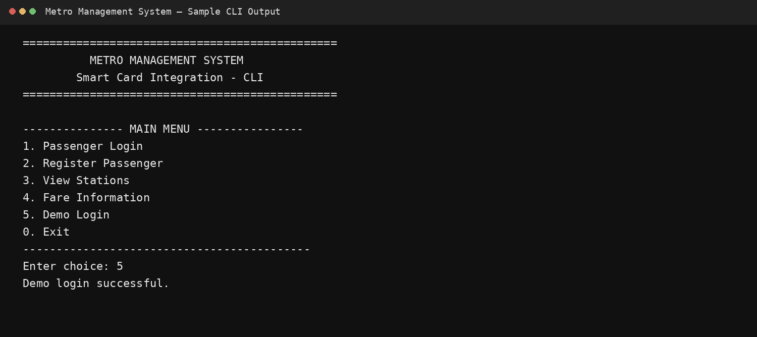
Figure 10.1 — Main menu and demo login.
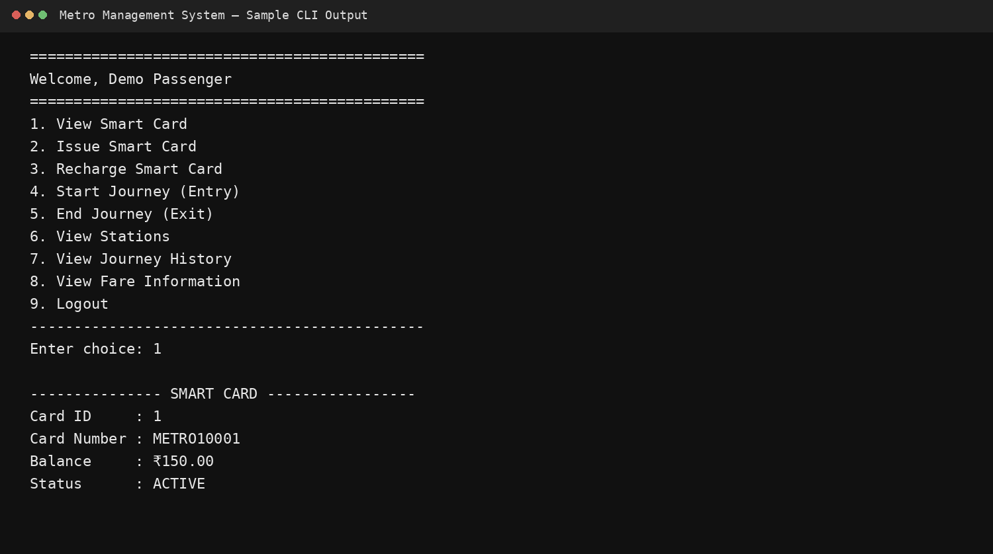
Figure 10.2 — Passenger menu and active smart-card details.
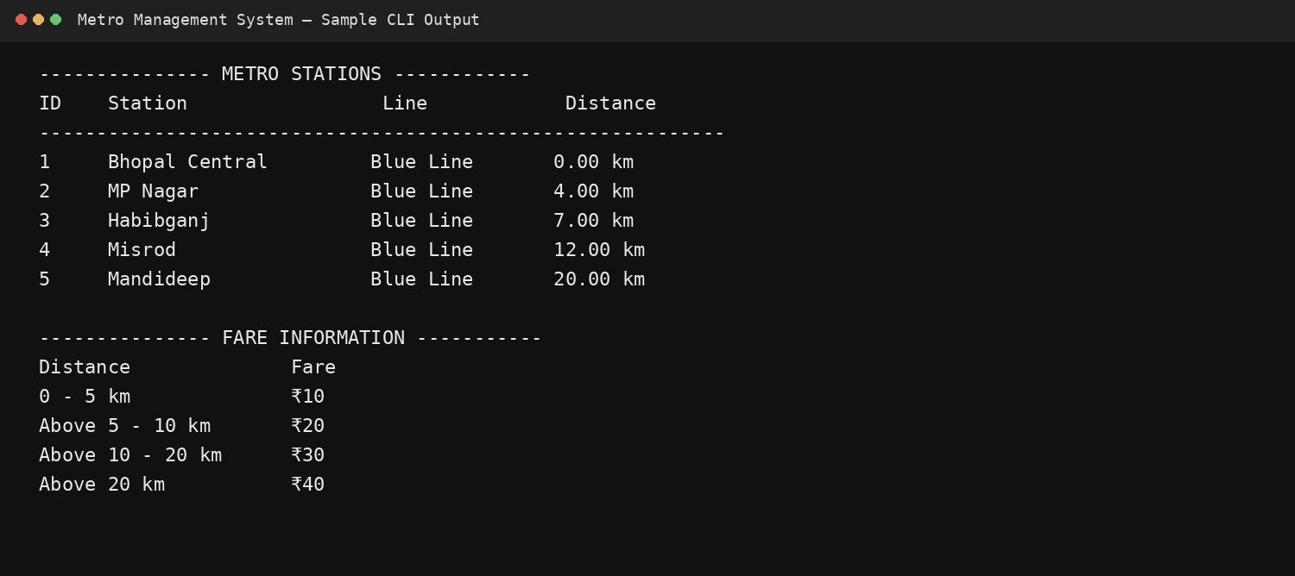
Figure 10.3 — Station listing and fare information.
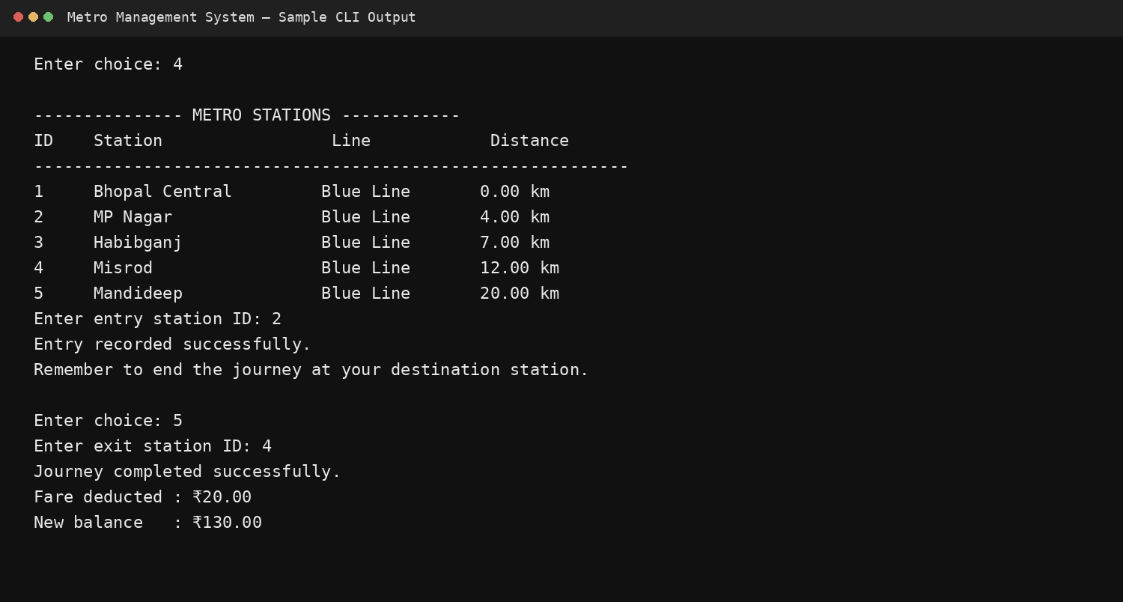
Figure 10.4 — Journey entry/exit and automatic fare deduction.
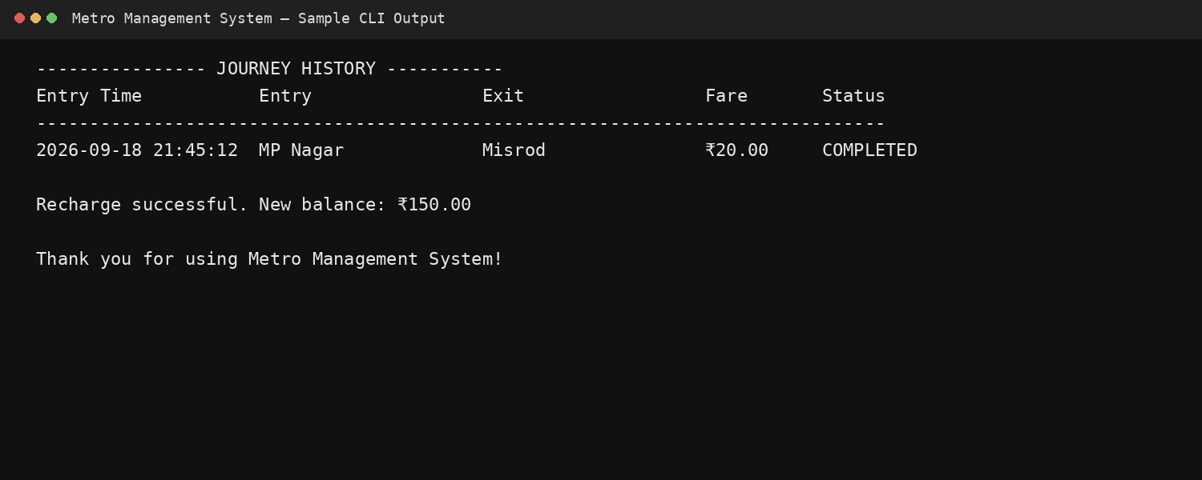
Figure 10.5 — Journey history and completion output.

11. Testing Approach
Testing is organized around functional scenarios and validation cases. The aim is to verify both successful operations and the error-handling paths implemented in MetroService and Main.
ID | Test | Input/Scenario | Expected Result
TC-01 | Demo login | Use preloaded demo credentials | Passenger menu opens
TC-02 | Registration validation | Blank name/phone/password | Validation message is displayed
TC-03 | Phone validation | Phone with non-digit or invalid length | Registration is rejected
TC-04 | Duplicate phone | Register an existing phone number | Database constraint is converted to readable validation error
TC-05 | Card display | View active demo card | Card number, balance and ACTIVE status shown
TC-06 | Recharge | Recharge with positive amount | Balance increases and RECHARGE transaction is stored
TC-07 | Recharge validation | Recharge with zero/negative value | Operation rejected
TC-08 | Start journey | Select valid entry station | OPEN journey created
TC-09 | Duplicate open journey | Start another journey before exit | Operation rejected
TC-10 | End journey | Select valid exit station with sufficient balance | Fare calculated, balance deducted, journey completed
TC-11 | Insufficient balance | Attempt journey with balance below fare | Operation rejected and transaction is rolled back
TC-12 | History | View journey history | Completed/open journeys are displayed
TC-13 | CLI help | Run Main with --help | Usage instructions displayed

11.1 Test Strategy
- Positive testing for normal passenger workflows.
- Boundary testing for fare slabs at 5, 10 and 20 km.
- Validation testing for missing fields and invalid numeric input.
- Database integrity testing through unique and foreign-key constraints.
- Transaction testing for recharge and end-journey operations.
- Regression checks after changes to fare, card and journey logic.

12. Challenges Faced
- Coordinating console input with database operations while keeping user messages clear.
- Maintaining consistent smart-card state across registration, issuance, recharge and journey operations.
- Ensuring that an open journey cannot be duplicated for the same card.
- Keeping fare deduction, journey completion and transaction logging consistent through database transactions.
- Handling invalid user input without terminating the CLI application.
- Balancing academic simplicity with production concerns such as password security and physical smart-card integration.

12.1 Resolution Approach
The implementation separates business operations into MetroService, uses ValidationException for expected validation failures, uses PreparedStatements for SQL calls and uses commit/rollback around critical multi-step operations. This keeps the main menu readable and makes the core workflow easier to test.

13. Learnings & Key Takeaways
- Object-oriented design becomes clearer when domain entities and responsibilities are separated into classes.
- Inheritance and abstraction can reduce duplication for related user types.
- JDBC provides a direct way to connect Java business logic with persistent relational data.
- PreparedStatements and database constraints are important even in small academic applications.
- Transactions are necessary when one user action changes several related records.
- Input validation is part of application design, not an optional add-on.
- A simple CLI can still demonstrate complete application flow when the requirements are well structured.
- Clear diagrams help communicate the same system at user, process, software and data levels.

14. Future Enhancements
Enhancement | Description
NFC/Smart-card hardware | Connect physical readers so entry and exit can be triggered by a real card.
QR ticketing | Add QR-based temporary tickets for users without reusable cards.
Online payment gateway | Allow secure digital recharge through UPI/cards/net banking.
Mobile application | Expose registration, balance, recharge and journey history through Android/iOS.
Monthly passes | Add pass products and configurable eligibility/validity rules.
Real-time train tracking | Integrate live train positions, platform information and arrival estimates.
Admin dashboard | Add station, passenger, card, fare and transaction administration.
Secure authentication | Replace plain-text passwords with salted hashing and secure session management.
Cloud deployment | Move the database and service layer to managed cloud infrastructure.
Analytics | Generate usage, revenue, peak-hour and station-demand reports.

15. References
1. Project source code — Main.java, MetroService.java, DatabaseConnection.java, FareCalculator.java and domain classes included in the submitted project archive.
2. Project database script — sql/metro_system.sql, containing schema definitions, relationships and demo data.
3. Project README — README.md, containing project overview, technology stack, setup and command-line execution guidance.
4. UML class diagram — docs/UML_Class_Diagram.svg included in the submitted project archive.
5. Oracle Java Documentation — Java language and standard library concepts used by the project.
6. MySQL Documentation — relational database, SQL, constraints and transaction concepts relevant to the implementation.
7. MySQL Connector/J Documentation — JDBC driver and Java-to-MySQL connectivity reference.
— End of Project Report —

