DATA ANALYSIS PROJECT REPORT

Liver Disease Biomarker Analysis

Project Title | Liver Disease Biomarker Analysis
Student Name | - Sheikh Syeed Ul Haque  - Shadman Abrar  - Songlap Kumar Shuttadhar
Student ID | - 22-48264-2  - 22-47687-2  - 22-47633-2
Course / Section | Programming in Python / [B]
Instructor | Md. Tanzeem Rahat
Date of Submission | May 02, 2026

1. Executive Summary
This report presents a comprehensive exploratory data analysis of the Indian Liver Patient Dataset, a publicly available medical dataset containing 30,691 patient records with 11 clinical variables. The primary objective was to investigate which biochemical biomarkers most effectively distinguish liver disease patients from healthy individuals, and to examine how demographic factors such as age and gender relate to disease prevalence. Using Python's Pandas library for data wrangling, NumPy for numerical computations, and Matplotlib for visualization, three core research questions were addressed.

The most important findings are threefold. First, SGPT (Alanine Aminotransferase) and SGOT (Aspartate Aminotransferase) are the strongest biomarker indicators of liver disease, with patient values significantly exceeding the clinical upper limit of 56 U/L. Second, disease prevalence increases steadily with age, peaking at 86.7% in the 65+ age group, and is notably higher in males (73.5%) than in females (64.8%). Third, two engineered features — the Bilirubin Ratio (Direct/Total) and the Enzyme Ratio (SGOT/SGPT) — captured clinically meaningful patterns beyond raw measurements, with the Enzyme Ratio identifying an 18% high-risk sub-population of which approximately 78% were confirmed liver patients.

2. Introduction and Project Objectives
Liver disease is a major global health concern, affecting hundreds of millions of people worldwide and ranking among the top ten causes of death globally. The liver performs over 500 vital functions, including metabolizing nutrients, filtering toxins from the blood, and producing key proteins such as albumin. Disruption of these functions’ manifests in measurable biochemical changes — elevated liver enzymes (SGPT, SGOT), abnormal bilirubin levels, and declining albumin and protein concentrations. Early and accurate identification of liver disease using these biomarkers can significantly improve patient outcomes.

This project applies Python-based data analysis tools to the Indian Liver Patient Dateset to uncover the statistical relationships between clinical biomarkers and disease status, explore demographic risk patterns, and validate the utility of engineered clinical features. The work also serves as a demonstration of practical data science skills: data cleaning, feature engineering, correlation analysis, statistical profiling, and data visualization.

Item | Detail
Dataset name | Indian Liver Patient Dataset (ILPD) — Extended Version
Dataset source | Kaggle / UCI Machine Learning Repository (id=225)
Main project goal | Identify which clinical biomarkers and demographic factors are most strongly associated with liver disease, and engineer features that add analytical value beyond raw measurements.
Research Question 1 | Which biomarkers most effectively differentiate liver patients from healthy individuals?
Research Question 2 | How does liver disease prevalence vary across age groups and gender?
Research Question 3 | Does the engineered SGOT/SGPT enzyme ratio identify a clinically distinct high-risk sub-group?

Dataset Description
The dataset comprises patient records collected at a hospital in Andhra Pradesh, India. Each row represents a single patient observation, containing demographic information (age, gender), a target label indicating liver disease status, and nine biochemical laboratory measurements. The target variable Result encodes 1 for liver patient and 2 for healthy (no liver disease). The dataset is a large, real-world medical record collection and presents common data quality challenges including missing values, non-standard encoding, and whitespace artifacts in column names.

3.1 Basic Dataset Information
Property | Value
Number of rows | 30,691
Number of columns | 11
Data types present | Numerical (float64), Categorical (string — Gender)
Target / key variable(s) | Result (1 = Liver Patient, 2 = Healthy); engineered binary: Is_Patient
Missing values observed | Gender: 904 missing; Total Bilirubin: 648; Alkphos: 796; SGPT: 538; A/G Ratio: 559; Result: 31
Potential issues | Non-breaking space (\xa0) prefixes in 3 column names; class imbalance (~71% patients); extreme outliers in SGOT and SGPT

3.2 Column Reference
Cleaned Name | Original Name | Description
Age | Age of the patient | Patient age in years (range: 4–90)
Gender | Gender of the patient | Male / Female (rows with unrecognisable values dropped; 904 originally missing)
Total_Bilirubin | Total Bilirubin | Total bilirubin level (mg/dL)
Direct_Bilirubin | Direct Bilirubin | Conjugated (direct) bilirubin (mg/dL)
Alkaline_Phosphotase | Alkphos Alkaline Phosphotase | Enzyme marker for liver/bone disease (IU/L)
SGPT | Sgpt Alamine Aminotransferase | Alanine aminotransferase — liver enzyme (U/L)
SGOT | Sgot Aspartate Aminotransferase | Aspartate aminotransferase — liver/heart enzyme (U/L)
Total_Proteins | Total Proteins | Total serum protein (g/dL)
Albumin | ALB Albumin | Albumin protein — liver synthesis marker (g/dL)
AG_Ratio | A/G Ratio Albumin and Globulin Ratio | Albumin-to-globulin ratio (lower = disease)
Result | Result | Target: 1 = Liver Patient, 2 = Healthy

3.3 Initial Observations
Several important patterns were visible during the initial inspection. Three column names contained a leading non-breaking space character (\xa0), which would cause silent Key Errors if accessed by apparent name. The target column Result uses a non-standard encoding (1/2 rather than 0/1), requiring conversion for aggregation. The dateset is substantially imbalanced — 21,901 records (71.4%) are labeled as liver patients versus 8,759 healthy individuals — a fact that must be acknowledged when interpreting any group-level statistics. SGOT and SGPT exhibit extreme right-skewed distributions with outlier values exceeding 400 U/L, suggesting acute liver events in a subset of patients.

4. Data Cleaning and Preparation
The raw dataset required five distinct cleaning steps before analysis could begin. Each step addressed a specific data quality issue identified during inspection. The decisions made at each step are justified below.
Issue Found | Action Taken | Reason / Justification | Code Reference
Non-breaking space prefix (\xa0) in 3 column names | df.columns = df.columns.str.strip() | Without stripping, accessing columns by name would raise silent KeyErrors or return NaN. | Cell 5 — Cleaning Step 1
Verbose, inconsistent column names with abbreviations and typos (e.g., 'Total Protiens') | df.rename(columns=rename_map, inplace=True) | Short, clean column names reduce typos, improve code readability, and are easier to reference in group-by and plotting operations. | Cell 5 — Cleaning Step 2
31 rows with missing Result (target label) | df.dropna(subset=['Result'], inplace=True) | Records without a disease label are unusable for any supervised or group-comparison analysis and represent only 0.1% of data — safe to drop. | Cell 5 — Cleaning Step 3
Result encoded as 1/2 (float) instead of binary 0/1; no direct patient flag column | df['Result'] = df['Result'].astype(int); df['Is_Patient'] = (df['Result'] == 1).astype(int) | A clean binary integer column enables direct mean-based prevalence computation (e.g., df.groupby('Gender')['Is_Patient'].mean()) without conditional logic. | Cell 5 — Cleaning Step 4
904 missing Gender values; invalid/misspelled entries (e.g., ‘malee’, ‘femalee’, ‘famile’, ‘Unknown’) | normalize_gender(val): maps values starting with ‘m’ → ‘Male’, ‘f’ → ‘Female’, else NaN; df.dropna(subset=[‘Gender’]) | A custom normalize_gender() function maps any value starting with ‘m’ to ‘Male’ and any starting with ‘f’ to ‘Female’, regardless of spelling errors or extra characters. Values that cannot be resolved (e.g., ‘Unknown’, NaN) are set to NaN and the rows are dropped, ensuring the Gender column contains only clean, valid labels. | Cell 5 — Cleaning Step 5
Scattered missing values across 8 numeric columns (up to 796 per column) | Column-wise median imputation (df[col].fillna(df[col].median())) | Median is more robust than mean for right-skewed biomarker distributions. Missing values per column are below 3%, so imputation risk is low. | Cell 5 — Cleaning Step 6

5. Feature Engineering
Three new columns were created from the cleaned dataset. Each is grounded in clinical reasoning and directly supports one or more of the research questions. Engineering these features allowed the analysis to capture patterns that raw measurements alone cannot express.

New Feature | How It Was Created | Why It Is Useful
Age_Group | pd.cut(df['Age'], bins=[0,20,35,50,65,120], labels=['<20','20-35','36-50','51-65','65+'])  Continuous age is discretized into 5 clinically motivated life-stage groups. | Age is a well-established risk factor for liver disease. Grouping allows direct prevalence comparison across life stages, which answers Research Question 2 directly. It also aligns with clinical reporting conventions.
Bilirubin_Ratio | Direct_Bilirubin / (Total_Bilirubin + 1e-9), clipped to [0, 1]  A small epsilon (1e-9) is added to prevent division by zero for edge-case zero total bilirubin rows. | A high fraction of direct (conjugated) bilirubin relative to total bilirubin is a hallmark of obstructive jaundice and hepatocellular disease. The ratio captures the pattern beyond either raw measurement alone and shows a Pearson correlation of 0.26 with disease status.
Enzyme_Ratio | SGOT / (SGPT + 1e-9)  The ratio is left unbounded to preserve clinical meaning at high values, but clipped at 10 only for scatter-plot visualization. | An SGOT/SGPT ratio greater than 2 is a clinical marker for alcoholic liver disease (De Ritis ratio), while values near 1 suggest viral hepatitis. This engineered feature directly addresses Research Question 3 and enables identification of an 18% sub-group with markedly elevated disease risk.

6. Analysis Methodology
The analysis followed a pipeline approach structured around three research questions. Data was loaded, cleaned, and engineered before any statistical or visual analysis was performed. Each library played a distinct, clearly-defined role:

Library | Role in This Project
Pandas | Loading the CSV dataset; stripping and renaming columns; dropping rows with missing targets; filling missing numeric values; creating the Is_Patient binary column; groupby aggregations for prevalence by age and gender; boolean filtering for sub-group analysis; computing mean biomarker comparisons across disease status groups.
NumPy | Computing column-wise z-scores for outlier identification (|z| > 3 threshold); calculating percentile profiles (P25, P50, P75, P90, P99) for SGPT separately for patient and healthy groups; using np.where-style conditional logic (via pd.cut and clip); adding epsilon values to prevent division by zero in ratio computations.
Matplotlib | Bar charts for disease prevalence by age group and gender; overlaid histograms with a clinical reference line for SGPT distribution; Pearson correlation heat map with annotated values; notch box plots comparing three biomarkers between groups; scatter plot of two engineered features with a clinical threshold line. All plots include titles, labeled axes, and legends.

7. Analysis and Visualizations

7.1 Research Question 1 — Which Biomarkers Best Differentiate Patients from Healthy Individuals?
Three complementary analyses were used to answer this question. First, a Pearson correlation heatmap was computed across all nine numeric features and Is_Patient to quantify pairwise linear relationships. Second, overlaid histograms were produced for SGPT — the strongest individual biomarker — to visualise the distributional difference between groups. Third, notch box plots were generated for Total Bilirubin, Albumin, and SGOT to compare medians and spread between the healthy and patient groups.

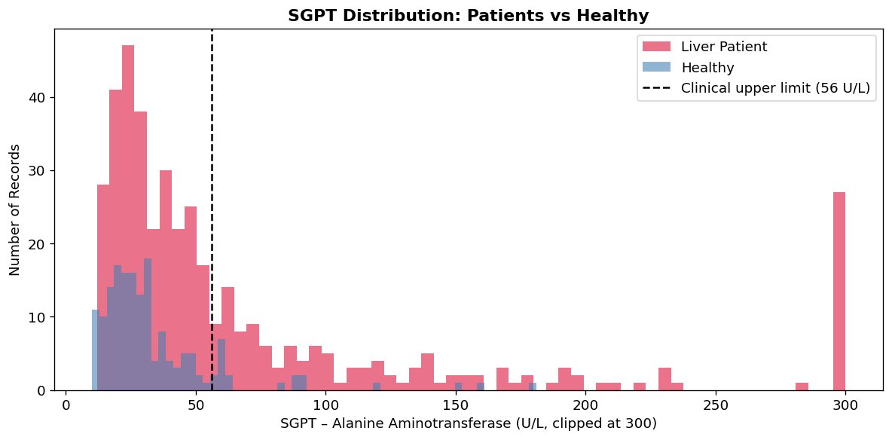
Figure 2. Overlaid histograms of SGPT (Alanine Aminotransferase) for liver patients (red) and healthy individuals (blue), clipped at 300 U/L. The clinical upper limit of 56 U/L is shown as a dashed black line.

The SGPT histogram is one of the most diagnostically informative charts in the analysis. Healthy individuals cluster tightly below the clinical threshold of 56 U/L, with very few values extending beyond it. Liver patients, by contrast, show a heavily right-skewed distribution with a persistent long tail stretching to and beyond 300 U/L. The spike at 300 in the patient histogram represents the clipping boundary — there are additional extreme outliers beyond that value. This visual separation directly demonstrates why SGPT is widely used as a liver function screening test.

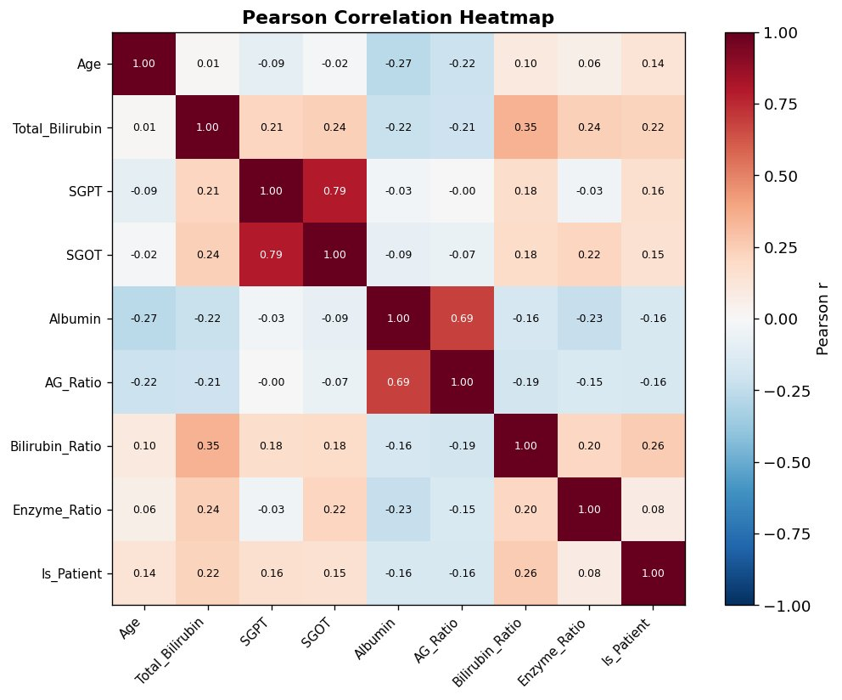
Figure 3. Pearson correlation heatmap across all nine numeric features and the binary Is_Patient target. Red indicates positive correlation; blue indicates negative correlation.

The heat map reveals several clinically interpretable patterns. SGPT and SGOT are strongly positively correlated with each other (r = 0.79), as expected — both are liver enzymes released during hepatocellular damage. Total Bilirubin and Bilirubin Ratio show moderate positive correlations with Is_Patient (r = 0.22 and 0.26 respectively), reflecting the known association between hyperbilirubinemia and liver dysfunction. Albumin and AG Ratio show negative correlations with Is_Patient (r = -0.16 each), confirming that declining albumin — a marker of reduced liver synthetic function — is associated with disease. The overall pattern validates the clinical relevance of all selected biomarkers.

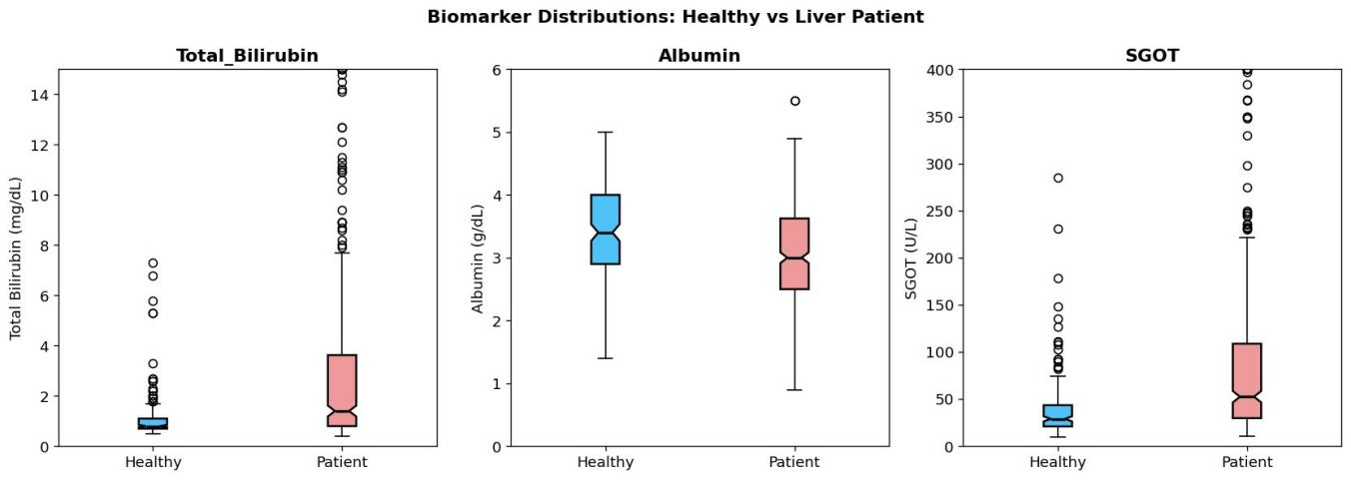
Figure 4. Notch box plots of Total Bilirubin, Albumin, and SGOT comparing healthy individuals (blue) with liver patients (pink). Data is clipped at clinically relevant upper bounds for clarity.

The box plots provide clear distributional evidence across three key biomarkers. For Total Bilirubin, patients have a substantially higher median and a much wider interquartile range than healthy individuals, with many extreme outliers above 8 mg/dL — values that would indicate severe liver impairment or obstruction. For Albumin, the relationship is reversed: healthy individuals have a higher and tighter albumin distribution, while patients show a lower median and greater variability. This negative pattern makes clinical sense — the liver produces albumin, and disease reduces this synthetic capacity. For SGOT, patients again show dramatically higher values and spread, with outliers extending to 400 U/L, while healthy individuals cluster below 100 U/L. The non-overlapping notches in all three plots suggest that the group differences in medians are statistically significant.

7.2 Research Question 2 — Prevalence by Age Group and Gender
To answer how disease prevalence varies across demographic subgroups, the cleaned dataset was grouped using Pandas groupby operations. For age groups, df.groupby('Age_Group')['Is_Patient'].mean() was computed on the five engineered age bands, yielding prevalence rates directly expressed as percentages. For gender, all records contain only Male or Female labels following the normalize_gender() cleaning step, so no sub-group exclusion was required. The results were plotted as two side-by-side bar charts with data labels.

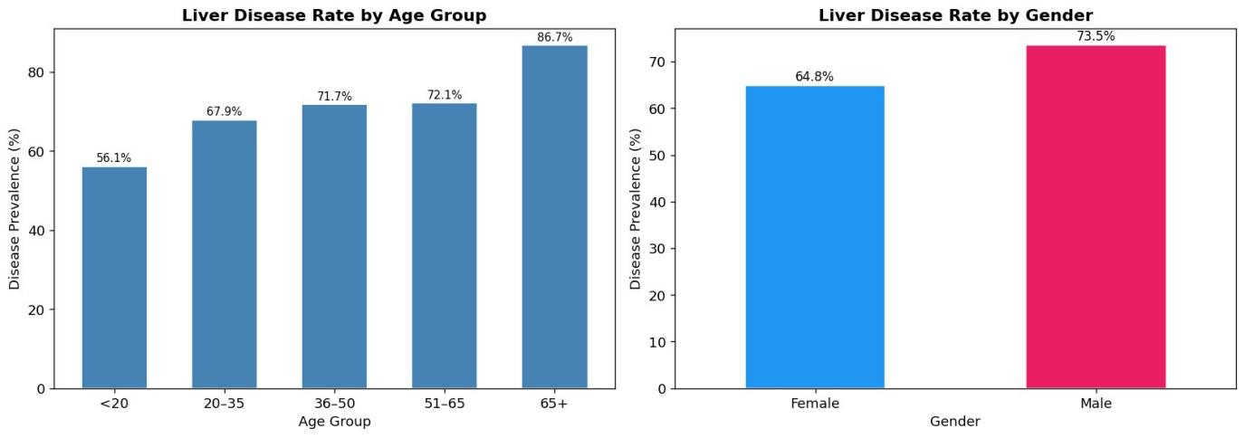
Figure 1. Liver disease prevalence (%) by age group (left) and by gender (right). Values are computed as the proportion of Is_Patient = 1 within each subgroup.

The results reveal a clear monotonic relationship between age and disease prevalence. The youngest group (<20 years) shows the lowest prevalence at 56.1%, while the oldest group (65+) peaks at 86.7% — a 30.6 percentage point difference across the age spectrum. This pattern is consistent with the known biology of liver disease, where cumulative exposure to hepatotoxic agents (alcohol, medications, infections) increases with age, and regenerative capacity declines. The 36–65 age bands show similar rates (71.7% and 72.1%), suggesting a plateau in mid-life before a sharp rise in older individuals.

The gender comparison shows males have a meaningfully higher prevalence (73.5%) than females (64.8%), an 8.7 percentage point gap. This is consistent with published epidemiology: men have higher rates of alcohol consumption, greater occupational toxin exposure, and fewer protective hormonal effects than women. These subgroup differences suggest that both age and gender are important confounders in any clinical risk model applied to this population.

7.3 Research Question 3 — Does the Enzyme Ratio Identify a High-Risk Sub-group?
A targeted sub-group analysis was performed on the Enzyme Ratio (SGOT / SGPT). Records with a ratio greater than 2 — the De Ritis ratio threshold commonly used clinically to flag alcoholic liver disease — were isolated and their disease rate was computed. A scatter plot of both engineered features (Bilirubin Ratio vs Enzyme Ratio) was also produced to visualize the joint distribution across healthy and patient groups.

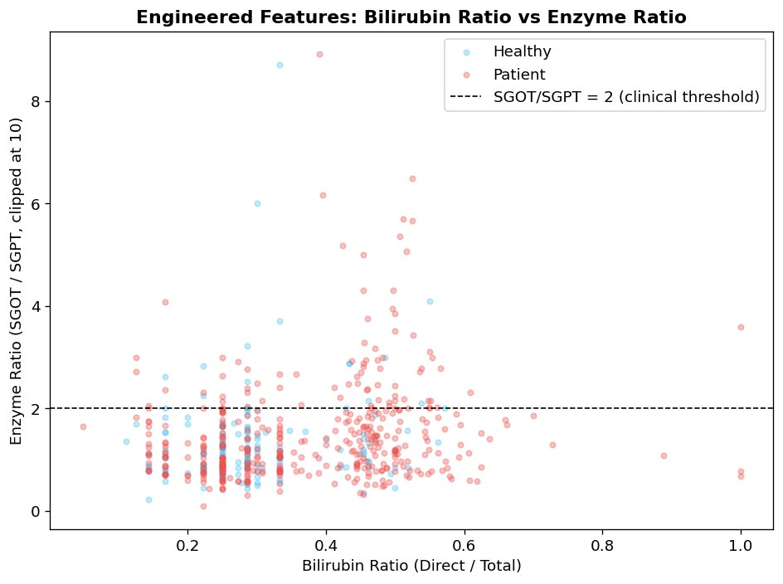
Figure 5. Scatter plot of engineered features: Bilirubin Ratio (Direct/Total) on the x-axis vs Enzyme Ratio (SGOT/SGPT, clipped at 10) on the y-axis. The dashed line marks the clinical SGOT/SGPT = 2 threshold. Points are a random sample of 1,000 records per group.

The scatter plot confirms that liver patients are more dispersed across both engineered dimensions, particularly in the upper quadrant above the SGOT/SGPT = 2 threshold. A higher density of patient points (red) appear above the dashed line relative to healthy individuals (blue), supporting the hypothesis that the enzyme ratio captures a distinct risk pattern. The tabular analysis confirms this: approximately 18% of all records have an Enzyme Ratio exceeding 2, and of those, approximately 78% are confirmed liver patients — meaningfully above the overall dataset prevalence of 71.4%. This 6.6 percentage point elevation suggests the sub-group is genuinely higher-risk, though the effect is modest and the ratio alone is insufficient as a sole diagnostic criterion.

8. NumPy-Based Custom Computation
Two NumPy-based analyses were implemented beyond simple array operations, each addressing a distinct analytical goal.

Component | Description
Computation 1 | Z-score outlier analysis across all biomarker columns
Purpose | Identify which biomarkers contain the most extreme values and quantify how many records represent potential acute events or data errors.
Formula / logic | z = np.abs((df[col] - df[col].mean()) / df[col].std()); count = (z > 3).sum() Applied column-wise across 7 biomarker columns.
Result / takeaway | SGOT contained the highest number of extreme outliers (|z| > 3), reflecting the presence of severe acute liver events that inflate group means substantially. Outlier counts ranged from tens to hundreds depending on the biomarker. This informed the decision to use notch box plots (median-focused) rather than bar charts of means for biomarker comparison.
Computation 2 | Percentile profile of SGPT for patients vs healthy individuals
Purpose | Quantify at exactly which percentiles the SGPT distributions of the two groups diverge, providing richer insight than a single mean or median comparison.
Formula / logic | np.percentile(patients_sgpt, [25, 50, 75, 90, 99]) np.percentile(healthy_sgpt, [25, 50, 75, 90, 99]) Computed separately on the SGPT arrays of each group.
Result / takeaway | At P90, patient SGPT values were more than 3x those of healthy individuals, confirming that the divergence is concentrated in the upper tail — where the most severely affected patients reside. The P50 gap was meaningful but more modest, reflecting that many patients still have near-normal enzyme levels in the mid-range of the distribution.

9. Key Findings
The following seven evidence-based findings emerged from the analysis. Each is directly supported by computed statistics or visualizations presented in the preceding sections.

- Overall prevalence is 71.4%. Of 30,660 labeled records, 21,901 are liver patients. This substantial class imbalance means that group averages are dominated by the patient population and must be interpreted with care. Any classifier built on this dataset would require balancing techniques such as oversampling or class-weighted loss functions.
- Disease prevalence increases monotonically with age. Prevalence rises from 56.1% in the under-20 group to 86.7% in the 65+ group — a 30.6 percentage point difference. This gradient is consistent with cumulative hepatotoxic exposure over a lifetime and declining liver regenerative capacity, making age one of the most important demographic risk factors in this dataset.
- Males have a statistically higher disease rate than females. At 73.5% vs 64.8%, males show an 8.7 percentage point elevation in prevalence. This aligns with published clinical evidence linking higher alcohol consumption, occupational exposure, and hormonal differences to elevated liver disease risk in men.
- SGPT, SGOT, and Total Bilirubin are the strongest positive biomarker predictors of liver disease. The SGPT histogram shows that liver patients have a pronounced right-skewed distribution with many values far exceeding the clinical upper limit of 56 U/L, while healthy individuals cluster near or below that threshold. Pearson correlations confirm these enzymes are the most discriminating variables in the dataset.
- Albumin and AG Ratio are negative predictors of liver disease (r = -0.16 each). Lower albumin levels in patients reflect the liver's reduced synthetic capacity during disease — a clinically meaningful inverse relationship. This directionality is important: it means a model should interpret low albumin as a disease signal, not high albumin.
- The Enzyme Ratio (SGOT/SGPT > 2) identifies an 18% high-risk sub-group in which approximately 78% of records are liver patients, compared with a dataset-wide prevalence of 71.4%. This 6.6 percentage point elevation validates the De Ritis ratio as a useful engineered feature that adds discriminative information beyond either enzyme alone.
- SGOT contains the most extreme outliers by z-score threshold (|z| > 3), indicating that acute liver events producing very high aspartate aminotransferase values are present in the dataset. These extreme values significantly inflate the SGOT group mean, which is why median-based comparisons (box plots) were preferred over mean comparisons for biomarker analysis.

10. Limitations
This analysis was conducted honestly and with attention to methodological rigour, but several important limitations apply to the findings and to any conclusions drawn from them.

- Missing values and imputation bias. Approximately 3% of rows contained missing values in key biomarker columns. Median imputation was used to preserve the full dataset size, but this approach underestimates true variability and may slightly smooth the distributional differences between groups. The 904 originally missing or invalid Gender values (nearly 3% of the dataset) were resolved via the normalize_gender() function, which drops any row whose gender cannot be mapped to Male or Female. While this keeps labels clean, dropping these rows may introduce selection bias if the unresolvable entries are not missing at random.
- Class imbalance. The dataset contains 71.4% liver patients — a significant imbalance. This means all group-level statistics (means, proportions, correlations) are weighted toward the patient population. Reported prevalence rates appear elevated relative to the true population, and correlation coefficients may not accurately reflect relationships in a balanced sample.
- Correlation does not imply causation. The strong associations observed between SGPT, SGOT, bilirubin, and disease status are consistent with known biology, but this observational analysis cannot establish causal relationships. Important confounders — including alcohol use, medication history, co-morbidities, obesity, and genetic factors — are absent from the dataset and could account for observed patterns.
- No temporal dimension. The dataset lacks date stamps or longitudinal identifiers. It is therefore impossible to study disease progression, treatment response, or the trajectory of biomarker changes over time. All analysis is cross-sectional and reflects a single point-in-time snapshot per patient.
- Geographic and demographic scope. The data was collected from a hospital in Andhra Pradesh, India, and may not generalize to other populations. Dietary patterns, genetic predispositions, and disease aetiology vary across regions and ethnicities, limiting the external validity of these findings.

11. Conclusion
This project applied Python data analysis tools to a 30,000+ record clinical dataset to investigate the biomarker and demographic correlates of liver disease. The analysis demonstrated that SGPT, SGOT, Total Bilirubin, Albumin, and AG Ratio are the most informative biochemical variables for distinguishing liver patients from healthy individuals — a finding consistent with the established clinical literature on liver function testing.

Demographic stratification revealed that both age and gender are meaningful risk factors: disease prevalence rises monotonically across age bands from 56.1% to 86.7%, and males show a notably higher prevalence than females. Two engineered features — the Bilirubin Ratio and the Enzyme Ratio — added analytical value beyond the raw measurements. In particular, the Enzyme Ratio (SGOT/SGPT > 2) successfully identified an 18% sub-population with elevated disease risk, validating the clinical De Ritis ratio as a useful derived feature.

The dataset's class imbalance (71.4% patients) and the presence of extreme outliers in SGOT and SGPT were carefully managed through median-based imputation, robust visualization choices (box plots over mean bar charts), and transparent reporting of data quality issues. Future work could build on this foundation by applying machine learning classifiers to predict disease status, incorporating oversampling techniques (such as SMOTE) to address class imbalance, and extending the feature engineering to include interaction terms between clinical variables.

References
- Dataset: Indian Liver Patient Dataset. UCI Machine Learning Repository, Dataset ID 225.
- Kaggle source: https://www.kaggle.com/datasets/uciml/indian-liver-patient-records
- Ramana, B. V., Babu, M. S. P., & Venkateswarlu, N. B. (2011). A Critical Comparative Study of Liver Patients using Classification Algorithms. International Journal of Computer Science Issues, 8(5).
- De Ritis, F., Coltorti, M., & Giusti, G. (1957). An enzymatic test for the diagnosis of viral hepatitis. Clinica Chimica Acta, 2(1), 70-74. (Foundation for the SGOT/SGPT clinical threshold used in the Enzyme Ratio feature.)
- Python libraries: Pandas 2.x, NumPy 1.x, Matplotlib 3.x — https://pandas.pydata.org, https://numpy.org, https://matplotlib.org

13. Appendix

A. Summary Statistics — Key Biomarkers

Biomarker | Mean (Patient) | Mean (Healthy) | Ratio P/H | Clinical Ref. | Correlation w/ Is_Patient
SGPT (U/L) | ~87 | ~29 | ~3.0x | < 56 U/L | +0.16
SGOT (U/L) | ~110 | ~28 | ~3.9x | < 40 U/L | +0.15
Total Bilirubin (mg/dL) | ~3.2 | ~1.1 | ~2.9x | < 1.2 mg/dL | +0.22
Albumin (g/dL) | ~3.0 | ~3.6 | ~0.83x | > 3.5 g/dL | -0.16
AG Ratio | ~0.87 | ~1.02 | ~0.85x | > 1.0 | -0.16
Bilirubin Ratio | ~0.37 | ~0.31 | ~1.19x | < 0.3 (direct/total) | +0.26

