**BIODATA**

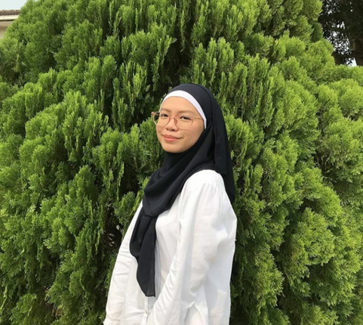

|  |  |
| --- | --- |
| Name | Nur Hamira Syafiqa Adlin bt Abdullah |
| Age | 20 years old |
| Date of birth | 7 February 2000 |
| Place of birth | Hospital Bersalin Kuala Lumpur (HKL) |
| Gender | Female |
| Status | Single |
| Race | Bumiputera Sabah |
| Nationality | Malaysia |
| Qualification education | Diploma in Information Management, UiTM Segamat Johor. |
| Skills | * Goodcommunication skills * Fluent in Malay and English * Expert in using adobe illustrator and photoshop * Expert in edit video |
| Hobby | 1. Watching movies 2. Watching K-Dramas 3. Hanging out with friends 4. Food Hunter 5. Travel |

**EXPERIENCE**

* The experience I will share is about my work experience who had started work at the age of 17 years old. The first job I did after Sijil Pelajaran Malaysia (SPM) as a cinema staff, namely Golden Screen Cinema (GSC) located at 1 Utama shopping mall center, Selangor. Started working in GSC at the end of the year 2017 when I was 17 years old. At GSC, it has four different departments such as Gold Class, Concession, Steward and Box office so my first department is in Gold Class department. Sometime, I also can work in other departments such as in Concession and Box Office Department. Working at GSC was not long, only six months by reason of getting an offer to continue studying at UiTM Segamat, Johor.
* Next work experience in the year 2018 is become a freelancer worker at Sunway Pyramid, Selangor for a week. This work is done during the three-week diploma interim leave. So, with that leave, I was working as a freelancer worker. Scope of work freelancer worker is working as a roadshow promoter who promotes the product from Preggo such as spaghetti, pasta and sauce.
* Besides, during semester break in semester two, I have also worked at a shoe store called BATA located at 1 Utama Shopping Mall Center, Selangor on the year 2019. Worked at BATA shoe store for six weeks only due to short midsem holidays. While working, I gained a lot of experience such as knowing the various types of shoes and learning how to use the POS system. After six-week work, I continue to study at UiTM.
* Furthermore, also during the semester break, has worked at The Burger Outpost located at1 Utama Shopping Mall Center, Selangor during early 2020 before COVID-19. The Burger Outpost is the same company with GSC but in the Food & Beverage (F&B) section. Here too I have been working in five weeks with my good friend which is Nissa Suraya who is also a UiTM Segamat student. After five-week work, I resigned because to continue study new semester.
* Lastly, during semester break semester 4, I work at clothe shop in my home area located in Damansara Damai that namely KB FAMILY. While working at KB FAMILY, I only walked to go to work because of the very close distance compared to previous work, I took public transport such as bus and MRT.



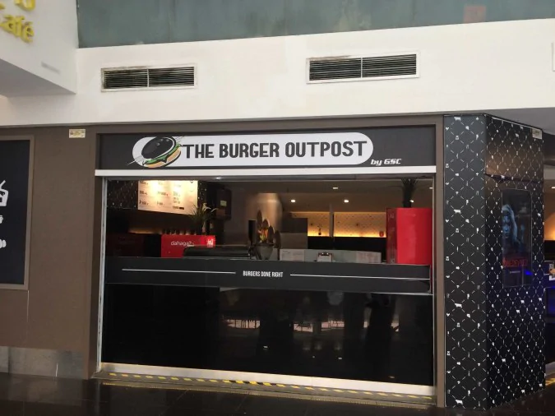



**EDUCATION**



1. **Obtained early education at Damansara Damai Primary School 1. Started entering this school at the age of 7 years old which is standard 1 to 12 years old which is standard 6. Becoming a school prefect from standard 3 to standard 6 and sit for exam Ujian Penilaian Sekolah Rendah (UPSR)**



1. **When 7 years old to 12 years old, I have also entered a religious school which is KAFA INTEGRASI AL-MUHTADIN. In this school, have learned about religious lessons such as Fiqh, Tawhid, Al-Quran, Jawi, Arabic, and many more. During standard 5, I was sitting an exam which is Ujian Penilaian Kelas Kafa and when standard 6, I also sit the exam for the final year such as Peperiksaan Sekolah Rendah Agama.**



1. **After finishing my primary school studies, I went on to high school which is SMK Damansara Damai 1 whereby primary and secondary schools are just adjacent. Entering this school from 13 years old until 17 years old** **and sit for the SPM examination. While in high school also a school prefect for five years.**



1. **In 2018, has successfully received an offer to continue studying at University Teknologi Mara, Campus Segamat, Johor. In the UiTM Segamat, has taken an Information Management course for 2 and a half years.**

**FAMILY**

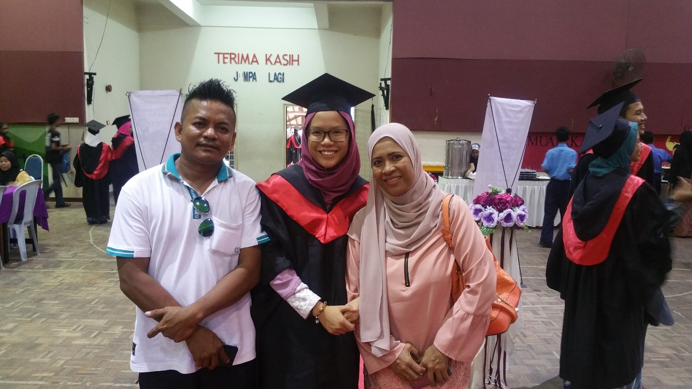

**With My Mom and My dad during convocation high school**

**GALLERY**



