**Simulation of Smart Fire-Detection Systems**

**CS 4420/5420**

**Project Documentation**

**Students Name:**

**Joe Monaco, Ian Ressa, Muhammed Syed**

**Academic Supervisor:**

**Dr. Hassan Rajaei**

**Spring 2022**

**Department of Computer Science**

**Bowling Green State University, Ohio**

**Simulation of Smart Fire-Detection Systems**

**Students:**

**Joe Monaco, Ian Ressa, Muhammed Syed**

Supervisor: Dr. Rajaei

Dept. of Computer Science

Bowling Green State University, Ohio

Reporting date: 04/22/2022

**Abstract**

Fire-detection systems are already standardized for safe and scalable use in varied systems. The advent of smart applications to building automation has made way for increased efficiency potential and realtime analysis opportunities with data collection and complex heuristics systems. This paper will outline possible methods wherein a fire-detection system that meets ‘smart’ criterion is implemented in a building setting. The modeled system’s performance will be compared to the incumbent system under a simulation of a building undergoing a developing fire emergency.

In addition to detection efficency, improvements that leverage the interconnectivity of the smart system will be made to make the fire-response protocol more nuanced, with goals such as fire isolation and pin-point reporting. To facilitate this, a ‘hub’ computer will act as a central server and heuristics engine to each edge-sensor in the system.

**Table of Contents**

1. Introductions 1

Backgrounds 1

Goals and Objectives 1

Key Project Questions 1

2. Related work 2

2.1. Summary of Reviewed Work 2

2.2. Highlights of Current Contribution 2

3. MySmart Application 2

3.1. Overview of Smart Healthcare [for example] 2

3.2. Simulation Problem 2

3.3. Conceptual Model 2

3.4. Strength and Limitation 2

3.5. Evaluation and Analysis 2

4. Implementations, Results, and Analysis 2

4.1. Base Model 2

4.2. Data Model 3

4.3. Improved Model 3

4.4. Result and Analysis 3

5. Proposal for Future Work 4

6. Conclusions 4

7. References 4

This page is left intentionally blank

### Introductions

## Backgrounds

Typical fire-detection systems consist of a ‘dumb’ Carbon Dioxide sensor, which activates a sound alarm for alerting those in the building, with the option of being hard-wired to other alarms in the building (such that you will hear the alarm in any room of the building), and automatically dialing an emergency line. This way is preferred for even modern building plans since it is reliable, inexpensive, and consistent.

The advent of ‘smartness’ and the introduction of smart systems within infrastructures that can handle them have shown that many processes can be absorbed into a network system, that allows for cross-communication, data-collection, and integration with other smart systems with potential for efficiency analysis.

## Goals and Objectives

The goal of this project is to attempt to model a possible ‘smart’ fire-detection system that retains the efficiency of its ‘dumb’ counterpart whilst adding functionality and potential for efficiency analysis.

## Key Project Questions

Some key questions our work seeks to answer are as follows:

* How can a fire-detection system that meets the specification for smart capabilities achieve a base-level of efficiency as the incumbent system?
* What features can enhance the incumbent system to make a building’s capability of not only fire-detection, but also preventative action and isolation?

### Related work

In this section, report the literature review first. Then closely look at the related work of the others in this area and find the differences between them and your work.

### Summary of Reviewed Work

For each related work, summarize important issues the article is presenting.

At the beginning of each summary, provide full retrieval information.

In addition, add a few lines and describe how this article answered your key questions you mentioned in the Introduction section.

### Highlights of Current Contribution

Highlight your project contribution here

### MySmart Application

Describe here why your smart app is important and what are current solutions. It should be a bit stand-alone for most readers to understand your project.

If your topic is, for example, Smart Home/Building/Healthcare/Cars, then you should change the name (i.e. MySmart Application to … e.g. Smart Home/… ) to reflect it.

You may change some sub-sections, add new, or remove those you may not need. However, you should describe your topic in details here. You should use citations with several references in your description. Describe the importance of the topic as well as your contribution.

### Overview of Smart Healthcare [for example]

### Simulation Problem

### Conceptual Model

### Strength and Limitation

### Evaluation and Analysis

### Implementations, Results, and Analysis

Describe in detail your simulations implementation, the input/output model, results and analysis, and their importance.

### Base Model

### Data Model

### Improved Model

### Result and Analysis

Describe in detail the obtained result and provide some basic analysis that the results suggesting.

If you have any table, use the format of Table 1, where the table number is on the top of the table, and a short description follows immediately after the number. The size and the rows and columns as well as the content clearly depend on you report.

**Table 1:** The sizes of the three matrices used in the sequential, pure OpenMP, pure MPI, and hybrid OpenMP-MPI models

|  |  |  |
| --- | --- | --- |
| Sizes of the three matrices used in each model. | | |
| Matrix | Rows | Columns |
| A | 5000 | 2000 |
| B | 2000 | 2500 |
| C | 5000 | 2500 |

You should use figures and tables to show the result and discuss what are the important of these results. For example, Figure 1 show the speed up of the programs executions with 8 processors and different matrix sizes for three different methods

**Figure 1:** Speed up comparisons between different scheduling and methods.

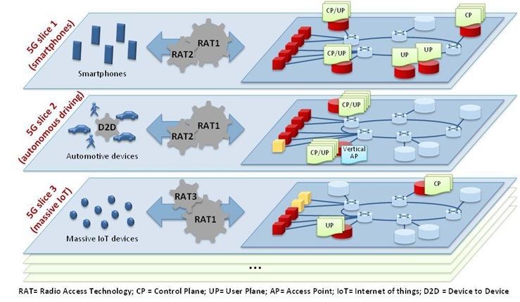

**Figure 2:** Network Slicing support in 5G (courtesy of NGMN) [x]

### Proposal for Future Work

This section proposes potential future works which could follow based on current work. Any good project should contribute to few new questions and/or ideas due reasons such as:

- not having enough time to fix a few problems encountered

- current implementation method is not efficient and enough, and hence should be replaced with a better one

- a problem encountered needs to be fixed more appropriately

- better method, or architectures,

- and tons of other factors! ….

### Conclusions

Tell your audience briefly:

- what you have down and why it is important

- what is your contribution

- what is the lessons learned from this project

### References

List all references is in index format where the index number indicates where first in the document that index has been referred to: e.g.

1. Borgia, E, 2014 “The Internet of Things vision: Key features, applications and open issues,” Computer Communications, vol. 54, pp. 1–31.
2. “5G Will Lead to Smarter Buildings & Cities: Blog: Smart Spaces,” 5G Will Lead to Smarter Buildings & Cities | Blog | Smart Spaces. [Online]. Available: https://www.smartspaces.app/blog/how-5g-will-lead-to-smarter-buildings-and-cities/. [Accessed: 30-Sep-2019].
3. Wilkinson, B., Allen, M., 2005, "Parallel Programming, Techniques and Applications Using Networked Workstations and Parallel Computers", Prentice Hall, Second addition
4. Rajaei, H. Mirzaei, F. (2018). IoT, Smart Homes, and ZigBee Simulation, SpringSim-CNS 2018, April 15-18, Baltimore, MD, USA
5. Rajaei, H. 2008, "A Shared- Edit & View Web-Based Simulation Framework", In Proceedings of the 11th Communications and Networking Simulation Symposium, CNS'08, sponsored by ACM/SCS, April 14-17, Ottawa
6. MPI Totorials, <http://www.lam-mpi.org/tutorials/>
7. *Cloud Computing: Principles and Paradigm*, Edited by Rajkumar Buyya, James Broberg and Andrzej Goscinski, John Wiley & Sons, Inc., 2011

**Appendix**

In this section add materials such as code, extra info, etc. which you think it is important but should not be directly in main document.