# Status Report for Project X

**Students: Joe Monaco, Ian Ressa, Syed Muhammed Abubaker**

**Supervisor: Dr. Rajaei**

Dept. of Computer Science

Bowling Green State University, Ohio

Spring 2022

**Report Date[1]: 3/21/2022**

For each of the following topics students/group should write short descriptions on the status of the project. The content will be changed as the projects process.

### Current Status

We are currently making the OMNet simulation based on the devised plan of modelling from the past week.

### Changes of Topic, Methods, Project Plan, or Directions

No changes from previous week.

### Accomplishment of objectives from Previous Meetings

Made sense of the logic of OMNet modules to be used.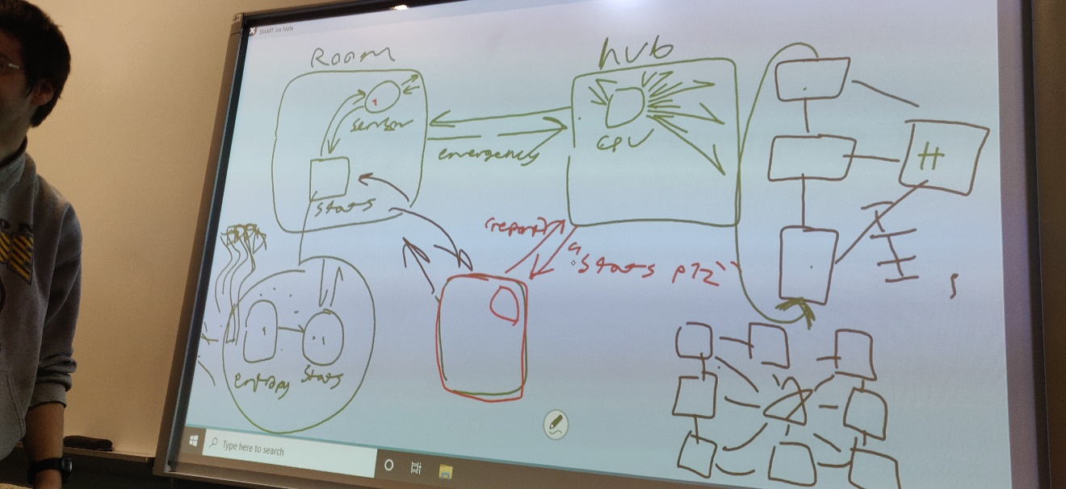

### To Do by the next week

Finish the simulation model and start data collection for project report and presentation.

### Risk analysis

* The exam put us back in the progress of our project, but we plan on making it up this week.

### Time Frame Control

- 13 Finish coding the model.

20 Finish writing the report and presentation.

### Related Documentations

1. The date of report (update needed)