LAB SETUP REPORT
Foundation & Environment Setup
Task 1 | Days 1–12 | ApexPlanet Cybersecurity Internship
Student Name | S.Md.Afzal
Application ID | APSPL2629639

1. Objective
This report documents the setup of a professional cybersecurity hacking lab as part of Task 1 (Days 1–12) of the ApexPlanet Cybersecurity Internship. The goal was to build strong fundamentals in cybersecurity, networking, cryptography, and configure a working virtual lab environment.

2. Setup Checklist & Status
Track the completion status of each setup step below:

Setup Step | Status
Install VirtualBox / VMware | Completed
Install Kali Linux (Attacker VM) | Completed
Install Metasploitable2 / DVWA (Target VM) | Completed
Configure Host-Only Network Adapter | Completed
Verify VM Connectivity (ping test) | Completed
Install Wireshark | Completed
Install Nmap | Completed
Install Burp Suite | Completed
Install Netcat | Completed
GitHub Repo Created | Completed

3. Environment Screenshots

3.1 Kali Linux VM
Capture a screenshot showing Kali Linux desktop running inside your virtual machine.

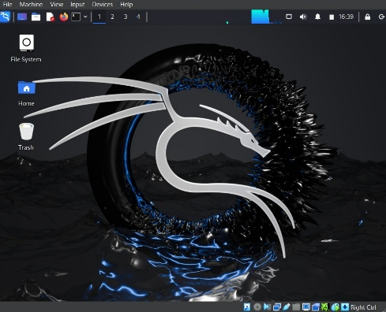

3.2 Metasploitable2 / DVWA Target Machine
Capture a screenshot of your target vulnerable machine running.

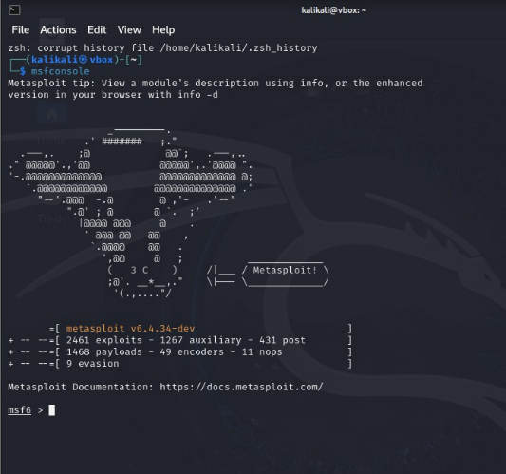

3.3 Wireshark Test Capture
Open Wireshark, start a packet capture on your lab network interface, and ping the target machine.
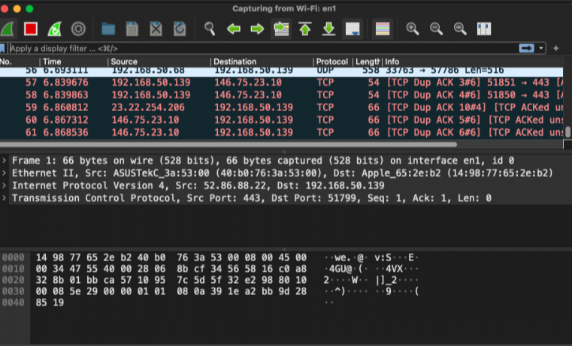

4. Cybersecurity Concepts Summary

4.1 CIA Triad
- Confidentiality – Ensuring data is only accessible to authorized users.
- Integrity – Ensuring data has not been altered by unauthorized parties.
- Availability – Ensuring systems and data are accessible when needed.

4.2 Threat Types Studied
- Phishing – Social engineering via deceptive emails or messages.
- Malware – Malicious software (viruses, trojans, ransomware).
- DDoS – Distributed Denial of Service attack overwhelming a target.
- SQL Injection – Exploiting database queries via unsanitized input.
- Brute Force – Trying all possible passwords/keys until success.
- Ransomware – Encrypts victim data and demands payment.

5. Linux Commands Practiced

Command | Purpose | Category
ls, cd, pwd | Navigate the file system | File Navigation
chmod, chown | Manage file permissions | Permissions
apt, dpkg | Install/manage packages | Package Mgmt
ifconfig, ip a | View network interfaces | Networking
ping [ip] | Test connectivity | Networking
netstat -an | View active connections | Networking
traceroute [host] | Trace network path | Networking

6. Cryptography Hands-On

6.1 OpenSSL Encryption Exercise
- Encrypted a test message using: openssl enc -aes-256-cbc -in plain.txt -out encrypted.bin
- Decrypted using: openssl enc -d -aes-256-cbc -in encrypted.bin -out decrypted.txt
- Verified that decrypted output matches original plaintext.

7. Observations & Challenges
Document any issues faced during setup and how you resolved them:

Challenge Faced | How I Resolved It
VirtualBox not detecting ISO file during Kali Linux installation | Mounted the ISO manually via Storage settings → Optical Drive in VM settings
Kali Linux VM had no network connectivity after install | Changed Network Adapter from NAT to Host-Only Adapter in VM settings and restarted
DVWA page not loading at target IP in browser | Started Apache & MySQL manually using service apache2 start and service mysql start on Metasploitable

