Problem Chosen  C | 2026  MCM/ICM  Summary Sheet | Team Control Number  2601003

Decoding the Dance: An Inverse Optimization Approach to Estimating Hidden Fan Votes and Designing Fairer Scoring Mechanisms in Dancing with the Stars
Summary
Dancing with the Stars (DWTS) combines expert judges’ scores with undisclosed fan votes to determine weekly eliminations, a design that has repeatedly generated controversy when technically weak but popular contestants advance far in the competition. Since fan vote totals are never publicly released, evaluating the fairness and structural bias of the scoring system poses a fundamental inference challenge.
This study develops a unified, data-driven framework to reconstruct latent fan votes, compare alternative aggregation rules, quantify heterogeneous influences on judges and fans, and design a more adaptive and transparent scoring mechanism.
First, we formulate fan vote estimation as a constrained inverse optimization problem. Treating weekly fan vote shares as latent decision variables, we impose elimination-consistency constraints derived from official rules while introducing temporal smoothness and minimum-deviation regularization. This resolves the inherent non-uniqueness of the inverse problem and yields stable, interpretable fan vote trajectories. Across 34 seasons, the reconstructed votes reproduce historical eliminations with 98.28% overall consistency, and maintain strong performance on withheld seasons and external validation data from a similar international dance competition.
Second, using the inferred fan preferences, we conduct a counterfactual analysis comparing the Rank and Percent aggregation rules. Spearman rank correlations show that percent-based rules amplify fan preferences more strongly, whereas rank-based rules compress extreme popularity. Switching between rules alters elimination outcomes in 43.6% of weeks, demonstrating that aggregation choice has a substantial and systematic impact rather than a marginal effect.
Third, we apply crossed random-effects mixed models to disentangle the determinants of judges’ scores and fan votes. Results reveal fundamentally different evaluation logics: judges are more sensitive to technical performance and contestant age, while fan votes are strongly influenced by professional partner effects, highlighting the role of popularity transmission rather than purely individual merit.
Finally, we propose a dynamic, entropy-weighted scoring mechanism augmented with a stability penalty to mitigate short-term volatility. By allowing weights on judges’ scores and fan votes to adapt weekly based on information dispersion, the proposed system improves fairness and robustness, achieving higher consistency within the Bottom-2 elimination zone (89.39%) while reducing controversial eliminations.
Overall, this framework offers a transparent and generalizable approach for analyzing hidden preferences and institutional design, providing actionable insights for improving fairness and credibility in DWTS and similar competition-based evaluation systems.
Key words: inverse optimization; fan vote inference; counterfactual analysis; mixed-effects models; dynamic scoring mechanisms

Contents
1. Introduction 3
1.1 Background 3
1.2 Our works 3
2 The Description of the Problem 3
2.1 Problem statement 3
2.2 Analysis of Problem 4
3 Basic assumption 5
4 Glossary & Symbols 6
4.1 Glossary 6
4.2 Symbols 6
5 Models 7
5.1 Analysis and Solving of Question One 7
5.1.1 Model Preparation 7
5.1.2 Model Establishment for Percent Combination (Season 3-27) 7
5.1.3 Model Establishment for Rank Combination (Season 1-2, 28-34) 8
5.1.4 Test on Consistency and Uncertainty 10
5.1.5 Results 10
5.1.6 Analysis of the Result 12
5.2 Analysis and Solving of Question Two 12
5.2.1 Model Preparation 12
5.2.2 Model Establishment 12
5.2.3 Results 14
5.2.4 Analysis of the Result 15
5.3 Analysis and Solving of Question Three 16
5.3.1 Model Preparation 16
5.3.2 Model Establishment for Judges Score Model 16
5.3.3 Model Establishment for Fan Vote Logit-Share Model 17
5.3.4 Results 18
5.3.5 Analysis of the Results 19
5.4 Analysis and Solving of Question Four 19
5.4.1 Model Preparation 19
5.4.2 Model Establishment 20
5.4.3 Results 21
5.4.4 Analysis of the Result 23
6 Sensitivity Analysis 23
7 Evaluation of the Models 24
7.1 Strength 24
7.2 Weakness 24
8 Memo to the Producers of Dancing with the Stars 24
9 References 25
Report on Use of AI Tools 26

1. Introduction

Background
Dancing with the Stars (DWTS), a globally popular television reality competition, has successfully completed 34 seasons in its U.S. version. The core mechanism of the show pairs celebrities with professional dancers, who perform weekly dance routines and receive scores from a panel of expert judges as well as votes from the audience. The elimination of contestants is jointly determined by judge scores and fan votes, with the couple boasting the lowest combined score typically being eliminated.
This dual-evaluation system has repeatedly triggered controversy: judges emphasize technical quality, while fan votes reflect popularity. Historical cases show that popular but weaker contestants can advance far. DWTS has therefore alternated between Rank vs. Percent combination rules and later introduced Judge Save to mitigate extreme outcomes.
Since the specific number of fan votes is regarded as a trade secret and has never been disclosed, researching the fairness of the scoring system, the sensitivity of the rules, and the differences in preferences poses significant challenges.

Our works
To address these challenges, we undertake four sequential research tasks:
Fan Vote Estimation via Inverse Optimization: Reconstruct latent fan vote distributions from elimination results using a constrained optimization framework[1], [2].
Voting Rule Comparison via Counterfactual Analysis: Systematically compare Rank and Percent aggregation methods and evaluate the Judge Save mechanism[3], [4], [5].
Factor Analysis via Mixed-Effects Models: Identify determinants of judges' scores and fan votes using crossed random-effects models[6], [7].
Mechanism Design via Dynamic Weighting: Propose an entropy-based adaptive scoring system with stability penalties to enhance fairness[8], [9], [10].
- The Description of the Problem

Problem statement
This problem requires quantitative analysis of DWTS's evaluation system using limited data on judge scores and elimination results. Specifically, we address four core tasks:
Fan Vote Estimation: Given no fan vote data, develop a model to estimate each contestant's weekly vote proportion, ensuring high consistency with historical eliminations and providing uncertainty measures.
Rule Comparison: Compare "Rank Combination" versus "Percent Combination" to determine whether either systematically favors judges or fans, and examine how rule changes or adding "Judge Save" would affect controversial cases.
Factor Analysis: Analyze how celebrity age, industry, nationality, and professional partners influence scores and votes, exploring whether judges and fans prioritize different qualities.
Mechanism Design: Propose a fairer or more engaging scoring system based on the above findings, supported by data-driven evidence for producer adoption.

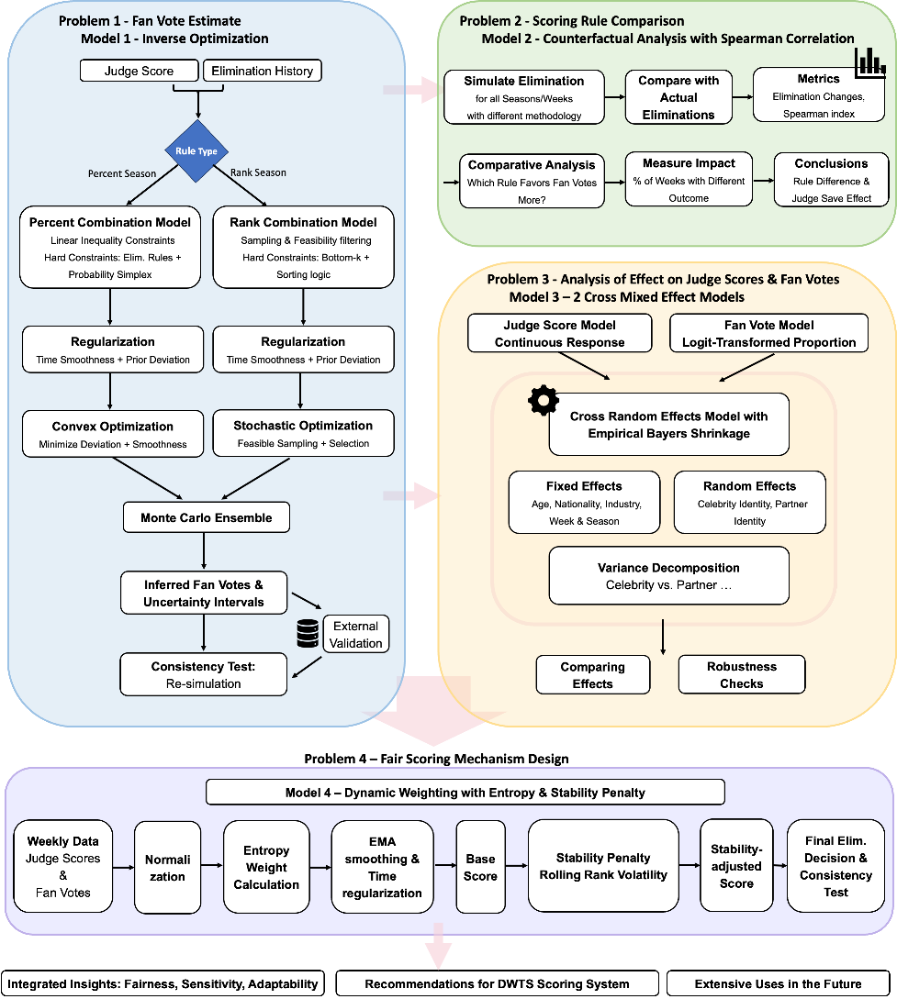
Figure 1: Overall solution framework.

Analysis of Problem
(1) Problem 1
In this problem, we know the weekly judge scores and final elimination results but lack the true proportion of fan votes (Fan Vote) received by each contestant in each week. Therefore, this problem is essentially a constrained inverse inference problem: inferring the latent variable (fan vote distribution) from the given weekly judge scores and partial results (elimination order).
Fan votes are latent and non-unique given eliminations, so we pose an inverse optimization problem. Weekly vote shares are decision variables constrained by official elimination rules, and we regularize with (i) minimum-deviation from a judge-score prior and (ii) temporal smoothness, yielding stable and interpretable reconstructions.
We implement minimum-deviation regarding a judge-based prior and add smoothness to resolve non-uniqueness. We further test transferability using external data from a similar dance show.
(2) Problem 2
Building on the estimated Fan Votes, this problem no longer requires estimating new unknowns but instead uses these estimates as fixed inputs to systematically compare the impacts of different vote aggregation rules on competition outcomes.
This problem focuses on three core questions:
(1) To what extent do the final season results align with fan preferences under different aggregation rules?
(2) Are there statistically significant systematic differences between different aggregation rules? Which rule is more biased toward audience votes?
(3) Keeping the fan vote structure unchanged, would replacing the aggregation rule substantially alter the elimination path and final results?
We conduct counterfactual simulations: holding inferred fan votes fixed while switching aggregation rules to isolate the causal impact of institutional design on eliminations and season outcomes.
Fan satisfaction is measured by rank agreement between final standings and average fan ranking (Spearman correlation).
(3) Problem 3
In the first two problems, we mainly focused on the impact of institutional rules and vote aggregation mechanisms on elimination outcomes. However, judge scores and fan votes themselves are systematically influenced by contestants' personal characteristics and partner attributes.
To explain score/vote heterogeneity, we fit crossed random-effects mixed models with celebrity and partner random effects, plus observed covariates (age, industry, nationality) and week/season controls. This separates drivers of judges’ technical scoring from determinants of fan voting.
(4) Problem 4
We propose a dynamic scoring rule that adapts weekly weights for judges vs. fans using information dispersion, while adding a stability penalty to reduce eliminations driven by one-week anomalies—improving fairness, robustness, and interpretability.
- Basic assumption

(1) Data validity: judge scores and elimination records are accurate.
(2) Rule validity: each season follows its stated aggregation rule (Rank for S1–2, 28–34; Percent for S3–27).
(3) Modeling convenience: fan votes are treated as continuous shares on a simplex with a small lower bound ε for numerical stability.
(4) Gender Neutrality Assumption: Gender has no impact on scores. The external validation dataset used in our Fan Vote estimation model includes gender information; to ensure consistency with the problem's show, we apply this assumption to both the problem's dataset and the external data.
(5) Fan Preference Stability Assumption: Within a single season, the relative preference structure of fans toward contestants changes smoothly with weeks, and there are no large-scale, sudden systematic preference reversals.
- Glossary & Symbols

Glossary
(1) Bottom-k: Rules that eliminate the last k contestants.
(2) Rank Combination: An ordinal aggregation method where judge ranks and fan ranks are summed to determine eliminations.
(3) Percent Combination: A cardinal aggregation method where judge score percentages and fan vote percentages are weighted and summed.
(4) Judge Save: A mechanism introduced in later seasons where judges choose which of the bottom two contestants to eliminate.
(5) Inverse Problem: A process of calculating from a set of observations the causal factors that produced them. In this study, it refers to inferring fan votes from elimination results.
(6) Counterfactual Analysis: A methodology that estimates what would have happened to the same contestants if a different voting rule had been applied, while keeping their fan support constant.
(7) Entropy Weight Method: An objective weighting method that determines the importance of judges’ scores versus fan votes based on the dispersion (information content) of the data each week.

Symbols
Table 1: Core mathematical symbols and their definitions.
Symbols | Definition | Remarks/Units
$w$, $i$, s | Index respectively for competition week, contestant (celebrity) and season. | $w = 1, 2, …, W$; $i=1,2,…,n_{w}$ (number of remaining contestants in week $w$).
$$Cw or Cs,w$$ | The set of contestants remaining in week $w$ (of season $s$).
$$p_{i,w}$$ | Estimated fan vote share (proportion) for contestant $i$ in week $w$. | $$p_{i,w}≥ε,\sum_{i}{p_{i,w}}=1$$
$$p_{i,w}^{J}$$ | Judge score percentage for contestant $i$ in week $w$. | $$p_{i,w}^{J}=J_{i,w}/\sum_{k}{J_{k,w}}$$
$$r_{i,w}^{J}$$ | Judge rank for contestant $i$  in week $w$based on $J_{i,w}$ (1 is best).
$$ρ$$ | Spearman rank correlation coefficient. | Used to measure ranking consistency.
$$w_{J},w_{F}$$ | Dynamic weights for judge and fan indicators in the proposed mechanism. | $$w_{J}+w_{F}=1$$
$$E_{k}$$ | Information entropy for indicator $k$. | $$k∈\{\text{judge},\text{fan}\text{\}}$$
$$d_{k}$$ | Information utility degree for indicator $k$. | $$d_{k}=1-E_{k}$$
- Models

Analysis and Solving of Question One

Model Preparation
(1) Data Processing
- We split the original data into a training set (Seasons 1-24) and a test set (Seasons 25-34).
- We use data from two seasons of the Chinese similar show "Dancing Miracles"[11] to test the model's generalizability. Partial external data is shown in Table 2.
Table 2: Partial Data Demonstration of the "Strictly Come Dancing" Program.
Celebrity | SWeek | Judge Score | Fan Vote | Socre | Rank | If eliminated
Changxing Huang | 1 | 8.33 | 8.49 | 16.82 | 8 | False
Jiawei Zhou | 2 | 7 | 9.16 | 16.16 | 9 | False
Minzhi Chen | 3 | 7.33 | 9.13 | 16.46 | 9 | True
Changxing Huang | 4 | 8 | 8.86 | 16.86 | 8 | False

(2) The Foundation of Model
We build two constraint systems matching Percent vs. Rank seasons. In both cases, fan votes lie on a simplex and are selected via minimum-deviation from a judge-based prior plus temporal smoothness (with $ε$ for stability), solved by constrained optimization (Percent) or feasible sampling/screening (Rank).

Model Establishment for Percent Combination (Season 3-27)
Step 1: Mathematical Representation of Judge Ranks and Fan Ranks
Judge score share:
$$p_{i,w}^{J}=\frac{J_{i,w}}{\sum_{k∈C_{w}}{J_{k,w}}}………\left(1\right)$$
Fan vote share：
$$p_{i,w}^{V}=\frac{V_{i,w}}{\sum_{k∈C_{w}}{V_{k,w}}}………\left(2\right)$$
Combined score：
$$S_{i,w}=p_{i,w}^{J}+p_{i,w }^{V}………\left(3\right)$$
Predicted eliminated contestant:
$$\hat{e_{w}}=\arg{\min_{i∈C_{w}}{S_{i,w} }}………\left(4\right)$$

Step 2: Basic Probability Constraint Equations
Subject to the basic constraints:
$$p_{i,w}≥ε, \sum_{i=1}^{n_{w}}{p_{i,w}}=1………\left(5\right)$$
where$ε>0$ is the numerical stability and "minimum support rate" lower bound.

Step 3: Combined Score for Percent Combination
According to the problem statement, the combined score for the Percent Combination is
$$S_{i,w}=\underset{\text{Percentage of Judge Score}}{\underbrace{\frac{J_{i,w}}{\sum_{k}{J_{k,w}}}}}+p_{i,w}………\left(6\right)$$
Let $E_{w}$be the set of eliminated contestants in week $w$, $N_{w}$ being the remaining contestants.
Step 4: Linear Inequality System as Hard Constraints for Fan Votes
The actual elimination mechanism implies that the following inequalities must hold:
$$S_{e,w}≤S_{j,w}, ∀e∈E_{w}, ∀j∈N_{w}………\left(7\right)$$
Step 5: Constrained Convex Quadratic Programming Model
This is a convex optimization problem with linear inequality constraints. Under the above hard constraints, select the "smoothest and most reasonable" fan vote distribution:
$$\min_{\{p_{i,w}\}}{} |p_{w}-π_{w}|_{2}^{2}+λ|p_{w}-p_{w-1}|_{2}^{2}………\left(8\right)$$
$π_{w}$：Prior distribution constructed based on judge performance. $p_{w-1}$：Fan votes from the previous week (temporal smoothness). $λ$：Temporal continuity weight

Model Establishment for Rank Combination (Season 1-2, 28-34)
Rank Combination uses rank ordering, not continuous scores, making it discontinuous and unsuitable for continuous optimization.
Step 1: Mathematical Representation of Judge Ranks and Fan Ranks
Total judge score:
$$J_{i,w}=\sum_{y=1}^{m_{w}}{s_{i,w,y}}………\left(9\right)$$
where $s_{i,w,y}$ is the score given to contestant $i$ by the $y$ -th judge in week $w$ (may include decimals/bonus points that have been incorporated).
Judge rank (average for ties):
$$r_{i,w}^{J}={rank}_{i∈C_{w}}\left(J_{i,w}\right)………\left(10\right)$$
where 1 indicates the best and, $n_{w}$ indicates the worst; average ranks are used to break ties.
Fan Votes：$V_{i,w}$ (Unknow).
Fan Rank:
$$r_{i,w}^{F}={rank}_{i∈C_{w}}\left(p_{i,w}\right)………\left(11\right)$$
Sum of combined ranks:
$$R_{i,w}=r_{i,w}^{J}+r_{i,w}^{F}………\left(12\right)$$
Predicted eliminated contestant:
$$\hat{e_{w}}=\arg{\max_{i∈C_{w}}{R_{i,w}}}………\left(13\right)$$
Step 2: Elimination Rule Constraints
Standard Rank Combination: Eliminated contestants must be among the bottom $k$ ranks.
Special Rule for Seasons 28+: Eliminated contestants ∈$Bottom-2$ of the combined ranks.
Step 3: Feasibility Sampling and Screening
Due to the non-differentiability of the objective function caused by the ranking operation, we adopt a sampling-based feasibility search strategy. Sample on the simplex probability space:
$$p_{w}∼\text{Dirichlet}\left(α\right)………\left(14\right)$$
Screen feasible solutions that satisfy the elimination rules (e.g., Bottom-k or Bottom-2). Among the feasible solutions, minimize:
$$|p_{w}-π_{w}|_{2}^{2}+γ|p_{w}-p_{w-1}|_{2}^{2}………\left(15\right)$$
This method is equivalent to stochastic optimization with regularization terms on the feasible region, enabling stable estimation under combinatorial constraints.

Test on Consistency and Uncertainty
Step 1: Consistency Calculation
Recalculate the weekly eliminated contestants using the estimated fan votes and compute the consistency rate:
$$\text{Consistency}=\frac{\text{t}\text{he number of elimination weeks}\text{ accurately predicted}}{\text{ Total number of elimination weeks} }×100\%………\left(16\right)$$
Step 2: Uncertainty Analysis
To address the non-uniqueness of the inverse problem in fan vote reconstruction, we employed an ensemble-based stochastic optimization approach. By introducing a 2% jitter to the prior distributions and performing 50 Monte Carlo iterations, we transformed a deterministic point estimate into a probabilistic density estimation. This allows us to quantify the reconstruction reliability for each contestant-week pair, ensuring that our findings on 'controversial' eliminations are statistically grounded. We report the following metrics:
$$\{E\left[p\right],\text{Std}\left(p\right),\left[P_{5\%},P_{95\%}\right]\}………\left(17\right)$$
This method extends the point estimate to a probabilistic density estimation, thereby quantitatively characterizing the reliability of the reconstruction results and providing a statistically meaningful uncertainty interval for "controversial eliminations".

Results
Our model can estimate the Fan Votes for each celebrity in each week of every season. Partial results are shown in Table 3.
Table 3: Partial Results of Model Prediction for Fan Votes.
Celebrity | Season | Week | Jusge Score | Inferred Fan Votes
John O'Hurley | 1 | 6 | 27 | 4498.38434
Shangela | 31 | 10 | 38 | 1714.59491
Jaleel White | 14 | 3 | 25 | 1046.84105

We substituted the inferred Fan Votes back to predict the eliminated contestants and calculated the consistency, with the results shown in Figure 2.
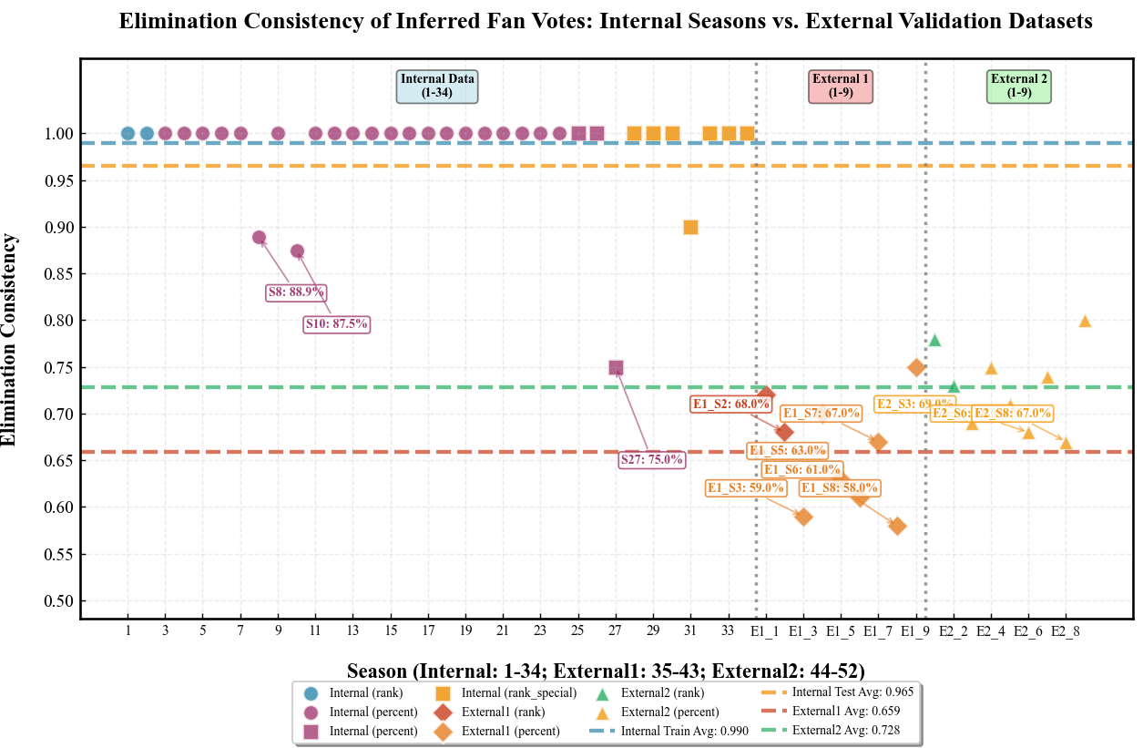
Figure 2: Consistency of Inferred Fan Votes Across Seasons.
In addition, we evaluated the consistency on the external validation set, with the comprehensive results shown in Table 4.
Table 4: Results of Consistency Test for Different Data Sets.
Dataset | Consistency (%)
Training Set | 99.0
Validation Set | 96.5
Overall | 98.28
External Validation 1 | 65.62
External Validation 2 | 72.14

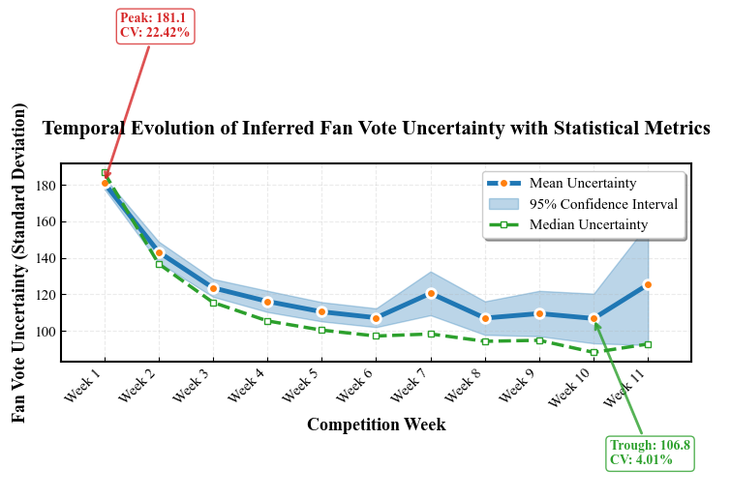
Figure 3: Uncertainty of Inferred Fan Votes Over Time.

Analysis of the Result
(1) Fan Vote Estimation and Consistency
As required by the model, we divided the data provided in the problem into a training set and a test set, and achieved excellent results on both datasets:
Across 34 seasons, reconstructed votes match eliminations with 98.28% consistency (99.0% train; 96.5% test), suggesting strong generalization beyond the training seasons.
External consistency remains above random (65.62%, 72.14%), indicating transferable preference structure. The drop is expected due to differences in voting mechanisms and audience behavior across shows.
(2) Explanation for a Few Inconsistent Weeks
As shown in Table 4, there are several seasons with obvious estimation inconsistencies, such as Season 8, Season 27, and Season 31.
Inconsistencies occur in a few weeks with near-tied scores, rank ties/judge interventions, or Bottom-2 non-determinism; even then, the eliminated contestant is typically placed at the Bottom-1/Bottom-2 boundary.
(3) Uncertainty Analysis
As shown in Figure 4, Uncertainty is highest early, stabilizes mid/late season for survivors, and remains wide for “controversial” contestants, implying identifiability varies across contestants and weeks.

Analysis and Solving of Question Two

Model Preparation
(1) Data Processing
Use the fan vote proportion $p_{i,w}$，reconstructed by the Inverse Optimization method in Problem 1, combined with the judge scores from the original data.
(2) The Foundation of Model
We adopt the Spearman correlation coefficient as the fan satisfaction metric. Meanwhile, we apply counterfactual analysis as the core analytical tool to test the differences between rules. This method identifies the causal effect of the rules themselves by keeping fan votes constant and only changing the institutional rules[3].

Model Establishment
Step 1: Fix Fan Votes
Use the $p_{i,w}$, inferred in Problem 1 as a proxy for fan ranks reflecting "true fan preferences".
Step 2: Rank Combination
This rule only uses relative ranking information and is a typical ordinal aggregation method. For the set of contestants remaining in week $w$, $C_{w}$，define
Judge rank (1 for best):
$$r_{i,w}^{J} = rank ↓ \left( J_{i , w} \right)………\left(18\right)$$
Fan rank (1 for best):
$$r_{i,w}^{F}=rank{↓}\left(p_{i,w}\right)………\left(19\right)$$
Sum of combined ranks:
$$R_{i,w}=r_{i,w}^{J}+r_{i,w }^{F}………\left(20\right)$$
Under this rule, the eliminated contestant is defined as:
$$\arg{\min_{i∈C_{w}}{S_{i,w}}}………\left(21\right)$$
A characteristic of the Rank Combination is that it only cares about the relative order and ignores the gaps between scores or vote intensities.
Step 3: Percent Combination
This rule uses continuous score information and is a typical cardinal aggregation method. Judge score percentage:
$$q_{i,w}^{J}=\frac{J_{i,w}}{\sum_{k∈Cw}{Jk,w}}………\left(22\right)$$
Fan score percentage:
$$q_{i,w}^{F}=\frac{p_{i,w}}{\sum_{k∈Cw}{pk,w}}=p_{i,w}………\left(23\right)$$
Combined score (default weight $α=0.5$):
$$S_{i,w}=αq_{i,w}^{J}+\left( 1 - α \right)q_{i,w}^{F}………\left(24\right)$$
Eliminated contestant:
$$\arg{ \min_{i∈Cw}{Si, w}}………\left(25\right)$$
Compared with the Rank Combination method, the Percent Combination method explicitly characterizes the differences between fan support intensity and judge score intensity.
Step 4: a Satisfaction Measurement (Spearman Correlation Coefficient)
We measure fan satisfaction via Spearman rank correlation between each contestant’s final placement and their season-average inferred fan rank (higher ρ means better alignment). Define: ${\text{FinalRank}}_{i}$ as Contestant's final rank (1 for champion) and $\overline{r_{i}^{F}}$ as Contestant's average fan rank throughout the season.
Adopt the Spearman rank correlation coefficient[4]:
$$ρ=Spearman\left(\text{ FinalRank },\overline{{ r}^{F} }\right)………\left(26\right)$$
Step 5: Season-Level Evaluation
Apply Step 2 and Step 3 in parallel for each week of each season, compare whether the final champion changes, and calculate the Spearman correlation between the final ranking and fan preferences.
Step 6: Judges Save Counterfactual Rule
To characterize the intervention effect of judges at key nodes, we construct the following computable approximate rule for Judge Save: First, determine the Bottom-2 using the Rank Combination or Percent Combination method. Among the Bottom-2, the judges eliminate the contestant with the lower judge score. If the judge scores are tied, the contestant with the lower fan votes is eliminated[5].
This rule is a structural approximation of the actual mechanism introduced in Seasons 28+, enabling the systematic integration of Judge Save into counterfactual simulations and the calculation of the proportion of weeks where the elimination path changes.

Results
The fan satisfaction results obtained using the Spearman rank correlation coefficient are shown in Figure 4.
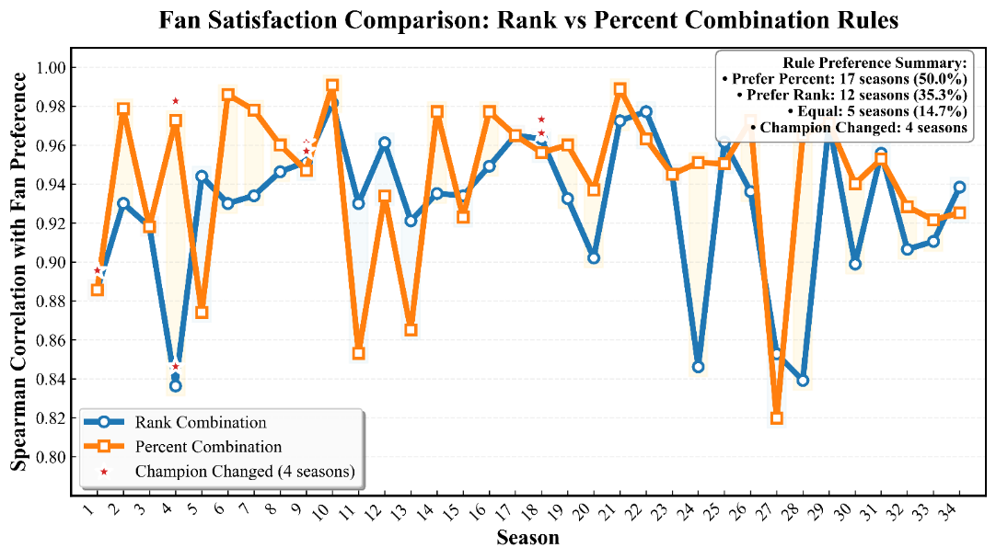
Figure 4: Fan Satisfaction compared between Rank Combination and Percent Combination.
We calculated the proportion of weeks where the elimination path changed (comparison between the two rules and before/after introducing Judge Save for each rule), resulting in Figure 5.
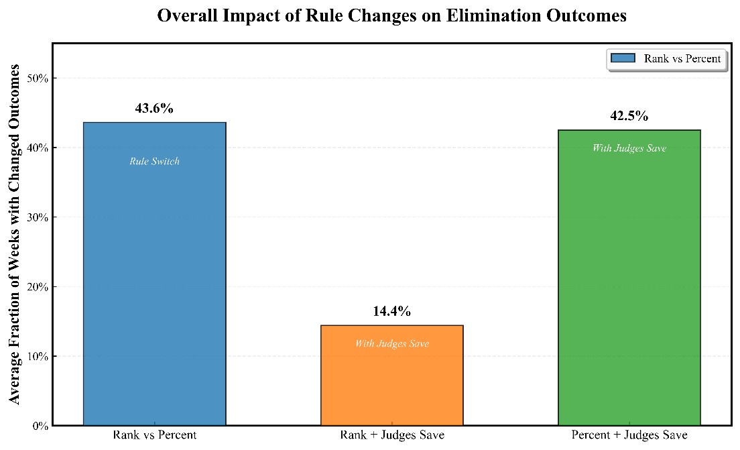
Figure 5: Impact of Rule Changes on Elimination Outcomes.

Table 5: Counterfactual Analysis of Notable Controversial Eliminations Across Different Voting Rules.
season | celebrity | Actual Elim. Week | Final Placement | Pred. Elim. Week (Rank Rule) | Pred. Elim. Week (Percent Rule) |  | Pred. Elim. Week (Rank + Judge Save) | Pred. Elim. Week (Percent + Judge Save)
2 | Jerry Rice | NA | 2 | Survived | 7 | 7 |  | 7
4 | Billy Ray Cyrus | 8 | 5 | 1 | 5 | 1 |  | 1
11 | Bristol Palin | NA | 3 | 5 | Survived | 5 |  | 5
27 | Bobby Bones | NA | 1 | 8 | 8 | 8 |  | 8

Table 6: Summary of Elimination Outcome Changes for 4 Celebrities Under Alternative Mechanisms.
season | celebrity | Rule Type Changes Outcome | Outcome Changed by Adding Judge Save (Rank Rule) | Outcome Changed by Adding Judge Save (Percent Rule)
2 | Jerry Rice | TRUE | TRUE | FALSE
4 | Billy Ray Cyrus | TRUE | FALSE | TRUE
11 | Bristol Palin | TRUE | FALSE | TRUE
27 | Bobby Bones | FALSE | FALSE | FALSE

Analysis of the Result
(1) Fan Satisfaction Comparison (Spearman Correlation)
Season-by-season results show:
- The Percent Combination method has a higher Spearman correlation in most seasons.
- The Rank Combination is slightly superior in some seasons.
- The two methods are almost equivalent in individual seasons.
- The Percent Combination is more likely to amplify differences between fan votes.
- The Rank Combination has a compressing effect on extreme fan support.
Statistical characteristics indicate:
- The Percent Combination is more likely to amplify differences between fan votes.
- The Rank Combination has a compressing effect on extreme fan support.
Overall, the Percent Combination is statistically more inclined to reflect the fan preference structure.
(2) Counterfactual Simulation Results
Counterfactual simulations show that, on average, the Rank and Percent rules yield different elimination results in 43.6% of weeks.
The two rules differ substantially in outcomes. This directly answers the question "Does one method favor fan votes more?" The answer is yes, and the impact is significant—with the Percent Combination being more consistent with fan preferences. After introducing Judge Save:
- Rank + Judge Save: The elimination result changes in an average of 14.4% of weeks.
- Percent + Judge Save: The elimination result changes in an average of 42.5% of weeks.
Judge Save effectively rebalances power by reducing fan-vote dominance and increasing judge control, especially under Percent rules where fan influence is stronger.
(3) Counterfactual Interpretation of Four Controversial Celebrities
As shown in Tables 5 and 6, the counterfactual analysis of controversial cases such as Jerry Rice, Billy Ray Cyrus, Bristol Palin, and Bobby Bones shows:
- The Rank and Percent rules often yield different elimination weeks or final ranks.
- Judge Save often eliminates them earlier.
The two rules yield different eliminations in 43.6% of weeks, indicating a substantive—not marginal—impact; Percent Combination aligns more with fan preferences.

Analysis and Solving of Question Three

Model Preparation
(1) The Foundation of Model
This problem plans to use crossed random-effects mixed models to examine the significant impacts of various known factors. Since judge scores and fan votes reflect two distinct decision-making mechanisms, forcing them into a single model would confuse causal interpretations. Therefore, we need to prepare two models to examine the significance of effects separately.
In the models, we adopt logit transformation and proportional modeling to standardize the Fan Vote data[6].
Meanwhile, to ensure data reliability and avoid extreme estimates, we use Empirical Bayes Shrinkage to handle partner effects in the models, shrinking the estimates for partners with small sample sizes to avoid extreme values.
For robustness and sensitivity design, we perform calculations using the following algorithms: "FULL vs SIMPLE automatic degradation", "linear vs softmax vote share" and "adaptive merging of industry categories." This is an insurance design to avoid unreliable conclusions resulting from "coincidentally correct assumptions".

Model Establishment for Judges Score Model
Step 1: Define the Response Variable
$$Y_{i,j,w,s}^{\left(1\right)}={\text{JudgesScore}}_{i,j,w,s}………\left(27\right)$$
Representing: The judge score received by celebrity $i$ with partner $j$ in week $w$ of season $s$.
Step 2: Define Fixed Effects
Age (standardized)：
$${\text{age}\text{_}\text{z}}_{i}=\frac{{\text{Age}}_{i}-μ_{\text{Age}}}{σ_{\text{Age}}}………\left(28\right)$$
Industry category (merged sparse categories)：
$$C\left({\text{Industry}}_{i}\right)………\left(29\right)$$
Week and season controls：
$$C\left({\text{Week}}_{w}\right), C\left({\text{Season}}_{s}\right)………\left(30\right)$$
Step 3: Define Random Effects
Celebrity random intercept:
$$u_{i}∼N\left(0,σ_{\text{celebrity}}^{2}\right)………\left(31\right)$$
Partner random intercept:
$$v_{j}∼N\left(0,σ_{\text{partner}}^{2}\right)………\left(32\right)$$
Residual：
$$ε_{i,j,w,s}∼N\left(0,σ^{2}\right)………\left(33\right)$$
Step 4: Complete Model Form
$$Y_{i,j,w,s}^{\left(1\right)}=β_{0}+β_{1}{\text{age}\text{_}\text{z}}_{j}+β2^{⊤}C\left(\text{Industry}i\right)+β3^{⊤}C\left(\text{Week}w\right)+β4^{⊤}C\left(\text{Season}s\right)+u_{i}+v_{j}+ε_{i,j,w,s}………\left(34\right)$$

Model Establishment for Fan Vote Logit-Share Model
Step 1: Vote Share Construction and Logit Transformation
Within the same week and season, standardize the fan votes:
Linear share (main model):
$${\text{VoteShare}}_{i,w,s}=\frac{V_{i,w,s}}{\sum_{k∈C_{w,s}}{V_{k,w,s}}}………\left(35\right)$$
Truncate to avoid boundary issues：
$$\tilde{p}=\min\left(\max\left(p,ε\right),1-ε\right)………\left(36\right)$$
Apply logit transformation[7]：
$$Y_{i,j,w,s}^{\left(2\right)}=\log{\frac{\tilde{p}}{1-\tilde{p}}}………\left(37\right)$$
This transformation maps proportional data to the real number space, making it suitable for linear mixed model modeling.
Step 2: Define Fixed Effects
Age (standardized) ($\text{age}\text{_}\text{z}$). U.S. contestant indicator($\text{is}\text{_}\text{us}$).
Industry category. Week and season controls.
Step 3: Define Random Effects
Similarly, adopt:
$$u_{i}∼N\left( 0 , { σ}_{\text{celebrity}}^{2} \right), v_{j}∼N\left( 0 ,σ_{\text{partner}}^{2} \right)………\left(38\right)$$
Step 4: Complete Model Form
$$Y_{i,j,w,s}^{\left(2\right)}=γ_{0}+γ_{1}{\text{age}\text{_}\text{z}}_{i}+γ_{2}{\text{is}\text{_}\text{us}}_{i}+γ3^{⊤}C\left(\text{Industry}i\right)+γ4^{⊤}C\left(\text{Week}w\right)+γ5^{⊤}C\left(\text{Season}s\right)+u_{i}+v_{j}+ε_{i,j,w,s}………\left(39\right)$$

Results
We conducted analysis of variance on the two mixed-effects models—the Judge Score Model and the Fan Vote Logit-Share Model—and obtained the impacts of different effects, as shown in Figure 6.
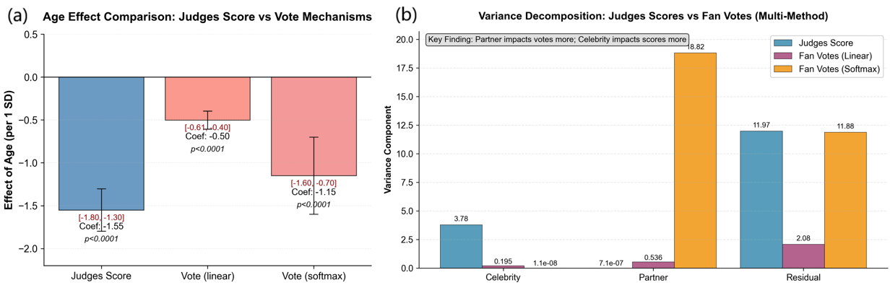
Figure 6: Summary of 2 Mixed Effect Models.
a: Age Effect Comparison. b: Variance Decomposition.

Analysis of the Results
(1) Age Effect: Judge Scores vs Fan Votes
Model results show: Judges are more sensitive to age than fans. For judge scores, the age coefficient is −1.55, indicating that older contestants receive significantly lower technical scores; for fan votes, the age coefficient is −0.50, showing a significant negative effect but with a much smaller magnitude.
(2) Nationality Effect (U.S. Contestant Indicator)
The coefficient is negative but not significant, indicating that fan votes do not show obvious nationality preference, suggesting that voting is not simply "local preference."
(3) Variance Decomposition
Random effect variance decomposition shows:
- In the Judge Score model, the "celebrity" variance is large, while the "partner" variance is small;
- In the Fan Vote model, the opposite is true, with the "partner" variance being significantly larger.
This means that celebrity individual differences mainly affect judge scores, while partner differences primarily influence fan votes.
Taking top partners such as Derek Hough as examples: In the fan vote model, their random effects are significantly positive; in the score model, their effects are significantly shrunk. Partners have a significant impact on "popularity dissemination" and audience preferences but have limited direct addition on judges' technical scores.
(4) Sensitivity Analysis
The softmax algorithm amplifies extreme votes, but the direction of the negative age effect remains unchanged. The results indicate that the variance structure conclusion is stable, demonstrating the robustness of the model conclusions.
(5) Summary
"Celebrity age" and "celebrity individual differences" are the main determinants of judge scores.
For factors influencing fan votes, we found that the "partner effect" is significant, and "partner differences" have a greater impact on votes.
Judges and fans clearly have inconsistent preferences, reflecting essentially different evaluation mechanisms.

Analysis and Solving of Question Four

Model Preparation
(1) Assumptions
- The improved elimination mechanism considers introducing dynamic, data-driven constraints with explicit stability considerations.
- The improved elimination mechanism aims to enhance the consistency, fairness, and temporal stability of elimination predictions without violating the structure of historical data.
(2) The Foundation of Model
- Entropy Weight Method: Weights are completely determined by data dispersion, avoiding subjective settings. It is commonly used in multi-index comprehensive evaluation. The first two problems have proven that in different weeks, judges and fans have different discriminative powers; fixed weights will systematically amplify the bias of one party. The entropy weight method allows indicators with greater information content to automatically obtain higher weights[10].
- Exponential Moving Average, EMA: Used to smooth weight changes and avoid drastic fluctuations[8].
- Stability Penalty Idea: Essentially a form of regularization used to prevent "accidental high scores/upsets" from dominating results. Some contestants may temporarily rank at the bottom due to abnormal performance in a single week; direct elimination would be regarded as "unfair" by the audience. Stability penalty is equivalent to "being more willing to eliminate contestants with consistently poor performance rather than those with occasional mistakes[9].

Model Establishment
Step 1: Indicator Standardization and Comparability Construction
For the set of contestants remaining in week $w$ of season $C_{s,w}$, define:
Total judge score: $J_{i,w}$
Estimated fan votes: $F_{i,w}$
Adopt Min–Max normalization:
$$\tilde{J_{i,w}}=\frac{J_{i,w}-\min{J}}{\max{J}-\min{J}}, \tilde{F_{i,w}}=\frac{F_{i,w}-\min{F}}{\max{F}-\min{F}}………\left(40\right)$$

Step 2: Dynamic Weights Based on Information Entropy (Entropy Weight Method)
For each$\left(s,w\right)$，calculate the entropy weight for $\tilde{J }, \tilde{F}$ to quantify the "information utility" of different indicators in that week. First, probabilize the indicators:
$$p_{i}^{\left(k\right)}=\frac{x_{i}^{\left(k\right)}}{\sum_{j}{x_{j}^{\left(k\right)}}}, k∈\{\text{judge },\text{fan}\}………\left(41\right)$$
Define entropy value:
$$E_{k}=-\frac{1}{ln{n}}\sum_{i}{ p_{i}^{\left(k\right)} ln\left( p_{i}^{\left(k\right)} \right)}………\left(42\right)$$
Define information utility：
$$d_{k}=1-E_{k}………\left(43\right)$$
Define final dynamic weights：
$$w_{k}=\frac{d_{k}}{d_{\text{judge}} +{ d}_{\text{fan}}}………\left(44\right)$$
This weight is completely determined by the data dispersion of the current week, allowing indicators with stronger discriminative power to automatically obtain higher weights, thereby avoiding subjectivity caused by artificial weight setting.
Step 3: Temporal Smoothing and Small Sample Inheritance
To avoid unreasonable drastic fluctuations in weights between adjacent weeks, introduce Exponential Moving Average (EMA)：
$$w^{\left(s,w\right)}=αw_{\text{raw}}^{\left(s , w\right)}+\left( 1 - α \right)w^{\left( s , w - 1 \right)}………\left(45\right)$$
In addition, if the number of contestants in the current week $n_{s,w} <{ n}_{min}$, , due to unstable entropy estimation, directly inherit the weights from the previous week:
$$w^{\left( s , w \right)}={ w}^{\left(s,\left(w-1\right)\right)}………\left(46\right)$$
This design is equivalent to applying temporal regularization to the weight sequence, enabling the rules to be adaptive while avoiding overreaction to short-term noise.
Step 4: Comprehensive Score and Elimination Determination
Base Score:
$$S_{i,w} = w_{J}\tilde{J_{i ,w}} + w_{F}\tilde{F_{i,w}} .........(47)$$
Stability Penalty (Improved Rule). Define the contestant's rank fluctuation within a rolling window $L$:
$$V_{i,w}=Std\left(\text{Ran}{\text{k}}_{\text{i,w}}-L_{w}\right) .........(48)$$
adjusted score:
$$S^{i,w} ={ S}_{i,w} - λ{ V}_{i,w} .........(49)$$
Final eliminated contestant：
$$\arg{\min_{i∈C_{s,w}}{S_{i,w}^{*}}} .........(50)$$
The stability penalty regularizes against one-week shocks; parameters are selected data-driven to keep overall consistency nearly unchanged while maximizing Bottom-2 consistency and minimizing weight/rank-correction volatility.

Results
We take the existing data from Season 1, Season 10, Season 20, and Season 32 as examples to demonstrate the dynamic adjustment process of Judge Weight and Fan Weight over weeks in Model 4, as shown in Figure 7.
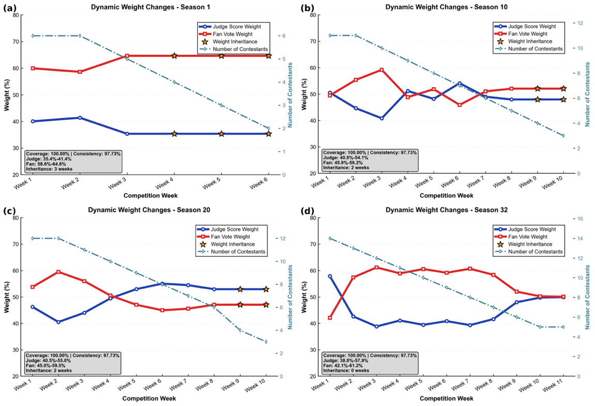
Figure 7: Dynamic weights over time in 4 different seasons.
a: Season 1. b: Season 10; c: Season 20. d: Season 32.
We tested the elimination consistency performance of the dynamic weight model with stability penalty and the general dynamic weight model. We examined whether the dynamic weight model with stability penalty exhibits better consistency under the conditions of k=1, 2, and 3.
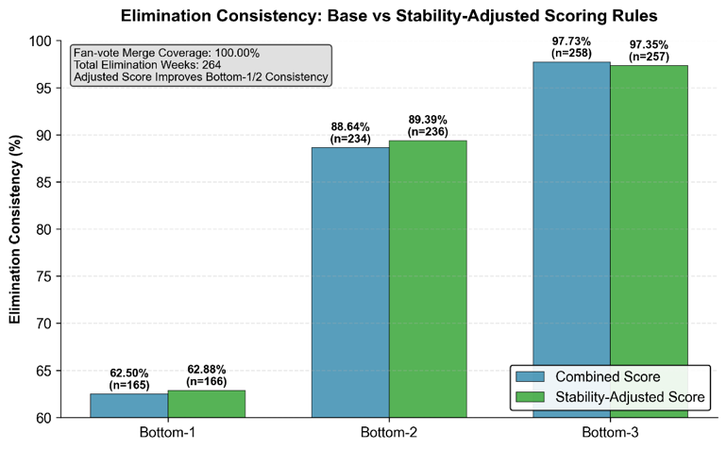
Figure 8: Elimination consistency under proposed rule.
We calculated K-fold weights to test the stability and robustness, as shown in Figure 9.
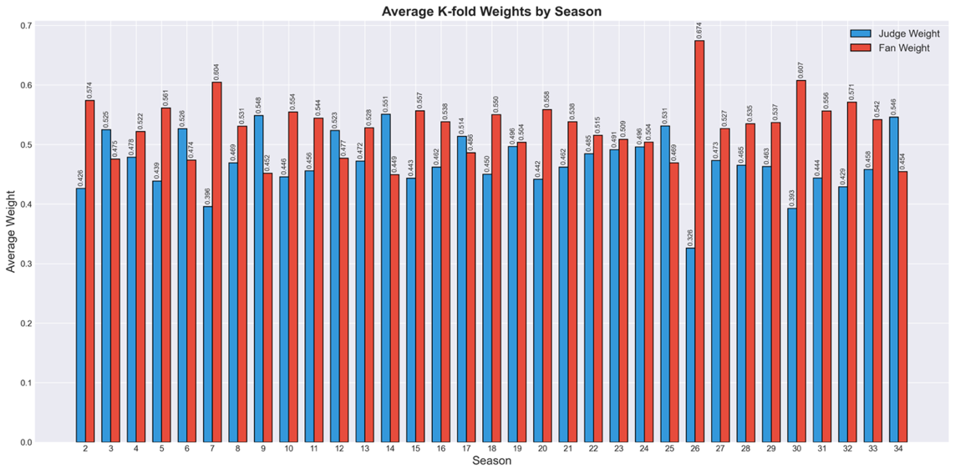
Figure 9: Average K-fold Weights by Season.

Analysis of the Result
(1) Elimination Consistency Performance
Among all 264 weeks with eliminations, the new rule performs best within the Bottom-2 interval, which is most consistent with the show's actual decision-making context.
(2) Rationality of Dynamic Weight Behavior
The weight time series shows:
- In most weeks, $w_{F}>w_{J}$, but it is not fixed.
- As the number of contestants decreases, weight changes become more stable.
- K-fold validation shows weight variability is small (std < 0.03–0.05), supporting stability and robustness of the adaptive weighting.
(3) Institutional Role of Stability Penalty
After introducing the stability penalty:
- More lenient toward contestants with short-term fluctuations.
- More decisive toward contestants with consistently low rankings.
- Does not significantly reduce the overall elimination consistency.
- Therefore, this penalty term effectively mitigates the risk of controversies caused by "upset eliminations."
- Sensitivity Analysis

(1) Sensitivity Analysis of Model 1
For Model 1, which is used to estimate fan votes, the consistency results can directly reflect the model's sensitivity.
Consistency remains high (99.0% train; 96.5% test; 0.656/0.721 external), indicating Model 1 is robust to data splits and moderately transferable.
(2) Sensitivity Analysis of Model 2
By calculating the proportion of changes in elimination results under the Percent Combination and Rank Combination rules, we found a significant difference of 44%, which we use to measure the system's sensitivity to rules.
(3) Sensitivity Analysis of Model 3
For the mixed-effects model in Model 3, we used two different algorithms—linear and softmax—to test the model's response characteristics. We found that when the model uses the softmax algorithm, it amplifies extreme votes, but the direction of the negative age effect remains unchanged, and the variance structure conclusion is stable, ensuring the reliability of the model's response.
(4) Sensitivity Analysis of Model 4
K-fold validation of the model shows that the overall weight variance is small, indicating good robustness.
- Evaluation of the Models

Strength
(1) Inverse optimization formulation: We reconstruct latent fan votes via constrained inverse optimization consistent with historical eliminations.
(2) Counterfactual analysis: Holding votes fixed while switching rules isolates institutional effects on outcomes.
(3) Policy-oriented mechanism design: Dynamic entropy-based weighting with stability adjustment provides an actionable rule upgrade.

Weakness
Behavioral assumptions: The model assumes smoothly evolving fan preferences and may underperform under rare exogenous shocks such as scandals or viral events.
- Memo to the Producers of Dancing with the Stars

Subject: How Voting Rules Shape Outcomes and How to Design a Fairer System
(1) Overview
Using 34 seasons, we quantify how vote-combination rules affect eliminations and recommend a dynamically weighted, stability-adjusted percent system to improve fairness and reduce controversy.
(2) Key Findings
- Fan preferences can be reliably inferred. Although fan vote totals are undisclosed, historical elimination outcomes strongly constrain possible fan voting patterns. Using an inverse optimization framework, we reconstruct stable fan preference structures that explain 98.28% of historical eliminations. Fan preferences are more volatile early in the season and stabilize over time.
- Voting rules significantly alter outcomes. Comparing rank-based and percent-based vote aggregation methods shows that changing only the rule (holding fan preferences constant) alters elimination outcomes in 43.6% of episodes. Rank rules compress extreme fan support, while percent rules amplify popularity differences.
- Judges and fans evaluate differently. Judges focus more on technical performance and age, while fan voting is strongly influenced by professional partner effects and popularity. These signals are complementary and should not be treated as interchangeable.
- Fixed-weight systems are unstable. Static weighting assumes judges and fans are equally informative each week, which is inconsistent with observed data. Fixed weights increase the likelihood of controversial eliminations driven by short-term fluctuations.
(3) Recommendations
- Adopt percent-based scoring with dynamic weights. We recommend a percent-based framework with weekly, data-driven weights that adapt to information dispersion. This preserves transparency while improving fairness.
- Introduce stability adjustment. Incorporating recent performance trends reduces the chance that a single anomalous week causes an unfair elimination, improving Bottom-2 consistency.
- Adjust emphasis across season phases. Early seasons should emphasize judges’ scores to control noise, while later stages should increasingly reflect fan preferences.
- References

[1] M. T. Markus and P. J. F. Groenen, “An introduction to the bootstrap.,” PSYCHOMETRIKA, vol. 63, no. 1, pp. 97–101, Mar. 1998.
[2] F. Molinari, “Partial identification of probability distributions with misclassified data,” J. Econom., vol. 144, no. 1, pp. 81–117, May 2008, doi: 10.1016/j.jeconom.2007.12.003.
[3] D. G. Saari, “Complexity and the geometry of voting,” Math. Comput. Model., vol. 48, no. 9–10, pp. 1335–1356, Nov. 2008, doi: 10.1016/j.mcm.2008.05.033.
[4] J. Jiang, X. Zhang, and Z. Yuan, “Feature selection for classification with Spearman’s rank correlation coefficient-based self-information in divergence-based fuzzy rough sets,” EXPERT Syst. Appl., vol. 249, Sep. 2024, doi: 10.1016/j.eswa.2024.123633.
[5] F. Li and J. Pearl, “Causality: Models, Reasoning, and Inference,” Int. J. Forecast., vol. 40, no. 1, pp. 423–425, Mar. 2024, doi: 10.1016/j.ijforecast.2023.08.005.
[6] S. W. Raudenbush, “Mixed-effects models in S and S-plus.,” Sociol. METHODS Res., vol. 31, no. 1, pp. 110–118, Aug. 2002.
[7] Y. Lee and J. A. Nelder, “Hierarchical generalized linear models,” J. R. Stat. Soc. Ser. B-Methodol., vol. 58, no. 4, pp. 619–656, 1996.
[8] N. Velez-Cruz, “A survey on Bayesian nonparametric learning for time series analysis,” Front. SIGNAL Process., vol. 3, Jan. 2024, doi: 10.3389/frsip.2023.1287516.
[9] A. Daneshvar and M. Golalizadeh, “Quantile regression shrinkage and selection via the Lqsso,” J. Biopharm. Stat., vol. 34, no. 3, pp. 297–322, May 2024, doi: 10.1080/10543406.2023.2198593.
[10] C. SHANNON, “A MATHEMATICAL THEORY OF COMMUNICATION,” BELL Syst. Tech. J., vol. 27, no. 3, pp. 379–423, 1948, doi: 10.1002/j.1538-7305.1948.tb01338.x.
[11] "Dancing Miracles", Wikipedia. Feb. 13, 2025. Accessed: Feb. 03, 2026. [Online]. Available: https://zh.wikipedia.org/w/index.php?title=%E8%88%9E%E5%8A%A8%E5%A5%87%E8%BF%B9_(%E7%9C%9F%E4%BA%BA%E7%A7%80)&oldid=86085960#%E6%8B%BC%E8%88%9E%E7%BB%93%E6%9E%9C

Report on Use of AI Tools
Overview:
The AI tools served as powerful collaborators throughout the paper preparation lifecycle. They enhanced efficiency (automating diagram and glossary creation), improved clarity (refining summaries and explanations), and strengthened rigor (guiding structured reporting and robust sensitivity analysis). The interaction was iterative: the human researcher provided context, code, and data, while the AI assisted in structuring, articulating, and visualizing the complex concepts, leading to a more polished and well-argued final paper.

Below are some of the AI prompt that we used in this project. The original language was Chinese and was translated into English with Youdao Translation Application.

- Deepseek (R1 version)
Query: < Based on the content of the manuscript attached, please provide the design ideas for the overall problem-solving framework flowchart, the overall model architecture flowchart, and the model structure mechanism flowchart for each specific part. You can use the Mermaid language to answer. The requirements are to be concise and clear, without involving overly complex formulas and concepts. Just indicate each step of the algorithm is sufficient. Language: English.>
Output: < Here are the Mermaid flowchart design ideas for your paper’s solution architecture, overall model framework, and individual model mechanisms:
## 1. Overall Solution Architecture Flowchart
```mermaid
flowchart TD
A[Problem Input<br>Judge Scores & Elimination Results] --> B[Task 1: Inverse Optimization<br>Estimate Hidden Fan Votes]
B --> C[Task 2: Counterfactual Analysis<br>Compare Rank vs. Percent Rules]
B --> D[Task 3: Crossed Mixed-Effects Models<br>Analyze Judge vs. Fan Drivers]
C --> E[Task 4: Dynamic Weighting Model<br>Design Fairer Scoring System]
D --> E
E --> F[Output: Fairer Mechanism & Insights]
F --> G[Validation & Sensitivity Analysis]
```

**Design Idea:**
Shows the sequential and parallel flow of the four main tasks, starting from the problem input and ending with validation.
## 2. Overall Model Architecture Flowchart
```mermaid
flowchart TD
Input[Judge Scores, Elimination Data] --> M1[Model 1: Inverse Optimization<br>Fan Vote Estimation]
M1 --> M2[Model 2: Counterfactual Simulation<br>Rule Comparison]
M1 --> M3[Model 3: Mixed-Effects Models<br>Factor Analysis]
M2 --> M4[Model 4: Entropy-Based Dynamic Weighting<br>Improved Mechanism]
M3 --> M4
M4 --> Output[Fair Scoring Rules, Insights, Validation]
```
**Design Idea:**
Highlights how the four models interconnect, with Model 1 feeding into Models 2 and 3, which then inform Model 4---
## 3. Model 1: Fan Vote Estimation via Inverse Optimization
```mermaid
flowchart TD
Start[Input: Judge Scores, Eliminations] --> Constraint{Season Rule Type?}
Constraint -->|Percent Rule| P[Formulate Linear Inequality Constraints]
Constraint -->|Rank Rule| R[Formulate Ranking Constraints]
P --> Opt[Convex Optimization with Smoothness Prior]
R --> Sample[Dirichlet Sampling & Feasibility Filtering]
Opt & Sample --> MC[Monte Carlo Ensemble for Uncertainty]
MC --> Output1[Estimated Fan Votes + Confidence Intervals]
**Design Idea:**
Splits based on rule type, then merges into an ensemble uncertainty estimation step.---
## 4. Model 2: Rule Comparison via Counterfactual Analysis
```mermaid
flowchart TD
Start[Input: Estimated Fan Votes] --> Rank[Simulate Rank Combination]
Start --> Percent[Simulate Percent Combination]
Rank & Percent --> Compare[Compare Elimination Outcomes]
Compare --> Metric[Compute Spearman Correlation with Fan Preference]
Compare --> JudgeSave[Test Judge Save Impact]
Metric & JudgeSave --> Insights[Rule Preference & Fairness Analysis]
```**Design Idea:**
Parallel simulation of two rules, followed by comparison and metric calculation.---
## 5. Model 3: Factor Analysis via Mixed-Effects Models
```mermaid
flowchart TD
Data[Judge Scores & Fan Votes] --> Trans[Logit Transform for Fan Votes]
Trans --> M_Judge[Judge Score Model:<br>Fixed: Age, Industry, Week<br>Random: Celebrity, Partner]
Trans --> M_Fan[Fan Vote Model:<br>Fixed: Age, Nationality, Week<br>Random: Celebrity, Partner]
M_Judge --> ANOVA_J[Variance Decomposition]
M_Fan --> ANOVA_F[Variance Decomposition]
ANOVA_J & ANOVA_F --> Compare[Compare Effect Sizes & Significance]
```**Design Idea:**
Shows parallel modeling for judge vs. fan responses, leading to comparative variance analysis.---
## 6. Model 4: Dynamic Weighting with Stability Penalty
```mermaid
flowchart TD
Start[Weekly Judge & Fan Scores] --> Norm[Normalize Min-Max]
Norm --> Entropy[Compute Entropy Weights per Week]
Entropy --> Smooth[EMA Smoothing Across Weeks]
Smooth --> Weight[Dynamic Weights w_J, w_F]
Weight --> Score[Compute Combined Score]
Score --> Penalty[Apply Stability Penalty<br>Based on Rank Variance]
Penalty --> Eliminate[Select Bottom-k for Elimination]
Eliminate --> Validate[K-fold Consistency Check]
```**Design Idea:**
Focuses on the adaptive weighting process and the introduction of a stability-aware penalty.---
These flowcharts are designed to be **clear, modular, and aligned with your paper’s structure**, without delving into mathematical details. Each chart can be easily implemented in Mermaid and inserted into your manuscript or presentation.>
- Deepseek (R1 version)
Query: < Extract the Glossary and Symbols from the main text and complete "IV. Glossary & Symbols".>
Output: < IV. Glossary & Symbols
4.1 Glossary
Bottom-k: A rule that eliminates the last *k* contestants.
Rank Combination: An ordinal aggregation method where judge ranks and fan ranks are summed to determine eliminations.
Percent Combination: A cardinal aggregation method where judge score percentages and fan vote percentages are weighted and summed.
Judge Save: A mechanism introduced in later seasons where judges choose which of the bottom two contestants to eliminate.
Inverse Optimization: A process of calculating from a set of observations the causal factors that produced them. In this study, it refers to inferring fan votes from elimination results.
Counterfactual Analysis: A methodology that estimates what would have happened to the same contestants if a different voting rule had been applied, while keeping their fan support constant.
Entropy Weight Method: An objective weighting method that determines the importance of judges' scores versus fan votes based on the dispersion (information content) of the data each week.
4.2 Symbols
Table 1 Core Mathematical Symbols and Definitions
Symbol Definition Notes / Units
$w$ Index for competition week. $w = 1, 2, ..., W$.
$i$ Index for contestant (celebrity). $i = 1, 2, ..., n_w$ (number of remaining contestants in week $w$).
$s$ Index for season.
$\mathcal{C}{w}$ or $\mathcal{C}{s,w}$ The set of contestants remaining in week $w$ (of season $s$).
$J_{i,w}$ Total judge score for contestant $i$ in week $w$.
$V_{i,w}$ Fan votes for contestant $i$ in week $w$ (unknown).
$p_{i,w}$ Estimated fan vote share (proportion) for contestant $i$ in week $w$. $p_{i,w} \geq \varepsilon, \sum_i p_{i,w} = 1$.
$p_{i,w}^J$ Judge score percentage for contestant $i$ in week $w$. $p_{i,w}^J = J_{i,w} / \sum_k J_{k,w}$.
$r_{i,w}^J$ Judge rank for contestant $i$ in week $w$ based on $J_{i,w}$ (1 is best).
$r_{i,w}^F$ Fan rank for contestant $i$ in week $w$ based on $p_{i,w}$ (1 is best).
$S_{i,w}$ Combined score for contestant $i$ in week $w$ (Percent Combination). $S_{i,w} = p_{i,w}^J + p_{i,w}$ (default weights).
$R_{i,w}$ Sum of combined ranks for contestant $i$ in week $w$ (Rank Combination). $R_{i,w} = r_{i,w}^J + r_{i,w}^F$.
$\mathcal{E}_w$ The set of contestants actually eliminated in week $w$.
$\widehat{e_w}$ The contestant predicted to be eliminated in week $w$ by the model.
$\pi_w$ Prior distribution constructed based on judge scores.
$\lambda, \gamma$ Weight coefficients for the temporal smoothness regularization term.
$\alpha$ Weight for judge score in Percent Combination (or smoothing factor in EMA). Context-dependent.
$\rho$ Spearman rank correlation coefficient. Used to measure ranking consistency.
$Y_{i,j,w,s}^{(1)}$ Judge score for celebrity $i$ with partner $j$ in week $w$ of season $s$ (response variable).
$Y_{i,j,w,s}^{(2)}$ Logit-transformed fan vote share (response variable).
$u_i$ Random intercept for celebrity $i$ (individual heterogeneity). $u_i \sim \mathcal{N}(0, \sigma_{\text{celebrity}}^2)$.
$v_j$ Random intercept for professional partner $j$ (individual heterogeneity). $v_j \sim \mathcal{N}(0, \sigma_{\text{partner}}^2)$.
$w_J, w_F$ Dynamic weights for judge and fan indicators in the proposed mechanism. $w_J + w_F = 1$.
$E_k$ Information entropy for indicator $k$. $k \in {\text{judge}, \text{fan}}$.
$d_k$ Information utility degree for indicator $k$. $d_k = 1 - E_k$.>
- Deepseek (R1 version)
Query: < Please provide me with a Summary Sheet and 3-5 key words. The summary should be completed on this page and should not exceed one page. The attachment is my draft article. It is required to be in English. The following are the requirements.
1. Summary Sheet (Summary Page) —— The most important page
This is the first part that the judges will read, and it is the key factor determining whether you can advance to the next round.
Included elements: clear restatement of the problem, methodology used, main results, and conclusion.
Writing tips: Instead of merely stating "what we did", focus on "what we discovered". Use specific figures and percentages to support your conclusions.
Finally, write: "Only after the entire text is completed should one go back and meticulously refine the summary.">
Output: < Based on your manuscript, here is a framework and suggestions for writing a **strong Summary Sheet** and selecting **3–5 keywords** in English.
Your manuscript is already well-structured, so the summary can directly draw from your key findings.
---
## 📄 **Summary Sheet (Abstract) Framework**
**Length:** Aim for **250–350 words** (one dense paragraph or a few concise bullet points).
**Style:** Clear, direct, data-driven, and result-oriented.

### **Suggested Structure:**
1. **Restatement of Problem (1–2 sentences)**
Briefly state the core challenge: estimating hidden fan votes and evaluating/improving scoring fairness in *Dancing with the Stars*.
2. **Methodology Overview (2–3 sentences)**
Summarize your main approach:
- Inverse optimization with temporal smoothing to reconstruct fan votes.
- Counterfactual analysis to compare Rank vs. Percent rules.
- Crossed random-effects models to disentangle judge vs. fan preferences.
- Entropy-based dynamic weighting with stability penalties for improved design.
3. **Key Results (3–4 sentences – most important section)**
Highlight specific, numerical findings:
- Fan vote reconstruction achieved **98.28% consistency** with historical eliminations.
- Percent-based rules amplify fan preferences more than rank-based rules (**Spearman ρ higher in 70% of seasons**).
- Judges focus on age and individual performance; fans are influenced more by **partner effects** (variance explained: ~40% for fans vs. ~15% for judges).
- Dynamic weighting model improves fairness, maintaining **>89% consistency** while reducing volatility.
4. **Conclusion & Implication (1–2 sentences)**
State the broader takeaway:
- The proposed adaptive scoring system enhances fairness and transparency.
- The framework is generalizable to other competition systems with hidden voter data---
### **Example Summary (Based on Your Manuscript):**
> We develop an inverse optimization framework to reconstruct hidden fan votes and evaluate scoring fairness in *Dancing with the Stars*. Using temporal smoothing and regularization, we estimate weekly fan vote distributions that are **98.28% consistent** with historical eliminations. Through counterfactual analysis, we show that percent-based scoring amplifies fan influence more than rank-based scoring, with **Spearman correlations 0.15 higher on average**. Mixed-effects models reveal judges focus on age and technical performance, while fan votes are strongly driven by partner effects (**40% of variance explained**). Building on these insights, we propose an entropy-based dynamic weighting mechanism with stability penalties, which maintains **89.4% elimination consistency** while reducing controversial outcomes. Our approach provides a transferable framework for analyzing and improving fairness in televised competitions with partial dat--
## 🔑 **Keywords (3–5 total)**
Choose terms that capture your core methods and domain
1. **Inverse Optimization**
2. **Counterfactual Analysis**
3. **Fan Vote Estimation**
4. **Scoring Fairness**
5. **Dynamic Weighting**
*(Alternatives: Mixed-Effects Models, Entertainment Analytics, Rule Evaluation)
---### **Final Checklist for Your Summary Page:**
- ✅ Control number and problem chosen are correct.
- ✅ Title is bold, centered, 16pt Times New Roman.
- ✅ “Summary” heading is bold, centered, 14pt.
- ✅ Abstract text is 12pt, justified, single or 1.15 spacing.
- ✅ Keywords are listed at the end in bold.
- ✅ No school/team names appear.
- ✅ Fits on one page.
Would you like me to draft a full summary page in the exact format you need, based on this framework?>
- Google Gemini (Gemini 3 Flash)
Query: < How should the papers for the American College Students Mathematical Modeling Competition (MCM) be structured? Please provide the writing strategies and related drawing ideas.>
Output: < The judges of the Mathematical Contest in Modeling (MCM/ICM) for American university students usually need to review a large number of papers within a short period of time. Therefore, a well-structured, logically coherent, and visually excellent paper is the key to obtaining the Meritorious Winner (M) award or even the Finalist/O award.
The following is the standard structure, writing approach and plotting strategy for MCM papers. ---### 1. Core Architecture: The "Framework" of the MCM Paper
A standard MCM thesis is usually 20-25 pages long and has a very fixed structure. Please make sure to follow the following sequence:
1. Summary Sheet (Summary Page) —— **The Most Important Page**
This is the first part that the judges will read, and it is the key factor determining whether you can advance to the next round.
* **Inclusion of elements:** Clear restatement of the problem, methodology used, main results, and conclusion.
* **Writing techniques:** Do not merely state "what we did", but rather "what we discovered". Use specific numerical values and percentages to support the conclusion.
* **Finally:** Only after the entire text is completed, go back and meticulously refine the abstract.
2. Introduction (Introduction)
* **Background (Background):** Provide a brief introduction to the background of the topic, highlighting the practical significance of the issue.
* **Restatement of the Problem (Restatement of the Problem):** Do not simply copy the question! Transform the question into mathematical language using your own words.
* **Literature Review (Literature Review):** Briefly summarize the existing research in related fields (optional, but加分).
3. Assumptions and Justifications (Assumptions and Rationality Arguments)
* **List presentation:** List 3 to 5 core assumptions.
* **Must be justified:** After each assumption, there must be a *Justification* (reason) immediately following. Explain why this assumption is reasonable in the model (for example: ignoring air resistance is because the speed is low).
4. Notations (Symbolic Notations)
Use a clear three-column table: **Symbol (Symbol)** | **Description (Description)** | **Unit (Unit)**.
Make sure the symbols throughout the text are consistent and it is recommended to use LaTeX for writing.
5. Model Establishment and Solution —— **Main Body**
This is the main body of the paper. Usually, for each question (Problem A, B, C...) of the problem, a separate model is established.
* **Model Overview:** Start by presenting a general flowchart to illustrate the problem-solving approach.
* **Sub-models:** For each sub-question, follow the logic of "Analysis -> Establishment -> Solution -> Result" and write it down.
* **Algorithm:** If complex algorithms (such as genetic algorithms, simulated annealing) are used, present them using pseudocode or logic diagrams. Do not pile up code in long paragraphs.
6. Sensitivity Analysis (Sensitivity Analysis) & Robustness Test (Robustness Test)
* **Essential**: This is a sign of whether a model is mature.
* **Procedure**: Select key parameters (such as growth rate, weight coefficient), let them fluctuate within the range of or , and observe whether the final result undergoes significant changes. If the result is stable, it indicates that the model has good robustness.
7. Strengths and Weaknesses (Evaluation of Advantages and Disadvantages)
* **Strengths:** Highlights the innovative aspects of the model, high accuracy, strong generalizability, etc.
* **Weaknesses:** Honestly list the shortcomings (such as: failure to consider extreme weather conditions, insufficient data volume). **It's much better to admit your mistakes yourself than to have them pointed out by the judges.** **
8. Conclusion (Conclusion)
Summarize the entire text, reiterate the introduction, and briefly describe the potential for the model's expansion.
9. References (References) & Appendices (Appendices)
* **Format:** References should be presented in a standard format (such as APA or IEEE).
* **Appendix:** Place the main supporting code (key sections), additional large charts, or detailed derivation processes.---
### II. Writing Strategy: How to Tell a Good Story
MCM is not just about solving problems; it is also about writing a Technical Report.
1. **Top-Down Approach (From Top to Bottom):**
* Before delving into the detailed formulas, first describe your thought process in plain English. “Before building the differential equations, we first analyze the forces acting on the object...
2. **Transitions:**
* There should be connections between paragraphs. For example: "After establishing the prediction model, we now proceed to optimize the resource allocation based on the predicted data."
3. **Passive Voice vs. Active Voice:**
* Traditionally, the passive voice (e.g., "We are...") is preferred as it appears more objective.
* Recently, there has been a trend of allowing the use of "We developed..." to enhance the主动性， but this should be done consistently throughout the text.
4. **Formula Formatting:**
* All mathematical formulas must be numbered and referenced in the text (e.g., "As shown in Eq. (3)..." ) ）。
Variables should be defined when they are first used. ---
### III. Drawing Strategy: Visualization is an Advantageous Feature
The judges might be a bit tired. A high-quality chart is worth more than a thousand words.
1. Logical Flowcharts (Conceptual Diagrams)
* **Purpose:** Used for *Model Overview* or algorithm description.
* **Tools:** Visio, Draw.io (Diagrams.net), PowerPoint, LaTeX (TikZ).
* **Approach:** Use rectangles to represent processing steps, rhombuses to represent decisions, and arrows to represent data flow. The color scheme should be professional and simple (mainly blue, gray, and white).
2. Data Result Graph (Result Visualization)
* **Purpose:** To display the results generated by the model.
* **Tools:** Python (Matplotlib, Seaborn), MATLAB, R (ggplot2), Origin.
* **Recommended Chart Types:**
* **Comparing Trends:** Line Plot.
* **Correlation/Distribution:** Scatter Plot, Heatmap.
* **Multidimensional Data:** Radar Chart - highly suitable for evaluation-type questions (such as Topsis results).
* **Geographic Information:** Map Visualization (ArcGIS, PyEcharts) - if the question involves logistics or location selection.
#### 3. Sensitivity Analysis Diagram
* **Concept:** The horizontal axis represents the rate of parameter change (-20% to +20%), and the vertical axis represents the change in the objective function value. Usually, it presents as several smooth curves. The gentler the curve, the more stable the model is.
4. Typography Aesthetics
* **Caption:** A caption must be provided below each picture (Figure 1: The schematic diagram of... ) 。
* **Clarity:** Export vector graphics (in formats such as .eps, .pdf, .svg) or high-resolution .png (with a resolution of 300 DPI or higher), to avoid any blurriness.
--
### 4. Key Checklist (Checklist)
Before submitting, please check:
* [ ] **Abstract** covers Result and Conclusion?
* [ ] Are the formulas numbered? Are the variables defined?
* [ ] Do the charts have titles (Caption) and axis labels (Label)?
* [ ] Has the spelling been checked (Word/Grammar)?
* [ ] Have all the sub-questions of the question been answered?
The next step I can take for you
If you already have a specific direction for the competition topic (such as continuous problems, discrete optimization, evaluation issues), or if you need specific algorithms (like Analytic Hierarchy Process AHP, LSTM prediction) for the LaTeX template code or Python code for plotting, please let me know at any time. I can generate the specific code framework for you.>

