**EECS2040 Data Structure Hw #4 (Chapter 5 Tree)**

**due date 5/30/2021, 23:59**

**By 107061123 孫元駿**

**Part 1**

1. (8%) What is the maximum number of nodes in a k-ary tree of height h? Prove your answer.

[Ans]: $\frac{k^{h-1} }{k-1}$

k-ary tree of height h, total num of nodes n

n = 1, $n=1=k^{0}$

n = 2, $n=1+k=k^{0}+k^{1}$

n = 3, $n=k^{0}+k^{1}+k^{2}$

Conclude that we get $h=i$, $n=\sum_{j=0}^{i-1}{k^{j} }$

Therefore, if h = h is the maximum number of nodes, $n=\sum_{j=0}^{h-1}{k^{j}= }\frac{k^{h-1} }{k-1}$

1. (12%) For a simple tree shown below,
2. Draw a list representation of this tree using a node structure with three fields: tag, data/down, and next.

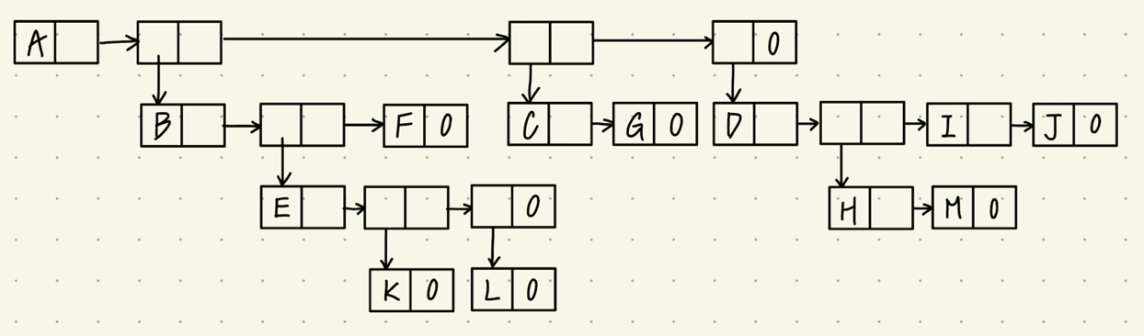

1. Write down a generalized list expression form for this tree.

(A(B(E(K, L), F), C(G), D(H(M), I, J)))

1. Convert the tree into a left-child and right-sibling tree representation

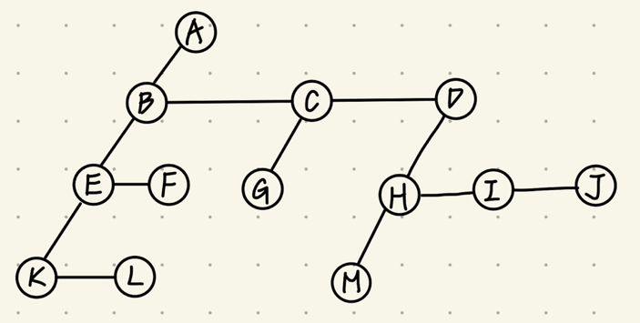

1. Draw a corresponding binary tree for this tree based on (c).

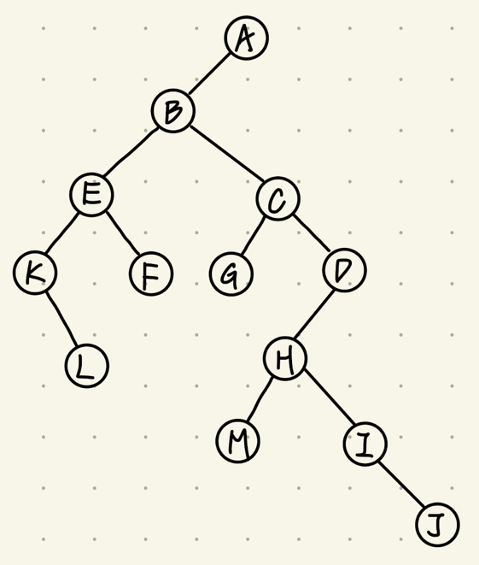



1. (10%) Draw the internal memory representation of the binary tree below using

(a) sequential representation.

/ A B / C D / / D / / E

(b) linked representation.

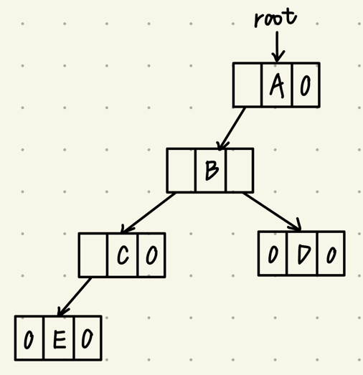

1. (4%) Extend the array representation of a complete binary tree to the case of complete trees whose degree is d, d > 1. Develop formulas for the parent and children of the node stored in position i of the array.

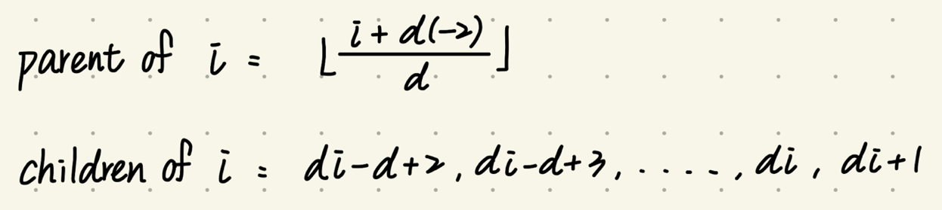

1. (16%) Write out the inorder, preorder, postorder, and levelorder traversals for the following binary trees.



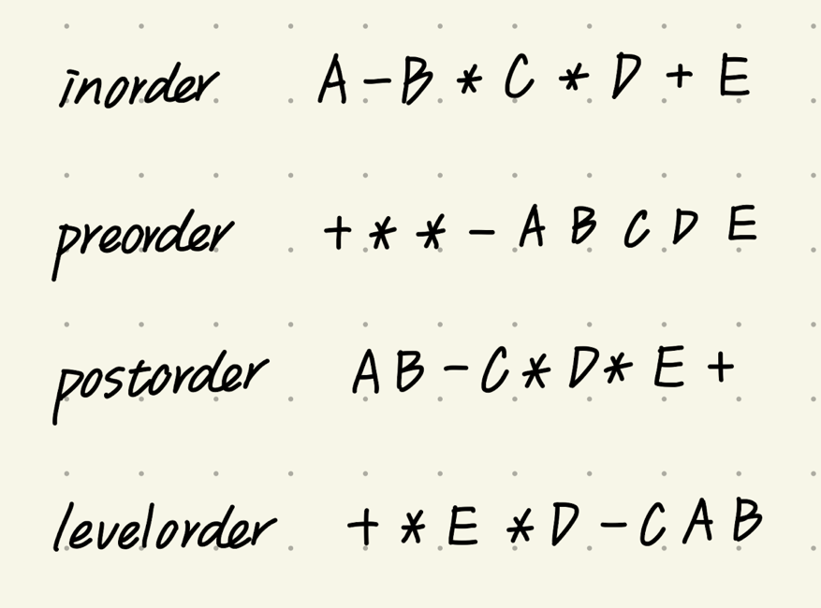

1. (30%) Given a sequence of 11 integer number: 50, 5, 30, 40, 80, 35, 2, 20, 15, 60, 70.

(a) Assume a Max heap tree is initialize with these 11 numbers placed into nodes of the tree according to node numbering of complete binary tree. Please draw the final Max heap tree after initialization process.

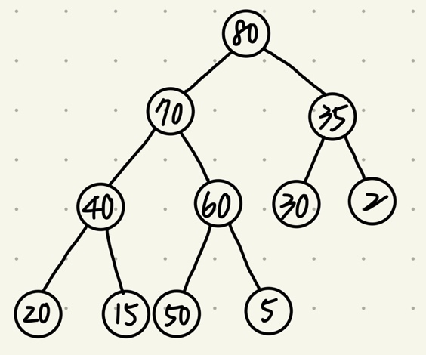

(b) Repeat (a) for Min Heap.

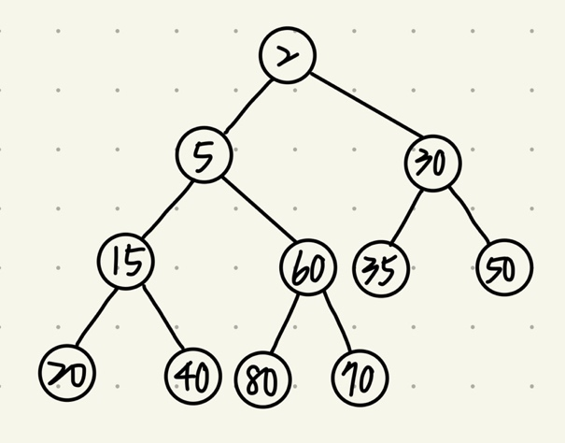

(c) Using the BST Insert function, (manually) insert the 11 number sequentially to construct a binary search tree. Draw the final 11-node BST.

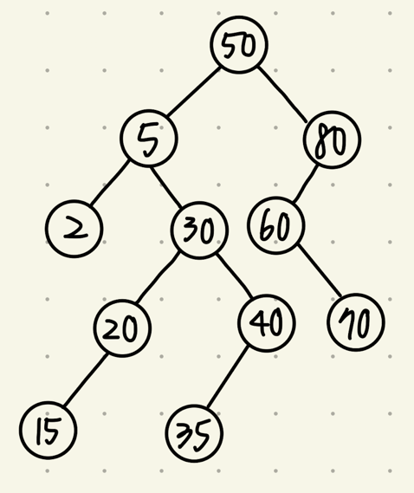

1. (20%) An 8-run with total of 25 numbers are to be merged using Winner tree and Loser tree. The numbers of the 8 runs are shown below. The first numbers form each of the 8 runs have been placed in the leaf nodes of the tree as shown. Then these eight numbers enter the tournament to get the overall winner.



1. Draw the winner tree and indicate the overall winner of this tournament.

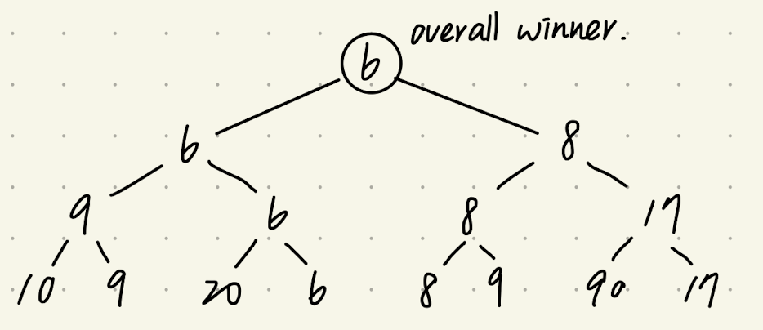

1. Draw the loser tree and indicate (draw) the overall winner of this tournament.

