**EECS2040 Data Structure Hw #5 (Chapter 6 Graph)**

**due date 6/6/2021 (Part 1)**

***Format***: Use a text editor to type your answers to the homework problem. You need to submit your HW in an HTML file or a DOCX file named as **Hw5-SNo.docx** or **Hw5-SNo.html**, where SNo is your student number. Submit the **Hw5-SNo.docx or Hw5-SNo.html** file via eLearn. Inside the file, you need to put the **header and your student number, name (e.g., EECS2040 Data Structure Hw #5 (Chapter 6) due date 6/6/2021 by SNo, name)** first, and then the **problem** itself followed by your **answer** to that problem, one by one. The grading will be based on the correctness of your answers to the problems, and the **format**. Fail to comply with the aforementioned format (file name, header, problem, answer, problem, answer,…), will certainly degrade your score. If you have any questions, please feel free to ask me.

**Part 1**

1. (10%) Does the multigraph below have an Eulerian walk? If so, find one.



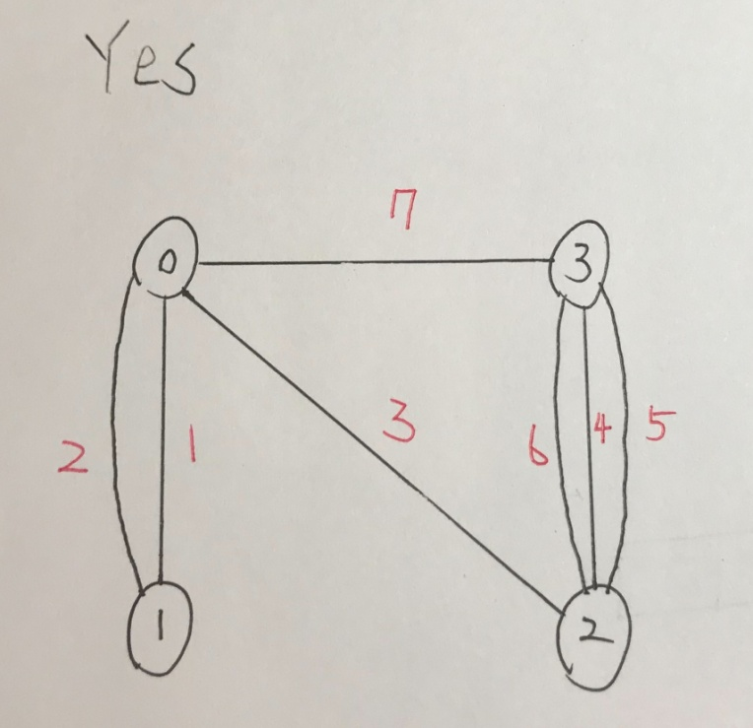

1. (10%) For the digraph below obtain
2. The in-degree and out-degree of each vertex
3. Its adjacency-matrix
4. Its adjacency-list representation
5. Its adjacency-multilist representation
6. Its strongly connected components



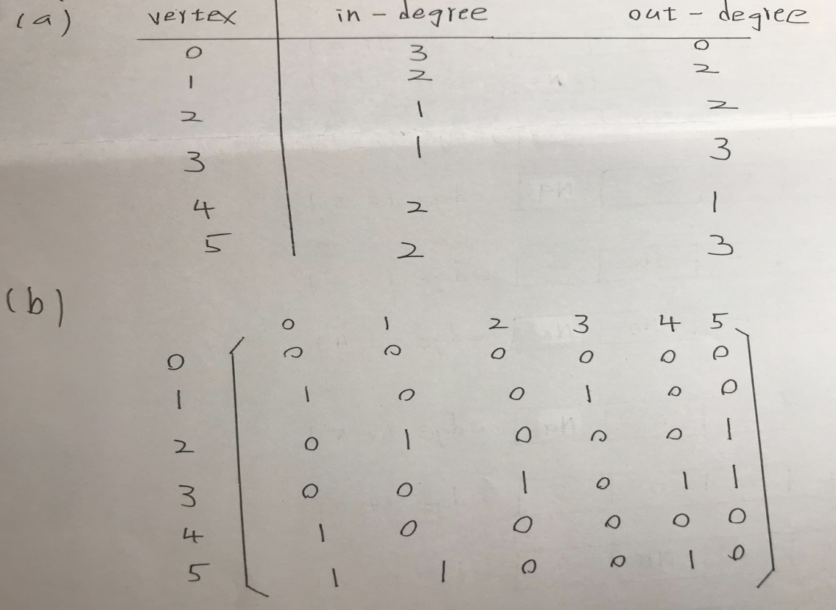

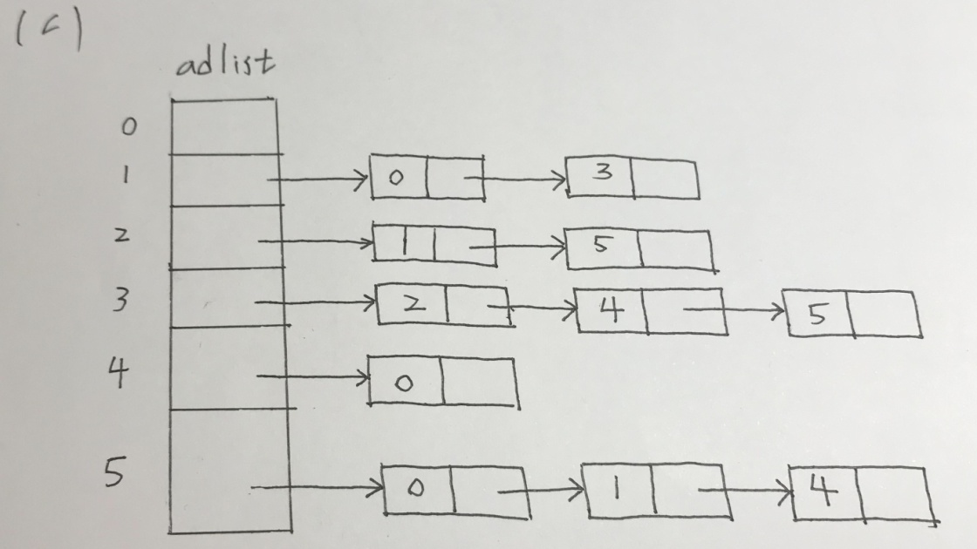

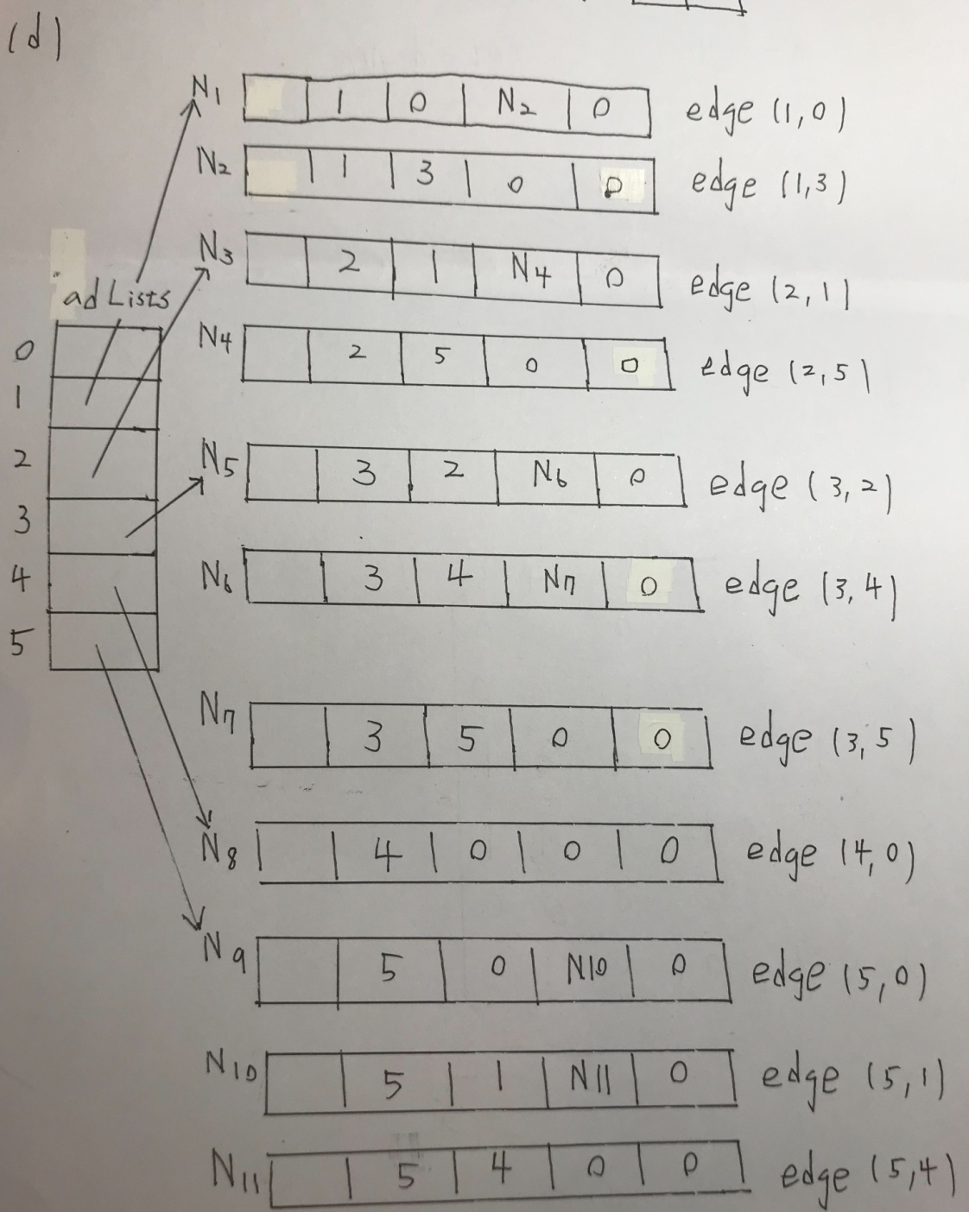

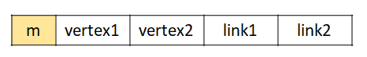

※使用Multilist 表示有向圖時，link2標示為NULL即可，若在link2標示上屬於vertex2的edge不扣分。

1. (10%) Is the digraph below strongly connected? List all the simple paths.



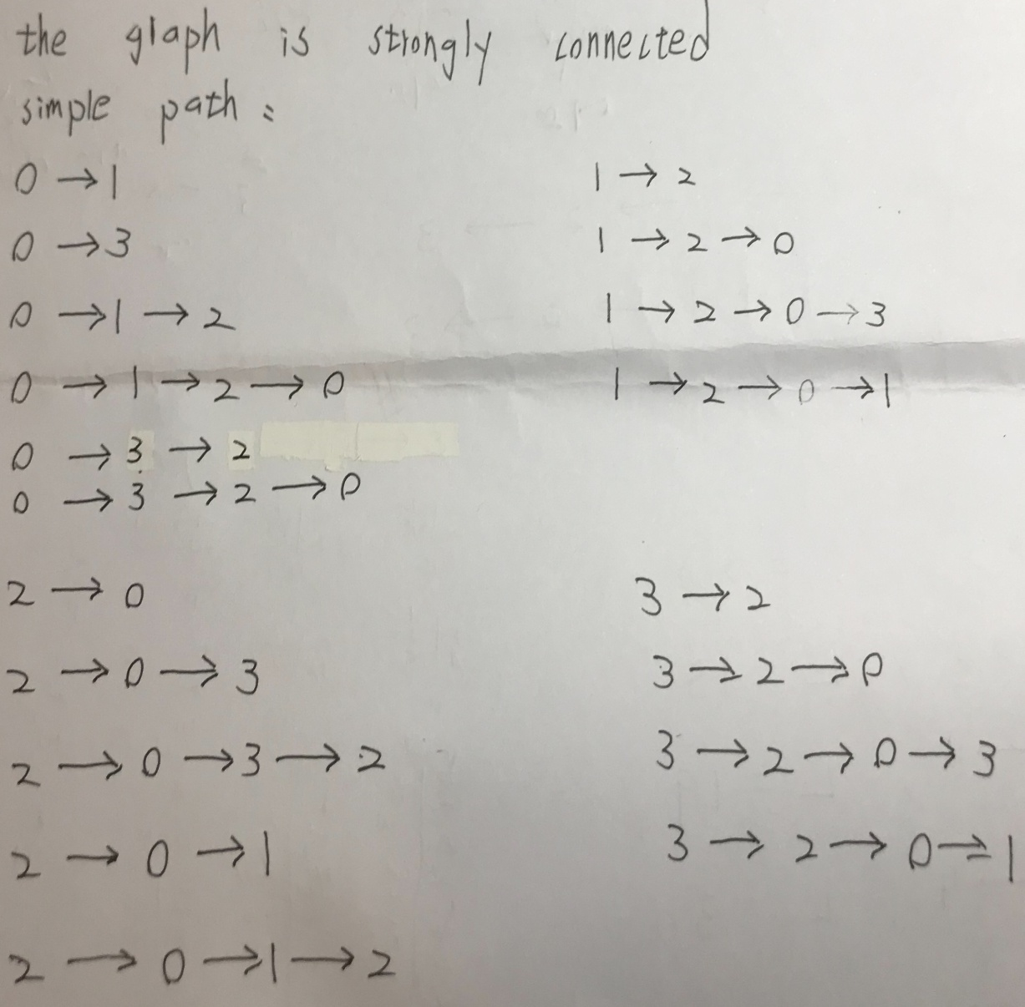

1. (10%) Draw the complete undirected graphs on one, two, three, four, and five vertices. Prove that the number of edges in an n-vertex complete graph is n(n-1)/2.

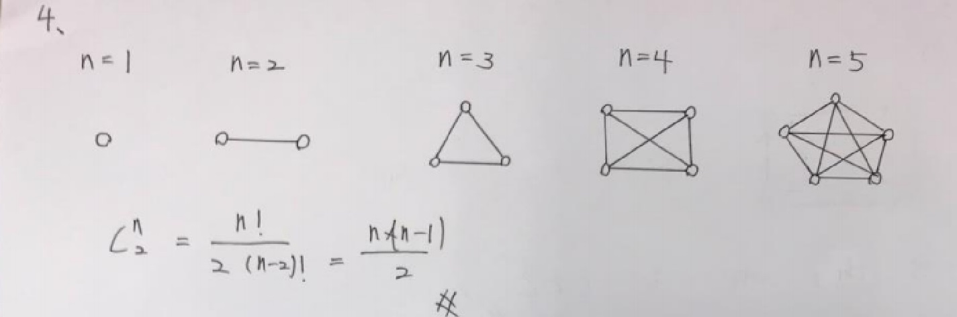

1. (10%) Apply depth-first and breadth-first searches to the complete graph on four vertices. Assume that vertices are numbered 0 to 3, are stored in increasing order in each list in the adjacency-list representation, and both traversals begin at vertex 0. List the vertices in the order they would be visited.

BFS;

0 - > 1 - > 2 - > 3

DFS;

0 - > 1 - > 2 - > 3

1. (20%) Use ShortestPath (Program 6.8) to obtain, in nondecreasing order, the lengths and the paths of the shortest paths from vertex 0 to all remaining vertices in the graph below.



|  |  |  |
| --- | --- | --- |
|  | path | lengths |
| 1 | 0 - > 1 | 20 |
| 2 | 0 - > 2 | 15 |
| 3 | 0 - > 2 - > 3 | 19 |
| 4 | 0 - > 1 - > 4 | 30 |
| 5 | 0 - > 2 - > 5 | 25 |

1. (10%) Using the directed graph below, explain why ShortestPath (Program 6.8) will not work properly. What is the shortest path between vertices 0 and 6?



|  |  |  |  |  |  |  |  |
| --- | --- | --- | --- | --- | --- | --- | --- |
|  | 0 | 1 | 2 | 3 | 4 | 5 | 6 |
| Dist[i] | 0 | ∞ | ∞ | ∞ | ∞ | ∞ | ∞ |
| P[i] | - | - | - | - | - | - | - |

↓

|  |  |  |  |  |  |  |  |
| --- | --- | --- | --- | --- | --- | --- | --- |
|  | 0 | 1 | 2 | 3 | 4 | 5 | 6 |
| Dist[i] | 0 | 2 | 3 | ∞ | ∞ | ∞ | ∞ |
| P[i] | - | 0 | 0 | - | - | - | - |

↓

|  |  |  |  |  |  |  |  |
| --- | --- | --- | --- | --- | --- | --- | --- |
|  | 0 | 1 | 2 | 3 | 4 | 5 | 6 |
| Dist[i] | 0 | 2 | 3 | 6 | ∞ | ∞ | ∞ |
| P[i] | - | 0 | 0 | 1 | - | - | - |

↓

|  |  |  |  |  |  |  |  |
| --- | --- | --- | --- | --- | --- | --- | --- |
|  | 0 | 1 | 2 | 3 | 4 | 5 | 6 |
| Dist[i] | 0 | 1 | 3 | 6 | ∞ | ∞ | ∞ |
| P[i] | - | 0 | 0 | 1 | - | - | - |

↓

|  |  |  |  |  |  |  |  |
| --- | --- | --- | --- | --- | --- | --- | --- |
|  | 0 | 1 | 2 | 3 | 4 | 5 | 6 |
| Dist[i] | 0 | 1 | 3 | 6 | 7 | 8 | ∞ |
| P[i] | - | 0 | 0 | 1 | 3 | 3 | - |

↓

|  |  |  |  |  |  |  |  |
| --- | --- | --- | --- | --- | --- | --- | --- |
|  | 0 | 1 | 2 | 3 | 4 | 5 | 6 |
| Dist[i] | 0 | 1 | 3 | 6 | 7 | 8 | 9 |
| P[i] | - | 0 | 0 | 1 | 3 | 3 | 4 |

Shortest path: 8

**Dijkstra's Algorithm doesn’t work for negative weight.**

1. (10%) Does the following set of precedence relations (<) define a partial order on the elements 0 through 4? Why?

0 < 1; 1 < 3; 1 < 2; 2 < 3; 2 < 4; 4 < 0

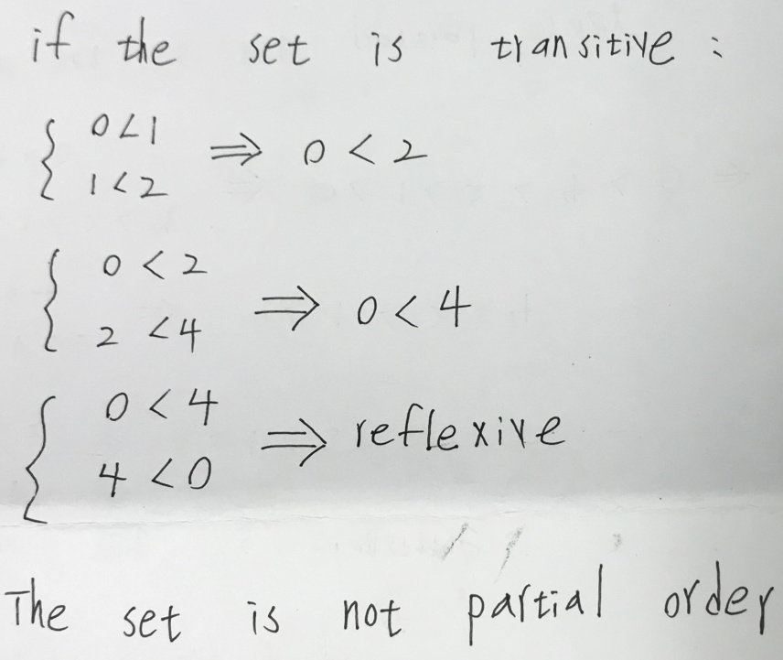

1. (10%) For the AOE network shown below,
2. Obtain the early, e(ai), and late, l(ai), start times for each activity. Use the forward-backward approach.
3. What is the earliest time the project can finish?
4. Which activities are critical? Fill the table below for answers to (a), (b), and (c).
5. Is there any single activity whose speed-up would result in a reduction of the project finish time?



|  |  |  |  |  |
| --- | --- | --- | --- | --- |
| activity | Early time | Late time | slack | critical |
| e(ai) | l(ai) | l(ai)- e(ai) |  |
| a1 | 0 | 4 | 4 | X |
| a2 | 0 | 0 | 0 | ○ |
| a3 | 5 | 9 | 4 | X |
| a4 | 6 | 6 | 0 | ○ |
| a5 | 6 | 12 | 6 | X |
| a6 | 12 | 12 | 0 | ○ |
| a7 | 12 | 15 | 3 | X |
| a8 | 12 | 12 | 0 | ○ |
| a9 | 15 | 15 | 0 | ○ |
| a10 | 15 | 15 | 0 | ○ |
| a11 | 16 | 16 | 0 | ○ |
| a12 | 19 | 19 | 0 | ○ |
| a13 | 16 | 19 | 3 | X |
| a14 | 21 | 21 | 0 | ○ |

(d)

Critical path:

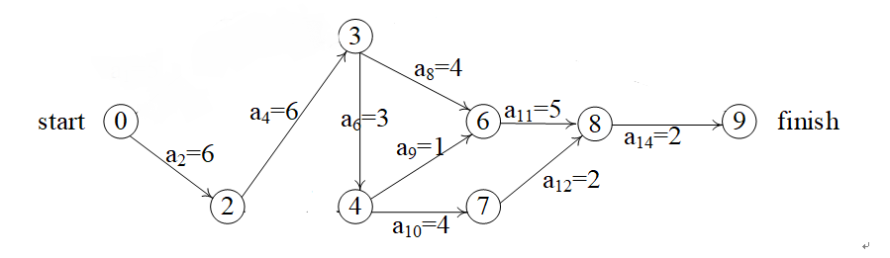

a2、a4、a14 are on all critical path,speed up one of them can reduce project finish time.