**EECS2040 Data Structure Hw #5 (Chapter 6 Graph)**

**due date 6/6/2021 (Part 1)**

**by 107061123, 孫元駿**

**Part 1**

1. (10%) Does the multigraph below have an Eulerian walk? If so, find one.



Ans: Yes, it has an Eulerian walk. 0→3→2→3→2→0→1→0

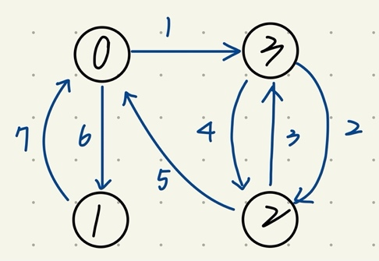

1. (10%) For the digraph below obtain
2. The in-degree and out-degree of each vertex

|  |  |  |
| --- | --- | --- |
| vertex | in-degree | out-degree |
| 0 | 3 | 0 |
| 1 | 2 | 2 |
| 2 | 1 | 2 |
| 3 | 1 | 3 |
| 4 | 2 | 1 |
| 5 | 2 | 3 |

1. Its adjacency-matrix

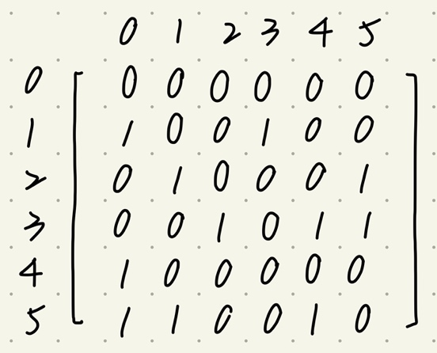

1. Its adjacency-list representation

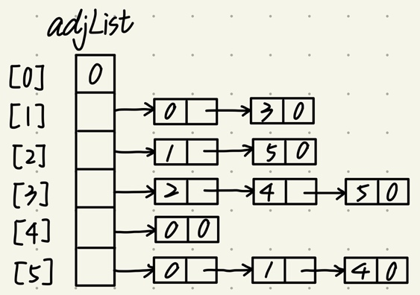

1. Its adjacency-multilist representation

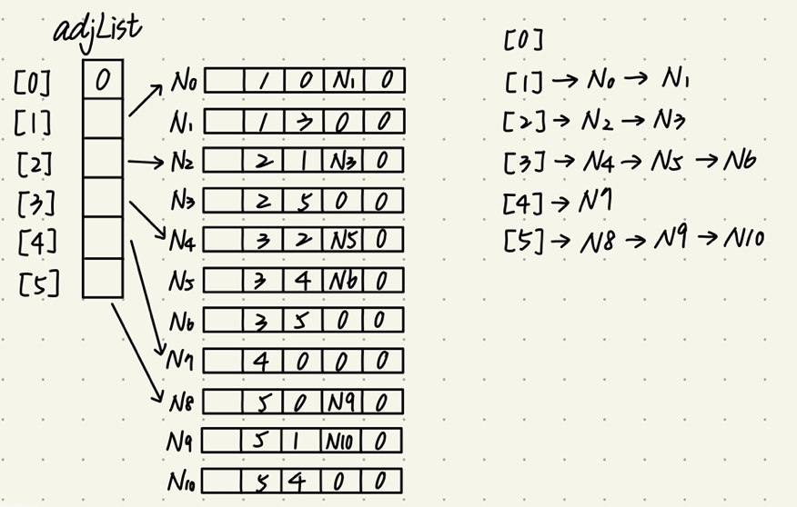

1. Its strongly connected components

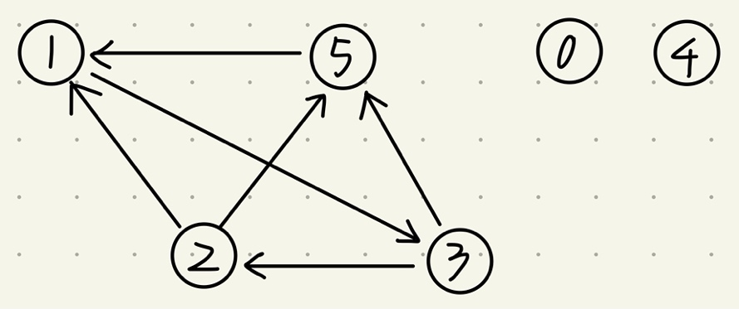



1. (10%) Is the digraph below strongly connected? List all the simple paths.



Ans: Yes, it is strongly connected.

From 0 to 1: 0→1

From 0 to 2: 0→1→2 or 0→3→2

From 0 to 3: 0→3

From 1 to 0: 1→2→0

From 1 to 2: 1→2

From 1 to 3: 1→2→0→3

From 2 to 0: 2→0

From 2 to 1: 2→0→1

From 2 to 3: 2→0→3

From 3 to 0: 3→2→0

From 3 to 1: 3→2→0→1

From 3 to 2: 3→2

1. (10%) Draw the complete undirected graphs on one, two, three, four, and five vertices. Prove that the number of edges in an n-vertex complete graph is n(n-1)/2.

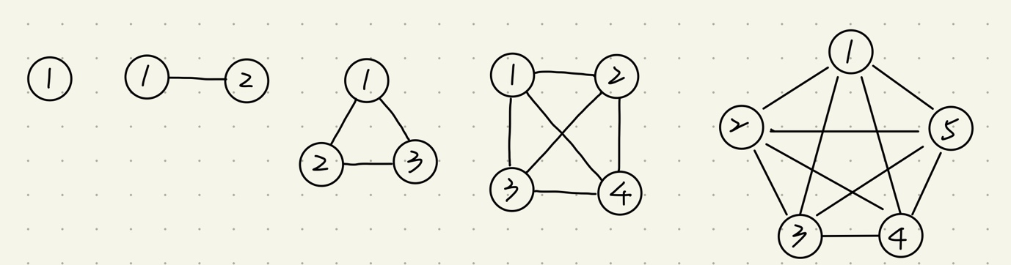

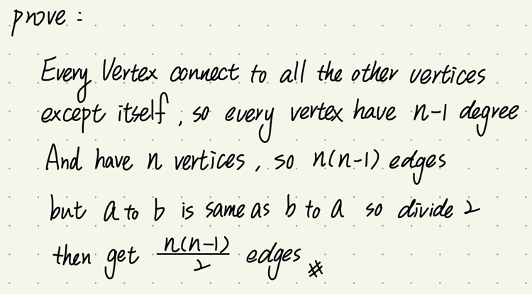

1. (10%) Apply depth-first and breadth-first searches to the complete graph on four vertices. Assume that vertices are numbered 0 to 3, are stored in increasing order in each list in the adjacency-list representation, and both traversals begin at vertex 0. List the vertices in the order they would be visited.

Ans:

DFS: 0→1→2→3

BFS: 0→1→2→3

1. (20%) Use ShortestPath (Program 6.8) to obtain, in nondecreasing order, the lengths and the paths of the shortest paths from vertex 0 to all remaining vertices in the graph below.



|  |  |
| --- | --- |
| paths | lengths |
| 0→2 | 15 |
| 0→2→3 | 19 |
| 0→1 | 20 |
| 0→2→5 | 25 |
| 0→1→4 | 30 |

1. (10%) Using the directed graph below, explain why ShortestPath (Program 6.8) will not work properly. What is the shortest path between vertices 0 and 6?

Ans: Because there is a negative edge cost in the graph so the ShortestPath will not work. For example, the shortest path from 0 to 1, by ShortedtPath, we will get the length 2, but actually, the shortest path is 1, and the path is 0→2→1.

The shortest path from 0 to 6 is 0→2→1→3→4→6, and the length is 8.

|  |  |
| --- | --- |
| paths | lengths |
| 0→2→1 | 1 |
| 0→2 | 3 |
| 0→2→1→3 | 5 |
| 0→2→1→3→4 | 6 |
| 0→2→1→3→5 | 7 |
| 0→2→1→3→4→6 | 8 |

1. (10%) Does the following set of precedence relations (<) define a partial order on the elements 0 through 4? Why?

0 < 1; 1 < 3; 1 < 2; 2 < 3; 2 < 4; 4 < 0

Ans: No, we get 0<4 from 0<1<2<3<4, but 4<0, then it is not irreflexive, so it is not partial order.

1. (10%) For the AOE network shown below,
2. Obtain the early, e(ai), and late, l(ai), start times for each activity. Use the forward-backward approach.
3. What is the earliest time the project can finish?
4. Which activities are critical? Fill the table below for answers to (a), (b), and (c).
5. Is there any single activity whose speed-up would result in a reduction of the project finish time?



|  |  |  |  |  |
| --- | --- | --- | --- | --- |
| activity | Early time | Late time | slack | critical |
| e(ai) | l(ai) |  |  |
| a1 | 0 | 4 | 4 | X |
| a2 | 0 | 0 | 0 | V |
| a3 | 5 | 9 | 4 | X |
| a4 | 6 | 6 | 0 | V |
| a5 | 6 | 12 | 6 | X |
| a6 | 12 | 12 | 0 | V |
| a7 | 12 | 15 | 0 | X |
| a8 | 12 | 15 | 3 | V |
| a9 | 12 | 12 | 0 | V |
| a10 | 15 | 15 | 0 | V |
| a11 | 16 | 16 | 0 | V |
| a12 | 19 | 19 | 0 | V |
| a13 | 16 | 19 | 3 | X |
| a14 | 21 | 21 | 0 | V |

Ans:

(b) 23

(d) $a_{2}、a_{4}、a_{14}$