**EECS2040 Data Structure Hw #6 (Chapter 7 Sorting, Chapter 8 Hashing)**

**due date 6/20/2021**

**by 107061123, 孫元駿**

***Format***: Use a text editor to type your answers to the homework problem. You need to submit your HW in an HTML file or a MS Word file named as **Hw6-SNo.docx** or **Hw6-SNo.html**, where SNo is your student number. Submit the **Hw6-SNo.docx** or **Hw6-SNo.html** file via eLearn. Inside the file, you need to put the **header and your student number, name (e.g., EECS2040 Data Structure Hw #6 (Chapter 7, 8) due date 6/20/2021 by SNo, name)** first, and then the **problem** itself followed by your **answer** to that problem, one by one. The grading will be based on the correctness of your answers to the problems, and the **format**. Fail to comply with the aforementioned format (file name, header, problem, answer, problem, answer,…), will certainly degrade your score. If you have any questions, please feel free to ask me.

**Part 1**

1. (50%) The list L: (12, 2, 16, 30, 8, 28, 4, 10, 20, 6, 18) is to be sorted by various sorting algorithm.
2. Write the status of the list at the end of each iteration of the **for** loop of InsertionSort (Program 7.5). Trace the program; understand it. Put your answer in the following table. (add necessary rows for your answer)

|  |  |  |  |  |  |  |  |  |  |  |  |
| --- | --- | --- | --- | --- | --- | --- | --- | --- | --- | --- | --- |
| j | [1] | [2] | [3] | [4] | [5] | [6] | [7] | [8] | [9] | [10] | [11] |
| - | **12** | 2 | 16 | 30 | 8 | 28 | 4 | 10 | 20 | 6 | 18 |
| 2 | **2** | **12** | 16 | 30 | 8 | 28 | 4 | 10 | 20 | 6 | 18 |
| 3 | **2** | **12** | **16** | 30 | 8 | 28 | 4 | 10 | 20 | 6 | 18 |
| 4 | **2** | **12** | **16** | **30** | 8 | 28 | 4 | 10 | 20 | 6 | 18 |
| 5 | **2** | **8** | **12** | **16** | **30** | 28 | 4 | 10 | 20 | 6 | 18 |
| 6 | **2** | **8** | **12** | **16** | **28** | **30** | 4 | 10 | 20 | 6 | 18 |
| 7 | **2** | **4** | **8** | **12** | **16** | **28** | **30** | 10 | 20 | 6 | 18 |
| 8 | **2** | **4** | **8** | **10** | **12** | **16** | **28** | **30** | 20 | 6 | 18 |
| 9 | **2** | **4** | **8** | **10** | **12** | **16** | **20** | **28** | **30** | 6 | 18 |
| 10 | **2** | **4** | **6** | **8** | **10** | **12** | **16** | **20** | **28** | **30** | 18 |
| 11 | **2** | **4** | **6** | **8** | **10** | **12** | **16** | **18** | **20** | **28** | **30** |

1. Trace Program 7.6 QuickSort, use it on the list L, and draw a figure similar to Figure 7.1 Quick Sort example starting with the list L. Put your answer in the following table. (add necessary rows for your answer)

|  |  |  |  |  |  |  |  |  |  |  |  |  |
| --- | --- | --- | --- | --- | --- | --- | --- | --- | --- | --- | --- | --- |
| R1 | R2 | R3 | R4 | R5 | R6 | R7 | R8 | R9 | R10 | R11 | left | right |
| [12 | 2 | 16 | 30 | 8 | 28 | 4 | 10 | 20 | 6 | 18] | 1 | 11 |
| [2 | 6 | 10 | 8 | 4] | 12 | [28 | 30 | 20 | 16 | 18] | 1 | 5 |
| 2 | [6 | 10 | 8 | 4] | 12 | [28 | 30 | 20 | 16 | 18] | 2 | 5 |
| 2 | [4] | 6 | [8 | 10] | 12 | [28 | 30 | 20 | 16 | 18] | 2 | 2 |
| 2 | 4 | 6 | [8 | 10] | 12 | [28 | 30 | 20 | 16 | 18] | 4 | 5 |
| 2 | 4 | 6 | 8 | 10 | 12 | [28 | 30 | 20 | 16 | 18] | 7 | 11 |
| 2 | 4 | 6 | 8 | 10 | 12 | [18 | 20 | 16] | 28 | [30] | 7 | 9 |
| 2 | 4 | 6 | 8 | 10 | 12 | [16] | 18 | [20] | 28 | [30] | 7 | 7 |
| 2 | 4 | 6 | 8 | 10 | 12 | 16 | 18 | [20] | 28 | [30] | 9 | 9 |
| 2 | 4 | 6 | 8 | 10 | 12 | 16 | 18 | 20 | 28 | [30] | 11 | 11 |
| 2 | 4 | 6 | 8 | 10 | 12 | 16 | 18 | 20 | 28 | 30 |  |  |

1. Write the status of the list L at the end of each phase of MergeSort (Program 7.9), i.e., draw the Merge tree (similar to Figure 7.4 in textbook) of this problem.

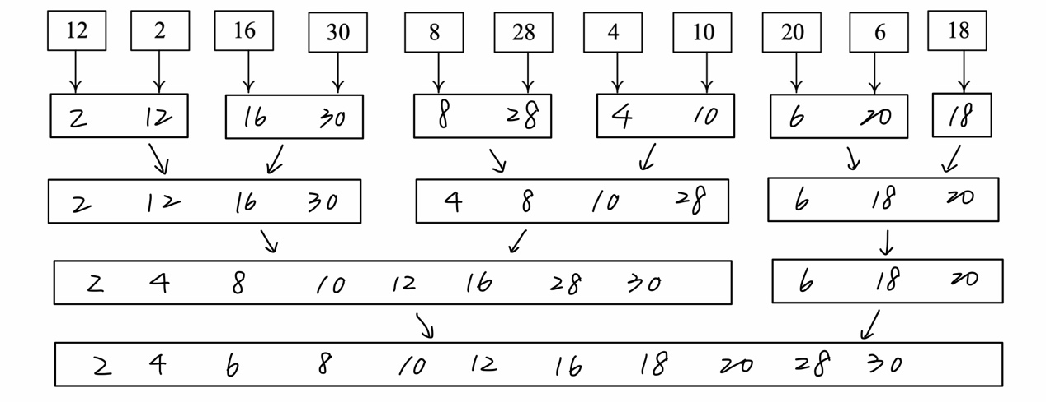

1. Write the status of the list L at the end of the first **for** loop as well as at the end of the second **for** loop of HeapSort (Program 7.14), i.e., you need to draw the following trees for: 1) input array, 2) initial heap, and 9 more trees with heap size from 10 down to 2 with corresponding sorted array. You can refer to similar results shown in Figure 7.8 in textbook.

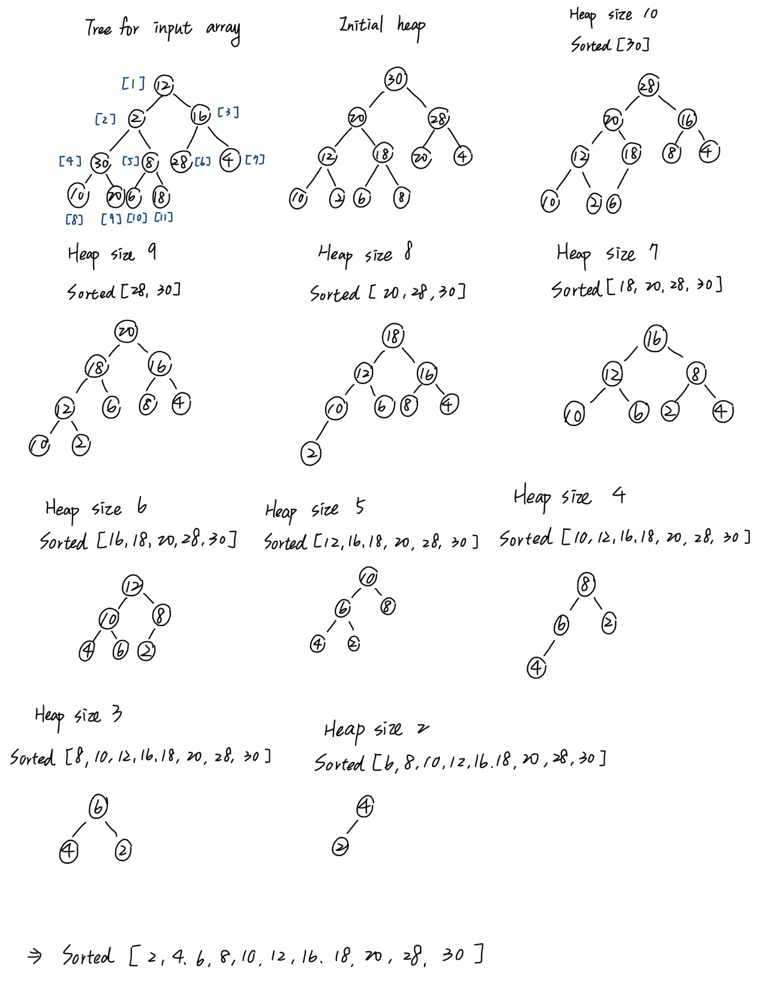

1. Write the status of the list L at the end of each pass of RadixSort (Program 7.15), using r = 10. That is fill the missing parts (the node boxes with numbers and arrows between e[j] and f[j] enclosed by red dashed rectangle in (ii) and (iii) part of the following figure, and the missing numbers in the resulting chain (red boxes) in (ii).)

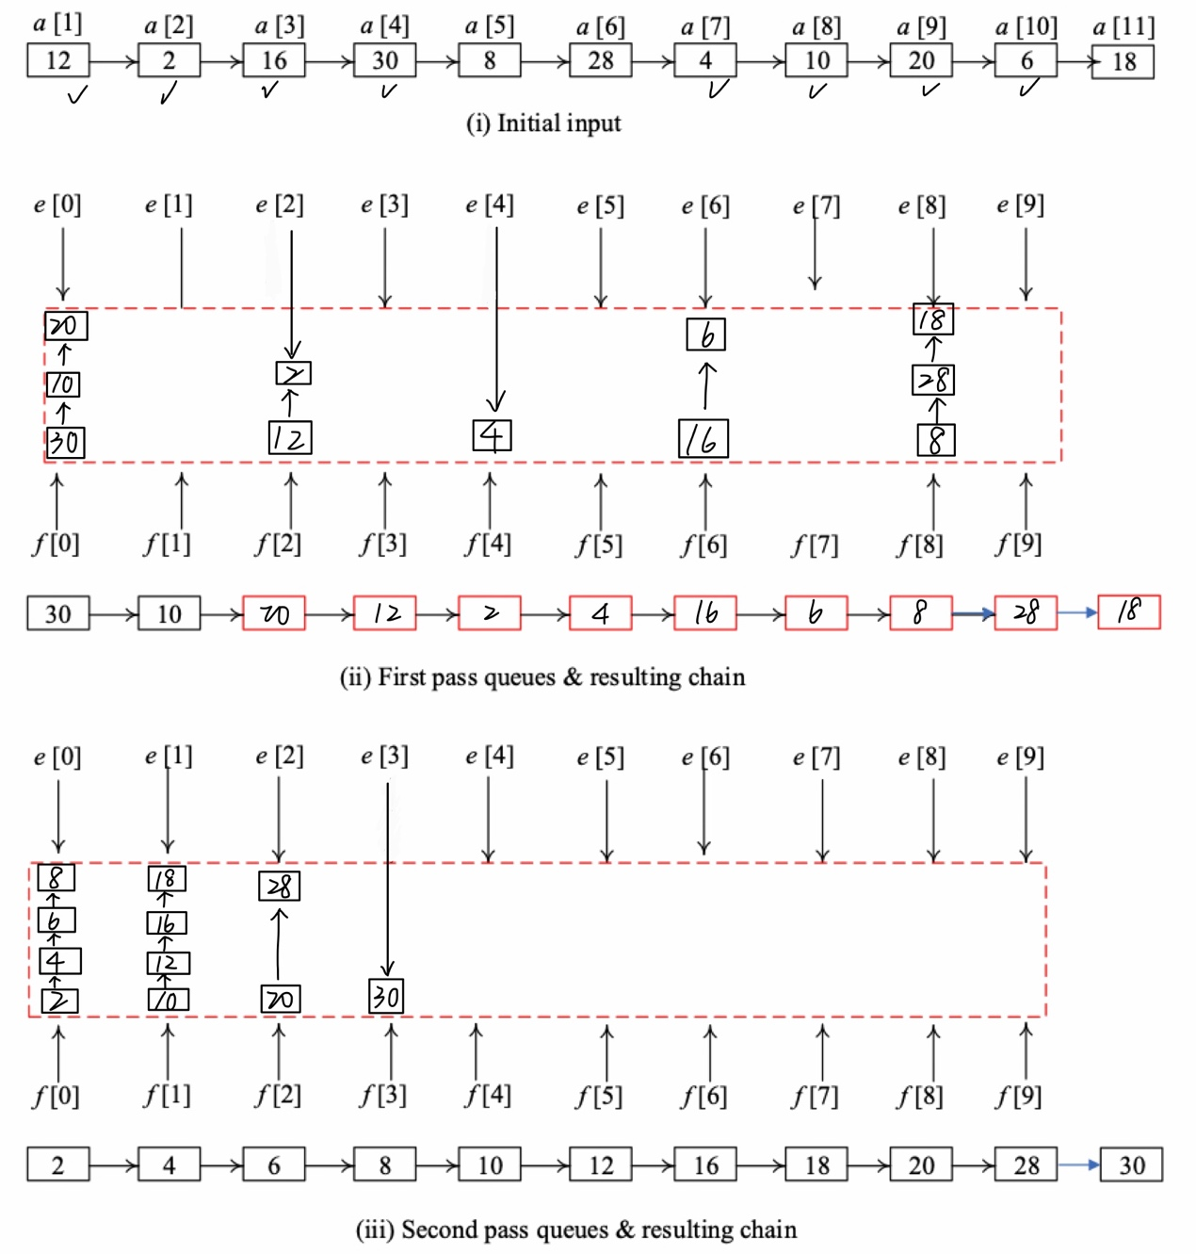

1. (10%) QuickSort (Program 7.6) is an unstable sorting method. Give an example of an input list in which the order of records with equal keys is not preserved.

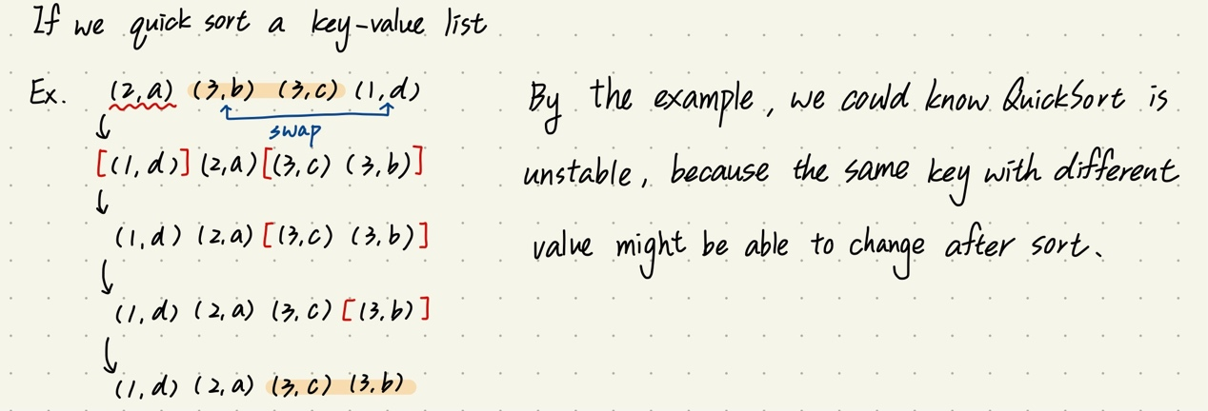

1. (10%) Show that MergeSort (Program 7.9) is stable
2. (10%) If we have n records with integer keys in the range [0,n2),then they can be sorted in O(nlogn) time using Heap Sort or Merge Sort. Radix Sort on a single key (i.e., d = 1 and r = n2) takes O(n2) time. Show how to interpret the keys as two subkeys so that Radix Sort will take only O(n) time to sort n records. (Hint: Each key, Ki, may be written as Ki = Ki1*n + Ki2 with Ki1 and Ki2 integers in the range [0,n).)
3. (10%) Show that the hash function h(k) = k%17 does not satisfy the one-way property, weak collision resistance, or strong collision resistance.
4. (10%) The probability *P*(*u*) that an arbitrary query made after *u* updates results in a filter error is given by $P\left(u\right)=e^{-u/n}{\left(1-e^{-uh/m}\right)}^{h}$. By differentiating *P*(*u*) with respect to *h*, show that *P*(*u*) is minimized when *h* = (log*e*2)*m*/*u*.