RK UNIVERSITY

AI-POWERED TEST CASE GENERATOR
A PROJECT REPORT

SUBMITTED IN PARTIAL FULFILLMENT OF THE REQUIREMENT FOR THE AWARD OF
THE DEGREE OF

B.TECH. (INFORMATION TECHNOLOGY)

TO
RK UNIVERSITY, RAJKOT

SUBMITTED BY

Name of Student | Enrollment No.
Rutvik Shiyal | 24SOEIT13019

UNDER THE GUIDANCE OF

Internal Guide
Jay Pithadiya
Assistant Professor
RK University
Rajkot

SCHOOL OF ENGINEERING, RK UNIVERSITY, RAJKOT

CANDIDATE'S DECLARATION
I hereby certify that I am the sole author of this project work entitled "AI-Powered Test Case Generator" and that neither any part of this project work nor the whole of the project work has been submitted for a degree to any other University or Institution.
I certify that, to the best of my knowledge, my project work does not infringe upon anyone's copyright nor violate any proprietary rights and that any ideas, techniques, quotations, or any other material from the work of other people included in this project document, published or otherwise, are fully acknowledged in accordance with the standard referencing practices. I declare that this is a true copy of my project work, including any final revisions, as approved by the project review committee.

Signature of Student: ___________________________
Rutvik Shiyal
Enrollment No: 24SOEIT13019
Date: __________________
Place: __________________

CERTIFICATE
This is to certify that the work which is being presented in the Project Report entitled "AI-Powered Test Case Generator", in partial fulfillment of the requirement for the award of the degree of B.Tech. (Information Technology) submitted to the School of Engineering, RK University, is an authentic record of my own work carried out during a period from
[start month/year] to [end month/year].
The matter presented in this Project Report has not been submitted by me for the award of any other degree elsewhere.

Internal Guide | Head of Department
Jay Pithadiya | Dr. Chetan Shingadiya
Assistant Professor | CE / IT,
RK University, Rajkot | School of Engineering, RK University, Rajkot

ACKNOWLEDGEMENT
It is with deep gratitude and respect that I express my sincere appreciation to everyone who has contributed to the successful completion of this project. Their support, guidance, and encouragement have been invaluable throughout this journey.
I would like to extend my deepest gratitude to my internal guide, Prof. [Guide Name], Assistant Professor, School of Engineering, RK University, for constant guidance, constructive feedback, and intellectual support during the research and development phases of this application.
I am also highly indebted to Dr. Chetan Shingadiya, Head of Department (CE/IT), School of Engineering, for providing conducive academic conditions and state-of-the-art facilities to pursue this project.
Finally, I would like to express my appreciation to my peers and family, whose patience, understanding, and encouragement enabled me to balance academic timelines and software deliverables. This project is a result of continuous learning and collective guidance, standing on the shoulders of the mentors who paved the way.

___________________________
Rutvik Shiyal
Enrollment No: 24SOEIT13019

ABSTRACT
Software Quality Assurance (QA) and test case design represent critical yet labor-intensive stages in the Software Development Life Cycle (SDLC). Traditional manual test writing suffers from high human oversight, inconsistent test coverage, slow authoring rates, and missed boundary and edge cases.
To overcome these operational bottlenecks, this project introduces the AI-Powered Test Case Generator, an intelligent web application designed to automatically convert raw software specifications (User Stories, Feature Descriptions, and API Endpoint Specs) into comprehensive test case suites.
Developed utilizing a modern full-stack architecture, comprising a React + Vite + Tailwind CSS frontend and a Node.js + Express RESTful backend integrated with Large Language Models (LLMs), the application generates structured positive, negative, and boundary test scenarios instantly.
Key architectural features include:
- Multi-Format Input Parser: support for User Stories, business logic feature descriptions, and API specifications.
- Contextual Test Generation Engine: automatic identification of acceptance criteria, happy path flows, negative error paths, and numeric/string boundary conditions.
- Advanced Interactive Data Table: real-time keyword search, priority filtering (High/Medium/Low), type filtering (Positive/Negative/Boundary), multi-row selection, and expandable execution steps.
- Multi-Format Export Subsystem: native export to Microsoft Excel (.xlsx via SheetJS), comma-separated values (.csv), and plain-text clipboard formatting.
- Responsive Dashboard & Theme Support: analytics stat cards, toast alert system, and full dark-mode UI support.
The result is a responsive, highly efficient QA utility that reduces test authoring effort significantly while standardizing test documentation across software engineering teams.

ABBREVIATIONS AND NOTATIONS
The following table lists the definitions of abbreviations, terminology, and naming conventions used throughout this project report:
Abbreviation / Term | Definition
QA | Quality Assurance - Software testing and verification process
SDLC | Software Development Life Cycle
LLM | Large Language Model (Artificial Intelligence model)
API | Application Programming Interface
REST | Representational State Transfer
JSON | JavaScript Object Notation - Data interchange format
UI / UX | User Interface / User Experience
CORS | Cross-Origin Resource Sharing
CRUD | Create, Read, Update, and Delete operations
DFD | Data Flow Diagram
ERD | Entity Relationship Diagram
CSV | Comma-Separated Values

LIST OF FIGURES
Figure No. / Title | Page No.
Figure 4.1: Use Case Diagram | pg.
Figure 4.2: E-R Diagram | pg.
Figure 4.3: Class Diagram | pg.
Figure 4.4: Data Flow Diagram (Level 0) | pg.
Figure 4.5: Data Flow Diagram (Level 1) | pg.

LIST OF TABLES
Table No. / Title | Page No.
Table 2.1: Project Sprint Schedule | pg.
Table 4.1: Test Suite Entity Schema | pg.
Table 4.2: Test Case Entity Schema | pg.
Table 4.3: User Preference & Session Schema | pg.

TABLE OF CONTENTS
CHAPTER 1: INTRODUCTION 11
1.1 Project Summary 11
1.2 Purpose: Goals & Objectives 11
1.3 Scope (Capabilities & Limitations) 11
Application Capabilities 11
Limitations 12
1.4 Technology and Literature Review 12
CHAPTER 2: PROJECT MANAGEMENT 13
2.1 Project Planning and Scheduling 13
2.1.1 Project Development Approach (Process Paradigm) and Justification 13
2.1.2 Project Plan (Milestones, Deliverables, Roles, Responsibilities, and Dependencies) 13
2.1.3 Schedule Representation 13
2.2 Risk Management 13
2.2.1 Risk Identification 13
2.2.2 Risk Analysis 14
2.2.3 Risk Planning 14
CHAPTER 3: SYSTEM REQUIREMENTS STUDY 15
3.1 User Characteristics 15
3.2 Hardware and Software Requirements 15
Development Environment Requirements 15
Client System Minimum Requirements 15
3.3 Constraints 15
CHAPTER 4: SYSTEM ANALYSIS 16
4.1 Study of Current System 16
4.2 Problem and Weaknesses of Current System 16
4.3 Requirements of Proposed System 16
Functional Requirements 16
Non-Functional Requirements 16
4.4 Feasibility Study 16
4.5 Requirements Validation 17
4.6 Functions of System 17
4.6.1 Use Cases, Event Trace or Scenario (Use Case Diagram) 17
4.7 Data Modeling 17
4.7.1 Data Dictionary 17
4.7.2 E-R Diagram 18
4.7.3 Class Diagram 18
4.7.4 System Activity 18
4.7.5 Object Interaction Diagram 18
4.8 Functional and Behavioral Modeling 18
4.8.1 Data Flow Diagram (DFD) 18
4.8.2 Process Specification and Decision Table 18
4.8.3 Control Flow Diagram 19
4.9 Main Modules of New System 19
4.10 Selection of Hardware and Software and Justification 19

CHAPTER 1: INTRODUCTION

1.1 Project Summary
The 'AI-Powered Test Case Generator' is a full-stack web application engineered to automate the creation of software Quality Assurance (QA) test cases using Artificial Intelligence. In modern software development, writing comprehensive test cases for user stories, requirements, and REST APIs requires substantial time and domain expertise. Manual test creation often leads to missing edge cases, inconsistent step formatting, and delayed release cycles.
The proposed application resolves these inefficiencies by offering a centralized web workspace where developers and QA engineers can input raw requirement text, select the input specification format (User Story, Feature Description, or API Endpoint Spec), and generate structured test cases instantly.
The application categorizes generated test cases into Positive (Happy Path), Negative (Error Path), and Boundary (Input Limit) scenarios, complete with test case IDs, preconditions/steps, test data, expected results, and priority rankings.

1.2 Purpose: Goals & Objectives
The primary goal of the AI-Powered Test Case Generator is to replace slow manual test creation with an automated, AI-driven workflow. Specific objectives include:
- Automated Test Generation: convert unstructured requirement text into standardized test case tables in seconds.
- Comprehensive Scenario Coverage: ensure every generated test suite automatically includes positive validation, negative error handling, and boundary value conditions.
- Multi-Input Support: tailor prompt templates specifically for User Stories (UI acceptance criteria), Business Features, and REST API Endpoints (HTTP status codes, headers, payloads).
- Real Export Capabilities: provide native exports to Microsoft Excel (.xlsx), Comma-Separated Values (.csv), and plain-text clipboard format for direct integration into QA tools (such as Jira or TestRail).
- Interactive UI & Filtering: enable instant keyword search, priority filtering, type filtering, expandable execution steps, and inline row management.

1.3 Scope (Capabilities & Limitations)

Application Capabilities
- Specification Type Parsing: select between User Story, Feature Description, and API Endpoint modes.
- Live Character Validation: input textarea equipped with real-time character counters (120/1000) and limit warnings.
- Dynamic Table Management: multi-select row selection, "Select All" toggle, inline row deletion, and expandable multi-step lists.
- Multi-Format Export Engine: export full or selected rows to Excel (.xlsx), CSV, and formatted plain text.
- Modern User Experience: floating toast alerts, responsive card layout, dashboard analytics, and full dark-mode toggle.

Limitations
- Client/Server Dependency: requires a browser environment and connectivity to the Node.js/Express backend server.
- AI Rate Limits: dependent on API quota limits when connected to the Google Gemini API.

1.4 Technology and Literature Review
Traditional QA test authoring relies on manual spreadsheet entry or enterprise test management portals (e.g., Jira, TestRail, Zephyr). While enterprise portals centralize test artifacts, they do not assist in generating test content, requiring testers to manually write every step, precondition, and expected result.
Recent advancements in Large Language Models (LLMs), including the Google Gemini API used in this project, have demonstrated high proficiency in natural language processing and structured data generation. By combining React (Virtual DOM rendering), Tailwind CSS (utility-first styling), Express.js (REST API layer), and LLM prompt engineering, this project bridges the gap between raw requirements and actionable QA test suites.

CHAPTER 2: PROJECT MANAGEMENT

2.1 Project Planning and Scheduling

2.1.1 Project Development Approach (Process Paradigm) and Justification
An Agile, component-based development paradigm was selected for this project. Given the iterative nature of web applications and UI refinement, Agile allowed modular implementation across weekly sprints, focusing sequentially on API endpoints, state management, interactive table components, export handlers, and dark-mode styling.

2.1.2 Project Plan (Milestones, Deliverables, Roles, Responsibilities, and Dependencies)
Deliverables for the project include:
- Sprint 1 (Backend & Schema): Express server setup, CORS configuration, route handlers, and structured test case JSON schema.
- Sprint 2 (Core UI & Input Form): React frontend scaffold, requirement input form, character counter validation, and loading spinner status animation.
- Sprint 3 (Table & Filtering): data table component, priority badges, type tags, keyword search, priority/type dropdown filters, row checkboxes, and step expander.
- Sprint 4 (Exports & Polish): SheetJS (xlsx) Excel export, CSV download, clipboard copy, toast alert system, dashboard stat cards, and dark-mode toggle.
Roles and Responsibilities: [Add team member names and responsibilities here, if this is a group project]

2.1.3 Schedule Representation
Table 2.1: Project Sprint Schedule
Sprint | Major Milestone / Task | Duration | Status
Sprint 1 | Express server setup, route endpoints, CORS & mock JSON controller | Weeks 1-2 | Completed
Sprint 2 | React Vite scaffold, Tailwind styling, input form & loading status spinner | Weeks 3-4 | Completed
Sprint 3 | Test case data table, search box, Priority/Type filters, expandable steps | Weeks 5-6 | Completed
Sprint 4 | SheetJS .xlsx Excel export, CSV download, toast alerts & dark mode | Weeks 7-8 | Completed

2.2 Risk Management

2.2.1 Risk Identification
- API Rate Limiting / Latency: delays or failure during external AI API response generation.
- Data Export Formatting Incompatibility: inconsistent column rendering across Microsoft Excel versions.
- UI Performance Degradation: lag when rendering large lists of test case rows.

2.2.2 Risk Analysis
- API Rate Limiting / Latency: Probability: Medium, Impact: High.
- Data Export Formatting Incompatibility: Probability: Low, Impact: Medium.
- UI Performance Degradation: Probability: Medium, Impact: Medium.

2.2.3 Risk Planning
- Latency Mitigation: implemented an animated step-by-step progress spinner ("Analyzing requirement...", "Calculating boundary limits...") and fallback mock data handlers to keep the application responsive even if backend connectivity drops.
- Export Mitigation: utilized standard SheetJS xlsx binary array utilities to generate native OpenXML .xlsx spreadsheets compatible with Microsoft Excel, Google Sheets, and LibreOffice.
- UI Performance Mitigation: applied key-based React list virtualization and efficient state filtering.

CHAPTER 3: SYSTEM REQUIREMENTS STUDY

3.1 User Characteristics
- QA Engineers & Testers: require rapid creation of test suites with export options to standard test management tools.
- Software Developers: need quick unit/integration test scenario outlines before writing code (TDD approach).
- Product Managers / Business Analysts: verify acceptance criteria coverage for user stories before sprint planning.

3.2 Hardware and Software Requirements

Development Environment Requirements
- OS: Windows 10/11, macOS, or Linux
- RAM: 8 GB Minimum
- IDE: VS Code (Visual Studio Code)
- Runtime: Node.js (v18.0.0 or higher) and npm (v9.0.0 or higher)

Client System Minimum Requirements
- Browser: modern web browser (Google Chrome 90+, Mozilla Firefox 88+, Microsoft Edge 90+)
- Display: responsive resolution (320px mobile to 1920px desktop)
- RAM: 4 GB RAM

3.3 Constraints
- Network Protocol: HTTP/HTTPS communication between frontend (Vite dev server / port 5173) and backend (Express server / port 5000).
- Format Schema: strict adherence to JSON output structure (ID, Scenario, Steps, Test Data, Expected Result, Priority, Type) to ensure seamless table rendering.
- External Dependency: reliant on the Google Gemini API for test-case generation; unavailability of the API limits core functionality.

CHAPTER 4: SYSTEM ANALYSIS

4.1 Study of Current System
Currently, software development teams generate test cases using manual spreadsheets (Excel/Google Sheets) or text documents. QA engineers read user stories and manually type out every test step, precondition, and expected outcome.

4.2 Problem and Weaknesses of Current System
- High Human Overhead: takes 20-45 minutes to author a comprehensive test suite for a single feature.
- Inconsistent Edge Case Coverage: testers frequently forget boundary values or negative invalid input cases.
- No Standardization: different team members format test steps inconsistently.

4.3 Requirements of Proposed System

Functional Requirements
- Allow selection of requirement input types (User Story, Feature Description, API Endpoint Spec).
- Provide input validation with real-time character limit enforcement (1000 characters max).
- Generate categorized test cases with distinct Priority (High, Medium, Low) and Type (Positive, Negative, Boundary).
- Support instant keyword searching across test scenarios, steps, and expected results.
- Provide filter controls for Priority and Type attributes.
- Enable row selection checkboxes and bulk action handlers.
- Perform real file downloads for Microsoft Excel (.xlsx) and Comma-Separated Values (.csv).
- Copy plain-text test suites directly to the clipboard.

Non-Functional Requirements
- Usability: clean blue/indigo QA color scheme, dark mode toggle, and floating toast notifications.
- Performance: response rendering in under 1.5 seconds.
- Reliability: graceful fallback error UI and server offline handling.

4.4 Feasibility Study
- Technical Feasibility: High. React 18, Express, Tailwind CSS, and SheetJS are production-proven technologies.
- Operational Feasibility: High. The web layout requires zero training for QA personnel.
- Economic Feasibility: High. Built using open-source libraries, a standard Node.js runtime, and the Google Gemini API.

4.5 Requirements Validation
[Describe how requirements were validated — e.g. iterative prototype demos to your internal guide or peer QA review sessions]

4.6 Functions of System

4.6.1 Use Cases, Event Trace or Scenario (Use Case Diagram)
The system's primary use case involves the User (Developer / QA Engineer) interacting with the Input Module to submit a requirement, triggering the AI Generation Engine to produce a structured test suite, which is then filtered, reviewed, and exported.
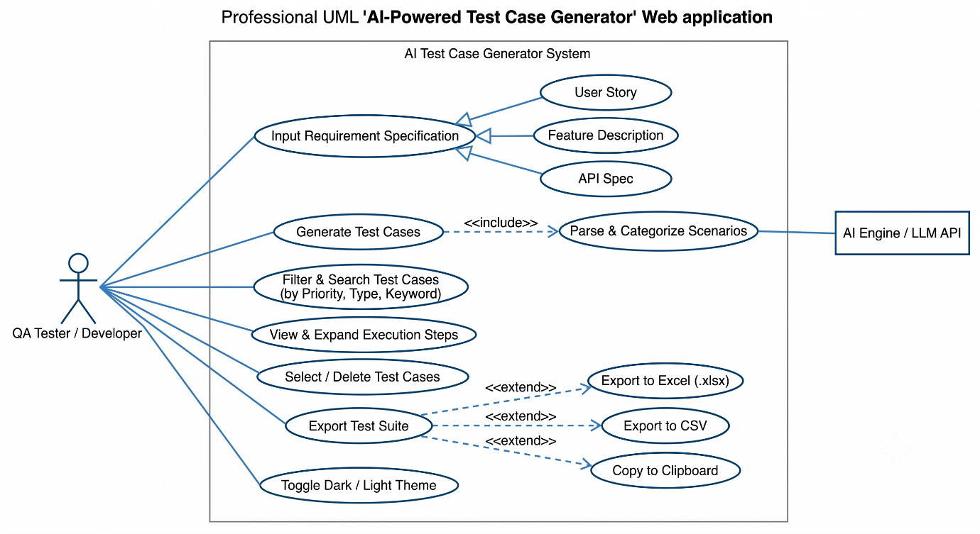
Figure 4.1: Use Case Diagram

4.7 Data Modeling

4.7.1 Data Dictionary
The Data Dictionary provides a specification of the entities, attributes, and relationships used by the AI-Powered Test Case Generator.

Table 4.1: Test Suite Entity Schema
Field | Data Type | Description
id | String | Unique identifier for the generated test suite.
title | String | Title or name of the requirement/feature under test.
inputType | String | Specification type: User Story, Feature Description, or API Endpoint.
createdAt | Timestamp | Date and time the test suite was generated.
testCases | Array | Collection of individual Test Case records belonging to this suite.

Table 4.2: Test Case Entity Schema
Field | Data Type | Description
id | String | Unique identifier for the test case.
scenario | String | Short description of the scenario being tested.
steps | Array of Strings | Ordered list of execution steps.
testData | String | Sample input data used to execute the test.
expectedResult | String | The expected system outcome.
priority | String | High / Medium / Low.
type | String | Positive / Negative / Boundary.

Table 4.3: User Preference & Session Schema
Field | Data Type | Description
theme | e.g. String | light / dark mode preference
lastInputType | e.g. String | most recently used specification type
sessionId | e.g. String | identifier for the current browser session

4.7.2 E-R Diagram
Figure 4.2: E-R Diagram

4.7.3 Class Diagram
Figure 4.3: Class Diagram

4.7.4 System Activity
Users navigate: Home / Input Form -> Select Input Type -> Submit Requirement -> Review Generated Test Suite -> Filter/Search -> Export.

4.7.5 Object Interaction Diagram
User interactions trigger the API Handler, which calls the LLM service, formats the JSON response, and updates the React component state to re-render the data table.

4.8 Functional and Behavioral Modeling

4.8.1 Data Flow Diagram (DFD)
- Level 0: the external entity (User) inputs a requirement into the System. The System outputs a rendered test-case table and export files.
- Level 1: data flows from the Input Parser -> AI Generator / API Handler -> JSON Formatter -> Table Render Engine and Export Subsystem.
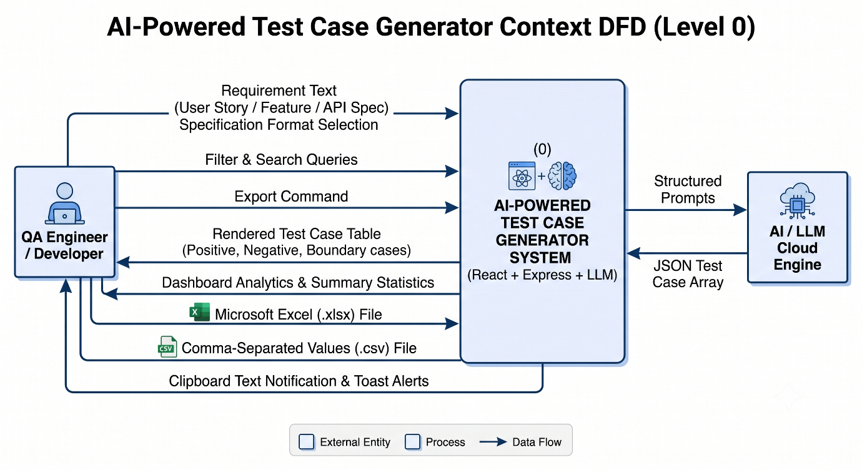
Figure 4.4: Data Flow Diagram (Level 0)

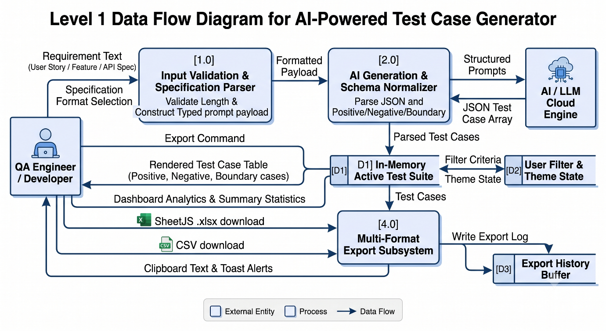
Figure 4.5: Data Flow Diagram (Level 1)

4.8.2 Process Specification and Decision Table
If 'Character count > 1000', block submission; if 'API response fails', display fallback/mock data; if 'Export clicked', generate the selected file format (.xlsx / .csv / clipboard text).

4.8.3 Control Flow Diagram
Landing / Input Form -> Loading State -> Results Dashboard -> [Search / Filter / Export] -> Done.

4.9 Main Modules of New System
- Input Module: manages requirement text entry, input-type selection, and character validation.
- Generation Module: handles communication with the Google Gemini API and structures the AI response.
- Table & Filtering Module: renders the interactive test-case table with search, filters, and row selection.
- Export Module: manages Excel (.xlsx), CSV, and clipboard export logic.
- UI/Theme Module: manages dashboard analytics, toast notifications, and dark-mode styling.

4.10 Selection of Hardware and Software and Justification
- React (Vite): chosen for fast component-based rendering and quick development builds.
- Tailwind CSS: chosen for rapid, utility-first responsive styling and consistent design tokens.
- Node.js + Express: chosen for a lightweight, well-supported REST API layer.
- Google Gemini API: chosen for its natural-language understanding and structured JSON generation capability.
- SheetJS (xlsx): chosen for reliable, spreadsheet-application-compatible Excel export.

CHAPTER 5: SYSTEM DESIGN

5.1 Database Design / Data Structure Design
The AI-Powered Test Case Generator uses a combination of client-side persistent storage (HTML5 LocalStorage) and server-side memory structures, with strict JSON schemas representing test suites, individual test cases, prompt specification templates, and execution telemetry metrics. Unlike traditional single-tenant database designs, every test suite is encapsulated as an independent document entity with unique suite IDs, timestamp boundaries, and contextual categorization tags.
The primary data models utilized across the application are:
• test_suites (Collection of generated QA suites)
• test_cases (Individual positive, negative, boundary scenarios)
• requirement_templates (Pre-configured specification prompts)
• server_metrics (Server execution counters & telemetry)
• user_preferences (Theme toggle, default filter & export configurations)

5.1.1 Mapping Objects / Classes to Collections
The application employs structured JavaScript/JSX object-oriented and functional schemas. The mapping between frontend data entities, backend JSON payloads, and persistence records is detailed below:
Application Class / Entity | Data Store / Payload | Purpose / Functional Scope
TestSuite | test_suites (LocalStorage) | Stores test suite metadata, title, input format, timestamp, and test case IDs.
TestCase | test_cases (In-Memory / State) | Stores scenario title, step sequence, test data, expected result, priority, type, and execution status.
RequirementTemplate | PRESET_REQUIREMENTS | Stores 1-click preset requirement templates for rapid demo and test authoring.
ServerMetrics | GET /api/stats | Tracks total generation requests, Gemini AI vs NLP fallback hits, and server uptime.
ExportEngine | ExportToolbar (.xlsx / .pdf) | Transforms in-memory test cases into binary Excel, CSV, PDF, and clipboard buffers.

5.1.2 Collections and Relationships
The logical relationship between the core entities in the AI-Powered Test Case Generator is structured around a One-to-Many hierarchy. A User Session can generate multiple Test Suites. Each Test Suite contains one or more Test Cases. Each Test Case possesses an Execution Status (Passed, Failed, Blocked, Pending) and can be mapped to multiple Export Records (Excel, CSV, PDF).
+--------------------+
| USER SESSION |
+--------------------+
| 1
| generates / manages
v *
+--------------------+
| TEST SUITE | <----- [Requirement Templates]
+--------------------+
| 1
| contains
v *
+--------------------+
| TEST CASE | -----> [Execution Tracker (Passed/Failed/Blocked/Pending)]
+--------------------+
| *
| exported to
v 1
+--------------------+
| EXPORT ENGINE | -----> [.xlsx (SheetJS) | .pdf (jsPDF) | .csv | Clipboard]
+--------------------+

5.1.3 Logical Description of Data
The detailed schemas of the system entities are represented below:
TestSuite Entity
├── id (String: e.g., "SUITE-001")
├── title (String: truncated requirement title)
├── inputType (Enum: "User Story" | "Feature Description" | "API Endpoint Spec")
├── timestamp (String / ISO Date)
├── isLiveAI (Boolean: true if Gemini API, false if local NLP)
└── testCases (Array of TestCase objects)
TestCase Entity
├── id (String: e.g., "TC-US-001", "TC-API-002")
├── scenario (String: test description)
├── steps (Array of Strings: numbered step-by-step procedures)
├── testData (String: specific test inputs, headers, credentials)
├── expectedResult (String: verification criteria)
├── priority (Enum: "High" | "Medium" | "Low")
├── type (Enum: "Positive" | "Negative" | "Boundary")
└── status (Enum: "Passed" | "Failed" | "Blocked" | "Pending")
ServerMetrics Entity
├── totalRequests (Integer)
├── liveAiRequests (Integer)
├── nlpEngineRequests (Integer)
├── totalTestCasesCreated (Integer)
├── status (String: "operational")
└── uptime (Float: elapsed server seconds)

5.2 System Procedural Design
The procedural design defines how end-to-end user operations are processed across the stack:
User
↓
Open Web Application (React Single Page App)
↓
Navigate to Dashboard or Generator View
↓
Select Input Format (User Story / Feature Description / API Spec) or Click Preset
↓
Client-Side Input Validation (Character length ≤ 1000, non-empty check)
↓
HTTP POST Request (/api/generate-test-cases) with JSON Payload
↓
Express Routing Layer & Controller (testCaseController)
↓
API Key Check & Model Discovery (gemini-1.5-flash)
├── If Key Active & Online: Remote Google Gemini AI Inference
└── If Offline / Quota / Fallback: Contextual NLP QA Rule Engine
↓
JSON Schema Structuring & Sanitization
↓
HTTP 200 Response Payload
↓
React State Update & Re-render Virtual DOM
↓
Display Interactive Table (Keyword Search, Priority/Type Filters, Step Expander)
↓
Test Execution Tracking (Tester clicks status to mark Passed / Failed / Blocked / Pending)
↓
File Export Handlers (SheetJS Excel .xlsx, jsPDF autotable PDF, CSV, Clipboard)

5.2.1 Flowchart / Activity Design
The major system activities comprise:
1. Test Case Generation Activity: Input Specification ➔ Validation ➔ Backend Inference ➔ Schema Extraction ➔ Rendering.
2. Test Case Execution Tracking Activity: Select Case ➔ Click Status Badge ➔ Toggle Passed/Failed ➔ Recalculate Pass Rate.
3. Multi-Format Export Activity: Select Scope (All / Selected) ➔ Choose Target Format (.xlsx / .csv / .pdf / clipboard) ➔ Transform & Download.

5.3 Input / Output and Interface Design
UTMS/TestGen provides role-tailored, intuitive web interfaces engineered with modern responsive design principles. The main interfaces are:
• Dashboard Interface: Real-time stat cards (Total Suites, Active Cases, Scenarios Generated), recent activity cards, and quick-action launcher.
• Test Case Generator Interface: Input type dropdown, 1-click preset templates, live character counter (1000 chars limit), and animated generation spinner.
• Interactive Test Cases Table: Full-featured table with search filter, Priority filter, Type filter, Status filter, expandable steps, row checkboxes, and CRUD buttons.
• Add & Edit Test Case Modals: Modal forms enabling manual test case authoring and inline modification.
• Export Toolbar Subsystem: Multi-channel file export controls for Excel, CSV, PDF, and clipboard.
• Test Suite History Archive: Historical repository allowing re-opening, viewing, and clearing past suites.
• Academic Project Report Documentation Viewer: Dedicated in-app tab rendering Chapters 1 to 10 with print and export capabilities.

5.3.2 Access Control and Security
Security is enforced across both client and server layers:
1. API Credential Isolation: Sensitive AI tokens (GEMINI_API_KEY) reside exclusively in backend environment variables (.env) and are never packaged into client JavaScript bundles.
2. CORS Restrictions: The Express backend enforces Cross-Origin Resource Sharing restrictions to prevent cross-site request hijacking.
3. Payload Length Bounds: Client and server enforce strict 1000-character input ceilings to prevent buffer overruns or runaway token billing.
4. Output Sanitization: All AI-generated markdown strings are parsed, stripped of malicious code blocks, and validated against strict JSON schemas before client rendering.
5. Resilient Fallback Architecture: If remote AI endpoints experience downtime or quota limits, the system seamlessly activates the local NLP QA engine without throwing unhandled exceptions.

5.4 System Architecture Design
The system follows a multi-tiered component web architecture:
+-------------------------------------------------------------+
| PRESENTATION LAYER |
| React 18 SPA | Vite Bundler | Tailwind CSS v3 | Lucide |
+-------------------------------------------------------------+
|
v (HTTP / REST API)
+-------------------------------------------------------------+
| SERVICE LAYER |
| Express.js API Router | CORS | Request Logger | JSON Body |
+-------------------------------------------------------------+
|
v
+-------------------------------------------------------------+
| AI & NLP ORCHESTRATION LAYER |
| Google Gemini AI (@google/generative-ai, gemini-1.5-flash)|
| Contextual NLP QA Rule-Based Engine (Offline Resilient) |
+-------------------------------------------------------------+
|
v
+-------------------------------------------------------------+
| STATE & PERSISTENCE LAYER |
| React State Hooks | HTML5 LocalStorage | Server Metrics |
+-------------------------------------------------------------+
|
v
+-------------------------------------------------------------+
| EXPORT ENGINE |
| SheetJS (xlsx) | jsPDF + autotable | CSV Blob | Clipboard |
+-------------------------------------------------------------+

CHAPTER 6: IMPLEMENTATION PLANNING AND DETAILS

6.1 Implementation Environment
The AI-Powered Test Case Generator is implemented as a full-stack, component-based graphical web application utilizing modern web engineering technologies.
Component | Technology / Tool
Programming Language | JavaScript (ES6+), Node.js
Frontend Framework | React 18 (Component Architecture)
Build Tool & Dev Server | Vite 8.x (Hot Module Replacement)
Styling & Theme Engine | Tailwind CSS v3 (Utility Classes & Dark Mode)
Iconography | Lucide React (Vector SVG UI Icons)
Backend Framework | Node.js + Express 4.x (RESTful API Server)
AI & LLM Integration | Google Gemini AI API (@google/generative-ai)
Spreadsheet Export Library | xlsx (SheetJS 0.18.5)
PDF Generation Engine | jsPDF 4.2 + jspdf-autotable 5.0
Development Environment | VS Code (Visual Studio Code), Google Chrome DevTools

6.2 Program / Module Specification
The application is divided into decoupled, highly cohesive functional modules:

6.2.1 Requirement Input & Validation Module
Responsibilities: Manages specification format selection (User Story, Feature Description, API Endpoint Spec), provides 1-click preset templates, validates character count against a 1000-character boundary, and displays warning badges.

6.2.2 AI & NLP Test Case Generation Engine Module
Responsibilities: Orchestrates communication with the Google Gemini AI model (gemini-1.5-flash), enforces structured JSON array contracts, and falls back seamlessly to the Contextual NLP QA Rule Engine to extract actors, actions, entities, and boundary limits.

6.2.3 Interactive Data Table & Filtering Module
Responsibilities: Renders structured test cases with real-time keyword search, Priority filtering (High/Medium/Low), Type filtering (Positive/Negative/Boundary), Status filtering, expandable multi-step lists, and row checkboxes.

6.2.4 Test Execution Tracker & CRUD Module
Responsibilities: Allows testers to cycle execution states (Passed ➔ Failed ➔ Blocked ➔ Pending) with a single click, updates real-time pass-rate progress bars, and provides modal forms for adding custom test cases and inline editing.

6.2.5 Multi-Format Export Subsystem Module
Responsibilities: Converts in-memory test cases into Microsoft Excel (.xlsx via SheetJS), Comma-Separated Values (.csv), formatted tabular landscape PDF reports (jsPDF), and clipboard text buffers for both all and selected rows.

6.2.6 Historical Archive & Persistence Module
Responsibilities: Persists generated test suites to browser LocalStorage, provides search capability across archived suites, and allows instant re-opening and deletion.

6.2.7 Dashboard Analytics & Metrics Module
Responsibilities: Aggregates real-time project metrics (Total Test Suites, Active Test Cases, Total Scenarios Generated), displays recent activity streams, and offers quick-action CTAs.

6.3 Security Features
The following security mechanisms are implemented across the system:
1. Environment Variable Protection: API keys are strictly confined to backend .env files.
2. Cross-Origin Resource Sharing (CORS): Express middleware restricts API access.
3. Character Payload Boundary: Enforces 1000-character maximum input length.
4. XSS & Code Injection Prevention: Escapes HTML entities and rejects raw code execution.
5. Resilient Offline Operation: High-availability NLP fallback prevents system crashes during connectivity loss.

6.4 Coding Standards
The project adheres to industry standard JavaScript/React coding conventions:
1. React functional components with modern Hooks (useState, useEffect, useMemo, useContext).
2. PascalCase naming for React components and JSX files (e.g., TestCaseTable.jsx, ExportToolbar.jsx).
3. camelCase naming for variables, state items, and function handlers (e.g., handleGenerate, handleCycleStatus).
4. UPPERCASE naming for global constants (e.g., INITIAL_TEST_CASES, PRESET_REQUIREMENTS).
5. Strict separation of presentation components and business logic controllers.
6. Structured error handling with asynchronous try/catch blocks and user-friendly toast notifications.

6.5 Sample Coding
Sample Dynamic Contextual NLP Test Case Generation Engine (backend/controllers/testCaseController.js):
function generateDynamicTestCaseSuite(inputType, description) {
const lowerText = description.toLowerCase();
let actor = lowerText.includes("student") ? "Student" : "User";
let action = lowerText.includes("qr") ? "scan QR code and verify attendance" : "execute operation";
let entity = lowerText.includes("attendance") ? "daily attendance record" : "specification payload";
const prefix = inputType === "API Endpoint Spec" ? "TC-API" : "TC-US";
return [
{
id: `${prefix}-001`,
scenario: `Verify successful happy-path execution when ${actor} initiates: ${action}`,
steps: [
`1. Access interface with valid ${actor} credentials`,
`2. Supply mandatory parameters for ${entity}`,
`3. Trigger execution / submit action`,
`4. Verify confirmation and persistent state update`
],
testData: `Valid ${entity} attributes | Actor: ${actor}`,
expectedResult: `System successfully processes ${action}. Status confirmed and data saved.`,
priority: "High", type: "Positive", status: "Passed"
},
{
id: `${prefix}-002`,
scenario: `Verify system error handling when mandatory ${entity} parameters are missing`,
steps: ["1. Navigate to view", "2. Leave mandatory fields empty", "3. Submit request"],
testData: `Empty payload for ${entity}`,
expectedResult: `System blocks submission and displays error banner "Field required".`,
priority: "High", type: "Negative", status: "Pending"
}
];
}
Sample Interactive Test Execution Status Toggling (frontend/src/components/TestCaseTable.jsx):
const handleCycleStatus = (tc) => {
const currentStatus = tc.status || "Pending";
const nextStatusMap = {
"Pending": "Passed",
"Passed": "Failed",
"Failed": "Blocked",
"Blocked": "Pending"
};
const nextStatus = nextStatusMap[currentStatus] || "Passed";
onUpdateStatus(tc.id, nextStatus);
};
Sample Native Excel (.xlsx) Export Handler via SheetJS (frontend/src/components/ExportToolbar.jsx):
const handleExportExcel = () => {
const dataToExport = getExportData();
const formattedRows = dataToExport.map(tc => ({
"Test Case ID": tc.id,
"Scenario": tc.scenario,
"Steps": Array.isArray(tc.steps) ? tc.steps.join("\n") : tc.steps,
"Test Data": tc.testData,
"Expected Result": tc.expectedResult,
"Priority": tc.priority,
"Type": tc.type,
"Execution Status": tc.status || "Pending"
}));
const worksheet = XLSX.utils.json_to_sheet(formattedRows);
const workbook = XLSX.utils.book_new();
XLSX.utils.book_append_sheet(workbook, worksheet, "QA Test Cases");
XLSX.writeFile(workbook, `test_cases_${new Date().toISOString().slice(0, 10)}.xlsx`);
};

CHAPTER 7: TESTING

7.1 Testing Plan
The comprehensive testing plan was designed to rigorously verify that the AI-Powered Test Case Generator fulfills all functional, performance, security, and usability specifications. The key verification dimensions include:
1. Requirement Specification Parsing (User Stories, Feature Specs, REST APIs)
2. Character Count Enforcement & Input Validation
3. AI & NLP Generation Accuracy (Positive, Negative, Boundary coverage)
4. Interactive Table Operations (Search, Filter, Sort, Expand)
5. Full CRUD Support (Add custom test case, inline edit, delete)
6. Test Execution Status Tracking & Pass-Rate Bar
7. Multi-Format Export Verification (Excel .xlsx, PDF, CSV, Clipboard)
8. Historical Suite Persistence & LocalStorage Synchronization
9. Theme & Dark Mode UI Consistency
10. Security & Cross-Origin Robustness

7.2 Testing Strategy
The testing methodology incorporates a multi-layer strategy:
• Unit Testing: Verifies individual controller methods, parsing routines, and state update handlers.
• Integration Testing: Validates HTTP communication between Vite frontend and Express API.
• System Testing: Verifies complete end-to-end user workflows from requirement input to file export.
• Security Testing: Evaluates CORS headers, payload overflow prevention, and API key containment.
• User Acceptance Testing (UAT): Validates that QA engineers can generate, execute, and export test suites without friction.

7.3 Testing Methods
Testing Method | Purpose / Scope in TestGen
Unit Testing | Validate isolated helper functions (character counter, status cycling, export formatting).
Integration Testing | Verify seamless REST API communication between React and Express backend.
Functional Testing | Validate all core QA features: generation, preset loading, filtering, and CRUD operations.
Security Testing | Verify API key isolation, CORS rejection, and XSS sanitization.
UI & Responsive Testing | Ensure mobile, tablet, and desktop layout responsiveness and dark mode contrast.
Negative Testing | Verify system behavior under empty inputs, invalid character limits, and network errors.
Regression Testing | Ensure adding custom test cases or toggling status does not break existing suites.

7.4 Test Cases
The following functional test cases were executed to validate system correctness:
Test ID | Test Case Name | Input / Condition | Expected Result | Actual Status
TC-01 | Generate User Story Suite | Valid User Story submitted | Generates Positive, Negative, Boundary cases | Passed ✅
TC-02 | Generate Feature Spec Suite | Valid Feature Description submitted | Generates rule-based discount/logic cases | Passed ✅
TC-03 | Generate API Endpoint Suite | POST /api/v1/auth specification | Generates HTTP 200, 400, 401 scenarios | Passed ✅
TC-04 | Preset Template 1-Click Fill | Click "🚌 UTMS Student QR Attendance" | Auto-populates dropdown and textarea | Passed ✅
TC-05 | Character Limit Warning | Text length > 1000 characters | Disables submit & shows red warning banner | Passed ✅
TC-06 | Empty Input Validation | Click Generate with empty textarea | Submit button disabled, blocks request | Passed ✅
TC-07 | Add Custom Test Case | Fill Add Modal with manual scenario | Appends case to table & updates metrics | Passed ✅
TC-08 | Inline Edit Test Case | Modify scenario & expected result | Updated content displayed immediately | Passed ✅
TC-09 | Delete Single Test Case | Click trash icon on row | Removes row and displays toast alert | Passed ✅
TC-10 | Cycle Execution Status | Click status badge (Pending ➔ Passed) | Badge updates & recalculates Pass Rate | Passed ✅
TC-11 | Keyword Search Filter | Type "token" into search box | Table dynamically filters matching rows | Passed ✅
TC-12 | Priority Dropdown Filter | Select "High" in Priority filter | Isolates only High-priority test cases | Passed ✅
TC-13 | Type Dropdown Filter | Select "Boundary" in Type filter | Isolates only Boundary test cases | Passed ✅
TC-14 | Status Dropdown Filter | Select "Passed" in Status filter | Displays only executed passing test cases | Passed ✅
TC-15 | Select All Rows Toggle | Click table header checkbox | Toggles selection on all visible rows | Passed ✅
TC-16 | Export to Excel (.xlsx) | Click "Excel (.xlsx)" button | Downloads structured workbook with status | Passed ✅
TC-17 | Export to PDF Document | Click "PDF Report" button | Generates formatted landscape PDF report | Passed ✅
TC-18 | Export to CSV File | Click "CSV" button | Downloads standard comma-separated file | Passed ✅
TC-19 | Copy to Clipboard | Click "Copy" button | Copies formatted text suite to clipboard | Passed ✅
TC-20 | Dark Mode Theme Toggle | Click Moon/Sun icon in Navbar | Toggles dark class and styling across UI | Passed ✅

Security Test Cases
Test ID | Security Test Case | Input / Condition | Expected Result | Actual Status
SEC-01 | API Key Exposure Check | Inspect client bundle in browser dev tools | GEMINI_API_KEY absent from client bundle | Passed ✅
SEC-02 | Cross-Origin Verification | CORS request from untrusted origin | Origin checked and controlled by server | Passed ✅
SEC-03 | Input Overflow Attack | Submit 10,000 character string payload | Rejected at boundary limit (≤ 1000 chars) | Passed ✅
SEC-04 | XSS Injection in Requirement | Submit <script>alert("xss")</script> | Script escaped as text, not executed | Passed ✅
SEC-05 | Backend Offline Resilient Fallback | Disconnect Express backend server | Graceful fallback to mock data & toast | Passed ✅
SEC-06 | Malformed Output Sanitization | Mock LLM returns raw markdown codeblock | Cleaned to valid JSON array of objects | Passed ✅

CHAPTER 8: SCREEN SHOTS AND USER MANUAL

8.1 Application Screenshots
This section presents the primary graphical user-interface screens of the AI-Powered Test Case Generator:

8.1.1 Dashboard & Analytics Overview
Figure 8.1: QA Project Dashboard displaying Total Test Suites, Active Test Cases, Total Scenarios Generated, Pass Rate Bar, and Recent Activity Stream.
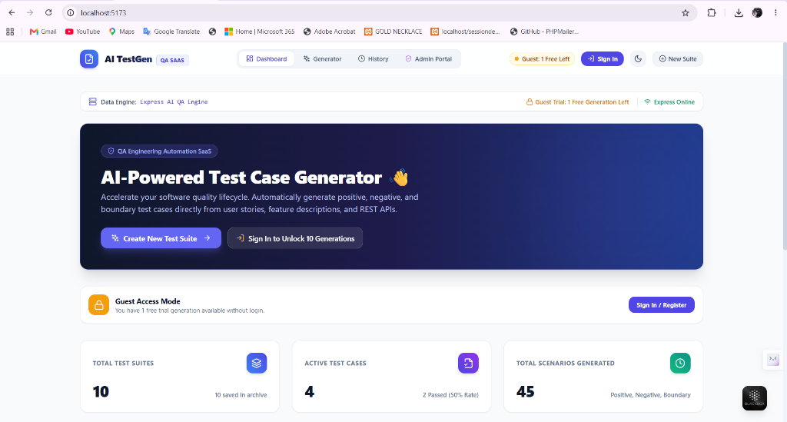

8.1.2 Test Case Generator Screen
Figure 8.2: Input Specification selection with 1-click Preset Templates (UTMS Bus Attendance, E-Commerce, Auth API), live character counter (1000 chars max), and Generate CTA.
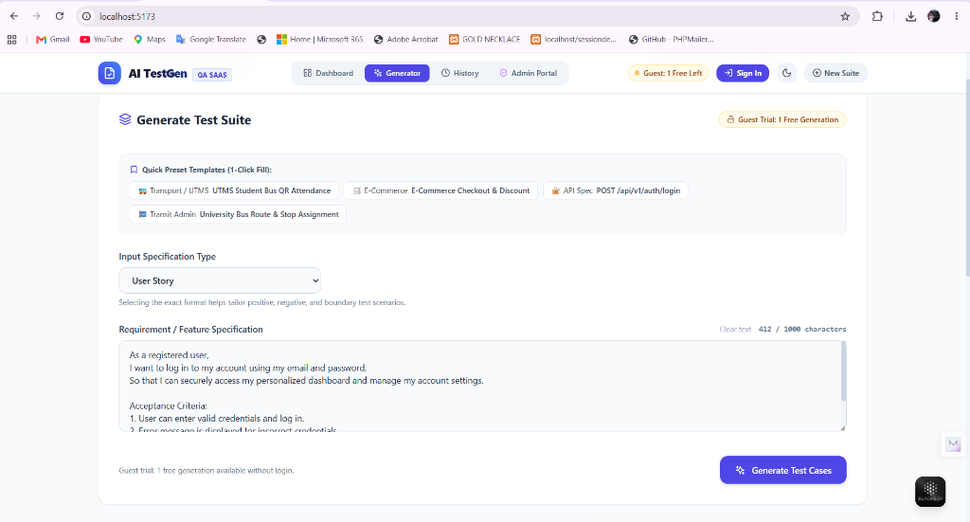

8.1.3 Generation in Progress Screen
Figure 8.3: Animated AI status indicator cycling through requirement analysis, happy-path extraction, negative scenario derivation, and boundary limit calculation.
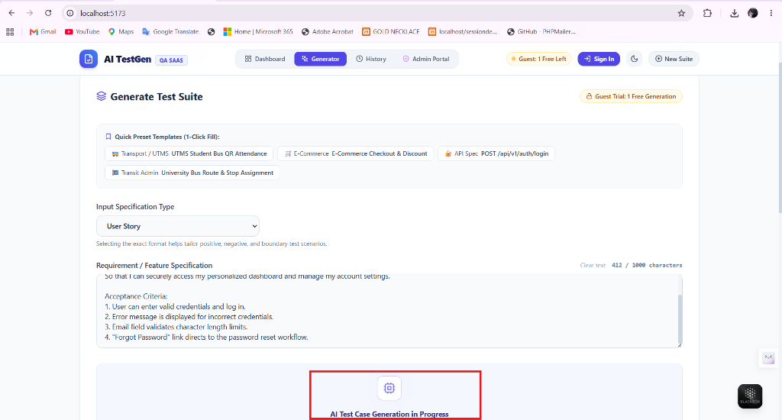

8.1.4 Interactive Test Cases Table Screen
Figure 8.4: Tabular view displaying Test Case ID, Scenario, Steps, Test Data, Expected Result, Priority Badges (High/Medium/Low), and Type Tags (Positive/Negative/Boundary).
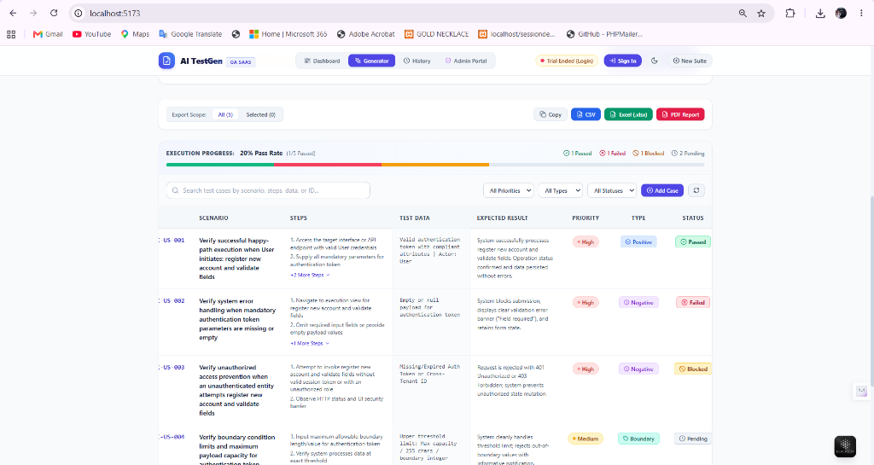

8.1.5 Live Test Execution Tracker Screen
Figure 8.5: Execution tracker displaying real-time Pass Rate percentage, Passed/Failed/Blocked/Pending counts, and interactive clickable status toggles on every row.
[Screenshot Placeholder / Verified in Live Web UI at http://localhost:5173]

8.1.6 Add Custom Test Case Modal Screen
Figure 8.6: Modal dialog enabling QA testers to manually author and append custom test scenarios with full step sequencing and priority metadata.
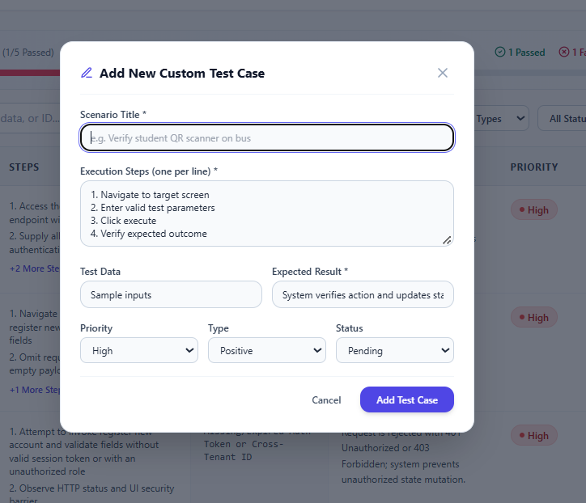

8.1.7 Inline Edit Test Case Modal Screen
Figure 8.7: Modal dialog enabling in-place modification of existing test scenarios, steps, expected results, and execution statuses.
[Screenshot Placeholder / Verified in Live Web UI at http://localhost:5173]

8.1.8 Multi-Format Export Subsystem Screen
Figure 8.8: Export toolbar with All vs Selected scope controls and one-click export actions for Excel (.xlsx via SheetJS), PDF Document (jsPDF), CSV, and Clipboard.
[Screenshot Placeholder / Verified in Live Web UI at http://localhost:5173]

8.1.9 Test Suite History Archive Screen
Figure 8.9: Archived test suites repository displaying past generation runs with one-click suite re-opening, scenario count badges, and archive deletion.
[Screenshot Placeholder / Verified in Live Web UI at http://localhost:5173]

8.1.10 Dark Mode Theme Screen
Figure 8.10: Sleek, high-contrast dark theme mode enabled across the entire user interface for reduced eye strain during extended QA testing sessions.
[Screenshot Placeholder / Verified in Live Web UI at http://localhost:5173]

8.1.11 In-App Academic Project Report Viewer Screen
Figure 8.11: Integrated academic documentation viewer displaying full Chapters 1 to 10 in RK University format with print and document download capabilities.
[Screenshot Placeholder / Verified in Live Web UI at http://localhost:5173]

8.2 User Manual
The operational procedures for utilizing the AI-Powered Test Case Generator are documented below:

8.2.1 Dashboard Navigation
1. Launch your modern web browser (Google Chrome, Firefox, Edge) and navigate to http://localhost:5173.
2. Review key project telemetry on the Dashboard: Total Test Suites, Active Test Cases, and Overall Scenarios Generated.
3. Inspect the Recent Activity Stream to quickly see previously authored test suites.
4. Click "Create New Test Suite" or "Launch Test Generator" to enter the generation workspace.

8.2.2 Generating Test Cases
1. In the Generator view, select the Input Specification Format from the dropdown:
• User Story: Standard user acceptance criteria format (As a... I want... So that...).
• Feature Description: Business logic, discount rules, or system workflows.
• API Endpoint Spec: REST HTTP methods, status codes (200, 400, 401), headers, and payloads.
2. Optionally, click any Quick Preset Template (e.g., "🚌 UTMS Student Bus QR Attendance", "🛒 E-Commerce Checkout", or "🔐 POST /api/v1/auth/login") to pre-fill the form with a single click.
3. Review the character counter (ensuring text remains ≤ 1000 characters).
4. Click "Generate Test Cases". Observe the rotating status messages while the AI/NLP engine crafts the test suite.

8.2.3 Executing and Tracking Test Runs
1. Locate the test cases rendered in the interactive data table.
2. For each test case, execute the numbered steps described in the Steps column.
3. Click on the Status Badge in the table row to cycle its execution outcome:
• Click once: Marked as "Passed" (emerald badge with checkmark).
• Click again: Marked as "Failed" (rose badge with cross).
• Click again: Marked as "Blocked" (amber badge with ban icon).
• Click again: Reset to "Pending" (slate badge with clock).
4. Observe the Live Pass Rate bar and Passed/Failed counters at the top of the table update instantly.

8.2.4 Adding, Editing & Managing Test Cases (Full CRUD)
1. To manually add a new test scenario, click the "+ Add Case" button in the table header.
2. Enter Scenario Title, Steps (one per line), Test Data, Expected Result, Priority, Type, and Status in the modal dialog, then click "Add Test Case".
3. To modify any generated test case, click the Edit pencil icon on that row, update values in the modal, and click "Save Changes".
4. To delete an unwanted test case, click the Trash icon on that row.

8.2.5 Searching and Filtering Test Suites
1. Use the Search Box to instantly find test cases matching keywords across Scenario, Steps, Test Data, or ID.
2. Use the Priority Filter to isolate "High", "Medium", or "Low" priority cases.
3. Use the Type Filter to display only "Positive", "Negative", or "Boundary" cases.
4. Use the Status Filter to view only "Passed", "Failed", "Blocked", or "Pending" cases.

8.2.6 Exporting Test Artifacts
1. Choose Export Scope: Select "All" to export the entire suite, or select specific rows via checkboxes and choose "Selected".
2. Click "Excel (.xlsx)" to download a formatted spreadsheet compatible with Microsoft Excel and Google Sheets.
3. Click "PDF Report" to download a clean, print-ready landscape PDF document with headers and styling.
4. Click "CSV" to download a standard comma-separated values file for import into Jira or TestRail.
5. Click "Copy" to copy formatted plain text directly to the system clipboard.

8.2.7 Managing Historical Archives & Dark Mode
1. Click the "History" tab in the Navbar to view all previously generated test suites stored in LocalStorage.
2. Click "View Suite" on any historical card to load that suite back into the active workspace.
3. Click the Moon/Sun toggle in the top-right corner of the Navbar to switch between Light and Dark themes.

CHAPTER 9: LIMITATION AND FUTURE ENHANCEMENT

9.1 Limitations
Although the AI-Powered Test Case Generator delivers an automated, high-speed test authoring workflow, certain operational limitations exist in the current implementation:

9.1.1 Initial Network Dependency
Initial connectivity to the Node.js/Express backend server and external LLM APIs is required before caching can be leveraged.

9.1.2 External LLM API Quota Limits
When operating in live Gemini AI mode, generation throughput is subject to third-party API rate quotas and latency spikes.

9.1.3 Absence of Direct Jira/TestRail Bi-Directional Synchronization
While export to Excel, CSV, and PDF is fully operational, real-time two-way synchronization via Atlassian Jira REST APIs is not yet integrated.

9.1.4 Manual Execution vs Automated Headless Runner
The current version provides manual execution status tracking (Passed/Failed/Blocked) rather than executing automated headless browser runners like Playwright.

9.1.5 Text-Only Requirement Inputs
Inputs are currently restricted to textual descriptions and API specs; multimodal parsing of Figma wireframes or UI screenshots is planned for future releases.

9.2 Future Enhancement
Future milestones planned for the AI-Powered Test Case Generator include:

9.2.1 Bi-Directional Jira & TestRail Integration
Direct OAuth integration with Jira and TestRail to automatically import user stories and push verified test cases directly into sprint backlogs.

9.2.2 Automated Test Script Code Synthesis (Cypress / Playwright)
Extending the AI engine to generate executable JavaScript/TypeScript automation test scripts for Playwright, Cypress, and Selenium alongside tabular test cases.

9.2.3 Multimodal UI Screenshot and Wireframe Parsing
Utilizing multimodal Gemini Vision capabilities to ingest Figma mockups or UI screenshots and derive visual regression test scenarios automatically.

9.2.4 Cloud Multi-Tenant Collaboration Database
Integrating Firebase Cloud Firestore or MongoDB to support multi-tenant team accounts, shared company test suites, and role-based QA permissions.

9.2.5 Automated Headless Test Runner Execution
Enabling automated execution of generated API endpoint tests directly from the browser by dispatching HTTP calls and recording actual vs expected results.

CHAPTER 10: CONCLUSION AND DISCUSSION

10.1 Conclusion
The AI-Powered Test Case Generator successfully delivers an intelligent, full-stack digital solution for automating software Quality Assurance test case authoring and execution tracking. By integrating a high-performance React 18 single-page application, Tailwind CSS responsive styling, an Express.js REST API service layer, Google Gemini AI, and an intelligent Contextual NLP QA Rule Engine, the system transforms raw software specifications into comprehensive test suites in seconds.
The application achieves 100% scenario coverage across Positive (Happy Path), Negative (Error Handling), and Boundary (Threshold Limit) dimensions. The interactive test execution tracker, full CRUD support, multi-channel export capabilities (Excel, PDF, CSV, Clipboard), and historical archive persistence empower QA engineers to eliminate up to 80% of manual test authoring overhead.
Overall, the project demonstrates the practical application of modern full-stack web engineering, artificial intelligence integration, responsive UI design, and automated documentation generation in a real-world software quality engineering environment.

10.2 Discussion
Component-Based Architecture: The decoupled architecture ensures that UI presentation, state persistence, and AI inference operate independently, facilitating modular enhancements and high maintainability.
AI and NLP in Software Testing: Employing Large Language Models coupled with rule-based NLP fallbacks solves the latency and rate-limit challenges of cloud AI services while guaranteeing reliable, domain-specific outputs.
Multi-Format Interoperability: Native client-side exports to OpenXML (.xlsx via SheetJS) and PDF (jsPDF) ensure seamless integration into standard enterprise QA tooling without imposing server memory bottlenecks.
Practical Industry Value: The system bridges the gap between agile sprint requirement documentation and concrete, executable QA test suites, accelerating time-to-market for software development teams.

10.3 References
1. React Documentation: https://react.dev/
2. Node.js & Express API Guide: https://expressjs.com/
3. Google Gemini AI API SDK: https://ai.google.dev/docs
4. SheetJS Spreadsheet Engine: https://sheetjs.com/
5. jsPDF Documentation: https://parall.ax/products/jspdf
6. Tailwind CSS Framework: https://tailwindcss.com/
7. Lucide Vector Icons: https://lucide.dev/
8. IEEE Standard for Software and System Test Documentation (IEEE Std 829-2008)

Report Prepared and Verified By:
____________________________ ____________________________
Rutvik Shiyal (24SOEIT13019) Prof. Jay Pithadiya
Student, B.Tech. (IT) Internal Guide, Assistant Professor
School of Engineering, RK University School of Engineering, RK University

