Form work Specification document.
This document is intended as a guide for specifying form changes in the SystemC suite of applications, it’s not exhaustive and changes required outside of those detailed here, should be discussed with a member of the SC&E team before requesting. This should mean that all changes come through in the same way and are possible within the limits of the system.
The benefit to SIT and the business is less need for the initial back and forth to ascertain what is needed and where…

Requesting changes / additions
Please use screenshots of the existing form(s) to request changes, examples will be provided below. Full screen screenshots are always appreciated as it provides the context of the changes, including the system being used and the actual name of the form. Where it is easier to do so, make a “mock up” of the element in Word / Excel etc and include that
Form Elements
There is a stand alone form in test called “CFR Element helper” which is covers most of the standard elements used in form creation with the correct names which is available for anyone with test access to refer to when specifying form changes / creation. I will use this form as the basis for this document.
Example of a wording change:
To request this a screenshot of the element where the text should be changed, and the text you want it changed to. This should be in text format to enable it to be copied and pasted into the relevant section:
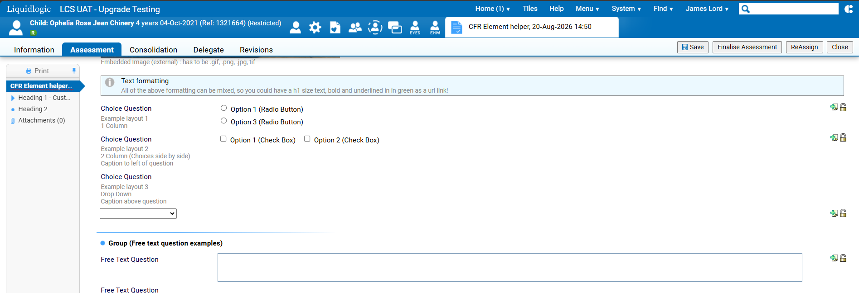
Please change “Example layout 1” to read “Layout 1 example” and make it bold and mandatory
Example of an additional element
To request this, a screen shot that includes the area you want the element adding, a clear indication of where the element should go, the type of element to be added and text required:
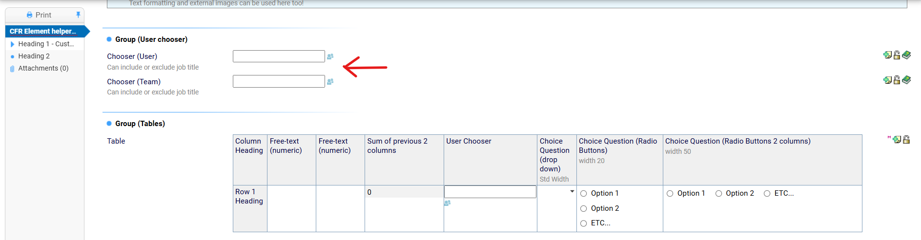
Please add a question here with the text “Please select your directorate”
This should have the following choices in a drop down
“Adult Services”, “Children Education and Familes” and “IT - Social Care & Education”
This question should be mandatory

Removal of an element
To remove an element, please send a screenshot including the element you want removed, with either the element highlighted:
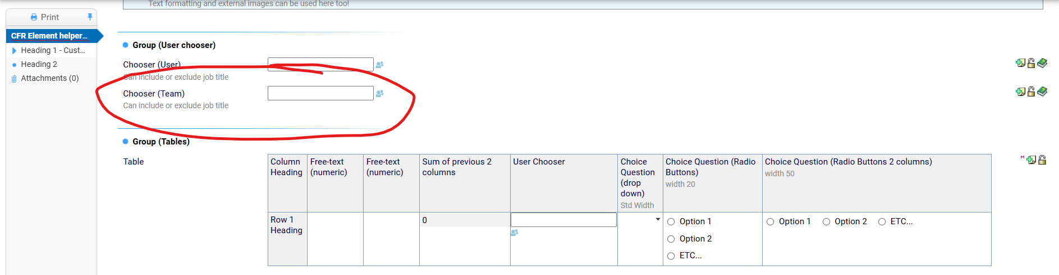
Please remove the highlighted User chooser
OR the exact text of the element you want removing:
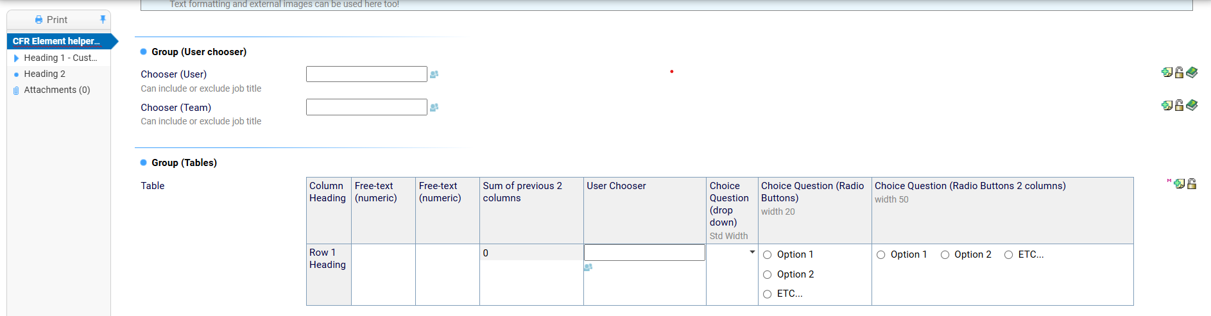
Please remove the User chooser entitled “Chooser (Team)”

Adding Headings and content
The same applies with adding a heading to a form where possible this should be contained in the same section of your request for example:
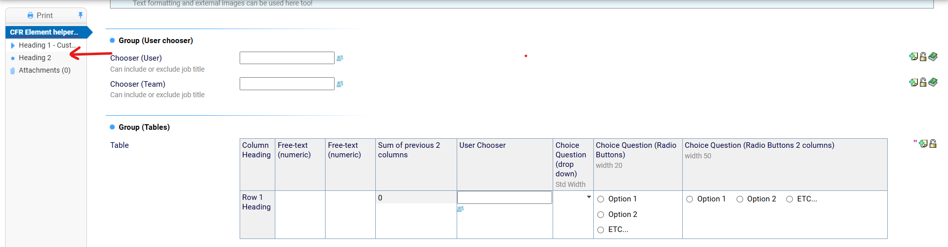
Please add a Header where indicated Entitled “Heading 1a”
This should be a Tier 2 heading and contain the following:
Information Box with the text “Please read carefully and fill in the questions below”
Question titled “Subject name” – this should be mandatory
Question titles “Phone number” – This should be a numeric field – numbers only
Table:
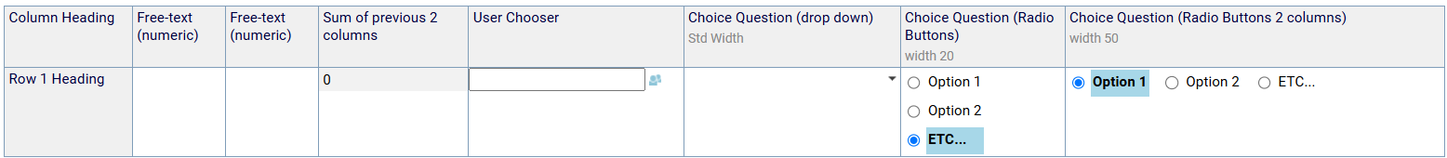
The user should be able to add rows for multiple entries
The heading should be above the table and should read “Table of Involvements” and should be bold

Logic and Logic changes
These can be complicated, and may need a conversation outside of the initial change document, where possible please specify though, as work can start immediately. Try to keep the request as simple as possible! E.g:
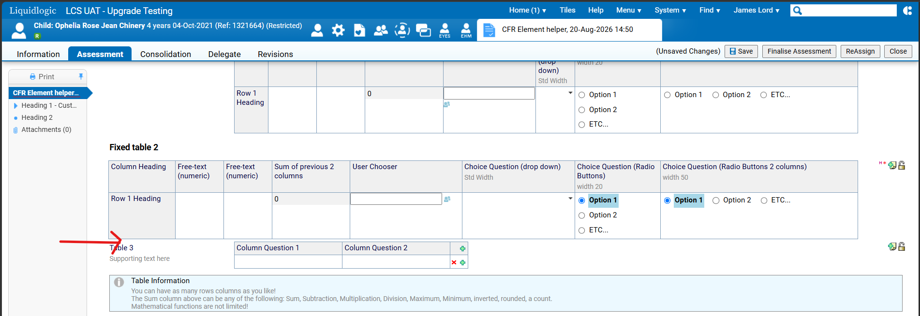
Please add a question between the bottom of table 1 and the top of table 2 with the text “Do you want to see table 2?” and the answers of “Yes” and “No” as radio buttons.
If “Yes” is selected table 2 should be hidden

