VERY simple guide to using Git:
Open GitHub Desktop :

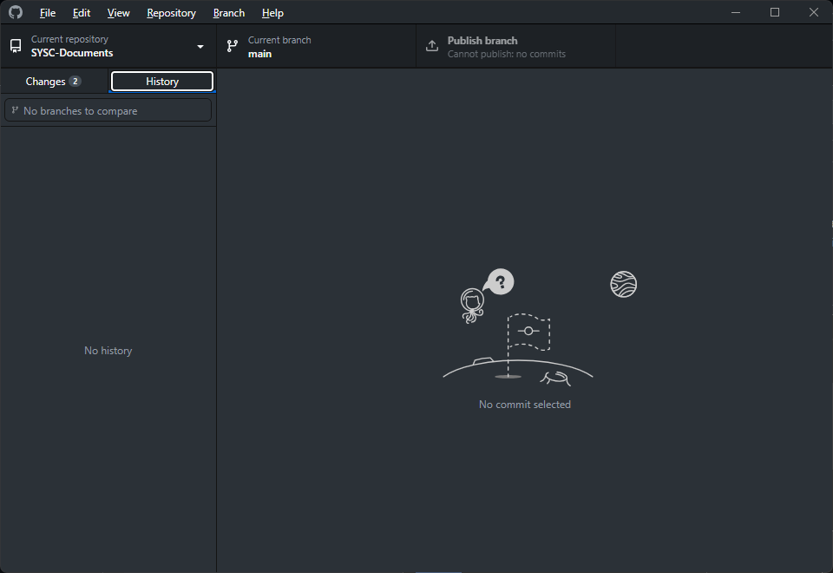

Go to File > Clone Repository
In the window that appears, click URL and add: https://github.com/SYSC-Documents/SYSC-Documents
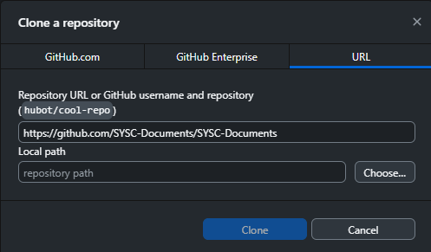

Click Clone to import the repo to your local machine
This will copy the entire content of the repository to you local machine and allow the folder it’s downloaded to the ability to sync with the repository, the screen below will be shown. To view the local directory, click :



As no changes have been made by you yet, the Git App will look like this:

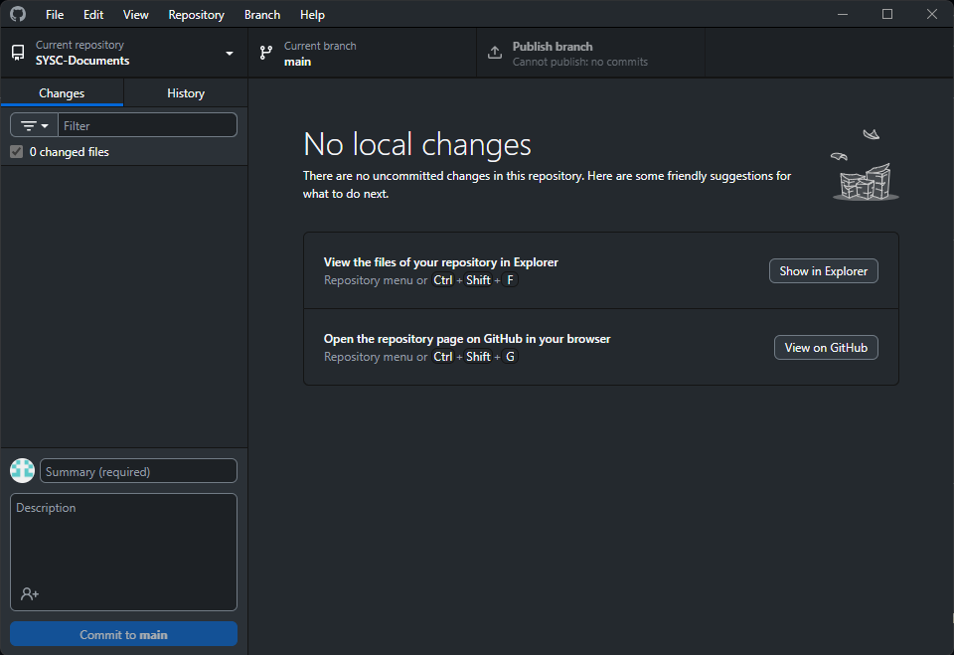

Any additions / changes should be made in the local copy of the repo as shown here to open the contents of the rep locally click the show in explorer link:
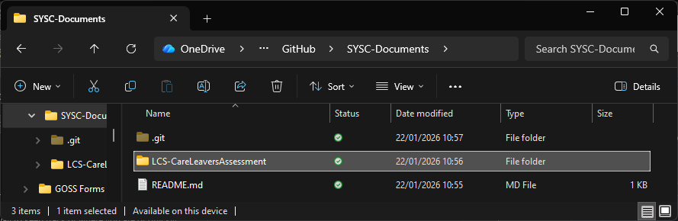

In this folder create / copy / edit the files you want to add or change in the repository, in my example I have added 2 directories and README.md files in each to explain what they’re for.
The Base page of the repository contains a README.md containing the structure and naming convention etc. to be used.

Changes made here will reflect in the GitHub Desktop client window as seen below, but at this point are only held on your machine, not the repository itself:

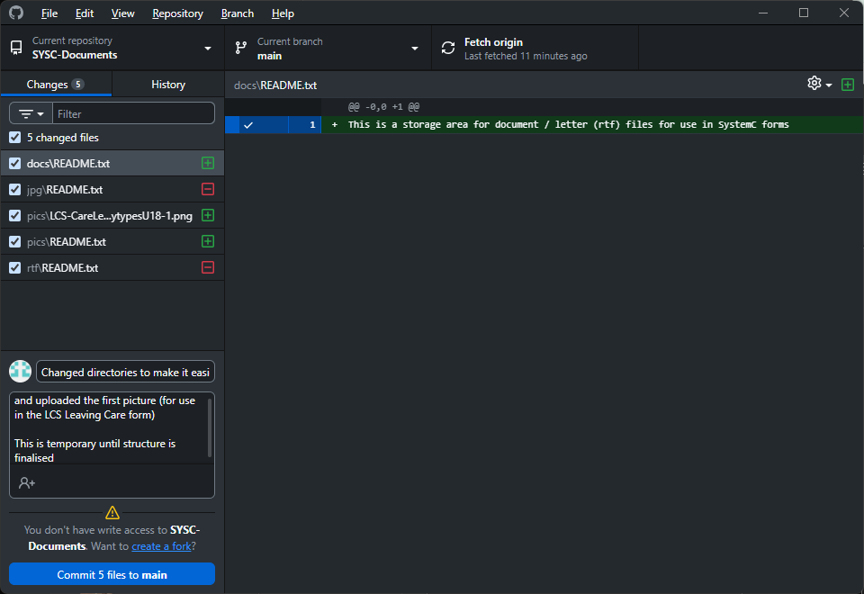
The files which will being added / removed or changed are listed on the left side of the screena

In order to add the files to the repo, a summary of what is being added (mandatory) and a description (optional) should be added in the box to the left (see README.md for convention)
When you click Commit (x) to main the files are pushed to a holding area, the final step is to publish them and make them available for use:

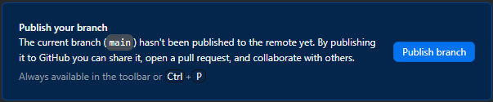

Your changes will be reflected in the history tab in the application:

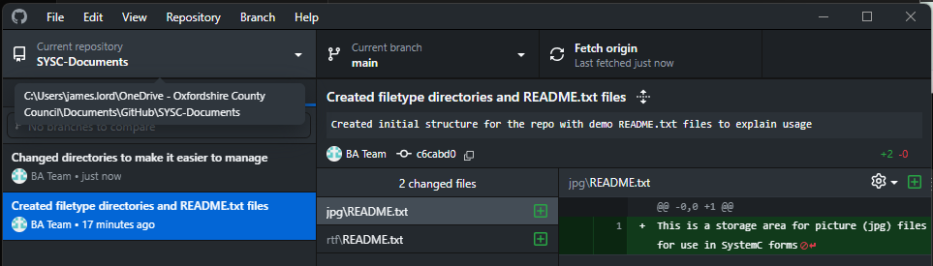

In order to get the link to use in your form click View on Github (or press Ctrl-Shift-G:

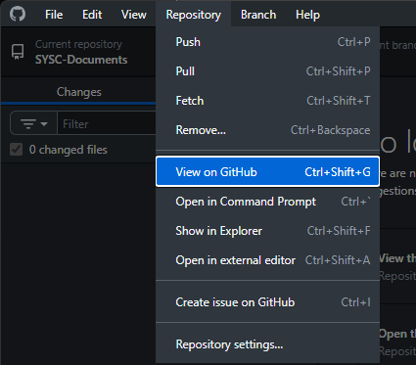

This will open the repo in a browser:

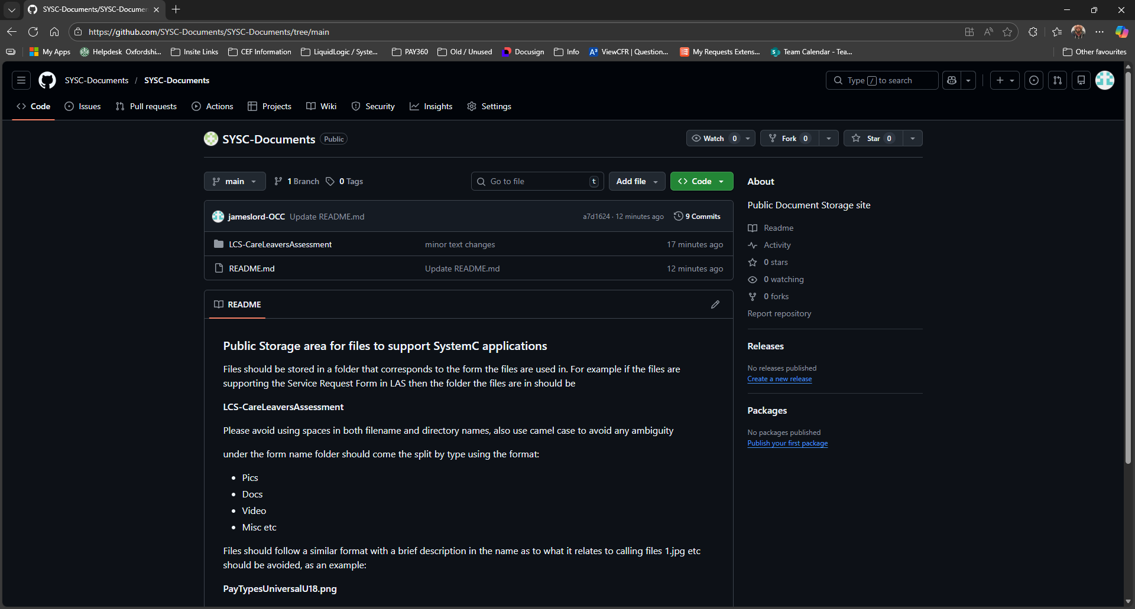

The directory structure is at the top, to get a usable web link to the file, simply click to the location of your file, click on the file itself then right click the “View raw” and select copy link:
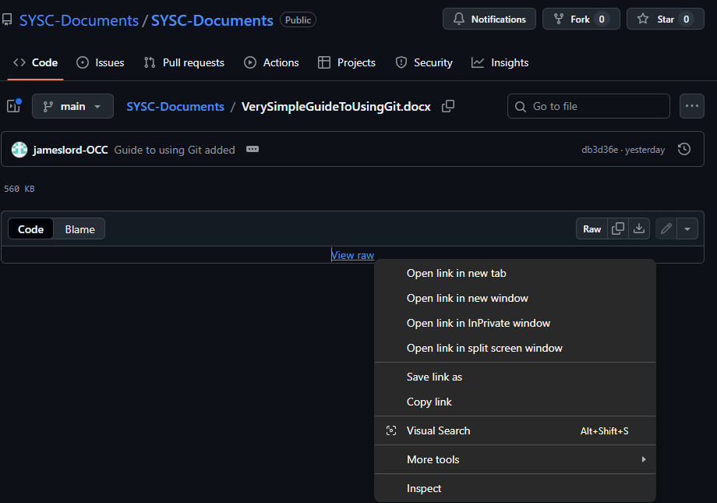
One of the big advantages of Git is that changes are logged and can be reverted if needed, it provides full version control of any and all changes. It also allows multiple people to work on the same things without interfering with each other’s work
Git is a big thing. If you’re interested there is a huge amount of documentation and resources at https://git-scm.com/ and a rundown of what Git is and how to use it at https://git-scm.com/book/en/v2

