**Database Design**

**TABLE OF CONTENTS**

|  |  |  |
| --- | --- | --- |
| **SL** | **Schema Name** | **Page Number** |
| 01 | Users | 3 |
| 02 | Admins | 4 |
| 03 | Client | 5 |
| 04 | Contact | 6 |
| 05 | Comment | 7 |
| 06 | Official | 8 |
| 07 | User | 9 |

**Users Schema**

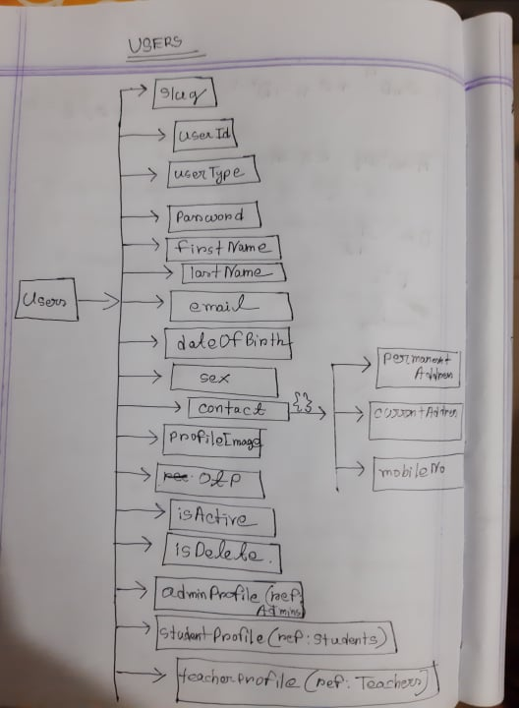

**Both Side Relation With:**

1. **Admins (**when we create a new admin then we need to put the Admin’s schema as a ref and in the Admin schema keep the User’s ref as well)
2. **Students (**when we create a new student then we need to put the Studenst’s schema as a ref and in the Student’s schema keep the User’s ref as well))
3. **Teachers (**when we create a new teacher then we need to put the Teacher’s schema as a ref and in the Teachers schema keep the User’s ref as well))

**Admins Schema**

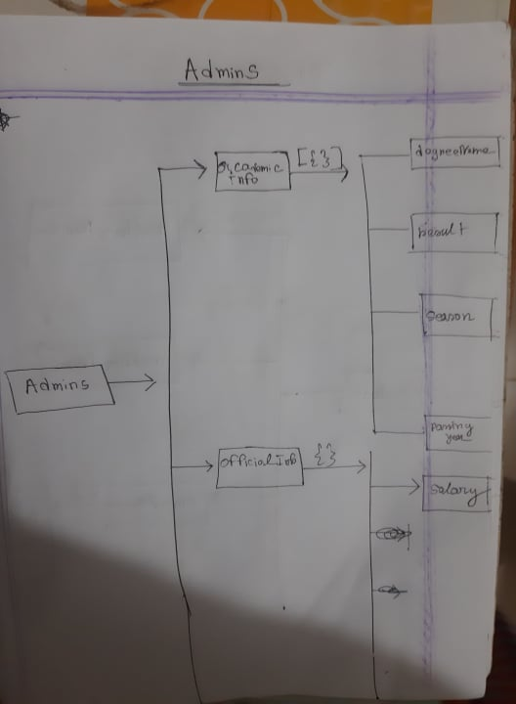

**Both Side Relation With:**

1. **Users (**when we create a new admin user then we need to put the Admin’s schema as a ref in the User Schema and in the Admin schema keep the User’s ref as well)

**Students Schema**

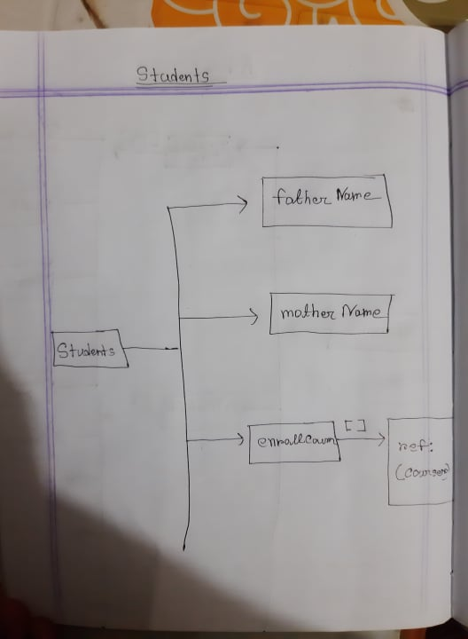

**Both Side Relation With:**

1. **Courses (**when student enrolled a new course then he or she needs to put the course id here as a ref and also put the Student’s id in the Course Schema)
2. **Users (**when we create a new student user then we need to put the Studenst’s schema as a ref in the User’s Schema and in the Student’s schema keep the User’s ref as well))

**Teachers Schema**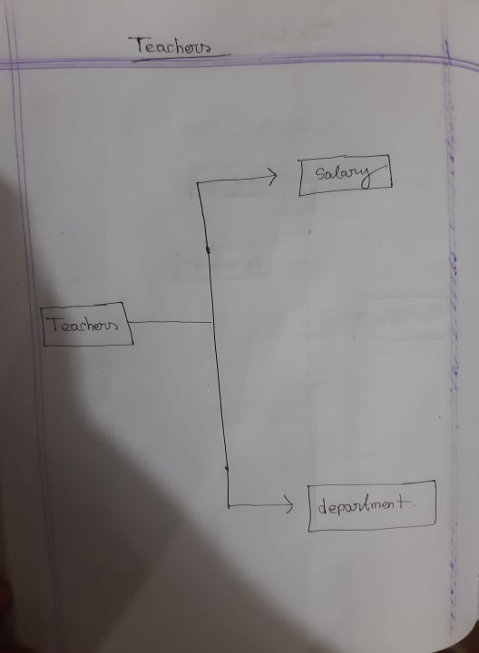

**Both Side Relation With:**

1. **Users (**when we create a new student user then we need to put the Studenst’s schema as a ref in the User’s Schema and in the Student’s schema keep the User’s ref as well))

**Courses Schema**

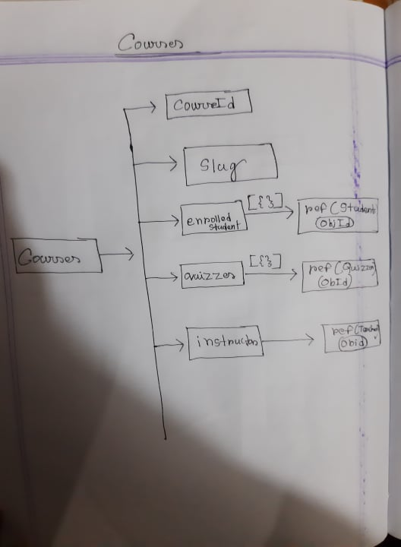

**One Side Relation With:**

1. **Student (**when student enrolled a new course then he or she needs to put the course id here as a ref and also put the Student’s id in the Course Schema)
2. **User (**when student user enrolled a new course then he or she needs to put the User scheam id here as a ref)
3. **Teachers (**when we create a new course then a Teachers Schema Object id will store here as a ref)

**Both Side Relation with:**

1. **Quizzes (**when we create a new quiz then that Quiezzes scheam id will be store here as a ref and in the Queizzes Schema This Course Scheam Id will be store as a ref)

**Quiezzes Schema**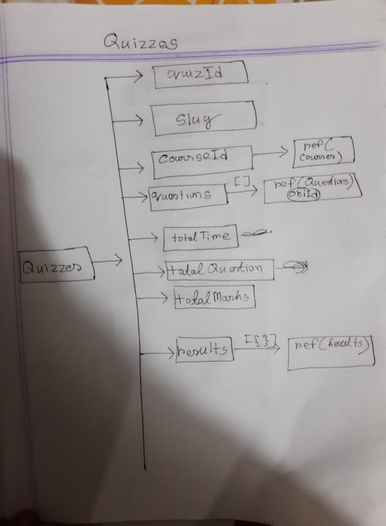

**One Side Relation With:**

1. **Client (**when we create a new blog we need to store the logged in user object id here as a ref )

**Both Side Relation with:**

1. **Courses (**when we create a new quiz then that Quiezzes scheam id will be store here as a ref and in the Queizzes Schema This Course Scheam Id will be store as a ref)
2. **Questions (**when we create a new quiz then all question of that quiz will store as a Question Scheam object id and In the Questions Schema Quizess object id will be store as a ref )
3. **Results: (**when a result will generate that time it will Store the Result’s object Id here as a ref and in the Result Schema this Quizzes Scheam Id will be store as a ref)

**Questions Schema**

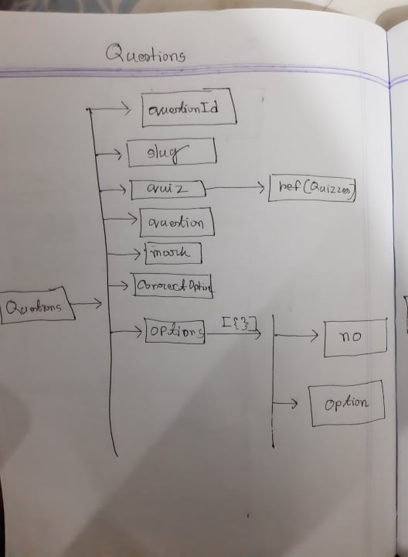

**Both Side Relation with:**

1. **Quizzess (**when we create a new quiz then all question of that quiz will store as a Question Scheam object id and In the Questions Schema Quizess object id will be store as a ref )

**Results Schema**

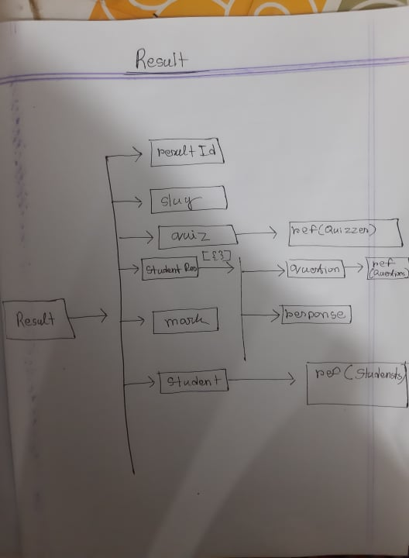

**One Side Relation With:**

1. **Users (**when we create a new result it will store that Users Scheam Object id here as a ref )
2. **Questions (**when student responses