AWS observation

1.1
S3 is our raw data storage. We store CSV files here which trigger the pipeline. The folder structure separates raw input data from query results.(Picture 1,2)

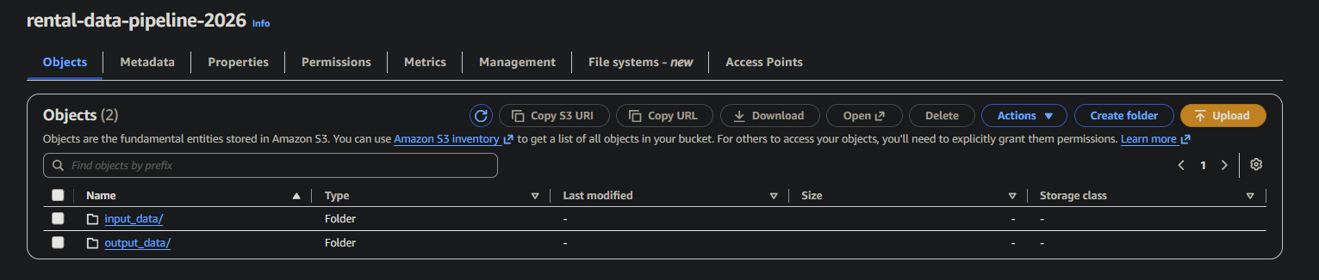
Picture -1

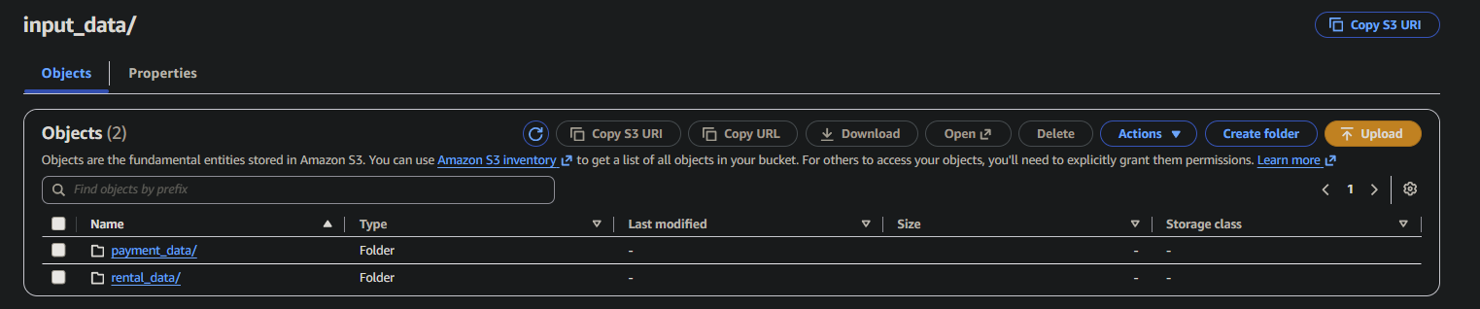
Picture – 2
1.2
IAM controls which services can access each other. Without proper IAM roles, Lambda cannot trigger Glue and Glue cannot read from S3. Here we show that Lambda has all necessary permissions.(Picture – 3)

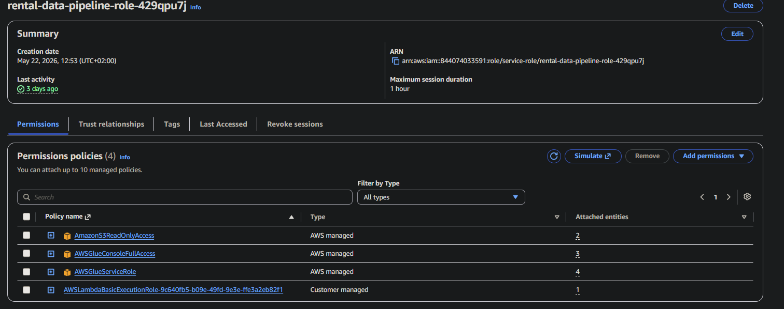
Picture – 3

1.3 Lambda is our event-driven trigger. It automatically detects when a new CSV file arrives in S3 and starts the Glue ETL job. No servers needed — it runs only when triggered.(picture - 4)

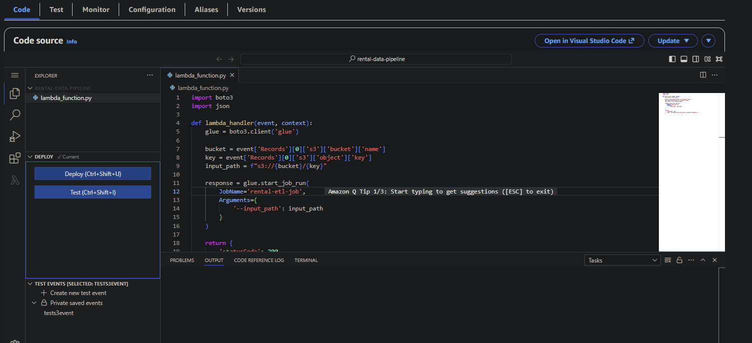
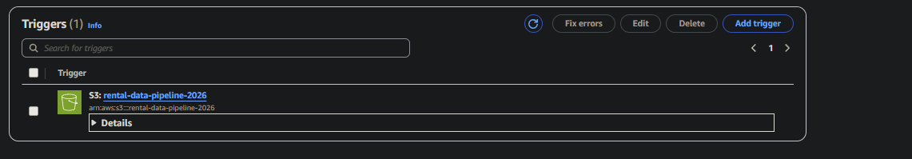
Picture – 4

1.4 Glue is our ETL engine. It reads raw CSV files from S3, cleans the data by dropping unnecessary columns and converting data types, then saves processed data back to S3 in Parquet format. Pictures (5,6,7)

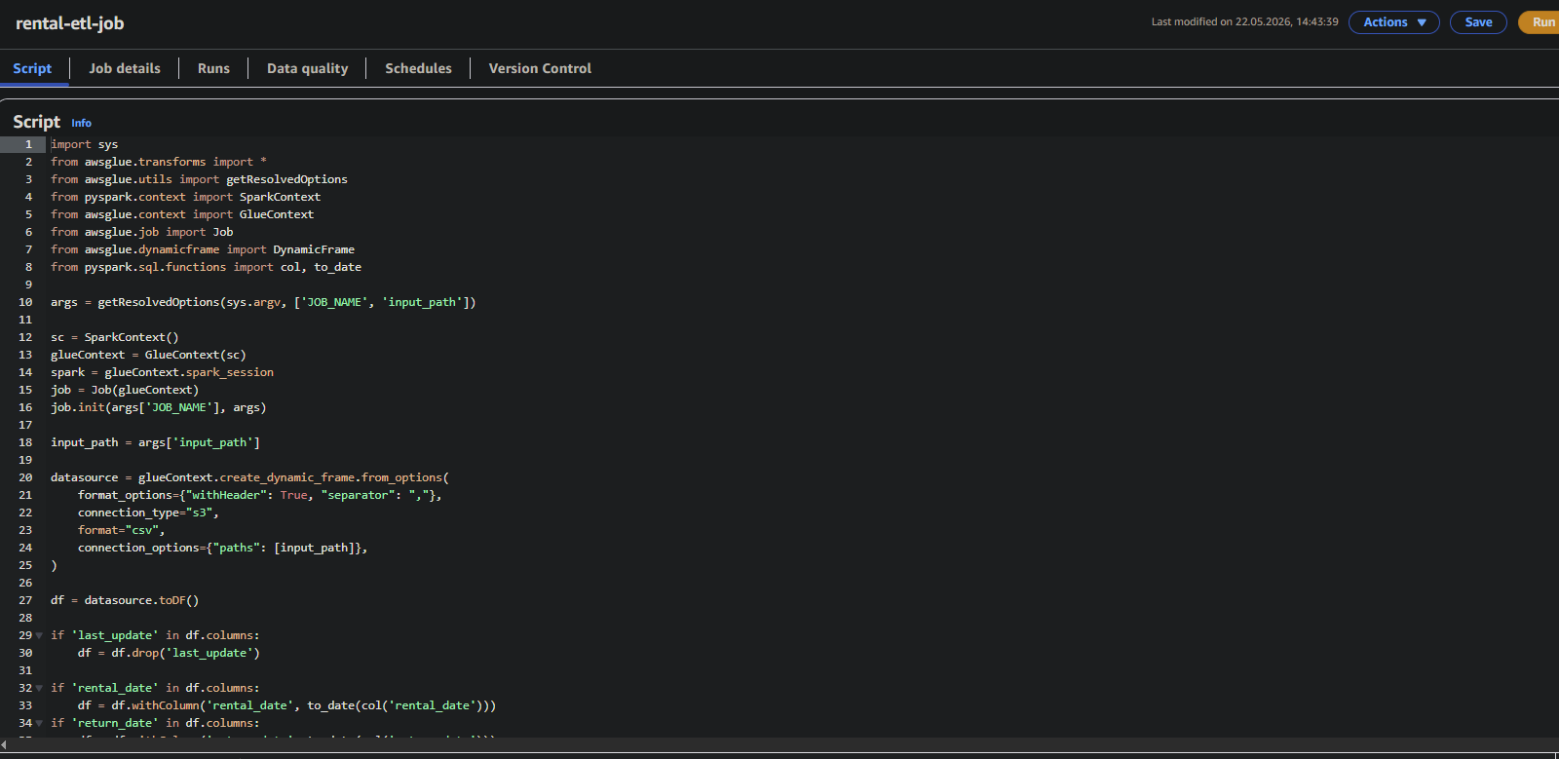
Picture – 5
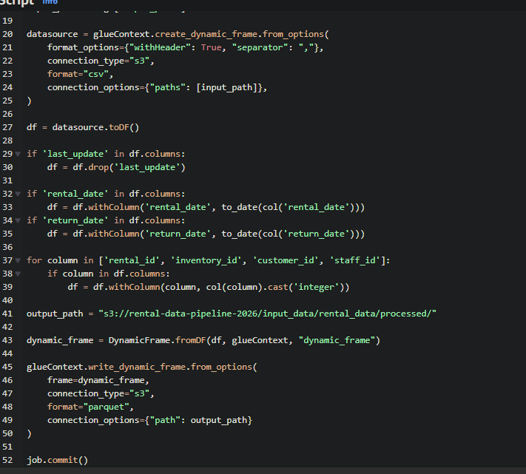
Picture – 6

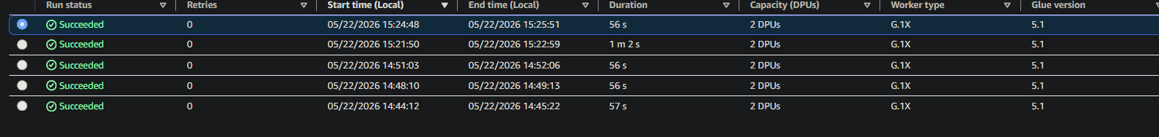
Picture - 7

1.5 Athena allows us to run SQL queries directly on files stored in S3 without moving data anywhere. We use it for analysis of rental and payment data.(Pictures 8,9,10,11)

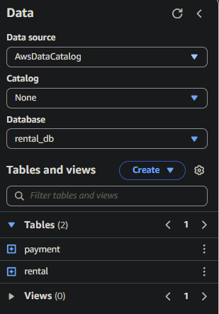
Picture 8

Total payments by customer

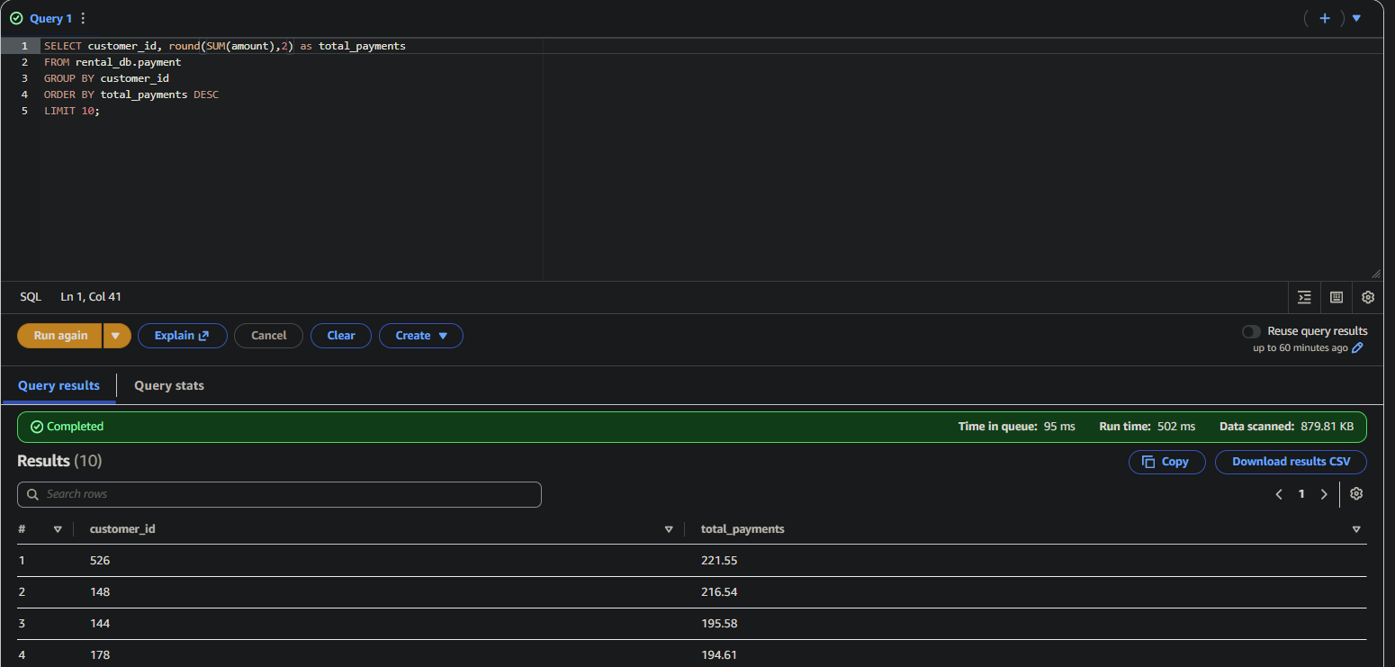
Picture 9

All rentals joined with payments

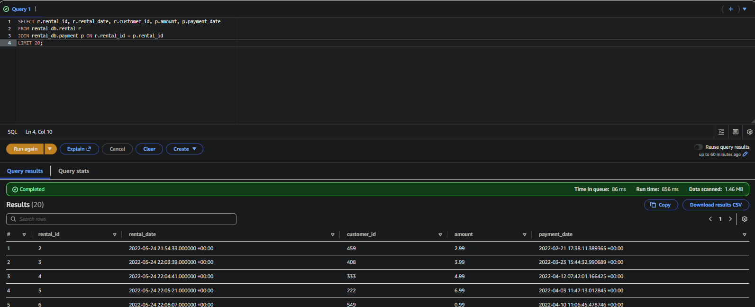
Picture 10

Active rentals without return date

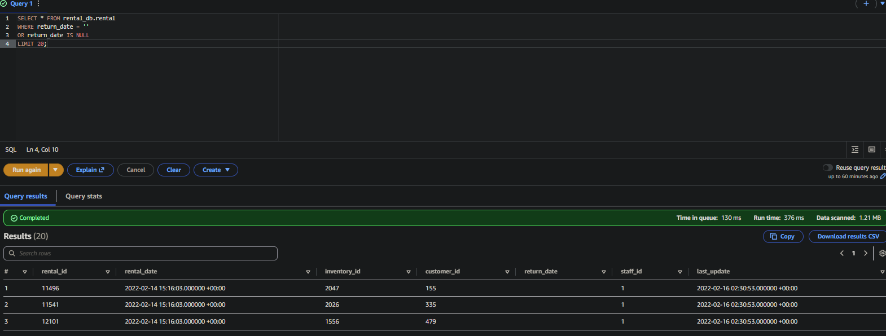
Picture 11

The Folder with our query results

