**Scenario:** **Moving data from AWS S3 bucket to azure SQL (if file size > 100kb and rows in file > 999)**

**Source**: Amazon S3 Bucket

**Destination**: Azure SQL

**Platform** **Used**: Azure Data Factory

1. First, we need to create an S3 bucket in AWS console
2. We need to add a container
3. Add files in to S3 container
4. Create a user and user group
5. Under user we need to create access key and access secret (it can be used to connect s3 bucket)
6. Give get access, list object access of s3 bucket to created user
7. Create linked service to connect s3 bucket in azure data factory
8. Create another linked service to azure SQL
9. Create data set relevant to S3 and azure SQL
10. Create pipeline with set of activities and apply logic regarding to size > 100kb and rows in a file > 999
11. End point to azure SQL
12. Check in Azure SQL for final output

**Amazon S3**

Aws side we need s3 bucket and container with data inside

Under iam in aws create user and generate access key by utilizing that we can connect from azure

Under user group create one and give access

Role access for specific user

{

"Version": "2012-10-17",

"Statement": [

{

"Effect": "Allow",

"Action": [

"s3:*"

],

"Resource": [

"arn:aws:s3:::yashtestingg",

"arn:aws:s3:::yashtestingg/*"

]

}

]

}

Get access is mandatory to retrieve access in azure

{

"Version": "2012-10-17",

"Statement": [

{

"Effect": "Allow",

"Action": [

"s3:GetObject",

"s3:ListBucket"

],

"Resource": [

"arn:aws:s3:::yashtestingg",

"arn:aws:s3:::yashtestingg/*"

]

}

]

}

{

"Version": "2012-10-17",

"Statement": [

{

"Effect": "Allow",

"Action": [

"s3:*",

"s3-object-lambda:*"

],

"Resource": "*"

}

]

}

{

"Version": "2012-10-17",

"Statement": [

{

"Effect": "Allow",

"Action": [

"s3:Get*",

"s3:List*",

"s3:Describe*",

"s3-object-lambda:Get*",

"s3-object-lambda:List*"

],

"Resource": "*"

}

]

}

Create linked service in azure

Select s3

Give access key and access secret test connection

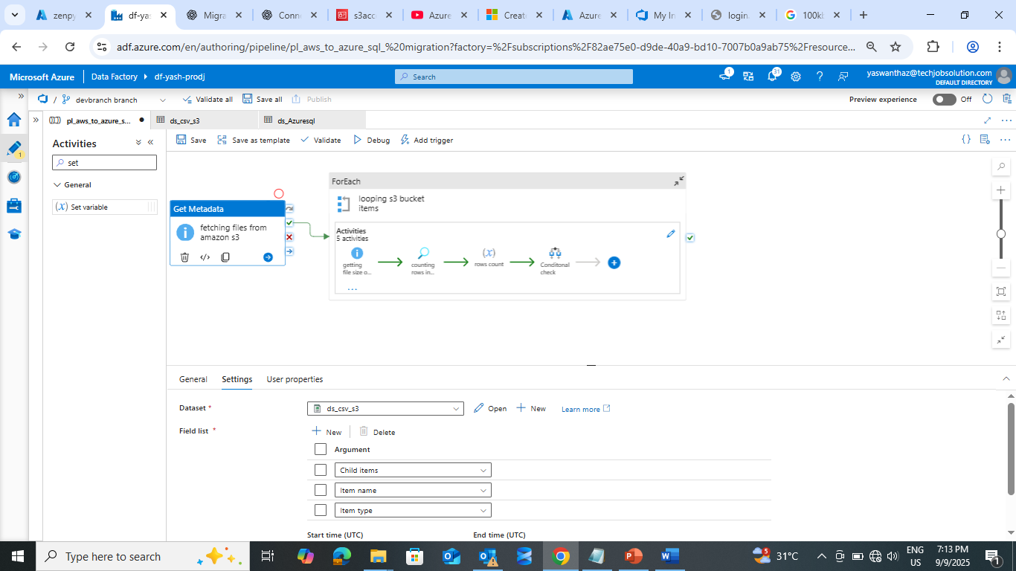

For each syntax:

@activity('fetching files from amazon s3').output.childItems

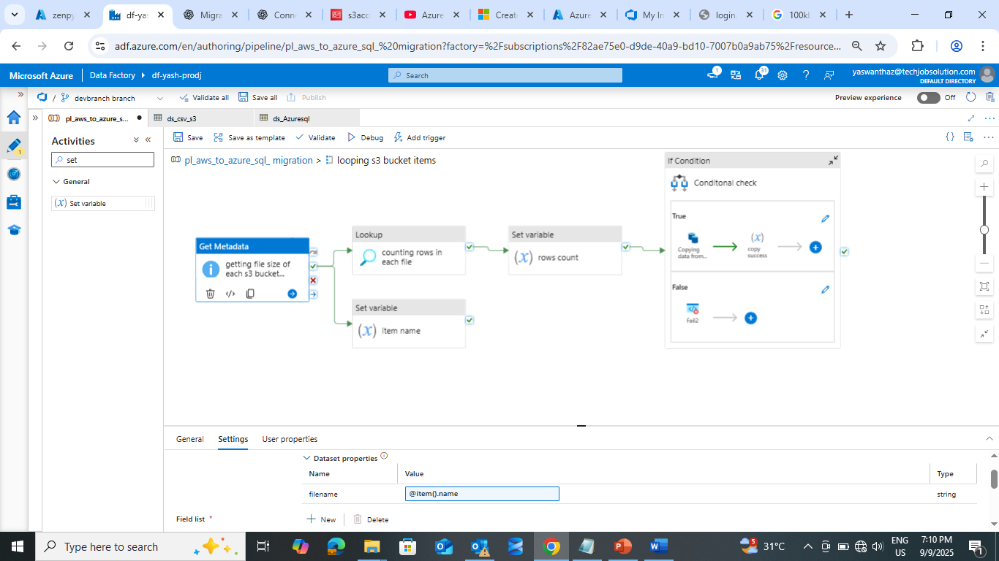

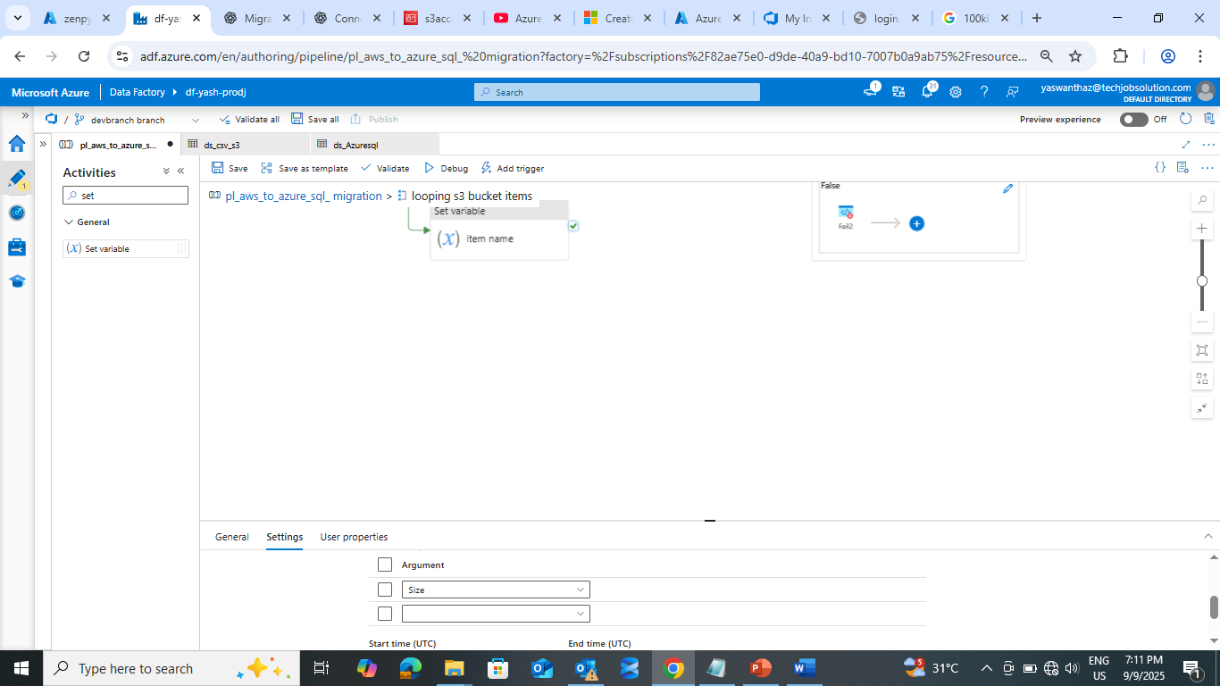

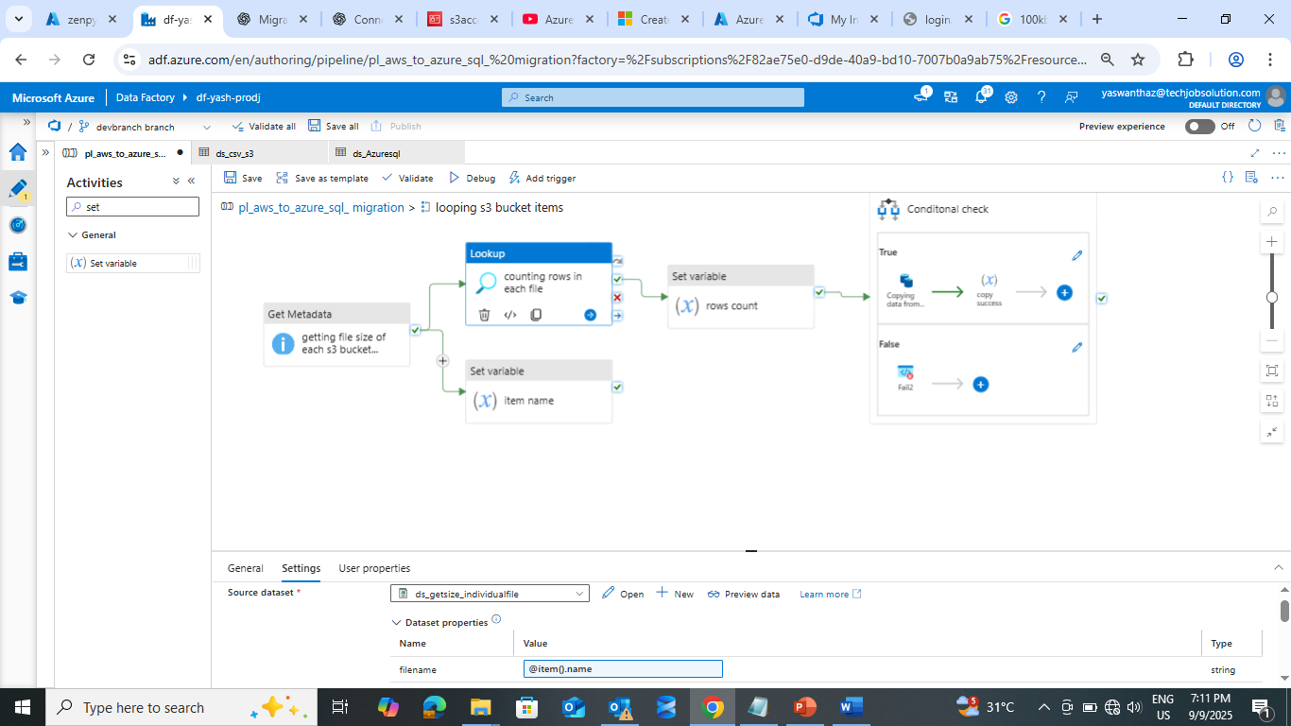

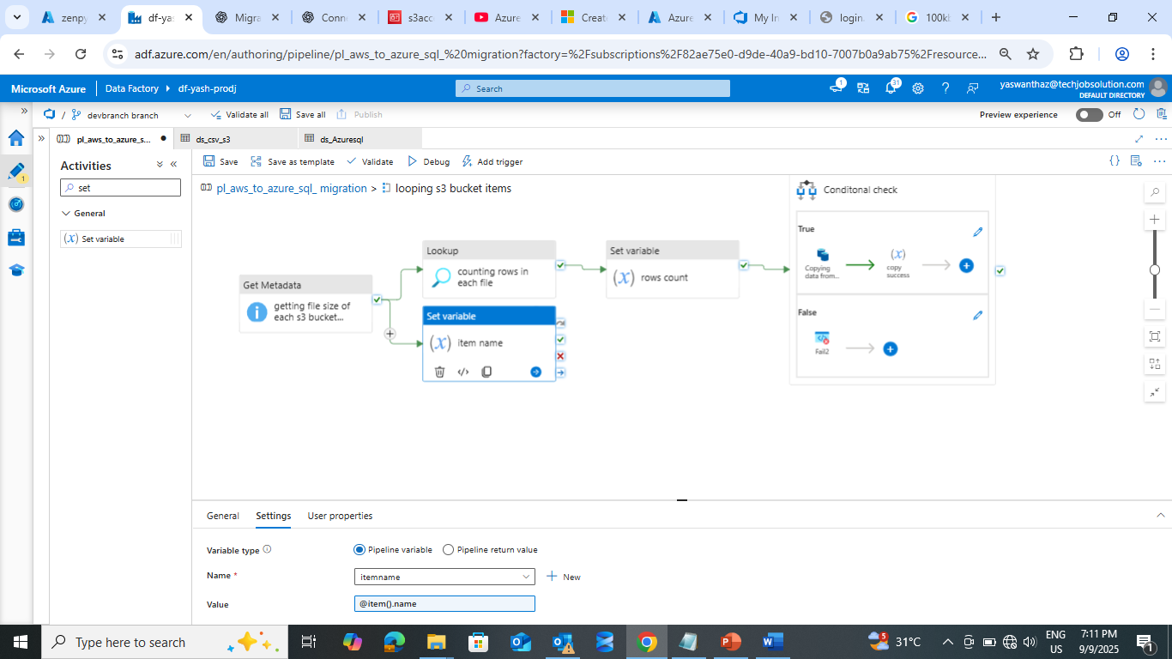

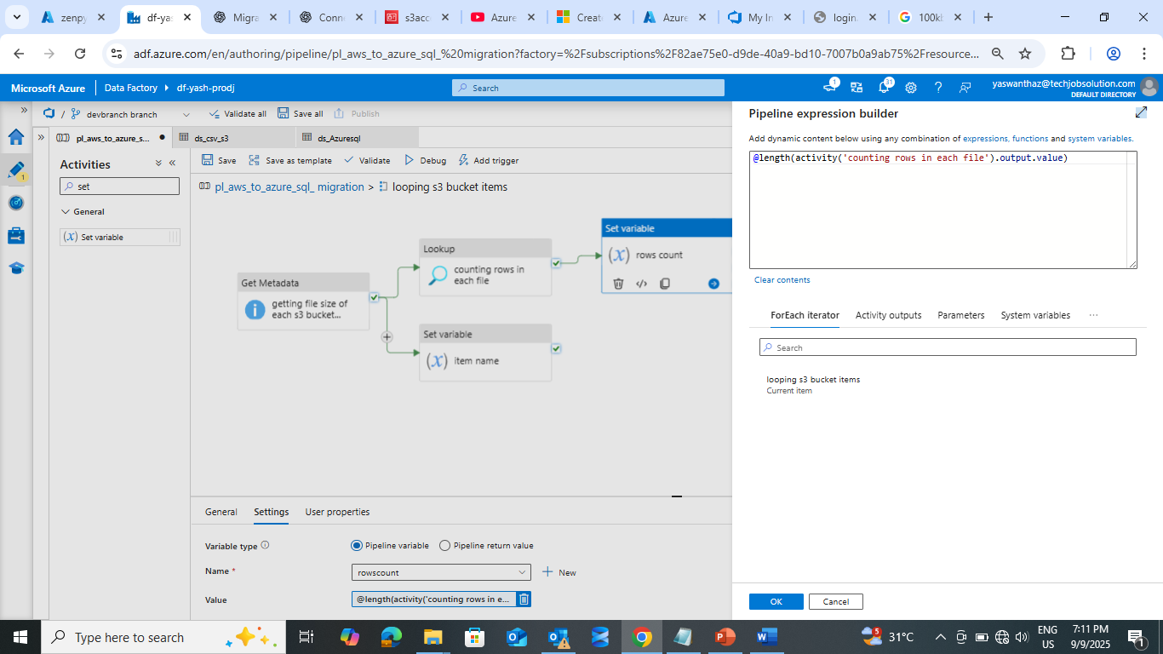

@length(activity('counting rows in each file').output.value)

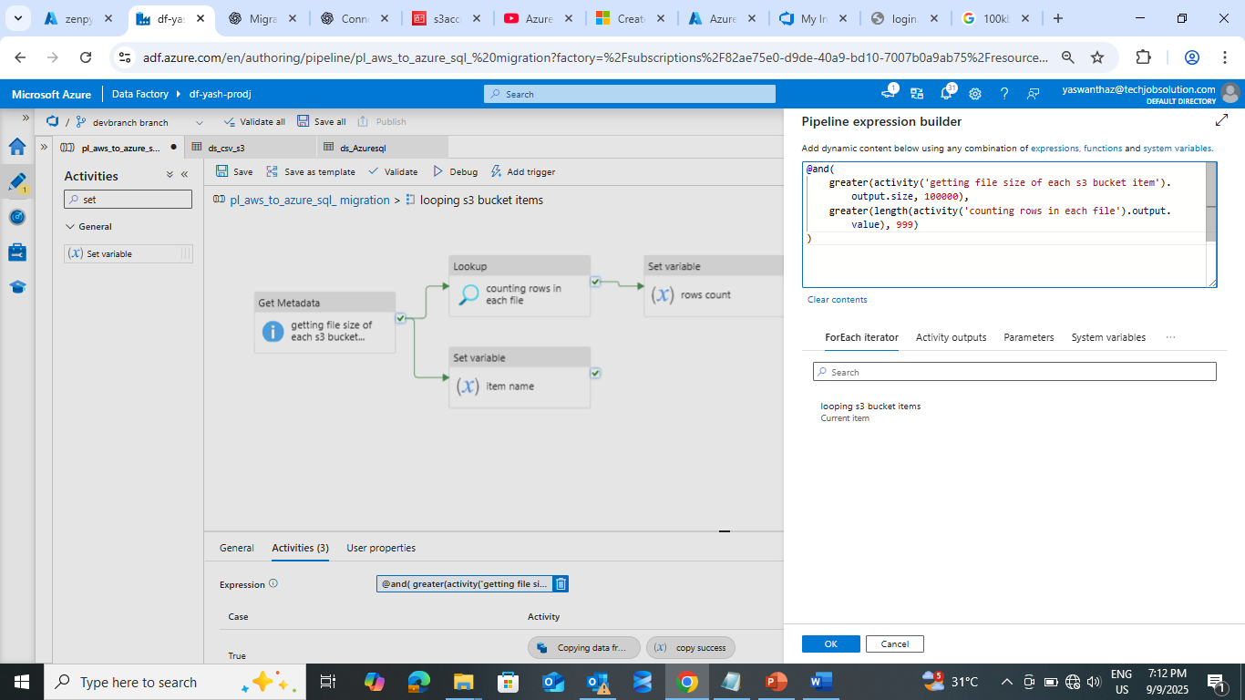

@and(

    greater(activity('getting file size of each s3 bucket item').output.size, 100000),

    greater(length(activity('counting rows in each file').output.value), 999)

)

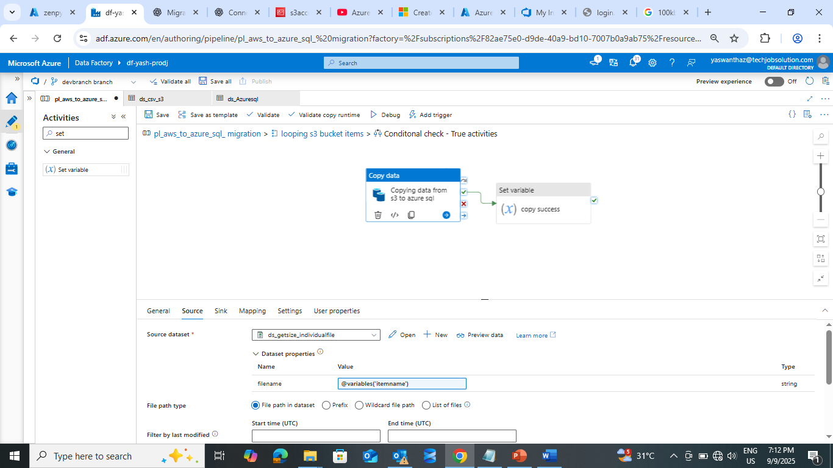

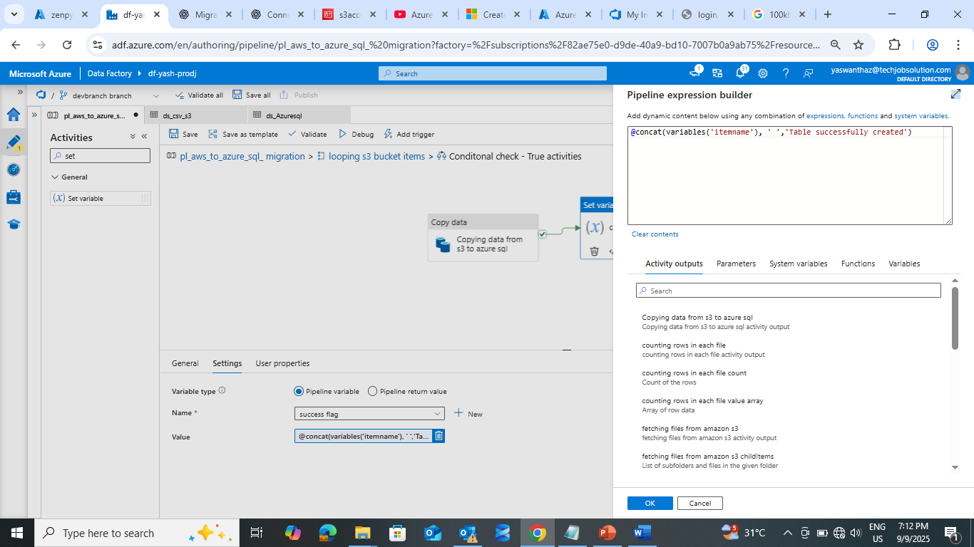

@concat(variables('itemname'), ' ','Table successfully created')

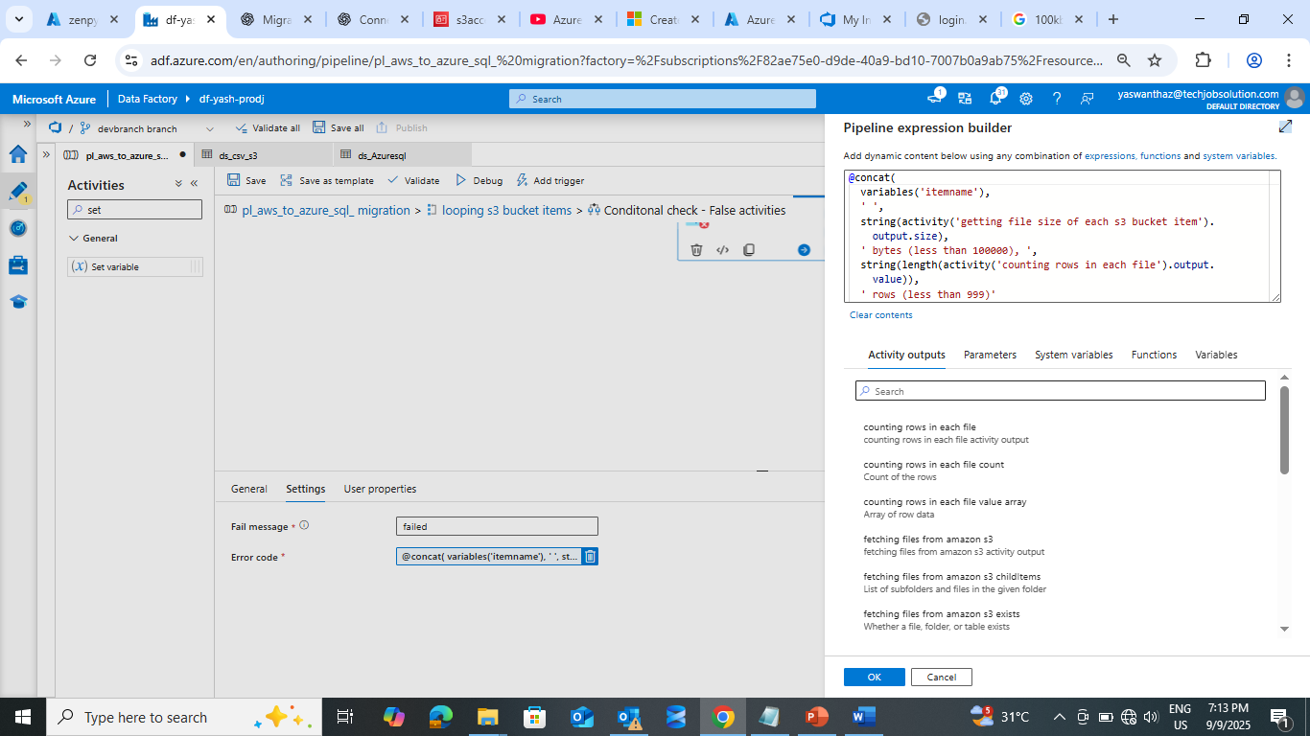

@concat(

  variables('itemname'),

  ' ',

  string(activity('getting file size of each s3 bucket item').output.size),

  ' bytes (less than 100000), ',

  string(length(activity('counting rows in each file').output.value)),

  ' rows (less than 999)'

)

Pipeline creation:

Inside Foreach

Pipeline Success:

* In execution it will check and filtered the files based on file size > 100kb and rows > 999 then it will store in to AzureSql as a table with same file name

Ex: source file name: bikesales.csv

Destination Azure Sql table name: dbo.bikesales

* In failure scenario it will store the filename and issue of failure in dbo.fileloadlog

