Game Design Document

Fill up the Following document

1. Write the title of your project.

Ninja Parkour Master

1. What is the goal of the game?

Defeat all the enemies and jump on all the platforms before time runs out

1. Write a brief story of your game.

You are a ninja who is invading an enemy ninja clan’s base. Kill all of the ninjas and do some epic parkour stunts to flex on them and make them feel sad that they aren’t as cool as you.

1. Which are the playing characters of this game?

* Playing characters are the ones which respond to the user based on the input from the user
* Cars, monkeys, dinos, wizards etc, are the playing characters in the game.

|  |  |  |
| --- | --- | --- |
| Number | Character Name | What can this character do? |
| 1 | Good ninja | This is who you play as. You will be able to shoot shurikens and jump around. |
| 2 | Bad ninjas | These are the enemies who will follow you and try to hurt you with their swords |
| 3 |  |  |
| 4 |  |  |
| 5 |  |  |
| 6 |  |  |
| 7 |  |  |
| 8 |  |  |

1. Which are the Non Playing Characters of this game?

* Non Playing characters are the ones which don't have an action or a behaviour when the user interacts with the game.
* Hurdles, stones, bananas, coins, etc are non playing characters in the game.

|  |  |  |
| --- | --- | --- |
| Number | Character Name | What can this character do? |
| 1 | Platforms | You jump on it |
| 2 |  |  |
| 3 |  |  |
| 4 |  |  |
| 5 |  |  |
| 6 |  |  |
| 7 |  |  |
| 8 |  |  |

Draw your imagination of this game. What does this game look like?

* Draw the game either on your computer or on paper,
* Add images of scenes of the game to show each of the playing and non-playing characters at least once.

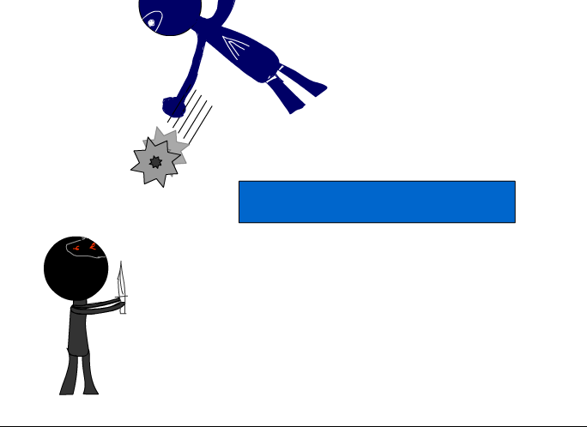

How do you plan to make your game engaging?

With epic music and a time limit, users will be forced to be fully engaged and in the zone when playing this game.