**Introduction/Summary**

**Questions & Answers**

*Structure and computational details*

1. What is a supercell?

A supercell of a unit cell can be used to describe the same crystal structure but has much larger volume. In other words, a supercell is made up of repeating unit cell of the crystal which involves some primitive cells.

1. Why do we need a supercell in our system?

Because a supercell can be used to describing a defect crystal, surface, and molecule that only small number of other atoms appear in the crystal structure that a unit cell does not contain. A supercell could make sure that there is no self-interaction of the displaced atom with itself and allow the use of periodic boundary conditions for computational models of crystal defects.

1. What periodic boundary conditions are and why do we use them?

Periodic boundary conditions are the k point in the first Brillouin zone. k is a reciprocal lattice vector that spans which comes from the Bloch theorem. We used the Bloch’s theorem to consider the number of electrons in the cell at an infinite number of k points rather than considering an infinite number of electrons. But we only consider a finite set of k points in the Brillouin zone. The error can be reduced by choosing a sufficiently dense set of k points.

We use them because the crystalline structure is periodically repeated and infinite that brings atom in and out. This means that we can simplify the calculation by applying periodic boundary conditions.

1. Why we have a vacuum region in our system?

We need a vacuum region to avoid interactions between two layers. The vacuum region is sufficient large that the potential energy will reach plateau which means that the potential energy can be calculated more precisely.

1. Can you tell:
   1. what is the basis set used?

Gaussian basis set is used.

TZVP-MOLOPT-SR-GTH basis set is used for Ag.

TZVP-MOLOPT-SR-GTH basis set is used for Au.

TZV2P-MOLOPT-SR-GTH basis set is used for Mo.

TZV-GTH-LDA-q18 basis set is used for Pt.

TZVP-GTH basis set is used for H.

* 1. what kind of calculation did you perform?

Use Density Function Theory to simplify Born Oppenheimer approximation and solve the Kohn and Sham equations to do geometry optimisation calculations.

* 1. what is the target accuracy for force calculation?

1.00e-3

* 1. what is the target accuracy for the SCF convergence?

1.00e-7

* 1. can you extract from the input the lattice parameters for your supercell?

|  |  |  |  |  |
| --- | --- | --- | --- | --- |
| Ag/Ag-H | A | 11.7687997818 | 0.0000000000 | 0.0000000000 |
| B | -5.8843998909 | 10.1920795831 | 0.0000000000 |
| C | 0.0000000000 | 0.0000000000 | 27.2068996429 |
| Au/Au-H | A | 11.8655004501 | 0.0000000000 | 0.0000000000 |
| B | 5.9327502251 | 10.2758248184 | 0.0000000000 |
| C | 0.0000000000 | 0.0000000000 | 27.2660999298 |
| Mo/Mo-H | A | 10.9724998474 | 0.0000000000 | 0.0000000000 |
| B | 3.6574960494 | 10.3449734437 | 0.0000000000 |
| C | 0.0000000000 | 0.0000000000 | 26.7192993164 |
| Pt/Pt-H | A | 11.2005996704 | 0.0000000000 | 0.0000000000 |
| B | -5.6002998352 | 9.7000038522 | 0.0000000000 |
| C | 0.0000000000 | 0.0000000000 | 26.8589000702 |
| H2 | A | 11.2005996704 | 0.0000000000 | 0.0000000000 |
| B | -5.6002998352 | 9.7000038522 | 0.0000000000 |
| C | 0.0000000000 | 0.0000000000 | 26.8589000702 |

Table 1 – Lattice parameters for different metals and metal-Hs

* 1. how many atoms do you have in your cell and describe the shape of your shell?

There are 65 atoms in my Metal-H cell that consist of 64 metal atoms and 1 hydrogen atom. There are 64 atoms in my Metal cell.

Lattice point A is parallel to the x-axis, lattice point B is in the xy-plane and lattice point C is parallel to the z-axis. In addition to that |a| = |b| ≠ |c|. Hence, the shape of the cell is not orthorhombic, it is hexagonal.

* 1. what is the hydrogen coverage in your system?

There is one hydrogen atom on each of the metal surface of the Ag, Au, Mo and Pt.

1. analysing the output files for your calculations, can you tell
   1. How many self-consistent cycles takes to converge for every geometry optimization steps on average?

|  |  |  |  |
| --- | --- | --- | --- |
| Metal/  Metal-H | Starting opt SCF | Opt step 1 SCF | Evaluate Min E SCF |
| Ag | 24 | 18 | 9 |
| Ag-H | 37 | 16 | 9 |
| Mo | 61 | 17 | 16 |
| Mo-H | 75 | 22 | 18 |
| Pt | 105 | 50 | 32 |
| Pt-H | 166 | 49 | 41 |

Table 2 – Self-consistent cycles for different metal and metal-H

The starting geometry optimisation of H2 molecule takes 23 SCF steps to converge and it has 5 optimisation steps with SCF 22, 22, 19, 14, and 11 steps respectively. The minimum energy occurs when the SCF run converged in 8 steps.

* 1. what is the number of electrons and the number of occupied orbitals in your system?

|  |  |  |
| --- | --- | --- |
| Metal/Metal-H | Number of electrons | Number of occupied orbitals |
| Ag | 704 | 367 |
| Ag-H | 705 | 366 |
| Mo | 896 | 474 |
| Mo-H | 897 | 468 |
| Pt | 1152 | 599 |
| Pt-H | 1153 | 599 |
| H2 | 2 | 1 |

Table 3 – Number of electrons and occupied orbitals for different metal and metal-H

* 1. did your calculation converge?

Yes, my calculation converged when the SCF reached its target accuracy.

1. Why do we need to optimise the geometric structure of our system?

Because an optimised geometry structure allows us to find the minimum potential (ground state) energy which associate to the equilibrium position of the atoms in the structure.

1. Describe the optimisation process in general and what you observed in the output of your calculations.

The geometry optimisation starts with an initial configuration, then we use the density field theory (DFT) to evaluate the ground state electron density. This step involves guessing an electron density which could be a random number, then use the guessed electron density to solve the Kohn and Sham equations and calculate a new electron density. If the difference between the new electron density and the initial guessed electron density is not smaller than the target accuracy of the SCF convergency, then set a new guess electron density to the previous calculated electron density and iterate the calculation again until the difference is smaller than the target accuracy of the SCF convergency.

Once the ground state electron density is calculated, we need to calculate the force by differentiating the potential energy surface equation, then update the atomic positions. If the force is smaller than the target accuracy, then the geometry optimisation is done. Otherwise, return to the step that solving the DFT problem until the force is smaller than the target accuracy.

For clean metal surface, the change in potential energy does not become apparent until the fifth decimal place for each optimisation steps and the sixth decimal place for metal surface with a H atom absorbed on it. This confirms that the target accuracy for the SCF convergence is 1.00e-7. At minimum potential energy, there are more occupied orbitals than at the start of the geometric optimisation. This means that electrons have been localised to more orbitals to minimise the repulsion between electrons and get the minimum potential energy at equilibrium bond length.

1. Compare the geometry of the initial and final structures of your Pt system (trajectory provided). Please include a picture which depicts the cell.

Pt-H system has 1 optimisation step. The starting optimisation step shows that the bond length of Pt-H is 1.56 Å, Pt-Pt (neighbouring) is 2.80 Å and Pt-Pt (layer) is 2.87 Å. The optimisation 1 shows the same bond length. Hence, we cannot distinguish them by looking the bond length. The Trajectories along the y-axis are shown in Figure 1.

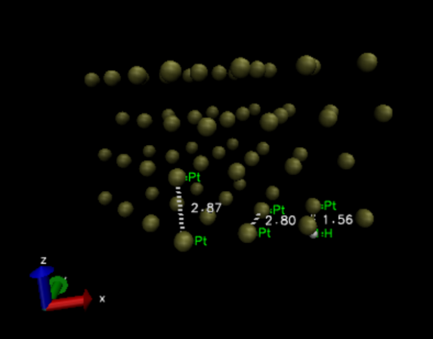 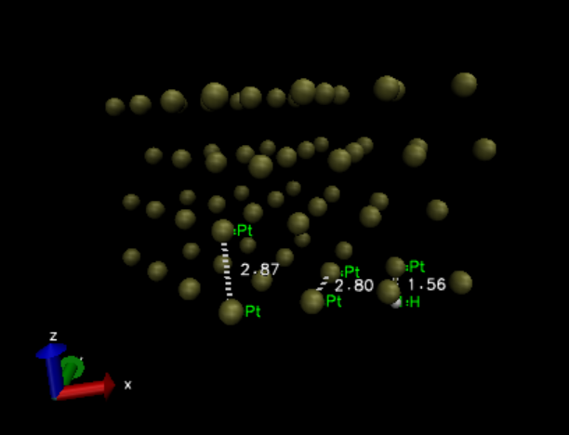

Figure 1 – Starting optimisation (LHS) and optimisation step 1 (RHS)

However, we could still see that the geometry has been optimised due to the change in potential energy. The potential energy of starting optimisation geometry is -7687.7458932803 Hartree and the optimisation step 1 is -7687.7458931062 Hartree. The difference appears at the seventh decimal place.

Pt-H relaxation system has 30 optimisation steps. The first optimisation step shows that the bond length between Pt atom and H atom is 1.55 Å. The final optimisation step shows the bond length of H-Pt is 1.56 Å which is longer than the first step. The first optimisation step shows that the bond length of Pt-Pt (layer) is 2.80 Å, whereas the final step shows that the Pt-Pt (layer) is 2.80 Å which is shorter than the initial step. The first optimisation step shows that the bond length of Pt-Pt (neighbouring) is 2.82 Å, whereas the final step shows that the Pt-Pt (neighbouring) is 2.79 Å which is shorter than the initial step. The Trajectories along the y-axis are shown in Figure 2.

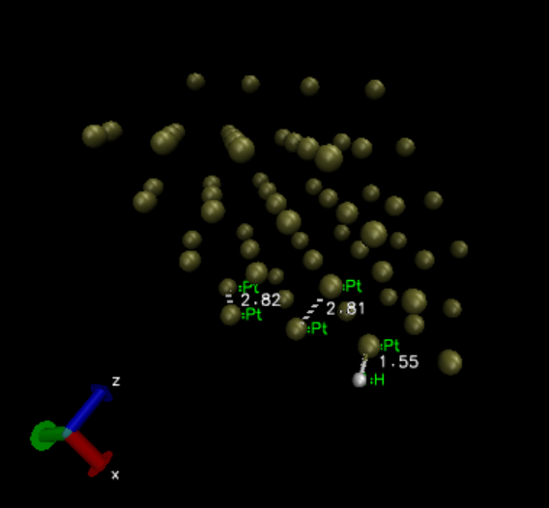

Figure 2 – First optimisation step (LHS) and final optimisation step (RHS)

1. Do you think you would obtain the same energy if you started from another initial guess?

No, I don’t think I would obtain the same energy if I started from another initial guess. If the initial guess is very close to the minimum potential energy and within the target accuracy for the SCF convergence, then the optimisation step would stop.

1. Find the value for the equilibrium lattice parameter and bulk modulus for all the simulated metals. How these values compare with experiments?

By comparing the experimental equilibrium lattice vector with the equilibrium lattice vector, we found that these two values are very close to each other as shown in Table 4. The trajectory of Murnagghan curve for experimental calculation as shown in Figure 3.

|  |  |  |  |  |
| --- | --- | --- | --- | --- |
| Metal | Equilibrium  Lattice Vector/Å | Experimental Equilibrium  Lattice Vector/Å | Total  Energy/Ry | Bulk Modulus/  Mbar |
| Ag | 4.1623 | 4.15 | -296.24 | 0.8685 |
| Au | 4.2023 | 4.20 | -266.03 | 1.3005 |
| Mo | 3.1677 | 3.15 | -272.95 | 2.4472 |
| Pt | 3.9657 | 3.95 | -960.98 | 2.5117 |

Table 4 – The equilibrium lattice parameter, minimum total energy and bulk modulus for Ag, Au, Mo and Pt

折线图

中度可信度描述已自动生成 折线图

Figure 3(a) – Ag Murnagghan curve Figure 3(b) – Au Murnagghan curve

Figure 3(c) – Mo Murnagghan curve Figure 3(d) – Pt Murnagghan curve

*Error estimation and selection of simulation parameters*

1. Can you qualitatively describe what k points are and why we need to use them?

k points are electron momentum values that are reciprocal lattice vectors in the Brillouin zone. k points are from the Bloch theorem states that wavefunctions have periodic magnitude in a periodic potential.

We use them because it is in the wavefunction that is the solution to the Kohn and Sham equations that is used to calculate the ground state electron density.

1. Can you qualitatively describe what a basis set is and why we need to use it?

A basis set is a set of functions that are from linear combination of atomic orbitals.

We use it because it is a set of known functions that is used to represent the Kohn and Sham wavefunction. In additional to that, it can turn the partial differential equations into algebraic equations which is suitable for computational calculation.

1. How does the total energy of a Pt surface change as a function of kpoints? (trajectory provided).

The total energy of a Pt surface decreases as k points increase and this would reach a minimum at approx. -480.43 Hartree (a.u.). Hence, the zero of the energy scale in this figure is at approx. -480.43 Hartree (a.u.). This means that the denser the k points are, the more accurate calculation it would be. The trajectory as shown in Figure 4.

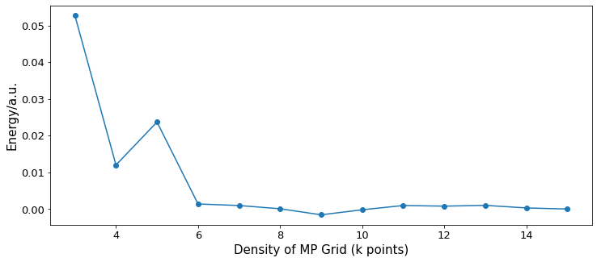

Figure 4 – Total energy of Pt surface changes as a function of k points

1. How do the errors in the evaluation of hydrogen chemisorption energy vary versus the size of the kpoint grid and with the size of the basis sets used? (data provided for a 3 layer thick Pt metal slab)? Show this for both systems with 1ML and ¼ ML H coverage

In general, the errors in the evaluation of hydrogen chemisorption energy get smaller as the size of k point grid increases as shown in Figure 5. This means that the H chemisorption energy has converged as k points increases.

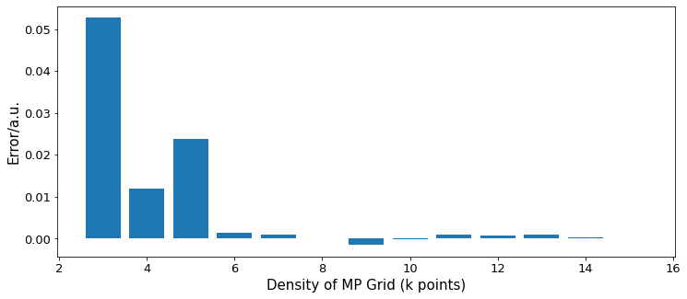

Figure 5 – Errors on energy of Pt surface vary with k points

For monolayer, the errors in the evaluation of hydrogen chemisorption energy decreases as the size of k point grid increases. However, we could still get very accurate energy by using 441 for ¼ monolayer. The error bar graph as shown in Figure 6.

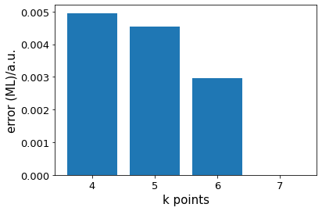

Figure 6 – Error on H chemisorption energy vs the size of the k points for monolayer (LHS) and ¼ monolayer (RHS)

The errors on hydrogen chemisorption energy vary with basis set in negative value. As more basis sets have been used, the smaller the error for both 1ML and ¼ ML as shown in Figure 7.

图标

Figure 7 – Error on H chemisorption energy vs different basis sets for monolayer (LHS) and ¼ monolayer (RHS)

1. How the error in the evaluation Hydrogen chemisorption energy versus k points and basis sets compares with the error in the evaluation of the total energy?

The error in the evaluation of the total energy is the same as the error in the evaluation hydrogen chemisorption energy. Hence, the smaller the error, the more accurate the total energy.

1. Assuming that the observation done in question above is general, which K points grid size and basis set is appropriate for calculations of chemisorption energy accurate to $≈0.03 eV/cell$?

0.03 eV ≈ 0.0011 Hartree. Hence, 441 k points grid for ¼ monolayer and TZV ¼ monolayer basis set is appropriate for calculations of chemisorption energy.

1. How large should be a supercell to reproduce the chemisorption energy with the same accuracy in at G?

A supercell should be scaled reciprocally to reproduce the chemisorption energy with the same accuracy in at G because k is a reciprocal lattice vector.

1. Do you expect in principle any effect in H chemisorption energy if H chemisorbed on a different metal facet or a different H coverage?

The metal facet that contains more metal atoms or more exposes might have lower H chemisorption energy because more available metal atoms that can adsorb H atoms which increase its probability. The H chemisorption energy might decease as the H coverage increases because: $$∆E_{ads}= \frac{1}{n} \left(E_{surf+nH}- E_{surf}- \frac{n}{2} E_{H_{2}}\right)$$

*The Hydrogen evolution reaction and electrocatalysis*

1. What is the computational hydrogen electrode?

Computational hydrogen electrode is a model that use atoms in gas phase as reference state. The hydrogen electrode provides a direct link between the free energies in gas-phase adsorption and those relevant in electrochemistry.

1. Can you describe the Hydrogen evolution reaction at metal electrodes and its energetics?

The hydrogen evolution reaction is production of hydrogen gas over the process of water electrolysis. There are two types of hydrogen evolution reactions. One is Volmer Tafler reaction which is chemical desorption and the other is Volmer Heyrovsky reaction which is electrochemical desorption. Volmer Tafler reaction is a proton and an electron to produce a proton that can donate on the metal surface. The hydrogen gas can be produced when two equivalent donated protons adsorb on the metal surface that can interact with each other. The Volmer Heyrovsky reaction is the additional proton to bring the donated proton away.

1. Illustrate qualitatively the Sabatier principle and how it is at the foundation of the observation of a volcano plot.

The Sabatier principle1 sates the interaction between catalysts and substrates should be neither too strong nor too weak to obtain the optimal catalyst. If the interaction is too strong, the product is hard to dissociate. If the interaction is too weak, the catalyst fails to bind with reactant.

On the left-hand side of the volcano plot, the H chemisorption energy is low this means that the binding energy of atomic hydrogen on Mo slab is low, but Mo-H has strong bond strength. On the right-hand side of the volcano plot, Ag and Au have stronger binding energy with atomic hydrogen, but weaker M-H bond strength. The calculated Hydrogen chemisorption energy for Ag, Au, Mo, and Pt as shown in Table 5 and the volcano plot as shown in Figure 8.

|  |  |  |
| --- | --- | --- |
|  | Chemisorption Energy/Hartree | log(i0/A cm-2) |
| Ag | 0.003 | -5.00 |
| Au | 0.011 | -6.60 |
| Mo | -0.031 | -7.07 |
| Pt | -0.020 | -3.34 |

Table 5 – Calculated H chemisorption energy for different metals

Figure 8 – Volcano plot of exchange current versus energy for hydrogen adsorption

1. How do we evaluate the H adsorption energy and the free energy of the adsorbed state?

$$∆E_{ads}= \frac{1}{n} \left(E_{surf+nH}- E_{surf}- \frac{n}{2} E_{H_{2}}\right)$$

Where $E_{surf+nH}$ is the energy of the system that hydrogen atom is adsorbed on the metal slab. $E_{surf}$ is the energy of the clean metal slab. $\frac{n}{2} E_{H_{2}}$ is the chemical potential to bring hydrogen in gas phase to the surface.

$$∆G= ∆E_{ads}+ ∆E_{ZPE}-T∆S_{ads}$$

Where $∆E_{ads}$ is the hydrogen chemisorption energy. $∆E_{ZPE}$ is the difference in zero-point energy between adsorbed and gas phase. $T$ is the temperature. $∆S_{ads}$ is the change in entropy.

A simplified equation with correction is that:

$$∆G= ∆E_{ads}+0.24 (eV)$$

Where $0.24 eV≈ 0.0088 Hartree$

1. Based on your volcano plot can you tell which metal is the best catalyst for Hydrogen evolution? Can you explain why?

Pt is the best catalyst for Hydrogen evolution because it has optimum binding energy with H atom and only requires very small overpotentials.

1. Is there any complicating issue which might make your prediction less reliable?

In this calculation, we have not considered the coverage effect, oxidation layer in negative branch, different crystal planes (facet), possible adsorption states for H atom can compete and complexity of interactions at interfaces. This could make our prediction less reliable.

1. Free energy diagram for hydrogen evolution at equilibrium (U = 0). for ‘‘standard’’ conditions corresponding to 1 bar of H2 and pH = 0 at 300 K?

Figure 9 – Free energy diagram for hydrogen evolution at equilibrium

**Conclusions**

**Reference**

1. J. Kari, J. P. Olsen, K. Jensen, S. F. Badino, K. B. R. M. Krogh, K. Borch and P. Westh, ACS Catal., 2018, 8, 11966–11972.

****************************************

*Tips to write a report:*

*The golden rule: Aim for clarity*

* *Structured statements that flow in a logical manner.*
* *Good use of diagrams and appropriate level of theory.*
* *Careful choice of content.*
* *Keep your language clear and simple.*
* *Label all tables and figures. Labels should be self-contained, which means that tables and figures should be interpretable by themself.*
* *Appropriate referencing of figures and tables.*
* *Cite previous works (with an accepted citation style) whenever is appropriate.*

*Introduction/Summary:*

*The purpose of the Introduction/Summary is to put the reader in the context of the experiment and to explain how the experiment was carried in the lab. It may contain a brief review of previous research, why the research was undertaken, an explanation of the techniques and why they are used and why it is important in a broader context.*

*Questions & Answers:*

* *There are a number of questions in the lab script that need to be answered in this section of the report.*
* *Depending on the nature of the question, it might be appropriate to use figures or tables to give a proper answer.*
* *It is highly encouraged to rationalise the answers.*

*Conclusions:*

*\*The Conclusions gives a general description of the results and findings and it should be related back to the Introduction. If appropriate, suggest improvements or additional experiment*