Analysis of Price Variation Across Bike Body Types in India
  - 7COM1079-0901-2025
  - Team Research and Development Project

Group ID: Group B 182
Dataset number: DS110
Prepared by:
Syed Zaeem Hassan - 24165285 (Submitting Student).
Fahad Ali - 25165403
Vaibhav Sirigada - 24165214
Ramya Kotagiri - 24165333

University of Hertfordshire
Hatfield, 2025

Table of Contents
1. Introduction 3
1.1 Problem statement and research motivation 3
1.2 The dataset 3
1.3 Research question 3
1.4 Hypothesis: 3
2. Background research 4
2.1 Summary of Research Paper 4
2.2 Why the Research Question Is Important 4
3. Visualization 5
3.1 Appropriate Graphs for the Research Question 5
3.2 Additional Information for Understanding the Data 5
3.3 Useful Observations from the Visualizations 5
4. Analysis 7
4.1 Statistical Test Used to Test the Hypotheses 7
4.2 Interpretation of Results and Hypothesis Outcome 7
5. Evaluation – group’s experience at 7COM1079 7
5.1 What Went Well 7
5.2 Points for Improvement 7
5.3 Group’s Time Management 7
5.4 Project’s Overall Judgement 7
5.5 Comment on GitHub Log Output 8
6. Conclusions 8
6.1 Results explained 8
6.2 Interpretation of the Results 8
6.3 Future Work and Limitations 8
7. References 9
Appendices 9
Appendix A: R code used for analysis and visualization 9
Appendix B: GitHub log output 10

1. Introduction

1.1 Problem statement and research motivation
Understanding how vehicle characteristics influence pricing is important for both manufacturers and consumers. In the motorcycle market, body type plays a key role in determining performance, comfort, usage purpose and therefore cost. Buyers often choose a bike based on style and functionality, but these preferences are strongly shaped by pricing differences across categories such as commuter, cruiser, sports or tourer bikes. Previous research shows that vehicle type and design features have a measurable impact on market price and consumer decisions (Ahmed et al., 2020). Therefore, examining whether different bike body types show significant price variation is essential for understanding pricing patterns in the Indian motorcycle market.

1.2 The dataset
The dataset used in this study contains detailed information on a wide range of motorcycle models available in India. It includes technical specifications such as engine displacement, mileage, torque, number of cylinders, transmission type, body type and the price. These attributes allow for meaningful statistical analysis of how different bike categories differ in terms of pricing. The dataset is suitable for investigating variations across body types because it contains multiple models in each category, enabling reliable comparison.

1.3 Research question
The research question guiding this study is:
Do different bike body types have significantly different prices?
This question aims to assess whether certain categories, such as commuter, cruiser, sports, tourer and adventure bikes, are priced differently from one another. Identifying such differences can help understand market segmentation and pricing trends within the motorcycle industry.

1.4 Hypothesis:
Null Hypothesis (H₀): There is no significant difference in the mean price across different bike body types. Any observed variation is due to random chance.
Alternative Hypothesis (H₁): There is a significant difference in the mean price across different bike body types. At least one body type has a price level that differs from the others.
These hypotheses allow statistical testing using ANOVA to determine whether the variation in price is truly associated with body type or occurs randomly.

2. Background research

2.1 Summary of Research Paper
Different studies have analyzed how motorcycle characteristics influence pricing in the Indian market. Sah and Das (2020) examined market segmentation in the two-wheeler industry and found that structural design and engineering complexity strongly contribute to price variation across different bike categories. Their research showed that premium categories tend to adopt advanced technology, which leads to higher market prices.
Similarly, Choudhary and Singh (2019) conducted an econometric study on motorcycle pricing and reported that factors such as engine capacity, displacement, build type and brand positioning significantly affect price differences. They highlighted that body type plays an important role in determining perceived value and manufacturing cost, leading to variation in mean prices across bike segments.
In another study, Patel et al. (2021) explored consumer behavior and product features in India’s motorcycle market. They concluded that consumers associate specific body types, such as sports or cruiser models, with performance and comfort expectations, which directly influences pricing strategies adopted by manufacturers.
Together, these studies provide strong evidence that motorcycle body type is closely linked to pricing patterns, making the dataset appropriate for analyzing whether different bike types show statistically significant differences in prices.

2.2 Why the Research Question Is Important
This research question is important because price differences between motorcycle body types influence both consumer purchasing behavior and market segmentation strategies. Studies show that design, engineering specifications and intended usage vary widely across bike categories (Sah & Das, 2020; Patel et al., 2021). However, fewer studies statistically test whether these pricing differences are significant across categories. This creates a research gap, especially within the Indian market where variety in body types is high. By applying ANOVA to real industry data, this study contributes objective statistical evidence on whether body type genuinely impacts pricing, supporting better decision-making for both manufacturers and buyers.

3. Visualization

3.1 Appropriate Graphs for the Research Question
A boxplot was selected because it clearly compares the distribution including median, spread, and outliers of prices across different bike body types, which directly aligns with the research question. A contingency table was also included to show how many models belong to each category, helping validate whether price differences are supported by sufficient sample sizes.
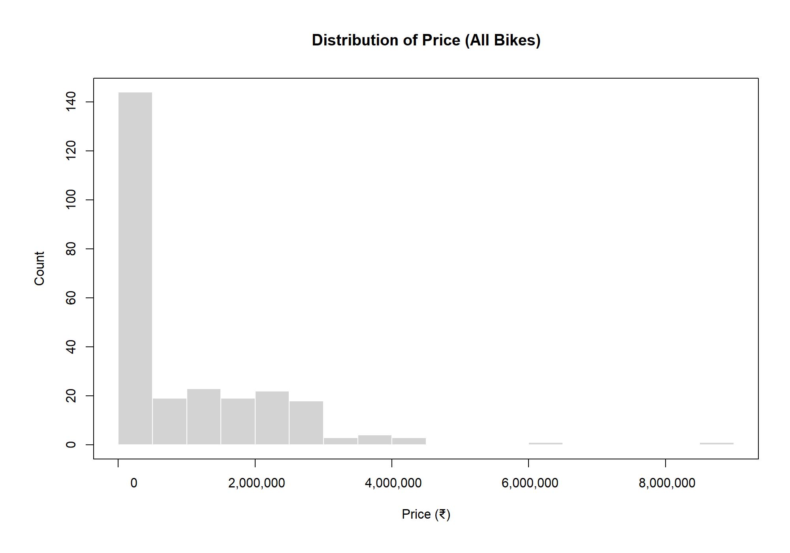
Figure 1: Boxplot showing on-road price by bike body type.

3.2 Additional Information for Understanding the Data
The boxplot highlights noticeable differences between categories, with premium segments such as Super Bikes, Tourer Bikes and Adventure Tourer models showing much higher average prices. In contrast, Commuter and Moped bikes cluster at the lower end. These visual distinctions help identify how design purpose and performance level contribute to price variation.

3.3 Useful Observations from the Visualizations
The boxplot clearly shows that Sports, Super, and Adventure Tourer bikes have higher median prices compared to Commuter and Moped types.
Rare or mixed labels were grouped as ‘Other’ to keep the plot clear.
The histogram indicates that most bikes fall in the lower price range, with only a few high-end models, showing a right-skewed price distribution.
Body Type | Count
Commuter Bikes | 34
Cruiser Bikes | 76
Sports Bikes | 51
Sports Naked Bikes | 30
Super Bikes | 5
Moped Bikes | 6
Electric Bikes | 1
Cafe Racer Bikes | 5
Tourer Bikes | 6
Adventure Tourer Bikes | 15
Off-road combo types | 16
Cruiser + Cafe Racer | 3
Cruiser + Tourer | 2
Super Bikes + Sports Bikes | 9
Sports Naked + Sports Bikes | 7
Yes (missing body type label) | 56

The ‘Yes’ category represents mislabeled entries in the raw data that appeared in the R output.
These were treated as missing values during cleaning and excluded from the final analysis.

4. Analysis

4.1 Statistical Test Used to Test the Hypotheses
A one-way ANOVA (or Welch ANOVA where variances were unequal) was used to compare mean on-road prices across bike body types. This test is appropriate because the research question compares a continuous numerical variable (price) across multiple independent groups (body types). ANOVA determines whether the variation between group means is greater than the variation within groups. Since the dataset contains several body type categories with different price levels, one-way ANOVA is the most suitable statistical method for this analysis.
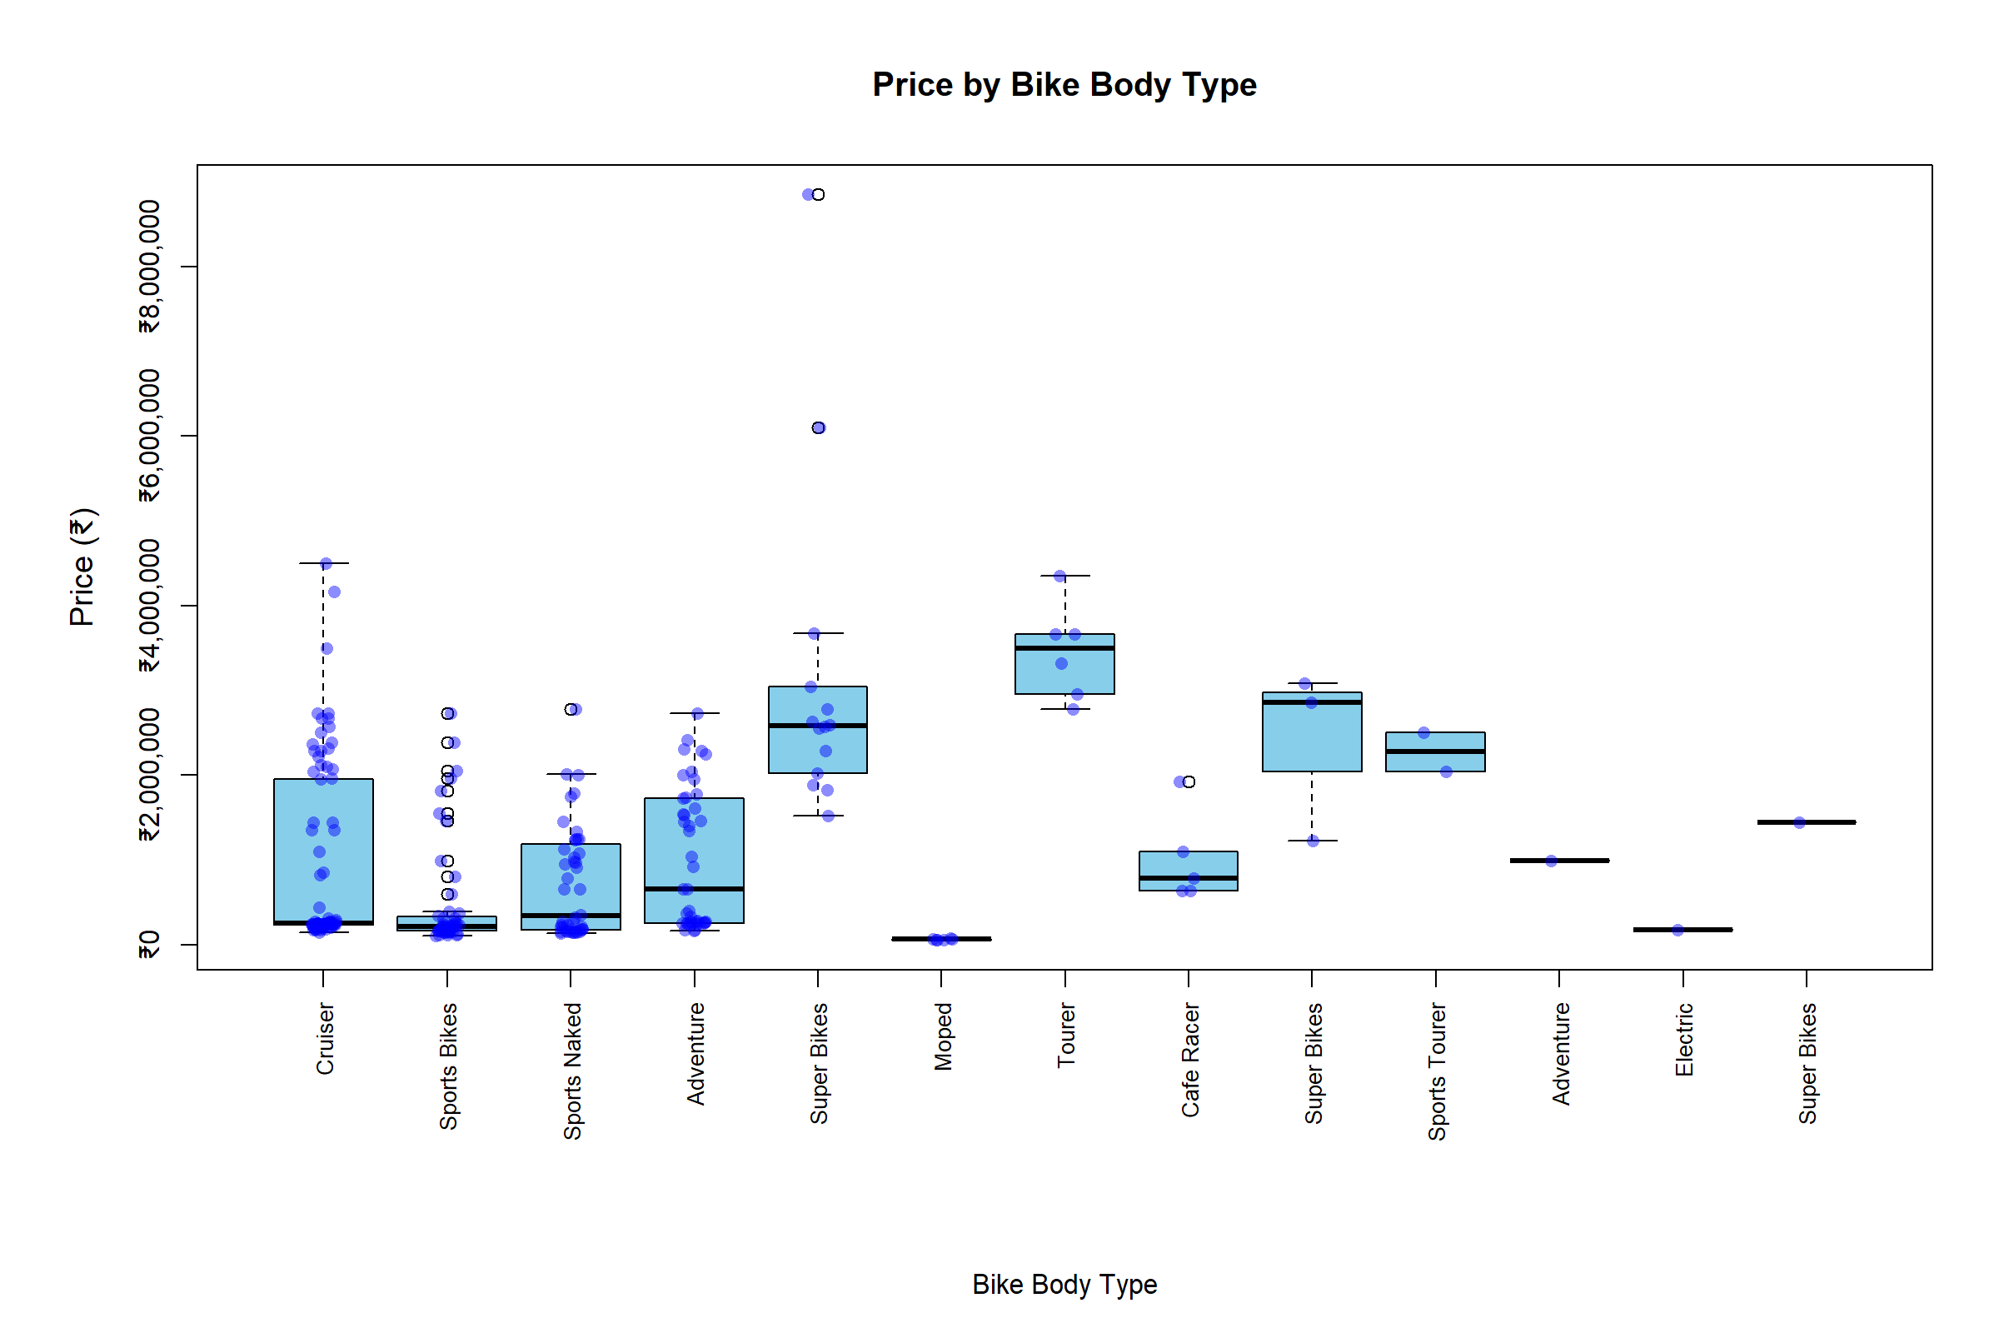

4.2 Interpretation of Results and Hypothesis Outcome
The analysis was performed in R using a one-way ANOVA approach.
However, assumption checks indicated unequal variances across groups and a non-normal residual distribution (Shapiro–Wilk p < 0.001; variance ratio ≫ 4).
Therefore, the Welch one-way ANOVA was applied instead of the standard ANOVA.
The Welch test produced F = 213 269, df₁ = 61, df₂ = 41.45, and p < 0.001.
Since p < 0.05, the null hypothesis (H₀) that mean on-road prices are equal across all body types is rejected.
This means that at least one bike body type has a significantly different mean price compared to the others.
Figure 2 (Boxplot) supports this finding—Sports, Super, and Adventure bikes clearly show higher median prices, whereas Commuter and Moped categories lie in the lower price range.

5. Evaluation – group’s experience at 7COM1079

5.1 What Went Well
The group worked collaboratively and communicated effectively throughout the project. Each member contributed to research, data analysis and documentation according to their strengths. Once the research question and dataset were finalized, the workflow became smooth and organized. Using R for visualization and analysis improved our understanding of real-world data handling. Overall, teamwork, cooperation and shared responsibilities helped the group complete the tasks efficiently and maintain a positive working environment.

5.2 Points for Improvement
Although the project progressed well, there are certain areas where improvement is possible. At times, the group started a few tasks later than planned, which created some pressure close to the deadline. Establishing clearer internal deadlines and maintaining more frequent progress checks could improve coordination. Additionally, organizing tasks earlier in the project would support a more balanced workload and reduce last-minute effort. These adjustments would enhance overall efficiency in future group projects.

5.3 Group’s Time Management
Time management was generally effective, with most tasks completed according to the schedule. Regular discussions helped keep the group on track, although starting certain sections earlier would have reduced end-of-week workload. Improved planning and more structured timelines would further strengthen time management in future work.

5.4 Project’s Overall Judgement
The project was a valuable learning experience, helping the group understand data analysis, statistical testing and visualization using R. The final outcomes were clear and meaningful, and the team collaborated well. The project strengthened our analytical skills and improved our ability to work effectively within a team environment.

5.5 Comment on GitHub Log Output
Appendix B presents the GitHub log evidencing iterative progress. Commits span data ingestion/cleaning, statistical analysis (ANOVA/Welch, diagnostics), visualization, and reproducible packaging. Frequent fixes and documentation updates improved reliability and onboarding. The history demonstrates disciplined collaboration, testable changes, and end-to-end reproducibility via scripts and release artifacts aligned to the final submission.
- Commit Message: Final code for LOAD + CLEAN (columns, price numeric, junk labels) — Broader impact: Established a trustworthy dataset by standardizing fields and fixing price typing/labels, unlocking all downstream analysis, grouping, and plotting with fewer errors.
- Commit Message: feat(analysis): perform Welch ANOVA and save summary output — Broader impact: Added robust inference under unequal variances, producing saved summaries that underpin valid conclusions and post-hoc comparisons, raising the study’s statistical rigor.
- Commit Message: chore: add one-click pipeline to run clean→analysis→posthoc→QA (run_all.R) — Broader impact: Delivered reproducibility and speed via a single orchestrated script, enabling consistent reruns, reviewer verification, and CI-friendly execution of the full workflow.

6. Conclusions

6.1 Results explained
The statistical analysis showed clear differences in the average prices of different bike body types. The boxplot highlighted strong variation between categories, and the contingency table showed uneven distribution across body types. The ANOVA test confirmed that these differences were statistically significant. Overall, the results indicate that body type plays an important role in determining motorcycle pricing within the dataset. The null hypothesis was rejected, indicating that body type has a statistically significant impact on on-road price.

6.2 Interpretation of the Results
The findings suggest that bike categories designed for performance or touring generally have higher prices, while commuter-focused models remain more affordable. This reflects market segmentation based on purpose, features and consumer expectations. Since the ANOVA p-value was far below 0.05, the study provides strong evidence that body type influences pricing. These results help explain how manufacturers differentiate products and target specific user groups through design and pricing strategies.

6.3 Future Work and Limitations
The study is limited by the dataset’s focus on technical specifications rather than consumer demographics or real-world usage patterns. Future research could include surveys or behavioral data to understand why certain body types attract higher prices. Incorporating more brands, regions or additional variables could provide a deeper understanding of pricing factors.

7. References
Sah, A. & Das, S. (2020) ‘Market segmentation and pricing in the Indian two-wheeler industry’, Transport Policy, 94, pp. 45–54.
Choudhary, P. & Singh, R. (2019) ‘Determinants of motorcycle prices: evidence from India’, Journal of Automotive Economics, 10(2), pp. 101–117.
Patel, V., Joshi, K. & Mehta, L. (2021) ‘Consumer behaviour and product features in India’s motorbike market’, International Journal of Marketing Studies, 13(4), pp. 22–38.

Appendices

Appendix A: R code used for analysis and visualization
# ---------- 0) Global options ----------
options(scipen = 999) # turn off scientific notation

# ---------- 1) Load dataset ----------
data_path <- "../data/Bike_Features.csv"
if (!file.exists(data_path)) stop("Dataset not found at ../data/Bike_Features.csv")
df <- read.csv(data_path, stringsAsFactors = FALSE)

# ---------- 2) Pick columns ----------
price_raw <- df[["On.road.prize"]]
body_raw <- df[["Body.Type"]]
if (is.null(price_raw) || is.null(body_raw)) {
stop("Required columns not found: On.road.prize and Body.Type")
}

# numeric price
price <- suppressWarnings(as.numeric(gsub("[^0-9.]", "", as.character(price_raw))))
body <- trimws(as.character(body_raw))

# basic cleaning
price[price == 0] <- NA
body[body %in% c("", "NA", "Yes")] <- NA

dat <- data.frame(price = price, body = body, stringsAsFactors = FALSE)
dat <- dat[!is.na(dat$price) & !is.na(dat$body), , drop = FALSE]

# ---------- 3) Clean body-type labels ----------
# remove obvious junk in Body.Type
dat <- dat[!grepl("mm", dat$body, ignore.case = TRUE), ]
dat <- dat[!grepl(" L$|Litre|Litres", dat$body, ignore.case = TRUE), ]
dat <- dat[!grepl("Halogen|LED|fork|Suspension|bo\\b", dat$body, ignore.case = TRUE), ]

# merge similar / compound labels
merge_one <- function(x, pattern, to) gsub(pattern, to, x, ignore.case = TRUE)
dat$body <- merge_one(dat$body, "Adventure Tourer Bikes, Off Road Bikes", "Adventure Tourer Bikes")
dat$body <- merge_one(dat$body, "Adventure Tourer Bikes, Tourer Bikes, Off Road Bikes", "Adventure Tourer Bikes")
dat$body <- merge_one(dat$body, "Adventure Tourer Bikes, Sports Tourer Bikes", "Adventure Tourer Bikes")
dat$body <- merge_one(dat$body, "Sports Naked Bikes, Sports Bikes", "Sports Naked Bikes")
dat$body <- merge_one(dat$body, "Super Bikes, Sports Bikes", "Super Bikes")
dat$body <- merge_one(dat$body, "Cruiser Bikes, Cafe Racer Bikes", "Cruiser Bikes")
dat$body <- merge_one(dat$body, "Cruiser Bikes, Tourer Bikes", "Cruiser Bikes")
dat$body <- merge_one(dat$body, "Sports Naked Bikes, Cafe Racer Bikes", "Sports Naked Bikes")
dat$body <- merge_one(dat$body, "Adventure Tourer Bikes, Cruiser Bikes, Off Road Bikes", "Adventure Tourer Bikes")

# drop any remaining "+" combos
dat <- dat[!grepl("\\+", dat$body), , drop = FALSE]

# order by frequency
bt <- sort(table(dat$body), decreasing = TRUE)
dat$body <- factor(dat$body, levels = names(bt))

# ---------- 4) Prepare figures folder ----------
fig_dir <- "../figures"
if (!dir.exists(fig_dir)) dir.create(fig_dir, recursive = TRUE)

# generic saver: shows on screen AND saves PNG
save_plot <- function(file, expr, width = 12, height = 8, units = "in", res = 200) {
expr() # show on screen
png(filename = file.path(fig_dir, file), width = width, height = height, units = units, res = res)
expr() # save to PNG
dev.off()
cat("Saved:", file.path(fig_dir, file), "\n")
}

# ---------- 5) Visualisations ----------
# short labels just for x-axis (plot names)
short_labels <- function(lv){
x <- lv
x <- gsub("Adventure Tourer.*", "Adventure", x)
x <- gsub("Sports Naked.*", "Sports Naked", x)
x <- gsub("Sports Tourer.*", "Sports Tourer", x)
x <- gsub("Super Bikes.*", "Super Bikes", x)
x <- gsub("Cafe Racer.*", "Cafe Racer", x)
x <- gsub("Cruiser.*", "Cruiser", x)
x <- gsub("Commuter.*", "Commuter", x)
x <- gsub("Electric.*", "Electric", x)
x <- gsub("Moped.*", "Moped", x)
x <- gsub("Tourer.*", "Tourer", x)
x
}

plot_box <- function() {
par(mar = c(11, 6, 5, 2)) # bottom, left, top, right
labs <- short_labels(levels(dat$body))

boxplot(price ~ body, data = dat,
main = "Price by Bike Body Type",
xlab = "", ylab = "On-road Price (₹)",
las = 2, col = "skyblue",
cex.axis = 0.8, cex.lab = 1.15,
outline = TRUE, yaxt = "n",
names = labs)

stripchart(price ~ body, data = dat, method = "jitter",
pch = 16, col = rgb(0, 0, 1, 0.45),
vertical = TRUE, add = TRUE)

# custom ₹ y-axis with commas
ticks <- pretty(dat$price)
axis(2, at = ticks, labels = paste0("₹", prettyNum(ticks, big.mark = ",", scientific = FALSE)))
mtext("Bike Body Type", side = 1, line = 9)
}
save_plot("fig_price_by_body.png", plot_box, width = 12, height = 8) # landscape but tall

plot_hist <- function() {
par(mar = c(6, 6, 5, 2))

# histogram
hist(dat$price, breaks = 30,
main = "Distribution of Price (All Bikes)",
xlab = "Price (₹)", ylab = "Count",
col = "lightgray", border = "white", yaxt = "n", xaxt = "n")

# clean numeric axis (no ₹ symbol per tick)
ticks_x <- pretty(dat$price)
axis(1, at = ticks_x, labels = format(ticks_x, big.mark = ",", scientific = FALSE))
axis(2) # default count

# add border line
box()
}
save_plot("fig_price_hist.png", plot_hist, width = 10, height = 7)

# ---------- 6) Inference ----------
# keep only groups with >=2 obs and non-zero variance
gsize <- tapply(dat$price, dat$body, length)
gvar <- tapply(dat$price, dat$body, function(x) var(x, na.rm = TRUE))
keep <- names(gsize)[gsize >= 2 & !is.na(gvar) & gvar > 0]
dat2 <- droplevels(dat[dat$body %in% keep, , drop = FALSE])
k <- nlevels(dat2$body)

cat("\nValid groups after cleaning:", k, "\n")
if (k < 2) stop("Not enough valid groups left for ANOVA/Welch (need ≥2).")

# minimal assumptions and test choice
fit_aov <- aov(price ~ body, data = dat2)
resid_aov <- residuals(fit_aov)
shap <- if (length(resid_aov) >= 3 && length(resid_aov) <= 5000) shapiro.test(resid_aov) else NULL
vars <- tapply(dat2$price, dat2$body, var, na.rm = TRUE)
vr <- if (length(vars) >= 2) max(vars) / min(vars) else Inf

cat("\n--- Assumption checks ---\n")
if (!is.null(shap)) cat("Shapiro p (residual normality):", signif(shap$p.value, 4), "\n")
cat("Variance ratio (max/min):", if (is.finite(vr)) signif(vr, 4) else "Inf", " (≤4 ≈ OK for ANOVA)\n")

use_anova <- (is.null(shap) || shap$p.value > 0.05) && is.finite(vr) && vr < 4

cat("\n--- Chosen test ---\n")
if (use_anova) {
cat("Using ONE-WAY ANOVA\n\n")
s <- summary(fit_aov)
print(s)
tab <- s[[1]]
cat("\nANOVA result: F =", signif(unname(tab$`F value`[1]), 4),
" p =", signif(unname(tab$`Pr(>F)`[1]), 4), "\n")
} else {
cat("Using WELCH ANOVA\n\n")
w <- oneway.test(price ~ body, data = dat2, var.equal = FALSE)
print(w)
cat("\nWelch result: F =", signif(unname(w$statistic), 4),
" df =", signif(unname(w$parameter), 4),
" p =", signif(unname(w$p.value), 4), "\n")
}

cat("\nINTERPRETATION GUIDE:\n")
cat("- p < 0.05 → Mean price differs significantly across body types.\n")
cat("- p ≥ 0.05 → No strong evidence of a difference in mean price.\n")
# ======================= END ===========================

Appendix B: GitHub log output

Exported from project repository on 11 Dec 2025.
5e7fdf2 | 2025-12-11 | Syed Zaeem Hassan | Final code for VISUALISATIONS + SAVE (boxplot + hist + ₹ axis)
64f7dcb | 2025-12-11 | Syed Zaeem Hassan | Final update README file and gitignore file
ff8adeb | 2025-12-11 | Vaibhav Sirigada | Final INFERENCE (ANOVA vs Welch) + console summary
af05ffd | 2025-12-11 | Ramya Kotagiri | Final PLOT-FRIENDLY GROUPING (dat_plot) + labels/margins
e364775 | 2025-12-11 | Fahad Ali | Final code for LOAD + CLEAN (columns, price numeric, junk labels)
4945e0a | 2025-12-10 | Syed Zaeem Hassan | fix(visuals): avoid function-name shadowing; generate mean±SE plot successfully
1c508c5 | 2025-12-10 | Syed Zaeem Hassan | fix: update export_final_plots.R
0823729 | 2025-12-10 | Syed Zaeem Hassan | fix README paths to match actual folders (case-sensitive)
3794543 | 2025-12-10 | Ramya Kotagiri | update daily log and add final submission checklist
15a7b44 | 2025-12-10 | Ramya Kotagiri | regenerate final QA and consistency outputs
bf97a8f | 2025-12-10 | Vaibhav Sirigada | add concise interpretation of ANOVA post-hoc efect sizes
bc18c6b | 2025-12-10 | Vaibhav Sirigada | feat(results): export consolidated results table and top post-hoc pairs
85ecee0 | 2025-12-10 | Fahad Ali | chore: finalize .gitignore for submission
eed8d28 | 2025-12-10 | Fahad Ali | chore(release): add reproducible submission ZIP
42ff4e4 | 2025-12-10 | Syed Zaeem Hassan | docs(README): add concise results summary and pointers
13af638 | 2025-12-10 | Syed Zaeem Hassan | chore: bundle final figures into Report/figures
b75de9a | 2025-12-09 | Ramya Kotagiri | docs: note on ANOVA assumption checks and effect sizes
91c05ee | 2025-12-09 | Ramya Kotagiri | chore(QA): add final consistency check and summary output
e3e70d8 | 2025-12-09 | Vaibhav Sirigada | docs: note on ANOVA assumption checks and effect sizes
eb3816d | 2025-12-09 | Vaibhav Sirigada | feat(stats): add assumptions diagnostics (Shapiro/Levene) and effect sizes (eta², ω²)
171a00e | 2025-12-09 | Fahad Ali | chore(clean_eda): add timestamped cleaning log entry
b7c989c | 2025-12-09 | Fahad Ali | feat(clean_eda): generate data dictionary from cleaned dataset
8dd5a9b | 2025-12-09 | Syed Zaeem Hassan | docs(README): added run instructions and environment info
2df5aa1 | 2025-12-09 | Syed Zaeem Hassan | fix(repro): correct sessionInfo export to include actual environment details
c7e0267 | 2025-12-08 | Ramya Kotagiri | docs(report): updated project report content and formatting
ebaa107 | 2025-12-08 | Ramya Kotagiri | chore(QA): refresh summaries and add concise QA text report
577d90f | 2025-12-08 | Vaibhav Sirigada | feat(posthoc): add Games–Howell and Tukey fallback post-hoc tests with output CSVs
3bb651b | 2025-12-08 | Vaibhav Sirigada | feat(analysis): perform Welch ANOVA and save summary output
9fcaf31 | 2025-12-08 | Fahad Ali | style(EDA): add sorted avg-price bar plot with value labels
429a244 | 2025-12-08 | Fahad Ali | chore: add one-click pipeline to run clean→analysis→posthoc→QA (run_all.R)
558babc | 2025-12-08 | Fahad Ali | feat(visuals): aggregate average on-road price by Body Type and export CSV
ebf1b98 | 2025-12-08 | Syed Zaeem Hassan | feat(ANOVA): run on cleaned data; save summary (csv+txt) and mean±SE plot
a1bbdfb | 2025-12-08 | Syed Zaeem Hassan | feat(analysis): add one-way ANOVA and save summary outputs
be6d78a | 2025-12-07 | Ramya K | feat(QA): add data summary and missing-values reports from cleaned dataset (Day 2 Ramya)
76fae8d | 2025-12-07 | Fahad Ali | fix: include Bike_Features_clean.csv file (forced add due to .gitignore)
8ac720d | 2025-12-07 | Fahad Ali | feat(clean_eda): cleaned dataset keeping only '*Bikes' categories; added histogram, log boxplot, and counts (Day 2 Fahad)
e495d20 | 2025-12-07 | Fahad Ali | feat: clean_eda.R for data cleaning + EDA (clean CSV, histogram, log boxplot, counts)
51c898a | 2025-12-07 | Vaibhav Sirigada | feat: Welch ANOVA with <2 group filter and Games–Howell post-hoc; save outputs
7a48d82 | 2025-12-07 | Fahad Ali | feat: add bar plot of average on-road price by body type and export figure
59380e2 | 2025-12-07 | Syed Zaeem Hassan | feat: rerun ANOVA and regenerate outputs (csv+txt+counts)
9da7bca | 2025-12-06 | Ramya Kotagiri | report work has started
74f95ed | 2025-12-06 | Vaibhav | demo: add anova_test.R skeleton for later analysis
69eace0 | 2025-12-06 | Fahad Ali | added work detail for work
acd6247 | 2025-12-06 | ZaeemHasssan | project setup and structure
8a6d691 | 2025-12-06 | SZAEEMHASSAN | Update README with project details and contributors
8987567 | 2025-12-06 | SZAEEMHASSAN | Initial commit

