Capstone1 – Java Ledger App: Project Description & Reflection

# 1. Objective

Implement a Java command-line ledger that records deposits and payments and provides basic reports. The application persists data to a local file (transaction.csv) and reads it at startup.

# 2. Design & Implementation

Main Components:

* LedgerApp.java – controls menus and user input.
* Transaction.java – plain object with date, time, description, vendor, amount.
* TransactionManager.java – handles save/load, date/time parsing, totals, and vendor filter.

Data Model: a single row per transaction: YYYY-MM-DD|HH:MM:SS|description|vendor|amount.

Reports include Month-to-Date, Previous Month, Year-to-Date, Previous Year, and Search by Vendor.

# 3. Techniques Used

* Java I/O (BufferedReader/BufferedWriter) for file persistence.
* java.time (LocalDate, LocalTime, DateTimeFormatter) for timestamps and filtering.
* Scanner for CLI input; minimal validation for numeric choices and amounts.
* Simple aggregation of totals for deposits (positive) and payments (negative).

# 4. Challenges & Resolutions

* Numeric input errors → used parsing with clear prompts; amounts stored as negative for payments.
* File write/append behavior → used append mode for `saveTransaction` and ensured working directory contains transaction.csv.
* Date range filtering → relied on LocalDate comparisons with basic menu-driven options.
* Case-insensitive vendor search → converted both vendor and query to lowercase.

# 5. Testing & Verification

Manual tests performed by running the app and capturing screenshots for key flows: add deposit, make payment, ledger views, and filters. Totals for deposits and payments were confirmed against entered values.

# 6. Learning Outcomes

* Reinforced Java file I/O, date/time APIs, and CLI design.
* Practiced separating concerns across classes and methods.
* Improved understanding of basic reporting and filtering in Java.
* Used Git/GitHub for versioning and publishing.

# Appendix: Screenshots To exit

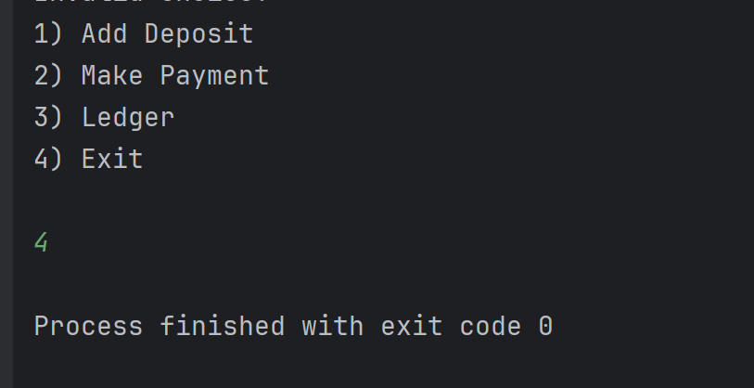

To Add deposit

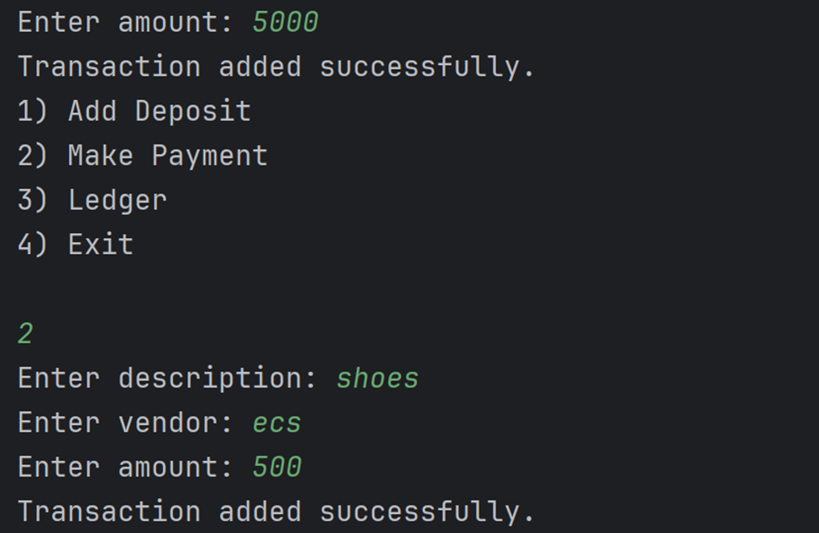

To make payment

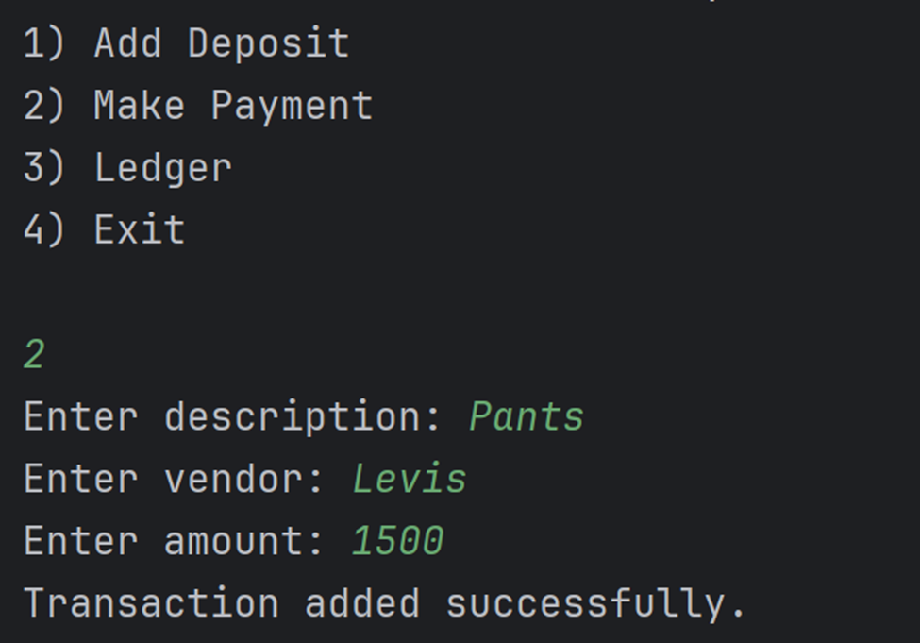

To show all transactions saved in csv file

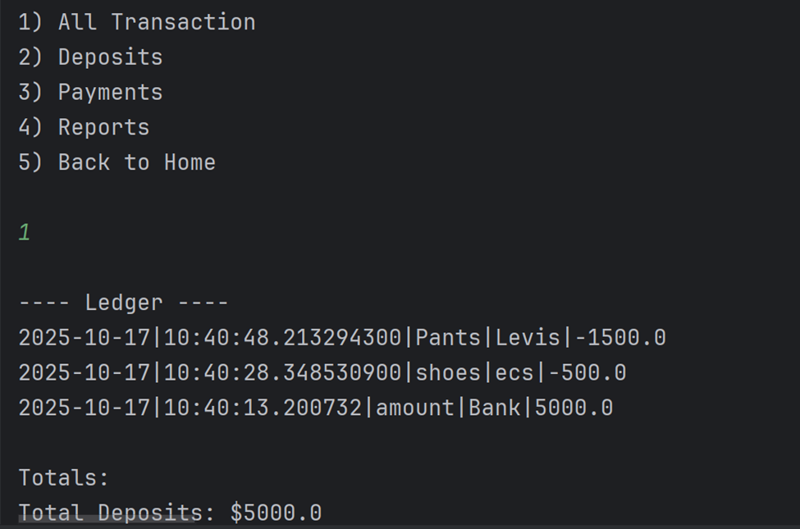

To print all payments

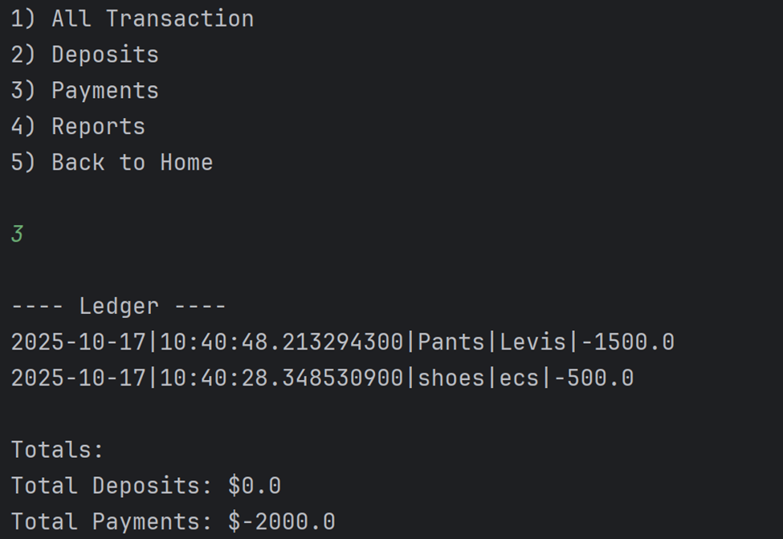

To print all deposits

